3GPP TSG-RAN4 Meeting #116 R4-2511845

Bengaluru, India, 25th – 29th August, 2025
CR-Form-v12.3
CHANGE REQUEST
 | 38.755 | CR | 0002 | rev | 1 | Current version: | 19.0.0
For HELP on using this form: comprehensive instructions can be found at
http://www.3gpp.org/Change-Requests.

Proposed change affects: | UICC apps |  | ME | x | Radio Access Network |  | Core Network

Title: | CR on TR maintenance
Source to WG: | Apple, Nokia, Ericsson
Source to TSG: | R4
Work item code: | FS_NR_FR1_DL_Frag_Carrier |  |  |  |  |  | Date: |  |  | 2025-08-10
Category: | F |  |  |  |  |  | Release: |  |  | Rel-19
 | Use one of the following categories:  F (correction)  A (mirror corresponding to a change in an earlier release)  B (addition of feature),  C (functional modification of feature)  D (editorial modification)  Detailed explanations of the above categories can  be found in 3GPP TR 21.900. |  |  |  |  |  |  |  | Use one of the following releases:  Rel-8 (Release 8)  Rel-9 (Release 9)  Rel-10 (Release 10)  Rel-11 (Release 11)  …  Rel-17 (Release 17)  Rel-18 (Release 18)  Rel-19 (Release 19)  Rel-20 (Release 20)
Reason for change: |  | As discussed in R4-2509436, several aspects in Clause 8.2 requires further clarificaiton or wording improvement. In addition, as raised in R4-2509164, the Reference section requires updating with the latest SID number. Additionally, according to the scenario definition in Section 8.2, page 88 of TR 38.755, the order of CA fallback with and without architecture change is incorrectly described in Figure 8.2.1-4.
Summary of change: |  | - General wording improvements  - Pointing out that Scenario 3a may not be allowed in current specification and thus would imply specification impact in future releases to support it  - Furhter clarifying Network-initiated and UE-initiated transition  - Updated the Reference section.  - Revised the description of CA fallback order in Figure 8.2.1-4 description.
Consequences if not approved: |  | There is ambiguity in the TR
Clauses affected: |  | 2, 5.4.1, 8.2, 8.3.2
 |  | Y | N
Other specs |  |  |  | Other core specifications |  |  |  | TS/TR ... CR ...
affected: |  |  |  | Test specifications |  |  |  | TS/TR ... CR ...
(show related CRs) |  |  |  | O&M Specifications |  |  |  | TS/TR ... CR ...
Other comments:
This CR's revision history:

<Start of Change #1>

2 References
The following documents contain provisions which, through reference in this text, constitute provisions of the present document.
- References are either specific (identified by date of publication, edition number, version number, etc.) or non-specific.
- For a specific reference, subsequent revisions do not apply.
- For a non-specific reference, the latest version applies. In the case of a reference to a 3GPP document (including a GSM document), a non-specific reference implicitly refers to the latest version of that document in the same Release as the present document.
[1] 3GPP TR 21.905: “Vocabulary for 3GPP Specifications”.
[2] RP-243002, “New SID: Study on NR FR1 DL Fragmented Carriers”.
[3] 3GPP TS 38.101-1: “NR; User Equipment (UE) radio transmission and reception; Part 1: Range 1 Standalone”.
[4] 3GPP TS 38.101-2: “NR; User Equipment (UE) radio transmission and reception; Part 2: Range 2 Standalone”.
[5] 3GPP TS 38.101-3: “NR; User Equipment (UE) radio transmission and reception; Part 3: Range 1 and Range 2 Interworking operation with other radios”.
[6] R4-2413339 Discussion on methods for reducing the number of UE Rx chains for Fragmented Carriers, RAN4#112, Nokia
[7] R4-2415390 Discussion on methods for reducing the number of UE Rx RF chains for Fragmented Carriers, RAN4#112bis, Nokia
[8] RP-233374, Fragmented carriers in the DL, TELUS, Bell Mobility, T-Mobile USA, Telstra Limited, US Cellular Corporation, Nokia, Nokia Shanghai Bell
[9] R4-2411691 On general aspects of fragmented carriers, RAN4#112, Huawei
[10] RP-241269, On Fragmented Carriers in Rel-19, Apple
[11] RP-241361, Recommended WF on Fragmented Carriers, MediaTek
[12] R4-2417201 WF on NR FR1 DL fragmented carriers study, RAN4#112bis
[13] R4-2413031 On architecture options for fragmented spectrum reception, RAN4#112, Skyworks
[14] R4-2416138 Discussion on UE Rx chain architecture and network assumption, RAN4#112bis, MediaTek
[15] R4-2420519 WF on NR FR1 DL fragmented carriers study, RAN4#113
[16] R4-2415804 On methods for reducing the number of UE Rx chain, RAN4#112bis, Huawei
[17] R4-2503479 TP to TR 38.755 on Clause 5, RAN4#114bis, CATT
[18] R4-2503558 TP for TR38.755: Company C evaluation results, RAN4#114bis, Qualcomm
[19] R4-2504452 TP on UE RF requirements impact for fragmented carriers, RAN4#114bis, Apple
[20] R4-2504214 Further discussion of impacts on UE RF requirements and DL performance impacts, RAN4#114bis, MediaTek
[21] R4-2504129 General aspects of Fragmented CA, RAN4#114bis, Nokia
[22] R4-2505109 WF on NR FR1 DL fragmented carriers study, RAN4#114bis, MediaTek, Apple, Qualcomm
[23] R4-2503556 Procedures for fragmented carriers, RAN4#114bis, Qualcomm
[24] R4-2501397 Discussion of impacts on UE RF requirements and DL performance impacts, RAN4#114, MediaTek
[25] R4-2504214 Further discussion of impacts on UE RF requirements and DL performance impacts, RAN4#114bis, MediaTek
[26] R4-2504239 Discussion of impacts on UE RF requirements and DL performance, RAN4#114bis, Spreadtrum, UNISOC
[27] R4-2506270 TP on RF requirements evaluation for fragmented carriers from company S, RAN4#115, Samsung
[28] R4-2504451 On UE RF requirements for fragmented carriers, RAN4#114bis, Apple
[29] R4-2506378 TP to TR38.755 on UE RF requirements impact for fragmented carriers, RAN4#115, ZTE
[30] R4-2504284 On RF requirements of fragmented carriers, RAN4#114bis, Huanwe
[31] R4-2503338 Impacts on UE RF requirements and DL performance, RAN4#114bis, Xiaomi
[32] R4-2502873 WF on NR FR1 DL fragmented carriers study, RAN4#114, Moderator (Mediatek Inc.), OPPO, vivo, ZTE, Nokia, Ericsson, Xiaomi, Apple, Samsung, Huawei
[33] R4-2500676 Topic summary for [114][124] FS_NR_FR1_DL_Frag_Carrier, RAN4#114, Moderator
[34] R4-2507939 TP for RRM aspect of FS_NR_DL_Frag_Carrier, RAN4#115, Nokia
[35] R4-2507951 TP for TR38.755: Summary for NR FR1 DL fragment carriers study, RAN4#115, MediaTek
[36] R4-2507952 TP for TR Summary on the evaluation results and further discussion on the one Rx RF chain mode applicability, RAN4#115, MediaTek
[37] R4-2508114 TP for TR indication of fragmented CA alternative 1, RAN4#115, vivo, apple, MediaTek
[38] R4-2505885 On methods for reducing the number of UE Rx chains for fragmented carriers, RAN4#115, Apple
[39] R4-2507953 TP to TR 38.755: on UE indication of supporting FR1 fragmented carriers, RAN4#115, CHTTL
[40] R4-2508113 TP for TR signaling indication for Option 2 new notations, RAN4#115, vivo, Apple, MediaTek
[41] R4-2507949 TP to TR 38.755 on UE indication to the network, RAN4#115, Ericsson, Xiaomi
[42] R4-2504039, "Discussion on UE capability indication for single Rx chain," Ericsson
[43] R4-2507950 TP to TR 38.755 on fallback behaviour, RAN4#115, Huawei, vivo, OPPO, Mediatek, Apple, ZTE
[44] R4-2503366 On fallback behavior and signaling aspect for fragmented carriers, RAN4#114bis, Samsung
[45] R4-2504213 Discussion on remaining signalling aspects for DL fragmented carriers study, RAN4#114bis, MediaTek
[46] R4-2504450 On methods for reducing the number of UE Rx chains for fragmented carriers, RAN4#114bis, Apple
[47] R4-2504260 Views on the usage of the FR1 fragmented carriers, RAN4#114bis, CHTTL
[48] R4-2411310 Views on UE RF architecture and NW deployment assumption for fragmented carriers, RAN4#112, Samsung, TELUS, Bell mobility.
[49] R4-2507938 TP for triggering condition option1 in FS_NR_DL_Frag_Carrier, RAN4#115, OPPO, Huawei, Apple, Nokia
[50] R4-2507947 TP for TR Discussion on signalling aspects, RAN4#115, MediaTek
[51] R4-2505784 Methods for reducing the number of UE Rx chains, RAN4#115, Xiaomi
[52] R4-2507476 TP for TR 38.755 on triggering condition, RAN4#115, Huawei
[53] R4-2505783 TP to TR 38.755 on RF requirements evaluation, RAN4#115, Xiaomi
[54] R4-2506376 TP to TR 38.755 on UE RF requirements evaluation for fragmented carriers, RAN4#115, Spreadtrum,UNISOC
[55] R4-2506378 TP to TR38.755 on UE RF requirements impact for fragmented carriers, RAN4#115, ZTE
[56] R4-2507477 TP for TR 38.755 on RF performance, RAN4#115, Huawei
[57] R4-2507948 TPs to TR 38.755 with aspects of Fragmented CA, RAN4#115, Nokia
[58] R4-2508114 TP for TR indication of fragmented CA alternative 1, RAN4#115, vivo, Apple, MediaTek
[59] R4-2507953 TP to TR 38.755: on UE indication of supporting FR1 fragmented carriers, RAN4#115, CHTTL
[60] R4-2507951 TP for TR38.755: Summary for NR FR1 DL fragment carriers study, RAN4#115, MediaTek

<End of Change #1>

<Start of Change #2>

5.4.1 SCell control for fragmented CA
If a change in HW configuration between UE using 1 Rx chain or 2 Rx chains for reception in a fragmented carrier aggregation deployment does impact the UE performance, system performance or the network, there is a need to ensure that whatever ‘mode’ the UE is operating in, this is aligned between the UE and the network. Hence, it needs to be well aligned between UE and network whether the UE is applying 1Rx chain or 2 Rx chain.
In many scenarios, where the UE can change between using 1Rx or 2Rx chains without performance impact, such UE autonomous switching could be possible without specification impact. However, if the UE change between using 1Rx or 2Rx in a Fragmented CA setup, does have system impact, it needs to be clear how and when such HW reconfiguration is allowed and can be performed.
If RAN4 explores solutions which operate differently than the current network controlled SCell operations, RAN4 may involve other working groups if needed.
A fragmented carrier configuration can consist of PCell + SCell and SCell + SCell.

<End of Change #2>

<Start of Change #3>

8.2 CA fallback and architecture switching
When either the in-gap interference or the self-interference is too high, the receiver is hard to maintain the “one Rx RF chain” mode, and the “fallback” behaviour needs to be studied. In order to make the application of this function more future-oriented, some higher-order CA combinations are also considered.
In total, two aspects should be involved when discussing fallback behaviour: “CA fallback” and “architecture switching”.
“CA fallback” means releasing at least one SCell in one band of the band combination, while the “architecture switching” means the switching from “One Rx RF chain (aka. fully shared Rx RF chain)” to legacy CA architecture [44], where legacy CA architecture includes fully separated Rx chain and partially shared Rx chain.When there is only one component carrier in one band, it is natural that UE RF hardware is also configured to legacy architecture for single carrier in the band.
When categorizing “CA fallback”, the following scenarios are involved:
a.) Legacy CA combination falls back to lower order CA
- Legacy CA combination belongs to mix of inter-band CA and intra-band CA with more than 2CCs, etc.
b.) Legacy CA combination falls back to “non-CA” mode
- Legacy CA combination belongs to intra-band CA combination with 2CCs.
When categorizing “architecture switching”, the following scenarios are involved:
a.) Architecture switches between “partially shared Rx RF chain” mode and “one Rx RF chain” mode
b.) Architecture switches between “fully separate Rx RF chain” mode and “one Rx RF chain” mode
Based on the analysis above, the fallback behaviour should be divided into the following three scenarios:
a.) Scenario 1: CA fallback without architecture switching
b.) Scenario 2: CA fallback with architecture switching
c.) Scenario 3: architecture switching without CA fallback
Below Figure 8.2-1 is an example to illustrate how the UE’s work mode transfers from “one Rx RF chain” to scenarios 1~3. The figure is generated based on Figure 3 in [45] and Figure 1 in [44].
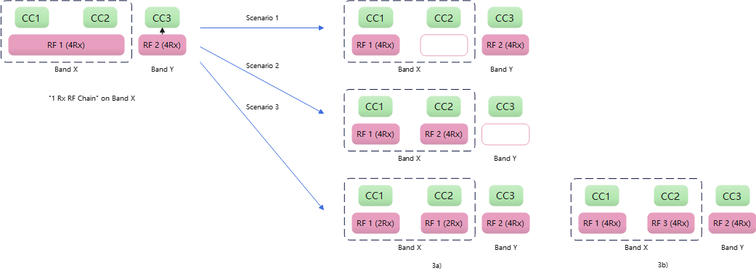
Figure 8.2-1: Fall-back behaviour, scenarios 1~3
For scenario 1, it does not require additional UE capability or network configuration, assuming normal CA reconfiguration from the network to enable the fallback is still required. As a default, any UE supporting “one Rx RF chain” supports Scenario 1 as the legacy CA fallback configuration. From network point of view, if the performance on CC2 is not at satisfactory level, the network could just release the CC2 using existing CA operation process. Based on the evaluation result in section 7, the performance loss of “one Rx RF chain” is comparable with that of the other CA configurations due to interference such as UL harmonic, intermodulation, limited cross band isolation, etc. in the RAN4 specification. It is therefore feasible to handle the CA configuration with “one Rx RF chain” as a normal CA configuration. It is also beneficial for early deployment of the fragmented carrier feature without requiring upgrading the network. On the other hand, as [46] pointed out, in some cases Scenario 1 might not be the best choice from network’s point of view if CC2 has larger bandwidth than CC3, or CC2 could achieve better channel quality using legacy CA architecture than CC3. Scenario 2 is thus considered.
For Scenario 2, it keeps CC2 and releases CC3 if the network decides CC2 could provide what the network expects with better performance than CC3. This scenario requires architecture switching, which means the RF chains previously used by CC3 need to be retuned to support CC2 in the case where all the Rx chains are used up. However, whether the RF chains for different bands could be flexibly switched across the bands depends on UE implementation and is band combination specific, which means such info as UE capability may need to be indicated to the network. Whether and how such information is indicated to network is for further study. Scenario 2 would be useful especially when the performance of CC2(CC1) could be improved a lot when switching back to legacy CA architecture, such as when there is serious Tx leakage, or the in-gap interference is quite high considering the non-collocated scenario. Additional UE measurement might be needed to assist the network to compare the performance of CC2 and CC3.
For Scenario 3, it does not reduce the number of CCs, but requires architecture switching with reduced Rxs or DL MIMO layers (Scenario 3a) or the same number of Rx/DL MIMO layers (Scenario 3b). It is worth noting that Scenario 3a may not be allowed in current specification and thus would imply specification impact in future releases to support it. Similar to Scenario 2, whether the switching is feasible depends on UE implementation and is band combination specific, and whether and how such information is indicated to network is for further study. Scenario 3b assumes there are enough spare Rx chains. [47] mentions the benefit of adopting “one Rx RF Chain” is not very clear from the RF performance aspect if there are spare Rx chains. On the other hand, the UE might get the benefit of power saving from “one Rx RF Chain” if the relevant conditions could ensure a satisfactory Rx performance.
It needs to be considered whether the transition from “one Rx RF Chain” to Scenario 1~3 is “network initiated” or “UE initiated”. “Network initiated” means the network sends a command to the UE to trigger the transition, with or without assistant indication or measurement report from the UE. “UE initiated” means the UE could execute the transition without receiving the network’s command. UE may inform the network after the transition happened. Network-initiated transition may or may not have standards impact, and UE-initiated transition might have standards impact if the interruption needs to be specified or UE needs to inform the network about the transition.
- Scenario 1, 2 and 3a involve the change of number of CCs or number of DL MIMO layers, which has to be configured by the network, i.e. ‘network initiated’.
- For Scenario 2, the network configuration might explicitly indicate the architecture switching, or the switching could be done by the UE autonomously.
- Scenario 3b could be transparent to the network if the UE has spare Rx chains, although some interruption is needed. The network could also intentionally configure Scenario 3b. Therefore both ‘network initiated’ or ‘UE initiated’ could apply to Scenario 3b.
More details on how the UE’s work mode switching from separate mode to “one RX RF chain” and falling back to scenarios 1~3 are achieved are as follows:

8.2.1 Case1: Partially shared switch to fully shared & fallback behaviour
According to section 5.2, the partially shared architectures contain both internal Rx path split and external Rx path split. These two partially shared architectures are expressed in the same form as below, i.e., the antenna is shared between CC1/2/3, and the other devices before down-conversion such as LNA, BPF are omitted here.
When partially shared architecture switches to fully shared architecture, for band nX CC1 and CC2 would be received by one RX RF chain together instead of each CC taking up one chain. Therefore, there would be one chain being released after each antenna.
According to the utilization of the released chain, there are two sub-scenarios: the released chain is not used (Fig 8.2.1-1), or the released chain is used to aggregate more CCs in the same band (Fig 8.2.1-3). As the new aggregated CCs belong to the same band and there is no new demand in the UE's hardware capability, it could be predicted that there is no new capability needed except for supporting the “one Rx RF chain” architecture.
a.) After sharing, the released chain is not used.
- Partially shared→ “one Rx RF chain”
Figure 8.2.1-1: Partially shared switch to “one Rx RF chain” mode
As can be seen in Fig 8.2.1-1, before sharing the partially shared architecture composes of one set of RX chain (one main Rx + one diversity Rx). After sharing half of the chain is released and unused which may have the benefit of power saving.
- Fallback behaviour:
Figure 8.2.1-2: Fallback to lower order CA combination (scenario1), or CA combination unchanged (scenario3)
b.) After one Rx RF chain is enabled, the released chain is used to aggregate more CCs in the same band.
- Partially shared→ “one Rx RF chain” & Fallback behaviour
The following analysis takes the 4Rx RFchain architecture as an example, and the analysis of the 2Rx RFchain architecture is similar. 4Rx UE contains one main receiver branch and three diversity receiver branches, which could be seen in Fig 8.2.1-3.
Figure 8.2.1-3: 4RX UE, switch to “one Rx RF chain” mode
Figure 8.2.1-4: 4RX UE, fall-back to a lower order CA combination
In Fig 8.2.1-4, for 4Rx UE the fallback behaviour would lead to a lower order CA combination with architecture unchanged (scenario1) or changed (scenario2).

<End of Change #3>

<Start of Change #4>

8.3.2 Triggering condition proposal for option 2: UE measurement to determine and indicate to the network
Triggering condition to enable “One Rx RF chain” with UE assisted in-gap interference measurement and indication
When the UE enables one Rx RF chain to receive two non-contiguous carriers, it was assumed another adjacent channel downlink carrier, from collocated second operator, in the gap may also exist at the same time. From companies’ simulation, when the power difference between the in-gap blocker and wanted carriers are higher than the image rejection ratio, i.e. 25dB, it may seriously degrade the receiving signal quality of wanted carriers. A new measurement mechanism can be needed to judge the in-gap blocker power level and compare it with the wanted signal power levels. Referring to [23], an example of UE states and example flow of state change are proposed as following:
State 1: UE is configured for CC1 on the band and meets the requirements accordingly
State 2: UE is configured for non-contiguous CC1 and CC2 on the band and uses two Rx chains to receive them and meets existing DL NCCA requirements accordingly
State 3: UE is configured for non-contiguous CC1 and CC2 on the band and uses one Rx RF chain to receive them and meets possible new requirements accordingly
State 4: UE is configured same as state 1 (CC1, PCell) and has been checked no more available Rx RF chain to receive intra-band non-contiguous CC2 using second Rx RF chain
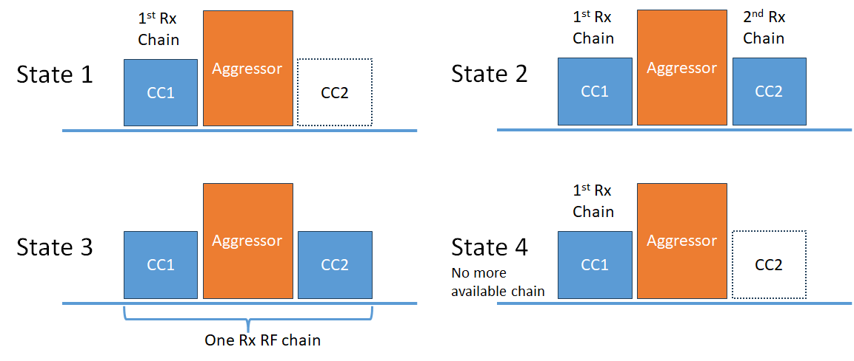
Figure 8.3.2-1: Description of different UE states for fragmented carriers
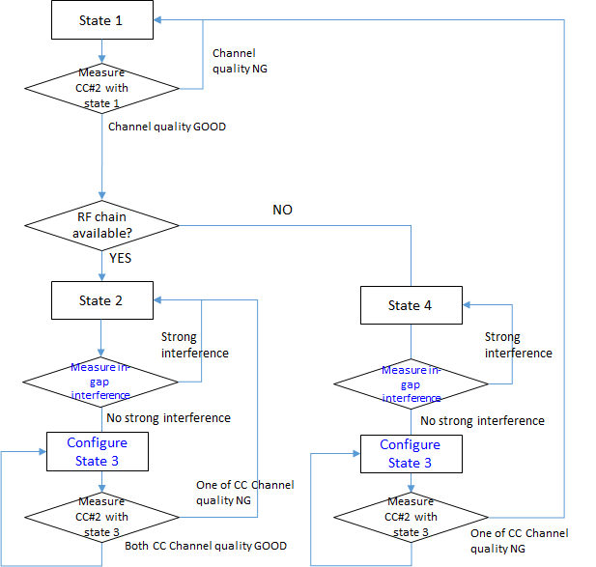
Figure 8.3.2-2: State diagram for switching between the states
When UE has more available Rx RF chain, UE can just apply legacy DL NCCA architecture to maintain best performance on receiving each CC as illustrated in Figure 8.3.2-2. UE can also be configured for measurement by network to check whether the large interference exists and whether UE is capable to receive one more CC when needed while UE is in state 2.
When UE does not have more available Rx RF chain (state 4), UE can still be configured for measurement by network doing the same check. UE can just report to network whether it is capable or not capable of “One Rx RF chain” as UE assistance information.
When UE is configured by network to perform measurement on both wanted CCs and in-gap interference, UE can simply use existing RSSI measurement approach for in-gap interference measurement. Network can configure the measurement bandwidth and the virtual RB location to the UE, wherein the RB location to be measured in the in-gap region can refer to PCC or one of the CCs. The details of measurement flow can be further discussed during WI phase if there is work item in the future.
The benefit of UE being able to measure in-gap interference can be observed from the state chart. Ping-pong between state 2 and state 3 or between state 4 and state 3 can be reduced if large in-gap interference can be discovered.
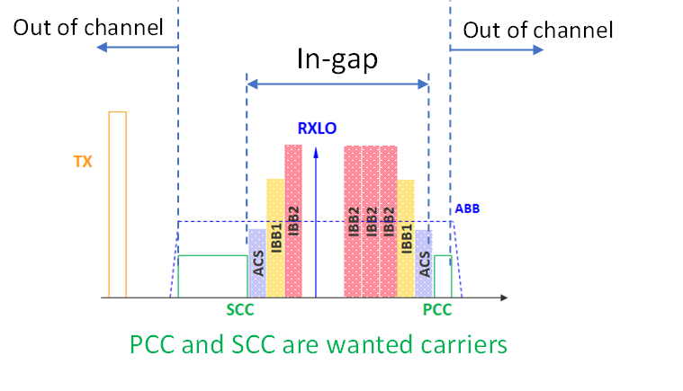
Figure 8.3.2-3: Spectrum plot of DL fragmented carriers and in-gap interference
It would be possible to measure noise level of both wanted CCs and in-gap interfeernce if total BW is within the 100MHz under one Rx RF chain mode. One possible method to measure in-gap interference level is to refer to existing RSSI measurement procedure with virtual RB ranking in the in-gap region or refer to measuring neighbour cell procedure. The measurement would be applicable in both one Rx RF chain mode and legacy (partial-separated Rx RF chain) mode.
The ping-pong between state 2/4 and state 3 can be reduced if UE can measure in-gap interference.
An alternative example to avoid frequent interruption due to UE measurement with self-assessment, single shot measurement/interruption can be applied before UE indication to Network. The workflow can be refereed to below figure.
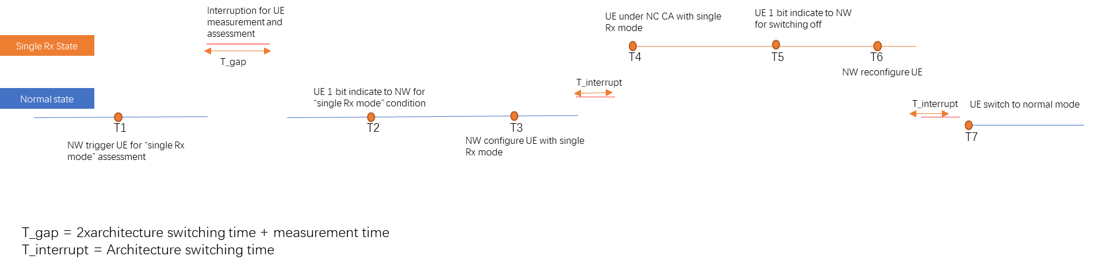
Figure 8.3.2-4: Work flow on UE switching between normal mode and single Rx mode

In-gap inter-operator interference may not be the only factor that has impact on DL receiving performance when one Rx RF chain mode is configured. During Rx performance evaluation and discussion between companies, it was found self-band Tx leakage also plays an important role. It would be more clear to understand these impacts via evaluating the two factors with the help from system level simulation. The simulation assumptions are listed in the Table 8.3.2-1 below.
Table 8.3.2-1: Assumptions for system level simulation
Parameter | NR
Carrier | 2G Hz
DL BW | 20MHz
UL BW | 20MHz
Antenna pattern | TR 38.901 Table 7.3-1
Network layout | 19-sites (57 sectors) with wrap-around
Inter-site distance in meter | 500 for 2GHz band for UMA
System loading and activity | Full buffer 100%
Network layout | 19-sites [57 sectors] with wrap-around
DL power control | No
UL power control | TR 36.942[8] section 5.1.1.6 (set 1) by bandwidth scale, target SNR at BS is 15 dB
NR UE dropping | NR UE: 100% outdoor  UE number: DL active UE: 10 UE per cell
Pathloss model | TR 38.901 UMA
O2I penetration loss | High penetration loss as in TR 38.901

It is assumed co-located inter-operators, taking 19-sites with 3 sectors in each site. 10 UEs in every sector per operator. These are illustrated below:
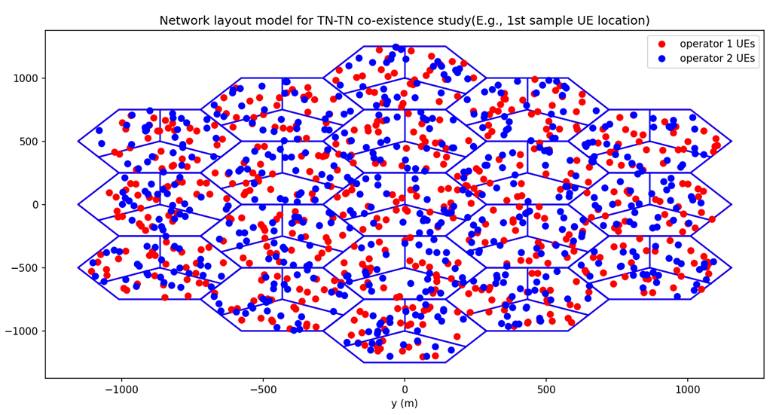
Figure 8.3.2-5: Network layout model for system level simulation

For the UE parameter assumptions, they are listed in the Table 8.3.2-2. One Rx RF chain ACS performance is evaluated with values of 15 and 26 dB. 33dB is assumed as performance reference of partial separated Rx RF chain configuration.
Table 8.3.2-2: UE assumptions for system level simulation
 |  | NR
UE | Tx ACLR | 30dB (ACLR1)  43dB (ACLR2)
 | Duplexer isolation between T/R | 50dB
 | Rx baseband analog filter Tx leakage rejection | 5dB (one Rx RF chain)  15dB (partial separated Rx RF chain)
 | Rx ACS | 15, 26dB (one Rx RF chain)  33dB (partial separated Rx RF chain)

Simulation result is illustrated in below figures.
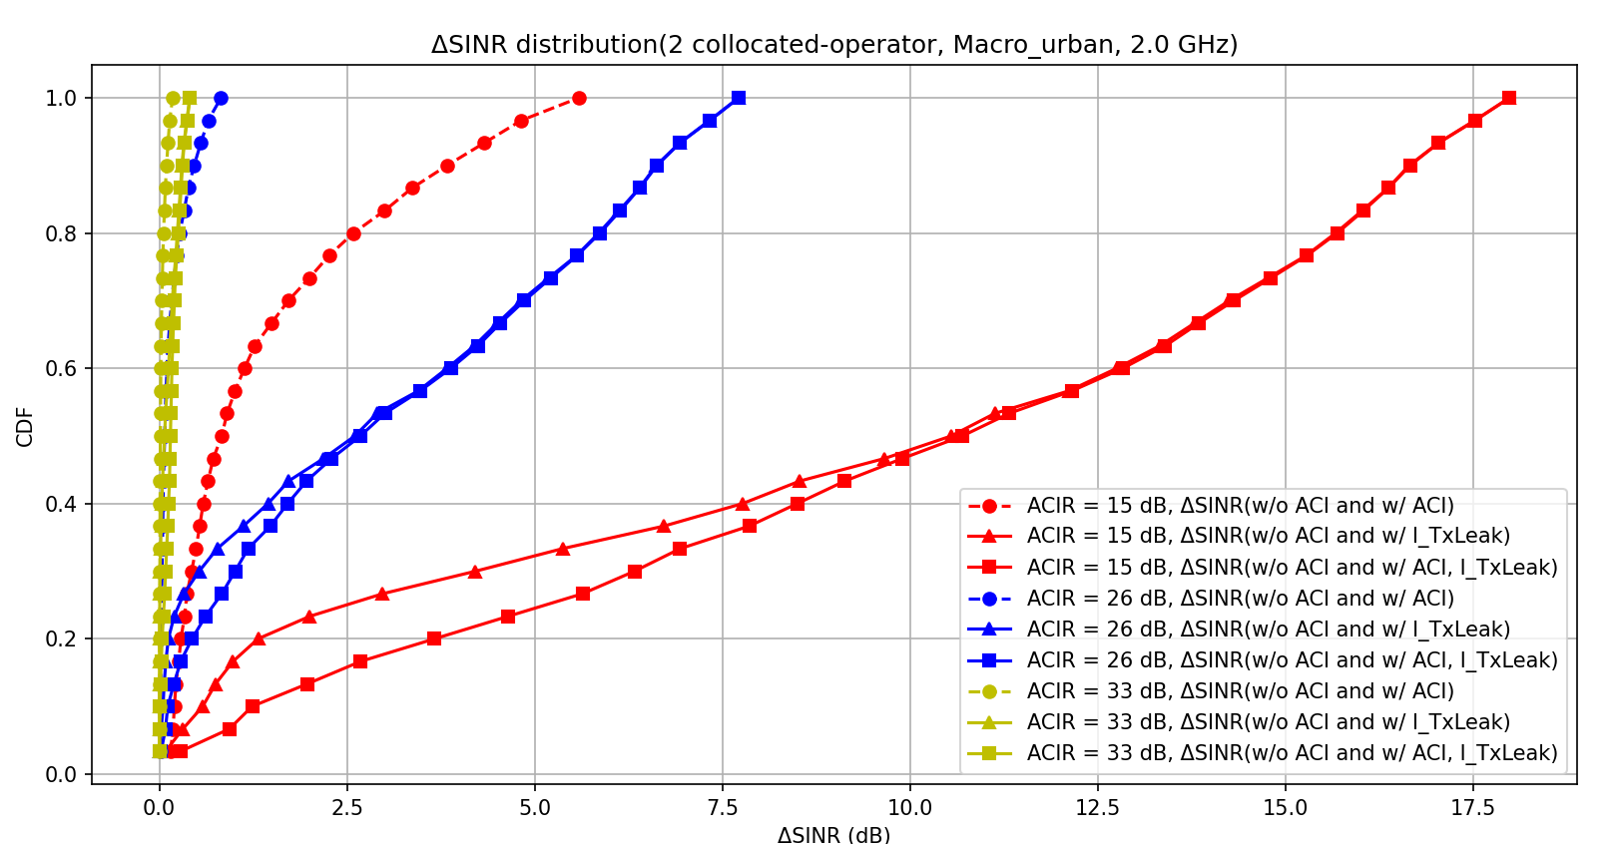
Figure 8.3.2-6: CDF of DL signal and interference distribution w w/o ACI of Tx leakage
From the simulation results, some important aspects can be observed:
a.) In-gap interference and Tx leakage both have impact on DL receiving SINR performance. Which one occupies larger portion may depend on UE implementation and the distance/channel condition between UE and gNB.
b.) UE self-judgement mechanism would be needed with considering both in-gap interference and Tx leakage. As long as UE can guarantee pass the adjusted minimum requirements, if specified. How to judge whether UE is capable for one Rx RF chain mode can be left to UE implementation.
c.) Even though there are some degradations on the DL receiving SINR, there are certain percentage of UEs can still benefit from enabling one Rx RF chain when higher order CA combo is configured, with acceptable degradation.

On how to decide to enable “One Rx RF chain” or fallback to normal mode, this can be left to UE implemention as long as UE can gurantee the Rx performance. Once UE detect “One Rx RF chain” operation is not suitable, UE can indiate to NW and NW can reconfigure UE with single CC or normal CA mode.
There are several ways to enable triggering condition, those options were summarized in below table.
Table 8.3.2-3: Options for triggering condition to enable “One Rx RF chain”
Options | Spec impact | Signaling overhead | UE implementation complexity | Potential performance impact
Option 1-1: Existing channel quality reporting and procedures without any change | Minimal | No additional signaling | No additional reporting | Not possible to monitor Tx leakage and in gap interference before UE switched to single RX mode.  Ping-pong effect between different states with frequently switching on/off when the RF performance degradation caused by “One Rx RF chain” is very large
Option 1-2: Reuse the existing channel quality reporting procedure with “One Rx RF chain”share Rx architecture measurement. | Small | Update to measurement configuration is needed to request UE performs measurement in “One Rx RF chain” | No additional reporting | NW is fully aware of the UE’s performance difference between “One Rx RF chain” state and legacy state  Measurement gap and interruption required before UE enter into Single RX mode for reporting
Option 2a: UE measurement reporting for in gap interference | Big impact with NW configuration and UE reporting (RAN1, RAN2 also need to be involved) | Signaling on measurement configuration and reporting | UE needs to follow NW configuration for measurement and reporting | NW can manage interference  Measurement gap and interruption required before UE enter into Single RX mode for reporting  Measurement reliability and/or accuracy has not been analyzed
Option 2b: UE self-assessment with 1bit indication to network | Small impact with 1bits indication  FFS whether measurement gap interruption required for monitoring interference before UE enter into CA mode | Limited signaling overhead on indication | UE self-judgment, no measurement reporting required | NW can aware whether UE state is suitable for single Rx mode  Measurement gap and interruption required before UE enter into Single RX mode for reporting  The UE indication may imply UE can pass RF minimum requirements  NW doesn’t have accurate expectation of how good UE could behave with the “One Rx RF chain”
The UE could evaluate how well it could behave with the “One Rx RF chain” based on the measurements it needs, such as the self-interference, the strength and location of the in-gap interference, etc. Then the UE indicates the evaluation result to the network, either a simple indication of “yes” or “no”, or in some finer granularity.
With the discussion above, either option 1 Existing channel quality reporting and procedures or option 2b UE self-assessment with 1bit indication to network may be more preferable.
There are ways to limit the potential impacts on the DL performance for PCell, e.g., 1) TDD CA configuration or FDD CA configurations that have large duplex gap would experience no or little self-interference issue. 2) In case of self-interference for FDD CA configurations, PCC SCC Swapping can be used. 3) The use of 1 Rx RF chain can be enabled when the UE is not located at cell edge.

<End of Change #4>

