3GPP TSG-RAN WG4 Meeting#116 DRAFT_R4-2511846

Bengaluru, India, 25 – 29 August 2025
CR-Form-v12.3
CHANGE REQUEST
 | 38.101-1 | CR | 2962 | rev | 1 | Current version: | 18.10.0
For HELP on using this form: comprehensive instructions can be found at
http://www.3gpp.org/Change-Requests.

Proposed change affects: | UICC apps |  | ME | X | Radio Access Network |  | Core Network

Title: | (NR_channel_raster_enh-Core) Correction to nominal CA spacing to accommodate UE-specific channel bandwidths
Source to WG: | Ericsson
Source to TSG: | R4
Work item code: | NR_channel_raster_enh-Core |  |  |  |  |  | Date: |  |  | 2025-08-25
Category: | F |  |  |  |  |  | Release: |  |  | Rel-18
 | Use one of the following categories:  F (correction)  A (mirror corresponding to a change in an earlier release)  B (addition of feature),  C (functional modification of feature)  D (editorial modification)  Detailed explanations of the above categories can  be found in 3GPP TR 21.900. |  |  |  |  |  |  |  | Use one of the following releases:  Rel-8 (Release 8)  Rel-9 (Release 9)  Rel-10 (Release 10)  Rel-11 (Release 11)  …  Rel-17 (Release 17)  Rel-18 (Release 18)  Rel-19 (Release 19)  Rel-20 (Release 20)
Reason for change: |  | The nominal CA spacing applicable when a UE-specific channel bandwidth configured within a component carrier is subject to different interpretations in the field; the definition of a contiguous CA configuration with configured UE-specific channel bandwidths unclear.  The nominal CA spacing is not defined when a UE is configured with a UE-specific channel bandwidth within a component carrier.
Summary of change: |  | Clause 5.4A.1: the nominal CA spacing between a UE specific channel bandwidth configured within a component carrier (CC2 below) and an adjacent NR carrier (CC1 below) is defined with the configured UE-specific channel bandwith (MHz), its corresponding carrier bandwidth (transmission bandwidth configuration) and center frequency replacing those of the said component carrier (CC2) as shown below:  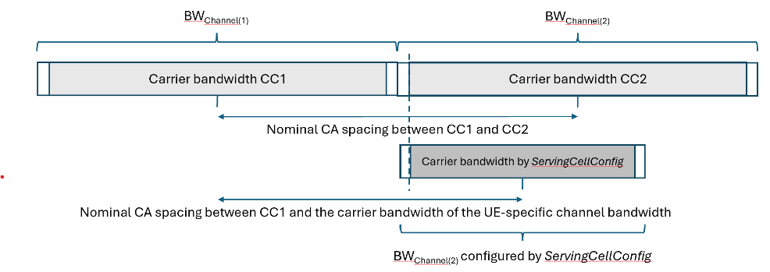  The carriers and UE specific channel bandwidth can also be located/centred on the enhanced channel raster.  A CA configuration with a UE-specific configured within a wider component carrier and a another NR component carrier can be non-contigous even if the CA configuration with the two carrier is contiguous (e.g. if the narrower UE-specific channel bandwidth shown in the figure above is configured at the upper edge of CC2).
Consequences if not approved: |  | Unclear whether a CA combination of a UE-specific CHBW and another adjacent carrier is contiguous or non-contiguous.
Clauses affected: |  | 5.4A.1
 |  | Y | N
Other specs |  |  | X | Other core specifications
affected: |  | X |  | Test specifications |  |  |  | . TS 38.521-1
(show related CRs) |  |  | X | O&M Specifications
Other comments:
This CR's revision history: |  | r1: the formulations of the corrections modified

< start of changes >

5.4A.1 Channel spacing for CA
For intra-band contiguous carrier aggregation with two or more component carriers, the nominal channel spacing between two adjacent NR component carriers is defined as the following unless stated otherwise:
For NR operating bands with a 100 kHz or 10 kHz channel raster:
while for NR operating bands without a 100 kHz channel raster:
with
n = µ₀
where BW_{Channel(1)} and BW_{Channel(2)} are the channel bandwidths of the two respective NR component carriers according to Table 5.3.2-1 with values in MHz, μ₀ is the largest μ value among the subcarrier spacing configurations supported in the operating band for both of the channel bandwidths according to Table 5.3.5-1 and GB_{Channel(i)} is the minimum guard band for channel bandwidth i according to Table 5.3.3-1 for the said μ value with μ as defined in TS 38.211. In case there is no common μ value for both of the channel bandwidths, μ₀=1 is selected and GB_{Channel(i)} is the minimum guard band for channel bandwidth i according to Table 5.3.3-1 for μ=1 with μ as defined in TS 38.211.
NEW:
The bandwidth BW_{Channel(i)} for determining the nominal channel spacing is the UE specific channel bandwidth, if configured by ServingCellConfig, the channel bandwidth of the NR component carrier otherwise.
The channel spacing for intra-band contiguous carrier aggregation can be adjusted to any multiple of least common multiple of channel raster, the enhanced channel raster if supported, and sub-carrier spacing less than the nominal channel spacing to optimize performance in a particular deployment scenario.
For intra-band contiguous carrier aggregation in NR bands restricted to operation with shared-spectrum channel access, the maximum deviation from the nominal channel spacing is 300 kHz.
For intra-band non-contiguous carrier aggregation, the channel spacing between two NR component carriers in different sub-blocks shall be larger than the nominal channel spacing defined in this clause.

5.4A.2 Channel raster for CA
< end of changes >

