3GPP TSG-RAN WG4 Meeting #110bis R4-2405995
Changsha, China, April 15 – April 19, 2024
Title: Way Forward for [110bis][305] NR_NTN_enh_Part1 Doppler pre-compensation into the guard band
Agenda Item: 6.16.9
Source: Huawei, Thales
Document for: Approval

Background
In the RAN4#110 meeting, although the draft big CR [1] was endorsed in RAN4#110 meeting, Doppler pre-compensation issues were not extensively discussed for FR2-NTN UE. Especially, RAN4 didn’t fully discuss the relationship among the guard band and transmission bandwidth configuration under large Doppler shift condition.
During the RAN4#110bis meeting, one contribution [2] identified this issue. Currently, there is no discussion on this Doppler pre-compensation issue for Ka band VSAT. For NGSO scenario, the Doppler pre-compensation could be up to 24ppm especially for LEO scenario. For 30GHz UL frequency, the maximum Doppler pre-compensation is about 720kHz. One RB could be shifted into the guard for 60kHz SCS when VSAT is handling the Doppler pre-compensation as figure 1.

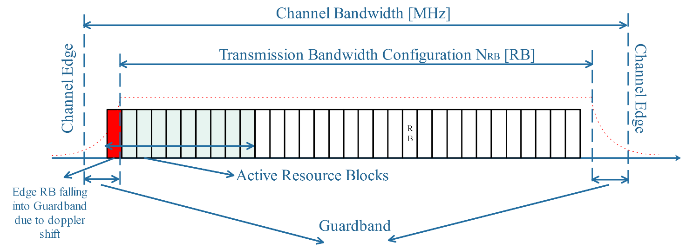
Figure 1 Edge RB falling into Guard band due to Doppler pre-compensation

For such scenarios, it may have impacts on both Tx and Rx requirements for NTN UE as the real guard band for UE is smaller than what we expected or specified. Although Doppler pre-compensation issues were discussed for FR1-NTN in Rel-18, which was raised by RAN5 LS [3]. However, due to the time being, the following testing configuration related to satellite access in table 1 were captured into the TS 38.101-5 for FR1-NTN UE assuming zero Doppler condition. That means current FR1-NTN UE RF requirements are only applicable to the GSO (Geostationary Orbit) scenario. In other words, there is no RF core requirements for NGSO (Non-Geostationary Orbit) scenario especial for LEO scenario in current NTN UE specification.
Table 1 testing configuration related to satellite access

A.4 Testing related to Satellite Access

A.4.1 General
The following test conditions should be maintained for Satellite Access when test equipment emulates the snapshot of the satellite link channel.
- The same ephemeris info will be maintained during each test.
- A set of ephemeris information are pre-defined for each satellite corresponding to respective epoch times in TS 38.508-1 [13].
- The range of the selected constant delay shift is as follows:
- For NGSO an altitude of 600km and 1200km on a circular orbit are considered. The range of the one-way delay between UE and satellite is from 2ms (lowest value for LEO orbit 600km) to 6.67ms (highest value for LEO orbit 1200km).
- For GSO the range of the one-way delay from UE to satellite is within 119.375ms to 128.79ms.
- Constant delay value is derived from ephemeris info (SIB19) and UE location associated to zero Doppler or non-zero Doppler value under test.

A.4.2 Test condition for transmitter characteristics
All requriements in section 6 for transmitter characteristics, other than frequency error in clause 6.4.1, shall be verified when Doppler conditions are set to zero and delay conditions are set to constant for all types of satellites.
Frequency error requirement in clause 6.4.1 shall be verified for at least two cases: one with zero Doppler condition and the other with a constant Doppler shift where the range of the absolute value of Doppler is greater than zero and up to [0.93] ppm if the IE field ntn-ScenarioSupport-r17 is present and indicated as GSO and up to 24 ppm if the IE field ntn-ScenarioSupport-r17 is present and indicated as NGSO or only the IE field nonTerrestrialNetwork-r17 is present. The delay condition is a constant.

A.4.3 Test condition for receiver characteristics
All requirements in section 7 for receiver characteristics shall be verified when Doppler conditions are set to zero and delay conditions are set to constant for all types of satellites.

A.4.4 Test condition for performance requirements
All requirements in section 8 for performance requirements shall be verified when Doppler conditions related to satellite motion for DL in service link are set to zero and delay conditions are set to constant for all types of NGSO satellites.
The one-way delay between UE and satellite for NGSO at an altitude of 600km is 2ms.

Based on the Justification for NTN testing for NGSO in the approved WID [4], NTN UE is expected to be verified under the dynamic conditions which may require the new channel model with varying Doppler shift.
NTN testing for NGSO
In Rel-18 the UE test coverage issue was identified in RAN5 for non-geostationary orbit (NGSO) when approaching the end of Rel-18, and correspondingly the solution was provided in RP-232682, where the UE supporting NGSO will be verified for frequency and timing compensation performance under the channel model with fixed Doppler shift or fixed delay shift which are randomly selected before the test.
Given that the mobile services in the NGSO satellite is a rapidly growing market segment, the NTN UE performance is expected to be fully verified to ensure that 3GPP tests cover the operation of UE with NGSO networks i.e. dynamic conditions, which may require the new channel model with varying Doppler shift and/or timing shift matching the motion trajectory of NGSO satellite.

In my understanding, such “dynamic conditions” will result in Non-zero Doppler conditions when verifying current RF requirements. As we discussed in our paper [2], the “dynamic conditions” need more discussion to address the issue that Edge RB falling into Guard band due to UE Doppler pre-compensation.

Way forward
Way Forward:
One issue is identified that Edge RB allocated to NTN UE may fall into Guard band due to UE Doppler pre-compensation in RAN4#110bis meeting.
In order to solve this issue, it’s recommended to add one RF core objective under NTN testing for NGSO on top of the RAN4 leading NTN WID RP-240857.

Reference
[1] R4-2401116, Big CR on TS38.101-5 for UE RF Requirements, Samsung Electronics France SA
[2] R4-2405340, Doppler shift issues for guard band and transmission bandwidth configuration, Huawei, HiSilicon
[3] R5-233672, LS on clarifications for Non-Terrestrial Networks, RAN5#99, May. 2023
[4] RP-240857, New WID: Enhanced requirements and test methodology for NR and IoT NTN, RAN4 chair (Huawei)

