3GPP TSG-RAN WG4 Meeting #110bis R4-2406618
Changsha, China, 15th – 19th April, 2024

Agenda item: 9.13.3
Source: CMCC
Title: WF on Ambient IoT in NR
Document for: Approval

Introduction
This way forward captures agreements on ambient IOT co-existence evaluation aspects in RAN4#110bis meeting.
The summary for ambient IOT is in R4-2405289 for information.

Way forward for co-existence evaluation

Topic 2-1: Deployment scenario
Issue 2-1-1: deployment scenarios for D1T1
Option 1-1: Legacy NR gNB are outdoor macro gNB while AIoT reader/CW/devices are all indoors. Legacy NR UE is only allowed outdoors.
Option 1-2: Legacy NR gNB are outdoor macro gNB while AIoT reader/CW/devices are all indoors. Legacy NR UE is indoor accessing to outdoor NR marco gNB
Option 2-1: Legacy NR gNB are co-located with AIoT reader and CW. All of NR and AIoT BS/UE/Reader/Device/CW are indoors. AIoT reader /CW and Legacy gNB share same hardware
Option 2-2: Legacy NR gNB are co-located with AIoT reader and CW. All of NR and AIoT BS/UE/Reader/Device/CW are indoors. AIoT reader /CW and Legacy NR gNB do not share same hardware. (less limitation on the power boosting)
Agreement:
- RAN4 to first evaluate co-existence for deployment scenario of option 1-1 and 1-2, and further study option 2-1 and 2-2.

Issue 2-1-2: deployment scenarios for D2T2
Option 1-1: Legacy NR gNB are outdoor macro gNB, AIoT intermediate UE/CW/devices are all indoors. Legacy NR UE is only allowed outdoor.
Option 1-2: Legacy NR gNB are outdoor macro gNB, AIoT intermediate UE/CW/devices are all indoors. Legacy NR UE is indoor.
Agreement:
- For D2T2 co-existence evaluation, Legacy NR gNB are outdoor macro gNB, AIoT intermediate UE/CW/devices are all indoors.
  - Consider option 1-1 and option 1-2 as the starting point

Topic 2-2: Spectrum usage
Issue 2-2-1: Spectrum usage for R2D in D1T1
Option 1: FDD DL spectrum for R2D
Option 2: FDD UL spectrum for R2D
Agreement:
- FFS on whether to prioritize FDD DL spectrum for R2D for D1T1 for co-existence evaluation.

Issue 2-2-2: Spectrum usage for CW transmission in D1T1 for the case that D2R backscattering is transmitted in the same carrier as CW for D2R backscattering
For the case that D2R backscattering is transmitted in the same carrier as CW for D2R backscattering, and for topology 1, the following cases for CW transmission are studied.
· Case 1-1: CW is transmitted from inside the topology, transmitted in DL spectrum
· Case 1-2: CW is transmitted from inside the topology, transmitted in UL spectrum
· Case 1-4: CW is transmitted from outside the topology, transmitted in UL spectrum

Agreement:
- For the case that D2R backscattering is transmitted in the same carrier as CW for D2R backscattering, consider the following for co-existence evaluation
  - CW transmits in either UL or DL spectrum
  - FFS on inside topology and outside topology.

Issue 2-2-4: Spectrum usage for R2D in D2T2
Agreement:
- Use FDD UL spectrum for R2D in D2T2.

Issue 2-2-5: Spectrum usage for CW transmission in D2T2 for the case that D2R backscattering is transmitted in the same carrier as CW for D2R backscattering
For the case that D2R backscattering is transmitted in the same carrier as CW for D2R backscattering, and for topology 2, the following cases for CW transmission are studied.
· Case 2-2: CW is transmitted from inside the topology (i.e., intermediate UE), transmitted in UL spectrum
· Case 2-3: CW is transmitted from outside the topology, transmitted in DL spectrum
· Case 2-4: CW is transmitted from outside the topology, transmitted in UL spectrum
Agreement:
- For the case that D2R backscattering is transmitted in the same carrier as CW for D2R backscattering
  - Use UL spectrum as the starting point for co-existence evaluation.
    - It won’t preclude the use of DL for backscattering transmission.
    - FFS on the minimum distance between the intermediate UE and A-IoT device

Topic 2-3: Spectrum deployment mode
Issue 2-3-2: Priorities of spectrum deployment mode for co-existence evaluation
Agreement:
- Prioritize the following spectrum deployment mode for RAN4 co-existence evaluation
  - A-IoT is located within a NR transmission bandwidth configuration
  - A-IoT which is operating indoor shares in-band spectrum with outdoor macro BS

Topic 2-4: Evaluation methodology
Issue 2-4-1: Evaluation methodology
Agreement:
- Use the Monte-Carlo method as baseline for co-existence evaluation, i.e. Section 5.3 in TR38.803
- Depending on the discussion on deployment scenarios, for some cases, calculation for the worst interference link may be enough.
- FFS on whether RAN4 needs to perform link level simulation

Issue 2-4-2: Performance metric for AIOT
Agreement:
- For NR system, use 5% throughput loss as performance metric as legacy.
- For AIOT system, including reader, device, intermediate UE, further discuss the performance metric:
  - Option 1: [10%] BLER, [Rx power]
  - Option 2: SINR degradation
  - Other options are precluded

Topic 2-5: Evaluation cases
Issue 2-5-1: device type
Agreement:
- Prioritize device 1 and 2a without a frequency shifter for coexistence evaluation.

Issue 2-5-2: Evaluation cases for D1T1 for device 1 and 2a between NR and AIOT
Agreement:
- FFS on evaluation cases for D1T1 for device 1 and 2a between NR and AIOT. Corresponding evaluation cases are listed for information. Note that some duplicated cases are omitted in the table.
Deployment scenario and topology | spectrum | aggressor | victim
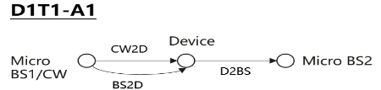  · Case 1-1: CW is transmitted from inside the topology, transmitted in DL spectrum  · Case 1-2: CW is transmitted from inside the topology, transmitted in UL spectrum | R2D: DL  CW2D and D2R: UL | CW and/or device | NR UL
 |  | NR UL | device and/or reader
 |  | reader | NR DL
 |  | NR DL | device
 | R2D: DL  CW2D and D2R: DL | CW and/or device | NR DL
 |  | NR DL | device and/or reader
 | R2D: UL  CW2D and D2R: UL | Reader | NR UL
 |  | NR UL | reader
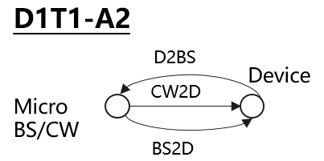  Self interference cancelation is needed for reader  · Case 1-1: CW is transmitted from inside the topology, transmitted in DL spectrum  · Case 1-2: CW is transmitted from inside the topology, transmitted in UL spectrum | R2D: DL  CW2D and D2R: UL | CW and/or device | NR UL
 |  | NR UL | device and/or reader
 |  | reader | NR DL
 |  | NR DL | device
 | R2D: DL  CW2D and D2R: DL | CW and/or device | NR DL
 |  | NR DL | device and/or reader
 | R2D: UL  CW2D and D2R: UL | reader | NR UL
 |  | NR UL | reader
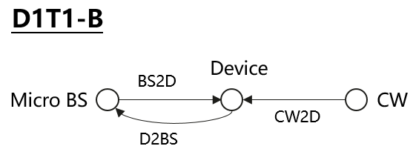  Self interference cancellation is needed for reader  · Case 1-4: CW is transmitted from outside the topology, transmitted in UL spectrum | R2D: DL  CW2D and D2R: UL | CW and/or device | NR UL
 |  | NR UL | device and/or reader
 |  | reader | NR DL
 |  | NR DL | device
 | R2D: UL  CW2D and D2R: UL | reader | NR UL
 |  | NR UL | reader

Issue 2-5-3: Evaluation cases for D2T2 for device 1 and 2a between NR and AIOT
Agreement:
- FFS on evaluation cases for D2T2 for device 1 and 2a between NR and AIOT. Corresponding evaluation cases are listed for information. Note that some duplicated cases are omitted in the table.
Deployment scenario and topology | spectrum | aggressor | victim
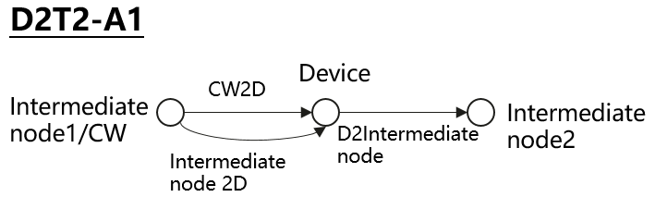  Case 2-2: CW is transmitted from inside the topology (i.e., intermediate UE), transmitted in UL spectrum | R2D: UL  CW2D and D2R: UL | CW and/or device | NR UL
 |  | NR UL | Device and/or reader
 |  | reader | NR UL
 |  | NR UL | device
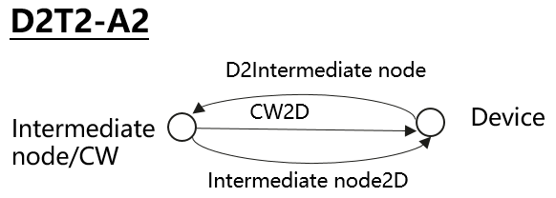  \  Case 2-2: CW is transmitted from inside the topology (i.e., intermediate UE), transmitted in UL spectrum  Self interference cancelation is needed for reader | R2D: UL  CW2D and D2R: UL | CW and/or device | NR UL
 |  | NR UL | Device and/or reader
 |  | reader | NR UL
 |  | NR UL | device
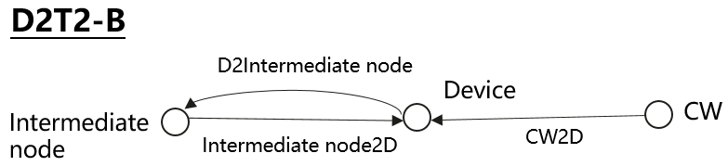  Case 2-3: CW is transmitted from outside the topology, transmitted in DL spectrum  Case 2-4: CW is transmitted from outside the topology, transmitted in UL spectrum  Self interference cancelation is needed for reader | R2D: UL  CW2D and D2R: UL | CW and/or device | NR UL
 |  | NR UL | Device and/or reader
 |  | reader | NR UL
 |  | NR UL | device
 | R2D: UL  CW2D and D2R: DL | CW and/or device | NR DL
 |  | NR DL | device and/or reader

Issue 2-5-4: Evaluation cases for device 2b between AIOT and NR
Agreement:
- FFS for evaluation cases for device 2b
Issue 2-5-5: Interference between AIOT systems
Agreement:
- RAN4 to first evaluate interference between AIOT and NR.
- FFS on interference between AIOT and AIOT

Topic 2-6: Evaluation parameters
There are no agreements on detailed parameters in RAN4#110bis meeting. Deatiled parameters for information can be found in summary document R4-2405289 and will be further discussed in next meeting.

Issue 2-6-2 and 2-6-3: Layout for D1T1 and D2T2
Agreement:
Use RAN1 agreements in RAN1#116bis meeting as baseline (copied as below).
- FFS on whether any updates are needed for RAN4 co-existence evaluation.
- FFS on other parameters.
RAN1 agreements:
For D1T1,
- InF-DH NLOS model defined in TR38.901 is used for D2R and R2D links as pathloss model in coverage evaluation.
For D2T2,
- InF-DL and InH-Office model defined in TR38.901is used as pathloss model in coverage evaluation,
  - NLOS for D2R and R2D links if InF-DL is used
  - LOS for D2R and R2D links if InH-Office is used
The following layout is used for evaluation purpose,
- FFS: CW distribution for D1T1-B and D2T2-B
Parameter | Assumptions for D1T1 | Assumptions for D2T2
Scenario | InF-DH | InH-office | InF-DL
Hall size | 120x60 m | 120 x50 m | 300x150 m
Room height | 10 m | 3m | 10 m
Sectorization | None
BS deployment / Intermediate UE dropping | 18 BSs on a square lattice with spacing D, located D/2 from the walls.  - L=120m x W=60m; D=20m  - BS height = 8 m  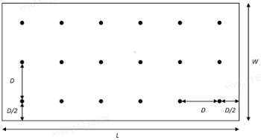 | - L=120m x W=50m;  - Intermediate UE height = 1.5 m  FFS: Intermediate UE dropping | - L=300m x W=150m;  - Intermediate UE height = 1.5 m  FFS: Intermediate UE dropping
Device distribution | Device Height= 1.5 m  AIoT devices drop uniformly distributed over the horizontal area | Device Height= 1.5 m  AIoT devices drop uniformly distributed over the horizontal area  FFS: which devices are involved in the evaluations | Device Height= 1.5m  AIoT devices drop uniformly distributed over the horizontal area  FFS: which devices are involved in the evaluations
Device mobility (horizontal plane only) | 3 kph | 3 kph | 3 kph

