3GPP TSG-RAN WG4 Meeting #110-Bis R4-XXXXX
Changsha, China, 15 – 20 April 2024

Title: LS on UE Capability for Asymmetric BW for less than 5 MHz
Response to:
Release: R18
Work Item: NR_FR1_lessthan_5MHz_BW

Source: Rakuten Mobile (RAN4)
To: RAN2 & RAN1

Contact person: Awn Muhammad
Awn.muhammad AT rakuten.com

Send any reply LS to: 3GPP Liaisons Coordinator, mailto:3GPPLiaison@etsi.org

Attachments: CR on 3Mhz Uplink with 5Mhz Downlink BCS for n28 [R4-XXX]

1 Overall description
In response to the new operational scenario introduced and endorsed through CR R4-2405066 (to be replaced with latest number), RAN4 has defined an Asymmetric Bandwidth Combination Set for NR band n28 featuring a 3 MHz uplink and a 5 MHz downlink. Currently, UE capability in TS 38.306 for 3 MHz do not distinguish between uplink and downlink bandwidths, which leads to potential issues in scenarios where UEs support asymmetric bandwidth combination sets including 3 MHz channel bandwidth either in uplink or potentially in future also downlink. Currently, there is no request and therefore no urgent need in RAN4 for asymmetric bandwidth combination set including 3 MHz in the downlink.
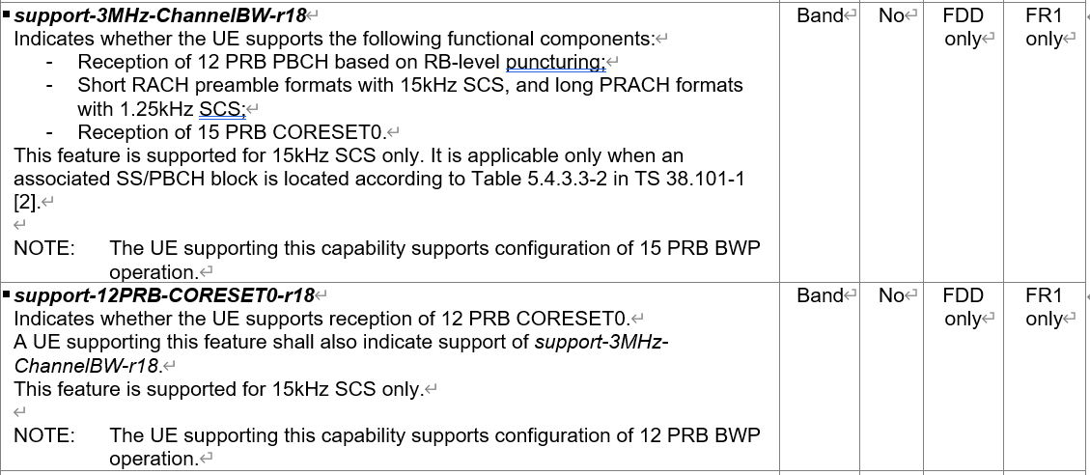
Figure 1 – TS 38.306 Support of 3 MHz Capability

2 Actions
To WG RAN 2 and RAN 1
ACTION: RAN4 respectfully requests RAN2 and RAN1 to examine the necessary modifications and define UE capabilities for optional support ofasymmetric bandwidths with
- 3 MHz in uplink
- and potentially also for 3 MHz in downlink if deemed necessary.

3 Dates of next TSG RAN WG4 meetings
RAN4#111 May 20 – 24, 2024 Fukuoka City, Fukuoka, JP

