3GPP TSG-RAN WG4 Meeting #110bis R4-2405266
Changsha, China, 15th – 19th April, 2024

Title: Topic summary for [110bis][113] NR_3Tx-4Rx_WI
Source: Moderator (OPPO)
Agenda item: 5.2
Document for: Information

Introduction
This summary cover Tdoc submitted in this meeting under agenda 4.2.3 (3T4R maintenance) and 5.22 (3Tx basket WI). The discussions below will be split into two sections with each topic.
Topic #1: 3T4R maintenance
Topic #2: 3Tx basket WI

Topic #1: 3T4R maintenance

Companies’ contributions summary
T-doc number | Company | Proposals / Observations
R4-2404507 | Huawei, HiSilicon | Discussion on 3Tx SAR solution for inter-band CA with PC1.5  Observation 1: For 3Tx inter-band UL CA with UL MIMO and with Tx diversity in power class 1.5, if the field of UE capability maxUplinkDutyCycle-interBandCA-PC2 is absent, the UE shall apply all requirements for the power class 1.5.  Observation 2: The definition of the default state for UE capability maxUplinkDutyCycle-interBandCA-PC2 is contradicted to the case in 3Tx inter band UL CA in power class 1.5.  Observation 3: To resolve the contradiction of the applicable power class for 3Tx inter-band UL CA in PC1.5 between RAN2 and RAN4, both modifying Rel-18 RAN2 spec to accommodate RAN4 design and improve RAN4 spec in sub-clause 6.2H.3.1 and 6.2L.3.1 are workable.  Proposal 1: Modify UE capability maxUplinkDutyCycle-interBandCA-PC2 in Rel-18 RAN2 spec to accommodate RAN4 design for 3Tx inter-band UL CA in power class 1.5. Either to remove ‘shall work on power class regardless of UL duty cycle’, or to add ‘For PC2 band combination,’ could be workable.
R4-2404606 | LG Electronics | draft CR on typo correction of higherpowerlimit for EN-DC
R4-2405490 | E-surfing Digital | draftCR on correction of condition for 3Tx SAR solution
R4-2405693 | E-surfing Digital | On the mutual relationship of conditions of SAR solution for 3Tx HPUE

Open issues summary

Sub-topic 1-1
Issue 1-1-1: Default behaviour when UE capability maxUplinkDutyCycle-interBandCA-PC2 is absent
- Proposal1: Modify UE capability maxUplinkDutyCycle-interBandCA-PC2 in Rel-18 RAN2 spec to accommodate RAN4 design for 3Tx inter-band UL CA in power class 1.5. Either to remove ‘shall work on power class regardless of UL duty cycle’, or to add ‘For PC2 band combination,’ could be workable. (Huawei)
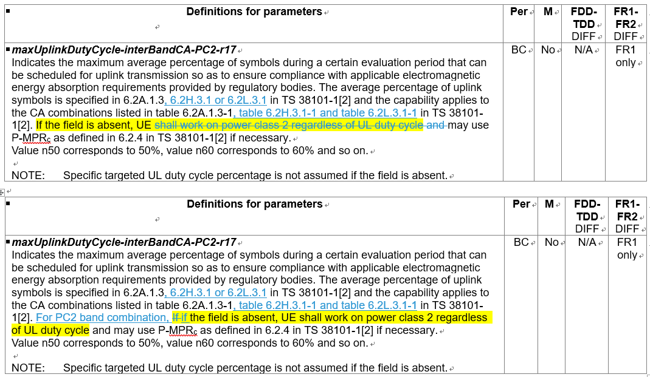
- Recommendation:
  - Add the clause and table titles to 38.306. Consider LS RAN2 for the changes.

- Proposal 2a: Change the mutual relationship between the UE capability maxUplinkDutyCycle-interBandCA-PC2 and network configuration 10log₁₀ ∑ p_{EMAX,c} or P_{EMAX,CA} of SAR solution, from inclusion and under inclusion status to the same level, referring to the corresponding requirements for PC2 UL CA. (E-surfing Digital)
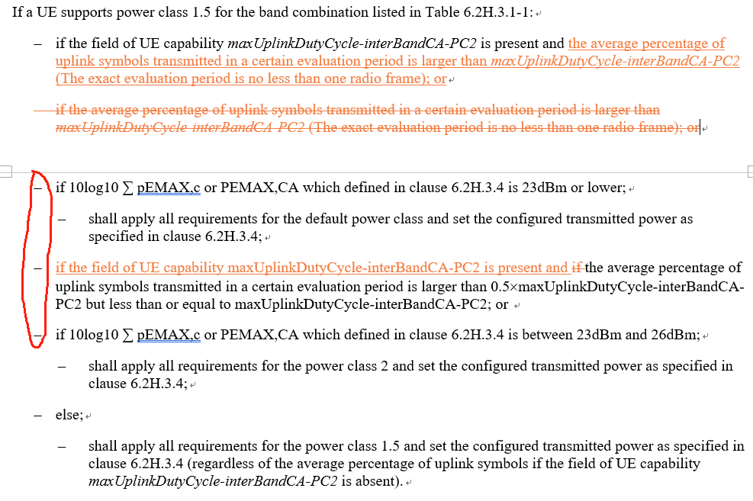
- Proposal 2b: Improve RAN4 spec in sub-clause 6.2H.3.1 and 6.2L.3.1 to avoid the contradiction between the default state for the capability maxUplinkDutyCycle-interBandCA-PC2 that UE shall work on power class 2 and the else state that is specified for 3Tx inter band UL CA in power class 1.5. Take the case of 3Tx inter-band UL CA with UL MIMO in PC1.5 as an example,
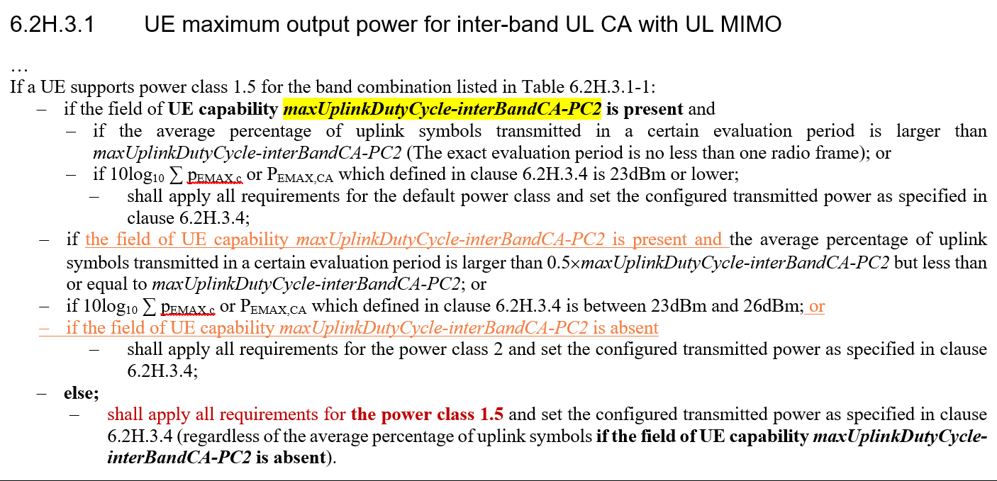

- Recommendation: TBA
  - For proposal 2a, the change marks of shifting the sections to the left are missing, need to be kept.

CRs
T-doc | Company | Title | Recommendation
R4-2404606 | LG Electronics | draft CR on typo correction of higherpowerlimit for EN-DC
R4-2405490 | E-surfing Digital | draftCR on correction of condition for 3Tx SAR solution

Topic #2: 3Tx basket WI

Companies’ contributions summary
T-doc number | Company | Proposals / Observations
R4-2404992 | Samsung | TP for TR 38.880_CA_n26A-n77A with 3Tx
R4-2405180 | OPPO | Draft CR 38101-1 Clarification of MIMO and TxD capability for PC3
R4-2405181 | OPPO | Draft CR 38101-3 Clarification of MIMO and TxD capability for PC3
R4-2405235 | ZTE | Correct the MOP tables for 3Tx band combination

TPs
T-doc number | Company | Title | Recommendation
R4-2404992 | Samsung | TP for TR 38.880_CA_n26A-n77A with 3Tx

Moderator note: below new T-docs are needed for this WI in the post meeting process.
- Big CR for 3Tx NR inter-band UL CA and EN-DC basket WI (38.101-1)
- TR 38.880 for 3Tx band combinations
- Revised WID for 3Tx NR inter-band UL CA and EN-DC basket WI

CRs
T-doc number | Company | Title | Recommendation
R4-2405180 | OPPO | Draft CR 38101-1 Clarification of MIMO and TxD capability for PC3
R4-2405181 | OPPO | Draft CR 38101-3 Clarification of MIMO and TxD capability for PC3
R4-2405235 | ZTE | Correct the MOP tables for 3Tx band combination

