3GPP TSG-RAN WG4 Meeting #110bis R4-2406578

Changsha, China, 15th – 19th April, 2024

Title: WF on MSD values for band combinations with simultaneous Rx-Tx
Agenda Item: 5.2
Source: Huawei
Document for: Approval

Issue 1: Simultaneous Rx-Tx applied to CA_n39A-n40A-n41A
In Murata paper R4-2404222, two different reference architecture options using triplexer are provided.
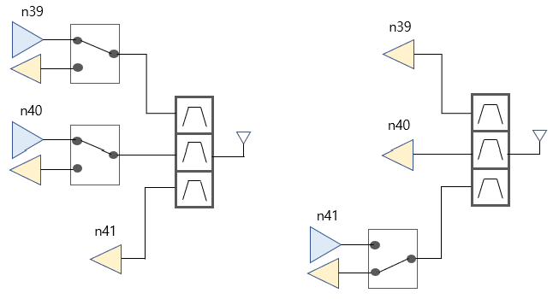
(a)

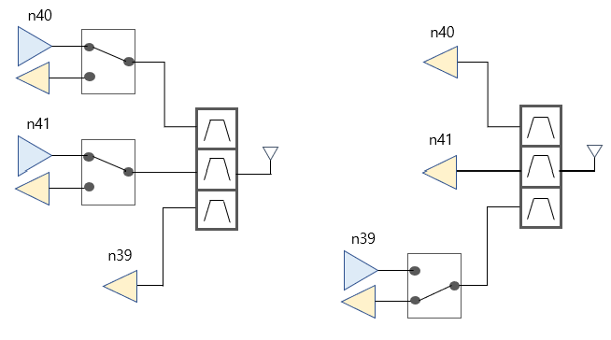
(b)
Figure 1-1. Murata reference architecture options using shared antenna, (a) and (b)
- Option 1: To average the MSD values calculated with the two reference architectures.
Table 1-1. 3DL/2UL MSDs for CA_n39A-n40A-n41A from Murata
Band / Channel bandwidth / N_{RB} / Duplex mode |  |  |  |  |  |  |  | Source of IMD
NR CA band combination | NR band | UL F_{c}  (MHz) | UL/DL BW  (MHz) | UL  L_{CRB} | DL F_{c} (MHz) | MSD  (dB) | Duplex mode
CA_n39-n40-n41 | n39 | 1917.5 | 5 | 25 | 1917.5 | N/A | TDD | N/A
 | n40 | 2302.5 | 5 | 25 | 2302.5 | N/A | TDD | N/A
 | n41 | N/A | 10 | N/A | 2685 | 31.6 | TDD | IMD3
 | n39 | N/A | 5 | N/A | 1917.5 | 31.6 | TDD | IMD3¹
 | n40 | 2302.5 | 5 | 25 | 2302.5 | N/A | TDD | N/A
 | n41 | 2685 | 10 | 50 | 2685 | N/A | TDD | N/A
NOTE 1: This band is subject to IMD5 also which MSD is not specified.

In Huawei paper R4-2404513, the architecture of n40 and n41 sharing antenna switch is provided.

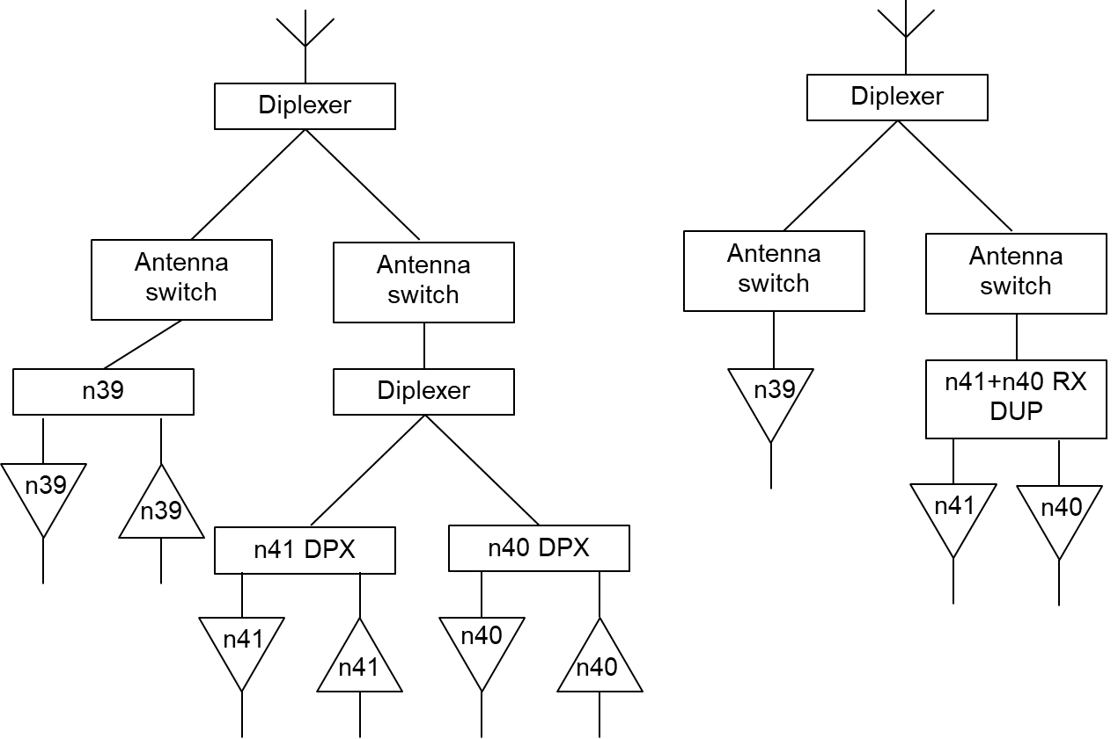
Figure 1-2. Reference UE architecture for CA_n39-n40-n41
- Option 2:
Table 1-2. 3DL/2UL MSDs for CA_n39A-n40A-n41A from Huawei
Band / Channel bandwidth / N_{RB} / Duplex mode |  |  |  |  |  |  |  | Source of IMD
NR CA band combination | NR band | UL F_{c}  (MHz) | UL/DL BW  (MHz) | UL  L_{CRB} | DL F_{c} (MHz) | MSD  (dB) | Duplex mode
CA_n39-n40-n41 | n39 | 1917.5 | 5 | 25 | 1917.5 | N/A | TDD | N/A
 | n40 | 2302.5 | 5 | 25 | 2302.5 | N/A | TDD | N/A
 | n41 | N/A | 10 | N/A | 2685 | 27.1 | TDD | IMD3
 | n39 | N/A | 5 | N/A | 1915 | 16.3 | TDD | IMD3¹
 | n40 | 2302.5 | 5 | 25 | 2302.5 | N/A | TDD | N/A
 | n41 | 2685 | 10 | 50 | 2685 | N/A | TDD | N/A
NOTE 1: This band is subject to IMD5 also which MSD is not specified.

In Qualcomm paper R4-2405452,

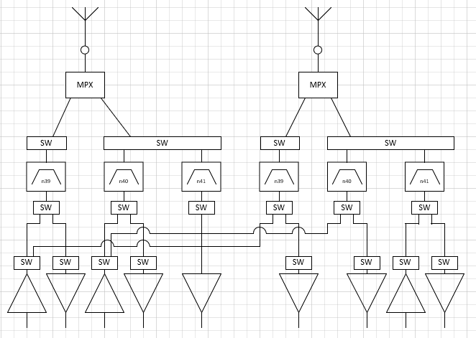
Figure 1-3. Reference UE architecture for simultaneous TX-RX 39-40, 40-41, 39-41
- Option 3:
Table 1-3. 3DL/2UL MSDs for CA_n39A-n40A-n41A from Qualcomm
Band / Channel bandwidth / N_{RB} / Duplex mode |  |  |  |  |  |  |  | Source of IMD
NR CA band combination | NR band | UL F_{c}  (MHz) | UL/DL BW  (MHz) | UL  L_{CRB} | DL F_{c} (MHz) | MSD  (dB) | Duplex mode
CA_n39-n40-n41 | n39 |  | 5 | 25 |  | N/A | TDD | N/A
 | n40 |  | 5 | 25 |  | N/A | TDD | N/A
 | n41 | N/A | 10 | N/A | 2685 | [29.8] | TDD | IMD3
 | n39 | N/A | 5 | N/A | 1915 | [24.9] | TDD | IMD3¹
 | n40 |  | 5 | 25 |  | N/A | TDD | N/A
 | n41 | 2685 | 10 | 50 |  | N/A | TDD | N/A
NOTE 1: This band is subject to IMD5 also which MSD is not specified.

<Way forward #1-1>
- To average MSD values provided by companies and accommodate various RF front-end and antenna structures for simultaneous Rx-Tx requirements for higher order band combinations of CA_n39A-n40A-41A
Band / Channel bandwidth / N_{RB} / Duplex mode |  |  |  |  |  |  |  | Source of IMD
NR CA band combination | NR band | UL F_{c}  (MHz) | UL/DL BW  (MHz) | UL  L_{CRB} | DL F_{c} (MHz) | MSD  (dB) | Duplex mode
CA_n39-n40-n41 | n39 | 1917.5 | 5 | 25 | 1917.5 | N/A | TDD | N/A
 | n40 | 2302.5 | 5 | 25 | 2302.5 | N/A | TDD | N/A
 | n41 | N/A | 10 | N/A | 2685 | [29.5] | TDD | IMD3
 | n39 | N/A | 5 | N/A | 1915 | [24.5] | TDD | IMD3¹
 | n40 | 2302.5 | 5 | 25 | 2302.5 | N/A | TDD | N/A
 | n41 | 2685 | 10 | 50 | 2685 | N/A | TDD | N/A
NOTE 1: This band is subject to IMD5 also which MSD is not specified.

- Sufficient attenuation level between bands should be considered in ΔT_{IB,c} and ΔR_{IB,c} , given that increased insertion loss of the triplexer compared to single filter.
Table 1 ΔT_{IB,c} due to CA_n39-n40-n41
Inter-band CA combination | ΔT_{IB,c} for NR bands (dB)⁹
 | Component band in order of bands in configuration¹⁰
CA_n39-n40-n41 | 0.3 | 0.6 | 0.6
NOTE 8: “-” denotes ΔT_{IB,c} = 0.
NOTE 9: The component band order in the configuration should be listed by the order of NR bands, such as for CA_n1-n3-n5 the band order from left to right is n1, n3 and n5.

Table 2 ΔR_{IB,c} due to CA_n39-n40-n41
Inter-band CA combination | ΔR_{IB,c} for NR bands (dB)⁷
 | Component band in order of bands in configuration⁸
CA_n39-n40-n41 | 0.3 | 0.6 | 0.6
NOTE 9: “-” denotes ΔR_{IB,c} = 0.
NOTE 10: The component band order in the configuration should be listed by the order of NR bands, such as for CA_n1-n3-n8 the band order from left to right is n1, n3 and n8.

Comment:

Issue 2: MSD values for higher order band combinations of CA_n39-n41 with simultaneous Rx-Tx
<Way forward #2-1>: The MSD value for CA_n28A-n39A-n41A with simultaneous Rx-Tx is
Band / Channel bandwidth / N_{RB} / Duplex mode |  |  |  |  |  |  |  | Source
NR CA band combination | NR band | UL F_{c} | UL/DL BW | UL | DL F_{c} (MHz) | MSD | Duplex mode | of IMD
 |  | (MHz) | (MHz) | C_{LRB} |  | (dB)
CA_n28-n39-n41 | n28 | 725 | 5 | 25 | 780 | N/A | FDD | N/A
 | n39 | N/A | 5 | N/A | 1895 | [32.6] | TDD | IMD2
 | n41 | 2620 | 10 | 50 | 2620 | N/A | TDD | N/A
 | n28 | 725 | 5 | 25 | 780 | N/A | FDD | N/A
 | n39 | 1985 | 5 | 25 | 1895 | N/A | TDD | N/A
 | n41 | N/A | 10 | N/A | 2620 | [32.6] | TDD | IMD2

<Way forward #2-2>: The MSD value for CA_n39A-n41A-n79A with simultaneous Rx-Tx is
Band / Channel bandwidth / N_{RB} / Duplex mode |  |  |  |  |  |  |  | Source
NR CA band combination | NR band | UL F_{c} | UL/DL BW | UL | DL F_{c} (MHz) | MSD | Duplex mode | of IMD
 |  | (MHz) | (MHz) | C_{LRB} |  | (dB)
CA_n39-n41-n79 | n39 | 1900 | 5 | 25 | 1900 | N/A | TDD | N/A
 | n41 | N/A | 10 | N/A | 2650 | [26.0] | TDD | IMD2¹
 | n79 | 4550 | 40 | 216 | 4550 | N/A | TDD | N/A
 | n39 | N/A | 5 | N/A | 1900 | [24.8] | TDD | IMD2¹
 | n41 | 2650 | 10 | 50 | 2650 | N/A | TDD | N/A
 | n79 | 4550 | 40 | 216 | 4550 | N/A | TDD | N/A
NOTE 1: This band is subject to IMD5 also which MSD is not specified.

Comment:

Issue 3: MSD values for higher order band combinations of CA_n40-n41 with simultaneous Rx-Tx
- Issue 3-1: CA_n40A-n41A-n79A with simultaneous Rx-Tx
Option 1(Murata R4-2400583):
Band / Channel bandwidth / N_{RB} / Duplex mode |  |  |  |  |  |  |  | Source
NR CA band combination | NR band | UL F_{c} | UL/DL BW | UL | DL F_{c} (MHz) | MSD | Duplex mode | of IMD
 |  | (MHz) | (MHz) | C_{LRB} |  | (dB)
CA_n40-n41-n79 | n40 | 2330 | 5 | 25 | 2330 | N/A | TDD | N/A
 | n41 | N/A | 10 | N/A | 2520 | 26.0 | TDD | IMD2
 | n79 | 4850 | 40 | 216 | 4850 | N/A | TDD | N/A
 | n40 | 2350 | 5 | 25 | 2350 | N/A | TDD | N/A
 | n41 | N/A | 10 | N/A | 2550 | 5.7 | TDD | IMD4
 | n79 | 4500 | 40 | 216 | 4500 | N/A | TDD | N/A
 | n40 | 2350 | 5 | 25 | 2350 | N/A | TDD | N/A
 | n41 | N/A | 10 | N/A | 2550 | 3.4 | TDD | IMD5
 | n79 | 4800 | 40 | 216 | 4800 | N/A | TDD | N/A
 | n40 | N/A | 5 | N/A | 2330 | 23.7 | TDD | IMD2
 | n41 | 2520 | 10 | 50 | 2520 | N/A | TDD | N/A
 | n79 | 4850 | 40 | 216 | 4850 | N/A | TDD | N/A
 | n40 | N/A | 5 | N/A | 2330 | 3.0 | TDD | IMD5
 | n41 | 2530 | 10 | 50 | 2540 | N/A | TDD | N/A
 | n79 | 4960 | 40 | 216 | 4960 | N/A | TDD | N/A

Option 2 (Huawei R4-2404515):
Band / Channel bandwidth / N_{RB} / Duplex mode |  |  |  |  |  |  |  | Source
NR CA band combination | NR band | UL F_{c} | UL/DL BW | UL | DL F_{c} (MHz) | MSD | Duplex mode | of IMD
 |  | (MHz) | (MHz) | C_{LRB} |  | (dB)
CA_n40-n41-n79 | n40 | N/A | 5 | N/A | 2335 | [23.5] | TDD | IMD2¹
 | n41 | 2545 | 10 | 50 | 2545 | N/A | TDD | N/A
 | n79 | 4880 | 40 | 216 | 4880 | N/A | TDD | N/A
 | n40 | 2340 | 5 | 25 | 2340 | N/A | TDD | N/A
 | n41 | N/A | 10 | N/A | 2600 | [26.2] | TDD | IMD2¹
 | n79 | 4880 | 40 | 216 | 4940 | N/A | TDD | N/A
NOTE 1: This band is subject to IMD5 also which MSD is not specified.

<Way forward #3-1>: The MSD value for CA_n40A-n41A-n79A with simultaneous Rx-Tx is
Band / Channel bandwidth / N_{RB} / Duplex mode |  |  |  |  |  |  |  | Source of IMD
NR CA band combination | NR band | UL F_{c} | UL/DL BW (MHz) | UL | DL F_{c} (MHz) | MSD | Duplex mode
CA_n40-n41-n79 | n40 | N/A | 5 | N/A | 2335 | [23.6] | TDD | IMD2¹
 | n41 | 2545 | 10 | 50 | 2545 | N/A | TDD | N/A
 | n79 | 4880 | 40 | 216 | 4880 | N/A | TDD | N/A
 | n40 | 2340 | 5 | 25 | 2340 | N/A | TDD | N/A
 | n41 | N/A | 10 | N/A | 2600 | [26.1] | TDD | IMD2¹
 | n79 | 4880 | 40 | 216 | 4940 | N/A | TDD | N/A
NOTE 1: This band is subject to IMD5 also which MSD is not specified.

- Issue 3-2: CA_n8A-n40A-n41A with simultaneous Rx-Tx
Option 1(Murata R4-2400583):
Band / Channel bandwidth / N_{RB} / Duplex mode |  |  |  |  |  |  |  | Source
NR CA band combination | NR band | UL F_{c} | UL/DL BW | UL | DL F_{c} (MHz) | MSD | Duplex mode | of IMD
 |  | (MHz) | (MHz) | C_{LRB} |  | (dB)
CA_n8-n40-n41 | n8 | 900 | 5 | 25 | 945 | N/A | FDD | N/A
 | n40 | N/A | 5 | N/A | 2360 | 3.0 | TDD | IMD5
 | n41 | 2530 | 10 | 50 | 2530 | N/A | TDD | N/A

Option 2 (Huawei R4-2404516):
Band / Channel bandwidth / N_{RB} / Duplex mode |  |  |  |  |  |  |  | Source
NR CA band combination | NR band | UL F_{c} | UL/DL BW | UL | DL F_{c} (MHz) | MSD | Duplex mode | of IMD
 |  | (MHz) | (MHz) | C_{LRB} |  | (dB)
CA_n8-n40-n41 | n8 | 895 | 5 | 25 | 940 | N/A | FDD | N/A
 | n40 | 2355 | 5 | 25 | 2355 | [3.58] | TDD | IMD5
 | n41 | N/A | 10 | N/A | 2520 | N/A | TDD | N/A

<Way forward #3-2>: The MSD value for CA_n8A-n40A-n41A with simultaneous Rx-Tx is
Band / Channel bandwidth / N_{RB} / Duplex mode |  |  |  |  |  |  |  | Source of IMD
NR CA band combination | NR band | UL F_{c} | UL/DL BW (MHz) | UL | DL F_{c} (MHz) | MSD | Duplex mode
CA_n8-n40-n41 | n8 | 895 | 5 | 25 | 940 | N/A | FDD | N/A
 | n40 | 2355 | 5 | 25 | 2355 | [3.29] | TDD | IMD5
 | n41 | N/A | 10 | N/A | 2520 | N/A | TDD | N/A

- Issue 3-3: CA_n28A-n40A-n41A with simultaneous Rx-Tx
Option 1(Murata R4-2400583):
Band / Channel bandwidth / N_{RB} / Duplex mode |  |  |  |  |  |  |  | Source
NR CA band combination | NR band | UL F_{c} | UL/DL BW | UL | DL F_{c} (MHz) | MSD | Duplex mode | of IMD
 |  | (MHz) | (MHz) | C_{LRB} |  | (dB)
CA_n28-n40-n41 | n28 | 725 | 5 | 25 | 780 | N/A | FDD | N/A
 | n40 | 2360 | 5 | 25 | 2360 | N/A | TDD | N/A
 | n41 | N/A | 10 | N/A | 2545 | 3.3 | TDD | IMD5

Option 2 (Huawei R4-2404517):
Band / Channel bandwidth / N_{RB} / Duplex mode |  |  |  |  |  |  |  | Source
NR CA band combination | NR band | UL F_{c} | UL/DL BW | UL | DL F_{c} (MHz) | MSD | Duplex mode | of IMD
 |  | (MHz) | (MHz) | C_{LRB} |  | (dB)
CA_n28-n40-n41 | n28 | 740 | 5 | 25 | 795 | N/A | TDD | N/A
 | n40 | 2380 | 5 | 25 | 2380 | N/A | TDD | N/A
 | n41 | N/A | 10 | N/A | 2540 | [3.52] | TDD | IMD5

<Way forward #3-3>: The MSD value for CA_n28A-n40A-n41A with simultaneous Rx-Tx is
Band / Channel bandwidth / N_{RB} / Duplex mode |  |  |  |  |  |  |  | Source of IMD
NR CA band combination | NR band | UL F_{c} | UL/DL BW (MHz) | UL | DL F_{c} (MHz) | MSD | Duplex mode
CA_n28-n40-n41 | n28 | 740 | 5 | 25 | 795 | N/A | TDD | N/A
 | n40 | 2380 | 5 | 25 | 2380 | N/A | TDD | N/A
 | n41 | N/A | 10 | N/A | 2540 | [3.41] | TDD | IMD5

