3GPP RAN WG4 Meeting #110bis R4-24xxxxx
Changsha, China, April 15th – 19th, 2024

Title: WF on MSD requirements with intra-band contiguous ULCA
Agenda item: 5.1.1.1
WI/SI: NR_CA_R18_intra-Core
Release: Rel-18
Source: Apple
Document for: Approval

1 Background

- Intra-band contiguous UL CA was first introduced in Rel-16 which covers both single TDD/FDD band and inter-band DL CA. In Rel-18, inter-band UL CA with intra-band contiguous UL CA in one band was further introduced (maximum of 3 CCs in UL configuration).

- Unlike single carrier UL, non-contiguous resource allocation may potentially be scheduled between the two contiguous UL carriers where the clustered inter-modulation products may induce more severe REFSENS degradation than contiguous UL resource allocation for FDD band self-interference and cross-band DL if simultaneous Rx/Tx is supported for the band combination.

- Owing to this concern, RAN4 had specifically introduced MSD requirements based on non-contiguous UL resource allocation in contiguous UL CA, as have been captured in TR 38.862 [1]. For inter-band UL CA with intra-band contiguous UL CA in one band, a new type of MSD requirement due to UL triple-beat inter-modulation interference was further introduced in Rel-18 [2].

- There are currently three types of MSD requirements which are associated with intra-band contiguous UL CA:
  - Single FDD band self-interference, such as for CA_n5B (Figure 1-1)
  - Inter-band CA with cross-band DL interference, such as for CA_n40A-n41C (Figure 1-2)
  - Inter-band CA with triple beat issue, such as for CA_n3A-n41C (Figure 1-3)

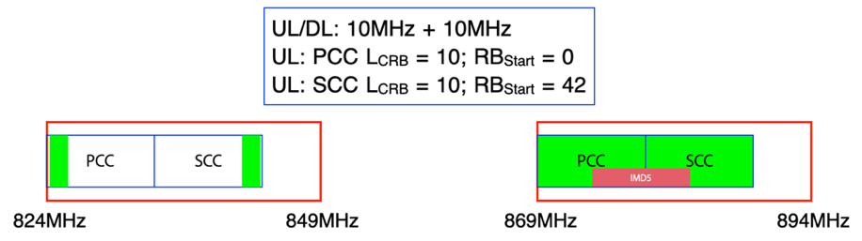

Figure 1-1 CA_n5B MSD test configuration

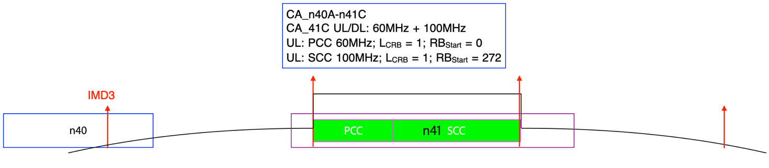

Figure 1-2 CA_n40A-n41C MSD test configuration
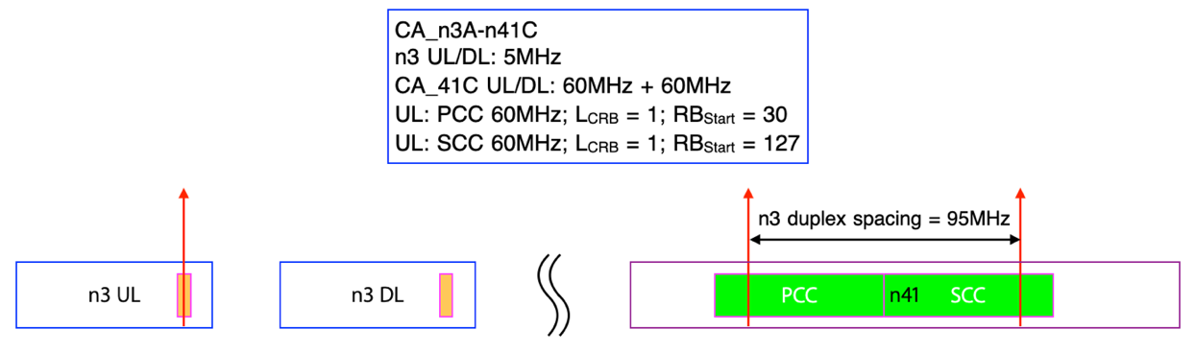

Figure 1-3 CA_n3A-n41C triple-beat MSD test configuration

- The UL configurations of the above MSD requirements have been specified with rather small RB allocations in the contiguous UL CA. The cross-band DL interference and triple-beat interference are even specified with only 1 RB in each of the contiguous UL carriers.

- As UL CA would be configured primarily to increase the UL throughout, it does not seem to be very practical to schedule small RB allocations non-contiguously between two contiguous UL carriers where the total resource allocation is even less than a single carrier can already provide.

- On the other hand, non-contiguous UL allocations may be subject to higher MPR/A-MPR in order to fulfill the emission requirements and the IMD power to the impacted DL carrier could potentially be very high based on the current specified MSD values.

- Based on the above concerns, in [3] it is proposed RAN4 to reconsider whether the MSD requirements resulting from intra-band contiguous UL CA are necessitated with good technical justifications.

- This way forward intends to initiate RAN4 to reconsider whether the MSD requirements resulting from intra-band contiguous UL CA configured with non-contiguous allocations are necessitated.

Way forward

Proposal 1: Companies are encouraged to consider the following options for handling the MSD requirements resulting from intra-band contiguous UL CA configured with non-contiguous allocations:

Option 1: No change from TR 38.862 guidelines

Option 2: Do not consider all MSD requirements resulting from intra-band contiguous UL CA configured with non-contiguous allocations.

Option 3: Do not consider only the MSD requirements resulting from intra-band contiguous UL CA configured with 1RB+1RB allocations.

Proposal 2: If Option 2 or Option 3 in Proposal 1 would be considered, which release to start taking effect?

Option 1: From earliest release where such MSD requirements have been specified.

Option 2: Rel-18

Option 3: Rel-19

Proposal 3: Is there a need to introduce cross-band MSD requirements resulting from intra-band contiguous UL CA configured with fully allocated maximum aggregated BW?

Option 1: Yes

Option 2: No

2.1 Company comments

Company | Comments
Skyworks(DBR) | If we agree that the 1RB+1RB allocation is not frequent, non-contiguous allocations will be used anyhow and since the current IMD order limitation is based on applying MPR for 1RB+1RB, using full+full or non-contiguous allocation with larger allocation will result in lower MPR and thus less decay of the IMDs than currently assumed. So it is a bit unfortunate to re-evaluate guidelines for TDD intra-ULCA at a moment where we are trying to make them stable. If we are open to revisit the assumptions, we do not think that MSD issues will disappear and creating a new framework will take time. As such would it be possible to keep what is in place for now and see what can be done in R19. Also even if 1RB+1RB is unlikely it properly tests the UE for two tone or triple beat performance which would anyhow result in MSD even at higher or full RB allocation. This non-linearity performance for intra-band ULCA is different than the single CC case in the fact that it is not reduced by improved image leakage versus minimum requirement.

References

- 3GPP TR 38.862 V17.1.0 (2022-06)
- R4-2220556 "WF on triple beat rules and MSD for inter-band with 2UL with intra-band ULCA", Murata Manufacturing Co Ltd. Skyworks., 3GPP TSG RAN WG4 Meeting #105, Toulouse, France, November 14th - 18th, 2022
- R4-2404180 “Reconsideration on MSD requirements with intra-band contiguous UL CA”, Apple, 3GPP TSG RAN WG4 Meeting #110bis, Changsha, China, April 15th – 19th, 2024

