**3GPP TSG-RAN WG4 Meeting #110bis *R4-2406684***

Changsha, China, April 15 – April 19, 2024

**Source:** Huawei, HiSilicon

**Title:** TP for 38.718-02-01 to introduce CA_n78A-n104A

**Agenda item:** 7.1.1.2

**Document for:** Approval

# 1 Background

This contribution provides the technical text proposal on the NR CA band combination CA_n78A-n104A, which has been captured in the latest basket WI [1].

# 2 Text Proposal

##### ---Start of changes TR 38.718-02-01 ---

## 5.x CA_n78-n104

### 5.x.1 Common for 1 band UL and 2 bands UL CA

#### 5.x.1.1 Operating bands for CA

Table 5.x.1.1-1: CA band combination CA_n78-n104

|  |  |  |  |  |  |  |  |
| --- | --- | --- | --- | --- | --- | --- | --- |
| NR Band | Uplink (UL) band | | | Downlink (DL) band | | | Duplex  mode |
| BS receive / UE transmit | | | BS transmit / UE receive | | |
| FUL_low – FUL_high | | | FDL_low – FDL_high | | |
| n78 | 3300 | – | 3800 | 3300 | – | 3800 | TDD |
| n104 | 6425 | – | 7125 | 6425 | – | 7125 | TDD |
|  | | | | | | | |

#### 5.x.1.2 Channel bandwidths per operating band for CA

Table 5.x.1.2-1: Supported bandwidths per CA band combination CA_n78-n104

|  |  |  |  |  |
| --- | --- | --- | --- | --- |
| NR CA configuration | Uplink CA configuration or single uplink carrier | NR Band | Channel bandwidth (MHz) | Bandwidth combination set |
| CA_n78A-n104A | CA_n78A-n104A | n78 | n78 channel bandwidths in Table 5.3.5-1 | 4 and 5 |
|  |  | n104 | n104 channel bandwidths in Table 5.3.5-1 |  |
|  | | | | |

#### 5.x.1.3 UE co-existence studies

Table 5.x.1.3-1/2 summarizes frequency ranges where harmonics and/or harmonics mixing occur for CA_n78-n104.

**Table 5.x.1.3-1: Impact of UL/DL Harmonic**

|  |  |  |  |  |  |  |  |  |  |  |  |  |
| --- | --- | --- | --- | --- | --- | --- | --- | --- | --- | --- | --- | --- |
|  |  |  |  |  | **2nd Harmonic** | | **3rd Harmonic** | | **4th Harmonic** | | **5th Harmonic** | |
| **Band** | **UL Low Band Edge** | UL High Band Edge | **DL Low Band Edge** | DL High Band Edge | UL Low Band Edge | UL High Band Edge | UL Low Band Edge | UL High Band Edge | UL Low Band Edge | UL High Band Edge | UL Low Band Edge | UL High Band Edge |
| n78 | 3300 | 3800 | 3300 | 3800 | 6600 | 7600 | 9900 | 11400 | 13200 | 15200 | 16500 | 19000 |
| n104 | 6425 | 7125 | 6425 | 7125 | 12850 | 14250 | 19275 | 21375 | 25700 | 28500 | 32125 | 35625 |

**Table 5.x.1.3-2: Impact of UL/DL Harmonic mixing**

|  |  |  |  |  |  |  |  |  |  |  |  |  |
| --- | --- | --- | --- | --- | --- | --- | --- | --- | --- | --- | --- | --- |
|  |  |  |  |  | **2nd Harmonic** | | **3rd Harmonic** | | **4th Harmonic** | | **5th Harmonic** | |
| **Band** | **UL Low Band Edge** | UL High Band Edge | DL Low Band Edge | DL High Band Edge | DL Low Band Edge | DL High Band Edge | DL Low Band Edge | DL High Band Edge | DL Low Band Edge | DL High Band Edge | DL Low Band Edge | DL High Band Edge |
| n78 | 3300 | 3800 | 3300 | 3800 | 6600 | 7600 | 9900 | 11400 | 13200 | 15200 | 16500 | 19000 |
| n104 | 6425 | 7125 | 6425 | 7125 | 12850 | 14250 | 19275 | 21375 | 25700 | 28500 | 32125 | 35625 |

The 2nd harmonic interference of UL band n78 may fall into the DL frequency range of band n104.

The UL band n104 frequency range may have a overlapping with 2nd harmonic mixing of DL band n78.

#### 5.x.1.4 ∆TIB,c and ∆RIB,c values

For CA_n78-n104, the ΔTIB,c and ΔRIB,c values are given in the tables below.

The following inputs are provided by companies.

Company 1: Additional 1.6dB insertion loss is assumed for the potential combiner. And the ΔTIB,c and ΔRIB,c values were derived for both bands based on the following formula referring to paper R4-162926 below.

**∆TIB = (Average Tx)/2 = 0.8**

**∆RIB = (Average Rx – 0.6)/2 = 0.5**

Company 2: ∆TIB: 1.0dB for n78 and n104, ∆RIB: 1.2dB for n78 and n104.

Company 3: ∆TIB: 1.0dB for n78 and 1.2dB for n104, ∆RIB: 0.5dB for n78 and 0.7dB for n104.

After averaging companies’ proposal, the values are calculated below.

Table 5.x.1.4-1: ΔTIB,c

|  |  |  |
| --- | --- | --- |
| Inter-band CA combination | ΔTIB,c for NR bands (dB)* | |
| Component band in order of bands in configuration** | |
| CA_n78-n104 | 0.9 | 1.0 |
| NOTE *: “-” denotes ΔTIB,c = 0.  NOTE **: The component band order in the configuration should be listed by the order of NR bands, such as for CA_n1-n3 the band order from left to right is n1 and n3. | | |

Table 5.x.1.4-2: ΔRIB,c

|  |  |  |
| --- | --- | --- |
| Inter-band CA combination | ΔRIB,c for NR bands (dB)* | |
| Component band in order of bands in configuration** | |
| CA_n78-n104 | 0.7 | 0.8 |
| NOTE *: “-” denotes ΔRIB,c = 0.  NOTE **: The component band order in the configuration should be listed by the order of NR bands, such as for CA_n1-n77 the band order from left to right is n1 and n77. | | |

#### 5.x.1.5 REFSENS requirements

**MSD due to cross band isolation:**

Referring to the contributions R4-2405325/R4-2405698/R4-2405450/R4-2405876, the calculations summary for MSD due to cross band isolation are summarised in Table 5.x.1.5-1 for different RF architectures.

**Table 5.x.1.5-1: calculation summary for CA_n78-n104 MSD due to cross band isolation**

|  |  |  |  |  |  |  |  |  |  |  |  |  |
| --- | --- | --- | --- | --- | --- | --- | --- | --- | --- | --- | --- | --- |
| **UL band** | **DL band** | **UL Fc** | **UL BW** | **SCS of UL band** | **UL RB Allocation** | **DL Fc** | **DL BW** | **Cross-band**  **Interference**  **source** | **Huawei**  **option 1** | **Murata**  **option 2** | **Qualcomm**  **option 3** | **Skyworks**  **option 4** |
| **(MHz)** | **(MHz)** | **(kHz)** | **LCRB** | **(MHz)** | **(MHz)** | **MSD (dB)** | | | |
| n78 | n104 | 3750 | 100 | 30 | 270 (RBstart=0) | 6435 | 20 | >ACLR2 | 4.78 ~ 12.82 | [10.3] | 4.8 | 17.2 |
| n104 | n78 | 6475 | 100 | 30 | 270 (RBstart=0) | 3795 | 10 | >ACLR2 | 26.29 ~ 17.12 | [17.2] | 4.3 | 10.1 |

The following test configurations for CA_n78-n104 MSD due to cross band isolation are proposed after averaging companies’ values below.

**Table 5.x.1.5-2: MSD due to cross band isolation for CA_n78-n104**

|  |  |  |  |  |  |  |  |  |  |
| --- | --- | --- | --- | --- | --- | --- | --- | --- | --- |
| UL band | DL band | UL Fc | UL BW | SCS of UL band | UL RB Allocation | DL Fc | DL BW | MSD | Cross-band  Interference  source |
| (MHz) | (MHz) | (kHz) | LCRB | (MHz) | (MHz) | (dB) |
| n78 | n104 | 3750 | 100 | 30 | 270 (RBstart=0) | 6435 | 20 | [14.4] | >ACLR2 |
| n104 | n78 | 6475 | 100 | 30 | 270 (RBstart=0) | 3795 | 10 | [15.8] | >ACLR2 |

**MSD due to 2nd harmonic interference:**

Referring to the contribution R4-2405325/R4-2405698/R4-2405450/R4-2405876, the calculations for MSD due to 2nd harmonic interference are summarised in Table 5.x.1.5-3 for different band n78 PA H2 Attenuation and Post PA Filter performance.

**Table 5.x.1.5-3: calculation summary for CA_n78-n104 MSD due to 2nd harmonic interference**

|  |  |  |  |  |  |  |  |  |  |  |  |
| --- | --- | --- | --- | --- | --- | --- | --- | --- | --- | --- | --- |
| **UL band** | **DL band** | **UL BW** | **SCS of UL band** | **UL RB Allocation** | **DL BW** | **UL/DL fc condition** | **UL/DL harmonic order** | **Huawei**  **option 1** | **Murata**  **option 2** | **Qualcomm**  **option 3** | **Skyworks**  **option 4** |
| **(MHz)** | **(kHz)** | **LCRB** | **(MHz)** | **MSD (dB)** | | | |
| n78 | n104 | 10 | [15] | 50 (RBstart=0) | 20 | NOTE 2 | UL2/DL1  direct-hit | 23.6~32.9 dB  Lcrb=24RB | [38.7] | 44.9 | 38.8 |
| n78 | n104 | 10 | [15] | 50 (RBstart=0) | 20 | NOTE 6 | UL2/DL1  near-miss |  | [10.6] | 16.2 |  |

The following test configurations for CA_n78-n104 MSD due to 2nd harmonic interference are proposed below. This DL band may be affected by near-miss interference for which the MSD is not specified

**Table 5.x.1.5-4: MSD due to 2nd harmonic interference for CA_n78-n104**

|  |  |  |  |  |  |  |  |  |
| --- | --- | --- | --- | --- | --- | --- | --- | --- |
| UL band | DL band | UL BW | SCS of UL band | UL RB Allocation | DL BW | MSD | UL/DL fc condition | UL/DL harmonic order |
| (MHz) | (kHz) | LCRB | (MHz) | (dB) |
| n78 | n104 | 10 | 15 | 50 (RBstart=0) | 20 | [37.5] | NOTE 2 | UL2/DL1  direct-hit |

**MSD due to 2nd harmonic mixing interference:**

Referring to the contribution R4-2405325/R4-2405698/R4-2405450/R4-2405876, the calculations for MSD due to 2nd harmonic mixing interference are summarised below for different DL channel bandwidths and 2nd harmonic mixing attenuation in LO.

* + Option 1: Huawei

|  |  |  |  |  |  |  |  |  |
| --- | --- | --- | --- | --- | --- | --- | --- | --- |
| **UL band** | **DL band** | **UL BW** | **SCS of UL band** | **UL RB Allocation** | **DL BW** | **MSD** | **UL/DL fc condition** | **UL/DL harmonic order** |
| **(MHz)** | **(kHz)** | **LCRB** | **(MHz)** | **(dB)** |
| n104 | n78 | 20 | 30 | 50 (RBstart=0) | 10 | 5.9~24.8dB | NOTE 1 | UL1/DL2 |
| n104 | n78 | 20 | 30 | 50 (RBstart=0) | 100 | 0.8~15.1dB | NOTE 1 | UL1/DL2 |

* + Option 2: Murata

|  |  |  |  |  |  |  |  |  |
| --- | --- | --- | --- | --- | --- | --- | --- | --- |
| **UL band** | **DL band** | **UL BW** | **SCS of UL band** | **UL RB Allocation** | **DL BW** | **MSD** | **UL/DL fc condition** | **UL/DL harmonic order** |
| **(MHz)** | **(kHz)** | **LCRB** | **(MHz)** | **(dB)** |
| n104 | n78 | 5 | 15 | 25 (RBstart=0) | 10 | [17.6] | NOTE 7 | UL1/DL2 |
| n104 | n78 | 20 | 15 | 100 (RBstart=0) | 100 | [9.9] | NOTE 7 | UL1/DL2 |
| NOTE 7: The requirements should be verified for UL NR-ARFCN of the aggressor (higher) band (superscript HB) such that  in MHz and  with  the carrier frequency in the victim (lower) band and  the channel bandwidth configured in the higher band. | | | | | | | | |

* + Option 3: Qualcomm

|  |  |  |  |  |  |  |  |  |
| --- | --- | --- | --- | --- | --- | --- | --- | --- |
| **UL band** | **DL band** | **UL BW** | **SCS of UL band** | **UL RB Allocation** | **DL BW** | **MSD** | **UL/DL fc condition** | **UL/DL harmonic order** |
| **(MHz)** | **(kHz)** | **LCRB** | **(MHz)** | **(dB)** |
| n104 | n78 | 20 | 15 | 50 (RBstart=0) | 10 | 24.5 | NOTE 7 | UL1/DL2 |

* + Option 4: Skyworks

|  |  |  |  |  |  |  |  |  |
| --- | --- | --- | --- | --- | --- | --- | --- | --- |
| **UL band** | **DL band** | **UL BW** | **SCS of UL band** | **UL RB Allocation** | **DL BW** | **MSD** | **UL/DL fc condition** | **UL/DL harmonic order** |
| **(MHz)** | **(kHz)** | **LCRB** | **(MHz)** | **(dB)** |
| n104 | n78 | 20 | 15 | 50 (RBstart=0) | 10 | 34.1 | NOTE 7 | UL1/DL2 |

The following test configurations for CA_n78-n104 MSD due to 2nd harmonic mixing interference are proposed below.

**Table 5.x.1.5-6: MSD due to 2nd harmonic mixing interference for CA_n78-n104**

|  |  |  |  |  |  |  |  |  |
| --- | --- | --- | --- | --- | --- | --- | --- | --- |
| UL band | DL band | UL BW | SCS of UL band | UL RB Allocation | DL BW | MSD | UL/DL fc condition | UL/DL harmonic order |
| (MHz) | (kHz) | LCRB | (MHz) | (dB) |
| n104 | n78 | 20 | 15 | 50 (RBstart=0) | 10 | [29] | NOTE 1 | UL1/DL2 |
| n104 | n78 | 20 | 15 | 50 (RBstart=0) | 100 | [18.8] | NOTE 1 | UL1/DL2 |

#### 5.x.1.6 OOB blocking exception requirements

There is no need to specify OOB blocking exception for CA_n78-n104.

### 5.x.2 Specific for 2 bands UL CA

#### 5.x.2.1 Maximum output power for inter-band CA

**Table 5.x.2.1-1: UE Power Class for uplink inter-band CA**

|  |  |  |
| --- | --- | --- |
| Uplink CA Configuration | Class 3 (dBm) | Tolerance (dB) |
| CA_n78A-n104A | 23 | +2/-3 |

#### 5.x.2.2 UE co-existence studies

Since both band n78 and n104 are TDD bands, the IMD interference from both UL band n78 and n104 will not fall into the UE DL receiver of both bands due to no DL slots at this time.

The intersection of the requirements for the individual bands specified in clause 6.5.3.2 from TS 38.101-1 shall also apply for the specified uplink carrier aggregation configurations. Intersection of a requirement means that both UL constituent bands have the same protected band requirement specified and if one or both protected bands have note(s) associated those note(s) also apply. No special protected frequency range for UL CA_n78A-n104A should be highlighted.

#### 5.x.2.3 REFSENS requirements

Since both band n78 and n104 are TDD bands, the IMD interference from both UL band n78 and n104 will not fall into the UE DL receiver of both bands due to no DL slots at this time. There is no RFESENS exception for UL CA_n78-n104.

### 5.x.3 General techinical analysis

#### 5.x.3.1 UE RF architecture

For antennas sharing, generally there are three main cases:

**Case 1:** RF chains and antennas in band n78 and n104 are fully separated for both main and diversity paths. If 1T4R/2T4R is supported for each band, the total numbers of antennas is up to 8.

**Case 2:** RF chains and antennas in band n78 and n104 are separated for main paths, but the antennas are shared for diversity paths. If 1T4R is supported for each band, the total number of antennas is up to 5. If 2T4R is supported for each band, the total number of antennas is up to 6.

**Case 3:** The antennas in band n78 and n104 are fully shared for both main and diversity paths. If 1T4R/2T4R is supported for each band, the total number of antennas is up to 4.

The schematic diagrams for each RF architecture case are shown below.

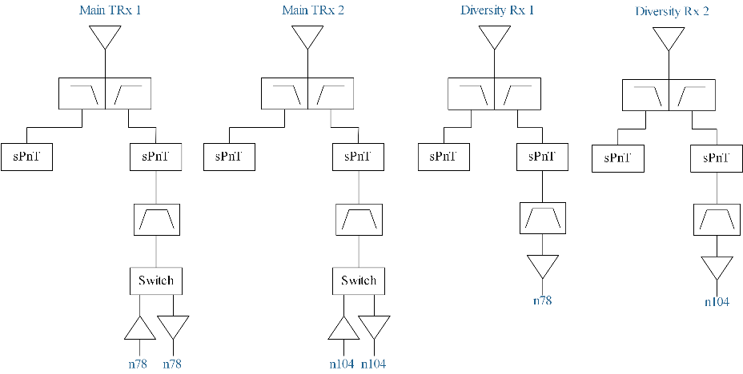

Figure 5.x.3.1-1: RF architecture case 1: Separate antenna for CA_n78-n104

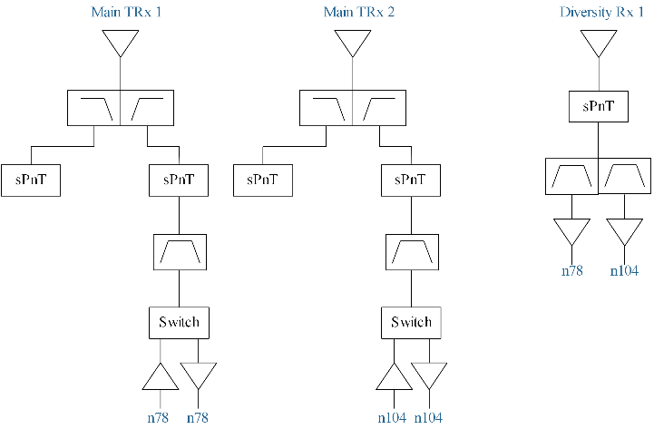

Figure 5.x.3.1-2: RF architecture case 2: common antenna in diversity chain for CA_n78-n104

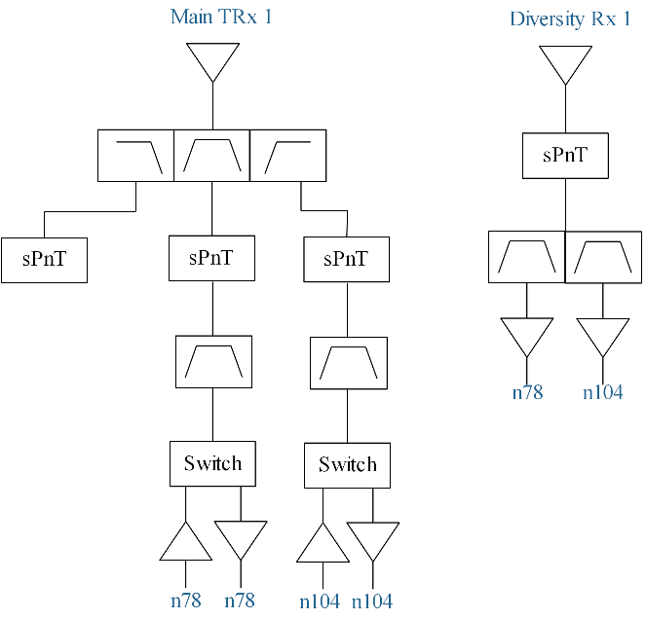

Figure 5.x.3.1-3: RF architecture case 3: common antenna in both main and diversity chain for CA_n78-n104

#### 5.x.3.2 UE RFFE filters assumptions

Currently, both band n78 and n77 shared the same full frequency filter (3300~4200MHz) in the real UE implementation. Thus, full frequency filter (3300~4200MHz) can be assumed for band n78 implementation.

For band n104 filters, three alternatives were proposed in way forward R4-2403794. The relative bandwidths are listed below. Quality factor (Q) values of filters for 6GHz will dominate the performance of filters. However, for a specific Quality factor (Q) value, the less relative bandwidth it is, the bettter filter performance can be achieved.

Table 5.x.3.2-1: relative bandwidth analysis for different filter alternative

|  |  |  |  |  |
| --- | --- | --- | --- | --- |
| **Filter frequency range** | 5150-7125 MHz | 5925-7125 MHz | 6425-7125 MHz | 3300~4200MHz |
| **Relative bandwidth** | 32% | 18.3% | 10.3% | 24% |

Currently, 3GPP specified band n104 (6425-7125 MHz) for IMT licensed service and band n96/n102 for unlicensed service. However, the maximum output power for band n104 and n96 are different. Generally, 20dBm/23dBm maximum output power for unlicensed band was specified **(for indoor scenario)**. But for band n104, at least 26dBm will be implemented same as band n78/n77, which will become the basic capability for the industry **(licensed bands are used for wide area)**. Based on the analysis above, the difference of MOP between licensed and unlicensed service will result the difference of power tolerance in the whole RF chain. Thus, it’s hard to share the same filter between licensed band n104 and unlicensed band n96.

So, from standard/implementation perspective, it’s not easy to coordinate these differences between licensed bands and unlicensed bands. One example is that 2.4GHz unlicensed band is never shared with either band n40 or band n41 due to different performance demands.

## ---End of changes---

# Reference

[1] RP-240761, “Revised WID Rel-18 NR Inter-band Carrier Aggregation/Dual Connectivity for 2 bands DL with x bands UL (x=1,2)”, ZTE Corporation