Hello all,

This is an invitation to RAN4#116 Webinar session on 25 – 29 August 2025. This invitation covers BDaT session.

GoToWebinar (GTW) conference calls will be set in each session. And one-way remote participants can be supported.

Please remember that consistent registration format is important for session chairing and hence **use the following format when you register: BriefCompanyName - Firstname, Lastname. An example is shown below**

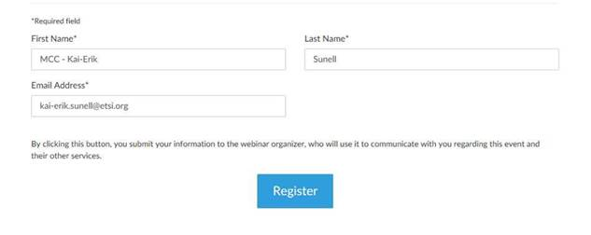

**where BriefCompanyName is ‘MCC’, Firstname is ‘Kai-Erik’ and Lastname is ‘Sunell’.**

Your email address for Webinar registration needs to be the same as for your 3GPP meeting registration.

Registration links are found below and they are session specific. You may register to all sessions, e.g. if you plan to switch between sessions or if you are able to listen to all sessions at the same time. Once you have registered for a session your registration is valid for the whole week.

**The starting time for BDaT session (25 August is 03:30 UTC (05:30 CEST) (09:00 local time) – 14:30 UTC (16:30 CEST) (20:00 local time)**. (Observe, registration links below show time in Paris time zone CEST).

**The starting time for BDaT session (26 – 28 August) is 02:30 UTC (04:30 CEST) (08:00 local time) – 14:30 UTC (16:30 CEST) (20:00 local time)**. (Observe, registration links below show time in Paris time zone CEST).

**The starting time for BDaT session (29 August)** **is 02:30 UTC (04:30 CEST) (08:00 local time) – 11:30 UTC (13:30 CEST) (17:00 local time)**. (Observe, registration links below show time in Paris time zone CEST).

Note 1: One-way remote participant is default and entail listen only mode.

Instructions on how to join the Webinars will be sent automatically every day.

|  |  |  |  |  |  |  |  |
| --- | --- | --- | --- | --- | --- | --- | --- |
| |  |  |  | | --- | --- | --- | | |  |  | | --- | --- | | |  | | --- | | **RAN4#116 BDaT Webinar Session (25 - 29 Aug)**  Mon, Aug 25, 2025 9:00 AM - 8:00 PM IST | | | | |  |  |  | | --- | --- | --- | | **RAN4#116 BDaT Webinar Session (25 - 29 Aug)**  Join us for a webinar beginning on Aug 25, 2025 at 9:00 AM IST.   |  |  | | --- | --- | | |  | | --- | | [Register now!](https://attendee.gotowebinar.com/register/3105863512163304796) | |   After registering, you will receive a confirmation email containing information about joining the webinar.  [View System Requirements](https://link.gotowebinar.com/help-system-requirements-attendees) | | |

BR,

Jin