**3GPP TSG-RAN WG4 Meeting # 116 R4-2509102**

**Bengaluru, India,** **25th -29th August, 2025**

**Agenda item:** 7.22.1

**Source:** Moderator (Huawei)

**Title:** Topic summary for [116][135] A-IoT_BSCW

**Document for:** Information

# Introduction

The thread [116][135] A-IoT_BSCW is on Rel-19 WI on solutions for Ambient IoT in NR (RP-243326 in RAN#106, revised to RP-250796 in RAN#107).

The topic summary are R4-2500687 (RAN4 #114), R4-2504688(RAN4#114bis) and R4-2507574 (RAN4#115) in previous meeting.

The following WF was agreed: R4-2502859 (RAN4 #114), R4-2505097(RAN4#114bis) and R4-2508101 (RAN4#115).

The summary covers contributions submitted under the agenda items including:

7.22.3.1 RF requirements for Type 1-C Ambient-IoT BS

7.22.3.3 RF requirements for CW

Companies’ contributions are as follows:

|  |  |  |  |  |
| --- | --- | --- | --- | --- |
| **Index No.** | **TDoc** | **Title** | **Source** | **Agenda item** |
| 1 | [**R4-2509327**](https://www.3gpp.org/ftp/tsg_ran/WG4_Radio/TSGR4_116/Docs/R4-2509327.zip) | Discussion on A-IoT BS requirements | CATT | 7.22.3.1 |
| 2 | [**R4-2509328**](https://www.3gpp.org/ftp/tsg_ran/WG4_Radio/TSGR4_116/Docs/R4-2509328.zip) | Discussion on RF requirements for CW for D1T1 | CATT | 7.22.3.3 |
| 3 | [**R4-2509330**](https://www.3gpp.org/ftp/tsg_ran/WG4_Radio/TSGR4_116/Docs/R4-2509330.zip) | draft TP for TS 38.194 to introduce base station output power and transmit ON/OFF power | CATT | 7.22.3.1 |
| 4 | [**R4-2509331**](https://www.3gpp.org/ftp/tsg_ran/WG4_Radio/TSGR4_116/Docs/R4-2509331.zip) | draft TP for TS 38.194 to introduce transmitter intermodulation | CATT | 7.22.3.1 |
| 5 | [**R4-2509714**](https://www.3gpp.org/ftp/tsg_ran/WG4_Radio/TSGR4_116/Docs/R4-2509714.zip) | Discussion on A-IoT BS requirements | CMCC | 7.22.3.1 |
| 6 | [**R4-2509715**](https://www.3gpp.org/ftp/tsg_ran/WG4_Radio/TSGR4_116/Docs/R4-2509715.zip) | Discussion on A-IoT CW requirements | CMCC | 7.22.3.3 |
| 7 | [**R4-2509718**](https://www.3gpp.org/ftp/tsg_ran/WG4_Radio/TSGR4_116/Docs/R4-2509718.zip) | TP for TR 38.194 6.5 Unwanted emissions and 6.6 Transmitter intermodulation | CMCC | 7.22.3.1 |
| 8 | [**R4-2509805**](https://www.3gpp.org/ftp/tsg_ran/WG4_Radio/TSGR4_116/Docs/R4-2509805.zip) | D2R LLS SNR simulation results update | Xiaomi | 7.22.3.1 |
| 9 | [**R4-2509808**](https://www.3gpp.org/ftp/tsg_ran/WG4_Radio/TSGR4_116/Docs/R4-2509808.zip) | Discussion on AIoT CW RF requirements | Xiaomi | 7.22.3.3 |
| 10 | [**R4-2509883**](https://www.3gpp.org/ftp/tsg_ran/WG4_Radio/TSGR4_116/Docs/R4-2509883.zip) | RF requirements for A-IoT BS | Huawei, HiSilicon | 7.22.3.1 |
| 11 | [**R4-2509884**](https://www.3gpp.org/ftp/tsg_ran/WG4_Radio/TSGR4_116/Docs/R4-2509884.zip) | draft TP to TS 38.194 on Transmitted signal quality | Huawei, HiSilicon | 7.22.3.1 |
| 12 | [**R4-2509885**](https://www.3gpp.org/ftp/tsg_ran/WG4_Radio/TSGR4_116/Docs/R4-2509885.zip) | draft TP to TS 38.194 on Reference sensitivity level and Dynamic range | Huawei, HiSilicon | 7.22.3.1 |
| 13 | [**R4-2510079**](https://www.3gpp.org/ftp/tsg_ran/WG4_Radio/TSGR4_116/Docs/R4-2510079.zip) | DraftCR to TS38.194 on ambient IoT BS general | LG Electronics UK | 7.22.3.1 |
| 14 | [**R4-2510247**](https://www.3gpp.org/ftp/tsg_ran/WG4_Radio/TSGR4_116/Docs/R4-2510247.zip) | Discussion on the RF requiremen of AIoT BS | vivo | 7.22.3.1 |
| 15 | [**R4-2510249**](https://www.3gpp.org/ftp/tsg_ran/WG4_Radio/TSGR4_116/Docs/R4-2510249.zip) | Discussion on the CW phase noise | vivo | 7.22.3.3 |
| 16 | [**R4-2510252**](https://www.3gpp.org/ftp/tsg_ran/WG4_Radio/TSGR4_116/Docs/R4-2510252.zip) | TP to TS 38.194 on CW frequency error and unwanted emssion | vivo | 7.22.3.3 |
| 17 | [**R4-2510844**](https://www.3gpp.org/ftp/tsg_ran/WG4_Radio/TSGR4_116/Docs/R4-2510844.zip) | on AIOT CW requirement | OPPO | 7.22.3.3 |
| 18 | [**R4-2510973**](https://www.3gpp.org/ftp/tsg_ran/WG4_Radio/TSGR4_116/Docs/R4-2510973.zip) | Phase noise specification for CW | Qualcomm Incorporated | 7.22.3.3 |
| 19 | [**R4-2511126**](https://www.3gpp.org/ftp/tsg_ran/WG4_Radio/TSGR4_116/Docs/R4-2511126.zip) | Further discussions on RF requirements for A-IoT BS | ZTE Corporation, Sanechips | 7.22.3.1 |
| 20 | [**R4-2511127**](https://www.3gpp.org/ftp/tsg_ran/WG4_Radio/TSGR4_116/Docs/R4-2511127.zip) | TP to TS38.194: REFSENS requirement for A-IoT BS and FRC | ZTE Corporation, Sanechips | 7.22.3.1 |
| 21 | [**R4-2511130**](https://www.3gpp.org/ftp/tsg_ran/WG4_Radio/TSGR4_116/Docs/R4-2511130.zip) | Discussion on RF requirement for CW node | ZTE Corporation, Sanechips | 7.22.3.3 |
| 22 | [**R4-2511289**](https://www.3gpp.org/ftp/tsg_ran/WG4_Radio/TSGR4_116/Docs/R4-2511289.zip) | Further discussion on RF requirements for CW | Huawei, HiSilicon | 7.22.3.3 |
| 23 | [**R4-2511290**](https://www.3gpp.org/ftp/tsg_ran/WG4_Radio/TSGR4_116/Docs/R4-2511290.zip) | TP to 38.194 on general and CW output power | Huawei, HiSilicon | 7.22.3.3 |
| 24 | [**R4-2511433**](https://www.3gpp.org/ftp/tsg_ran/WG4_Radio/TSGR4_116/Docs/R4-2511433.zip) | TP to TS38.194 : ACS , Inband blocking, OOB and Spurious | Ericsson | 7.22.3.1 |
| 25 | [**R4-2511438**](https://www.3gpp.org/ftp/tsg_ran/WG4_Radio/TSGR4_116/Docs/R4-2511438.zip) | A-IoT BS RF impact | Ericsson | 7.22.3.1 |
| 26 | [**R4-2511439**](https://www.3gpp.org/ftp/tsg_ran/WG4_Radio/TSGR4_116/Docs/R4-2511439.zip) | CW node RF impact overview | Ericsson | 7.22.3.3 |

Note: R4-2509717 (original submitted to AI 7.22.2) also is included in topic #4 draft TP part.

# Topic #1: A-IoT BS TX

### Issue 1-1: Modulation quality

* Proposals:
  + **Proposal 1**： Adopt the RF envelop parameters definitions 1~5. (R4-2509883, Huawei)

An is measured peak high level for the nth chip, in units of V/m or A/m

Bn is measured peak low level for the nth chip, in units of V/m or A/m

Anavg is the measured average high level for the nth chip during 1/3 center chip duration, in units of V/m or A/m

Bnavg is the measured average low level for the nth chip during 1/3 center chip duration, in units of V/m or A/m

Ripple (1):

Ripple_high (%) = ((An − Anavg) / (Anag-Bnavg)) × 100%

Ripple_low (%) = ((Bn − Bnavg) / (Anavg-Bnavg)) × 100%

Modulation depth (2):

For each chip, Modulation depth =(Anavg-Bnavg)/Anavg

RF Envelop Rise Time (3):

The time from 0.1 ×(Anavg-Bnavg) +Bnavg to 0.9 ×(Anavg-Bnavg)+Bnavg

RF Envelop Fall Time (4):

The time from 0.9 ×(Anavg-Bnavg) +Bnavg to 0.1 ×(Anavg-Bnavg)+Bnavg

Pulsewidth (5)

The pulse width is the time between two points on the pulse where the signal reaches 50% of (Anavg-Bnavg)+Bnavg

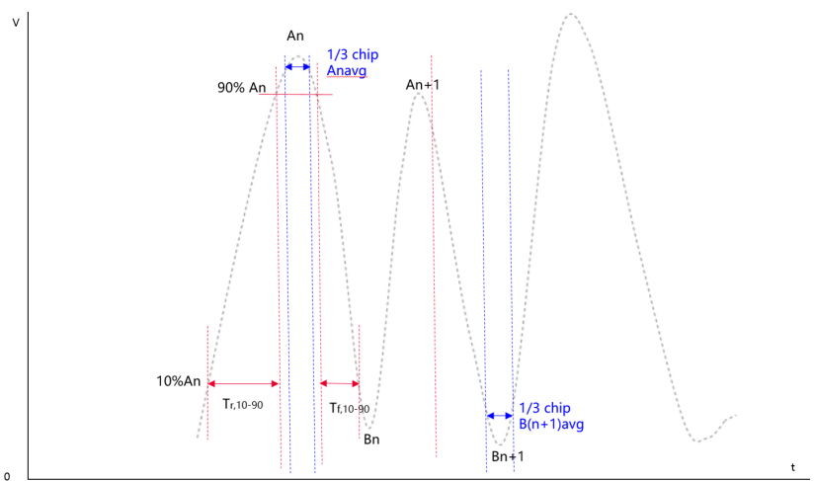

* Figure 1 R2D signal diagram
  + **Proposal 2:** The SIP should not be excluded from the ripple requirement verification. (R4-2510247, Vivo)
  + **Proposal 3:** Consider RF impairments, the RF envelope requirements can be defined as Table 3. (R4-2509883, Huawei; R4-2511126, ZTE)
* Table 1: A-IoT BS RF envelope parameters

|  |  |  |  |  |  |  |
| --- | --- | --- | --- | --- | --- | --- |
| **R2D Chip duration：Tc** | **Parameter** | **Symbol** | **Mimimum** | **Nominal** | **Maximum** | **Units** |
| $$Tc=\frac{{10}^{3}}{M*15}(us)$$ M∈ {2,6,12,24} | Modulation Depth | (A–B)/A | 80 | 90 | 100 | % |
| RF Envelope Ripple | Ripple_high  Ripple_low | 0 |  | ±15 | % |
| RF Envelop Rise Time | Tr,10-90 |  |  | 0.66Tc | µs |
| RF Envelop Fall Time | Tf,10-90 |  |  | 0.66Tc | µs |
| RF Pulsewidth | PW |  | 1Tc | 1.3 Tc | µs |

* + **Proposal 4**: LS to RAN1 to ask if the baseband can ripple suppression in OOK signal generation. (R4-2511438, Ericsson)
  + **Proposal 5**: Considering to introducing the below timing mask when the baseband waveform ripple can be suppressed within a limited range. (R4-2511438, Ericsson)
* 
* Figure 2: Timing mask for OOK bit-0

Table 2: Timing mask paratmer (Tchip = $\frac{{10}^{3}}{M*15} (us)$)

|  |  |  |
| --- | --- | --- |
| Parameter | Min | Max |
| t1 | 0 | 1/3 Tchip |
| t2 | 1/3 Tchip | [Tchip] |
| t3 | 0 | 1/3 Tchip |

Huawei:is it possible not to define ripple requirement.

ZTE: 15% ripple should include both RF and BB.

* Agreement:
  + **Parameters:**

Discuss whether to agree with or revise the parameter definitions:

* + - An is measured peak high level for the nth chip, in units of V/m or A/m
    - Bn is either a pre-determined value in percentage of An or based on measured peak low level for the nth chip, in units of V/m or A/m
    - Anavg is the measured average high level for the nth chip during 1/2 duration above 90%An, in units of V/m or A/m
    - Bnavg is the measured average low level for the nth chip during 1/2 duration below 10%An, in units of V/m or A/m
  + **Modulation Depth:**
    - For each chip, Modulation depth =(Anavg-Bnavg)/Anavg
    - (A–B)/A>=80%
  + **RF Envelope Ripple**
    - **Option 1**

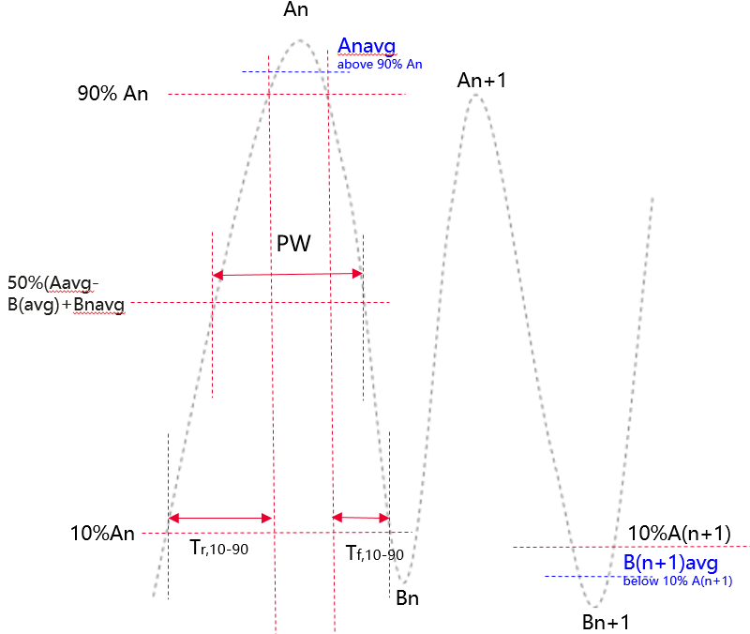

* + - * Ripple_high (%) = ((An − Anavg) / (Anag-Bnavg)) × 100% <=±15%
      * Ripple_low (%) = ((Bn − Bnavg) / (Anavg-Bnavg)) × 100%<=±15%
      * Note: SIP is included for the ripple requirement
  + **RF Envelope Rise/Fall Time:**
    - * RF Envelop Rise Time: The time from 0.1 ×(Anavg-Bnavg) +Bnavg to 0.9 ×(Anavg-Bnavg)+Bnavg Tr,10-90 <=0.66Tc
      * RF Envelop Fall Time: The time from 0.9 ×(Anavg-Bnavg) +Bnavg to 0.1 ×(Anavg-Bnavg)+Bnavg Tf,10-90 <=0.66Tc
    - **Option 2:**
* 
* Figure 2: Timing mask for OOK bit-0

Table 2: Timing mask paratmer (Tchip = $\frac{{10}^{3}}{M*15} (us)$)

|  |  |  |
| --- | --- | --- |
| Parameter | Min | Max |
| t1 | 0 | 1/3 Tchip |
| t2 | 1/3 Tchip | [Tchip] |
| t3 | 0 | 1/3 Tchip |

* + **RF Pulsewidth:** 
    - The pulse width is the time between two points on the pulse where the signal reaches 50% of (Anavg-Bnavg)+Bnavg, PW <=1.3 Tc

### Issue 1-2: ACLR

* Proposals are summarized as follows:
* Table4 Proposed ACLR summary

|  |  |  |  |  |  |  |  |  |
| --- | --- | --- | --- | --- | --- | --- | --- | --- |
|  | **R4-2509327, CATT; R4-2511438, Ericsson** | | **R4-2509714, CMCC** | | **R4-2509883, Huawei** | | **R4-2511126, ZTE** | |
|  | **Option 1** | | **Option 2** | | **Option 3** | | **Option 4** | |
| **R2D CBW** | **offset** | **ACLR** | **offset** | **ACLR** | **offset** | **ACLR** | **offset** | **ACLR** |
| 200 kHz | 100kHz | 40/50dB | >=100kHz | 40/50dB | 100kHz | 40/45dB | 100kHz | 30/40dB |
| 400 kHz | 100kHz | 40/50dB | >=100kHz | 40/50dB | 100kHz | 40/45dB | 100kHz | 30/40dB |
| 600 kHz | 100kHz | 40/50dB | >=100kHz | 40/50dB | 100kHz | 40/45dB | N/A | 30/40dB |
| 800 kHz | 100kHz | 40/50dB | >=100kHz | 40/50dB | 100kHz | 40/45dB | N/A | 30/40dB |

* Recommended WF
  + Option 1:100kHz offset, 35/40dB
  + Option 2: 100kHz offset, 40-45dB

### Issue 1-3: OBUE

* Proposals:
  + **Option 1:** OBUE requirement for standalone NB-IoT MR BS can be reused for A-IoT BS with both 1PRB and multiple PRB configurations. (R4-2509327, CATT)
  + **Option 2:** For A-IoT micro BS with 200 kHz R2D CBW, reuses the operating band unwanted emissions requirements of standalone NB-IoT Medium Range BS for A-IoT micro BS. (R4-2509883，Huawei)

For A-IoT micro BS with 400/600/800kHz R2D CBW, use the operating band unwanted emissions requirements in Table 7 and 8. (R4-2509883，Huawei)

Table7 A-IoT medium range BS operating band unwanted emission limits, BS maximum output power 31 < Prated,c ≤ 38 dBm , for 400/600/800kHz R2D CBW

|  |  |  |  |  |
| --- | --- | --- | --- | --- |
| **R2D CBW** | **Frequency offset of measurement filter ‑3dB point, Δf** | **Frequency offset of measurement filter centre frequency, f_offset** | **Minimum requirement (Note 1, 2)** | **Measurement bandwidth (Note 8)** |
| 400kHz | 0 MHz ≤ Δf < 0.4 MHz | 0.015 MHz ≤ f_offset < 0.415 MHz | Prated,c -40dB - $\frac{11}{0.4}$ ($\frac{f_offset}{MHz}$- 0.015) dB | 30 kHz |
| 0.4 MHz ≤ Δf < 0.8 MHz | 0.415 MHz ≤ f_offset < 0.815 MHz | Prated,c - 51dB- $\frac{5}{0.4}$ ($\frac{f_offset}{MHz}$-0.415) dB | 30 kHz |
| 0.8 MHz ≤ Δf < 1.6 MHz | 0.815 MHz ≤ f_offset < 1.6 MHz | Prated,c - 56dB | 30 kHz |
| 1.6 MHz ≤ Δf < Δfmax | 1.6 MHz ≤ f_offset < f_offsetmax | -25dBm | 100kHz |
| 600kHz | 0 MHz ≤ Δf < 0.6 MHz | 0.015 MHz ≤ f_offset < 0.615 MHz | Prated,c – 40dB - $\frac{13}{0.6}$ ($\frac{f_offset}{MHz}$-0.015) dB | 30 kHz |
| 0.6 MHz ≤ Δf < 1.2 MHz | 0.615 MHz ≤ f_offset < 1.2 MHz | Prated,c – 53dB - $\frac{5}{0.6}$ ($\frac{f_offset}{MHz}$-0.615) dB | 30 kHz |
| 1.2 MHz ≤ Δf < 1.8 MHz | 1.2 MHz ≤ f_offset < 1.8 MHz | Prated,c - 58dB | 30 kHz |
| 1.8 MHz ≤ Δf < Δfmax | 1.8 MHz ≤ f_offset < f_offsetmax | -25dBm | 100K |
| 800kHz | 0 MHz ≤ Δf < 0.8 MHz | 0.015 MHz ≤ f_offset < 0.815 MHz | Prated,c – 40dB- $\frac{14}{0.8}$ ($\frac{f_offset}{MHz}$-0.015) dB | 30 kHz |
| 0.8 MHz ≤ Δf < 1.6 MHz | 0.815 MHz ≤ f_offset < 1.6 MHz | Prated,c – 54dB- $\frac{5}{0.8}$ ($\frac{f_offset}{MHz}$-0.815) dB | 30 kHz |
| 1.6 MHz ≤ Δf < 2.4 MHz | 1.6 MHz ≤ f_offset < 2.4 MHz | Prated,c - 59dB | 30 kHz |
| 2.4 MHz ≤ Δf < Δfmax | 2.4 MHz ≤ f_offset < f_offsetmax | -25dBm | 100K |

Table 8 A-IoT medium range BS operating band unwanted emission limits, BS maximum output power Prated,c ≤ 31 dBm , for 400/600/800kHz R2D CBW

|  |  |  |  |  |  |
| --- | --- | --- | --- | --- | --- |
| **R2D CBW** | **Frequency offset of measurement filter ‑3dB point, Δf** | **Frequency offset of measurement filter centre frequency, f_offset** | **（old）Minimum requirement (Note 1, 2)**（note：this is original proposal in paper R4-2509883） | **（new）Minimum requirement (Note 1, 2)** （note：this is revised from proposal in paper R4-2509883 to correct some error） | **Measurement bandwidth (Note 8)** |
| 400kHz | 0 MHz ≤ Δf < 0.4 MHz | 0.015 MHz ≤ f_offset < 0.415 MHz | Prated,c -30dB - $\frac{11}{0.4}$ ($\frac{f_offset}{MHz}$- 0.015) dB | -9dBm - $\frac{11}{0.4}$ ($\frac{f_offset}{MHz}$- 0.015) dB | 30 kHz |
| 0.4 MHz ≤ Δf < 0.8 MHz | 0.415 MHz ≤ f_offset < 0.815 MHz | Prated,c - 41dB- $\frac{5}{0.4}$ ($\frac{f_offset}{MHz}$-0.415) dB | -20dBm- $\frac{5}{0.4}$ ($\frac{f_offset}{MHz}$-0.415) dB | 30 kHz |
| 0.8 MHz ≤ Δf < 1.6 MHz | 0.815 MHz ≤ f_offset < 1.6 MHz | -31dBm | -25dBm | 30 kHz |
| 1.6 MHz ≤ Δf < Δfmax | 1.6 MHz ≤ f_offset < f_offsetmax | -25dBm | -25dBm | 100kHz |
| 600kHz | 0 MHz ≤ Δf < 0.6 MHz | 0.015 MHz ≤ f_offset < 0.615 MHz | Prated,c – 30dB - $\frac{13}{0.6}$ ($\frac{f_offset}{MHz}$-0.015) dB | -9dBm - $\frac{13}{0.6}$ ($\frac{f_offset}{MHz}$-0.015) dB | 30 kHz |
| 0.6 MHz ≤ Δf < 1.2 MHz | 0.615 MHz ≤ f_offset < 1.2 MHz | Prated,c – 43dB - $\frac{5}{0.6}$ ($\frac{f_offset}{MHz}$-0.615) dB | -22dBm - $\frac{5}{0.6}$ ($\frac{f_offset}{MHz}$-0.615) dB | 30 kHz |
| 1.2 MHz ≤ Δf < 1.8 MHz | 1.2 MHz ≤ f_offset < 1.8 MHz | -21dBm | -27dBm | 30 kHz |
| 1.8 MHz ≤ Δf < Δfmax | 1.8 MHz ≤ f_offset < f_offsetmax | -25dBm | -25dBm | 100K |
| 800kHz | 0 MHz ≤ Δf < 0.8 MHz | 0.015 MHz ≤ f_offset < 0.815 MHz | Prated,c – 30dB- $\frac{14}{0.8}$ ($\frac{f_offset}{MHz}$-0.015) dB | -9dBm - $\frac{14}{0.8}$ ($\frac{f_offset}{MHz}$-0.015) dB | 30 kHz |
| 0.8 MHz ≤ Δf < 1.6 MHz | 0.815 MHz ≤ f_offset < 1.6 MHz | Prated,c – 44dB- $\frac{5}{0.8}$ ($\frac{f_offset}{MHz}$-0.815) dB | -23dBm - $\frac{5}{0.8}$ ($\frac{f_offset}{MHz}$-0.815) dB | 30 kHz |
| 1.6 MHz ≤ Δf < 2.4 MHz | 1.6 MHz ≤ f_offset < 2.4 MHz | -21dBm | -28dBm | 30 kHz |
| 2.4 MHz ≤ Δf < Δfmax | 2.4 MHz ≤ f_offset < f_offsetmax | -25dBm | -25dBm | 100K |

* + **Option 3:** Consider the 10dB relaxation on top of standalone NB-IoT BS emission mask.（R4-2511126, ZTE）
* Recommended WF
  + The OBUE requirements will depend on the final ACLR requirements:
  + Different options are shown as below

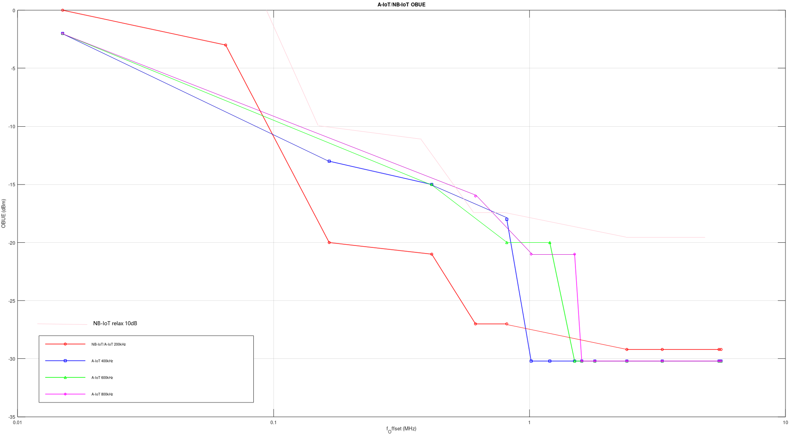

# Topic #2: A-IoT BS RX

### Issue 2-1: Reference sensitivity level

*Background:*

*Following conclusion* *of reference sensitivity level for A-IoT BS was captured in TR38.769*

*Copied from TR38.769:*

Regarding the reference sensitivity level for A-IoT BS, RAN4 reached the following consensus:

* For BS type 1-C,

$$P_{REFSENS}\left(dBm\right)=-174dBm+10×{log10}(BW)+N_{F}+I_{M}+SNR+[ desens target]$$

*Copied from WF R4-2508101*

* Agreement:
  + Define REFSENS for both OOK and BPSK. Depending on the simulations, they may or may not be the same.
  + Use [X dB] as the desens target, with CW single tone input through a signal generator, CW input level to BS Ant is assumed as [TBD] dBm;
* Proposals:
  + **Proposal 1**: It’s suggested to use real CW node for reader REFSENSE testing instead of signal generator. (CMCC，R4-2509714)
    - Observation 5: if companies insist on no update of current agreements, we need to define much stricter residual phase noise performance for REFSENSE definition, i.e. lower desense. (CMCC，R4-2509714)
  + **Proposal 2**: The proposed CW input power, desense target, and reference sensitivity are summarized below:

**Table 7 Summaries on prposed CW input power, desens target and ref sens**

|  |  |  |  |  |
| --- | --- | --- | --- | --- |
|  | CW input level to BS Ant | Desens target | Reference sensitivity | Source |
| Option 1 | -38dBm | 30 | -96dBm@15kHz, BPSK;  -73dBm@3520kHz, BPSK | R4-2509883, Huawei |
| Option 2 | -36dBm | 36 |  | R4-2511126, ZTE |
| Option 3 | [-15.5dBm] | 30 |  | R4-2511438, Ericsson |
| Option 4 | From a few meters to tens of meters | 20 | -106dBm@15kHz, OOK | R4-2509714, CMCC |

* + **Proposal 3:** R=1 is the worst case for sensitivity，suggest to consider reference sensitivity requirements for the reader without frequency shift (R=1) (R4-2509883，Huawei)
* Ericsson: if real CW is used, different CW performance, including phase noise, can impact the test outcome.
* ZTE:we will define the phase noise requirements for CW.
* Ericsson:signal generator will avoid the case where different CW performs differently.
* CMCC: signal generator may idealize the signal and cannot fully reflect the impacts from real CW.
* Recommended WF
  + CW testing signal source:it is FFS between real CW node for reader REFSENSE testing and signal generator.
    - The feasibility of the signal generator to repeat real CW performance is FFS.
  + CW input level to BS Ant -38dBm
  + Desens target 30dB, depend on CW input level to BS Ant

### Issue 2-2: SNR value

* Proposals:
  + **Proposal 1**: OOK vs BPSK SNR
    - Align the D2R power definition between requirement of device backscatter and reader sensitivity SNR, which is the power of 1st sideband and exclude the CW. (Vivo，R4-2510247)
    - Use a 3 dB higher SNR than that of BPSK to calculate the OOK reference sensitivity under the same conditions. (R4-2509883，Huawei)
    - Same REFSENS is applied to both OOK and BPSK. (Vivo，R4-2510247)
  + **Proposal 2**: SNR values are summarized as follow:

|  |  |  |  |
| --- | --- | --- | --- |
| SNR for BPSK | SNR for OOK | Note |  |
| -6.4 | / |  | R4-2509714, CMCC |
| -4.2 | 0.5 |  | R4-2511126, ZTE |
| -7.3 |  | Without SFO | R4-2509805, Xiaomi |
| -7 |  | Preamble + 1 or 2 midamble,96bist | R4-2509805, Xiaomi |
| -6 |  | For 15kHz D2R TBW | R4-2509883, Huawei |
| -6 |  | For 2880kHz D2R TBW | R4-2509883, Huawei |
| / | -4 |  | R4-2511438, Ericsson |
| Averge: -6.15 | Averge: -1.75 |  |  |

* + **Proposal 3**：No SFO can be assumed for BS receiver RF test. (Ericsson，R4-2511438)
* Recommended WF
  + Agree the average [-6dB~-4.2dB] SNR for BPSK；
  + OOK sensitivity is 3dB poor than that of BPSK at least:
    - If only consider the sideband power as a reference, the SNR of BPSK and OOK is similar, but OOK's practical sensitivity is at least 3 dB worse because its total signal power is less efficiently utilized.OOK contains a DC component with power equal to the sideband power.

ZTE: compared with BPSK, RAN1 has agreed 6dB relaxation for OOK.

### Issue 2-3: Dynamic range

* Proposals:
  + **Proposal 1:** No need to define the dynamic range requirement for A-IoT BS. (ZTE, R4-2511126)
  + **Proposal 2:**  Use Table 14 as the dynamic range requirement. (R4-2509883, Huawei)

Table 14 Dynamic range

|  |  |  |  |  |
| --- | --- | --- | --- | --- |
| **D2R channel bandwidth [kHz]** | **D2R transmission bandwidth[kHz]** | **Wanted signal mean power [dBm]** | **Interfering signal mean power [dBm] / BWConfig** | **Type of interfering signal** |
| 200 | 15 | -76 | -102.2 | AWGN |
| 3520 | 2880 | -70 | -79.4 | AWGN |

* Agreement:
  + No need to define the dynamic range requirement

### Issue 2-4: ACS

*Copied from RAN4#114bis WF R4-2505097*

### Issue 2-3: ACS

* Agreement:
  + For ACS requirements, use legacy NB-IoT requirements as starting point（114bis，R4-2505097）
  + FFS on the frequency offset for ACS requirement（114bis，R4-2505097）
* Proposals:
  + **Proposal 1:** The ACS for NB-IoT standalone MR BS can be reused for A-IoT BS.For ACS requirement, additional frequency offset of ±100kHz is not required for A-IoT BS.( R4-2509327, CATT)
  + **Proposal 2**: Reuse the ACS and IBB requirement in legacy NR BS. No need to consider the 7.5kHz misalignment between a wanted signal and ACS/IBB interferer. (Ericsson，R4-2511438)
  + **Proposal 3**: No need to define ACS requirements for A-IoT BS. If it must be defined, considering the following ACS requirements for A-IoT BS. (R4-2509883，Huawei)

Table 15: Adjacent channel selectivity for A-IoT Medium Range BS

|  |  |  |  |  |
| --- | --- | --- | --- | --- |
| A-IoT  channel bandwidth of the lowest/highest carrier received [kHz] | Wanted signal mean power [dBm] | Interfering signal mean power [dBm] | Interfering signal centre frequency offset to the lower/upper Base Station RF Bandwidth edge or sub-block edge inside a sub-block gap [kHz] | Type of interfering signal |
| 200 | PREFSENS + 19.5dB (Note) | -60 | ±100 | 5 MHz DFT-s-OFDM NR signal, 15 kHz SCS, 1 RB |
| 3520 | PREFSENS + 19.5dB (Note) | -60 | ±100 | 5 MHz DFT-s-OFDM NR signal, 15 kHz SCS, 1 RB |
| Note: PREFSENS depends on the sub-carrier spacing as specified in Table X | | | | |

* + **Proposal 4**: propose to define the ACS requirement as 20-30dBc for A-IoT BS with 3MHz DFT-s-OFDM signal configuration. (ZTE，R4-2511126)
  + Proposal 5: reuse the same ACS and IBB as standalone NB-IoT with interference signal mean power as -44dBm and wanted signal mean power could scale with CBW(CMCC)
* Recommended WF
  + Option 1: Modify the ACS of NB-IoT standalone MR BS
    - no need to consider the 7.5kHz misalignment
    - Interfering signal mean power [-47~60]dBm
  + Option 2: No need to define ACS

CMCC: prefer to defining ACS requirement. We propose to reuse the same requirements as NB-IOT.

Ericsson: prefer to defining ACS requirement

ZTE: A-IOT can have quite different CBW from NB-IOT. Not straightforward to reuse NB-IOT requirement to A-IOT.

Huawei: we prefer to option 2. But can compromise to specify the requirement.

Agreement:

Specify ACS requirement for A-IOT BS with one of the following options

* + Option 1: Modify the ACS of NB-IoT standalone MR BS
    - no need to consider the 7.5kHz misalignment
    - Interfering signal mean power [-47~60]dBm or ACS is relaxed to [20-30dB].
  + Option 2: Reuse the ACS of NB-IoT standalone MR BS for 200kHz. The ACS for other CBW can be scaled accordingly

### Issue 2-5: narrowband blocking

* Proposal:
  + **Proposal 1**: The narrowband blocking requirement for NB-IoT standalone MR BS can be reused for A-IoT BS. (R4-2509327, CATT)
  + **Proposal 2**: No need to define narrowband blocking requirements for A-IoT BS. If it must be defined, considering the Table 16 and 17 narrowband blocking requirements for A-IoT BS. ( R4-2509883，Huawei)

Table 16: Narrowband blocking requirement for A-IoT Medium Range BS

|  |  |  |  |  |
| --- | --- | --- | --- | --- |
|  | A-IoT  channel bandwidth of the lowest/highest carrier received [kHz] | Wanted signal mean power [dBm] | Interfering signal mean power [dBm] | Type of interfering signal |
| Medium Range BS | 200 | PREFSENS + 12 dB (Note 1) | -60 | See Table 17 |
| 3520 | PREFSENS + 12 dB (Note 2) | -60 | See Table 17 |
| Note 1: PREFSENS depends on the sub-carrier spacing as specified in Table x.  Note 2: PREFSENS depends on the sub-carrier spacing as specified in Table x. | | | | |

Table 17: Interfering signal for Narrowband blocking requirement for A-IoT Medium Range BS

|  |  |  |
| --- | --- | --- |
| A-IoT  channel bandwidth of the lowest/highest carrier received [kHz] | Interfering RB centre frequency offset to the lower/upper Base Station RF Bandwdith edge or sub-block edge inside a sub-block gap [kHz] | Type of interfering signal |
| 200 | ±(240 +m*180),  m=0, 1, 2, 3, 4, 9, 14 | 3 MHz E-UTRA signal, 1 RB* |
| 3520 | ±(240 +m*180),  m=0, 1, 2, 3, 4, 9, 14 | 3 MHz E-UTRA signal, 1 RB* |
| Note*: Interfering signal consisting of one resource block is positioned at the stated offset, the channel bandwidth of the interfering signal is located adjacently to the lower/upper Base Station RF Bandwidth edge. | | |

* Agreement:
  + No need to define narrowband blocking

### Issue 2-6: General intermodulation

* Proposals:
  + **Option 1:** No need. (R4-2509327, CATT; R4-2509883，Huawei; R4-2511126, ZTE)
  + **Option 2**: Reuse the RX intermodulation requirement. (Ericsson，R4-2511438)
* Recommended WF

### No need

### Issue 2-7: Narrowband intermodulation

* Proposals:
  + **Proposal 1:** No need (R4-2509327, CATT; R4-2509883, Huawei; R4-2511126, ZTE)
  + **Proposal 2**: for narrow band IMD requirements, the interference level is suggested as -53dBm. Other parameters are suggested to reuse the same value as NB IoT system. (CMCC，R4-2509714)
  + **Proposal 3:** Reuse the RX intermodulation requirement. (Ericsson, R4-2507495)
* Recommended WF
  + for narrow band IMD requirements, the interference level is suggested as -53dBm. Other parameters are suggested to reuse the same value as NB IoT system.

CMCC: we see the likelihood of coexistence between A-IOT and NB-IOT. That’s why this requirement is needed.

# Topic #3: CW

### Issue 3-1: OFF power MBW

* Proposals:
  + Three companies propose 1MHz（CMCC, R4-2509715; Xiaomi, R4-2509808; Huawei, R4-2511289）, one propose max device CBW （Oppo, R4-2510844）, and one propose 180kHz（ZTE，R4-2511130）
* Agreement:
  + OFF power MBW is 1MHz

### Issue 3-2: Phase noise

* Proposals:
  + **Option 1-1**: Not to define Rel-19 phase noise for D1T1（Huawei, R4-2511289；ZTE，R4-2511130；CATT，R4-2509328）
  + **Option 1-2**: the phase noise requirement is about 70-80dBc for the case when BW without phase noise cancellation capability. If companies think such requirement is much challeging, we can only consider BS with phase noise cancellation capability in R19.（CMCC，R4-2509715）
  + **Option 2-1:** For BS without phase noise cancellation capability, it is proposed to define the CW phase noise limit as in Table 2-3. （Huawei, R4-2511289）

Table 2-3: CW phase noise limit（Huawei, R4-2511289）

|  |  |  |
| --- | --- | --- |
| **Δf (kHz)** | **Phase noise emission limit (dBm)** | **Measurement bandwidth** |
| 60 | [-25] | [7.5 kHz] |
| 120 | [-28] | [7.5 kHz] |

* + **Option 2-2:** Define the phase noise requirement according to the state of art of oscillator. （Xiaomi, R4-2509808）
    - 7.5kHz frequency offset to CW frequency can be considered as the start point of the frequency offset of CW phase noise requirement. （Xiaomi, R4-2509808）
    - Phase noise can be defined as -110 dBc/Hz from 7.5kHz frequency offset to CW frequency if it’s not very difficult with the state of the art. （Xiaomi, R4-2509808）
  + **Option 2-3:** The limit of phase noise can be defined as -30 dBm/7.5kHz at 120kHz offset from the center frequency of CW. (Vivo, R4-2510249)
  + **Option 2-4**: The phase noise requirement of CW node is proposed to be defined as table 1 (Oppo, R4-2510844)

**Table 1 Phase noise requirement for the CW node**

|  |  |
| --- | --- |
| **Frequency distance toward the CW centre** | **Phase noise (dBc/Hz)** |
| **10Hz** | **-57** |
| **100Hz** | **-87** |
| **1kHz** | **-99** |
| **7.5kHz** | **-102** |
| **2880kHz** | **-127** |

* + **Option 2-5**: For CW without shared reference, the phase noise of CW is 90 dBc for +/- 8.25 kHz. (Qualcomn，R4-2510973)
  + **Option 2-6**：Specify the above unwanted emission for CWT node. (Ericsson, R4-2511439)

**Table 1-x: CW node spectrum emission level**

|  |  |  |
| --- | --- | --- |
| **Δf (kHz) from the CW frequency** | **Emission limit (dBc)** | **Measurement bandwidth** |
| ± 7.5 | -114 | 1Hz |
| ± 60 | -117 | 1Hz |
| ± 480 | -128 | 1Hz |

* + Discuss whether phase noise effects could be incorporated through BS sensitivity degradation
  + If phase noise requirements are to be define, discuss whether option 2-3 can be agreed

### Issue 3-3: Unwanted emission

### *Copied from 114bis WF R4-2505097*

### Issue 3-5: Unwanted emission

* Agreement:
  + FFS on unwanted emission boundary and corresponding values: （114bis，R4-2505097）
  + Option 1: The unwanted emission of CW is defined from minimum small frequency shift ± D2R transmission bandwidth/2 to the boundary of D2R channel bandwidth

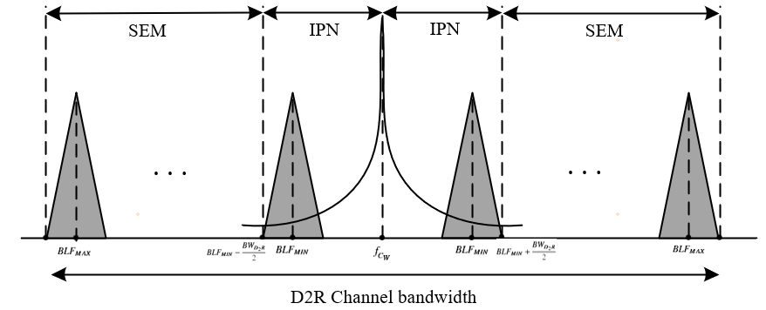

* + Option 2: FFS whether or not to define channel bandwidth for CW
  + Option 3: The spectrum emission mask of the CW node applies to frequencies (Δf) starting from the assigned transmission frequency. The spectrum emission mask for CW node is defined as in Table 2.2-4.

**Table 2.2-4: CW node spectrum emission mask**

|  |  |  |
| --- | --- | --- |
| **Δf (kHz)** | **Emission limit (dBm)** | **Measurement bandwidth** |
| ± 0-90 | N/A |  |
| ± 90-270 | -15 | 30 kHz |
| ± 270-450 | -20 | 30 kHz |
| ± 450- Δfmax | -27 | 30 kHz |

* + Other options are not precluded.
* Proposals:
  + **Option 1**: The frequency range of Δf from ±0 to 90kHz can be covered by phase noise and left to implementation. (R4-2509328, CATT)
    - The spectrum emission mask for CW node can be defined as table 1.( CATT，R4-2509328)

**Table 1: CW node spectrum emission mask**

|  |  |  |
| --- | --- | --- |
| **Δf (kHz)** | **Emission limit (dBm)** | **Measurement bandwidth** |
| ± 0-90 | N/A |  |
| ± 90-270 | -15 | 30 kHz |
| ± 270-450 | -20 | 30 kHz |
| ± 450- Δfmax | -27 | 30 kHz |

* + **Option 2:** use minimum D2R CBW as the boundary for CW unwanted emission requirements. i.e. inside the minimum D2R CBW, we define phase noise if needed, while outside the CBW, we define unwanted emission requirements.
    - the same NB-IoT unwanted emission requirement with 33dBm output power is suggested for CW node.( CMCC，R4-2509715)
  + **Option 3**：It is proposed to adopt the following proposal for CW node.( Huawei, R4-2511289)
* **Table 2.2-3: CW node spectrum emission mask**

|  |  |  |
| --- | --- | --- |
| **Δf (kHz)** | **Emission limit (dBm)** | **Measurement bandwidth** |
| ± 200 | -18 | 30 kHz |
| ± 250 | -20 | 30 kHz |
| ± 350 | -25 | 30 kHz |
| ± 800 | -26 | 30 kHz |
| ± 1200 | -19 | 1 MHz |
| ± 5200~Δfmax | -23 | 1 MHz |

* Recommended WF
  + Discuss whether option 3 can be agreed

Agreement:

* + Adopt the following proposal for CW node.
* **Table 2.2-3: CW node spectrum emission mask**

|  |  |  |
| --- | --- | --- |
| **Δf (kHz)** | **Emission limit (dBm)** | **Measurement bandwidth** |
| ± 200 | -18 | 30 kHz |
| ± 250 | -20 | 30 kHz |
| ± 350 | -25 | 30 kHz |
| ± 800 | -26 | 30 kHz |
| ± 1200 | -19 | 1 MHz |
| ± 5200~Δfmax | -23 | 1 MHz |

### Issue 3-4: CW channel bandwidth

* Proposals:
  + **Proposal 1**: Channel bandwidth for CW signal needs to be defined. (CATT，R4-2509328)
  + **Proposal 2**: The channel bandwidth for CW signal can be defined as 15kHz. (CATT，R4-2509328)
* Recommended WF
  + No definition of channel bandwidth for CW is needed.

### Issue 3-5: CW channel raster

* Proposals:
  + Reuse the R2D channel raster for CWT node channel raster.（Ericsson，R4-2511439；Huawei, R4-2511289）
* Recommended WF
  + Follow conclusion in thread [116][134]

### Issue 3-6: CW others

### *Copied from 114bis WF R4-2505097*

### Issue 3-8: CW others

* Agreement:
  + CW transmission and A-IoT BS downlink data transmission are non-concurrent. （114bis，R4-2505097）
    - FFS whether or not introduce the synchronization requirement of 3 us between CW node and A-IoT BS
* Proposals:
  + **Proposal 1**: propose not to specify the timing requirement for CW node.( ZTE，R4-2511130)
  + **Proposal 2**: Reflect the above agreement in TS 38.194.（CW transmission and A-IoT BS downlink data transmission are non-concurrent.）(Ericsson，R4-2511439)
* Agreement:
  + No need to specify the timing requirement for CW node in RF spec. it can be discussed under RRM.
  + Discuss how to capture “CW transmission and A-IoT BS downlink data transmission are non-concurrent”.

# Topic #4: draft TP to TS38.194

* Recommended WF
  + Discuss whether to agree with or revise draft TPs:
  + Whether to capture CW phase noise (R4-2510973) in TS depends on the Issue 3-2

|  |  |  |  |
| --- | --- | --- | --- |
| No. | Section in TS38914 | Volunteer company | RAN4#116 TPs submitted |
| 1 | 5.3 BS channel bandwidth 5.4 Channel arrangement | CMCC | R4-2509717, CMCC（this is submitted in 7.22.2） |
| 2 | 6.1 General 6.2 Base station output power 6.3 Transmit ON/OFF power | CATT, LGE | R4-2509330，CATT  LGE，R4-2510079 |
| 3 | 6.4 Transmitted signal quality | Huawei，ZTE | R4-2509884，Huawei |
| 4 | 6.5 Unwanted emissions 6.6 Transmitter intermodulation | CMCC，CATT | R4-2509331，CATT  R4-2509718，CMCC |
| 5 | 7.1 General 7.2 Reference sensitivity level 7.3 Dynamic range | ZTE, Huawei | R4-2511127，ZTE  R4-2509885，Huawei |
| 6 | 7.4 In-band selectivity and blocking 7.5 Out-of-band blocking | Ericsson | Ericsson，R4-2511433 |
| 7 | 7.6 Receiver spurious emissions 7.7 Receiver intermodulation 7.8 In-channel selectivity | Ericsson, ZTE | Ericsson，R4-2511433 |
| 8 | 8.1 General 8.2 CW Output power | Huawei, OPPO | Huawei ，R4-2511290 |
| 9 | 8.3 Frequency error 8.4 Unwanted emission | Vivo，ZTE | Vivo，R4-2510252 |