3GPP TSG RAN #103 RP-240719
Maastricht, Netherlands, March 18-21, 2024

Agenda item: 9.1.4.6
Source: Apple (Moderator)
Title: Moderator's summary for discussion on Sidelink
Document for: Discussion

Introduction
In RP-240019 (Proposed Summary for RAN Rel-19 Package: RAN4 Part) prepared by RAN Chair and RAN4 Chair, the following proposed scope is endorsed as a starting point for discussion in RAN#103.

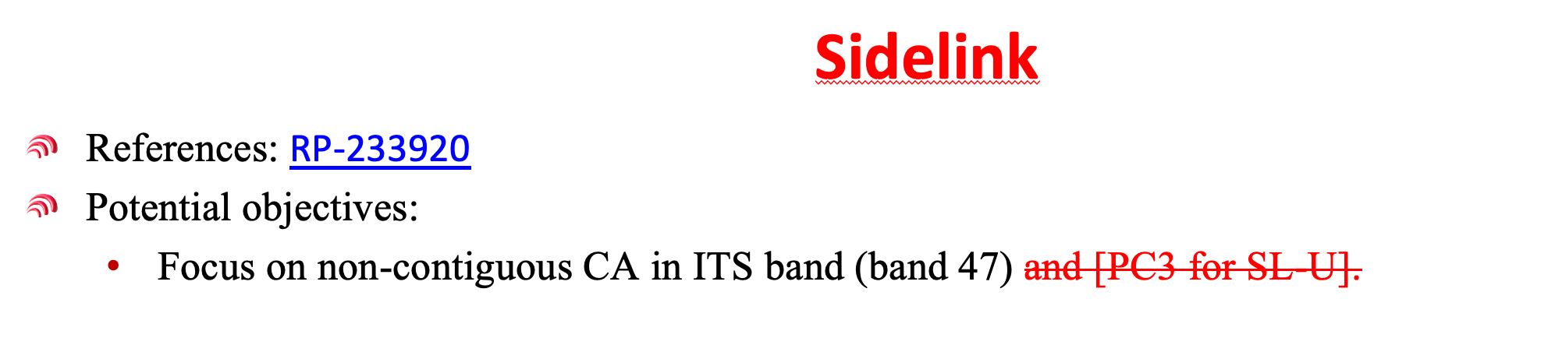
This document summarizes the relevant contributions on this topic and provides moderator recommendations for further discussions with an aim to reach an agreement on R19 WI scope.

List of relevant contributions and their views
RP-240315 | Considerations for Release-19 RAN4-led WI/SIs | KT | do we have room to also introduce power class 3 for NR SL-U?
RP-240434 | Views on other RAN4-led topics for Rel-19 | Huawei, HiSilicon | The following objectives could be considered for Rel-19 sidelink enhancement  - Specify the intra-band non-contiguous CA including 10MHz+10MHz and 10MHz+20MHz with power class 2 (PC2) and power class 3 (PC3)  - Sidelink CA operation band combinations and configurations  - Update channel arrangement including channel spacing, raster, sync raster, and other aspects, if needed  - Tx requirements  - Maximum output power and MPR for PC2 and PC3  - Update configured output power, output power dynamic, Transmit signal quality, out-of-band emission, spurious emissions, if needed  - Rx requirements  - Update REFSENS, Maximum input level, ACS, blocking, etc, if needed  - Specify the intra-band contiguous CA with power class 2 (PC2)  - Sidelink CA operation band combinations and configurations  - Tx requirements  - Maximum output power and MPR for PC2  - Update other RF requirements, if needed  No RRM and demodulation performance requirements would be needed for above Rel-19 sidelink enhancement.
RP-240547 | Views on Rel-19 RAN4 cross-area and other topics | Intel | Core part:  - Specify the necessary RF requirements for intra-band non-contiguous Sidelink CA with the focus on band n47.  - Include CC combinations 10MHz + 10MHz and 10MHz + 20MHz for UE Power Class 2 (26 dBm) and Power Class 3 (23 dBm)
RP-240310 | R19 NR Sidelink continuation and enhancements in RAN4 | OPPO | 1. For SL CA enhancement  - Specify requirements for intra-band non-contiguous CA with power class 3  - Targeted band combination is SL_n47(2A)  - Bandwidth combinations are 10+10MHz and 10+20MHz  - UE with separate chains to support non-contiguous CA is prioritized  - Specify requirements for intra-band contiguous CA with non-contiguous RB allocation  - Targeted band combination is SL_n47B with power class 3  2. For SL unlicensed  - Specify new NS values for SL unlicensed bands n46, n96 and n102 based on companies’ input
RP‑240329 | Motivation on Rel-19 further NR sidelink evolution | LG Electronics, Volkswagen AG | Objectives  - Specify the following requirements for NR sidelink CA in n47.  - Intra-band non-contiguous CA with power class 2 and power class 3  - Intra-band contiguous CA with power class 2  - Intra-band contiguous CA with non-contiguous RB allocation  - Specify the missing requirements for NR sidelink in unlicensed spectrum.  - Remaining 12 NS values  - Specify the corresponding RRM core requirements for the above features.
RP‑240548 | Input on Rel-19 NR Sidelink CA in RAN4 | Volkswagen AG, Continental Automotive Technologies GmbH, ROBERT BOSCH GmbH, LG Electronics | Work item objectives:  - Support of intra-band non-contiguous CA in band n47, including the Component Carrier (CC) combinations 10MHz + 10MHz and 10MHz + 20MHz, for UE Power Class 2 (26 dBm) and Power Class 3 (23 dBm)  - Introduction of Power Class 2 (26 dBm) for intra-band contiguous sidelinkCA in band n47
RP‑240397 | Views on R19 topics impacting both RF and RRM | CATT | Objectives  •Specify necessary RF requirements for sidelink CA  •Specify necessary RRM requirements for sidelink CA if any

Moderator recommendations for further discussions

Intra-band non-contiguous CA in band n47
It is agreeable to consider the following WI scope in the WID:
- Specify the RF requirements for NR sidelink CA in n47:
  - Intra-band non-contiguous CA with power class 2 and power class 3
  - Component Carrier (CC) combinations 10MHz + 10MHz and 10MHz + 20MHz
- Specify the corresponding RRM core/performance requirements if identified.

Intra-band contiguous CA in band n47
It is recommended to assess the amount of work required for support of intra-band contiguous CA with power class 2, as is requested by 5GAA in the LS (RP-240023), and then decide whether it can be included in the WID:
- Specify the RF requirements for NR sidelink CA in n47:
  - Intra-band contiguous CA with power class 2
- Specify the corresponding RRM core/performance requirements if identified.

Offline discussions and conclusions

Discussions
OPPO: we support inclusion of contiguous CA.
LGE: considering there is not much difference in supporting contiguous and non-contiguous CA, we support inclusion of contiguous CA. Do we focus on CA only or want to consider leftover issues? RAN4 agreed that if the missing part in R18 cannot be included in R19, it can be discussed as R18 maintenance.
Meta: we support inclusion of contiguous CA. Similar view as LG, legacy issues should be considered in R19.
RAN4 chair: we follow the endorsed summary.
Vivo: is there any RRM core requirements?
Intel: there is already generic RRM requirements specified in R18.
Ericsson: we need to visit the applicability section to make sure if there is any RRM impact.
Xiaomi: for Intra-band non-contiguous CA, we should focus on PC3 first.
Moderator: we can say PC3 start first in the WID.
VW: we are OK with starting PC3 first. PC2 should be included in the WID. Also want to support contiguous CA.
Apple: 5GAA mentions both contiguous and non-contiguous CA. They come as a package.

Conclusions

4.2.1 Intra-band non-contiguous CA in band n47
The WI scope was revised as follows with change marks:
- Specify the RF requirements for NR sidelink CA in n47:
  - Intra-band non-contiguous CA with power class 2 and power class 3
  - Component Carrier (CC) combinations 10MHz + 10MHz and 10MHz + 20MHz
- [Specify the corresponding RRM core/performance requirements if identified.]

4.2.2 Intra-band contiguous CA in band n47
As the workload seems manageable, it may be acceptable to include intra-band contiguous CA in the scope. The WI scope was revised as follows with change marks:
- Specify the RF requirements for NR sidelink CA in n47:
  - Intra-band contiguous CA with power class 2
- [Specify the corresponding RRM core/performance requirements if identified.]

