3GPP TSG RAN #103 RP-240718
Maastricht, Netherlands, March 18-21, 2024

Agenda item: 9.1.4.6
Source: Apple (Moderator)
Title: Moderator's summary for discussion on ATG
Document for: Discussion

Introduction
In RP-240019 (Proposed Summary for RAN Rel-19 Package: RAN4 Part) prepared by RAN Chair and RAN4 Chair, the following proposed scope is endorsed as a starting point for discussion in RAN#103.

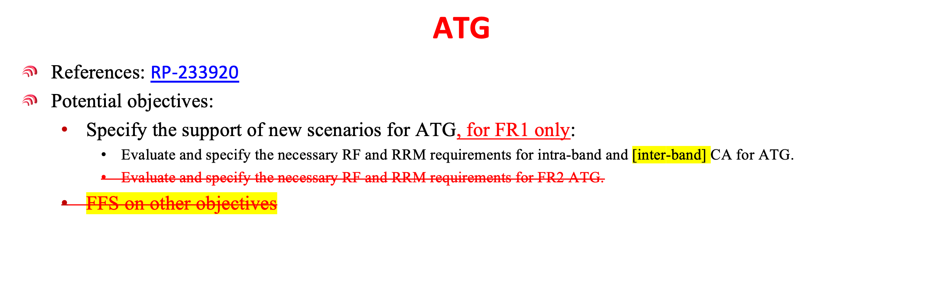
This document summarizes the relevant contributions on this topic and provides moderator recommendations for further discussions with an aim to reach an agreement on R19 WI scope.

List of relevant contributions and their views
RP-240434 | Views on other RAN4-led topics for Rel-19 | Huawei, HiSilicon | The following objectives could be considered for Rel-19 ATG enhancement:  - Specify the intra-band and inter-band CA band combination and configurations for ATG  - Decide the example band combinations  - Specify the necessary UE RF requirements for ATG intra-band and inter-band CA (example band combinations)  - Tx requirements including maximum output power, configured Tx power, output power dynamics, Tx signal quality, SEM, ACLR  - Rx requirements including REFSENS, maximum input level, ACS, blocking and etc  - Specify the necessary BS RF requirements for ATG including  - TAE requirements for intra-band and inter-band CA for ATG  - Specify the necessary RRM core/performance requirements for intra-band and inter-band CA for ATG including  - SCell activation/de-activation delay requirements and interruption requirements  - RRM measurement requirements  - Specify the necessary demodulation performance requirements for intra-band and inter-band CA for ATG
RP-240547 | Views on Rel-19 RAN4 cross-area and other topics | Intel | Core part:  - Evaluate and specify the necessary RF and RRM requirements for intra-band and inter-band CA for ATG.  Performance part:  - Specify the necessary RRM performance requirements and test cases for intra-band and inter-bandCAforATG.
RP-240154 | Views on Rel-19 ATG enhancement | CMCC, China Unicom | - CA to enhance capacity  - Define ATG BS and ATG UE requirements  - Define RRM Core requirements:  - Define Performance requirements  - Including  - FR1 intra-band CA, e.g. n79C, n41C, n78C  - FR1+FR1 inter-band CA, e.g. n3+n39, n34+n39, n1+n78  - R18 leftover issues  - FR1 MIMO: In R18, two kinds of ATG UE types have been defined, one with omni-directional antenna and the other with antenna array. For the UE with antenna array, if dual-polarization antenna is used, UL MIMO can be supported. However, corresponding requirements are not specified in Rel-18.
RP‑240397 | Views on R19 topics impacting both RF and RRM | CATT | Objectives  •Core  •Specify ATG BS and ATG UE RF requirements for intra-band and inter-band FR1 CA.  •Specify ATG UE RRM core requirements for intra-band and inter-band FR1 CA.  •Performance  •Specify ATG BS RF conformance test for intra-band and inter-band FR1 CA.  •Specify ATG UE RRM performance requirements for intra-band and inter-band FR1 CA.  •Specify ATG BS and UE demodulation requirements for intra-band and inter-band FR1 CA.

Moderator recommendations for further discussions

Intra-band and [inter-band] CA
It is agreeable to consider the following WI scope in the WID:
- Specify the RF requirements for intra-band and [inter-band] CA
  - FR1 intra-band CA, e.g. n79C, n41C, n78C
  - [FR1+FR1 inter-band CA, e.g. n3+n39, n34+n39, n1+n78]
- Specify corresponding RRM core requirements
- Specify corresponding RRM performance and demodulation requirements

R18 leftover issues: support of MIMO
It is recommended to assess the amount of work required for support of UL MIMO for UE with antenna array where dual-polarization antenna is used and then decide whether it can be included in the WID:
- Specify the RF/RRM/Demod requirements for support of UL MIMO for UE with antenna array where dual-polarization antenna is used.

Offline discussions and conclusions

Discussions
CMCC: to have enough ATG capacity, inter-band CA is needed. Also prefer to have MIMO with 2TX.
LGE: support inter-band CA. regarding example bands, can consider one in this WI and leave the others to basket WIs.
Apple: support inter-band CA. is it for co-located scenarios?
CMCC: we consider only co-located scenarios.
ZTE: it is fine to include UL-MIMO.
Apple: UL-MIMO for single CC only or CA?
CMCC: UL-MIMO is for single CC and CA is for DL only.
Ericsson: need to be cautious about ruling out non-co-located scenario.
Apple: will there be RRM impact for support of UL-MIMO?
Intel: need to be careful about the inclusion of UL-MIMO. What is the workload? Can we consider doing it as part of maintenance?
CMCC: no need to specify RRM for UL-MIMO. Prefer to keep UL-MIMO as part of R19, as the workload is manageable.
Intel: we agree the workload of supporting UL-MIMO is small.
Huawei: we prefer to include this work after Dec. 2024.
Moderator: there seems to be consensus that the workload associated with support of UL-MIMO is small.

Conclusions

4.2.1 Intra-band and [inter-band] CA
The WI scope was revised as follows with change marks:
- Specify the RF requirements for intra-band co-located and inter-band co-located DL CA
  - FR1 intra-band contiguous CA, e.g. n79C, n41C, n78C
  - FR1+FR1 inter-band CA, e.g. n3+n39, n34+n39, n1+n78
- Specify corresponding RRM core requirements
- Specify corresponding RRM performance and demodulation requirements

4.2.2 3.2 R18 leftover issues: support of MIMO
As the workload seems manageable, it may be acceptable to include the support of UL-MIMO in the scope. The WI scope was revised as follows with change marks:
- Specify the RF/Demod requirements for support of UL MIMO with 2TX for single CC for UE with dual-polarization antenna.
  - UE RF requirement
  - BS demod requirement

