3GPP TSG RAN #103 RP-240717
Maastricht, Netherlands, March 18-21, 2024

Agenda item: 9.1.4.6
Source: Apple (Moderator)
Title: Moderator's summary for discussion on Intra-band non-collocated CA/DC
Document for: Discussion

Introduction
In RP-240019 (Proposed Summary for RAN Rel-19 Package: RAN4 Part) prepared by RAN Chair and RAN4 Chair, the following proposed scope is endorsed as a starting point for discussion in RAN#103.

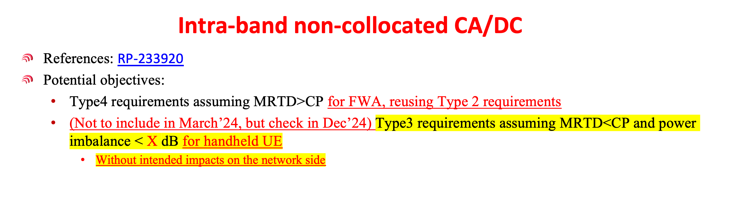
This document summarizes the relevant contributions on this topic and provides moderator recommendations for further discussions with an aim to reach an agreement on R19 WI scope.

List of relevant contributions and their views
RP-240315 | Considerations for Release-19 RAN4-led WI/SIs | KT | consider Type 3 UE in Dec. ‘24
RP-240262 | Other RAN4-led topics for Rel-19 | Nokia | If a WI in Rel-19 then only work on Type 4 requirements assuming MRTD>CP
RP-240434 | Views on other RAN4-led topics for Rel-19 | Huawei, HiSilicon | the following obejctives could be considered for the enhancement of intra-band non-collocated CA/DC:  - Specify the requirements for type 4 receiver assuming MRTD>CP for FWA  - RF requirements: update power imbalance requirements if needed  - RRM core/performance requirements: update MTTD and MRTD requirements if needed and update the other requirements including scheduling restriction/availability, SCell operation related delay and interruption  - Demodulation: specify the PDSCH demodulation performance requirements if needed  - Try to reuse the existing type 2 requirements as much as possible  - FFS: Specify the requirements for Type3 requirements assuming MRTD<CP and power imbalance < X dB for handheld UE  - Check in Dec’ 2024.
RP-240547 | Views on Rel-19 RAN4 cross-area and other topics | Intel | Core part:  1. Study the feasibility and specify support or non-co-located scenarios  for both FR1 inter-band non-contiguous EN-DC with overlapping or  partially overlapping bands and FR1 intra-band non-contiguous NRCAfor4-  layer casewith separated Rx-chains  • Investigate and specify the tolerable power imbalance and required  arrival time differences between carriers  • Specify MRTD andMTTD requirements and other identified RRM  • Consider Type 4a/4b type of devices with 6/8 separated Rx chains  Performance part:  2. Specify RRM performance requirements and test cases  3. Specify PDSCH demodulation requirements
RP-240101 | Motivation on supporting Intra-band non-collocated EN-DC/NR-CA deployment in Release 19 | KDDI, Docomo, KT, LG Uplus, SoftBank, Telecom Italia, Samsung | - Type 4 requirements assuming MRTD>CP for FWA, reusing Type 2 requirements  - (Not to include in March’24, but check in Dec’24) Type 3 requirements assuming MRTD<CP and power imbalance < X dB for handheld UE  - Without intended impacts on the network side
RP‑240495 | On intra-band non-collocated NR CA/EN-DC in R19 | Apple | Proposal 1: It is proposed to take X = 6dB as the baseline for type 3a/3b UE.  Proposal 2: Network signaling to allow dynamic switching between 2MIMO layer (Type 2 UE) and 4MIMO layer (Type 3 UE) is preferred.

Moderator recommendations for further discussions

Type 4 UE
It is agreeable to consider the following WI scope in the WID:
- Specify the core requirements for type 4 FWA UE (as defined in R4-2217734, WF on NonCol_intraB_ENDC_NR_CA for New Type UE) that supports non-co-located scenarios for both FR1 inter-band non-contiguous EN-DC with overlapping or partially overlapping bands and FR1 intra-band non-contiguous NR-CA for 4-layer DL MIMO, where MRTD>CP is assumed.
  - RF power imbalance requirements
  - RRM requirements including MTTD and MRTD requirements and other identified requirement such as scheduling restriction/availability, SCell operation related delay and interruption.
- Specify the corresponding performance requirements for type 4 FWA UE (as defined in R4-2217734, WF on NonCol_intraB_ENDC_NR_CA for New Type UE) that supports non-co-located scenarios for both FR1 inter-band non-contiguous EN-DC with overlapping or partially overlapping bands and FR1 intra-band non-contiguous NR-CA for 4-layer DL MIMO, where MRTD>CP is assumed.
  - RRM performance requirements
  - PDSCH demodulation performance requirements
Note: The requirements specified for type 2 UE should be reused as much as possible

Type 3 UE
It is agreeable to check if the following scope can be added to the WI in Dec. 2024.
Specify the requirements for Type3 requirements assuming MRTD<CP and power imbalance < X dB for handheld UE.

Offline discussions and conclusions

Discussions
KDDI: it is better to add specific bands.
OPPO: to include both 4a and 4b
Apple: In R18, UE type is not bundled with MRTD. Are we going to define different UE types for co-located scenario? Or just use Type 1.
CATT: 4 layer per CC

Conclusions

4.2.1 Type 4 UE
The WI scope was revised as follows with change marks:
- Specify the core requirements for type 4a/b FWA UE (as defined in R4-2217734, WF on NonCol_intraB_ENDC_NR_CA for New Type UE) that supports non-co-located scenarios for FR1 inter-band non-contiguous EN-DC with overlapping or partially overlapping bands and/or FR1 intra-band non-contiguous NR-CA for up to 4-layer DL MIMO per CC, where both RTD>CP and RTD < CP are included.
  - RF power imbalance requirements of up to 25dB
  - RRM requirements including MTTD and MRTD requirements and other identified requirement such as scheduling restriction/availability, SCell operation related delay and interruption.
  - Work is limited to EN-DC/NR-CA for bands 42, n77/n78
  - [Specify type 4a/b UE behavior in co-located scenarios (MRTD < CP) depending on whether network signaling is provided.]

- Specify the corresponding performance requirements for type 4a/b FWA UE.
  - RRM performance requirements
  - PDSCH demodulation performance requirements

4.2.2 Type 3 UE
It is agreeable to check if the following or similar scope can be added to the WI in Dec. 2024.
Specify the requirements for Type3 requirements assuming MRTD<CP and power imbalance < X dB for handheld UE.
- Without intended impacts on the network side

