**3GPP TSG RAN #103 RP-240716**

**Maastricht, Netherlands, March 18 – 21, 2024**

**Title: Moderator's summary for discussion on NR channel BW less than 5MHz for TN**

**Source: Moderator (vivo)**

# Introduction

This document summarizes the discussion related to R19 WI on NR channel BW less than 5MHz for TN in RAN #103 meeting. Submitted contributions in RAN #103 are listed as below:

|  |  |  |
| --- | --- | --- |
| [RP‑240262](D:\\RAN\\TSGR_103\\docs\\RP-240262.zip" \t "_blank) | Other RAN4-led topics for Rel-19 | Nokia |
| [RP‑240547](D:\\RAN\\TSGR_103\\docs\\RP-240547.zip" \t "_blank) | Views on Rel-19 RAN4 cross-area and other topics | Intel Corporation |
| [RP‑240108](D:\\RAN\\TSGR_103\\docs\\RP-240108.zip" \t "_blank) | 3 MHz NR CA/DC request for Release 19 | Anterix, UIC, T-Mobile, Southern Linc, Rakuten |

The baseline objectives in RAN chair guideline is as below

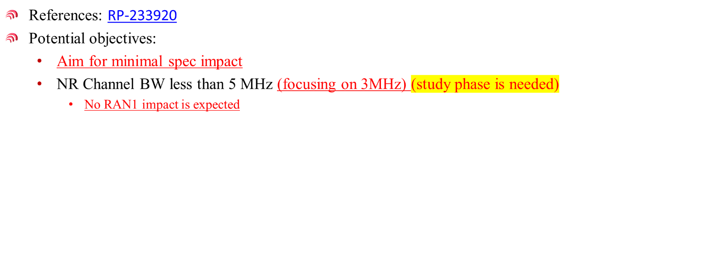

# Summary of contributions

In the operators paper RP-240108, operators have listed the request of 3MHz NR CA/DC for Release 19.

* CA/DC of 3MHz in band n100 with 5MHz and 10MHz in band n101 (3MHz n100: 12RB and 15RB cases).
* CA/DC of 5MHz in band n100 with 5MHz and 10MHz in band n101 (5MHz n100: 20 and 24RB cases).
* Inter-band CA: CA\_n106A-n48A (n106, n48) and CA\_n106A-n26A (n106, n26).
* Inter-band EN-DC within FR1: NE-DC\_n106\_26A (n106, 26).
* 3MHz in band n26 with n48 and n106.
* 3MHz in band n85 with existing T-Mobile commercial bands such as n25, n41, n66 and n71
* 3MHz in band n28 with existing Rakuten commercial bands such as n3

In paper RP-240262, detailed objectives are proposed:

|  |
| --- |
| * Introduce support for CA and DC with 3MHz CBW and another NR CBW   + Example band combination could be CA\_n100-n101 * Define RRM requirements, for inter-band CA   As a subsequent step, consider introducing HPUE (PC1) support for UL CA configurations with 3MHz CBW and another NR CBW |

Paper RP-240547 suggest to focus on inter-band CA scenarios and limit the scope only to RRM requirements. Also, paper suggest the work shall be completed by RAN #106, i.e., Dec 2024.

# Moderator recommendation on detailed objectives

Based on the summary, moderator suggest to consider the following objectives as starting point in RAN #103 meeting. these are several words/bullets with square brackets. In moderator understanding, these bullets require further discussions in RAN #103 meeting to finalize the detailed objectives.

Meanwhile, moderator proposed draft WID RP-240727 with justifications and other aspects of WID. Companies are suggested to discuss the wording of justification and other aspects in the draft WID. Based on the discussion outcome from this summary, moderator will update the objectives accordingly.

Moderator’s recommendation before the meeting (To be revised during the offline sessions)

|  |
| --- |
| * Define common co-located [and non-co-located] inter-band NR CA/DC UE RF requirements with 3MHz CBW in the one band and 5MHz or 10MHz CBW in the other band   + Example band combination: CA/DC of 3MHz in band n100 and 5MHz or 10MHz in band n101 * Define RRM requirements for inter-band CA and DC * [Define single carrier PC1 support with 31dBm per band transmit power limitation (i.e., the power on n101 and n100 while in CA should not exceed 31dBm in each carrier) for UL CA configuration with 3MHz in band n100 and 5MHz or 10MHz in band n101 for non-handheld UE]   Noted: other band combinations than example band combinations can be specified in basket WIs after the above generic requirements are specified. |