3GPP TSG RAN #103 RP-240716

Maastricht, Netherlands, March 18 – 21, 2024

Title: Moderator's summary for discussion on NR channel BW less than 5MHz for TN
Source: Moderator (vivo)

Introduction
This document summarizes the discussion related to R19 WI on NR channel BW less than 5MHz for TN in RAN #103 meeting. Submitted contributions in RAN #103 are listed as below:

RP-240262 | Other RAN4-led topics for Rel-19 | Nokia
RP-240547 | Views on Rel-19 RAN4 cross-area and other topics | Intel Corporation
RP-240108 | 3 MHz NR CA/DC request for Release 19 | Anterix, UIC, T-Mobile, Southern Linc, Rakuten

The baseline objectives in RAN chair guideline is as below
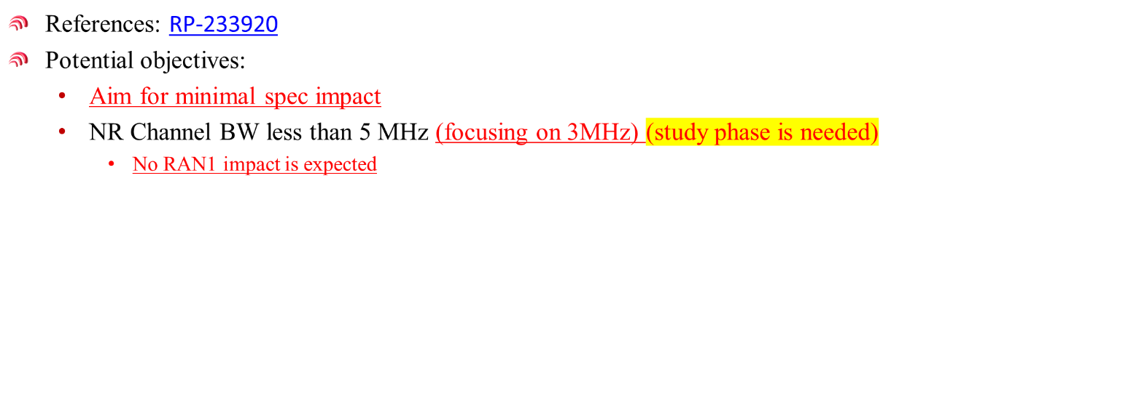

Summary of contributions
In the operators paper RP-240108, operators have listed the request of 3MHz NR CA/DC for Release 19.
- CA/DC of 3MHz in band n100 with 5MHz and 10MHz in band n101 (3MHz n100: 12RB and 15RB cases).
- CA/DC of 5MHz in band n100 with 5MHz and 10MHz in band n101 (5MHz n100: 20 and 24RB cases).
- Inter-band CA: CA_n106A-n48A (n106, n48) and CA_n106A-n26A (n106, n26).
- Inter-band EN-DC within FR1: NE-DC_n106_26A (n106, 26).
- 3MHz in band n26 with n48 and n106.
- 3MHz in band n85 with existing T-Mobile commercial bands such as n25, n41, n66 and n71
- 3MHz in band n28 with existing Rakuten commercial bands such as n3
In paper RP-240262, detailed objectives are proposed:
- Introduce support for CA and DC with 3MHz CBW and another NR CBW
  - Example band combination could be CA_n100-n101
- Define RRM requirements, for inter-band CA
As a subsequent step, consider introducing HPUE (PC1) support for UL CA configurations with 3MHz CBW and another NR CBW

Paper RP-240547 suggest to focus on inter-band CA scenarios and limit the scope only to RRM requirements. Also, paper suggest the work shall be completed by RAN #106, i.e., Dec 2024.

Moderator recommendation on detailed objectives
Based on the summary, moderator suggest to consider the following objectives as starting point in RAN #103 meeting. these are several words/bullets with square brackets. In moderator understanding, these bullets require further discussions in RAN #103 meeting to finalize the detailed objectives.
Meanwhile, moderator proposed draft WID RP-240727 with justifications and other aspects of WID. Companies are suggested to discuss the wording of justification and other aspects in the draft WID. Based on the discussion outcome from this summary, moderator will update the objectives accordingly.

Moderator’s recommendation before the meeting (To be revised during the offline sessions)
- Define common inter-band [co-located] RF requirements for CA and DC with 3MHz CBW and 5MHz and 10MHz NR CBW
  - Example band combination: CA/DC of 3MHz in band n100 and 5MHz and 10MHz in band n101
- Define RRM requirements, for inter-band CA
- [Define PC1 supports for UL configuration assigned for both bands with 3MHz in band n100 and [5MHz and 10MHz in band n101] for non-handheld UE]

Noted: other band combinations than example band combinations can be specified in basket WIs after the above generic requirements are specified.

