3GPP TSG RAN #103 RP-240715

Maastricht, Netherlands, March 18 – 21, 2024

Title: Moderator's summary for discussion on Demodulation performance requirements enhancements
Source: Moderator (vivo)

Introduction
This document summarizes the proposals on Release 19 WID on demodulation performance requirements enhancements under agenda 9.1.4.5 in RAN #103 meeting.
Submitted contributions in RAN #103 for agenda 9.1.4.5 are listed as below:

RP-240069 | Proposals on Demodulation topics for Rel-19 | NTT DOCOMO, INC.
RP-240254 | Way Forward on Spatial Channel Modelling in Rel-19 | BT, Nokia, AT&T, Bell Mobility, Bouygues Telecom, Deutsche Telekom, Ericsson, Intel, Keysight, KT Corp., Orange, Rohde & Schwarz, SK Telecom, Telecom Italia, Telenor, Telia Company, Telstra, T-Mobile USA, Verizon, Vodafone
RP-240261 | Demodulation topics for Rel-19 | Nokia
RP-240334 | Views on Demo topics for Rel-19 | Qualcomm Incorporated
RP-240352 | Views on RAN4 Rel-19 demodulation requirement enhancement | China Telecom
RP-240379 | Views on the scope of R19 demodulation topics | Samsung
RP-240433 | Views on Demodulation topics for Rel-19 | Huawei, HiSilicon
RP-240455 | MediaTek Views on RAN4 Rel-19: Demod | MediaTek Inc.
RP-240473 | Views on Rel-19 Demod enhancement | ZTE, Sanechips
RP-240484 | Views on RAN4 Demodulation package | Ericsson
RP-240493 | Apple’s view on RAN4 led Demod enhancement for Rel-19 | Apple
RP-240546 | Views on Rel-19 RAN4 Demodulation topics | Intel Corporation

In RP-240019, baseline objectives for demodulation performance requirements is provided as below:
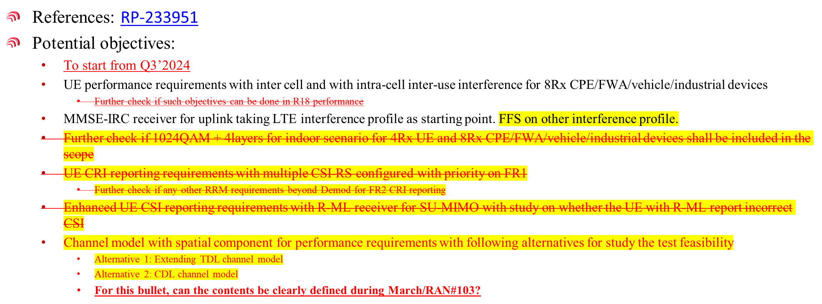

Summary of contributions on Demodulation topics
In the below table, companies view on candidate objectives are summarized.
Also, these are several papers indicate the additional topics/objectives, i.e., objectives #4, #5 and #6. Based on the baseline objectives provided by RAN and RAN4 chair, moderator suggest not to consider these objectives in this summary.

 | Candidate objectives for Rel-19 and supporting companies | Details of objectives
1 | UE performance requirements for 8Rx  Supporting companies:  CTC, Qualcomm, Huawei, MTK (with reasonable SINR), Ericsson, Apple, ZTE  Not support:  Intel (Low priority), Nokia (Introduce improved channel modelling before introducing further 8Rx requirements) | Proposed objectives:  - Define the following UE performance requirements for 8Rx CPE/FWA/vehicle/industrial devices:  - PDSCH demodulation and CQI reporting requirements with inter-cell interference with MMSE-IRC receiver  - [Interference profile: Reuse the Rel-17 interference profiles for 2/4Rx UE as starting point] - Huawei, Ericsson, Apple  - PDSCH demodulation requirements with intra-cell inter-user interference with MMSE-IRC receiver  - [FFS: PDSCH requirements with link adaption  - Consider 4 MIMO layers as starting point] - Huawei  - [The above performance requirements are release independent from Rel-18] - Huawei, [CTC]  - [FFS: This objective is expected to be completed by RAN#107.] - Ericsson
2 | BS demodulation requirements with MMSE-IRC advanced receiver  Supporting companies:  CTC, DCM, Samsung, ZTE, Ericsson, Apple, Intel  Not support:  Huawei | Proposed objectives:  - Define BS performance requirements with inter-cell interference based on the following parameters:  - Receiver type: MMSE-IRC receiver  - [With DMRS based interference covariance estimation] - Samsung  - Focus on FR1 - DCM, Intel  - [PUSCH as high priority] - Samsung, DCM  - [Homogeneous deployment as high priority] - DCM  - [Focus on slot-based transmission and aligned SCS among cells] - Samsung  - Reuse LTE interference profile in TR 36.884 as a starting point. Other interference profiles are not precluded.
3 | Channel model with spatial component  Supporting companies:  BT, AT&T, Bell Mobility, Bouygues Telecom, Deutsche Telekom, Ericsson, Intel, Keysight, KT Corp., Orange, Rohde & Schwarz, SK Telecom, Telecom Italia, Telenor, Telia Company, Telstra, T-Mobile USA, Verizon, Vodafone, Nokia  Not support:  - CTC: Not for Rel-19, can be considered in Rel-20.  - Qualcomm, Huawei: Feasibility study should be prioritized.  - Samsung, MTK, Apple: If needed study TDL extension for Rel-19 performance part instead of CDL modelling.  - ZTE: Should be led by RAN1 in the channel model SID. | Proposed objectives:  - Option 1: Study Item to identify and define practical spatial channel modelling methodology for RAN4 demodulation and CSI reporting requirements  - Use the tuned repeatable spatial channel model of TR38.827 as the basis and identify any necessary changes.  - Methodology shall be applicable to SU-MIMO as well as being extended to be applicable to MU-MIMO.  - Verify test methodology feasibility including test complexity and achievable results uncertainty. The test complexity shall not be significantly increased.  - The methodology shall include both FR1 and FR2  Proposed objectives (If this objective will be included in Rel-19):  - Option 2: Study TDL extension for Rel-19 performance part instead of CDL modelling (Apple, Samsung, MTK)  - Option 3: Combine with objective #1, i.e., Define PDSCH demodulation requirements for channel model with spatial component, under intra-cell inter-user interference for 8Rx CPE/FWA/vehicle/industrial devices (CTC)
4 | CRI Reporting Requirements  Supporting companies:  Apple, Intel (Medium priority) | Proposed objectives:  - Study the framework and methodology for CRI reporting requirements  - Re-use the LTE CRI reporting framework as a starting point  - Define CRI reporting requirements with multiple CSI-RS configured  Moderator note：this objective will NOT discussed in summary
5 | 1024QAM + 4layers  Not support:  Apple, Intel (low priority) | Moderator note：this objective will NOT discussed in summary
6 | CQI report for R-ML SU-MIMO receiver  Not support:  Apple, Intel (low priority) | Moderator note：this objective will NOT discussed in summary

Moderator recommendation on detailed objectives
In RAN #103 meeting, moderator suggest to focus on the recommended detailed objectives during the offline session. Meanwhile, moderator proposed draft WID RP-240726 with justifications and other aspects of WID. Companies are suggested to discuss the wording of justification and other aspects in the draft WID. Based on the discussion outcome from this summary, moderator will update the objectives accordingly.
For UE performance for 8Rx and BS performance with inter-cell interference, these are several bullets and sub-bullets with square brackets. In moderator understanding, these bullets require further discussions in RAN #103 meeting to finalize the detailed objectives.
On spatial channel modelling, it is moderator observation that different companies showed different view on whether to study the TDL channel extension or spatial channel model using the tuned repeatable spatial channel model of TR38.827 as the basis. Moderator lists these two options in the recommended objectives which are supposed to converge during the discussions. Related performance requirements based on the outcome of channel model discussion can be discussed later.

Moderator’s recommendation before the meeting (To be revised during the offline sessions)
- Define the following UE performance requirements for 8Rx CPE/FWA/vehicle/industrial devices:
  - PDSCH demodulation and CQI reporting requirements with inter-cell interference with MMSE-IRC receiver
    - Reuse the Rel-17 interference model for 2/4Rx UE
  - PDSCH demodulation requirements with intra-cell inter-user interference with MMSE-IRC receiver
    - Reuse the existing interference model for 2/4Rx UE

- Define FR1 PUSCH performance requirements with inter-cell interference [in homogeneous and heterogeneous deployment] based on the following assumptions:
  - Receiver type: MMSE-IRC receiver

  - [Focus on slot-based transmission and aligned SCS among cells]
  - [Reuse LTE INR based interference profile in TR 36.884 as starting point. Other interference profiles are not precluded.]
  - Scenarios:
    - FDD synchronous deployments
    - TDD synchronous deployments with aligned UL:DL configurations among cells
    - Slot-based transmission and aligned SCS among cells
  - Reuse LTE INR based interference profile in TR 36.884 as a starting point. Other interference profiles are not precluded.

Moderator Note: Further check in Dec.24 on additional interference scenarios (e.g. MMSE-IRC to address the co-channel CLI)

