3GPP TSG RAN #103 RP-240714

Maastricht, Netherlands, March 18 – 21, 2024

Title: Moderator's summary for discussion on RRM enhancements
Source: Moderator (vivo)

Introduction
This document summarizes the proposals on Release 19 WID on RRM performance requirements enhancements under agenda 9.1.4.4 in RAN #103 meeting.
Submitted contributions in RAN #103 for agenda 9.1.4.4 are listed as below:

Tdoc | Title | Source
RP-240058 | Motivation on Scell with uplink only transmission | KDDI Corporation, ZTE, Sanechips
RP-240059 | New WID: Scell with uplink only transmission | KDDI Corporation, ZTE, Sanechips
RP-240068 | Proposals on RRM topics for Rel-19 | NTT DOCOMO, INC.
RP-240110 | Views on R19 candidate RRM topics | Spreadtrum Communications
RP-240132 | Views on Rel-19 RAN4 RRM scope | vivo
RP-240153 | CMCC views on Rel-19 RAN4 RRM topics | CMCC
RP-240260 | RRM topics for Rel-19 | Nokia
RP-240313 | R19 UE RRM enhancement | OPPO
RP-240328 | Proposals on Rel-19 RAN4-led RRM | LG Electronics Deutschland
RP-240333 | Views on RRM topics for Rel-19 | Qualcomm Incorporated
RP-240350 | Views on candidate RRM topics for RAN4 Rel-19 | China Telecom
RP-240378 | Views on the scope of R19 RRM topics | Samsung
RP-240396 | Views on Rel-19 RRM topics | CATT
RP-240432 | Views on RRM topics for Rel-19 | Huawei, HiSilicon
RP-240454 | MediaTek Views on RAN4 Rel-19: RRM | MediaTek Inc.
RP-240472 | Views on Rel-19 RRM enhancement | ZTE, Sanechips
RP-240491 | Apple’s view on RAN4 led RRM enhancement for Rel-19 | Apple
RP-240505 | Views on Rel-19 RAN4 RRM package | Ericsson Inc.
RP-240545 | Views on Rel-19 RAN4 RRM topics | Intel Corporation

To be noted, two papers submitted un 9.1.4.4 are moved to NTN thread for further discussion
RP-240079 | Motivation to support mobile VSAT in NGSO deployment scenarios | Eutelsat Group, Fraunhofer IIS, Fraunhofer HHI, Airbus, ESA, Novamint, MediaTek, Sharp, Thales, SyncTechno Inc., Continental Automotive, TTP, Lockheed Martin, Robert Bosch GmbH
RP-240080 | Regulatory status of NTN in bands above 10 GHz post WRC-23 | Eutelsat Group

In RP-240019, baseline objectives for RRM requirements is provided as below:
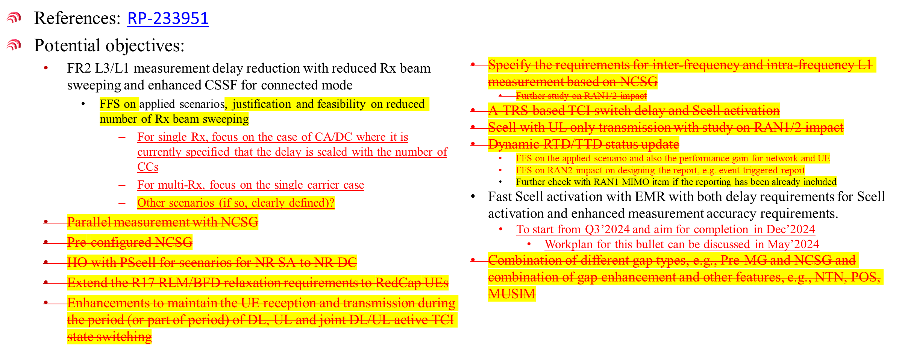

Summary of contributions on Demodulation topics
In the below table, companies view on candidate objectives are summarized.
Also, these are several papers indicate the additional topics/objectives, i.e., objectives #4, #5 and #6. Based on the baseline objectives provided by RAN and RAN4 chair, moderator suggest not to consider these objectives in this summary.

 | Candidate objectives for Rel-19 and supporting companies | Details of objectives
1 | FR2 L3/L1 measurement delay reduction | Proposed objectives:  - FR2-1 SSB based L3 and L1 measurement delay reduction for connected mode  - For UE in multiple-Rx simultaneous reception mode on single carrier [and CA]:  Supporting: LG  - Study and, if feasible, enhance to reduce FR2-1 L3/[L1] measurement delay by optimizing following factor:  - Rx beam sweeping factor  - [Reducing RX beam sweeping factor based on AI/ML based beam prediction]  Supporting: CMCC  - [Taking Rel-18 FR2 SCell activation delay reduction as baseline]  Supporting: CMCC, LG  - [Study suitable scenarios and conditions to decrease the measurement delay in FR2 with reduced beam scaling factor]  Supporting: Samsung  - For UE not in multiple-Rx simultaneous reception mode:  - Study and, if feasible, enhance to reduce FR2-1 L3/L1 measurement delay by optimizing following factor(s):  - CSSF  - [FFS on assumption on number of searchers, e.g., 3 and relative scenarios, e.g., in FR1+FR2，UE supporting Per-FR gap]  Supporting: Huawei, OPPO  - [FFS on applied enhanced CSSF in FR1]  Supporting: China Telecom  - Note 1: the above enhancement by reducing CSSF focuses on CA/DC scenario  - Note 2: Whether and how CSSF enhancement can be applied to UE in multiple-Rx simultaneous reception mode in CA/DC scenario can be discussed after concluding the above enhancement.  - [Note: The scope of above FR2-1 L3 measurement reduction focuses on the RRM measurement delay.]  Other L3 operation can be considered: MTK  - [Note: The scope of above FR2-1 L1 measurement reduction includes the following L1 operations:  - L1-RSRP/L1-SINR measurement  - BFD evaluations  - CBD evaluations  - RLM evaluations]  Supporting: Apple
2 | Fast Scell activation with EMR | Proposed objectives:  - Fast SCell/[PScell] activation with EMR supporting: OPPO  - Study and, if feasible, enhance to reduce the SCell activation delay with valid EMR reporting upon UE entering RRC_Connected mode  - [FFS UE continue performing idle/inactive measurement after entering connected mode]  Supporting: Nokia, OPPO  Not supporting: CMCC, CATT, vivo  - [FFS enhanced measurement accuracy requirements]  Supporting: Nokia  Not supporting: CMCC, CATT, vivo  - [FFS apply in FR1]  Supporting: LG,  - Note: RAN4 to start this work from Q3’2024 and aim for completion in Dec’2024. Workplan for this bullet can be discussed in May’2024
3 | Other objectives | Extend the R17 RLM/BFD relaxation requirements to RedCap UEs  Supporting: Spreadtrum, QC, MTK, Ericsson  Scell with uplink only transmission  Supporting: KDDI, ZTE, Intel  HO with PScell  Supporting: QC, MTK  FR2 unknown SCell activation based on Temporary RS  Supporting: Huawei  Interruptions enhancement at NR SRS antenna port switching  Supporting: Huawei  L1/L2 mobility inter-frequency measurement enhancement  Supporting: Huawei  Inter-frequency measurement based on NCSG  Supporting: MTK  Dynamic RTD/TTD status update (operation with RTD > CP)  Supporting: Intel  Parallel measurement with NCSG  Supporting: Intel  Pre-configured NCSG  Supporting: Intel  Moderator Note: Based on RAN/RAN4 chair guideline, these objectives are not to be discussed

Moderator recommendation on detailed objectives
In RAN #103 meeting, moderator suggest to focus on the recommended detailed objectives during the offline session. Meanwhile, moderator proposed draft WID RP-240725 with justifications and other aspects of WID. Companies are suggested to discuss the wording of justification and other aspects in the draft WID. Based on the discussion outcome from this summary, moderator will update the objectives accordingly.
For recommended objectives, these are several bullets and sub-bullets with square brackets which are proposed by companies. In moderator understanding, these bullets require further discussions in RAN #103 meeting to finalize the detailed objectives.

Moderator’s recommendation before the meeting (To be revised during the offline sessions)
- FR2-1 SSB based L3 [and L1] measurement delay reduction for connected mode
  - For UE[supporting multiple-Rx simultaneous reception] on single carrier:
    - Study [suitable scenarios and conditions] and, if feasible, introduce methods reduce FR2-1 L3 measurement delay by optimizing following factor:
      - Rx beam sweeping factor

  - For UE not in multiple-Rx simultaneous reception mode:
    - Study [suitable scenarios and conditions] and, if feasible, enhance to reduce FR2-1 L3/[L1][] measurement delay by optimizing following factor(s):
      - CSSF [outside gap]
      - [Beam sweeping factor]
      - [FFS on assumption on number of searchers, e.g., 3 and relative scenarios, e.g., in FR1+FR2，UE supporting Per-FR gap]
      - [FFS on applied enhanced CSSF in FR1]
    - [Note 1: the above enhancement by reducing CSSF focuses on CA/DC scenario]
    - Note 2: Whether and how CSSF enhancement can be applied to UE in multiple-Rx simultaneous reception mode in CA/DC scenario can be discussed after concluding the above enhancement.
  - [Note: The scope of above FR2-1 L3 measurement reduction focuses on the RRM measurement delay.]
  - [Note: The scope of above FR2-1 L1 measurement reduction includes the following L1 operations:
    - L1-RSRP/L1-SINR measurement
    - BFD evaluations
    - CBD evaluations
    - RLM evaluations]
- Fast SCell/[PScell] activation with EMR
  - Study and, if feasible, enhance to reduce the SCell activation delay with valid EMR reporting upon UE entering RRC_Connected mode
  - [FFS UE continue performing idle/inactive measurement after entering connected mode]
  - [FFS enhanced measurement accuracy requirements]
  - [FFS apply fast scell activation in FR1]
Note: RAN4 to start this work from Q3’2024 and aim for completion in Dec’2024. Workplan for this bullet can be discussed in May’2024

