3GPP TR 33.855 V1.4.0 (2019-03)
Technical Report
3rd Generation Partnership Project;
Technical Specification Group Services and System Aspects;
Security Aspects;
Study on security aspects of the 5G Service Based Architecture (SBA)
(Release 16)



The present document has been developed within the 3rd Generation Partnership Project (3GPP TM) and may be further elaborated for the purposes of 3GPP.
The present document has not been subject to any approval process by the 3GPP Organizational Partners and shall not be implemented.
This Report is provided for future development work within 3GPP only. The Organizational Partners accept no liability for any use of this Specification.
Specifications and Reports for implementation of the 3GPP TM system should be obtained via the 3GPP Organizational Partners' Publications Offices.

Keywords
<keyword[, keyword]>

3GPP
Postal address

3GPP support office address
650 Route des Lucioles - Sophia Antipolis
Valbonne - FRANCE
Tel.: +33 4 92 94 42 00 Fax: +33 4 93 65 47 16
Internet
http://www.3gpp.org
Copyright Notification
No part may be reproduced except as authorized by written permission.
The copyright and the foregoing restriction extend to reproduction in all media.

© 2018, 3GPP Organizational Partners (ARIB, ATIS, CCSA, ETSI, TSDSI, TTA, TTC).
All rights reserved.

UMTS™ is a Trade Mark of ETSI registered for the benefit of its members
3GPP™ is a Trade Mark of ETSI registered for the benefit of its Members and of the 3GPP Organizational Partners
LTE™ is a Trade Mark of ETSI registered for the benefit of its Members and of the 3GPP Organizational Partners
GSM® and the GSM logo are registered and owned by the GSM Association
Contents
Foreword 7
Introduction 7
1 Scope 8
2 References 8
3 Definitions, symbols and abbreviations 9
3.1 Definitions 9
3.2 Abbreviations 9
4 Key Issues 9
4.1 General SBA Key Issues 9
4.1.1 Key Issue #1: Confidentiality protection of signalling messages 9
4.1.1.1 Issue description 9
4.1.1.2 Threat description 9
4.1.1.3 Potential security requirements 9
4.1.2 Key Issue #2: Integrity protection of signalling messages while allowing for modifications 10
4.1.2.1 Issue description 10
4.1.2.2 Threat description 10
4.1.2.3 Potential security requirements 10
4.1.3 Key Issue #3: Replay protection of signalling messages 10
4.1.3.1 Issue description 10
4.1.3.2 Threat description 10
4.1.3.3 Potential security requirements 11
4.1.4 Key Issue #4: NF-NF Authentication 11
4.1.4.1 Issue description 11
4.1.4.2 Threat description 11
4.1.4.3 Potential security requirements 11
4.1.5 Key Issue #5: NF-NF Authorization 11
4.1.5.1 Issue description 11
4.1.5.2 Threat description 11
4.1.5.3 Potential security requirements 11
4.1.6 Key Issue #6: NF-NRF Authentication 12
4.1.6.1 Issue description 12
4.1.6.2 Threat description 12
4.1.6.3 Potential security requirements 12
4.1.7 Key Issue #7: NF-NRF Authorization 12
4.1.7.1 Issue description 12
4.1.7.2 Threat description 12
4.1.7.3 Potential security requirements 12
4.1.8 Key Issue #8: NRF-NRF Authentication 12
4.1.8.1 Issue description 12
4.1.8.2 Threat description 12
4.1.8.3 Potential security requirements 12
4.1.9 Key Issue #9: NRF-NRF Authorization 12
4.1.9.1 Issue description 12
4.1.9.2 Threat description 12
4.1.9.3 Potential security requirements 12
4.1.10 Key Issue #20: Protection of SeCoP interfaces 12
4.1.11 Key Issue #21: Secure message transport via the SeCoP 13
4.1.12 Key Issue #22: Authorization of NF service access in Indirect Communication 13
4.1.13 Key Issue #23: NF to NF authenticaton and authorization in Indirect communication 14
4.1.14 Key Issue #24: Service access authorization within a NF Set or a NF Service Set 14
4.1.15 Key Issue #25: Indirect communication in roaming scenarios 14
4.1.16 Key Issue #26: Protection of N9 interface 14
4.1.17 Key Issue #27: Support of a UP gateway function on the N9 interface 14
4.2 SEPP-/N32-specific Key Issues 14
4.2.1 Key Issue #10: Termination points of N32 security 14
4.2.1.1 Issue description 14
4.2.1.2 Threat description 14
4.2.1.3 Potential security requirements 14
4.2.2 Key Issue #11: Local provisioning of SEPP protection policies 15
4.2.2.1 Issue description 15
4.2.2.2 Threat description 15
4.2.2.3 Potential security requirements 15
4.2.3 Key Issue #12: Provisioning of SEPP protection policies over N32 15
4.2.3.1 Issue description 15
4.2.3.2 Threat description 15
4.2.3.3 Potential security requirements 15
4.2.4 Key Issue #13: SEPP session setup 16
4.2.4.1 Issue description 16
4.2.4.2 Threat description 16
4.2.4.3 Potential security requirements 16
4.2.5 Key Issue #14: Application of ciphering and integrity protection to JSON object using JOSE 16
4.2.5.1 Issue description 16
4.2.5.2 Threat description 16
4.2.5.3 Potential security requirements 17
4.2.6 Key Issue #15: Malicious messages received on the N32 interface 17
4.2.6.1 Issue description 17
4.2.6.2 Threat description 19
4.2.6.3 Potential security requirements 19
4.2.7 Key Issue #16: N32 error signalling 19
4.2.7.1 Issue description 19
4.2.7.2 Threat description 19
4.2.7.3 Potential security requirements 19
4.2.8 Key Issue #17: Modifications by authorized intermediaries on N32 19
4.2.8.1 Issue description 19
4.2.8.2 Threat description 20
4.2.8.3 Potential security requirements 20
4.2.9 Key Issue #18: Inter-PLMN routing and TLS 20
4.2.9.1 Key issue detail 20
4.2.9.2 Security threats 21
4.2.9.3 Potential security requirements 21
4.2.10 Key Issue #19: Configurational error handling by the SEPP 21
4.2.10.1 Issue description 21
4.2.10.2 Threat description 21
4.2.10.3 Potential security requirements 21
5. General Requirements 21
6 Solutions 21
6.1 Solution #1: Authorization of NF service access 21
6.1.1 Introduction 21
6.1.2 Solution details 22
6.1.2.1 Service authorization procedure for non-roaming scenarios 22
6.1.2.2 Authorization of NF service access for roaming scenario 23
6.1.3 Evaluation 23
6.2 Solution #2: Application layer protection based on JSON Object Signing and Encryption (JOSE) 23
6.2.1 General 23
6.2.2 Application layer protection based on JOSE 24
6.2.2.1 JSON based IEs that require protection (WHAT) 24
6.2.2.2 Integrity and Confidentiality protection schemes (HOW) 24
6.2.2.2.1 Integrity protection based on JSON patch 24
6.2.2.2.2 Authorization of modifications based on JSON patch 27
6.2.2.2.3 Authentication of intermediaries 28
6.2.2.2.4 Rewriting of HTTP message into JSON-object 28
6.2.2.3 Key management aspects 28
6.2.3 Evaluation 28
6.3 Solution #3: NF service registration process 29
6.3.1 Introduction 29
6.3.2 Solution Details 29
6.3.3 Evaluation 29
6.4 Solution #4: Authorization of NF service access 29
6.4.1 Introduction 29
6.4.2 Solution details 30
6.4.2.1 Authorization of NF service access in the same PLMN 30
6.4.2.2 Authorization of NF service access in different PLMNs 32
6.4.1 Evaluation 33
6.5 Solution #5: Using mediation services with end-to-end encryption 33
6.5.1 Generic 33
6.5.2 End-to-end encryption using HTTPS or TLS 33
6.5.3 End-to-end security using JOSE 34
6.5.4 Migration paths after accepting this solution 36
6.5.5 Possible deployments 36
6.5.6 Evaluation 36
6.6 Solution #6: Policies for protection on the N32 interface 37
6.6.1 Introduction 37
6.6.2 Solution details 37
6.6.3 Evaluation 37
6.7 Solution #7: Signaling based provisioning of message protection policy in partner SEPPs 38
6.7.1 Introduction 38
6.7.2 Solution details 38
6.7.3 Evaluation 39
6.8 Solution #8: Inter PLMN routing and TLS: Solution Options 39
6.8.1 Introduction 39
This solution addresses Key Issue #18: Inter-PLMN routing and TLS.6.8.2 Bump in the TLS 39
6.8.3 TLS tunnel or VPN from NF to SEPP 39
6.8.4 Using local SEPP FQDN in request URI 39
6.8.5 Mapped FQDN in request URI 40
6.8.6 Evaluation 41
6.9 Solution #9: N32 message anti-spoofing within the SEPP 41
6.9.1 Introduction 41
6.9.2 Solution Details 41
6.9.3 Evaluation 42
6.10 Solution #10: Mitigation against fraudulent registration attack between SEPPs 42
6.10.1 Introduction 42
6.10.2 Solution Details 42
6.10.3 Evaluation 42
6.11 Solution #11: Security policy provisioning for SEPP 42
6.11.1 Introduction 42
6.11.2 Solution Details 43
6.11.3 Evaluation 43
6.12 Solution #12: End-to-end data protection in hop-by-hop network communication links 43
6.12.1 Introduction 43
6.12.2 Integrity protection with non-repudiation and traceability of changes 44
6.12.3 Integrity protection with non-repudiation, traceability of changes, and authorization 44
6.12.4 Confidentiality protection with authorization 45
6.13 Solution #13: Content and structure of protection policies 45
6.13.1 Introduction 45
6.13.2 Data-type encryption policy 46
6.13.3 NF API data-type placement mapping 46
6.13.4 Modification policy 46
6.13.5 Evaluation 47
6.14 Solution #14: Provisioning and negotiation of protection policies 47
6.14.1 Introduction 47
6.14.2 Provisioning of the policies in the SEPP 47
6.14.3 Negotiation of protection policies 47
6.14.4 Evaluation 47
6.x Solution #x: <Title of solution> 47
6.x.1 Introduction 48
6.x.2 Solution Description 48
6.x.3 Solution Evaluation 48
7 Conclusions 48
8 Recommendations 48
8.1 Recommendations for Release 15 normative work 48
8.2 Recommendations for Release 16 normative work 48
Annex A: Working Agreements 49
SBA Offline Session – 21st May 2018 49
SBA Offline Session – 22nd May 2018 49
Annex B: Options for integrity protection on the N32 interface 51
Annex X: Change history 52

Foreword
This Technical Report has been produced by the 3rd Generation Partnership Project (3GPP).
The contents of the present document are subject to continuing work within the TSG and may change following formal TSG approval. Should the TSG modify the contents of the present document, it will be re-released by the TSG with an identifying change of release date and an increase in version number as follows:
Version x.y.z
where:
x the first digit:
1 presented to TSG for information;
2 presented to TSG for approval;
3 or greater indicates TSG approved document under change control.
y the second digit is incremented for all changes of substance, i.e. technical enhancements, corrections, updates, etc.
z the third digit is incremented when editorial only changes have been incorporated in the document.

Introduction
3GPP TS 23.501 [2] defines 5G services with a new service based architecture (SBA) approach. The present document reviews the interactions in this new architecture, determines key issues and

1 Scope
3GPP TS 23.501 [2] defines 5G services with a new service based architecture (SBA) approach.
The present document reviews the interactions in this new architecture, determines key issues relating to the security of SBA elements and interfaces, details potential solutions and recommends normative work for releases 15 and 16.

2 References
The following documents contain provisions which, through reference in this text, constitute provisions of the present document.
- References are either specific (identified by date of publication, edition number, version number, etc.) or non-specific.
- For a specific reference, subsequent revisions do not apply.
- For a non-specific reference, the latest version applies. In the case of a reference to a 3GPP document (including a GSM document), a non-specific reference implicitly refers to the latest version of that document in the same Release as the present document.
[1] 3GPP TR 21.905: "Vocabulary for 3GPP Specifications".
[2] 3GPP TS 23.501: "System Architecture for the 5G System".
[3] 3GPP TS 23.502: "Procedures for the 5G System".
[4] JSON Object Signing and Encryption (https://datatracker.ietf.org/wg/jose/charter).
[5] IETF RFC 7515: "JSON Web Signature" (https://tools.ietf.org/html/rfc7515).
[6] IETF RFC 7516: "JSON Web Encryption" (https://tools.ietf.org/html/rfc7516).
[7] IETF RFC 7518: "JSON Web Algorithms" (https://tools.ietf.org/html/rfc7518).
[8] V. Goyal, O. Pandey, Amit Sahai, and B. Waters, "Attribute-based encryption for fine-grained access control of encrypted data," in Proc. CCS '06, New York, 2006, pp. 89-98.
[9] J. Bethencourt, A. Sahai, and B. Waters, "Ciphertext-Policy Attribute-Based Encryption" in Proc. SP '07, 2007, pp. 321-334.
[10] C. Chen, J. Chen, H.-W. Lim, Z. Zhang, D. Feng, "Combined Public-Key Schemes: The Case of ABE and ABS" in Proc. Provable Security '12, Lecture Notes in Computer Science, vol. 7496, 2012, pp. 53-69.
[11] 3GPP TS 33.501: "Security architecture and procedures for 5G System".
[12] S3-181481 Prevent fraudulent Registration Request attack
[13] S3-181480 N32 message anti-spoofing within the SEPP
[14] GSMA, “IPX Network End-to End Security Guidelines”, V1.0, Nov 2017
[15] IETF RFC 8446: "The Transport Layer Security (TLS) Protocol Version 1.3"
[16] IETF RFC 1123 Requirements for Internet Hosts -- Application and Support
[17] 3GPP TR 23.742 Study on Enhancements to the Service-Based Architecture

3 Definitions, symbols and abbreviations

3.1 Definitions
For the purposes of the present document, the terms and definitions given in 3GPP TR 21.905 [1] and the following apply. A term defined in the present document takes precedence over the definition of the same term, if any, in 3GPP TR 21.905 [1].

3.2 Abbreviations
For the purposes of the present document, the abbreviations given in 3GPP TR 21.905 [1] and the following apply. An abbreviation defined in the present document takes precedence over the definition of the same abbreviation, if any, in 3GPP TR 21.905 [1].
SeCoP Service Communication Proxy

4 Key Issues

4.1 General SBA Key Issues

4.1.1 Key Issue #1: Confidentiality protection of signalling messages

4.1.1.1 Issue description
Confidentiality protection of (some information elements in) signalling messages transferred between NFs ensures that third parties are unable to extract any relevant information from the communication. Failing to provide such protection for signalling traffic between any two NFs by means of ciphering can be considered a key issue for both security and user privacy.
In inter-PLMN communication, IPX providers offer valuable services to operators that may require them to access certain information contained in the transferred signalling messages. Thus, protecting the confidentiality of every single information element might not be desirable.
In particular, leaking the IMSI, cryptographic material and location data may constitute a breach of user’s privacy and may lead to fraud towards the operator.

4.1.1.2 Threat description
A lack of confidentiality protection for 5GC signalling messages may lead to the following security threats:
- Leakage of sensitive information about mobile customers, such as SUPI and/or location data
- Leakage of potentially sensitive information about the PLMN itself
- Theft of service, if authentication information/authorization credentials are transferred unciphered

4.1.1.3 Potential security requirements
Relevant IEs in 5GC signalling messages exchanged via intra-PLMN communication shall be confidentiality protected.
As for inter-PLMN communication, certain sensitive information elements shall always be confidentiality protected:
- Authentication Vectors
- Cryptographic Material
- Location Data
As per agreement between operators, certain sensitive information elements shall be confidentiality protected:
- Identifiers such as IMSI, SUPI, NAI, PEI and/or IMEI;
Additionally, it is recommended to cipher the remaining information elements as well, unless agreed otherwise with the roaming partner or IPX provider.

4.1.2 Key Issue #2: Integrity protection of signalling messages while allowing for modifications

4.1.2.1 Issue description
Integrity protection ensures that signalling messages transferred between NFs cannot be modified without the receiving party noticing that such modification occurred. In combination with authenticity, integrity is an essential guarantee for the correctness and validity of messages.
In inter-PLMN communication, however, IPX providers offer valuable services to opeartors that may require them to modify certain information contained in the transferred signalling messages. Thus, it might be desireable to allow for certain modifications by authorized intermediates on N32 even if the messages are integrity protected.

4.1.2.2 Threat description
The lack of integrity protection for 5GC signalling messages may lead to the following security threats:
- Man in the Middle attacks that actively modify signalling messages between NFs
- Lack of availability caused by malformed messages due to unnoticed modifications during transfer
- Theft and fraud towards an operator

4.1.2.3 Potential security requirements
5GC signalling messages in both intra- and inter-PLMN communication shall be integrity protected.
In intra-PLMN communications, intermediaries shall be able to apply modifications without breaking the integrity protection.
A receiving PLMN shall be able to identify the intermediary that applied modifications and verify that this was authorized.

4.1.3 Key Issue #3: Replay protection of signalling messages

4.1.3.1 Issue description
Replay protection of signalling messages transferred between NFs ensures that it is not possible to successfully gain service from an NF by recording genuine messages and re-sending them at a later point in time.

4.1.3.2 Threat description
The lack of replay protection for 5GC signalling messages may lead to the following security threats:
- Theft of service
- Leakage of potentially sensitive information about mobile customers and the network itself
- Loss of control, in case authorization credentials are replayed

4.1.3.3 Potential security requirements
5GC signalling messages in both intra- and inter-PLMN communication shall be replay protected.

4.1.4 Key Issue #4: NF-NF Authentication

4.1.4.1 Issue description
Authentication ensures that an attribute claimed by a given entity is actually correct. In the context of communication and NF-NF signalling in particular, authenticating the communication peer’s identity is a key objective in order to guarantee the validity of transferred messages. Authentication is also a prerequisite for conducting authorization which itself is another key issue for 5GC signalling. already mentioned in TS 23.501 [2].

4.1.4.2 Threat description
Not mutually authenticating two NFs that is not mutually authenticated could potentially allow attackers to perform the following types of attacks:
- Operating malicious NFs claiming to be genuine peers in order to request certain services (theft of service) or information (data leakage)
- Man in the Middle attacks between any genuine NFs of a given PLMN

4.1.4.3 Potential security requirements
NFs shall be able to mutually authenticate each other.

4.1.5 Key Issue #5: NF-NF Authorization

4.1.5.1 Issue description
Authorization comprises the definition and enforcement of access rights or privileges to certain resources or services. TS 23.501 [2] outlines a high-level NF service authorization framework, in which the consuming and producing NF both play a key role. After the Consumer NF has been successfully authorized by the NRF, it may subsequently be subject to another authorization procedure conducted by the Producer NF, which decides whether a certain service request is allowed based on information on “request type granularity”.

4.1.5.2 Threat description
If an NF does not authorize incoming requests from other NFs in the same PLMN, attackers would potentially be able to perform the following types of attacks:
- Requesting and successfully obtaining services from the NF that are not allowed for third parties, e.g. in order to extract potentially sensitive information about the network
- Causing a Denial of Service situation by successfully forcing the NF to perform resource-demanding operations

4.1.5.3 Potential security requirements
An NF shall validate whether a requesting NF is authorized to request a given service(s).

4.1.6 Key Issue #6: NF-NRF Authentication

4.1.6.1 Issue description
Since the NRF comprises the central repository of registered NFs and available NF services in a 5GC, there are several key message exchanges between NRF and its peer NFs that require secure communication. Therefore, just as in NF-NF signalling, authentication of the message source in any communication between NF and NRF is crucial. Furthermore, authentication between NF and NRF is also a prerequisite for conducting authorization which itself is another key issue for 5GC signalling and already mentioned in TS 23.501 [2].

4.1.6.2 Threat description
Communication between NF and NRF that is not mutually authenticated could potentially allow attackers to perform the following types of attacks:
- Performing Man in the Middle attacks between any genuine NFs and NRFs of a given PLMN
- Registering a malicious NF with the genuine NRF of a given PLMN
- Operating a malicious NRF in order to trick genuine NFs not to register with the genuine NRF of a given PLMN

4.1.6.3 Potential security requirements
Communication between NF and NRF shall be mutually authenticated.

4.1.7 Key Issue #7: NF-NRF Authorization

4.1.7.1 Issue description
Authorization comprises the definition and enforcement of access rights or privileges to certain resources or services. TS 23.501 [2] outlines a high-level NF service authorization framework, in which both the consuming NF and NRF play a key role. In particular, the NRF checks whether the Consumer NF is allowed to discover Producer NF instances of the requested services: “This is performed on a per NF granularity by NRF”.

4.1.7.2 Threat description
If an NRF does not authorize incoming requests from NFs in its PLMN, attackers would potentially be able to perform the following types of attacks:
- Sending registration requests from malicious NFs which are controlled by the attacker
- Requesting services from the NRF that third parties are not allowed to consume, e.g. in order to gain information about the PLMN (potentially considered secret)
- Flooding the NRF with resource-demanding operations that may lead to a Denial of Service situation

4.1.7.3 Potential security requirements
An NRF shall validate whether a given NF is authorized to register with or request certain services – such as NF service discovery – from the NRF.

4.1.8 Key Issue #8: NRF-NRF Authentication

4.1.8.1 Issue description
For any NF service discovery that is carried out in inter-PLMN communication, the initial discovery request will be transferred from the NRF in the Consumer NF’s PLMN to the NRF in the Producer NF’s PLMN. The same applies to the response, potentially containing information about how to address the Producer NF and a token for authorization purposes. In order to ensure that NF service discovery is perfomed by valid peers, communication between two NRFs relies on mutual authentication.

4.1.8.2 Threat description
Communication between NRFs across different PLMNs that is not mutually authenticated could potentially allow attackers to perform the following types of attacks:
- Performing Man in the Middle attacks between the local NRF and an NRF of a genuine roaming partner
- Querying of address information from an NRF, thereby leaking potentially secret data about the PLMN

4.1.8.3 Potential security requirements
Communication between NRFs shall be mutually authenticated.

4.1.9 Key Issue #9: NRF-NRF Authorization

4.1.9.1 Issue description
As described in Key Issue #8, communication between two NRFs precedes every service discovery an NF may send to a foreign PLMN. Being exposed to such external requests, the NRF is a valuable target for attackers that may try to send malicious requests in order to obtain illegitimate service or information. Therefore, the NRF is a key element in the 5GC NF service authorization framework and needs to ensure its communication peers are authorized to request a certain service.

4.1.9.2 Threat description
If an NRF does not authorize incoming requests from NRFs in other PLMN, attackers would potentially be able to perform the following types of attacks:
- Sending discovery requests from malicious NRF which are controlled by the attacker
- Requesting services from the NRF that third parties are not allowed to consume, e.g. in order to gain information about the PLMN (potentially considered secret)

4.1.9.3 Potential security requirements
An NRF shall validate whether a requesting NRF is authorized to request the given service(s).

4.1.10 Key Issue #20: Protection of SeCoP interfaces

4.1.10.1 Issue description
If a PLMN operator utilizes an SeCoP to enable indirect communication, connections between the SeCoP and other 5GC Network Functions must offer the same level of security as direct NF-NF or NF-NRF communication. Therefore, the interfaces between SeCoP and all communicating parties connected to it have to be mutually authenticated. With the exception of special cases, such as NRF or SEPP, which allow for service requests without prior authorization, the SeCoP may also verify whether a connected NF is allowed to make use of certain SeCoP services before accepting any such requests.
The purpose of this key issue is to study the following security aspects of the SeCoP:
- Authentication and authorization of the connecting NFs by the SeCoP
- SeCoP interfaces with the NRF to perform service registration/de-registration and service discovery on behalf of another NF
- Confidentiality protection, integrity protection and replay protection SeCoP at the SeCoP interface towards the Network Functions connected to it

4.1.10.2 Threat description

Unauthenticated access to the SeCoP may lead to the following threats:
- Spoofing attacks
- Theft of service
- Man in the middle attacks between SeCoP and N(R)F
A lack of confidentiality protection may lead to leakage of sensitive information.
A lack of integrity protection may lead to unnoticed modification of information in transit.
A lack of replay protection may lead to several negative impacts as a result of replay attacks, such as theft of service, leakage of sensitive information, or loss of control.

4.1.10.3 Potential security requirements
Communication between the SeCoP and its communication peers shall support confidentiality protection, integrity protection and replay protection.
The SeCoP shall perform mutual authentication with each communication peer before granting access to its services.
The SeCoP may further perform authorization of a requesting NF before granting access to certain services.

4.1.11 Key Issue #21: Secure message transport via the SeCoP

4.1.11.1 Issue description
As of 3GPP Rel-16, 5GC not only supports direct communication between N(R)Fs within a single PLMN, but also indirect communication via a Service Communication Proxy (SeCoP). According to TR 23.742 [17], this SeCoP: "should support [to] protect the integrity and confidentiality of the communication."
In order to offer a similar level of protection as in the case of direct communication that is secured by TLS, the SeCoP is required to support replay protection as well. As an entity sitting between two NFs, the SeCoP must protect integrity protection, confidentiality protection and replay protection of communication between NFs.

4.1.11.2 Threat description
A lack of confidentiality protection by the SeCoP may lead to leakage of sensitive information.
A lack of integrity protection by the SeCoP may lead to unnoticed modification of information in transit.
A lack of replay protection by the SeCoP may lead to several negative impacts as a result of replay attacks, such as theft of service, leakage of sensitive information, or loss of control.

4.1.11.3 Potential security requirements
The 5G system shall support confidentiality and integrity protection as well as replay protection of transferred messages for indirect communication.

4.1.12 Key Issue #22: Authorization of NF service access in Indirect Communication

4.1.12.1 Issue description
In Rel-15, verification of claims in the OAuth 2.0 access token is performed solely at the NF service producer. The token is assumed to be a self-contained JWT token, and the NF service producer, which receives the access token from the NF service consumer, is assumed to possess the necessary NRF public key to validate the token. There is no other specified method to verify the token.
In Rel-16, Service Communication Proxy (SeCoP) is introduced to enable indirect communication between two NFs.
The purpose of this key issue is to study security aspects related to authorization of NF service access in Indirect Communication between NFs.

4.1.12.2 Threat description
Not applicable

4.1.12.3 Potential security requirements

Not applicable

4.1.13 Key Issue #23: NF to NF authenticaton and authorization in Indirect communication

4.1.13.1 Issue description
SA2 has enhanced the Network Function Service Framework to support indirect communication between NF services via a Service Communication Proxy (SeCoP).
The purpose of this key issue is to study the impact of indirect communication on security aspects of service access authentication and authorization:
a) NF to NF authentication in intra-PLMN scenarios relied on authentication at the transport layer. This needs to be studied further since end to end protection at the transport layer between NFs may no longer be possible.
b) In R15 there was no separate procedure for OAuth 2.0 Client authentication. It relies on authentication at the transport layer (for e.g. with TLS), which may no longer be possible in indirect communication mode.
c) Execution of OAuth 2.0 procedures for service access authorization will need to be clarified.
d) In R15, NF service producer could handle specific token claims (such as PLMN ID) in a UE specific manner. This may no longer be possible in a scenario where verification of authorization claims in the token is delegated to SeCoP.
e) It may be that there are multiple SeCoPs within a PLMN, each coordinating many NFs. Communication between these SeCoPs needs to be secured, as well as access control to NFs needs to be managed.

4.1.13.2 Threat description
Lack of mutual authentication between two NFs could allow attackers to perform the following types of attacks:
- Malicous Network functions gaining access services (theft of service) or information (data leakage)
- Man-In-The-Middle (MITM) attacks between any genuine NFs of a given PLMN

4.1.13.3 Potential security requirements
TBD

4.1.14 Key Issue #24: Service access authorization within a NF Set or a NF Service Set

4.1.14.1 Issue description
Rel-16 is introducing the concept of NF instance Set/NF Service instance Set, which are essentially a group of interchangeable NF instances/NF Service instances of the same type, supporting the same services and the same Network Slice(s). Rel-16 also allows re-selection of a NF instance or a NF Service instance within the Set for subsequent transaction.
The purpose of this key issue is to study the impact of this concept on OAuth 2.0 based authorization of Network Function service access.

4.1.14.2 Threat description
Unauthorized access to NF instances or NF Service Instance within a set may potentially lead to attackers performing the following types of attacks:
- Obtaining services from a NF Instance or a NF Service Instance to extract potentially sensitive information about the network
- Launching Denial of Service attackes by performing resource-demanding operations on the NF instance

4.1.14.3 Potential security requirements
TBD

4.1.15 Key Issue #25: Indirect communication in roaming scenarios

4.1.15.1 Issue description

When indirect mode of communication is used between two NFs in the roaming scenario, the two NFs do not connect with their respective SEPPs directly. The NFs communicates via the SeCoP. The SeCoP will have to establish a secure connection with the SEPP.
In Rel-15, telescopic FQDN feature with wildcard certificate for SEPP is used to enable NFs to establish a TLS connection with the SEPP.
Rel-16 also allows both direct and indirect communications between NFs to co-exist within one and the same network.
The purpose of this key issue is to study the impact of Indirect communication between NFs in roaming scenarios.

4.1.15.2 Threat description
Not applicable.

4.1.15.3 Potential Architecture requirements
System shall support interoperability with Rel-15.

4.1.16 Key Issue #26: Protection of N9 interface

4.1.16.1 Issue description
In the Roaming 5G System architecture – Home Routed scenario, a GTP_U tunnel is established per PDU session between two User Plane Functions (UPF) in the VPLMN and HPLMN. The GTP_U traffic is sent over the N9 interface between the two UPFs.
Inter-PLMN user traffic on N9 contains any home-routed user traffic from the visited network to the home network. This traffic may contain sensitive information that needs to be protected from external visibility and manipulation.
According the objectives of this study, improved flexibility for protection of data exchanged on N9 needs to be studied, as different levels of protection may be required for different use cases.

4.1.16.2 Threat description
Lack of protection of Inter-PLMN user traffic on N9 may lead to attacks that cause leakage of sensitive information and unauthorized modification of information.

4.1.16.3 Potential security requirements
Confidentiality, integrity and replay protection shall be supported for Inter-PLMN GTP_U communication on the N9 interface.
Editor’s Note: Flexible protection of GTP_U communication on N9 is FFS.

4.1.17 Key Issue #27: Support of a UP gateway function on the N9 interface

4.1.17.1 Issue description
In the 5G system, the roaming interfaces of user plane (N9) and control plane (N32) traffic are separate. In the Rel-15 5G architecture, the SEPP acts as protection function on the control plane (N32) interface. However, in Rel-15 a protection function on the user plane (N9) interface is missing. Aim of this key issue is to study the introduction of a new UP gateway function on the N9 roaming interface for the protection of the user plane.
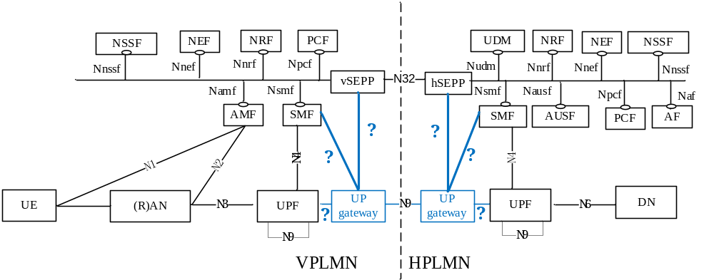
Figure 4.1.17.1-1 UP gateway function in the roaming 5G System architecture with home routed scenario. For local breakout, the key issue is not applicable as N9 is not a roaming interface.
The new function needs to be able to bind incoming user plane traffic to PDU sessions established, managed and released at the control plane. Hence the new function needs an interface to a control plane function handling PDU sessions. It seems that the SMF, the SEPP or the UPF are natural candidates for the other endpoint of this new interface. Hence another aim of this key issue is to study the introduction of a new interface with the new UP gateway function as one endpoint.
Solutions to this key issue need to address the following architecture requirements:
Editor's Note: Requirements on the N9 interface need to be captured in a separate clause.
- The 5G system shall support a UP gateway function for user plane protection on the N9 roaming interface.
Editor's Note: The introduction of a new function in the 5G system needs to be aligned with SA2.
- The 5G system shall support a new interface with the UP gateway function as one endpoint, which enables exposure of session information to the UP gateway function.
Editor's Note: The introduction of a new interface in the 5G system needs to be aligned with SA2.
- The new interface shall support the following functionalities:
- Inform the new UP gateway function with at least the TEID for established GTP-U sessions on N9 and the IP addresses and port numbers of the tunnel endpoints.
- Inform the new UP gateway function when PDU and GTP-U sessions are released via control plane.
- Inform the control plane function about events detected on N9.

4.1.17.2 Threat description
Not applicable

4.1.17.3 Potential security requirements
Not applicable

4.2 SEPP-/N32-specific Key Issues

4.2.1 Key Issue #10: Termination points of N32 security

4.2.1.1 Issue description
Protection measures are applied to information transferred via N32 between two PLMN which can potentially terminate in different endpoints of the communication, i.e.:
- In the communicating NFs themselves (i.e. end-to-end protection)
- In a SEPP of each PLMN (i.e. SEPP-to-SEPP protection)
- At each of the (maximum two) IPX providers in the path between SEPPs (i.e. hop-by-hop protection)
Each of these options offers a different level of security and requires careful consideration with regards to the complexity and the potential impact on the overall 5GC SBA architecture. The final solution needs to offer as much protection as possible whilst catering for industry-specific requirements on the interconnect, as outlined by GSMA DESS [14].

4.2.1.2 Threat description
A N32 security solution that is too restrictive may not fit the Rel-15 SBA model of SA3, thus leading to additional complexity. A N32 security solution that is too complex may decrease the chances of it being used in real-world deployments.
A N32 security solution that is too permissive may not fulfil the requirements posed by GSMA DESS [14].

4.2.1.3 Potential security requirements
The N32 security solution should have minimal impact on the Network Functions involved.
The N32 security solution should support the ability for mobile network operators to delegate security functionality to another entity.

4.2.2 Key Issue #11: Local provisioning of SEPP protection policies

4.2.2.1 Issue description
When a SEPP receives a message to be sent out to a different PLMN via N32, it applies certain protection measures to it. In order to allow for a uniform protection of any given information element, independent of the sending NF, the SEPP needs to be able to detect what data-types are contained in a received message and by what means to protect them. This information is contained in a Protection Policy Suite, comprised of Data-type Encryption Policy and Data-type Modification Policy and the related attribute mappings that describe what data-types (e.g. subscription identifier or location data) are contained in the individual information elements. Thus, there needs to be a standard format for these policies as well as a standard way of locally provisioning them to the SEPP.

4.2.2.2 Threat description
If there is no standard format for such Protection Policy Suites, ensuring a uniform protection of all outgoing messages on N32 will be next to impossible.
Furthermore, since the Protection Policies Suites will also be exchanged between roaming partners, a standard format is a fundamental prerequisite for ensuring interoperability between different SEPPs. Failing to provide such may impede working inter-PLMN signalling.

4.2.2.3 Potential security requirements
There shall be a standard format for Protection Policy Suites, comprised of Data-type Encryption Policy and Data-type Modification Policy and the related attribute mappings.
A SEPP shall apply confidentiality and integrity protection to outgoing N32 messages according to its local Protection Policy Suite.
A receiving SEPP shall enforce modifications to incoming N32 messages according to the sender’s Modification Policy.

4.2.3 Key Issue #12: Provisioning of SEPP protection policies over N32

4.2.3.1 Issue description
In order to correctly interpret incoming messages on N32, a SEPP needs to know which attributes are protected in what way (i.e. only integrity protected or ciphered). While the ciphering information in form of thr Data-type Encryption Policy is likely to be agreed by both roaming partners in advance as part of their business agreement, there is merit in validating that both SEPPs are configured with the same policy during the initial handshake.
As for the second part of the Protection Policy Suite, it is crucial that the SEPP of a roaming partner is provided with the Data-Type Modification Policy, thereby enabling it to verify the validity of modifications performed by intermediates.

4.2.3.2 Threat description
If two SEPPs are unable to agree on a Protection Policy Suite, there is a possibility of ambiguous states when rewriting messages or misaligned protection measures at both ends of the communication, thereby rendering N32 communication faulty or even completely defective.
Furthermore, if a SEPP does not provide its local Data-type Modification Policy to its peer SEPP, the latter is unable to verify whether the intermediate IPX provider it does not have a business agreement with only made modifications in adherence to the policy.

4.2.3.3 Potential security requirements
The Data-type Encryption Policy shall be negotiated during the initial SEPP handshake.
A SEPP shall be able to negotiate Data-type Encryption Policies with its peer SEPPs via N32-c. This includes the respective attribute mapping necessary for correctly interpreting a message. Both information shall be transferred confidentiality, integrity and replay-protected.
The Data-type Modification Policy should be exchanged during the initial SEPP handshake.
A SEPP shall be able to exchange Data-type Modification Policies with its peer SEPPs via N32-c. This includes the respective attribute mapping necessary for correctly interpreting a message. Both information shall be transferred confidentiality, integrity and replay-protected.

4.2.4 Key Issue #13: SEPP session setup

4.2.4.1 Issue description
In order to apply the required protection mechanisms to outgoing messages as well as verifying and rewriting incoming messages on the N32 interface, two peer SEPPs need to agree on some principles of communication first. This comprises the following information:
- Type of N32 Protection, i.e. TLS or ALS
- Cipher Suites for ALS
- ALS keys for confidentiality protection
- ALS keys for integrity protection
- ALS key expiry
The exchange of above information can be summarized as SEPP session setup, which needs to be performed whenever two SEPPs start to exchange messages.

4.2.4.2 Threat description
If there is no standard way of exchanging the information outlined in the previous subsection, two SEPPs may not be able to successfully establish a secure N32 connection, thereby impeding inter-PLMN communication and roaming for customers from/to the related PLMNs.

4.2.4.3 Potential security requirements
There shall be a standard session setup procedure performed by the SEPP in order to agree on core principles required for secure message transfer over N32.

4.2.5 Key Issue #14: Application of ciphering and integrity protection to JSON object using JOSE

4.2.5.1 Issue description
In order to protect all parts of an outgoing messageon N32, including HTTP Request Line and potential HTTP headers, the SEPP will have to rewrite every message into a defined JSON structure before applying JOSE protection mechanisms to it.

4.2.5.2 Threat description
If a SEPP is unable to correctly re-write N32 messages or apply JOSE algoritms, there is no way to ensure the protection of confidentiality or integrity for messages on the N32 interface.
Furthermore, ambiguities in the application of rewriting rules and protection measures are to be avoided for interoperability reasons. If there is no standard way of conducting these message transformations, a SEPP may not be able to re-build the original HTTP message from protected one received on N32, thereby impeding roaming traffic between two operators.

4.2.5.3 Potential security requirements
There shall be a standard way of re-writing messages and applying JOSE protection measures for integrity and confidentialy on N32.
A SEPP shall verify the integrity of all incoming N32 messages. Messages with fail this integrity check shall be descarded.
A SEPP shall verify whether intermediates that performed changes on incoming N32 messages are authorized to do so according to the contained signature and the related Data-Type Modification Policy.

4.2.6 Key Issue #15: Malicious messages received on the N32 interface

4.2.6.1 Issue description
In order to properly analyse the potential impact of malicious messages on the N32 interfaces and how to mitigate their security risk, we structure our analysis into three different parts. Specifically, we differentiate between possible message origins, destinations, as well as threat categories, as outlined below.
A. Message origin - Any incoming message received by the SEPP on N32 originates from one of the following groups:
- Genuine roaming partners
- IPX providers
- Other parties in the IPX network
B. Message destination - Messages received by the SEPP on N32 can have one of the following destinations:
- The SEPP itself (i.e. SEPP-to-SEPP signalling)
- Network Functions within one’s own PLMN
- Others (incl. Network Functions in PLMNs of 3rd parties, invalid addresses, etc.)
C. Threat category – Expected message types on N32 can be broadly grouped into the following categories:
- 3GPP application signaling (Session management, Mobility management, etc. – known from previous Releases)
- SBA specific signaling (Service Registration, Service Discovery, Service Access, Service Subscription)
- SEPP-to-SEPP signaling
Using this model, we are able to take into account every possible attack vector of malicious messages by exhaustively combining all the categories above, i.e. each origin with each destination, with each threat. Note that some of the combinations can be ruled out definitively by considering the basic, already agreed SEPP functionalities.

Observation 1: During the initial N32-c handshake the SEPP shall authenticate any peer SEPP that it receives messages from based on the other party’s root certificate, which has been exchanged previously via out-of-band measures. Incoming N32-c messages from SEPPs that cannot be authenticated by a root certificate shall be discarded.
Observation 2: An N32-f connection utilizes encryption and integrity keys that are derived during the initial N32-c session. Incoming N32-f messages that do not belong to an active N32-f connection with a valid set of cryptographic keys shall be discarded by the SEPP.
Based on Observation 1 and 2, we can exclude message origin A.2 and A3 from further analysis. It is fair to assume that IPX providers will not operate their own SEPP in order to act as an individual PLMN. While some operators may very well choose to outsource their SEPP to an IPX provider, the messages originiating from their PLMNs would still be authenticated on the basis of the operator’s own root certificate, not that of the IPX provider.
However, operators will most certainly have to exchange root certificates with IPX providers to authenticate intermediate IPX providers that perform message modifications. Therefore, it needs to be ensured that an IPX provider is not able to pose as an individual roaming partner, i.e. a genuine source of N32 signaling on the basis of these certificates. In order to clearly differentiate between certificates that are used to authenticate roaming partners and certificates that are used to authenticate message modifications by intermediates, the SEPP will have to support separate certificate storages.
Potential security requirement 1: The SEPP shall be able to clearly differentiate between certificates used for authentication of peer SEPPs and certificates used for authentication of intermediates performing message modifications, e.g. by implementing separate certificate storages.
If above Potential security requirement 1 is realized, the authentication of messages from all other parties in the IPX network is bound to fail, since the SEPP’s certificate storage for authentication is only provisioned with root certificates of genuine roaming partners. This leaves us with only genuine roaming partners (A.1) as a source for malicious messages. The possible message origins types are shown in the figure below.
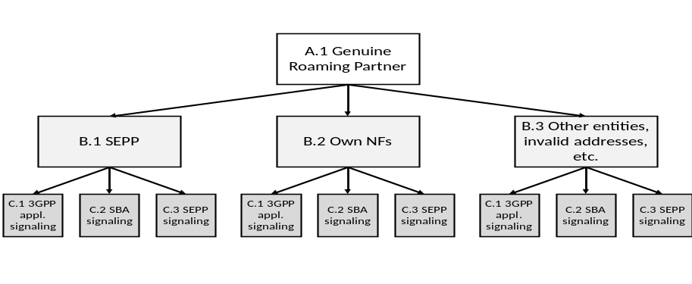
Figure 1: Potential N32 message types originating in PLMNs of genuine roaming partners
As for the SEPP as the final destination of messages (B.1), it can be safely assumed that a hardened SEPP will only accept SEPP-to-SEPP signaling which is needed to authenticate peers, negotiate N32 session keys, etc. Any other form of Control Plane traffic, i.e. 3GPP application (C.1) and SBA-specific signaling (C.2), will usually not terminate in the SEPP. If the SEPP does receive N32 messages that it is unable to understand anyway, these messages must, of course, be discarded.
Potential security requirement 2: The SEPP shall discard malformed N32 signaling messages.
Thus, only the combination of B.1/C.3 is worth analyzing further. We already established that the SEPP will authenticate incoming SEPP-to-SEPP signaling and will discard malformed messages. Another potential threat on N32 is excessive SEPP-to-SEPP signaling, e.g. key re-negationation requests, in order to cause a denial of service on the receiver’s side. Thus, an additional protection mechanism that is necessary on N32 is rate limitation.
Potential security requirement 3: The SEPP shall impement rate-limiting functionalities to defend itself and subsequent Network Functions against excessive Control Plane signaling. This includes SEPP-to-SEPP signaling messages.
Control Plane signaling by successfully authenticated roaming partners and with valid source/destination addresses will eventually be routed by the SEPP to the receiving NF. However, this does not rule out malicious contents completely. As [12] points out, a genuine roaming partner could e.g. still send fraudulent messages that may result in a denial of service for a user connected to a differernt PLMN as well as additional cost for the HPLMN.
Up till now, most kinds of malicious messages discussed in this document were related to unauthenticated or unauthorized parties trying to send messages to a certain PLMN – an issue that is best prevented at the foremost edge of the network, i.e. by the SEPP. To counter the problem of fraudulent 3GPP application signaling (e.g. session management, mobility management, etc.), the NFs themselves need to implement certain security functionalities as well. Detailed measures depend on Stage 3 message contents, but they will be similar to measures performed for legacy protocols by SS7 firewalls and Diameter Edge Agents.
Potential security requirement 4: Each network function shall implement anti-spoofing measures by validating every incoming message for plausibility and against its internal state machine. Messages that are not valid according to the protocol specification and network state shall be discarded by the NF.
Incoming messages on N32 may also contain spoofed destination addresses or alternatively, valid addresses that do not belong to the SEPP’s own PLMN (B.3). Whether or not this is due to any malicious intent or caused by a misconfiguration, and regardless of the message type (C.1/C.2/C.3), the SEPP shall never accept or forward such messages. Similarly, anti-spoofing checks must be applied for origin identities on different protocol layers that should belong to the same origin, e.g. source addresses, FQDNs, PLMN IDs. This is an addition to the SEPP’s anti-spoofing mechanisms already captured in the living document on SBA security [13]. Again, detailed measures depend on Stage 3 message contents.
Potential security requirement 5: The SEPP shall implement anti-spoofing mechanisms that enable cross-layer validation of source and destination address and identifiers (e.g. FQDNs or PLMN IDs). If there is a mismatch between different layers of the message or the destination address does not belong to the SEPP’s own PLMN, the message shall be discarded.

4.2.6.2 Threat description
As the primary element of filter and policy enforcement functionality for inter-PLMN signalling, it is one of the main tasks of a SEPP to protect the NF of its own PLMN from malicious traffic. If it fails to do so, attackers might be able to abuse the roaming interface to perform various types of fraud, cause leakage of information or induce Denial of Service situations, thereby preventing genuine customers or roaming partners from being served.

4.2.6.3 Potential security requirements
The receiving SEPP shall be able to verify whether the sending SEPP is authorized to use the PLMN ID in the received N32 message.
The SEPP shall be able to clearly differentiate between certificates used for authentication of peer SEPPs and certificates used for authentication of intermediates performing message modifications.
The SEPP shall discard malformed N32 signaling messages.
The SEPP shall impement rate-limiting functionalities to defend itself and subsequent NFs against excessive CP signaling. This includes SEPP-to-SEPP signaling messages.
The SEPP shall implement anti-spoofing mechanisms that enable cross-layer validation of source and destination address and identifiers (e.g. FQDNs or PLMN IDs).

4.2.7 Key Issue #16: N32 error signalling

4.2.7.1 Issue description
The N32 interface connects two SEPP that are potentially controlled by different mobile network operators or even other parties in case an operator decides to outsource certain security functionalities. The fact that N32 also allows for modifications by authorized intermediaries arguably renders it one of the most complex interfaces of the 5GC. Therefore, N32 needs to support error signalling capabilities for all significant message exchanges and foreseeable error cases in order to enable SEPP operators to perform testing and debugging during setup and operation.

4.2.7.2 Threat description
Missing support for error signalling on the N32 interface will prevent SEPP opertors to efficiently analyze and debug errors that may occur. In turn, this may negatively affect the stability of inter-PLMN signalling, thereby violating the essential security principle of availability.

4.2.7.3 Potential security requirements
The SEPP shall support the functionality to signal errors that may occur on the receiving end of communication back to the sending SEPP.
The SEPP shall support operator configuration for handling of received error messages and resulting actions.

4.2.8 Key Issue #17: Modifications by authorized intermediaries on N32

4.2.8.1 Issue description
Mobile network operators transfer signalling data via the IPX network with the help of third parties (i.e. IPX providers) offering services that, for example, alleviate interoperability issues or mitigate common fraud scenarios. According to GSMA DESS [14], to allow for such value-added services, IPX providers require access to certain message contents on N32.

4.2.8.2 Threat description
If the N32 security solution does not allow for modifications by authorized intermediaries, operators will not be able to make use of mediation and security services offered by IPX providers.
Furthermore, if operators depend on certain services offered by their IPX providers, not allowing for authorized modifications might provide an incentive for not enabling security on the N32 interface at all.

4.2.8.3 Potential security requirements
The N32 security solution shall allow for authentication and authorization of intermediaries.
The N32 security solution shall allow modifications by authorized intermediaries.
The N32 security solution shall protect information elements on a per-field basis.
The N32 security solution shall allow mobile network operators to control what IEs may or may not be modified by authorized intermediaries.
The N32 security solution shall allow mobile network operators to identify how IEs were modified by authorized intermediaries.
The N32 security solution shall allow mobile network operators to revoke the permission to modify messages in transit.

4.2.9 Key Issue #18: Inter-PLMN routing and TLS

4.2.9.1 Key issue detail
For service invocation between different PLMNs, the SEPP needs to terminate TLS in order to modify requests and responses. This request rewriting is needed because of topology hiding and for the application layer security solution.
The FQDN in the Request URIs contain the FQDN of the remote PLMN. In order to terminate TLS, the SEPP needs to provide a certificate on behalf of remote PLMN.
TLS 1.3 [15] does not support static RSA and Diffie-Hellman cipher suites, which enable the server's private key to be shared with server-side middleboxes. It is no longer possible for a server to share a key with the middlebox and allow middlebox to access TLS session data.

The situation is illustrated in more detail in the service discovery and service request flows in Figure 4.2.9.1-1:
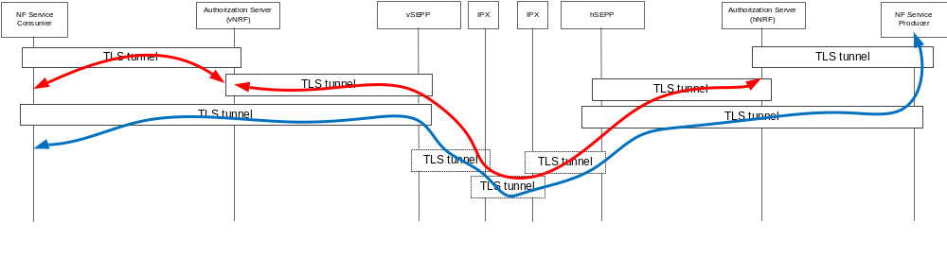
Figure 4.2.9.1-1: Service discovery and service request flows
Red arrows represent service discovery flows.
Blue arrows represent service request flows.
The TLS tunnels to, from, or between IPXs may not be present.

4.2.9.2 Security threats
If the SEPP is issued certificates on behalf of the remote PLMN, it impersonates the remote PLMN.

4.2.9.3 Potential security requirements
SEPPs shall not be provisioned with TLS certificates containing domain names belonging to other PLMNs.
Chosen solution shall be compatible with TLS 1.3 [15].

4.2.10 Key Issue #19: Configurational error handling by the SEPP

4.2.10.1 Issue description
Application Layer Security (ALS) as described in TS 33.501 [11] allows for modification of N32-f messages in transfer by authorized third parties. It is the receiving SEPP’s responsibility to validate whether the added JSON-patches are legitimate with regards to the modifying party as well as the modification policies of that particular N32 connection. This message validation may fail for a variety of reasons, such as:
- Missing patch by first IPX-provider in the path
- Invalid IPX-provider signature
- Attempted modification of a non-modifiable IE, according to the modification policy
What is missing in the current specification in TS 33.501 [11] is a clear ruleset describing how the receiving SEPP shall deal with different error scenarios, both in terms of local error handling as well as error signalling to the source of the N32-f message. In order to properly handle an incoming N32-f message, the SEPP must be able to determine which of the following actions 1.X and 2.X to take, should an error occur in one of the contained IPX-provider patches:
1. Local error handling
1.1 Drop message
1.2 Drop individual patch
1.3 Forward message
2. Error signalling
2.1 No error signalling
2.2 Error signalling to the original source
2.3 Error signalling to both the original source and the IPX-provider
Editor’s Note: Whether more options for local error handling and error signalling are required is FFS.
Since 3GPP standards can hardly dictate how SEPPs of each individual operator are to behave, there must at least be a requirement for a configuration which allows to control the error handling described above for each individual scenario.

4.2.10.2 Threat description
A SEPP that does not allow for configurational error handling will be unable to adapt to the specific tasks an operator outsources to its IPX-providers. Depending on what information elements the IPX-provider has to access and/or modify, a flawed or missing patch may render the whole message useless. In other scenarios, an IPX-provider may offer services that are "nice-to-have" but not strictly necessary. In these cases, discarding the message as a whole and waiting for retransmission may not be justified.

4.2.10.3 Potential security requirements
The SEPP shall support configurable error handling and error signalling per individual error cause and per individual N32 connection.
Editor's Note: The granularity of configuration for error handling and error signalling is FFS.

5. General Requirements
Editor's note: this clause details security requirements that are not part of a key issue such as performance requirements.

6 Solutions

6.1 Solution #1: Authorization of NF service access

6.1.1 Introduction
This clause specifies authorization procedures for authorizing NF service consumer to access services provided by NF service producer.
Granularity of authorization is per service based. In the case of authorization by NRF, prior to accessing a service defined in TS 23.502 [3], the NF service consumer requests a token from NRF. The token records and proves that NF service consumer is permitted to access the service provided by the service producer. The NF service producer verifies the token before executing the requested service. The authorization token can be reused to avoid requesting authorization for every service access.
Editor's Note: It is assumed that NRF authenticates the NF service consumer before authorization. The authentication method is FFS.

6.1.2 Solution details

6.1.2.1 Service authorization procedure for non-roaming scenarios
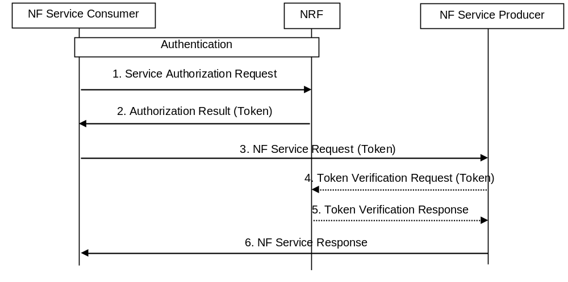
Figure 6.1.2.1-1: Service authorization procedure for non-roaming scenario
1) NF service consumer to NRF: Service Authorization Request (NF type and NF instance ID of service consumer, NF type and NF instance ID of service producer, NF service name). Service Authorization Request is included in Nnrf_NFDiscovery_Request [3] if the NF Service Consumer requests service authorization along with NF service discovery request.
2) NRF to NF Service Consumer: Authorization Result (Token).
NRF checks whether the access can be permitted according to the maintained authorization information. If the service can be authorized, NRF sends the result along with a token that proves this authorization. The token should include the NF type and NF instance ID of NF service consumer, the NF type and NF instance ID of NF service producer, the NF service name that will be accessed, and a credential such as MAC (Message Authentication Code) or digital signature. If the token can be reused within a period of time, the expiration date should also be included. If Service Authorization Request is included in Nnrf_NFDiscovery_Request, NF service producer should include Authorization Result in Nnrf_NFDiscovery_Request Response [3] which will be sent to the NF Service Consumer.
3) NF service consumer to NF service producer: NF Service Request (NF type and NF instance ID of service consumer, NF service name, Token).
4) NF service producer to NRF: Token Verification Request (Token).
If NF service producer is able to verify the token, step 4 and step 5 are skipped. Otherwise, NF service producer requests NRF to verify the token through Token Verification Request.
5) NRF to NF service producer: Token Verification Response.
NRF informs NF service producer the verification result. Token Verification Request and Response could introduce much overhead, thus it is recommended to verify the token by NF service producer itself.
6) NF service producer to NF service consumer: NF Service Response.
If the token is valid and the NF service Request is consistent with the information in the token, NF service producer executes the requested service and response to NF service consumer.
Editor's Note: Parameters of the messages and parameters in the token are FFS.
Editor's Note: How to compute and verify the credential included in the token is FFS.

6.1.2.2 Authorization of NF service access for roaming scenario
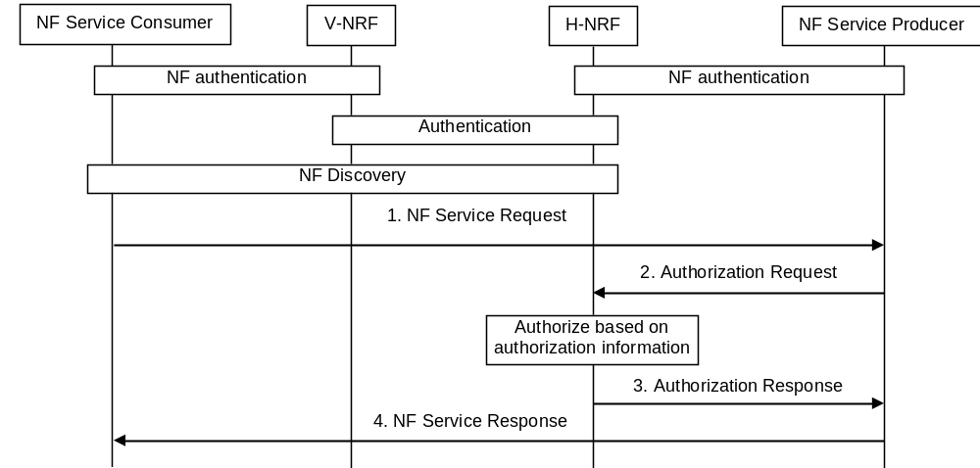Figure 6.1.2.2-1: Authorization of NF service access for roaming scenario
1) NF service consumer to NF service producer: NF Service Request (NF type and NF instance ID of service consumer, NF type and NF instance ID of service producer, NF service name).
2) NF service producer to NRF in Home PLMN: Authorization Request (NF type and NF instance ID of service consumer, NF type and NF instance ID of service producer, NF service name).
3) NRF in Home PLMN to NF service producer:
NRF in Home PLMN checks whether the access can be permitted according to the maintained authorization information (static policies). If the service can be authorized, NRF in Home PLMN sends the Authorization Response to the NF service producer.
4) NF service producer to NF service consumer:
If authorized, NF service producer executes the requested service and response to NF service consumer.
Editor's Note: The authentication mechanisms between different PLMNs is FFS.

6.1.3 Evaluation
Editor's note: The evaluation is FFS

6.2 Solution #2: Application layer protection based on JSON Object Signing and Encryption (JOSE)

6.2.1 General
Following aspects are considered when designing a solution for e2e protection of application layer information in the HTTP payload:
- Which protocol to use to secure JSON content
- Where to implement e2e security in the network
- Which JSON information elements to protect and what kind of protection is required
- Algorithms to use for protection and their negotiation between two Edge Proxy end points
- Key management aspects including key distribution to the Edge Proxies
- Protection mechanism that allows selective protection of the payload while allowing other unprotected payload to be modified by the intermediaries

6.2.2 Application layer protection based on JOSE
JOSE [4] provides a set of specifications to protect JSON based data structures. These include standards for:
- representation of integrity-protect JSON data based on public-key digital signatures as well as symmetric-key MACs using JSON Web Signing (JWS) [5],
- representation of encrypted data using JSON Web Encryption [6],
- specifying how to encode public keys as JSON-structured objects,
- specifying algorithms and algorithm identifiers using JSON Web Algorithm [7],
- specifying a means to protect private and symmetric keys via encryption.
JOSE is used to protect JSON based application content in SBA.

6.2.2.1 JSON based IEs that require protection (WHAT)
JOSE framework will be used to integrity protect all the JSON IEs in the HTTP message payload. The JSON Web Signature [5] applies integrity protection either based on digital signatures (asymmetric protection) or Message Authentication Codes (symmetric protection). The resulting data structure is of JSON type and contains JWS Signature representing a digitally signed or MACed message payload.
JOSE framework will be used to confidentiality protect Authentication Vector (AVs), cryptographic keys, SUPI and Location data (e.g. Cell ID and Physical Cell ID) contained in the HTTP message. The JSON Web Encryption [6] is based on the use of Authenticated Encryption with Associated Data (AEAD) based encryption algorithms. Hence it applies both confidentiality protection and integrity protection on the Authentication Vectors.
Editor's Note: This clause shall be revisited again in Phase 2 if any change is identified in the list of IEs identified in this clause for protection in Phase 1.

6.2.2.2 Integrity and Confidentiality protection schemes (HOW)
Editor's Note: This clause shall include the following aspects - whether Confidentiality protection and Integrity protection is based on Asymmetric encryption or Symmetric encryption, protection schemes needed to allow intermediate nodes to modify application layer information, if required.

6.2.2.2.1 Integrity protection based on JSON patch
There is a requirement for "e2e" integrity protection in conjunction with requirement for intermediaries to be able to modify the message in a verifiable way.
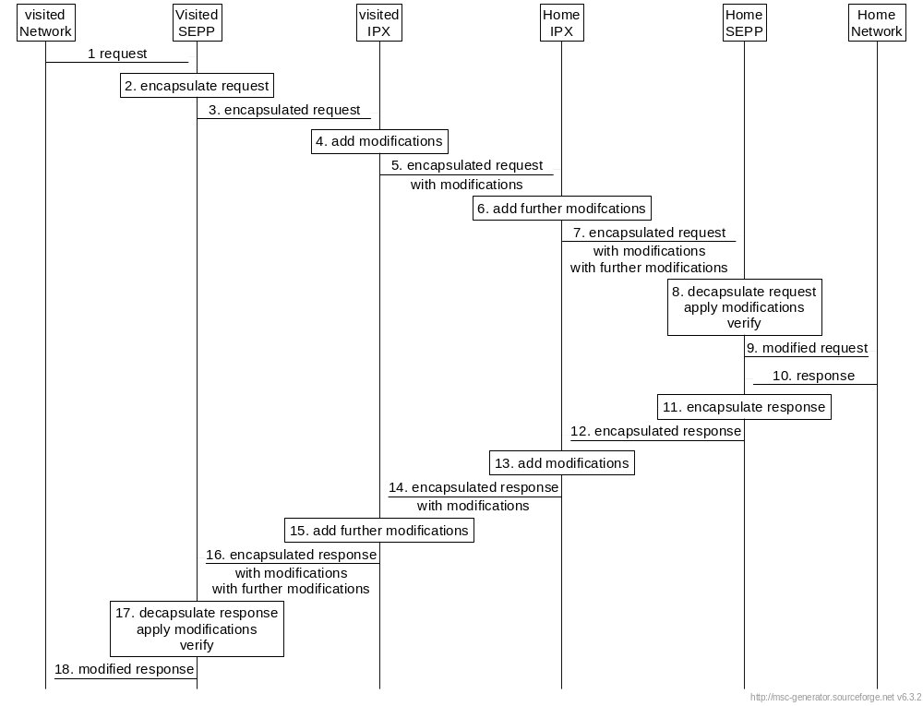
Figure 6.2.2.2-1: Message flow across N32 interface
1. The vSEPP receives an HTTP request.
2. The vSEPP encapsulates the HTTP request into a JSON object encapsulatedRequest consisting of three JSON objects:
- the request lines is put into an element called requestLine containing an element each for the method, the URI, and the protocol of the request received in step 1.
- the header of the request received in step 1 is put in into an element called httpHeaders, with one element per header of the original request.
- the body of the request received in step 1 is put into an element called http body.
Editor's note: how to deal with multipart messages is FFS.
The vSEPP includes its own identity and the encapsulatedRequest into a JSON object called partRequest as well to allow the hSEPP to identify the originator.
Editor's note: it is FFS whether: The vSEPP shall include the first intermediary's ID in the partRequest. This authorizes the first intermediary to perform modifications.
Editor's Note: Only authorized intermediaries are allowed to perform modifications. Authorization mechanism is FFS
Editor's note: whether the hSEPP should include a policy which elements are allowed to be changed by the first intermediary is FFS.
The vSEPP integrity protects the complete partRequest using JWS.
The integrity protected partRequest is put into an array.
3. The vSEPP uses HTTP POST to send the encapsulated request to the first intermediary (visited network's IPX provider).
4. The first intermediary (e.g. visited network's IPX provider) checks the integrity and authenticity of the encapsulated request. It parses the encapsulated request and determine which changes are required. The first intermediary creates a JSON element called operations, taking the syntax and semantic from RFC 6902, that, when applied as a JSON patch to the encapsulated request, will result in the desired request. If no patch is required, the operations element is empty.
Editor's note: error handling in case of failed integrity check is FFS.
The first intermediary creates a JSON element called partRequest that includes the intermediary's identity, and integrity protect the partRequest in a JWS.
Editor's note: whether the part Request includes the hSEPP ID or the next intermediaries' ID to authorize further changes is FFS. Inclusion of a policy is not required, because this would be under the home networks remit.
The integrity protected partRequest is appended to the array inside the encapsulated request created in step 2.
5. The first intermediary sends the encapsulated request to the second intermediary (home network's IPX) as in step 3.
6. The second intermediary checks the integrity and authenticity of the encapsulated request and the partRequest. It parses the encapsulated request, apply the modifications described in the partRequest and determine further modifications required to result in the desired request. These modifications are recorded as a further patch request. Further processing is like in step 4 (create a pertRequest and integrity protect).
Editor's note: it is FFS, if a policy is included in step 2, how and whether the second intermediary can check that the first intermediary only changed allowable elements.
7. The second intermediary sends the encapsulated request to the hSEPP as in step 3.
Note: The behaviour of the intermediaries is not normative, but the hSEPP assumes that behaviour for processing the resulting request.
8. The hSEPP checks the integrity and authenticity of the encapsulated request and the partRequests. The hSEPP checks whether the modifications performed by the intermediaries were permitted by policy. The hSEPP decapsulates the encapsulated request, verify signatures, apply the patches in the partRequests in order, perform filtering on the resulting request, and create a new HTTP request according to the "patched" encapsulatedRequest.
Editor's note: which signatures the hSEPP needs to verify is FFS
9. The hSEPP sends the HTTP request resulting from step 8 to the home network's NF.
10.-18. These steps are analogous to steps 1.-9., but treating the HTTP response like the HTTP request.
Below is an example to illustrate the elements in the JSON:
partRequest created by vSEPP
{
"partRequest": {
"previousSignature": "",
"originatorIdentity": "some MNO's SEPP",
"encapsulatedRequest": {
"requestLine": {
"method": "POST",
"URI": "APIroot/nausf_auth/v1/ue_authentications",
"protocol": "HTTP/2"
},
"httpHeader": {
"Accept: application/json",
"Content-Type: application/json",
"host: ": "hplmn.f.q.dn",
"content-length: ": 100
},
"body": {
"UE-id": "maguro_suci",
"Serving network name": "some_VPLMN",
"access_type": "5G" }
},
"nextHopIdentity": "next intermediaries name"
}
}
partRequest created by Intermediary
{
"partRequest": {
"previous": "<signature of previous request entry in requesthistory array>",
"next": "<expected next originator>",
"originator": "intermediary name",
"operations": [
{
"op": "replace",
"path": "/HTTP-headers/Host",
"value": "HPLMN2.com"
},
{
"op": "replace",
"path": "/HTTP-headers/Content-Length",
"value": "131"
},
{
"op": "add",
"path": "/HTTP-body/new_element",
"value": "value1"
}
]
}
}

The complete request with change history as will arrive at the hSEPP

{
"requestHistory": [
{
"integrityProtectedPartRequest": "protectedHeader.protectedPayloadIsPartRequestFromVSEPP.signature"
},
{
"integrityProtectedPartRequests": "protectedHeader.protectedPayloadIsPartRequestFromFirstIntermediary.signature"
},
{
"integrityProtectedPartRequests": "protectedHeader.protectedPayloadIsPartRequestFromFirstIntermediary.signature"
}
]
}

6.2.2.2.2 Authorization of modifications based on JSON patch
The receiving SEPP requires a policy S which elements may be changed by the first IPX provider and a policy R which elements may be changed by the second IPX provider.
The sending SEPP informs the receiving SEPP of policy S either out of band or by including the policy (or link thereto) in the message itself. The receiving SEPP applies the policy that policies cannot be modified by intermediate IPX providers. Policy R is local to the receiving SEPP.
Each policy consists of a list of paths with the allowed operations. Below is an example:
"allowed-operations": [
{
"op": "replace",
"path": "/HTTP-headers/Host"
},
{
"op": "replace",
"path": "/HTTP-headers/Content-Length"
},
{
"op": "add",
"path": "/HTTP-body/new_element"
}
]

The receiving SEPP verifies the modifications proposed by the first IPX in the incoming message against policy S. If a policy violation occurred, the receiving SEPP informs the sending SEPP of the policy violation in an error message with the appropriate HTTP error code and enough information for the sending SEPP to pinpoint the policy violation. The receiving SEPP discards the incoming message. The SEPP sending the original message (i.e. the one receiving the error message) applies the policy that policy violation messages cannot be modified by intermediate IPX providers.
The receiving SEPP verifies the modifications proposed by the second IPX in the incoming message against policy R. If a policy violation occurred, the receiving SEPP informs the second IPX provider out of band. The receiving SEPP also informs the sending SEPP of the fact that a policy violation occurred in an error message with the appropriate HTTP error code, and discard the incoming message. The SEPP sending the original message (i.e. receiving the error message) applies the policy that policy violation messages cannot be modified by intermediate IPX providers.
Editor's Note: what the sending SEPP will do when receiving an error code is FFS.

6.2.2.2.3 Authentication of intermediaries
Each intermediary has its own certificate infrastructure. The sending SEPP includes the root CA of the first IPX intermediary in its policy. The sending SEPP signs its policy.

6.2.2.2.4 Rewriting of HTTP message into JSON-object
The solution "Integrity protection based on JSON patch" described in clause 6.2.2.2.1 also contains a solution for rewriting the HTTP message into a JSON object. Once the HTTP message has been rewritten in this way, it becomes more straight-forward to apply JOSE protection to selected elements of the message. Hence the rewriting process is of importance even for a solution without standardized modifications of intermediaries.
It thus seems reasonable to consider the following steps as a separate solution:
Rewriting of HTTP-message into JSON-object:
The vSEPP encapsulates the HTTP request into a JSON object encapsulatedRequest consisting of three JSON objects:
- the request line is put into an element called requestLine containing an element each for the method, the URI, and the protocol of the request received in step 1.
- the header of the request received in step 1 is put in into an element called httpHeaders, with one element per header of the original request.
- the body of the request received in step 1 is put into an element called http body.
Editor's Note: It is for further study, whether including the identity of the vSEPP in the JSON-object is necessary.

6.2.2.3 Key management aspects
Editors' Note: This clause shall include the following aspects - whether Confidentiality protection and Integrity protection is based on Asymmetric encryption or Symmetric encryption, how to establish the required keys for Integrity and Confidentiality protection.

6.2.3 Evaluation
Editor's note: The evaluation is FFS

6.3 Solution #3: NF service registration process

6.3.1 Introduction
Editor's note: Each solution should list the key issues that it addresses. There may be references to the key issues different from 'X' (when addressing more than one key issues).

6.3.2 Solution Details
During initial provisioning and configuration of NF, NRF is configured with NF's public key and other information. And NF is configured with public key of NRF and other information.
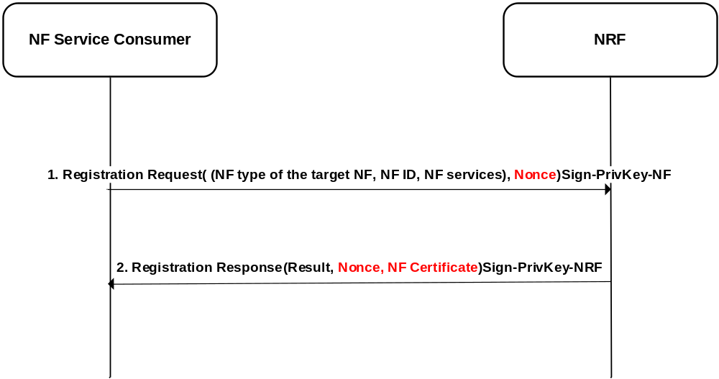
Figure 6.3.1-1 Authentication of NF service registration
1) NF service consumer sends Nnrf_NFManagement_NFRegister Request message to NRF, signed by NF's private key and encrypted using public key of NRF. Registration request includes a nonce for replay protection.
2) NRF sends Registration response signed by NRF private key. Registration response includes NF certificate and other parameters.
3) Upon receipt if registration response, NF service consumer checks the integrity the Nnrf_NFRegister_Response by using public key of NRF decrypts the payload by NF Service consumer's private key.

6.3.3 Evaluation
Editor's note: The evaluation is FFS

6.4 Solution #4: Authorization of NF service access

6.4.1 Introduction
During initial provisioning and configuration of NF, NRF is configured with NF's public key and other information. And NF is configured with public key of NRF and other information. During service registration, NF obtains certificate from NRF for its public key.
Service request and response uses TLS to establish a secure session between NF Service Consumer and NF Service Producer using their corresponding certificates. Upon successful Service request and response, a secure association is established between NF service consumer and NF service producer which provides secure session between the two.
Service request and response can function within same PLMN or across PLMNs. Subsequent sections describe the detailed flow for each case.

6.4.2 Solution details

6.4.2.1 Authorization of NF service access in the same PLMN
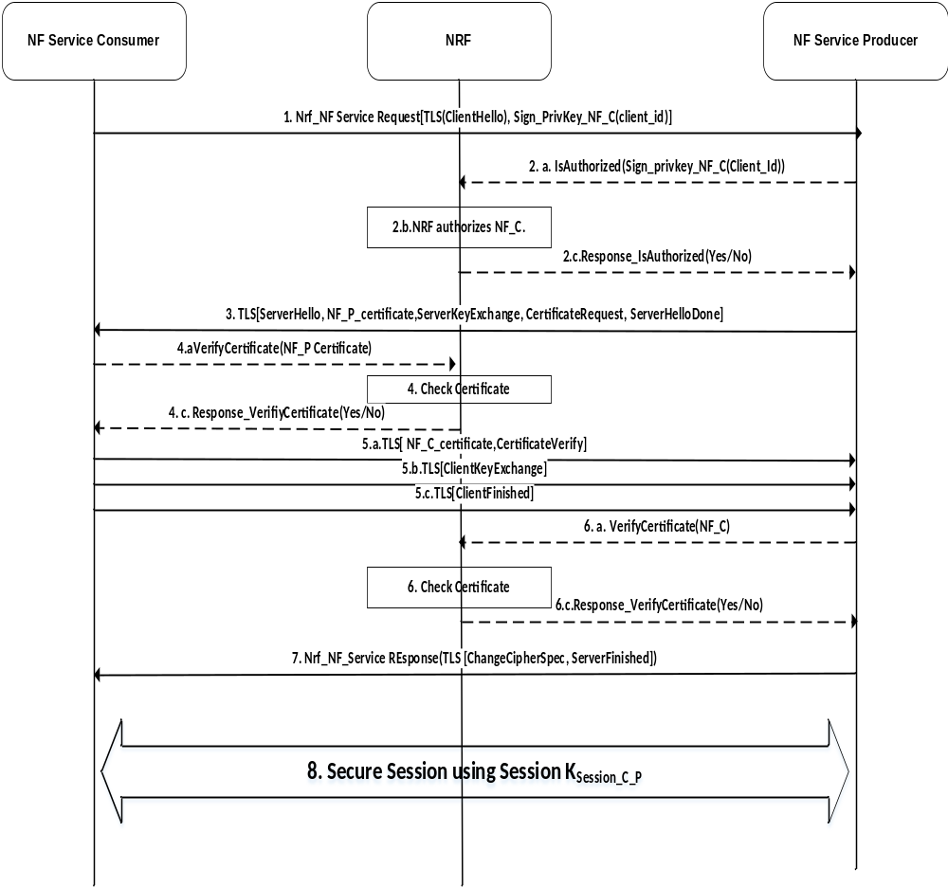
Figure 6.4.2.1-1: Authorization of NF service request in the same PLMN
1. The NF Consumer sends an NF Service request to NF producer. It contains a self-signed client ID. Service request also includes a client TLS [client_hello] message for the NF Producer. The contents of TLS client_hello are defined in the TLS specification.
2.
a. The NF Producer forwards the Signed Client ID as a payload to IsAuthorized message to NRF.
b. NRF verifies client ID signature. If the NF Consumer ID is successfully verified, NRF checks the stored NF profile information to determine whether the access can be permitted. If the service can be provided, NRF sends the verification result back to NF Service Producer. If verification is unsuccessful, NF Service producer does not proceed.
Editor's Note: IsAuthorized Request and response messages and VerifyCertificate message need to be defined. Its format and parameters are FFS.
3. The NF Producer replies to the NF Consumer with TLS[server_hello], which further includes information elements such as server_hello, NF_P_Certificate, server_key_exchange, certificate_request, server_hello_done. These information elements are defined in the RFCs for the TLS.
4. Upon receiving the TLS[server_hello] message NF consumer forwards the message to its NRF through VerifyCertificate message. NRF verifies the NF Producer certificate received in TLS [server_hello].
5. Upon successful verification of NF producer certificate, NF Consumer replies with TLS [client key exchange], which further contains information element such as client_certificate (NF_C_Certificate), client_key_exchange, client_certificate_verify, change_cipher_spec, client_finished, etc.
6. After receiving the TLS [client_certificate] message NF consumer forwards the message to its NRF through VerifyCertificate message. NRF verifies the NF Consumer certificate received in TLS [client_certificate] by NRF's public key.
7. NF producer sends Nrf_Nf_Service Response with TLS [Server_finished] with change_cipher_spec to the NF Consumer.
8. Session Key (K_{SESSION_C_P}) is used to secure further communication between NF consumer and producer.

6.4.2.2 Authorization of NF service access in different PLMNs
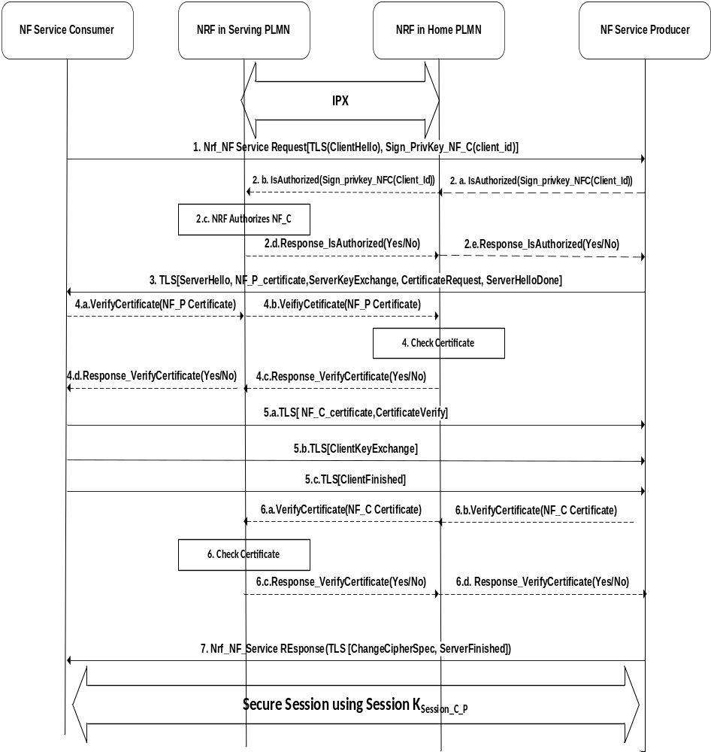
Figure 6.4.2.2-1: Authorization of NF service access across PLMNs
1. The NF Consumer sends an NF Service request to NF producer in the home PLMN. It contains a self-signed client ID. Service request also includes a client TLS [client_hello] message for the NF Producer. The contents of TLS client_hello are defined in the TLS specification.
2. The NF Producer forwards the Signed Client ID as a payload to IsAuthorized message to NRF in home PLMN. hNRF acts proxy for NRF in serving PLMN and forwards the signed payload to it. Serving NRF verifies the Client ID signature. If the NF Consumer ID is successfully verified, NRF checks the stored NF profile information to determine whether the access can be permitted. If the service can be provided, NRF sends the verification result back to NF Service Produce through hNRF proxy. If verification is unsuccessful, NF Service producer does not proceed.
Editor's Note: IsAuthorized Request and response messages need to be defined. Its format and parameters are FFS.
3. The NF Producer replies to the NF Consumer with TLS[server_hello], which further includes information elements such as server_hello, NF_P_Certificate, server_key_exchange, certificate_request, server_hello_done. These information elements are defined in the RFCs for the TLS.
4. NF Service producer's certificate is sent to NRF in HPLMN for verification through the VerifyCertificate message. Serving NRF acts as a proxy and just transfer the payload to Home NRF. The NRF in HPLMN verifies the NF producer's certificate received in TLS [server_hello].
5. NF Consumer replies with TLS [client key exchange], which further contains information element such as client_certificate (NF_C_Certificate), client_key_exchange, client_certificate_verify, change_cipher_spec, client_finished etc.
6. NF Service consumer certificate is sent to NRF in SPLMN for verification through the VerifyCertificate message. HPLMN NRF acts as a proxy and just transfer the payload to Serving NRF. The NRF in Serving PLMN verifies the NF Consumers certificate received in TLS [client_certificate].
7. NF producer sends Nrf_Nf_Service Response with TLS [Server_finished] with change_cipher_spec to the NF Consumer.
8. Session Key (K_{SESSION_C_P}) is used to secure further communication between NF consumer and producer.

6.4.1 Evaluation
Editor's note: The evaluation is FFS

6.5 Solution #5: Using mediation services with end-to-end encryption

6.5.1 Generic
The scenario that is depicted in the figure below is a scenario with two MNOs, MNO A and MNO B and two IPX providers, IPX A and IPX B. The IPX provider A provides mediation services for MNO A and IPX provider B provides mediation services for MNO B. Both MNOs have one network function (NF), which is left unnamed. This solution provides two possible implementations, one where two SEPPs communicate securely with each other via HTTPS or TLS, and one where JOSE is used for the protection of the messages between two SEPPs.

6.5.2 End-to-end encryption using HTTPS or TLS
In this version of the solution, it is assumed that the SEPPs themselves use HTTPS for providing end-to-end security. In this case, the solution works as follows:
1. The SEPP A receives a HTTP(S) Request from NF A as usual.
2. In case this request contains sensitive information according to clause 9.1.3.3, the SEPP A performs an action to hide these fields for the mediation service. This action is not to be standardized. Some examples are:
a. Replacing the values of these with some other values, e.g. a hash of the value. The SEPP A stores the hash of the value and the corresponding value temporarily.
b. Entirely removing the fields from the message and storing bot the header and the value temporarily.
c. Encrypting the fields using some proprietary mechanism.
3. The SEPP A invokes the Mediate service running at the IPX A by sending a MediateAndReturn Request message to the IPX provider. The MediateAndReturn Request contains the message that was received from the NF A and has its sensitive information removed or hidden according to step 2.
4. The Mediation services performs its mediation
5. The mediation service sends the MediateAndReturn Response message, which contains the mediated message, to the SEPP A.
6. Upon reception, the SEPP A reinserts the sensitive information. This action depends on how the SEPP A has removed or hidden the sensitive information and can be entirely proprietary.
7. The SEPP A then sends the mediated version of the original NF A's request to the SEPP B over HTTPS. So the request would look like a request that came from NF A apart from the mediated fields.
8. The SEPP B receives the request, and if mediation is deemed necessary, the SEPP B also removes or hides the sensitive fields from the message.
9. The SEPP B then invokes the Mediate service running on IPX B by sending a MediateAndReturn Request message to IPX B.
10. The mediation service performs its mediation.
11. The mediation service sends the MediateAndReturn Response message, which contains the mediated message.
12. The SEPP B re-inserts the sensitive information.
13. And finally, SEPP B sends the request to NF B.
In short, the solution relies on standard HTTP and HTTPS. In between the steps 2 and 6, the SEPP A will either have to keep state or use an encryption / decryption mechanism. In between the steps 8 and 12, the SEPP B has a similar task. In case IPX provider hosts the SEPP (e.g. for small operators), the steps 2-6 would probably be left out altogether.
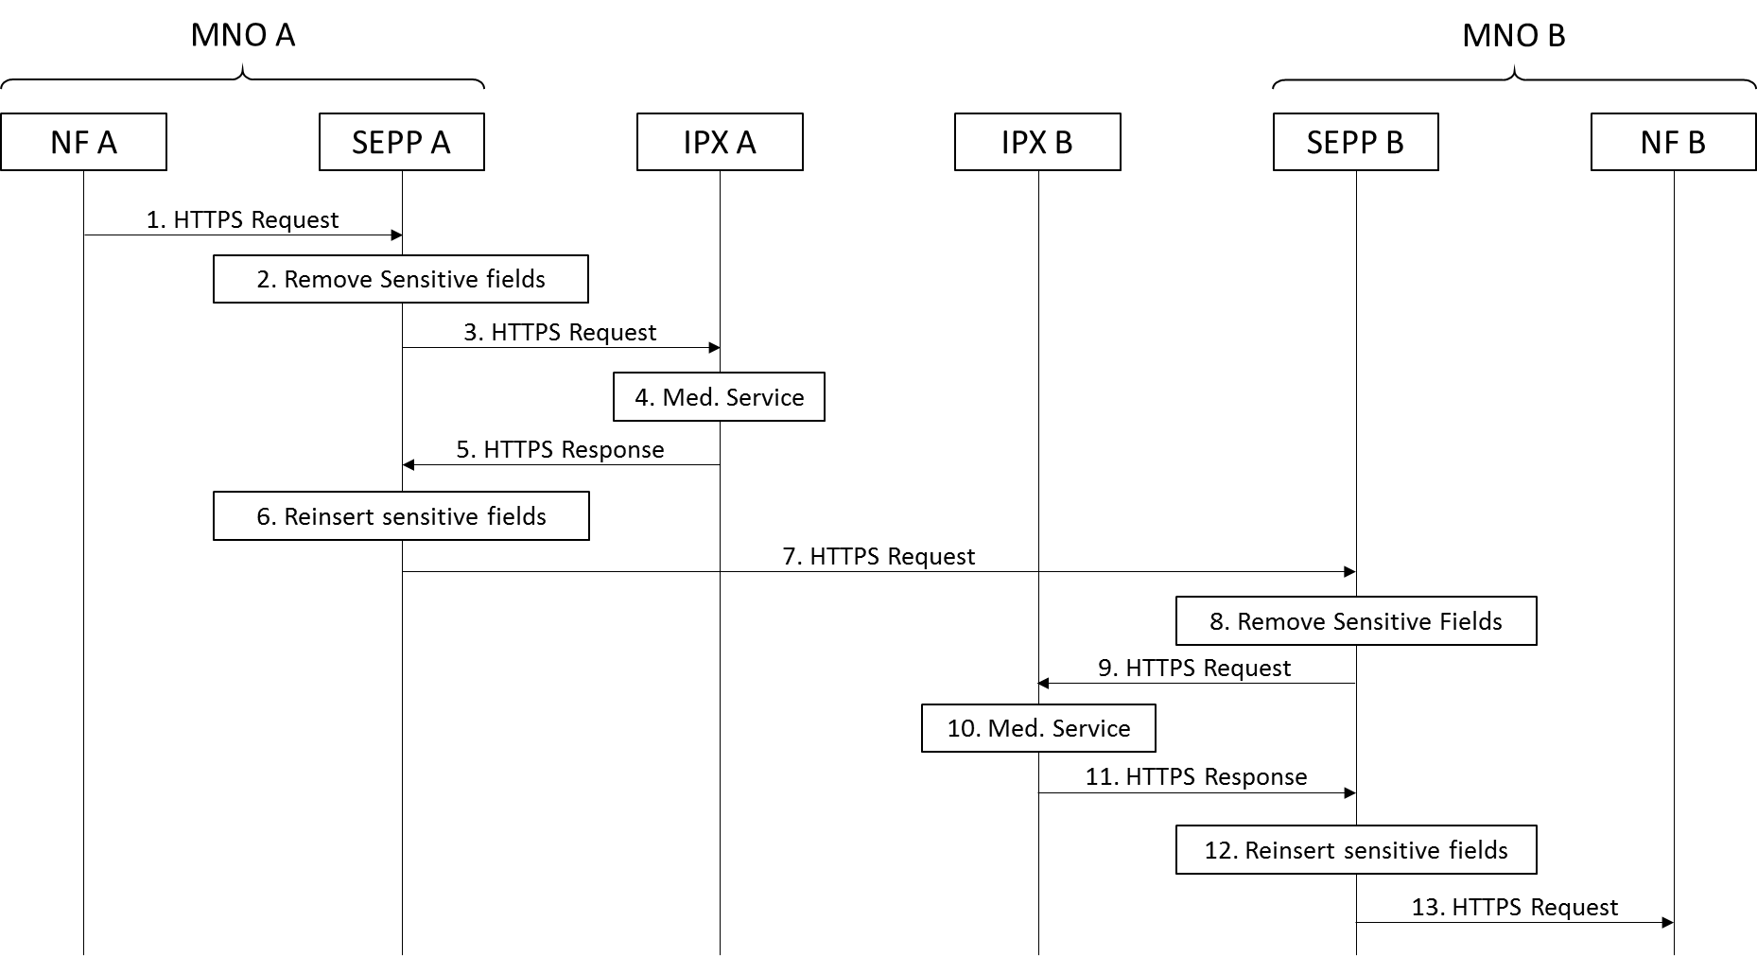
Figure 6.5.2-1: Mediation service using HTTPS

6.5.3 End-to-end security using JOSE
In this version of the solution, it is assumed that the SEPPs themselves use HTTP request with an encrypted JOSE payload for providing end-to-end security. In this case, the solution works as follows:
1. The SEPP A receives a HTTP(S) Request from NF A as usual.
2. The SEPP A takes the request and wraps the whole request into a JSON format. So, the request headers go into a field called 'HTTPRequestHeader', a binary blob goes into a field called 'BinaryBlob' and the session cookie goes into a field called 'SessionCookie'. Then, the SEPP determines whether the message contains sensitive information according to clause 9.1.3.3 and performs an action to hide these fields for the mediation service. This action is not to be standardized. Some examples are:
a. Replacing the values of these with some other values, e.g. a hash of the value. The SEPP A stores the hash of the value and the corresponding value temporarily.
b. Entirely removing the fields from the message and storing bot the header and the value temporarily.
c. Encrypting the fields using some proprietary mechanism.
3. The SEPP A invokes the Mediate service running at the IPX A by sending a MediateAndReturn Request message to the IPX provider. The MediateAndReturn Request contains the message that was received from the NF A and has its sensitive information removed or hidden according to step 2.
4. The Mediation services performs its mediation
5. The mediation service sends the MediateAndReturn Response message, which contains the mediated message, to the SEPP A.
6. Upon reception, the SEPP A reinserts the sensitive information. This action depends on how the SEPP A has removed or hidden the sensitive information and can be entirely proprietary. The SEPP A encrypts the message using standard JOSE using the target SEPP's public key.
7. The SEPP A then sends the mediated version of the original NF A's request to the SEPP B over HTTP.
8. The SEPP B receives the request, decrypts the request, and if mediation is deemed necessary, the SEPP B also removes or hides the sensitive fields from the message.
9. The SEPP B then invokes the Mediate service running on IPX B by sending a MediateAndReturn Request message to IPX B.
10. The mediation service performs its mediation.
11. The mediation service sends the MediateAndReturn Response message, which contains the mediated message.
12. The SEPP B re-inserts the sensitive information.
13. And finally, SEPP B reconstructs the HTTP Request from the JSON fields and sends the HTTP Request to the NF B.
In short, the solution relies on standard HTTP and JOSE. A complicating factor is that the SEPPs will have to convert the entire HTTP Request into a JSON object, which in itself will be contained in another HTTP request. The receiving SEPP will have to do the reverse conversion. Like in the solution based on HTTPS, in between the steps 2 and 6, the SEPP A will either have to keep state or use an encryption / decryption mechanism. In between the steps 8 and 12, the SEPP B has a similar task. In case IPX provider hosts the SEPP (e.g. for small operators), the steps 2-6 would probably be left out altogether.
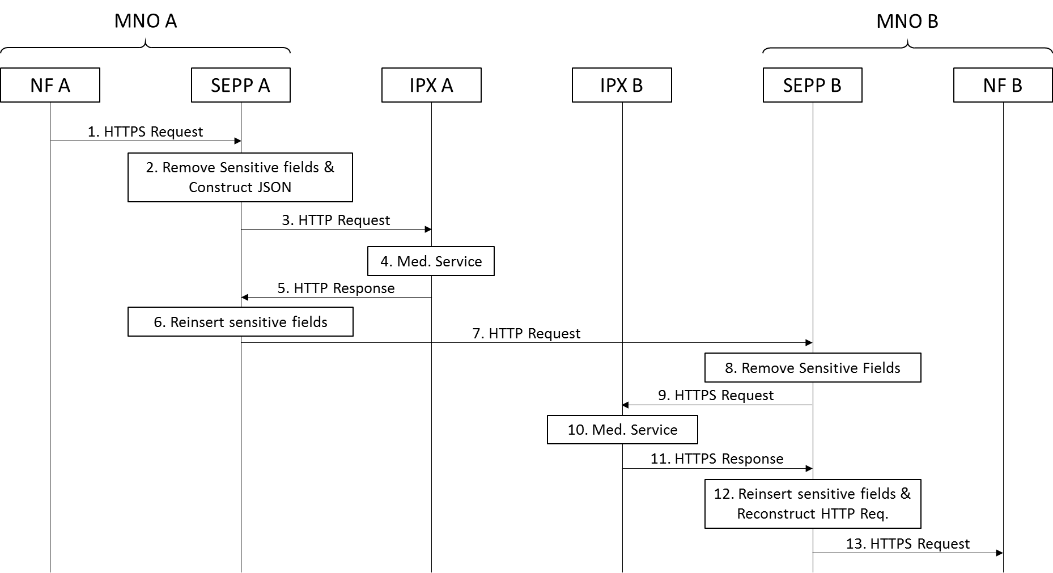
Figure 6.5.3-1: Mediation service using JOSE end-to-end encryption

6.5.4 Migration paths after accepting this solution
One possible drawback of the solution is that it will 'stick' even past its due date. The solution provides therefore proposes to name the mediation service in 3GPP specs. By standardizing a name, it becomes possible to migrate to a newer service by using a service under the newer name and migration remains under control of 3GPP. Investments in existing services and SEPPs will not be affected and IPX providers can distinguish themselves by operating the newer service.

6.5.5 Possible deployments
In this solution, it is always assumed that the SEPP is located in the MNO domain and the mediation service is located in the IPX domain. As a drawback, there is an additional message exchange between the SEPP in the MNO domain and the mediation service in the IPX domain. There are two possible deployments that alleviate this problem:
- Colocation of the SEPP in the IPX domain: This is a likely deployment scenario for smaller operators, but should not be the standard preferred option.
- Colocation of the mediation service in the MNO domain: In this deployment, the mediation service is run as a service on premise for the MNO. This is a deployment scenario for larger operators, but will depend on the willingness of IPX providers to run their service offsite.

6.5.6 Evaluation
This solution has a number of drawbacks:
- It introduces additional messages (in total 4 if mediation is used twice);
- The SEPP needs to either keep state for removing / reinserting the sensitive fields;
- TLS handshake for HTTP request will take time and messages;
- MNO needs to operate both a connection to IPX Mediation Service and a 'direct' connection to MNO peers (both can be over the same IPX network, but doesn't have to go there).
On the other hand:
- It mostly reuses standard HTTP, etc. making it relatively easy to implement;
- Works with end-to-end security, also if different from what is presented here;
- Offers a migration path;
- Does not expose the sensitive information to the IPX provider, while making mediation services possible;
- Can be specified within the timeframe available;
- Allows IPX providers to continue to offer their services, even if end-to-end security is used.

6.6 Solution #6: Policies for protection on the N32 interface

6.6.1 Introduction
Editor's note: Each solution should list the key issues that it addresses. There may be references to the key issues different from 'X' (when addressing more than one key issues).

6.6.2 Solution details
Editor's Note: This section has multiple options for provisioning of protection policy in the SEPP. Formatting of this clause is needed to list out the options in a readable way.
A message protection policy determines which part of a certain message is integrity protected, which part of a certain message is confidentiality protected, and which part of a certain message is modifiable by IPX providers. For application layer protection of messages on the N32 interface, the SEPP applies message protection policies.
Editor's Note: The specification of the protection policy is in scope of CT4. SA3 requires that the granularity is at service level or more fine-grained. Whether 'per subscription' is relevant, is to be discussed between SA3 and CT4. Other details are for CT4 to decide.
If the SEPP neither has nor obtains a policy applicable for a specific message, the SEPP applies a default policy.
Editor's Note: Which IEs are protected according to the default policy is for further study.
For the protection of a specific message, an NF may include a message protection policy applicable for that specific message into the message.
The SEPP retrieves a message protection policy from the NRF, if operator configuration requires, e.g. when the SEPP has no message protection policy available for a message to be sent on N32.
Editor's Note: It is for further study whether the procedure is a service offered by the NRF.
The SEPP also supports local configuration of message protection policy, e.g., by OA&M system. Configuration may occur during initial provisioning of SEPP or through dynamic updates any time the policy needs an update e.g., due to network configuration change.
The SEPP sends message protection policy error messages to NFs or the NRF if operator configuration requires, e.g. for the case that the SEPP has no policy applicable for a specific message.
It is up to operator configuration how the SEPP behaves if more than one policy applicable for a specific message are available to the SEPP.

6.6.3 Evaluation
Editor's note: The evaluation is FFS

6.7 Solution #7: Signaling based provisioning of message protection policy in partner SEPPs

6.7.1 Introduction
Editor's note: Each solution should list the key issues that it addresses. There may be references to the key issues different from 'X' (when addressing more than one key issues).

6.7.2 Solution details
The signaling based provisioning and update of the message protection policy in a roaming partner SEPP allow the two SEPPs to share each other network's protection policy information.
This scheme is useful in scenarios where a local SEPP obtains its message protection policy information through an out of band mechanism such as via the OA&M interface or from a central repository, and not via in-band scheme such as for e.g. embedded in HTTP messages from Network functions themselves.
When the local SEPP in a network gets its initial copy of the message protection policy or if there is an update in the network that resulted in an update to its copy of the message protection policy the local SEPP initiates a handshake with each of its remote partner SEPPs in different networks. It provides its version of the protection policy to each of them. In the response, the SEPPs in the remote network may decide to provide the latest version of its message protection policy.
A mutually authenticated TLS connection is used for protecting SEPP to SEPP signaling messages over N32. TLS is e2e between two SEPPs with no intermediaries in between.
In the following illustration, Registration Request message flow from clause 13.5 in TS 33.501 is reused.
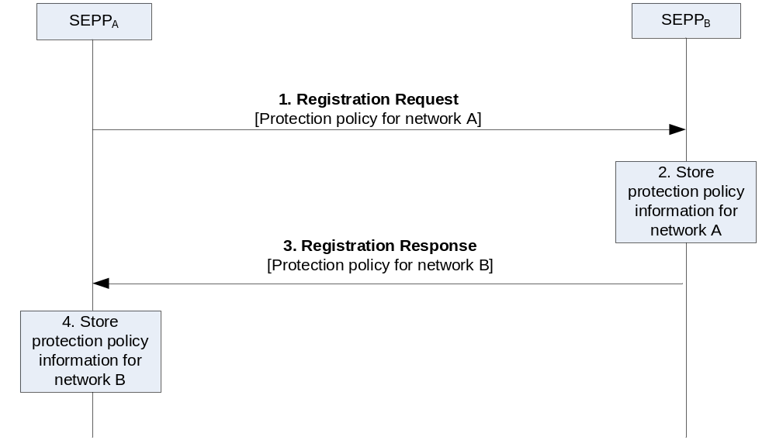
Figure 6.7-1: Signaling based provisioning of message protection policy in partner SEPPs
1. The SEPP which initiated the TLS connection sends a Registration Request message to the responding SEPP including the its message protection policy for protecting the NF service messages belonging to its network.
2. The responding SEPP stores the received message protection policy for network A.
3. The responding SEPP sends a Registration Response message to initiating SEPP including its message protection selected security mechanism for protecting the NF service messages belonging to its network.
4. The initiating SEPP stores the message protection policy for network B.

6.7.3 Evaluation
Editor's note: The evaluation is FFS

6.8 Solution #8: Inter PLMN routing and TLS: Solution Options

6.8.1 Introduction

This solution addresses Key Issue #18: Inter-PLMN routing and TLS.6.8.2 Bump in the TLS
In this solution option, TLS seems to be end-to-end from an NF point of view, but is forced to be terminated in the SEPPs instead. This is made possible by providing the SEPPs with certificates representing the remote PLMN, signed by their own CA. This either requires a large number of pre-provisioned certificates, certificate creation on the fly, multilevel wild card certificates or the certificates would have to include the actual IP of SEPP.
Pros: No changes to current specifications.
Cons: Unorthodox solution, should work technically but may introduce implementation issues. The solution needs to be repeated for possible SEPP-IPX, IPX-IPX TLS usage.

6.8.3 TLS tunnel or VPN from NF to SEPP
In this solution, the inter-PLMN service request would be in http plain text but sent to the SEPP over TLS (stunnel, etc.).
Alternatively, the transport layer protection does not need to be a TLS tunnel but could be any "VPN" connection that can be authenticated and that provides sufficient security.
Pros: Solves TLS issues in SEPP, same approach could be used between PLMN and IPX.
Cons: Adds requirements for NFs as a separate setup for the NF-SEPP tunnel is needed. It would not work if QUIC is introduced in a future release.

6.8.4 Using local SEPP FQDN in request URI
In this solution option, the URI would always point to the next-hop and hence TLS could be terminated in an ordinary way. The actual target NF FQDN could be carried in some other place in the header or body of the message.
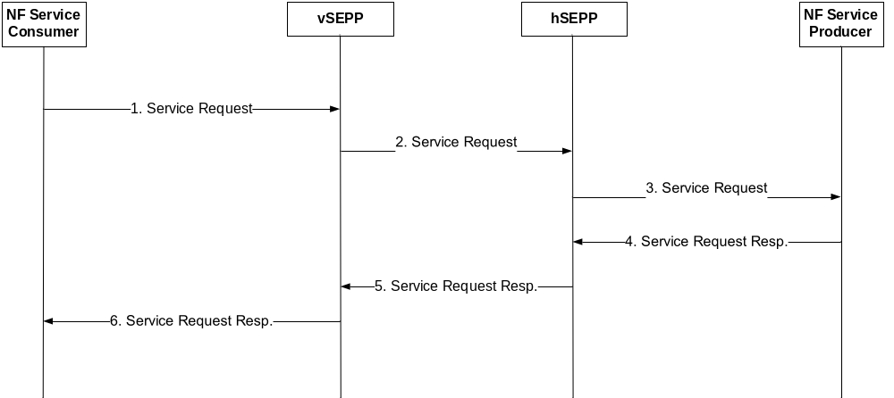
Figure 6.8.4-1: Message routing in roaming scenarios
NOTE: IPXs not depicted for the sake of clarity.
The message flow for this solution is the following, see also Figure 6.8.4-1:
1) The consumer NF initiates the service request towards the local vSEPP URL, target PLMN FQDN is carried in message header or body.
2) The vSEPP forwards the service request towards the next-hop URL. The next-hop URL may be either an IPX proxy or the SEPP of the roaming partner.
3) The hSEPP forwards the service request to the URL of the target producer NF.
4) The producer NF sends the response back to the URL of the local hSEPP.
5) The local hSEPP forwards the service request towards the next-hop URL. The next-hop URL may be either an IPX proxy or the SEPP of the roaming partner.
6) The vSEPP forwards the response to the consumer NF
Pros: Solves TLS termination issues.
Cons: Requires changes to current SA2 and CT4 specifications.

6.8.5 Mapped FQDN in request URI
This solution introduces added functionality to SEPP.
During NF service discovery in inter-PLMN communication, the involved elements perform the following actions:
1. The consumer NF in the serving PLMN requests the service discovery from its own NRF for a producer NF in the home PLMN.
2. The NRF sends a discovery request to the home NRF. Inter-PLMN message exchange between NRFs happens through cSEPP and pSEPP via N32.
3. The home NRF returns the producer NF's FQDN, e.g. "pNF.foreign_network.tld", and sends the response back to the requesting NRF via the pSEPP.
4. Depending on operator policy, the pSEPP may rewrite the producer NF's FQDN inside the discovery response if necessary, for topology hiding, e.g. "rewritten_pNF.foreign_network.tld".
5. The pSEPP transfers the discovery response via N32 to the cSEPP.
6. The cSEPP, of which the internal interface has FQDN "cSEPP.own_network.tld", rewrites the producer NF's FQDN to a new unique FQDN consisting of a unique label as first element of FQDN and the cSEPP FQDN as suffix: "label.cSEPP.own_network.tld". The "label" can be any unique label that the cSEPP can translate back to original producer NF's FQDN. This unique label in the cSEPP that maps to original producer NF's FQDN can be called a Rendezvous Point at the cSEPP.
7. The cSEPP sends the discovery response including the new FQDN to its own NRF, which will in turn forward this information to the consumer NF.
8. The consumer NF resolves the received FQDN to the IP address of the cSEPP.
9. The consumer NF sets up a TLS connection to the IP of cSEPP. The hostname is the FQDN received from local NRF.
10. The cSEPP authenticates towards the consumer NF using a wildcard certificate for "*.cSEPP.own_network.tld"
11. The cSEPP rewrites the hostname in the HTTP request, e.g. to "rewritten_pNF.foreign_network.tld"
12. The pSEPP rewrites the hostname in the HTTP request, e.g. to "pNF.foreign_network.tld", establishes a TLS connection to producer NF unless it already exists and sends the message to the corresponding producer NF.
Similarly whenever a callback URI is provided during subscription for notification(s), or other scenarios (e.g PDU session creation at H-SMF by a V-SMF where V-SMF provides a callback URI of the PDU session representation at the V-SMF), the SEPP at the receiving side rewrites the authority part of the URI with a new unique FQDN consisting of a unique label and cSEPP FQDN as suffix.
Pros: Solves TLS termination issues without the need for multilevel wildcard certificates
Cons: Additional functionality to SEPP. Also requires either a FQDN mapping table to be kept in SEPP or a new encoding scheme for flattening the original remote FQDN to an acceptable DNS label [6].

6.8.6 Evaluation
For Key issue #18: Inter-PLMN routing and TLS, solution option "Using local SEPP FQDN in request URI" of Solution #8 is SA3's recommendation for normative work.

6.9 Solution #9: N32 message anti-spoofing within the SEPP

6.9.1 Introduction
Editor's note: Each solution should list the key issues that it addresses. There may be references to the key issues different from 'X' (when addressing more than one key issues).

6.9.2 Solution Details
As the first point of contact for incoming signalling messages on N32, it is the responsibility of the Security Edge Protection Proxy to protect the PLMN and its NFs from malicious messages. Such messages might contain spoofed JSON content within the HTTP body in order to obtain unauthorized service access or obtain information about the topology of a given PLMN. Therefore, SEPP is able to perform anti-spoofing on incoming messages, enforcing the following plausibility checks:
- Matching of MNC and MCC: If MCC and MNC or PLMN-ID is contained in an incoming message on N32, the receiving SEPP verifies that the combination of MCC and MNC is valid.
- Validation of the originating SEPP's certificate: The receiving SEPP validates the TLS certificate of the originating SEPP. This includes matching of the originating FQDN with the one that the certificate was issues for.
- Matching of MNC and MCC and SEPP FQDN: If MCC and MNC or PLMN-ID is contained in an incoming message on N32, the receiving SEPP verifies that the originating SEPP's FQDN matches the one expected for the contained PLMN-ID.
- Matching of SUPI and expected SUPI-range: If the SUPI is contained in an incoming message on N32, the receiving SEPP verifies that it is either within the operators own SUPI-range or the pre-configured SUPI-range of an associated roaming partner.
In case any of the above-mentioned checks fail, the SEPP discards the incoming message.

6.9.3 Evaluation
Editor's note: The evaluation is FFS

6.10 Solution #10: Mitigation against fraudulent registration attack between SEPPs

6.10.1 Introduction
This solution addresses Key Issue #3: Fraudulent registration message over N32 interface.

6.10.2 Solution Details
To mitigate this attack, the VSEPP generates a secret based on the certificate which negotiated between SEPPs and the PLMN ID (MCC and MNC in NF ID), or the VSEPP generates a signature by using the PLMN ID and its private key. The VSEPP sends the secret or signature together with the PLMN ID to the HSEPP through the N32 message. The HSEPP verifies the secret based on the certificate and the PLMN ID, or verify the signature based on the serving network's public key and the PLMN ID. The HSEPP sends a response to the VSEPP through the N32 message.

6.10.3 Evaluation
Editor's note: The evaluation is FFS

6.11 Solution #11: Security policy provisioning for SEPP

6.11.1 Introduction
Editor's note: Each solution should list the key issues that it addresses. There may be references to the key issues different from 'X' (when addressing more than one key issues).

6.11.2 Solution Details
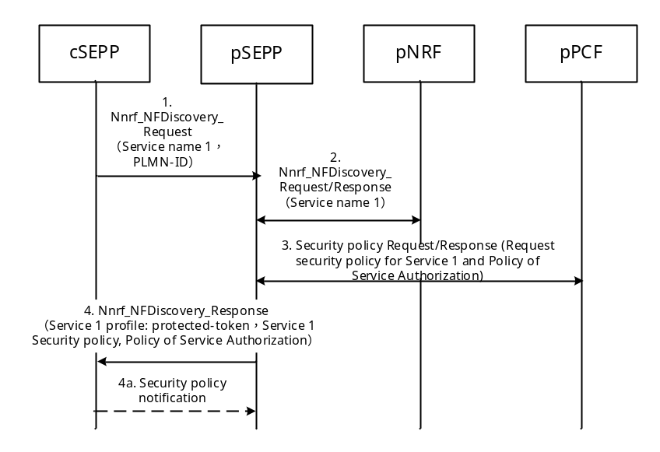
Figure 4.3.X-1: Security policy provisioning for SEPP
1. The cSEPP (the SEPP in the consumer PLMN) sends a service discovery request to the pSEPP (the SEPP in the producer PLMN). The service discovery request message includes the name of the required service (service 1) and the PLMN-ID of the producer PLMN.
2. The pSEPP sends the discovery request message to the pNRF. The pNRF generates the authorization token of the service 1, and send it to the pSEPP.
3. The pSEPP sends a security policy request message to the pPCF. The pPCF returns the security policy of the service 1 and the security policy of service authorization to the pSEPP.
4. The pSEPP sends the security policy of service 1, the security policy of service authorization and the protected (e.g. encrypted) token in the service discovery response message. The pSEPP protects the token based on the security policy of service authorization.
4a. Upon receipt of the service discovery response message from the pSEPP, the cSEPP verifies the token in the response message based on the security policy of service authorization. In addition, the cSEPP may send a security policy notification message based on its own configuration, which includes cSEPP-supported security policies.

6.11.3 Evaluation
Editor's note: The evaluation is FFS

6.12 Solution #12: End-to-end data protection in hop-by-hop network communication links
Editor's Note:
- Entities generating and distributing the public/private keys mentioned in this solution need to be clarified;
- For the proposed solution Call Flows need to be added.

6.12.1 Introduction
Consider a hop-by-hop network communication link, e.g., in a 5G or 4G IPX network, whose nodes correspond to IPX entities. In particular, such a link corresponds to N32 interface in 5G. Assume that data is arranged in a signaling message as a sequence of information elements (IEs), e.g., as a sequence of AVPs in the 4G Diameter protocol. For example, IEs can be implemented as JSON elements.
Signaling messages go from source to destination via specified intermediate peers which can be authorized to read or modify (change or delete) the IEs or can add the new ones. The communication links thus have an intrinsic hop-by-hop nature and, as such, can be protected in the hop-by-hop manner (e.g., by TLS tunnels over http in 5G or by IPSec tunnels in 4G). However, such hop-by-hop protection does not ensure end-to-end integrity protection with non-repudiation and traceability of changes. Neither does it ensure that only authorized nodes should perform changes in a signaling message. Neither does it ensure that only authorized nodes should have read access to sensitive IEs.

6.12.2 Integrity protection with non-repudiation and traceability of changes
The solution described in this clause ensures end-to-end integrity protection with non-repudiation by using hash functions and digital signatures. Each node receives only the last signaling message meant to be received by that node, after all the changes performed by previous nodes along the link, along with some auxiliary information.
The signaling message received by any node along the link is verified as authentic if and only if all included digital signatures are verified as valid. In that case, the receiving node also learns and verifies as authentic all the change operations performed by previous nodes in the respective received signaling messages. It also verifies as authentic any information about the nodes (e.g., their identity attributes) associated with the respective digital signatures. Non-repudiation is ensured by digital signatures, with respect to this associated information. Digital signatures are performed only by the nodes adding or modifying the IEs in a signaling message.
The solution is defined as follows:
1. If a node adds a new IE to the sequence, then it associates to it an index that is different from the indexes of other IEs in the sequence, before sending the new IE to the next node. In particular, this relates to the source node.
2. If a node modifies a received IE, by changing or deleting its value, then it associates to the modified IE a hash0 value of its original value, without modifying its index, before sending it to the next node. Here, the hash0 function must be collision-resistant, e.g., a cryptographic hash function, or, if IE is very short, an identity function, which is not one-way.
3. If a node does not modify a received IE, then it forwards it to the next node in the same form.
4. If a node neither adds new IEs nor modifies the existing IEs in a received signaling message, then it forwards the received signaling message as a whole to the next node.
5. If a node adds or modifies at least one IE in a signaling message, then it computes a hash value of the concatenation of the hash0 values of all added or modified IEs including their indexes. Then, it computes a digital signature on the resulting hash value, by applying the respective private key, and adds a new IE containing the digital signature together with the indexes of the added or modified IEs. Here, the hash function must be a cryptographic hash function, which is both collision-resistant and one-way.
6. Each computed digital signature should include anti-replay protection mechanisms (e.g., based on nonces).
7. Upon receiving a signaling message, each receiving node verifies all the digital signatures included in the signaling message, by iteratively exploiting the associated hash0 values of the original values of modified IEs and by applying the respective public keys for verification.
8. The method can be applied to all or to only selected IEs in a signaling message, where the selection should be performed by the nodes adding new IEs.

6.12.3 Integrity protection with non-repudiation, traceability of changes, and authorization
In the solution described in clause 4.3.x.2, each receiving node can locally store the authorizations of all previous nodes for performing the changes in a signaling message and can then verify the consistency of the traced operations by comparing them with the stored authorizations. However, the local storage and update of authorizations can be impractical, especially if nodes belong to different domains. If classical digital signatures are used, then an inter-operator public-key infrastructure (PKI) is required, which may be impractical.
A more effective and efficient method, using attribute-based cryptosystems is described in the following:
- Authorization rights of a node for performing the changes in a signaling message are expressed by an access policy in terms of the node attributes (e.g., their identity or domain attributes).
- Such an access policy is (dynamically) embedded in a digital signature of a node by using attribute-based signatures (ABS) or identity-based signatures (IBS) [3]. The node attributes are embedded in the node private key for signing.
- In ABS, there is a common public key for signature verification and a multiplicity of private signing keys.
- An ABS signature can be verified as valid if and only if the embedded node attributes satisfy the embedded access policy and the signed information is authentic.
- Such write authorization rights are then verified by verifying a digital signature and by checking if the access policy embedded in the digital signature is compliant with the write access policy associated with an IE (e.g., as an integral part of IE value).

6.12.4 Confidentiality protection with authorization
Confidentiality of sensitive IEs can be protected by using encryption. The objective is that the source node, or any intermediate node adding new sensitive IEs to a signaling message, should encrypt these IEs in such a way that only the further nodes along the link that are authorized to read these IEs (including the destination node) are in possession of the respective private decryption key. Classical solutions are not satisfactory due to impractical key management.
A more effective and efficient method, using attribute-based cryptosystems is described in the following:
- Confidentiality of selected IEs with authorized access to decryption keys is achieved by applying attribute-based encryption (ABE) or identity-based encryption (IBE), where the relevant read access policy is (dynamically) embedded in ciphertext and the node attributes in its decryption key (ciphertext-policy ABE – CP-ABE) [9]. Preferably, both CP-ABE and ABS should use the same public and private keys (ABES) [10]. Alternatively, the relevant node attributes is embedded in ciphertext and the access policy in the node decryption key (key-policy ABE – KP-ABE) [8].
- In ABE, there is a common public key used for encryption and a multiplicity of private decryption keys.
- In ABE, the decryption can work if and only if the embedded node attributes satisfy the embedded access policy. This means that the read authorization rights are thus ensured automatically.
- ABE should be used for establishing a common shared key for a symmetric-key encryption/decryption. The same key is automatically shared by the encryption node all authorized decryption nodes. Moreover, this key can be used as static, together with a key-derivation function in order to generate dynamic session keys for encryption.
- The integrity protection of modified and re-encrypted IEs should be performed on ciphertexts, in order to enable for the nodes that are not authorized to decrypt/read encrypted IEs to verify the integrity of these IEs.

6.13 Solution #13: Content and structure of protection policies

6.13.1 Introduction
A protection policy determines which part of a certain message is integrity protected, which part of a certain message is confidentiality protected, and which part of a certain message is modifiable by IPX providers. For application layer protection of messages on the N32 interface, the SEPP applies message protection policies.
In this solution, the following protection policies are introduced:
- Data-type encryption policy that specifies which data types need to be confidentiality protected;
- A modification policy that specifies which IEs are modifiable by intermediaries.
In addition, there is a mapping between the data-types in the data-type encryption policy and the IEs in NF API descriptions which is given in a NF-API data-type placement mapping. For each message, the resulting policy is the combination of the data-type protection policy with the date-type mapping and the data field modification policy. The resulting policy applies to the message after rewriting by the SEPP.
In this solution, it is not specified how the data-type mapping gets to the SEPP.

6.13.2 Data-type encryption policy
The SEPP contains an operator controlled protection policy that specifies which types of data is encrypted. The data-types defined at this moment are the following:
- Data of the type 'SUPI'
- Data of the type 'location data'
- Data of the type 'key material'
- Data of the type 'authentication token'
- Data of the type 'other data requiring encryption'
This policy is on a per roaming partner basis.
The policy contains an identifier that identifies the policy.

6.13.3 NF API data-type placement mapping
Each NF API data-type placement mapping contains the following:
- Which IEs contain data of the type 'SUPI'
- Which IEs contain data of the type 'location data'
- Which IEs contain data of the type 'key material'
- Which IEs contain data of the type 'other data requiring encryption'
Where the location of the IEs refers to the location of the IEs after the SEPP has rewritten the message for transmission over N32.
An NF API data-type placement mapping furthermore contains data that identifies the NF API, namely:
- The name of the NF
- The version
- An identifier
NOTE: Larger networks can contain multiple NFs with the same API, e.g. three AMFs. The NF API policy applies to all NFs with the same API.
The NF API data-type placement mapping resides in the SEPP.

6.13.4 Modification policy
The modification policy specifies which IEs can be modified by an IPX provider of the sending SEPP. The IEs refer to the IEs after the SEPP has rewritten the policy.
This policy is specific per roaming partner and per IPX provider that is used for the specific roaming partner.
This policy resides at the SEPP.

6.13.5 Evaluation
This solution achieves the following:
- The ability to configure the usage of encryption by the operator; and
A mechanism to activate and deactivate NF policies in the SEPP.

6.14 Solution #14: Provisioning and negotiation of protection policies

6.14.1 Introduction
In order for the SEPP to apply the protection policies, it needs to be provisioned with the:
- Data-type encryption policy;
- NF API Data-type placement mapping;
- The modification policy.
This solution proposes to manually configure the SEPP.

6.14.2 Provisioning of the policies in the SEPP
The SEPP contains an interface that the operator can use to manually configure the protection policies in the SEPP.
The SEPP is able to store and process the following policies for outgoing messages:
- A generic data-type encryption policy;
- Roaming partner specific encryption policies that will take precedence over a generic data-type encryption policy if present;
- One NF API Data-type placement mapping;
- Multiple modification policies, to handle modifications that are specific per IPX provider and modification policies that are specific per IPX provider and roaming partner.
The SEPP is also able to store and process the following policies for incoming messages:
- Roaming partner specific encryption policies;
- A modification policies per roaming partner that specifies which fields can be modified by which IPX providers.

6.14.3 Negotiation of protection policies
In addition to statically configuring the protection policies between roaming partners, two SEPPs can also exchange their modification policies in the initial handshake. In that case, both SEPPs include their modification policies in the initial handshake and store the received policies.

6.14.4 Evaluation
This solution describes how the protection policies are provisioned in the SEPP.

6.x Solution #x: <Title of solution>

6.x.1 Introduction

6.x.2 Solution Description

6.x.3 Solution Evaluation

7 Conclusions
Editor's note: this section will have conclusions based on the key issues and the proposed solutions

8 Recommendations

8.1 Recommendations for Release 15 normative work
Editor's note: this section will have recommendations for normative work in Rel.15

8.2 Recommendations for Release 16 normative work
Editor's note: this section will have recommendations for normative work in Rel.16

Annex A: Working Agreements
Editor's note: this section will be removed as the TR is completed.

SBA Offline Session – 21st May 2018
Symmetric vs. asymmetric cryptography
- Agreement: always use AEAD for SEPP-to-SEPP protection and signatures for data that may require modifications by IPX providers.
- Nokia to prepare a new CR for the TS based on S3-181948.
Session negotiation
- Agreement: use TLS key exporter to derive keys directly from TLS session.
- Agreement: same procedure to be run again (i.e. set up TLS tunnel, utilize TLS key exporter) for key refreshment.
- Agreement: no dedicated session keys for operator-to-IPX signaling (i.e. data that may require modifications by IPX providers), because JWS will use asymmetric keys that will be exchanged out of band.
- To be captured by KPN in SBA TR (or TS directly).
Initial handshake
- Agreement: Information that may be negotiated during initial handshake: cipher suites, protection policies.
- Nokia to prepare a new CR for the TS based on S3-181922.
Application of ciphering/integrity protection to JSON using JOSE
- Message protection using JOSE is agreed and to be captured in S3-181948 (revision of S3-181890, S3-181823)
- Way of documenting JOSE profiles still uncertain, to be discussed in plenary session.
- TS 33.210 seems like a good fit, but contains only TLS profiles up till now.
- Ericsson to prepare the final CR based on S3-181824.
Provisioning of protection policies for the local SEPP
- Agreement: Manual provisioning mandatory in Rel-15, dynamic procedure ruled out (may be added in Rel-16).
- KPN to rephrase their discussion document (S3-181732) into a CR against the SBA TR.
Provisioning of protection policies for the remote SEPP over N32
- Agreement: Manual provisioning mandatory in Rel-15 (e.g. part of roaming agreement), optional dynamic procedure to be defined as well by CT4.
- KPN to rephrase their discussion document (S3-181732) into a CR against the SBA TR.

SBA Offline Session – 22nd May 2018
Format of protection policies
- Question: Whether and how to split work on format details between SA3 and CT4?
- Agreement: SA3 to define the format of both policy files (for encryption and integrity protection).
- Protection Policy for Encryption:
- Agreement: Protection policy for encryption is local to SEPP, i.e. not exchanged over N32 in Rel-15 (possible exchange of policies in Rel-16 may be defined by CT4).
- Agreement: SEPP will be configured with "data location information" per NF-type, describing where to find a certain high-level data type (SUPI, location info, etc.) in the message, and "data protection policy" per roaming partner, describing how to protect these high-level data types.
- KPN to prepare a CR for the SBA TR.
- Protection Policy for Integrity:
- Agreement: Generally, same structure as Protection Policies for Encryption ("data location information" + "data protection policy", which will contain data that may be modified by IPX providers).
- Agreement: Format of integrity policy to be specified by SA3, contents to be defined by CT4. Policies will be based on re-written messages.
- Agreement: Protection Policy for Integrity may optionally be exchanged over N32 in Rel-15. Details are to be defined by CT4.
- Ericsson/Docomo/KPN to prepare a CR for the SBA TR.
Message re-writing
- General structure of the re-written message is agreed.
- Unclear whether CT4 will agree to all the details. May have comments regarding the performance of re-writing operation.
- Nokia to prepare a CR based on S3-181908 as proposal to CT4, asking them for feedback.
TLS issues relating to inter-PLMN routing
- Resolved, taken care of in S3-181957.
Malicious messages
- Agreed requirements for SEPP and NFs during SA3#91Bis in S3-181955.
- More time needed to derive solutions.
NF to NF authorization in inter-PLMN communication
- Issue is still open. Some companies questioned the use of Oauth in roaming scenarios.
IPX message modifications
- Issue is still open.
Error handling
- Issue is still open.

Annex B:
Options for integrity protection on the N32 interface
The JSON framework offers three cryptographic mechanisms for integrity protection: keyed MACs, digital signatures and authenticated encryption with additional data (AEAD). Keyed MACs and AEAD are symmetric mechanisms while digital signatures are asymmetric.
JSON Web Signatures (JWS) [11] provide integrity protection for arbitrary data using MACs or digital signatures. JSON Web Encryption (JWE) [2] represents encrypted content using JSON-based data structures. All content encryption algorithms in JWE are authenticated encryption algorithms, meaning that these algorithms provide integrity protection of the data, as well as confidentiality protection. All content encryption algorithms in JWE permit the inclusion of Additional Authenticated Data (AAD). This is data which is integrity protected but not encrypted. Therefore, JWE can be used when confidentiality protection is only required for certain IEs. Whether JWE can be used when no encryption is required is undefined.
Table B-1: Comparison of options for integrity protection on N32 interface
 | MAC | Digital signature | Authenticated encryption
Confidentiality and integrity protection achievable within JOSE framework | Yes – JWE encapsulating JWS or JWS including JWE | Yes – JWE encapsulating JWS or JWS including JWE | Yes – JWE only
Allows integrity protection only | Yes | Yes | Undefined
Signature/MAC size(s) | JWS: 256 bits – 512 bits  JWE: 128 bits | JWS: 512 bits – 2048 bits  JWE: 128 bits | JWE: 128 bits
Non-repudiation | No | Yes | No
Confidentiality protection for specific IEs | Yes | Yes | Yes
Separate keys for integrity protection and encryption | Yes | Yes | Maybe (algorithm dependent)
Allows IPX modifications | Maybe – Different keys for endpoints and IPXs preferred. | Yes - IPXs need own certificates for signing message changes. Multiple signatures can be added to one message. | Maybe – Different keys for endpoints and IPXs required.

When both encryption and integrity protection are required the simplest mechanism for integrity protection for SEPP-SEPP communications is authenticated encryption, which is provided by all JWE encryption algorithms. This requires the least overhead of all options, both in terms of bandwidth and processing. Using an authenticated encryption mechanism reduces complexity, making it less likely that mistakes will be made in securing messages. Authenticated encryption algorithms also reduce the possibility of combining integrity and encryption algorithms in an insecure manner.
When integrity protection alone is required the behaviour of JWE is undefined, so JWS is a more appropriate mechanism for messages which require no encryption. MACs are preferable to signatures in this scenario due to their reduced overhead. Alternatively, JWE could be used, with a defined "null" value for the JWE plaintext.
An IPX might not have a relationship with every operator to whom it routes a message, hence agreeing shared keys might be difficult. Therefore, digital signatures are the most appropriate integrity protection mechanism for IPX modifications. The disadvantage of using digital signatures is that they add an overhead to communications in terms of bandwidth and a cryptographic overhead for signing and verification. Therefore, addition of digital signatures to every modified message could significantly increase the IPX's processing requirements.

Annex X:
Change history
Change history
Date | Meeting | TDoc | CR | Rev | Cat | Subject/Comment | New version
05/2018 | SA3#91bis | S3-181964 | - | - | - | First draft based on living document S3-181715 | 0.1.0
05/2018 | SA3#91bis | S3-182090 | - | - | - | Updates based on new living document S3-181945 | 0.2.0
2018-06 | SA#80 | SP-180456 |  |  |  | Presented for information | 1.0.0
2018-07 |  |  |  |  |  | Editorial fixes (EditHelp + MCC) | 1.0.1
2018-08 | SA3#92 | S3-182683 |  |  |  | Version after SA3#92 incorporating changes from S3-182503 | 1.1.0
2018-09 | SA3#92bis | S3-183058 |  |  |  | Version after SA3#92bis incorporating changes from S3-183093, S3-183094, S3-183095, S3-183096  Changes Release to 16, as study is not concluded in Rel-15 timeframe | 1.2.0
2018-11 | SA3#93 | S3-183724 |  |  |  | Version after SA3#93 incorporating changes from S3-183723 | 1.3.0
2019-03 | SA3#94-AH | S3-191031 |  |  |  | Version after SA3#94-AH incorporating changes from S3-190964, S3-190965, S3-190967, S3-190968, S3-190980, S3-190981, S3-190982, S3-190983, S3-190984 | 1.4.0

