News

IALA joins 3GPP as MRP
The International Organization for Marine Aids to Navigation (IALA), an intergovernmental organization dedicated to the promotion of safe, economic and efficient movement of vessels - through harmonised Marine Aids to Navigation, has joined 3GPP as a Market Representation Partner (MRP).
Since 2018, collaborative efforts have been increasing between 3GPP and IALA. Initially through the Rel-16 Maritime Communication Services over 3GPP system study (TR 22.819) and more recently during the discussions around and prioritization of 3GPP Rel-18 and Rel-19 features, with IALA participation as a ‘vertical’ industry representative.
The arrival of the coastal states’ Ministries and Regional authorities, alongside their respective Industrial Members will help to ensure that Marine Aids to Navigation contributions are now driven even more effectively through 3GPP standards.
The 3GPP OP#54 meeting approved the MRP request from IALA unanimously, on November 14, 2025.

www.iala.int

Election update
2025 has been a year of Technical Specification Group and Working Group elections, with 17 of the 18 Chair positions and 30 of the 38 Vice-Chair posts decided this year.
Congratulations to our re-appointed and newly elected officials – For the next two years.
TSG |  |  |  | Role | Company
CT | Plenary | Peter | Schmitt | Chair | Huawei
 |  | Hiroshi | Ishikawa | Vice-Chair | NTT DOCOMO
 |  | Biao | Long | Vice-Chair | China Telecom
 |  | Francois | Piroard | Vice-Chair | Airbus
CT | WG1 | Lena | Chaponniere | Chair | Qualcomm
 |  | Behrouz | Aghili | Vice-Chair | Apple
 |  | Sung Hwan | Won | Vice-Chair | Nokia
CT | WG3 | Susana | Fernandez | Chair | Ericsson
 |  | Apostolos | Papageorgiou | Vice-Chair | Nokia
 |  | Yue | Sun | Vice-Chair | China Telecom
CT | WG4 | Yue | Song | Chair | China Mobile
 |  | Anders | Askerup | Vice-Chair | Cisco Systems
 |  | Zhijun | Li | Vice-Chair | ZTE
CT | WG6 | Heiko | Kruse | Chair | IDEMIA
 |  | Ly-Thanh | Phan | Vice-Chair | Thales
RAN | Plenary | Younsun | Kim | Chair | Samsung
 |  | Enrico | Buracchini | Vice-Chair | Telecom Italia
 |  | Jerome | Vogedes | Vice-Chair | T-Mobile
 |  | Xutao | Zhou | Vice-Chair | vivo
RAN | WG1 | Xiaodong | Xu | Chair | CMDI
 |  | Sorour | Falahati | Vice-Chair | Ericsson
 |  | Hiroki | Harada | Vice-Chair | NTT DOCOMO
RAN | WG2 | Diana | Pani | Chair | InterDigital
 |  | Kyeongin | Jeong | Vice-Chair | Samsung
 |  | Erlin | Zeng | Vice-Chair | CATT
RAN | WG3 | Sean | Kelley | Chair | Nokia
 |  | Lixiang | Xu | Vice-Chair | Samsung
 |  | Xudong | Yang | Vice-Chair | Huawei
RAN | WG4 | Yang | Tang | Chair | Apple Inc
 |  | Gene | Fong | Vice-Chair | Qualcomm
 |  | Shan | Yang | Vice-Chair | China Telecom
RAN | WG5 | Jacob | John | Chair | Motorola Mobility
 |  | Xiaozhong | Chen | Vice-Chair | CATT
 |  | Pradeep | Gowda | Vice-Chair | Qualcomm
SA |  | Puneet | Jain | Chair | Intel
 |  | Johannes | Achter | Vice-Chair | Deutsche Telekom
 |  | Laeyoung | Kim | Vice-Chair | LG Elec.
 |  | Tao | SUN | Vice-Chair | China Mobile
SA | WG1 | Vasil | Aleksiev | Chair | Deutsche Telekom
 |  | Yusuke | Nakano | Vice-Chair | KDDI Corp.
 |  | QUN | WEI | Vice-Chair | China Unicom
SA | WG2 | Andy | Bennett | Chair | Samsung
 |  | Dario Serafino | Tonesi | Vice-Chair | Qualcomm
 |  | Wanqiang | Zhang | Vice-Chair | Huawei
SA | WG3 | Rajavelsamy | Rajadurai | Chair | Samsung
 |  | Marcus | Wong | Vice-Chair | OPPO
 |  | Alf | Zugenmaier | Vice-Chair | NTT DOCOMO
SA | WG4 | Gilles | Teniou | Chair | Tencent
 |  | Mary-Luc | Champel | Vice-Chair | Xiaomi
 |  | Tomas | Jansson | Vice-Chair | Ericsson
SA | WG5 | Lan | Zou | Chair | Huawei
 |  | Zhulia | Ayani | Vice-Chair | Ericsson
 |  | Zhaoning | Wang | Vice-Chair | China Unicom
SA | WG6 | Atle | Monrad | Chair | InterDigital
 |  | Basavaraj (Basu) | Pattan | Vice-Chair | Samsung
 |  | Jukka | Vialen | Vice-Chair | Airbus

Setting the bar high for continuity was TSG RAN WG5 who appointed Jacob John for a sixth term as the group’s Chair. He takes the record for longevity from Phil Brown, who served five terms from 2005 – 2012 as Chair.
“Following on from Phil’s long and fruitful Chairing of the group I did not expect to match that longevity. I feel that the continuity we have had in the RAN5 leadership serves this group very well. I am honoured to carry on, I never chased the record, but I am very proud to have been given a sixth term.” Said Jacob John, WG RAN5 Chair.
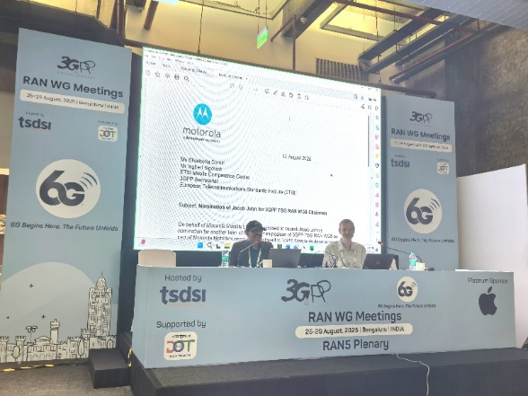
Jacob John at RAN5#108
An up-to-date list of all of the group Officials can be found at https://www.3gpp.org/3gpp-groups

RAN WGs in Bengaluru
The attendance at TSG RAN Working Group meetings, 25 – 29 August 2025, has been hailed as the largest standards meeting to have taken place in India, with over 1500 experts onsite, in person. Congratulation to TSDSI and DoT India on the event and their sustained engagement in the 3GPP 6G vision. 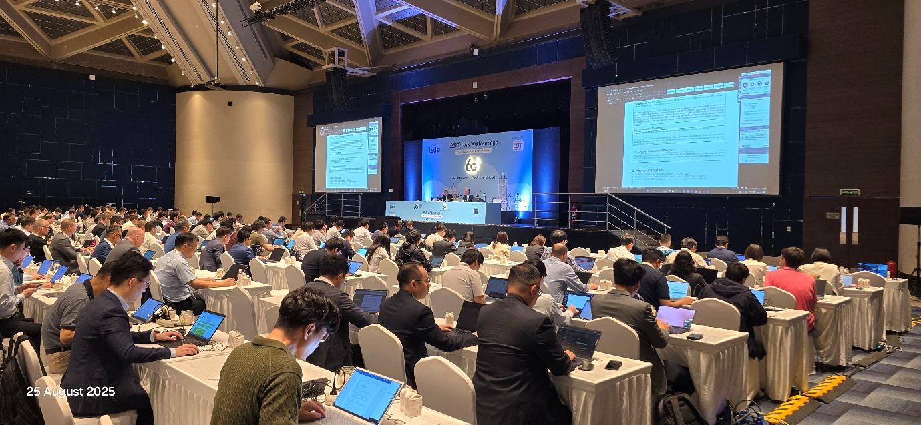

Broadcast show IBC features WG SA4
The leadership of 3GPP WG SA4 (Multimedia Codecs, Systems and Services) were recently under the spotlight at IBC2025, Amsterdam (Sept 12–15), with their presentation that covered a wide range of technologies, including:
- Immersive Voice and Audio Services (IVAS)
- Next-Generation Audio & Video
- Advanced Media Delivery over 5G
- XR and Metaverse-Oriented Services
These developments are part of 3GPP since Rel-18, enabling 5G Advanced media services to serve the TV industry.
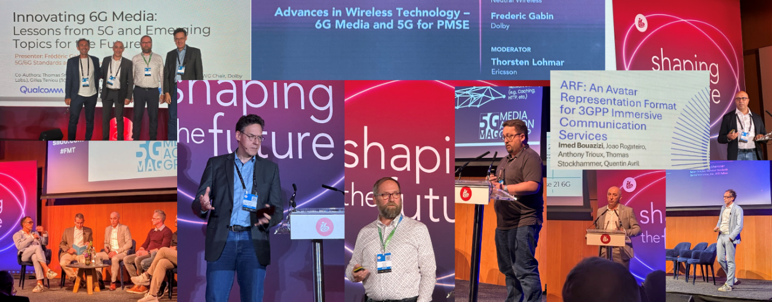

Running for good
There have been two charity runs in 2025, organised by the MCC’s Emmanuelle Wurffel. The first was in Malta’s Pembroke Natura 2000 parklands, after the close of the RAN group meetings on Wednesday, May 21.
This run in the sun raised over €7000 for hospicemalta.org.
The second run of the year took place in the early evening of Wednesday August 27, when delegates ran in memorial of Peter Hedman collecting over €10,000 for Hjärnfonden – A Swedish research body to which Peter was himself a regular donor (https://www.hjarnfonden.se/).
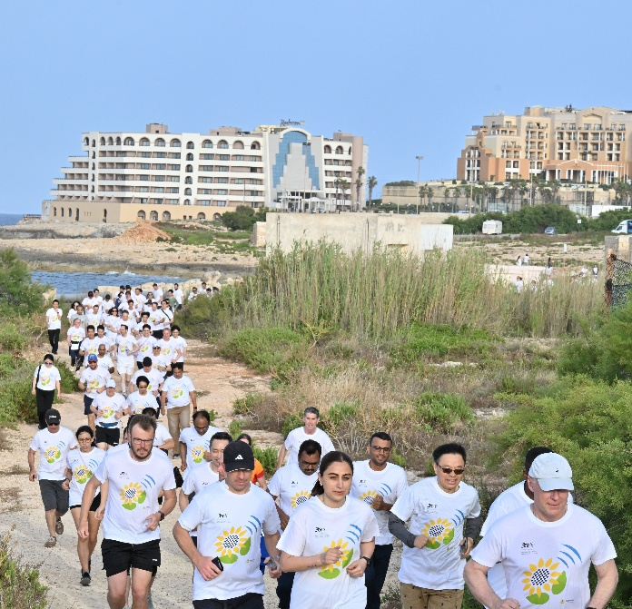 | 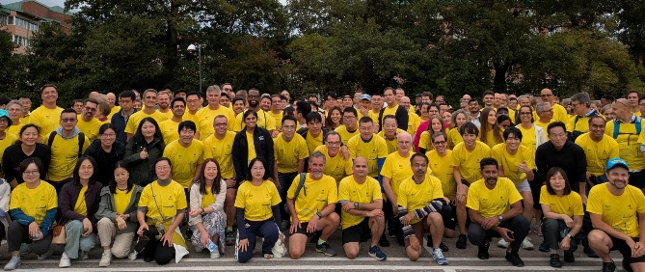

Back page: ‘NEWS’ not a look inside.

Calendar of Meetings
Here is a snapshot of upcoming TSG (Bold) and WG meetings until the end of 2026.
Meeting | Start date | City
CT, SA and RAN Working Groups | 17-Nov-25 | Dallas
CT / RAN / SA Plenaries - TSGs#110 | 08-Dec-25 | Baltimore
CT and SA Working Groups | 09-Feb-26 | TBC - India
RAN Working Groups | 09-Feb-26 | Gotenborg
WG CT6 | 17-Feb-26 | La Ciotat, FR
CT / RAN / SA Plenaries - TSGs #111 | 09-Mar-26 | Fukuoka
CT, SA and RAN Working Groups | 13-Apr-26 | Malta
WG SA4 | 11-May-26 | Montreal
CT, SA and RAN Working Groups | 18-May-26 | TBC - China
CT / RAN / SA Plenaries - TSGs #112 | 08-Jun-26 | Singapore
CT and SA Working Groups | 24-Aug-26 | Prague
RAN Working Groups | 24-Aug-26 | Maastricht
CT / RAN / SA Plenaries - TSGs #113 | 14-Sep-26 | Madrid
CT and SA Working Groups | 12-Oct-26 | Prague
RAN Working Groups | 12-Oct-26 | TBC - South Korea
CT, SA and RAN Working Groups | 16-Nov-26 | Calgary
CT / RAN / SA Plenaries - TSGs #114 | 07-Dec-26 | Boston

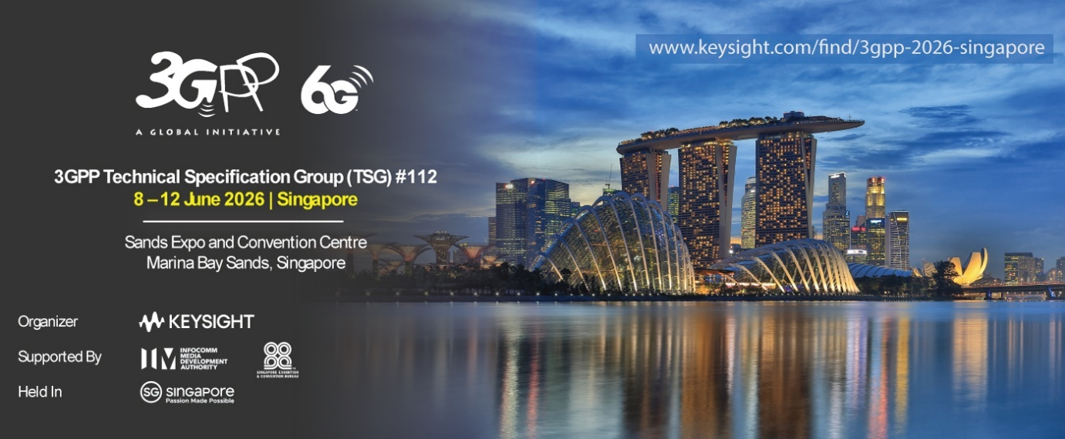
The 112th Plenary meetings will be held in Singapore, June 8-12, 2026. The meeting host, Keysight Technologies has recently sent the invitation letter to 3GPP delegates and registration is now open for the three TSGs’ meetings to be held at the Sands Expo and Convention Centre.

