Front cover
- Change date to December 2025
- Can the big image be darkened so we don’t recognise the people?
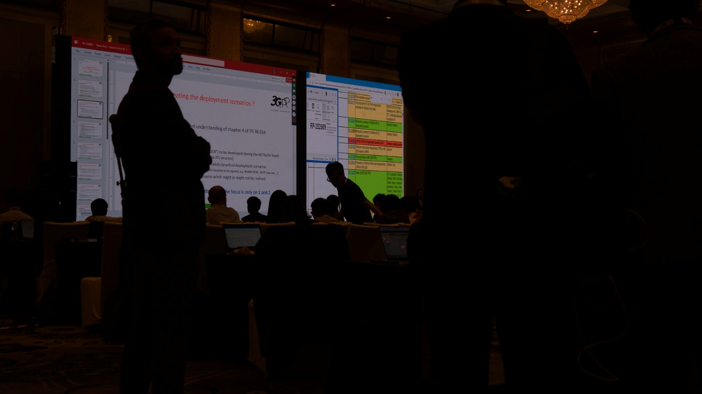
- Can we switch the top right photo to this one:




5G Advanced maturity
Release 19 represents the coming of age of 5G-Advanced. In September 2025, features and core specification work were successfully completed, with the protocols becoming stable in December – allowing the industry to implement Rel-19 effectively.
The MCC is now working on TR 21.919 - Release 19 description, which is a summary of the completed Work Items at its functional freeze.
Major Rel-19 topics bring further advances in:
Artificial Intelligence and Machine Learning (AI/ML) in networks - AI/ML in the NR Air Interface - Extended Reality & Metaverse - eMBB - Massive MIMO – Duplex Evolution - Energy Efficiency & low power solutions - RedCap - Ambient IoT – Sensing & ISAC studies - Improved uplink coverage and reduced latency. . .as well as more on Non-Terrestrial Networks and features for a variety of vertical industries’ emerging use cases.
INSIDE: This issue of Highlights contains articles that dig deeper into the work on Rel-19:
5G-Advanced XR features as the bridge towards 6G - Application Enablement for mobile Metaverse Services - The Network Digital Twin - Charging Enhancements - NAS UE policy delivery service - Low power wake-up signal and radio - WG CT3 AI/ML features. . .
<no image needed>

