**3GPP TSG-SA5 Meeting #159S5-24xxxx**

**Sophia-Antipolis, France, 17- 21 February 2025**

**Source: Ericsson**

**Title: Discussion paper on specification structure for LCM of NF Deployment**

**Document for: Endorsement**

**Agenda Item: 6.19.6**

# 1 Decision/action requested.

***The group is asked to endorse the proposal.***

# 2 References

[1] 3GPP TS 28.531: " Management and orchestration; Provisioning".

[2] 3GPP TS 28.533: " Management and orchestration; Architecture framework".

[3] 3GPP TS 28.500: " Telecommunication management; Management concept, architecture and requirements for mobile networks that include virtualized network functions".

[4] 3GPP TS 28.525: " Telecommunication management; Life Cycle Management (LCM) for mobile networks that include virtualized network functions; Requirements”.

[5] 3GPP TS 28.526: " Telecommunication management; Life Cycle Management (LCM) for mobile networks that include virtualized network functions; Procedures”.

[6] 3GPP TS 28.527: " Telecommunication management; Life Cycle Management (LCM) for mobile networks that include virtualized network functions; Stage 2”.

[7] 3GPP TS 28.528: " Telecommunication management; Life Cycle Management (LCM) for mobile networks that include virtualized network functions; Stage 3”.

[8] 3GPP TR 28.869: "Study on Cloud Aspects of Management and Orchestration v1.2.0"

# 3 Rationale

The current 3GPP SA5 specifications specify the life cycle management and orchestrations of virtualized parts of 5G Network functions using ETSI NFV MANO only, Figure 1 illustrates the relevant specifications structure for both 4G and 5G:

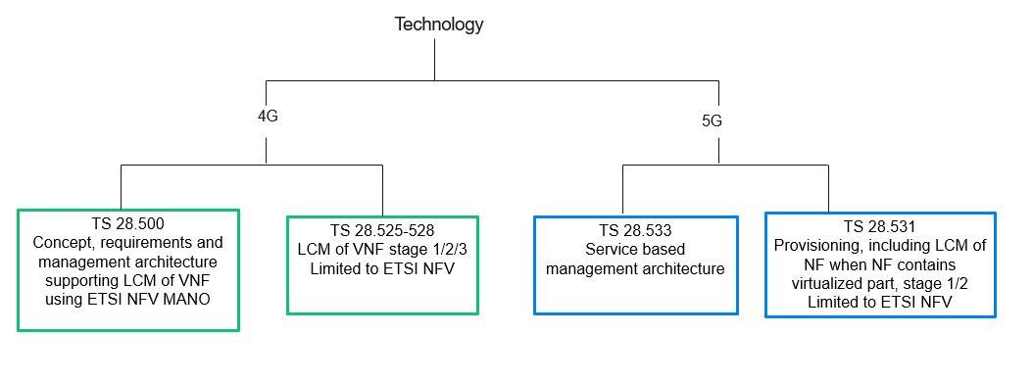

Figure 1 Current 3GPP specifications relevant to LCM of VNF

The Rel-19 study on Cloud Aspects of Management and Orchestration enhances 3GPP management system to support various industry solutions (not limited to ETSI NFV MANO) for the cloud deployment of 3GPP networks. In TR 28.869, it proppses the new terminology of NF Deployment, and the architure/use cases/requirements that allow 3GPP management system to interact with a generic orhcestraion and management entity to support LCM of NF Deployment.

For future normative work, the following specification structure is recommended, such structure provides clear separation between 4G and 5G, minimize churn on existing specifications to avoid non backward compatible issues, with a new TS as umbrella specification covering generic concept, architecture, use cases and requirements, and further branch off to existing LCM specifications when ETSI NFV MANO is used:

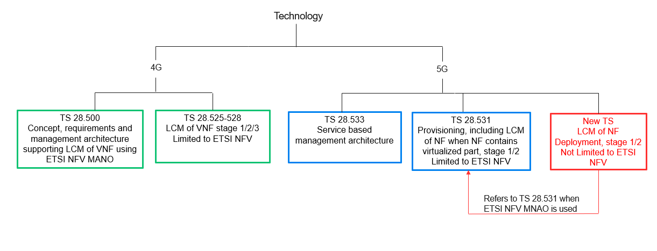

Figure 2 Proposal of 3GPP specificaiton structure to support LCM of NF Deployment

# 4 Detailed proposal

The group is asked to endorse the recommendation as below:

Recommendations:

* Propose a new TS to capture concept and terminology, architecture, use cases, requirements to support LCM of NF Deploymenent(s) not limited to ETSI NFV, with reference to TS 28.531 for the requirements, use cases and procedures when ETSI NFV MANO is used.
* Update existing TS 28.531 if needed to cover the cloud native aspects in ETSI NFV scope.