**3GPP TSG-SA5 Meeting #154 *S5-24xxxx***

Changsha, China, 15 - 19 April 2024

**Source: Ericsson**

**Title: Discussion paper on modelling 5GC**

**Document for: Endorsement**

**Agenda Item: 6.19.13**

# 1 Decision/action requested

***In this box give a very clear / short /concise statement of what is wanted.***

# 2 References

[1] [S5-241032](https://www.3gpp.org/ftp/TSG_SA/WG5_TM/TSGS5_153/Docs/S5-241032.zip) Discussion paper on management support for 5G Core

[2] 3GPP [TS 29.510](https://portal.3gpp.org/desktopmodules/Specifications/SpecificationDetails.aspx?specificationId=3345) 5G System; Network function repository services; Stage 3.

[3] 3GPP [TS 28.541](https://portal.3gpp.org/desktopmodules/Specifications/SpecificationDetails.aspx?specificationId=3400) Management and orchestration; 5G Network Resource Model (NRM); Stage 2 and stage 3

[4] 3GPP [TS 23.501](https://portal.3gpp.org/desktopmodules/Specifications/SpecificationDetails.aspx?specificationId=3144) System architecture for the 5G System (5GS)

# 3 Rationale

## 3.1 Introduction

This contribution is based on the discussion paper on management support for 5G Core presented at #153 meeting, see [S5-241032](https://www.3gpp.org/ftp/TSG_SA/WG5_TM/TSGS5_153/Docs/S5-241032.zip) reference [1]. The intention is to include all 5GC defined network functions in the 5GC NRM. During the discussion the group observed that a proposal should avoid duplication of information. This discussion paper revisits the current way the 5GC is modelled and proposes a new way of modelling 5GC avoiding duplication.

The 5G system is described as a service-based architecture and a reference point architecture as shown in respectively Figure 3.1.1 and 3.1.2. Figure 3.1.1 shows a 5G system where the 5GC control plane network functions interact via service-based interfaces. The service-based interfaces are dynamically controlled/managed by the NRF, which keeps a repository of all 5GC network functions, see TS 29.501 reference [2]. The management system does not need to be directly involved in the lifecycle management of the 5GC control plane functions and interfaces. From a modelling point of view the management system manages fault and performance of all 5GC control plane network functions, UPF and (R)AN.



Figure 3.1.1: Non-Roaming 5G System Architecture [4]

Figure 3.1.2 shows a 5G system where the 5GC network functions interact via reference points. In this scenario there is no capability to dynamically control the lifecycle of network functions and the interfaces. The reference point interfaces are static/less dynamic and are configured through the management plane.



Figure 3.1.2: Non-Roaming 5G System Architecture in reference point representation [4]

## 3.2 Observations.

**Observation 1**: The current 5GC model only represents the reference point representation of a 5G CN (Figure 3.1.2). Introduction of new network functions requires specification of a new individual/dedicated network function IOC and new end-point IOC(s).

**Observation 2:** The properties of all 5GC end-points specified in TS 28.541 [1] are always identical (applies to 69 EPs only N3 also includes an additional property). There is no need for this level of modelling as the attributes required are the same, the only difference is the IOC name.

**Observation 3**: A named EP (IOC) extends the properties of the abstract IOC *EP_RP* with localAddress and remoteAddress.

**Observation 4:** Any extension of the current 5GC UML model requires significant updates and increases the risk of mistakes being made.

**Observation 5:** Subject to deployment, the EP addresses may be managed by 3GPP Mgmt. System or some external function or service. For the former, the configuration is done via the writable attributes localAddress and remoteAddress. For the latter, the assigned values are accessible via read-only attributes localAddress and remoteAddress. For example, 5GC deployments with NRF would be read-only.

## 3.3 Potential solutions

**Solution 1:** Use model driven approach, a common IOC with interface specific data. See Figure 3.3.1. The new IOC should be documented in TS 28.622/623 as it is a common definition. As the interfaceType is used with 5GC a reference to clause 5 in TS 28.541 may be sufficient documentation. The EP IOCs in the 28.541 clause 5 are to be removed.

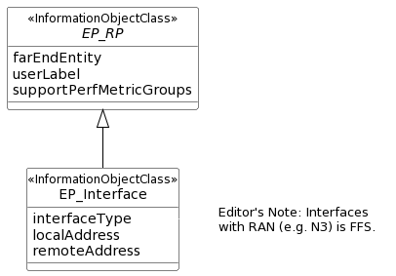

Figure 3.3.1a: Example of generic class with added property interfaceType

An interfaceType identifies the interface protocol which for a 5GC can be any one of N2, N4, N5, N6, N7, N8, N9, N1, N12, N13, N14, N15, N16, N17, N20, N21, N22, N26, S5C, S5U, Rx, MAP_SMSC, NLS, NL2, N27, N31, N32, N60, N33, Npc4, Npc6, Npc7, N88x, Npc8, N58, N59, N40, N41, N42, N28, N61, N62, N63, N84, N85, N86, N87, N89, N96, NL3, NL5, NL6, NL9, N3mb, N19mb, N4mb, Nmb9, N16mb, N11mb, Nmb1, SM12, SM13, SM14, N34.

The generic EP_Interface class has to be connected to a generic class that represents any one of the 5GC network function IOCs, this needs to be done with a new <<ProxyClass>> as shown in Figure 3.3.1b.

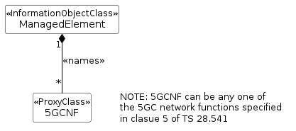

Figure 3.3.1b: 5GC NRM containment/naming relationship

A generic view of the transport with the EP_Interface and 5GCNF is shown in Figure 3.3.1c

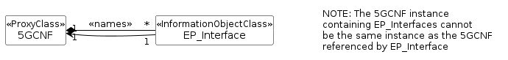

Figure 3.3.1c: Transport view of a 5GC network function with all other 5GC network functions

To address observation 5 the attribute table may be modified and the localAddress/remoteAddress are made CM instead of Optional. The ‘CM’ with constraint that both localAddress/remoteAddress must be supported “if the 3GPP Mgmt. Systems supports EP management”.

|  |  |  |  |  |  |
| --- | --- | --- | --- | --- | --- |
| Attribute name | S | isReadable | isWritable | isInvariant | isNotifyable |
| localAddress | CM | T | T**/F (NOTE)** | F | T |
| remoteAddress | CM | T | T**/F (NOTE)** | F | T |
| NOTE: The isWritable qualifier is "T" if the attribute is configurable via 3GPP Mgmt. System.  The isWritable qualifier is "F" otherwise. | | | | | |

**Solution 2:** Use a new dataType definition for EP and add new attribute to the ManagedFunction IOC. The new dataType and the new IOC should be documented in TS 28.622/623 as it is a common definitions. As the eP_Interface is used with 5GC ManagedFunction a reference to clause 5 in TS 28.541 may be sufficient documentation. The EP IOC in the 28.541 clause 5 are to be removed.

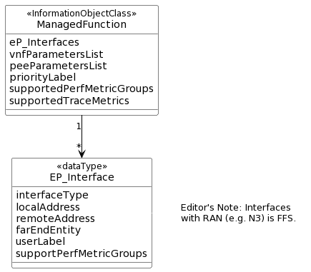

**Figure 3.3.2: ManagedFunction with added property eP_Interfaces**

The solution to have a simpler UML representation of all 5GC network function is shown in Figure 3.3.1b is applicable. Since the managed function includes the eP_Interface information no separate transport view is required to be shown.

**Solution 3:** Use a new dataType definition for EP and add new attribute to all 5GC NF’s. For example, the attribute eP_Interface is added to the AMF IOC. The new dataType should be documented in TS 28.622/623 as it is a common definition and eP_Interface is added all of the 5GC network functions in clause 5 of TS 28.541. The EP IOCs in the 28.541 clause 5 are to be removed.

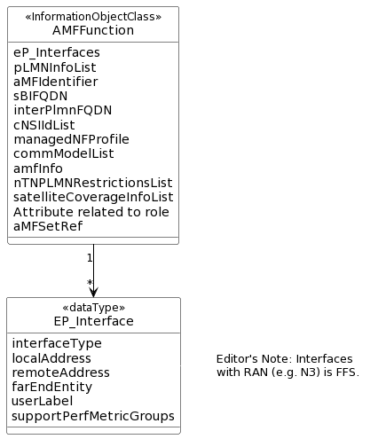

Figure 3.3.3: Example of a 5GC network function (AMF) with added property eP_Interfaces

The solution to have a simpler UML representation of all 5GC network function is shown in Figure 3.3.1b is applicable. Since a named ManagedFunction (e.g., AMF) includes the eP_Interface information no separate transport view is required to be shown.

## 3.4 Discussion

In a model driven approach, the common information (common attributes) is modelled in an IOC (solution 1) or in a dataType (solution 2 and 3) allowing the definitions to be re-used by other IOC(s).

Both solution 1 and 2 allow the number of IOCs with same information to be reduced. Solution 1 allows EP_Interface to be pre-configured as is the case in the current specification, while in solution 2 and solution 3 an actual named ManagedFunction must exist in the management system to be able to configure the EP_interface.

Solution 1 models the transport view in a simpler way than it is currently while in solution 2 and 3 the transport view is not explicitly modelled, but information in contained in the 5GC managed network functions.

## 3.5 Conclusion

As solution 1 does not change the current behaviour, the group recommends solution 1.

## Annex A UML code

**UML Code solution 1**

@startuml

skinparam backgroundColor white

skinparam classBackgroundColor white

skinparam classBorderColor black

skinparam Shadowing false

skinparam noteBackgroundColor white

skinparam noteBorderColor white

skinparam arrowColor black

skinparam ClassStereotypeFontStyle normal

hide circle

abstract class EP_RP <<InformationObjectClass>> {

farEndEntity

userLabel

supportPerfMetricGroups

}

class EP_Interface <<InformationObjectClass>> {

interfaceType

localAddress

remoteAddress

}

EP_RP <|-- EP_Interface

note right of EP_Interface

Editor's Note: Interfaces

with RAN (e.g. N3) is FFS.

end note

@enduml

**UML of 5GC NRM containment/naming relationship**

@startuml

skinparam backgroundColor white

skinparam classBackgroundColor white

skinparam classBorderColor black

skinparam Shadowing false

skinparam noteBackgroundColor white

skinparam noteBorderColor white

skinparam arrowColor black

skinparam ClassStereotypeFontStyle normal

hide circle

hide members

class ManagedElement <<InformationObjectClass>>

class 5GCNF <<ProxyClass>>

ManagedElement "1" *-- "*" 5GCNF: <<names>>

note right of 5GCNF

NOTE: 5GCNF can be any one of

the 5GC network functions specified

in clause 5 of TS 28.541

end note

@enduml

**UML of Transport view of a 5GC network function with all other 5GC network functions**

@startuml

skinparam backgroundColor white

skinparam classBackgroundColor white

skinparam classBorderColor black

skinparam Shadowing false

skinparam noteBackgroundColor white

skinparam noteBorderColor white

skinparam arrowColor black

skinparam ClassStereotypeFontStyle normal

hide circle

hide members

left to right direction

class EP_Interface <<InformationObjectClass>>

class 5GCNF <<ProxyClass>>

5GCNF "1" *-- "*" EP_Interface: <<names>>

5GCNF "1" <-- "1" EP_Interface

note right of EP_Interface

NOTE: The 5GCNF instance

containing EP_Interfaces cannot

be the same instance as the 5GCNF

referenced by EP_Interface

end note

@enduml

**UML Code solution 2**

@startuml

skinparam backgroundColor white

skinparam classBackgroundColor white

skinparam classBorderColor black

skinparam Shadowing false

skinparam noteBackgroundColor white

skinparam noteBorderColor white

skinparam arrowColor black

skinparam ClassStereotypeFontStyle normal

hide circle

class ManagedFunction <<InformationObjectClass>> {

eP_Interfaces

vnfParametersList

peeParametersList

priorityLabel

supportedPerfMetricGroups

supportedTraceMetrics

}

class EP_Interface <<dataType>> {

interfaceType

localAddress

remoteAddress

farEndEntity

userLabel

supportPerfMetricGroups

}

ManagedFunction "1" --> "*" EP_Interface

note right of EP_Interface

Editor's Note: Interfaces

with RAN (e.g. N3) is FFS.

end note

@enduml

**UML Code solution 3**

@startuml

skinparam backgroundColor white

skinparam classBackgroundColor white

skinparam classBorderColor black

skinparam Shadowing false

skinparam noteBackgroundColor white

skinparam noteBorderColor white

skinparam arrowColor black

skinparam ClassStereotypeFontStyle normal

hide circle

class AMFFunction <<InformationObjectClass>> {

eP_Interfaces

pLMNInfoList

aMFIdentifier

sBIFQDN

interPlmnFQDN

cNSIIdList

managedNFProfile

commModelList

amfInfo

nTNPLMNRestrictionsList

satelliteCoverageInfoList

Attribute related to role

aMFSetRef

}

class EP_Interface <<dataType>> {

interfaceType

localAddress

remoteAddress

farEndEntity

userLabel

supportPerfMetricGroups

}

AMFFunction "1" --> "*" EP_Interface

note right of EP_Interface

Editor's Note: Interfaces

with RAN (e.g. N3) is FFS.

end note

@enduml

**End of change**