3GPP TSG-SA5 Meeting #144-e S5-22xxxx

e-meeting, 27 June – 01 July 2022

Source: Huawei

Title: Discussion on scenarios of KQIs of video uploading, remote controlling and cloud VR

Document for: Discussion
Agenda Item: 6.5.20

1 Decision/action requested
In this document the detailed description of KQI scenarios are discussed.

2 References
[1] 3GPP TR 28.863 v0.2.0: "Study on Key Quality Indicators (KQIs) for 5G service experience"
[2] 3GPP TS 26.247 "Transparent end-to-end Packet-switched Streaming Service (PSS); Progressive Download and Dynamic Adaptive Streaming over HTTP (3GP-DASH)"
[3] 3GPP TS 26.118: "Virtual Reality (VR) profiles for streaming applications".

3 Discussion
In the SI of KQI_5G the following scenarios will be studied:
- Video uploading
- Remote controlling
- Cloud VR
This document will discuss the detailed description of scenarios and make a comparison of the scenarios discussed in SA4.
3.1 Video Uploading
The service of video uploading include video generation and video uploading. Video generation related to the configuration of the device and the video codec. Video uploading related to the video uplink to the server.
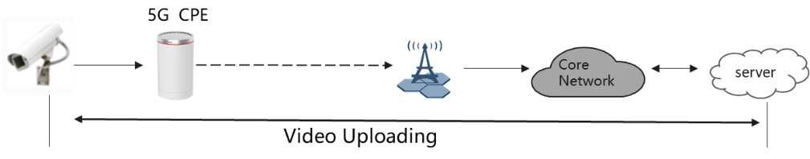
Figure 1: Video uploading scenario 1
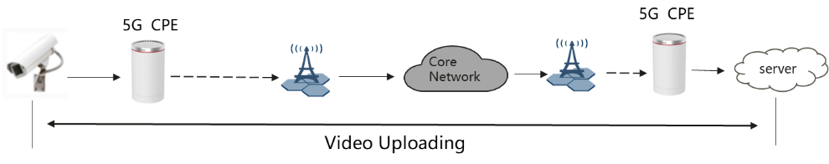
Figure 2: Video uploading scenario 2
TS 26.247 [2] from SA4 defines the QoE matrics of the service of DASH. In the following Figure 7-1: System Architecture for 3GP-DASH, the main part of DASH is to define the part from server to the client. That is the downlink media streaming from the server to the client. Currently no standardized metrics for uplink streaming are defined. So the service of video uploading and the defined DASH in [2] is different. Video uploading is mainly for uplink of the video while the QoE matrics for DASH is for downlink. The KQI of the video uploading will be studied in SA5 besed on the collected information from the application layer or calculated from other source e.g. KPI. If certain new QoE matrics is needed, LS could be sent to SA4 for cooperation.

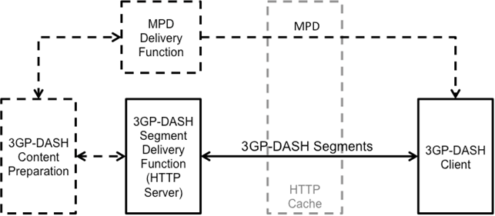

3.2 Remote controlling
In remote controlling scenarios, real-time interaction services are involved. URLLC slicing is used in 5G SA networking to meet ultra-low latency requirements. Real-time interactive services are mainly small-packet transmission services, which do not require network bandwidth but require ultra-low latency. For industrial-grade URLLC services, unqualified delay may cause service failures instead of performance problems. Therefore, it is important to analyze the delay fulfillment boundary. The network side needs to ensure that the delay is lower than the boundary instead of the absolute value of the delay. For example, if the SLA requirement is 10 ms, the evaluation focuses on ensuring that most service measurements are within the 10 ms boundary, or the proportion that exceed the delay boundary is as low as possible.
Remote controlling services include video uploading, video playing and PLC (Programmable Logic Controller) controlling. Video Uploading is introduced separately. KQIs of Video playing could be studied based on the DASH in TS26.247 [2]. In remote controlling the scenario of PLC controlling will be studied. It is not in the scope of SA4 (the main objectives of the 3GPP TSG SA WG4 (SA4) are the specifications of codecs for speech, audio, video, graphics and other media types related to emerging services such as extended realities (XR) and gaming, as well as the system and delivery aspects of such contents.). We will mainly focus on the network support for the certain service. The KQIs for remote controlling should be studied and defined in SA5.
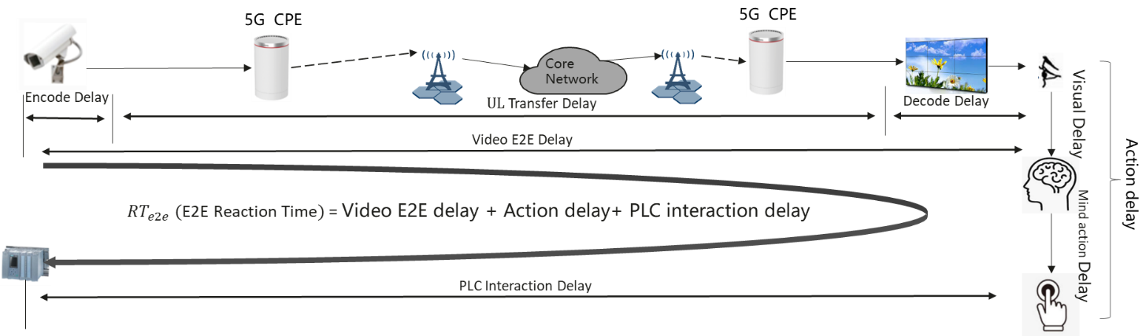

3.3 Cloud VR
In TS 26.118 [3] VR matrics are introduced as the scenarios in the Figure 9.2.1-1: Client reference architecture for VR metrics in [3] from OP1 to OP5 as listed below.
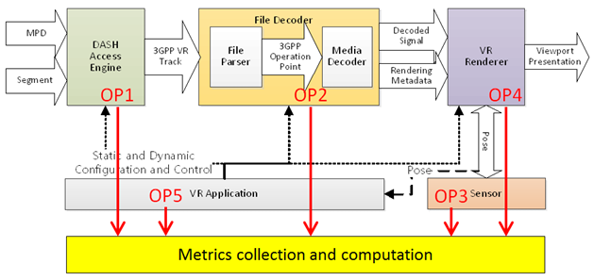
OP1 (DASH access engine):
- A sequence of transmitted network requests, each defined by its transmission time, contents, and the TCP connection on which it is sent
- For each network response, the reception time and contents of the response header and the reception time of each byte of the response body
- The projection/orientation metadata carried in network manifest file if applicable
- The reception time and intended playout time for each received segment
OP2 (file decoder):
- Media resolution
- Media codec
- Media frame rate
- Media projection, such as region wise packing, region wise quality ranking, content coverage
- Mono vs. stereo 360 video
- Media decoding time
OP3 (sensor):
- Head pose
- Gaze direction
- Pose timestamp
- Depth
OP4 (render)：
- The media type
- The media sample presentation timestamp
- Wall clock counter
- Actual presentation viewport
- Actual presentation time
- Actual playout frame rate
- Audio-to-video synchronization
- Video-to-motion latency
- Audio-to-motion latency
OP5 (VR application):
- Display resolution
- Max display refresh rate
- Field of view, horizontal and vertical
- Eye to screen distance
- Lens separation distance
- OS support, e.g. OS type, OS version
Furthermore, not all of the above listed matrics are defined as QoE matrics. The defined metrics are from the following three aspects:
- Comparable quality viewport switching latency
- Rendered viewports metric
- VR Device information
Note that the metric functionality is based on the QoE metrics concept in 3GP-DASH [2], but further extended to also cover VR-specific metrics.
The KQIs for cloud VR could be studied based on the QoE matrics in TS26.118. If any more matrics are needed for OAM, LS could be sent to SA4 to consider defining the new QoE matrics.

4 Detailed proposal
It is proposed that the description of the details of the scenarios of video uploading, remote controlling and cloud VR be added in TR 28.863 issue #2.

