3GPP TSG SA WG5 Meeting 137-e TDoc S5-213429

electronic meeting, online, 10 - 19 May 2021

Source: Ericsson

Title: External exposure via BSS

Document for: Approval
Agenda Item: 6.5.6

1 Decision/action requested
Approve the contribution.

2 References
[1] 3GPP TS 28.824 Study on on network slice management capability exposure

3 Rationale
Exposure of service data to companies that are external to the operator are regulated by contracts. Different customers may have access to different management capabilities. It may differ on what attributes/policies/intents are allowed to be changed, in which value ranges changes are allowed and which performance metrics are allowed to be exposed.
The role of the BSS in this proposal is to check the authorisation for the actions that a customer would like to do and that the customer does not get information that is not according to the contract. This as it is not foreseen that the network and service layers will have contract information per customer.

4 Detailed proposal
First change

3.3 Abbreviations
For the purposes of the present document, the abbreviations given in 3GPP TR 21.905 [1] and the following apply. An abbreviation defined in the present document takes precedence over the definition of the same abbreviation, if any, in 3GPP TR 21.905 [1].
BSS Business Support System
CSP Communication Service Provider
NOP Network OPerator

First change

4 Overview

4.X General

4.X.1 Concepts related to network management capability exposure

4.x.1.y Exposure via BSS

4.x.1.y.1 General
Exposure of service data to companies that are external to the operator are regulated by contracts. Different customers may have access to different managment capabilities. It may differ on what attributes/policies/intents are allowed to be changed, in which value ranges changes are allowed and which performance metrics are allowed to be exposed.
The slice data with the ServiceProfile is located in the network manager.
Even if the external interface always goes via BSS, there are different scenarios for how a customer, e.g. vertical, can influence the ServiceProfile.
The capabilities required from a Vertical have to be the same on the interface between NOP Network manager and CSP Service manager. The external interface is external to the administrative domain of the operator, while te internal interface is inside the administrative domain of the operator.

4.x.1.y.2 Exposure scenarios
Scenario 1: The NOP may interface to an external CSP that are doing the service management and have a machine to machine interface between the CSP’s "service manager" and the NOP’s "network manager" via BSS.
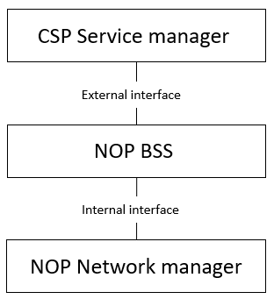
Figure 4.x.1.y.2-1 Service to network interface beeing an external interface
Scenario 2: The CSP might have a machine to machine interface towards their customers (e.g. a vertical) via their BSS. The CSP needs to have an interface towards NOP from their “service manager”. The NOP may have a machine to machine interface between the "service manager" and the "network manager" via BSS.
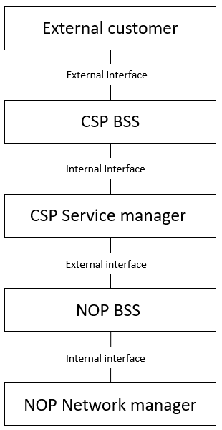
Figure 4.x.1.y.2-2 External customer interface to CSP
Scenario 3: The operator may have interface to other companies that are buying services and have machine to machine interface to the operators’s "service manager" via BSS.
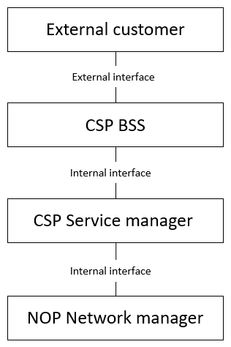
Figure 4.x.1.y.2-3 BSS to customer interface being an external interface
Considering scenario 1, 2, and 3 the needs of an external customer always has to be reflected on the internal interface between NOP Network manager and CSP Service manager no matter how many companies are in the chain between the NOP and the External customer, Actions from a Vertical must be possible on the interface between NOP Network manager and CSP Service manager.
The management capabilities that an external customer (e.g. Vertical) has access to via a BSS have to be supported on the internal interface. How the capabilties are exposed to an external customer is not subject to standardization in 3GPP.

