3GPP TSG-SA5 Meeting #137-e S5-21xxxx

Online, , 10th May 2021 - 19th May 2021

Source: Modeling Managed Management Functions

Title: Nokia, Nokia Shanghai Bell

Document for: Approval
Agenda Item: 6.4.4 (Additional NRM features)

1 Decision/action requested
Discuss and agree the content.

2 References
None.

3 Rationale
The "ManagedElement" is defined in TS 28.622 as follows:
"This IOC represents telecommunications equipment or TMN entities within the telecommunications network providing support and/or service to the subscriber."
The curent usage of the "ManagedElement" in SA5 is focused on "telecommunications equipment", also called Network Elements (NEs) or a Network Functions (NFs), hence to the boxes defined by RAN and SA2.
But a "ManagedElement" may represent also "TMN entities" and TS 28.622 contains as an example the ManagementNode" as a special kind (subclass) of "ManagedElement", what can be seen from the following statement in the definition of "ManagementNode":
"This class [ManagementNode] has similar characteristics as the ManagedElement. The main difference between these two classes is that the ManagementNode has a special association to the managed elements that it is responsible for managing."
This means that TS 28.622 contains the rules for modeling a managed Management Function (MnF) as defined in TS 28.533. An example of a managed MnF is the Management Data Anylytics Function (MDAF) which should probably be better called MDA MnF.
As outlined in clause 4.5 of TS 28.533 a MnF can be deployed as a separate entity or embedded in a NF. What is not mentioned expliciltely but self-understood is that a specific XYZ MnF can be combined with other MnFs and integrated into a management node. Three different deployment scenarios are hence possible and need to be modeled.
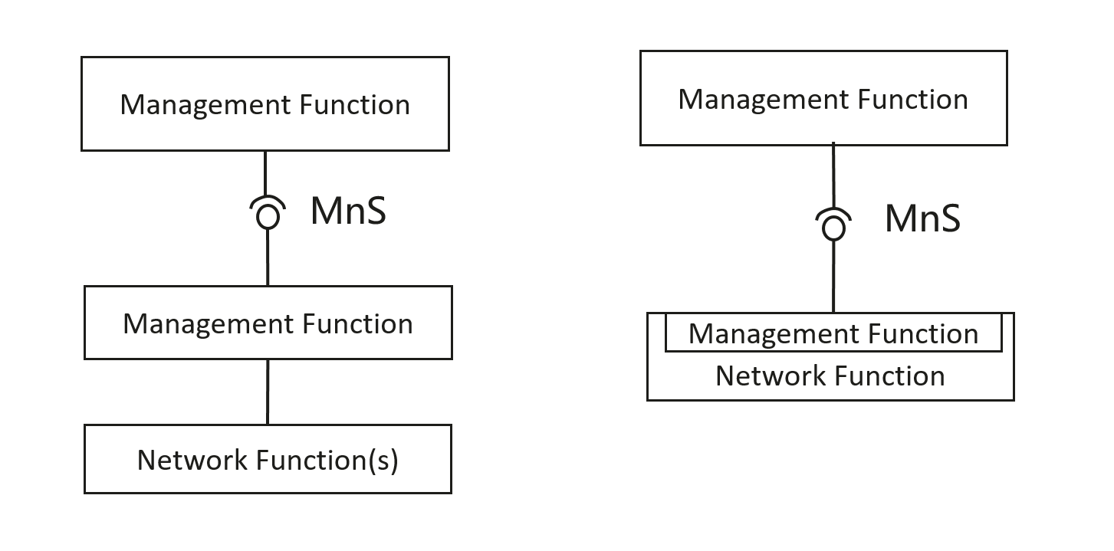
Figure 4.5.2 Examples of MnS deployment scenario

MnF is a separate entity: (left+right top management fuction) as consumer of MnS
The MnF is modeled like a NF. The "ManagedElement" name-contains one or more Management Functions, and the "MnsAgent".
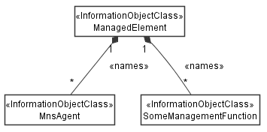
NRM Model fragment when the MnF is a separate entity

MnF is embedded in a NF: (right diagram- second management function )
Management Functions and Network Functions live happily together below a common "ManagedElement".
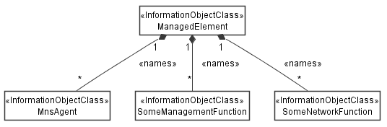
NRM Model fragment when the MnF is embedded in the NF

MnF is part of a management node (alternative 1): analytics function is part of management node.
The "ManagementNode" contains the Management Functions.
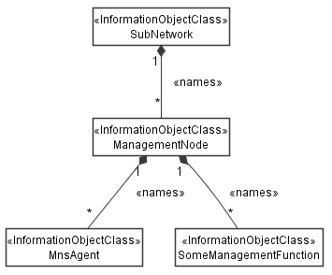
MnF is part of a management node (alternative 2):
The "SubNetwork" contains the Management Functions.

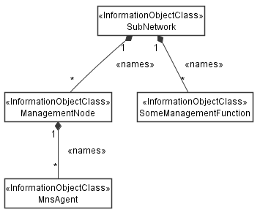

4 Detailed proposal
The term "TMN entities" does not align with SBMA terminology. Also, the fact that a "ManagedFunction" may be both a Network Function and a Management Function should be more visible in 28.622. The fact that a "ManagementNode" can contain "ManagedFunction" should be mirrored into the class diagram.

It is proposed to update 28.622 in Rel-17 with the points mentioned above in mind.

