3GPP TSG SA WG5 Meeting 136-e TDoc <TDocNumber>

electronic meeting, online, 1 - 9 March 2021

Source: China Unicom

Title: Discussion paper for NRM solution support network sharing scenarios

Document for: Approval
Agenda Item: 6.4.17

1 Decision/action requested
It proposes to discuss and endorse

2 References
[1] S5-211444 Discussion paper for NR NRM support 5G MOCN network sharing scenario
[2] S5-205304 Discuss on NR NRM update to support MOCN network sharing scenario
[3] S5-212270 RAN Sharing NRM support for MOCN
[4] S5-212197 Rel-17 CR TS 28.541 Enhance the NRM definitions to support NG-RAN network sharing

3 Rationale

3.1 Background

NR NRM for MOCN network sharing has been discussed several times, and now has formed two solutions:
- S5-212197 proposes to increase IOC PhysicalDU and NRPhysicalCellDU. It is used to indicate the part that cannot be differentiated by the operator in the sharing scenario; and modify some attributes of the existing GNBDUFunction and NRCellDU and update them to configurations.
- S5-212270 increase IOCs of LogicalDU and NRLogicalCellDU. It adds the attributes that operators need to configure independently to these new IOCs, and modify some attributes of the existing GNBDUFunction and NRCellDU and update them to configurations

3.2 Discussions and way forward

1. The existing NRM cannot meet the requirements, and IOC needs to be added to enable NRM to support operator-based configuration, which should at least include: multiple PLMN configuration, multiple CellId configuration, and some attributes in the SIB.
2. For the above two models, it can be seen that the common point is that both GNBDUFunction and NRCellDU have been modified, which means that the attributes that can be independently configured by operators in the multi-operator scenario need to be split; the main issue is that which part the new IOC should belong to.
3. According to the above two options, we propose a new option 3(figure below), which adds IOC SharedGNBDUFuntion, inherited from ManagedFunction IOC (defined in TS 28.622[30]). The SharedGNBDUFuntion includes IOCLogicalDU and IOCNRLogicalCellDU. This solution combines option 1 and option 2 together, the achitecture looks more clear.
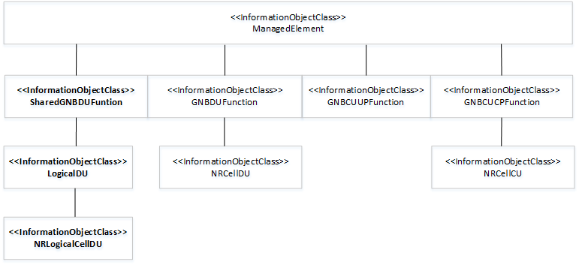
Option 3

4 Detailed proposal
Proposal#1: It proposes to discuss and endorse option 3 above NG-RAN management solution and corresponding NR NRM update to support each endorsed requirement.

