3GPP TSG-SA5 Meeting #146 S5-226xxx

Toulouse, France, 14 – 18 Nov 2022

Source: CATT

Title: Discussion paper on Satellite Charging

Document for: Discussion
Agenda Item: 7.x.x

1 Decision/action requested
Discuss the Satellite Charging.

2 References
[1] 3GPP TS 23.501: "System architecture for the 5G System (5GS); Stage 2"
[2] 3GPP TS 23.502: "Procedures for the 5G system, Stage 2".
[3] 3GPP TS 23.503: "Policy and Charging Control Framework for the 5G System".
[4] 3GPP TS 32.256: "Telecommunication management; Charging management; 5G connection and mobility domain charging; stage 2".
[5] 3GPP TS 22.261: "Service requirements for the 5G system"
[6] 3GPP TR 23.700-27: "Study on 5G System with Satellite Backhaul"
[7] 3GPP TR 23.700-28: "Study on Integration of satellite components in the 5G architecture"

3 Rationale

3.1 Background and Motivation
3GPP has discussed the support of satellite access and satellite backhaul in 5GS.
- SA1 has specified some requirements (e.g. KPIs for a 5G system with satellite access) on charging aspects for satellite access and satellite backhaul in TS 22.261[5].
- In Rel-17, SA2 has enhanced the 5GS to support satellite access and satellite backhaul as specified in the TS 23.501[1], TS 23.502[2] and TS 23.503[3].
- In Rel-18, SA2 is conducting new studies on enhancement of 5GS for satellite (see TR 23.700-27[6] and TR 23.700-28[7]) which are aimed at identifying and evaluating potential enhancements to the 5G System architecture to support satellite backhaul and integration of satellite components in the 5G architecture.
- RAN WGs has defined satellite-enabled NG-RAN in the item of NR_NTN_solutions.
To support the integration of satellite into 5GS, the charging aspect for satellite access and satellite backhaul should be considered. This contribution is to provide initial analysis on this aspect.

3.2 Discussions

3.2.1 Introduction of 5GS integrating satellite
The Fig.1 shows the high-level 5G network architecture with satellite access and satellite backhaul. In the existing 5G network with satellite enabled NG-RAN, the satellite works in transparent mode to transfer the user data. In the existing 5G network with satellite backhaul, the satellite network acts as the transport network between gNB and 5GC.
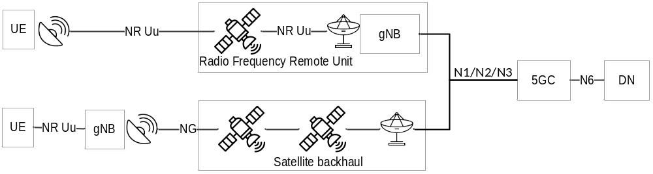
Fig.1 Satellite transparent transmission
In Rel-17, new RAT Types values "NR(LEO)", "NR(MEO)", "NR(GEO)" and "NR(OTHERSAT)" are defined in 5GC to distinguish the different NR satellite access types, where different NR satellite access can support different QoS requirements, i.e. 5QIs with different PDBs. Rel-17 also defines satellite backhaul category referring to the type of the satellite (i.e. GEO (Geostationary Orbit), MEO (Medium Earth Orbit), LEO (Low Earth Orbit) or OTHERSAT) to imply different packet delivery latency of backhaul connections over satellite network, where it is assumed that all backhaul connections for a UE are over a single satellite.
In Release 18, the satellite backhaul may involve multi-hops of ISL (Inter-satellite Link) or multi-types of backhaul connections are over different satellites as shown in the Fig.2. SA2 studied these scenarios in FS_5GSATB and concluded to further enhance 5GS to support such dynamical satellite backhaul as specified in TR 23.700-27[6].
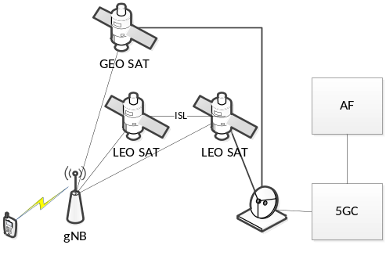
Fig.2 Satellite backhaul via ISL or different satellites
In addition, SA2 also studied the support of Satellite Edge Computing and Local Data Switching in the TR 23.700-27[6], where Satellite Edge Computing allows UEs to access edge computing services on GEO satellite for efficienct data transmission; local data switching allows the UPF onboard to locally switch UE to UE communication data, which can significantly reduce transmission latency if two UEs in a communication are served by same satellite or adjacent satellites as shown in Fig.3.
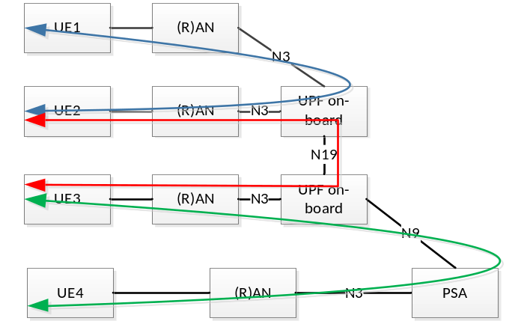
Fig.3 Local Data Switching via multiple UPFs on-board

3.2.2 Observations
According to the current work for 5GS integrating satellite, we think there maybe following impacts on charging to be considered.

3.2.2.1 Data connectivity charging
While transferring a certain volume of data via satellite access or satellite backhaul in 5GS, the charging information related to data connectivity over satellite in PDU session and QoS flows within PDU session needs to be collected. The uplink and downlink data volumes of 5G satellite traffic usage might be reported separately.
Moreover, due to dynamic satellite network topology and distinguished transmission capabilities provided by different types of satellites, the QoS control for the case of satellite backhaul needs to be enhanced. Additional information (e.g. dynamic satellite backhaul parameters such as delay and category) might also need to be collected for satellite charging.
This document proposes to consider the particular charging procedure, charging information and CDR for data connectivity charging via satellite, in charging aspect.

3.2.1.2 Mobility charging
A PLMN may have both terrestrial 3GPP access and satellite 3GPP access. In this scenario, separate N2 instances are handling separate access type nodes. However, the coverage of the satellite access network may span over the coverage of the terrestrial access network.
In order to support the NR satellite, the RAT "NR(LEO)", "NR(MEO)", "NR(GEO)" and "NR(OTHERSAT)" have been specified in 5GC to distinguish the different NR satellite access types in TS 23.501[1]. The AMF determines the RAT Type based on an indication provided in N2 interface.
In addition, to ensure that the regulatory requirements are met, the UE location needs to be verified by AMF to enforce that the selected PLMN is allowed to operate in the current UE location. The trigger conditions in AMF for charging specified in TS 32.256 [4] may be influenced by these factors (e.g. location reporting).
This document proposes to consider the particular charging procedure, charging information and CDR for mobility charging via satellite, in charging aspect.

3.2.1.3 Satellite Edge Computing service charging
Since the edge computing services can be supported by the UPF on the GEO satellite to reduce the latency for data transmission and minimize the backhaul resources consumption, the traffic of edge computing services may be transferred via the UPF on the GEO satellite. Therefore, edge computing service charging via the satellite may need to be studied.

3.2.1.4 Local Data Switching charging
When network traffic is routed through the same satellite or adjacent satellites, three types of traffic forwarding methods are defined for UEs through Local Data Switching, i.e. UPF on-board local switching, N19-based forwarding via UPF on-board and N9-based forwarding via UPF on-board and PSA on the ground as shown in the Fig.3. Therefore, the Local Data Switching charging may need to be studied.

4 Detailed proposal
SA5 is asked to agree to investigate charging aspects on support of satellite in 5GS as following:
- Possible charging scenarios and potential charging requirements related to the satellite access and satellite backhaul;
- Potential charging solutions for the satellite access and satellite backhaul.
- investigates possible new charging aspects for the following key items:
  - QoS requirements for satellite in 5GS
  - Satellite Edge Computing via UPF on-board
  - Local Data Switching via UPF on-board
  - PCC/QoS control enhancement for dynamic satellite backhaul (e.g. new triggers)

