3GPP TSG-SA3 Meeting #107-e S3-22xxxx

e-meeting, 16 - 20 May 2022 Revision of S3-22xxxx

Source: Xiaomi, China Telecom

Title: Discussion on PC5 Key Hierarchy for ProSe U2N Relay Communication

Document for: Discussion
Agenda Item: 4.13

1 Decision/action requested
This contribution discusses the PC5 Key Hierarchy for protecting ProSe U2N relay communication.

2 References
[1] TS 33.503: “Security Aspects of Proximity based Services (ProSe) in the 5G System (5GS)”
[2] TS 33.536: “Security aspects of 3GPP support for advanced Vehicle-to-Everything (V2X) services”

3 Rationale
According to TS 33.503 v0.3.0 [1], the solutions for establishing 5G ProSe U2N communication security can be categorized into the procedure over user plane and the procedure over control plane.
As per clause TS 33.503 [1] clause 6.3.3.2.3, the key hierarchy for user plane procedure has 4 layers of keys. The keys from top to bottom are PRUK K_{NRP} K_{NRP-SESS} (NRPEK and NRPIK). By running the GBA procedure, the 5G PKMF shall use Ks(_ext)_NAF as the top-level key PRUK. Therefore, the keys for user plane procedure from top to bottom can be seen as PRUK (Ks(_ext)_NAF) K_{NRP} K_{NRP-SESS} (NRPEK and NRPIK).
As per clause TS 33.503 [1] clause 6.3.3.3.3, the key hierarchy for control plane procedure has 5 layers of keys. The keys from top to bottom are K_{AUSF_P} 5GPRUK K_{NR_ProSe} K_{relay-sess} (K_{relay-enc} and K_{relay-inc}). Actually, the top-level key K_{AUSF__P} is derived from K_{AUSF}, which is generated by running the 5G ProSe Remote UE specific authentication procedure. It means that the current key hierarchy over control plane has 6 layers of keys in total. The keys from top to bottom are K_{AUSF} K_{AUSF-P} 5GPRUK K_{NR_ProSe} K_{relay-sess} (K_{relay-enc} and K_{relay-inc}).
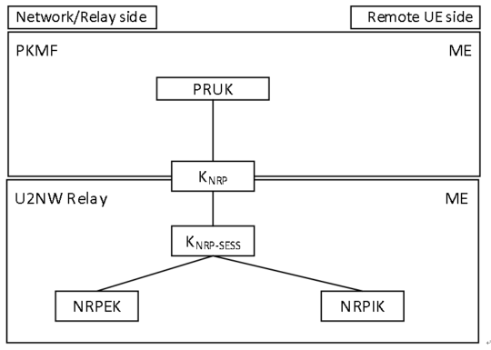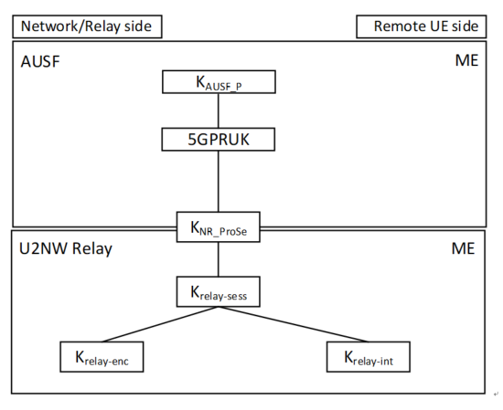
Based on the above analysis, it is identified that the control plane procedure has two extra layers of keys than the user plane procedure. The extra layers and difference between the key layers for user plane and control plane procedures woud increase the complexity of implementation on both the UE side and core network side. Therefore, the key hierarchy for user plane procedure and that for control plane procedure should be as consistent as possible.
Observation 1: The key hierarchy for control plane procedure in current TS 33.503 [1] is not aligned with the key hierarchy for user plane procedure.
Moreover, the existing key hierarchy for control plane procedure has serveral unclarities. Firstly, in the current version of TS 33.503 [1], there is no clear definition for how K_{AUSF_ P} is derived from K_{AUSF}.
Clause 6.3.3.3.2
7f. The AUSF of the 5G ProSe Remote UE and the 5G ProSe Remote UE shall derive a new K_{AUSF_P} (different from K_{AUSF}). NAS SMC procedure is not performed between 5G ProSe Remote UE and AMF of the 5G ProSe UE-to-Network Relay.
Clause 6.3.3.3.3
- K_{AUSF_P}: A key derived based on primary authentication, only used to derive 5GPRUK. It is different from K_{AUSF}.
Observation 2: There is no clear description for how K_{AUSF_ P} is derived from K_{AUSF} in current TS 33.503 [1].
Secondly, the existing solution may not correctly establish the correlation between the RSC and the ccorresponding layer of keys.
According to TS 33.536 [2] and TS 33.503 [1], 5GPRUK (control plane) or PRUK (user plane) is the root credential of security of the PC5 unicast link, which is generated or derived by running the authentication procedure. And the K_{NR_ProSe} (control plane) or K_{NRP} (user plane) is the root key established between the two entities communicating over NR PC5 unicast link.
Clause 6.3.3.3.2 (user plane key description)
- PRUK: The root credential of security of the PC5 unicast link.
- K_{NRP}: This is a 256-bit root key that is shared between the two entities that communicating using NR PC5 unicast link. It may be refreshed by re-running the authentication signalling using the long-term credentials. Nonces are exchanged between the UEs and used with the K_{NRP} to generate a K_{NRP-sess} (the next layer of keys). K_{NRP} may be kept even when the UEs have no active unicast communication session between them. The 32-bit K_{NRP} ID is used to identify K_{NRP.}
Clause 6.3.3.3.3 (control plane key description)
- 5GPRUK: The root credential derived from K_{AUSF_P} that is the root of security of the PC5 unicast link.
- K_{NR_ProSe}: This is a 256-bit root key that is established between the two entities that communicating using NR PC5 unicast link. It may be refreshed by re-running the authentication to derive a fresh 5GPRUK. SUPI shall behave the same value as parameter P0 in Annex A.7.0 of TS 33.501 [3].
Although the definitions of the keys on comparable layers in control plane and user plane are consistent in TS 33.503 [1], the derivation functions of the same level keys are somehow inconsistent. The main difference is the usage of RSC. As defined in TS 33.503 [1], in the user plane solution, Ks(_ext)_NAF is used as PRUK which is not bound with RSC, while the input parameters for deriving K_{NRP} include RSC, K_{NRP} freshness parameter 1 and K_{NRP} freshness parameter 2.
Clause 6.3.3.2.2 (user plane)
4d. The 5G PKMF of the 5G ProSe Remote UE shall generate K_{NRP} freshness parameter 2 and derive K_{NRP} using the PRUK identified by PRUK ID, RSC, K_{NRP} freshness parameter 1 and K_{NRP} freshness parameter 2. Then, the 5G PKMF of the 5G ProSe Remote UE sends a Key Response message that contains K_{NRP} and K_{NRP} freshness parameter 2 and the PC5 security policies of the relay service to the 5G PKMF of the 5G ProSe UE-to-Network Relay. This message shall include GPI if generated.
However in the control plane, the deriviation of the 5GPRUK is bound with RSC; while for deriving the K_{NR_ProSe}, the input parameters are nonce 1 and nonce 2. Since 5G PRUK is the root of security of the PC5 unicast link base on the defintion, RSC information should not be bound with 5G PRUK, but should be bound with K_{NR_ProSe}.
Annex A.2 5GPRUK derivation function (control plane)
When deriving a 5GPRUK from K_{AUSF}, the following parameters shall be used to form the input S to the KDF:
- FC = 0xXX;
- P0 = SUPI;
- L0 = length of SUPI.
- P1 = relay service code;
- L1 = length of relay service code.
The input key KEY is K_{AUSF}.
SUPI shall behave the same value as parameter P0 in Annex A.7.0 of TS 33.501 [3].
Annex A.4 K_{NR_ProSe} derivation function (control plane)
When deriving the K_{NR_ProSe} from 5GPRUK key, the following parameters shall be used to form the input S to the KDF:
- FC = 0xZZ;
- P0 = Nonce_2;
- L0 = length of Nonce_2;
- P1 = Nonce_1;
- L1 = length of Nonce_1
The input key KEY shall be 5GPRUK key.
SUPI shall be have the same value as parameter P0 in Annex A.7.0 of TS 33.501 [3].
Observation 3: The correlation between the RSC and the root key 5GPRUK in current TS 33.503 [1] is incorrect.
To address the issues in the above observations for aligning and correcting the key hierarchy over user plane and control plane, two proposals are introduced as follows.

4 Detailed proposal
Proposal 1: For control plane solution, the K_{AUSF} derived during ProSe authentication should be named and used as K_{AUSF_P}, so as to be differentiated from the K_{AUSF} derived during primary authentication. Meanwhile, the RSC should be used for deriving K_{NR_ProSe} but not be used for deriving 5GPRUK, which should be bound with the specific service type, e.g. ProSe U2N relay service.
Proposal 2: For user plane solution, one more layer in the key hierarchy over user plane should be added, i.e. PRUK should be derived from Ks(_ext)_NAF, making PRUK bound with the specific service type, e.g. ProSe U2N relay service and making it consistent with the key hierarchy for control plane.
Based on the above two proposals, it is proposed to approve the corresponding pCRs.

