3GPP TR 33.700-30 V0.3.0 (2026-02)
Technical Report

3rd Generation Partnership Project;
Technical Specification Group Services and System Aspects;
Study on Security Aspects of Satellite Access in 5G;
Phase 4
(Release 20)
 | 
The present document has been developed within the 3rd Generation Partnership Project (3GPP TM) and may be further elaborated for the purposes of 3GPP.
The present document has not been subject to any approval process by the 3GPP Organizational Partners and shall not be implemented.
This Specification is provided for future development work within 3GPP only. The Organizational Partners accept no liability for any use of this Specification.
Specifications and Reports for implementation of the 3GPP TM system should be obtained via the 3GPP Organizational Partners' Publications Offices.

3GPP
Postal address

3GPP support office address
650 Route des Lucioles - Sophia Antipolis
Valbonne - FRANCE
Tel.: +33 4 92 94 42 00 Fax: +33 4 93 65 47 16
Internet
http://www.3gpp.org

Copyright Notification
No part may be reproduced except as authorized by written permission.
The copyright and the foregoing restriction extend to reproduction in all media.

© 2024, 3GPP Organizational Partners (ARIB, ATIS, CCSA, ETSI, TSDSI, TTA, TTC).
All rights reserved.

UMTS™ is a Trade Mark of ETSI registered for the benefit of its members
3GPP™ is a Trade Mark of ETSI registered for the benefit of its Members and of the 3GPP Organizational Partners
LTE™ is a Trade Mark of ETSI registered for the benefit of its Members and of the 3GPP Organizational Partners
GSM® and the GSM logo are registered and owned by the GSM Association

Contents
Foreword 5
1 Scope 7
2 References 7
3 Definitions of terms and abbreviations 7
3.1 Terms 7
3.2 Abbreviations 7
4 Architecture assumptions 7
5 Key issues 8
5.1 Key Issue #1: Authenticated UE to exchange NAS messages with multiple satellites in split-MME architecture 8
5.1.1 Key issue details 8
5.1.2 Security threats 8
5.1.3 Potential security requirements 8
5.X Key Issue #X: <Key Issue Name> 9
5.X.1 Key issue details 9
5.X.2 Security threats 9
5.X.3 Potential security requirements 9
6 Solutions 9
6.0 Mapping of Solutions to Key Issues 9
6.1 Solution #1: Derivation of Satellite-Specific NAS keys for S&F Operation 9
6.1.1 Introduction 9
6.1.2 Solution details 9
6.1.3 Evaluation 10
6.2 Solution #2: NAS Security Context Isolation via Satellite-Specific NAS COUNT 10
6.2.1 Introduction 10
6.2.2 Solution details 11
6.2.3 Evaluation 11
6.3 Solution #3: UE context management for S&F operation 12
6.3.1 Introduction 12
6.3.2 Solution details 12
6.3.3 Evaluation 13
6.4 Solution #4: Separate NAS COUNT pair per SatelliteID within an EPS Security Context 14
6.4.1 Introduction 14
6.4.2 Solution details 14
6.4.3 Evaluation 18
6.5 Solution #5: Protection for NAS message of authenticated UE in split-MME architecture 18
6.5.1 Introduction 18
6.5.2 Solution details 19
6.5.2.1 DL NAS signalling protection 19
6.5.2.2 UL NAS signalling protection 20
6.5.3 Evaluation 20
6.6 Solution #6: Secure NAS messages via using different NAS keys in multiple satellites 21
6.6.1 Introduction 21
6.6.2 Solution details 21
6.6.3 Evaluation 22
6.7 Solution #7: Solution for NAS COUNT synchronization in store-and-forward operations 23
6.7.1 Introduction 23
6.7.2 Solution details 24
6.8 Solution #8: New specific rules to handle NAS Counter Overflow in S&F mode 25
6.8.1 Introduction 25
6.8.2 Solution details 26
6.8.2.1 Uplink case 26
6.8.2.2 Downlink case 26
6.8.2.3 Considerations on the range of NAS counters deviation between satellites 27
6.8.2.4 Message sequence 28
6.8.3 Evaluation 31
6.9 Solution #9: Secure NAS messages via one pair of COUNTs 31
6.9.1 Introduction 31
6.9.2 Solution details 32
6.9.3 Evaluation 32
6.10 Solution #10: NAS keys isolation in S&F operations 32
6.10.1 Introduction 32
6.10.2 Solution details 33
6.10.3 Evaluation 34
6.11 Solution #11: Solution to the NAS key stream re-use issue during S&F operations 34
6.11.1 Introduction 34
6.11.2 Solution details 34
6.11.2.1 Key stream separation 34
6.11.2.2 NAS COUNT synchronization 35
6.11.3 Evaluation 36
6.Y Solution #Y: <Solution Name> 37
6.Y.1 Introduction 37
6.Y.2 Solution details 37
6.Y.3 Evaluation 37
7 Conclusions 37
7.Z Key Issue #Z: <Key Issue Name> 37
Annex <A>: <Informative annex title for a Technical Report> 38
Annex <X>: Change history 39

Foreword
This Technical Report has been produced by the 3rd Generation Partnership Project (3GPP).
The contents of the present document are subject to continuing work within the TSG and may change following formal TSG approval. Should the TSG modify the contents of the present document, it will be re-released by the TSG with an identifying change of release date and an increase in version number as follows:
Version x.y.z
where:
x the first digit:
1 presented to TSG for information;
2 presented to TSG for approval;
3 or greater indicates TSG approved document under change control.
y the second digit is incremented for all changes of substance, i.e. technical enhancements, corrections, updates, etc.
z the third digit is incremented when editorial only changes have been incorporated in the document.
In the present document, modal verbs have the following meanings:
shall indicates a mandatory requirement to do something
shall not indicates an interdiction (prohibition) to do something
The constructions "shall" and "shall not" are confined to the context of normative provisions, and do not appear in Technical Reports.
The constructions "must" and "must not" are not used as substitutes for "shall" and "shall not". Their use is avoided insofar as possible, and they are not used in a normative context except in a direct citation from an external, referenced, non-3GPP document, or so as to maintain continuity of style when extending or modifying the provisions of such a referenced document.
should indicates a recommendation to do something
should not indicates a recommendation not to do something
may indicates permission to do something
need not indicates permission not to do something
The construction "may not" is ambiguous and is not used in normative elements. The unambiguous constructions "might not" or "shall not" are used instead, depending upon the meaning intended.
can indicates that something is possible
cannot indicates that something is impossible
The constructions "can" and "cannot" are not substitutes for "may" and "need not".
will indicates that something is certain or expected to happen as a result of action taken by an agency the behaviour of which is outside the scope of the present document
will not indicates that something is certain or expected not to happen as a result of action taken by an agency the behaviour of which is outside the scope of the present document
might indicates a likelihood that something will happen as a result of action taken by some agency the behaviour of which is outside the scope of the present document
might not indicates a likelihood that something will not happen as a result of action taken by some agency the behaviour of which is outside the scope of the present document
In addition:
is (or any other verb in the indicative mood) indicates a statement of fact
is not (or any other negative verb in the indicative mood) indicates a statement of fact
The constructions "is" and "is not" do not indicate requirements.

1 Scope
The present document studies the security mechanisms that permit an authenticated UE to exchange NAS messages with multiple satellites without performing UE authentication or key negotiation (NAS SMC) between the UE and satellites in split-MME architecture for Store and Forward Satellite operation.
The study of security mechanisms applies to NB-IoT NTN only.

2 References
The following documents contain provisions which, through reference in this text, constitute provisions of the present document.
- References are either specific (identified by date of publication, edition number, version number, etc.) or non-specific.
- For a specific reference, subsequent revisions do not apply.
- For a non-specific reference, the latest version applies. In the case of a reference to a 3GPP document (including a GSM document), a non-specific reference implicitly refers to the latest version of that document in the same Release as the present document.
[1] 3GPP TR 21.905: "Vocabulary for 3GPP Specifications".
[2] 3GPP TS 23.401: "General Packet Radio Service (GPRS) enhancements for Evolved Universal Terrestrial Radio Access Network (E-UTRAN) access".
[3] 3GPP TS 33.401: "3GPP System Architecture Evolution: Security Architecture".
[4] 3GPP TS 24.301: " Non-Access-Stratum (NAS) protocol for Evolved Packet System (EPS); Stage 3".

3 Definitions of terms and abbreviations

3.1 Terms
For the purposes of the present document, the terms given in 3GPP TR 21.905 [1] and the following apply. A term defined in the present document takes precedence over the definition of the same term, if any, in 3GPP TR 21.905 [1].
example: text used to clarify abstract rules by applying them literally.

3.2 Abbreviations
For the purposes of the present document, the abbreviations given in 3GPP TR 21.905 [1] and the following apply. An abbreviation defined in the present document takes precedence over the definition of the same abbreviation, if any, in 3GPP TR 21.905 [1].
<ABBREVIATION> <Expansion>

4 Architecture assumptions
The following architecture assumptions are applied to the study:
- The general features and the Split MME architecture of Store and Forward Satellite operation are described in Annex O.2 of TS 23.401 [2] are used as architecture assumptions in this study.

5 Key issues
Editor’s Note: This clause contains all the key issues identified during the study.

5.1 Key Issue #1: Authenticated UE to exchange NAS messages with multiple satellites in split-MME architecture

5.1.1 Key issue details
One of the architectural assumptions for Store and Forward Satellite operation is that when the service link is available, there is no feeder link and inter satellite link. There are two example deployment options for Store and Forward Satellite operation given in Annex O of TS 23.401 [2], i.e. Split MME architecture and Full EPC in each satellite.
For the split-MME architecture, S&F Satellite operation may involve multiple satellites allocated by an S&F Monitoring List. In this scenario, the UE context needs to be synchronized between the multiple MME-onboard(s) and the associated MME-ground. The synchronization of UE context between the MME-ground and MME-onboard(s) is out of the scope of 3GPP.
According to Annex N of TS 33.401 [3], regular LTE procedures are used to provide security between UE and network for the split-MME architecture. This means that once the UE completes an interaction with a satellite, the UE context in the satellite must be synchronized to other satellites before these satellites can perform any subsequent S&F Satellite operations with the UE. This significantly reduces the data exchange efficiency of the entire system.
Ideally, for an IoT device, once it is registered in the network and its UE context has been distributed to the satellites included in the S&F Monitoring List, the UE can exchange data with these satellites without the need for UE context synchronization between the satellites.
This key issue focuses on solutions that meet the following conditions:
- The UE context of the UE registered in the network has been provided to the satellites included in the S&F Monitoring List;
- The UE can perform Mobile Originated (MO) or Mobile Terminated (MT) data transmission with the satellites that have the UE context;
- The UE context does not need to be synchronized across the multiple satellites for supporting the MO/MT data transmissions. However, UE context synchronization may still be required for other changes not being associated with the MO/MT data transmission.

5.1.2 Security threats
If the NAS COUNTs are not synchronized across multiple satellites, an attacker may intercept and replay previously transmitted NAS messages. Since different satellites may accept outdated NAS COUNT values, the replay protection mechanism could be bypassed, leading to unauthorized actions.
Key stream may be reused if the security contexts are not well-managed across multiple satellites.

5.1.3 Potential security requirements
The 3GPP system shall support means to secure NAS messages exchange in the store and forward satellite operations.

5.X Key Issue #X: <Key Issue Name>

5.X.1 Key issue details

5.X.2 Security threats

5.X.3 Potential security requirements

6 Solutions
Editor’s Note: This clause contains the proposed solutions addressing the identified key issues.

6.0 Mapping of Solutions to Key Issues
Table 6.0-1: Mapping of Solutions to Key Issues
 | Key Issues
Solutions | 1
1 | X
2 | X
3 | X
4 | X
5 | X
6 | X
7 | X
8 | X
9 | X
10 | X
11 | X

6.1 Solution #1: Derivation of Satellite-Specific NAS keys for S&F Operation

6.1.1 Introduction
This solution addresses Key Issue #1: Authenticated UE to exchange NAS messages with multiple satellites in split-MME architecture.
This solution proposes a mechanism to derive unique NAS integrity and encryption keys for each satellite by using the satellite ID as an additional input parameter during the NAS key derivation.

6.1.2 Solution details
In this solution, it is proposed to derive distinct set of NAS keys for each satellite from the common root key K_{ASME}. The satellite-specific NAS keys are derived by the UE and the network using the KDF as specified in TS 33.220 [x].
For a serving Satellite n, the NAS integrity key K_{NASint} and the NAS encryption key K_{NASenc} are derived from the K_{ASME} with the following parameters as input:
- FC = 0xxx
- P0 = algorithm type distinguisher
- L0 = length of algorithm type distinguisher (i.e. 0x00 0x01)
- P1 = algorithm identity
- L1 = length of algorithm identity (i.e. 0x00 0x01)
- P2 = Satellite ID n.
- L2: length of Satellite ID n.
Where Satellite ID is an identifier uniquely indicating an MME-onboard. The Satellite ID of a given satellite is broadcast by the eNB within the SIB31 and the Satellite ID of the satellites that might be serving a given UE are included within the S&F Monitoring List, which is sent by the MME to indicate the satellite(s) that the UE may (re)-attempt NAS procedures (TS 23.401 clause 4.13.9.1).
As a result of using satellite-specific keys, the UE and each MME-onboard maintain independent pairs of NAS COUNT for their mutual communication. The NAS COUNTs are not synchronized with other satellites.
Upon receiving the UE context, the MME-onboard derives its satellite-specific NAS keys using its own Satellite ID. If the proposed mechanism is optionally supported, the MME-onboard can provide the UE an indicator, indicating that the separate NAS keys are implemented, together with the monitoring list. The UE derives the NAS keys for a Satellite ID immediately upon receiving the S&F Monitoring List, or when it determines to initiate a NAS procedure with a satellite present in the list with which no prior keys have been derived.
The UE and the MME-ground need to manage the multiple satellite-specific security context by associating each Satellite ID with the satellite-specific NAS keys and NAS COUNTs. When the MME-ground detects that the NAS COUNT for any satellite is about to wrap around, the MME-ground performs AKA procedure with the UE via any MME-onboard. Upon successful AKA completion, a new K_{ASME} is established. The MME-grounds then provide the new K_{ASME} to all MME-onboards in the S&F Monitoring List. The MME-onboards and the UE then derive new satellite-specific NAS keys and reset NAS COUNTs.

6.1.3 Evaluation
This solution proposed to use satellite-specific NAS keys for each satellite to prevent key stream reuse. There is no need to synchronize the NAS COUNT between satellites.
The solution has the following impacts:
- a new KDF needs to be defined;
- The UE and the MME-onboard needs to derive and store satellite-specific NAS keys;
- The UE and MME-ground needs to manage the multiple satellite-specific NAS keys and NAS COUNTs.
- If the proposed mechanism is optionally supported, the MME-onboard needs to provide the UE an indicator, indicating that the separate NAS keys are implemented, together with the monitoring list.

- The MME-ground needs to provide updated K_{ASME} to all MME-onboards in the S&F Monitoring List.
- If multiple satellites are involved, multiple NAS security contexts need to be established between UE and MME.
- This solution is not backward compatible for pre-Rel-19 UEs.

6.2 Solution #2: NAS Security Context Isolation via Satellite-Specific NAS COUNT

6.2.1 Introduction
This solution addresses Key Issue #1: Authenticated UE to exchange NAS messages with multiple satellites in split-MME architecture.
This solution proposes a mechanism ensuing different satellite using different COUNT to protect NAS message and therefore eliminates the need for real-time NAS COUNT synchronization across satellites.

6.2.2 Solution details
This solution is based on the following assumptions and principles:
- the UE and each MME-onboard maintain independent pairs of NAS COUNTs (one for uplink, one for downlink) for their mutual communication. The NAS COUNTs are not synchronized with other satellites.
Based on the above principle, the existing procedures are reused to protect the NAS message between the UE and the network. The NAS integrity and confidentiality protection algorithms are same as defined in TS 33.401 [3], with the following modification to the construction of the 32-bit COUNT input parameter:
For a serving Satellite n:
COUNT := Satellite ID n || NAS OVERFLOW || NAS SQN
Where
- Satellite ID n is the 8-bit ID of Satellite n which is an identifier uniquely indicating an MME-onboard coded as a binary coded integer value from 0 to 255 as specified in 3GPP TS 24.301 [4]. The SatelliteID identifier of a given satellite is broadcast by the eNB within the SIB31 and the SatelliteID identifiers of the satellites that might be serving a given UE are included within the S&F Monitoring List, which is sent by the MME to indicate the satellite(s) that the UE may (re)-attempt NAS procedures (TS 23.401 clause 4.13.9.1)
- NAS OVERFLOW is a 16-bit value which is incremented each time the NAS SQN is incremented from the maximum value. It is maintained for the connection with Satellite n.
- NAS SQN is the 8-bit sequence number carried within each NAS message between UE and MME-onboard n. It is maintained for the connection with Satellite n.
All other input parameters (KEY=K_{NASint}/K_{NASenc}, BEARER, DIRECTION, LENGTH) and the algorithm execution remain unchanged.
If the proposed mechanism is optionally supported, the MME-onboard can provide the UE an indicator, indicating that the separate NAS COUNTs are implemented, together with the monitoring list. After receiving the indicator, the UE knows that the NAS COUNT needs to be construct with the above method.
The UE and the MME-ground need to manage the multiple satellite-specific security context by associating each Satellite ID with the satellite-specific NAS COUNTs. When the MME-ground detects that the NAS COUNT for any satellite is about to wrap around, the MME-ground performs AKA procedure with the UE via any MME-onboard. Upon successful AKA completion, a new K_{ASME} is established. The MME-grounds then provide the new K_{ASME} to all MME-onboards in the S&F Monitoring List. The MME-onboards and the UE then derive new NAS keys by running NAS SMC, and reset NAS COUNTs.

6.2.3 Evaluation
This solution proposed to use satellite-specific NAS COUNTs for each satellite to prevent key stream reuse. There is no need to synchronize the NAS COUNT between satellites, and no change to the NAS keys.
The solution has the following impacts:
- A new NAS COUNT construction mechanism is needed;
- The UE and MME-ground needs to manage the multiple satellite-specific NAS COUNTs.
- If the proposed mechanism is optionally supported, the MME-onboard needs to provide the UE an indicator, indicating that the separate NAS COUNTs are implemented, together with the monitoring list.

- The MME-ground needs to provide updated K_{ASME} to all MME-onboards in the S&F Monitoring List.
- If multiple satellites are involved, multiple NAS security contexts need to be established between UE and MME.
- This solution is not backward compatible for pre-Rel-19 UEs.

6.3 Solution #3: UE context management for S&F operation

6.3.1 Introduction
This solution addresses Key Issue #1: Authenticated UE to exchange NAS messages with multiple satellites in split-MME architecture.
After the UE is authenticated and NAS security is established, the satellite will send a security token to the UE, which contains the UE's current context. When the UE attempts to connect to another satellite, it will provide the security token to that satellite. The satellite will use the content in the security token to reconstruct the UE context and communicate directly with the UE through secure NAS messages.

6.3.2 Solution details
UE context management procedure for S&F operation is shown in the following figure.
Figure 6.3.2-1: UE context management procedure for S&F operation
0. The security key materials used to provide confidentiality and integrity protection for security tokens used in S&F operations are pre-configured in the satellites. The security tokens are used to transfer UE contexts from one satellite to another satellite.
1. The MME-ground provides UE authentication vectors to the MME-onboards when the feeder link is available.
2. The UE and satellite perform the authentication procedure when the service link is available.
3. The UE and satellite execute the Security Mode Command (SMC) procedure after the authentication procedure.
4. The UE and satellite exchange downlink/uplink data through secure NAS messages.
5. The satellite generates a security token based on the current context of the UE, which is protected by confidentiality and integrity using the security materials received in step 0. The token contains all the information required to reconstruct the UE context in another satellite, such as NAS keys, NAS COUNTs, etc.
NOTE 1: The detailed information of the security token structure and protection mechanism will be specified during the normative phase.
6. The satellite sends the security token to the UE through a NAS message and ends the connection with the UE. The satellite does not need to store the UE context after ending the connection with the UE. The UE stores the received security token.
7. When the UE connects to another satellite, it sends an Initial NAS message to the satellite, which includes the security token.
8. The satellite decrypts and verifies the security token using the security materials received in step 0. If the verification is successful, the satellite will attempt to exchange downlink/uplink data directly through secure NAS messages.
NOTE 2: Attackers may eavesdrop on communication between UEs and satellites, record the tokens, and then resend them to other satellites. Because the tokens are encrypted, attackers are unable to successfully perform subsequent NAS communication with the satellites. However, DoS attacks caused by this cannot be avoided.
9. The satellite performs the same operation as step 5
10. The satellite and UE performs the same operations as step 6.
11. The MME-onboards and MME-ground exchange downlink/uplink data when the feeder link is available.

6.3.3 Evaluation
This solution uses the target UE as an intermediate entity to securely transmit the UE context from one satellite to another, thereby meeting the requirements of Key Issue #1.
The advantages of this method are:
- UE can connect to any satellite that supports S&F services.
The disadvantages of this method are:
- Need to specify security token.
- Existing authentication and NAS security procedures need to be enhanced to include security token sharing from network to UEs.
- Security tokens add complexity to the security procedures.
- This solution is not backward compatible for pre-Rel-19 UEs.
- The security token is susceptible to a replay attack and could enable a DoS attack against the satellite.
- Transmission of the security token will increase the latency and probability of failure for NAS messages that include the token.

6.4 Solution #4: Separate NAS COUNT pair per SatelliteID within an EPS Security Context

6.4.1 Introduction
This solution addresses Key Issue #1.
This solution is based on using separate pairs of NAS counters per Satellite ID in the EPS security context when the UE is served by multiple satellites operating in S&F mode and the UE registration remains valid even the serving satellite changes over time (i.e., the UE is not required to attach/detach in each satellite pass). The list of SatelliteID(s) in which the registration is valid is provided to the UE using the S&F Monitoring List.

6.4.2 Solution details
This solution applies to a satellite network operating in S&F mode and, it’s especially relevant for deployments based on the split MME architecture (see TS 23.402 Annex O.2) in which a UE registration remains valid across multiple satellites (unlike a full EPC deployment, where registration is only valid in one satellite).
The solution consists of enabling an option for the UE to use separate pairs of NAS counters (i.e. UL_NAS_Count and DL_NAS_Count) per SatelliteID within its EPS security context, where:
- SatelliteID is an identifier uniquely indicating an MME-onboard. The SatelliteID identifier of a given satellite is broadcast by the eNB within the SIB31 and the SatelliteID identifiers of the satellites that might be serving a given UE are included within the S&F Monitoring List, which is sent by the MME to indicate the satellite(s) that the UE may (re)-attempt NAS procedures (TS 23.401 clause 4.13.9.1)
- UL_NAS_Count is the uplink NAS counter related to the uplink NAS messages sent to the MME-onboard associated with SatelliteID.
- DL_NAS_Count is the downlink NAS counter related to the downlink NAS messages received from the MME-onboard associated with SatelliteID.
On the network side, this solution allows each MME-onboard to independently maintain its own pair of NAS counters, which shall no longer to be synchronised across the subset of the MME-onboard instances (identified each by a SatelliteID) that belong to the same logical MME in charge of the registered UE. This is depicted in Figure 6.Y.2-1, which is based on Figure O.2-1: "Split-MME" architecture for supporting Store and Forward Satellite operation for SMS and CP CIoT services” in Annex O.2 in TS 23.401.
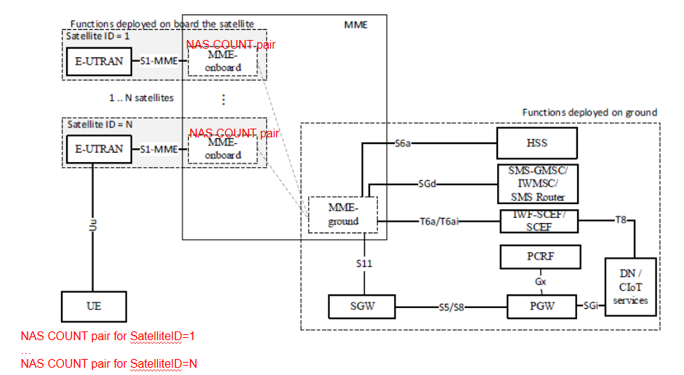
Figure 6.4.2-1: Illustration of the solution consisting on using separate NAS COUNT pairs per SatelliteID
To ensure backward compatibility with Rel-19 UEs, which will still assume that NAS counters are synchronised across the satellites of the S&F Monitoring List, the proposed solution can be introduced as an optional capability for both UE and network (NW). Therefore, a UE capable of handling separate NAS counters per SatelliteID is expected to indicate such capability to the NW and the network , if capable of handling separate NAS counters per SatelliteID, should be able to indicate the UE whether this option is activated (i.e. the UE should use separate NAS counters per SatelliteID) or deactivated (i.e. the UE shall assume NAS counters are kept synchronised). In case the NW does not support this capability, the UE shall assume that NAS counters are synchronised across the satellites of the S&F Monitoring List.
This solution also considers the use of the “SatelliteID” value as part of the NAS COUNT 32-bit value.In this respect, the padding bits of the NAS Count are filled with the SatelliteID, as illustrated in Figure 2, so thatthe NAS messages used between the UE and a given satellite cannot be replayed with another satellite given NAS COUNT values will not match.
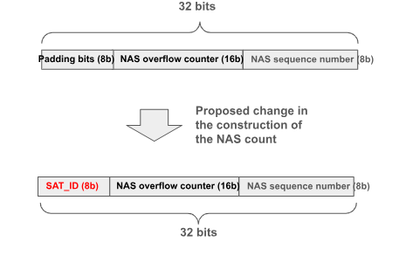
Figure 6.4.2-2: Filling NAS COUNT padding bits with SatelliteID
The activation of the EPS security context between the UE and the set of satellites of the S&F Monitoring List relies on:
(1) legacy LTE procedures for EPS security context activation as stated Annex N of TS 33.401, which is conducted between the UE and one of the MME-onboard entities, and,
(2) propagation/synchronisation of the activated EPS security context to the set of MME-onboard(s) and associated MME-ground, considering that how MME-onboard(s) interacts with MME-ground and how synchronization of the UE context between them is done is outside the scope of 3GPP, as stated in the principles of the split-MME architecture in 23.401 Annex O.2.
Accordingly, once the EPS security context is ready /synchronised in an MME-onboard, the UE and the MME-onboard can start interacting using a separate pair of NAS COUNTs. NAS COUNTs are assumed to be pre-set to zero in each MME-onboard(s).
Before any of the pairs of NAS COUNT associated with each of the satellites wraps around, the MME is expected to trigger EPS AKA run to activate fresh NAS keys. This will result in an update of the EPS security context (with the fresh NAS key and reset of NAS COUNT values) that shall be propagated/synchronised across all MME-onboard(s) and associated MME-ground in the same way that this is done when the EPS security context is established for the first time.

Figure 6.4.2-3 provides an illustrative message sequence of the proposed solution. The sequence considers a system of two satellites (Sat#A and Sat#B) utilizing the split-MME architecture. It covers the entire process, starting from the triggering of the initial attach and default PDN connectivity request through to data transfer across successive satellite coverage windows. The message sequence considers a UE using CP CIoT Optimization, for which there is no requirement to establish AS security.
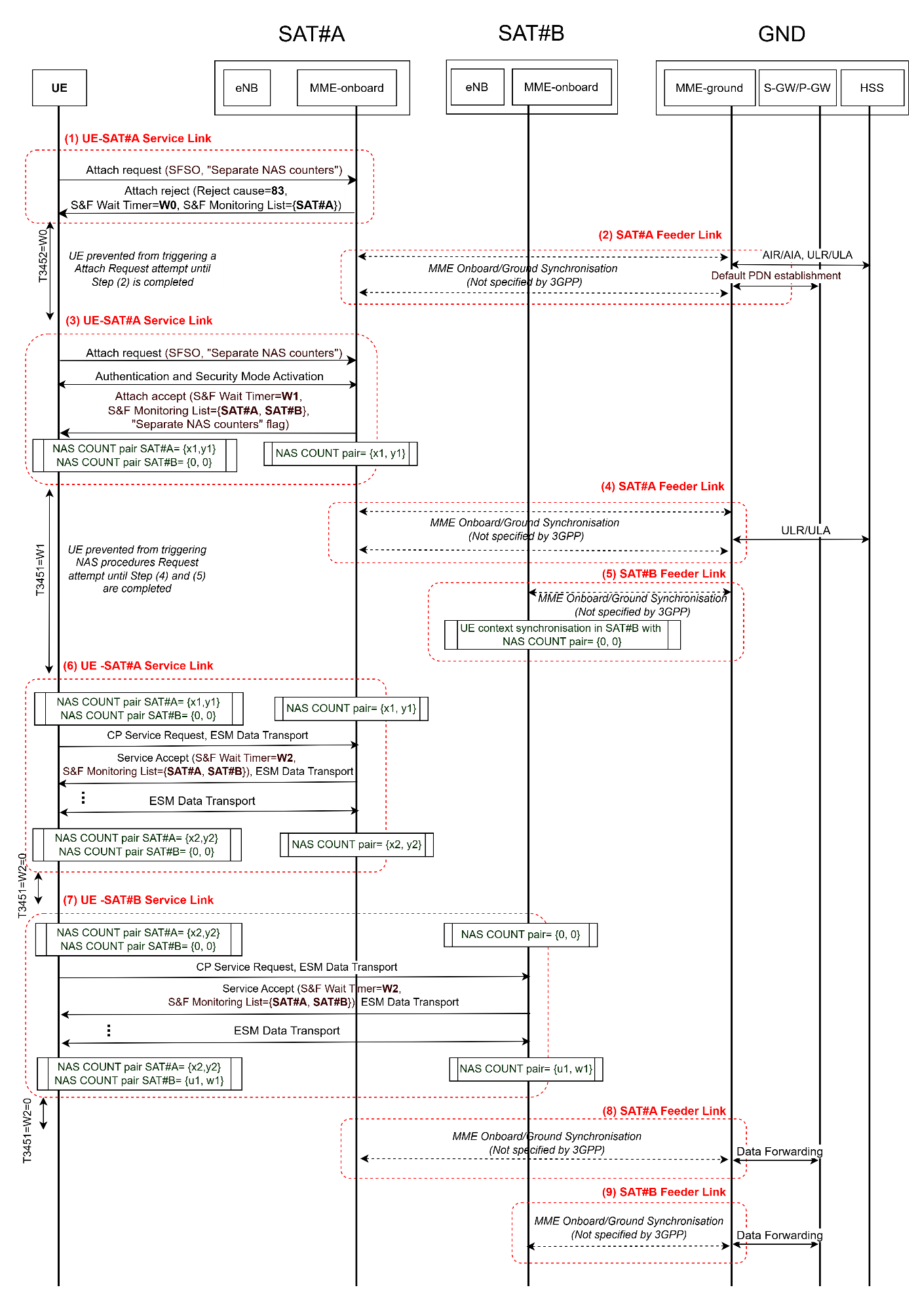
Figure 6.4.2-3: Message sequence illustration for separate NAS COUNT pairs per satelliteID solution
Step (1): UE-SAT#A Service Link
- The UE sends an Attach Request along with a PDN connectivity request to SAT#A. The Attach Request is assumed to include the SFSO (S&F satellite operation supported) bit in the UE network capability IE, as specified in Rel-19, plus the new UE network capability proposed in this solution. This indicates that the UE is capable of handling separate NAS counters per SatelliteID (referred to hereafter as “Separate NAS counters supported”).
- Assuming the on-board MME in SAT#1 lacks the context to authenticate the UE, SAT#A sends an Attach Reject with reject cause #83 ("Procedure cannot be completed due to unavailable feeder link while MME is operating in S&F mode"). The Attach Reject includes an S&F Monitoring List={SAT#A}, informing the UE which satellites the network expects a reattempt from to complete the procedure, and an S&F Timer=W0, preventing the UE from triggering such a reattempt before the network has been able to upload the UE context for authentication into the serving satellites (SAT#A in this case).
Step (2): SAT#A Feeder Link
- Via on-board MME and ground MME synchronization (a procedure not specified by 3GPP, as stated in Annex O.2 of TS 23.401), the ground MME is made aware of the Attach Request in Step (1). It then triggers an AIR/AIA (Authentication Information Request/Answer) exchange for Authentication Vector (AV) retrieval and a ULR/ULA (Update Location Request/Answer) exchange, indicating to the HSS the provisional nature of the location update, as established in 4.13.9 of TS 23.401. The ground MME also triggers the PDN connection establishment steps toward the S-GW/P-GW.
- Once these procedures are completed, the ground MME uploads the UE context to the on-board MME, providing the necessary data for the UE to complete the initial attach procedure in the next coverage window.
Step (3): UE-SAT#A Service Link
- The UE sends the Attach Request with a PDN connectivity request to SAT#A. As in Step (1), this includes the SFSO and the new “Separate NAS counters supported” indications.
- Given that the UE context is now present, the on-board MME in SAT#1 can establish NAS security using existing mechanisms defined in TS 33.401 and successfully complete the attach. In this case, the Attach Accept provides the UE with an S&F Monitoring List={SAT#A, SAT#B}, informing the UE which satellites the network expects to maintain the updated UE context, and an S&F Timer=W1, instructing the UE not to trigger new NAS procedures until the network has completed the context synchronization across the serving satellites (SAT#A and SAT#B in this example).
- As a result of this interaction, the NAS COUNT values for SAT#A increase to, for example, {x1, y1}.
Step (4): SAT#A Feeder Link
- Via on-board and ground MME synchronization, the ground MME is made aware of the successful attach completion in Step (3) and retrieves the full UE context from SAT#A (NAS keys, NAS COUNT pair for SAT#A, etc.).
- The ground MME then completes the final ULR/ULA exchange to finalize the location update.
Step (5): SAT#B Feeder Link
- Via on-board and ground MME synchronization, the ground MME uploads and synchronizes the recently created UE context to SAT#B, allowing the UE to be served by this satellite. Importantly, since the ground MME knows the UE supports “Separate NAS counters”, the NAS COUNT pair uploaded to SAT#B does not need to be synchronized with the pair used by SAT#A and can be set to {0,0}. For a UE not supporting this capability, the NAS COUNT pair uploaded to SAT#B must remain synchronized with that of SAT#A.
Step (6): UE-SAT#A Service Link
- Data transfer is performed in this coverage window. For example, the UE triggers a Control Plane Service Request, with data encapsulated in an ESM data transport container. A Service Accept is expected from SAT#A, given that a valid UE context is available. Multiple successive ESM data transport exchanges may follow, increasing the NAS COUNT pair for SAT#A from {x1, y1} to {x2, y2}.
- The Service Accept may also update the S&F Monitoring List and the S&F Timer (W1). If “Separate NAS counters” is supported, W1 can be set to zero, as the UE can be served by SAT#B in Step (7) without the network needing to synchronize NAS COUNT values {x2, y2} to SAT#B first. Otherwise, W1 must be set to prevent NAS procedures with SAT#B until synchronization is complete.
Step (7): UE-SAT#B Service Link
- Data transfer is performed in this coverage window with SAT#B. The NAS COUNT pair for SAT#B increases from {0, 0} to {u1, w1}.
- As in Step (6), the S&F Wait Timer can be set to zero, allowing the UE to use any forthcoming coverage from SAT#A and SAT#B.
Steps (8) & (9): SAT#A / SAT#B Feeder Link
- Data stored in SAT#A and SAT#B is downloaded to the ground MME and forwarded to the S-GW/P-GW.

6.4.3 Evaluation
The following impacts are needed:
- The EPS Security Context in the UE and MME needs to handle separate pairs of NAS COUNT per SatelliteID.
- A new NAS COUNT construction mechanism is needed to include the SatelliteID.
- To ensure backward compatibility, a new network capability and UE capability are needed to indicate support of satellite-specific NAS COUNTs.
The table below indicates how the security threats identified for KI#1 are accounted by the proposed solution.
Security threats (Section 5.2.2) | Mitigation
If the NAS COUNTs are not synchronized across multiple satellites, an attacker may intercept and replay previously transmitted NAS messages. Since different satellites may accept outdated NAS COUNT values, the replay protection mechanism could be bypassed, leading to unauthorized actions. | The NAS COUNT value includes the SatelliteID. This prevents reusing NAS COUNT values across the satellites.
Key stream may be reused if the security contexts are not well-managed across multiple satellites. | EPS security context across satellites are assumed to be always synchronized, excepting the NAS COUNT values which are independent for each satellite.  NAS COUNT values include the SatelliteID. This prevents reusing NAS COUNT values across the satellites and so reusing a key stream.

Editor's Note: Further evaluation is FFS.

6.5 Solution #5: Protection for NAS message of authenticated UE in split-MME architecture

6.5.1 Introduction
This solution is proposed to address Key Issue #1, providing a protection method for exchanging the NAS message in the Store and Forward satellite operations.
As specified in TS 33.401 [3], the NAS security is terminated on the MME-onboard, and the ground segment of the network ensures that the latest NAS security context of the UE is available at the MME-onboard. When multiple satellites are involved in the Store and Forward satellite operation, the NAS COUNTs should be synchronized to mitigate the replay attack.
This solution proposes that NAS COUNTs are maintained and managed by the UE and MME-ground. When a DL NAS message of authenticated UE is received, the MME-ground is responsible for selecting the MME on-board based on the coverage availability information. As defined in TS 23.401 [2], the satellite coverage availability information provisioned to the MME describes when and where satellite coverage with both service link and feeder link connectivity is expected or not expected to be available in an area. By using the coverage availability information, this solution assumes that the UE can receive the DL NAS messages from MME on-board(s) in sequence.
In other words, the MME-ground selects the MME on-board that will be available to the UE earliest. For the selected MME on-board, the MME-ground provides the value of DL NAS COUNT together with the DL NAS signaling. Since the selection is based on the coverage availability information, the MME on-board(s) will be available for UE in sequence and the value of DL NAS COUNT will be received in order, which mitigates the replay attack in the Store and Forward satellite operations.
For UL NAS messages of authenticated UE, the UE includes the Satellite ID in the UL NAS signalling, then uses the NAS security keys to protect the UL NAS signalling, including the Satellite ID. Once receiving the NAS signalling, the MME on-board verifies the integrity by using the NAS security key. If the verification is successful, the MME on-board further checks whether the received Satellite ID is associated with the onboard satellite. By checking the Satellite ID, the replay attack (i.e., resend the protected NAS signaling to another MME on-board) can be detected.

6.5.2 Solution details

6.5.2.1 DL NAS signalling protection
Figure 6.5.2-1: Protection for DL NAS messages of authenticated UE
- The UE and MME-ground hold the latest NAS COUNTs, including the UL NAS COUNT and DL NAS COUNT.
At Time 1:
- The MME-ground receives the DL NAS signaling #1 of the authenticated UE from another EPS NF.
- Based on the coverage availability information, the MME-ground selects one of the MME on-board(s) (e.g. MME on-board the SAT1) to transmit the DL NAS signaling #1.
- The MME-ground sends the DL NAS signaling #1 together with the latest value of DL NAS COUNT (e.g. DL NAS COUNT #1), and increases the DL NAS COUNT by one.
If the service link is not available, the MME on-board the SAT1 stores the DL NAS COUNT #1 together with the DL NAS signaling #1.
At Time 2:
- The MME-ground receives the DL NAS signaling #2 of the authenticated UE from another EPS NF.
- Based on the coverage availability information, the MME-ground selects one of the MME on-board(s) (e.g. MME on-board the SAT2) to transmit the DL NAS signaling #1.
- The MME-ground sends the DL NAS signaling #2 together with the latest value of DL NAS COUNT (e.g. DL NAS COUNT #2), and increases the DL NAS COUNT by one.
If the service link is not available, the MME on-board the SAT2 stores the DL NAS COUNT #2 together with the DL NAS signaling #2.
At Time 3 and Time 4, the UE can receive the protected DL NAS message in sequence.
- Once the service link becomes available (Time 3), the MME on-board the SAT1 generates the integrity-protected and confidentiality-protected NAS signaling #1 and sends it to the UE.
NOTE 1: Time 3 may happen before Time 2. In this case, Step #7 is performed before Steps #4-6.
- Once the service link becomes available (Time 4), the MME on-board the SAT2 generates the integrity-protected and confidentiality-protected NAS signaling #2 and sends it to the UE.
If the DL NAS message is delivered out-of-order and the security verification is failed, the UE may send the failure report message to the MME on-board. Whether to send the failure report message is determined by the UE. If the UE determines not to send the failure report message, the DL NAS messages will time out. The failure report message is protected as defined in clause 6.5.2.2 and includes the entire or four least significant bits of DL NAS overflow counter maintained by the UE. If the verification of failure report is passed, the MME on-board re-constructs the DL NAS COUNT based on the received NAS overflow counter and re-performs the integrity and confidentiality protection.

6.5.2.2 UL NAS signalling protection
In the split-MME architecture, the UE includes the Satellite ID in the UL NAS signalling, then uses the NAS security keys to protect the UL NAS signalling, including the Satellite ID.
Once receiving the NAS signalling, the MME on-board verifies the integrity by using the NAS security key. If the verification is successful, the MME on-board further checks whether the received Satellite ID is associated with the onboard satellite. If the received Satellite ID matches with the identifier of satellite hosting the MME on-board, the MME on-board stores the UL NAS DATA and updates the local stored UE NAS context (i.e., increases the UL NAS COUNT). Otherwise, the MME on-board discards this NAS signalling.

6.5.3 Evaluation
This solution addresses the security requirements of Key Issue #1.
For the protection of DL NAS messages, the coverage availability information is used by the MME-ground for selecting the MME on-board. By using the coverage availability information, this solution assumes that the UE can receive the DL NAS messages from MME on-board(s) in sequence. If DL NAS messages are delivered out-of-order and security verification fails, the UE can send a failure report message to the MME on-board to provide the DL NAS overflow counter. By re-constructing the DL NAS COUNT, the MME on-board can perform the integrity and confidentiality protection and resend the protected DL NAS message.
For the protection of UL NAS messages, the Satellite ID is included in the NAS signalling and protected by the NAS security keys.
This solution is aligned with the security mechanism defined in Annex N of TS 33.401 [3] and UE security handling for EPS systems.
The DL NAS COUNT is synchronized after the UE detects that the DL NAS message verification has failed and sends the failure report message.

6.6 Solution #6: Secure NAS messages via using different NAS keys in multiple satellites

6.6.1 Introduction
This solution addresses “Key issue #1: Authenticated UE to exchange NAS messages with multiple satellites in split-MME architecture”.
This solution is based on split MME architecture. S&F Satellite operation may involve multiple satellites allocated by an S&F Monitoring List. In order to prevent reusing key stream, one possible approach is to use different NAS keys when UE interacts with different satellites. This solution can improve the data exchange efficiency of the entire system.

6.6.2 Solution details
Based on the existing authentication procedures, this solution proposes to use different NAS keys when UE exchanges data with multiple satellites.
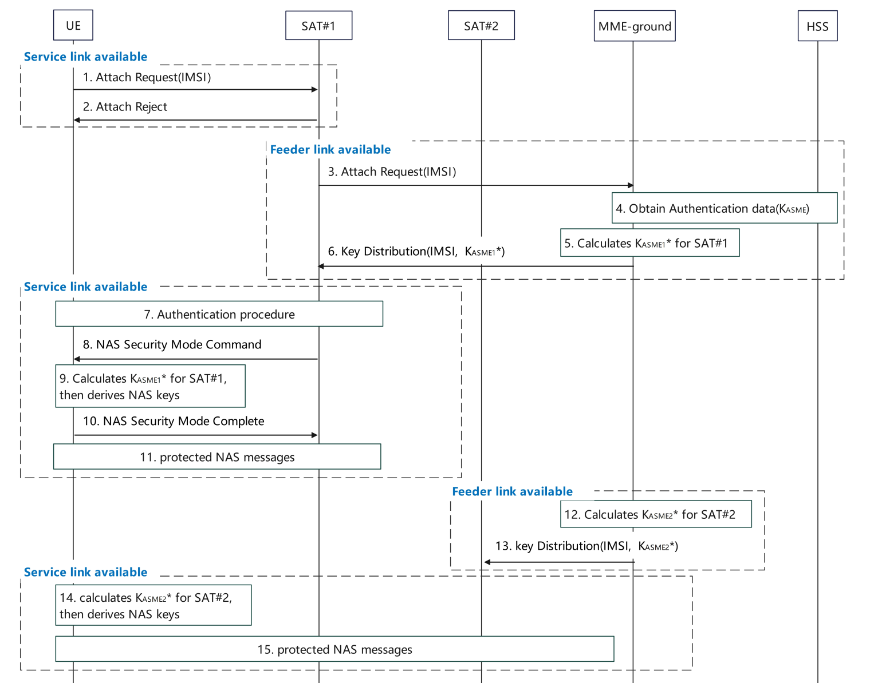
Figure 6.6.2-1 Enhanced NAS security for multiple satellites in S&F mode
SAT#1 has available Service Link.
- The UE sends the Attach Request to SAT#1.
- If SAT#1 does not have context to authenticate the UE, then sends the Attach Reject.

SAT#1 has available Feeder Link.
- SAT#1 sends the Attach Request to the MME-ground.
- The MME-ground obtains authentication data including K_{ASME}, as defined in TS 33.401 [3].
- The MME-ground determines to use SAT#1 to serve UE, then the MME-ground calculates K_{ASME1}* by using K_{ASME} and SAT Id of SAT#1.
- The MME-ground distributes K_{ASME1}* for SAT#1 during the transmission of AV.

SAT#1 has available Service Link.
- The authentication procedure is completed, as defined in TS 33.401 [3].
- SAT#1 derives NAS keys based on the K_{ASME1}* using existing mechanism as defined in TS 33.401[3] and sends the NAS security mode command integrity protected.
- The UE calculates K_{ASME1}* using the same method as the MME-ground in step5, and further derives the NAS keys using existing mechanism as defined in TS 33.401[3], then the UE verifies the NAS security mode command.
- If successfully verified, the UE sends the NAS security mode complete to SAT#1.
- After the NAS SMC procedure, the UE and SAT#1 send protected NAS messages.

SAT#2 has available Feeder Link.
- The MME-ground determines to use SAT#2 to serve the UE, the MME-ground calculates K_{ASME2}* by using K_{ASME} and SAT Id of SAT#2.
- The MME-ground distributes K_{ASME2}* for SAT#2. Then SAT#2 derives the NAS keys by using K_{ASME2}*.

SAT#2 has available Service Link.
- The UE establishes RRC connection with SAT#2 and calculates K_{ASME2}* using the method as the MME-ground in step12, and further derives the NAS keys by using K_{ASME2}*.
NOTE 1: The UE obtains the SAT Id of SAT#2 broadcast by the satellite SAT#2 to derive KASME2*.
The UE sends a protected initial NAS message to SAT#2. The successful processing of the initial NAS message by the satellite SAT#2 activates the NAS key between the UE and the satellite SAT#2. The UE and SAT#2 exchange protected NAS messages.
NOTE 2: As described in TS 23.401[2], the MME-ground together with the associated MME-onboard(s) behave jointly as a single MME entity. For multiple satellites, assume MME-onboards have the same list of ordered NAS security algorithms. After NAS SMC, the selected NAS security algorithms could be synchronized for MME-onboards. Each satellite/UE pair maintains independent COUNTs.
NOTE 3: As Store-and-Forward satellite operations involve sparse, infrequent transmissions, spread across multiple satellites, COUNT wrap-around can only occur over a substantial amount of time. It is left to network policy to determine when the MME ground re-authenticates the UE to avoid COUNT wrap around.
NOTE 4: To secure NAS messages using different NAS keys during handover-like processes in Store-and-Forward satellite operations, the UE handles satellite changes as cell reselection events and performs a protected tracking area update procedure using NAS keys.

6.6.3 Evaluation
This solution addresses the Key Issue #1, and it applies for S&F operations with multiple satellites. In this solution, the UE can exchange data with multiple satellites efficiently without security risk.
The solution has the following impacts:

This solution requires the MME-ground and the UE to derive new keys (i.e. K_{ASME}* derivation based on K_{ASME}) for different satellites and the UE needs to maintain multiple NAS COUNTs. This solution requires the key transfer from MME-ground to MME-onboard.
If the UE interacts with a new satellite, it computes a new K_{ASME}* and derives new NAS keys based on the same NAS security algorithms.
The same UE context cannot be re-used across satellites because new NAS keys need to be generated by the UE.
Each MME on-board needs to maintain a separate pair of NAS COUNTs.

To secure NAS messages using different NAS keys during handover-like processes in Store-and-Forward satellite operations, the UE handles satellite changes as cell reselection events and performs a protected tracking area update using NAS keys derived from the base KASME and the target satellite’s SAT ID, ensuring secure continuity without requiring real-time context synchronization between satellites.
The use of the Satellite ID when deriving the K_ASME* per satellite is a new capability that requires new means for support indication and activation.
The solution requires the UE to derive a satellite specific key for each satellite the UE establishes a NAS connection with.

6.7 Solution #7: Solution for NAS COUNT synchronization in store-and-forward operations

6.7.1 Introduction
As per the threat described in the key issue #1, an attacker may intercept and replay previously transmitted NAS messages. This solution proposes the following to address this threat:
- A new “Satellite access information” can be included as part of Initial UE message sent from satellite eNB to MME. This information can be used by MME to enable UE context synchronization including NAS COUNT verification and synchronization for the satellites included in the S&F Monitoring List.
  - A “3GPP satellite access type” in Access type information element (reference : TS 24.501 [X] clause 9.11.2.1A) is included. Considering satellite access as a different access type to enable an independent NAS COUNT for “3GPP satellite access type”.
- MME-onboard and MME-onground synchronize the NAS COUNT values for UEs whose security contexts are provided to the satellites included in the S&F Monitoring List. The mechanism of this synchronization across multiple satellites is out of 3GPP scope, however, 3GPP can recommend certain actions as follows:
  - MME-onboard and MME-onground need to ensure that a given NAS COUNT value shall be accepted at most one time and only if message integrity verifies correctly. This is in accordance with clause 4.4.3.2 from TS 24.501 [X].
  - If MME-onboard receives a new message from a UE for which the UE security context is available with the satellite, and the integrity verification is verified successfully, the MME-onboard:
    - Request MME-onground for NAS COUNT duplicate verification. This can also be done using NAS sequence number verification.
    - If MME-onground responds indicating that the NAS COUNT is duplicate, OR if there is a timeout because of long delay in obtaining the feeder link, MME-onboard discards that message from UE.
    - If MME-onground responds indicating that the NAS COUNT is NOT duplicate, MME-onboard consider it as a valid message and proceed to ensure seamless connectivity for the UE.

6.7.2 Solution details
Figure 6.7.2-1: Message sequence showing NAS COUNT verification at MME
As shown in Figure 6.7.2-1:
- In Step 2, UL and DL NAS COUNTs are synchronized between MME-onboard and MME-onground entities. Note that from UE’s perspective, MME is expected to be seen as a single logical entity. Hence, in this solution, the proposal is to ensure UL and DL NAS COUNT synchronization between MME-onboard entities to ensure replay protection.

- In Step 3, if a genuine UE sends a NAS message, with UE security context available in Satellite#2, the integrity verification succeeds. The MME-onboard stores the message in the UE security context.

- In Step 5, MME-onboard requests the NAS COUNT verification with MME-onground.

- In Step 6, MME-onground responds with the verification status.
When messages are received simultaneously from multiple satellites by MME-onground, then the coordination between MME-onboards and MME-onground ensures that duplicates are dropped and the NAS security context is maintained seamlessly for the UE.

- In case feeder link is not available for a long time, and there may be a timeout implemented, the MME-onboard drops this NAS message from the UE. Also, if the UL NAS COUNT verification status indicates duplicate or old NAS message, the MME-onboard drops it in order to ensure replay protection requirements stated in clause 4.4.3.2 of TS 24.501.
- If the UL NAS COUNT verification status from MME-onground indicates that it is not a duplicate or old message, MME-onboard processes it further.
- In Step 8, MME on-ground can provide latest DL NAS COUNT values to MME onboard of satellite 2 which is now the serving satellite for the UE. This step can be executed conditionally if the UL NAS COUNT verification succeeds.

6.7.3 Evaluation
This solution addresses Key Issue #1.
This solution has the following advantages:
- proposes the use of a new “Satellite access information” which can be included in the initial UE message sent from satellite eNB to MME and also recommends the MME-onboard and MME-onground synchronize the NAS COUNT values for UEs whose security contexts are provided to the satellites included in the S&F Monitoring List. This prevents the threat as described in Key Issue #1 from occurring.
This solution has the following disadvantages:
- it requires the use of additional overhead in order to enable the storage of “Satellite access information” and NAS COUNT synchronization, but this overhead is necessary to enable such security features.
- it does not consider any possible impacts on subsequent AS security context establishment.
Note that this solution has impacts on signaling between MME on-ground and MME-onboard. However, the communication between MME on-ground and MME-onboard is not in scope of 3GPP.
This solution assumes that the serving MME-onboard has a feeder link with the MME-ground to check the NAS COUNT validity.
This solution impacts only the split-MME. Optionally if “satellite access type” is used, UEs can be impacted.

6.8 Solution #8: New specific rules to handle NAS Counter Overflow in S&F mode

6.8.1 Introduction
This solution addresses KI#1.
In S&F Satellite operation, the subset of satellites operating in S&F Mode in which a given UE registration is valid (i.e. satellites included in the S&F Monitoring List), are expected to maintain a synchronised UE context, even though the synchronisation mechanism is outside the scope of 3GPP.
This solution proposes to add an exception with respect to the synchronisation of the NAS counters, referred hereafter as “NAS counters synchronization relaxation”. Based on the added exception, this solution proposes introducing specific rules for managing the pair of NAS counters stored by the UE and by the MME operating S&F Mode as follows:
- When a UE registration is valid in multiple satellites operating in S&F mode, each time the UE interacts with one of these satellites, the UL NAS Overflow Counter (OC) stored in the UE may be higher than the UL NAS OC stored in the MME of the serving satellite. This discrepancy can arise due to previous interactions between the UE and other serving satellites of the same PLMN, where the UL NAS OC in the UE was incremented due to the UL NAS SQN wrap-around. In such a case, if the MME fails to verify the integrity of a received NAS packet using the last stored UL NAS OC, the MME may attempt to validate the message integrity using a series of consecutively incremented UL NAS OC values. If one of the attempts is successful, the MME updates its stored UL NAS OC accordingly.
- Similarly, when a UE registration is valid in multiple satellites operating in S&F mode, the DL NAS Overflow Counter (OC) stored in the UE may be higher than the last DL NAS OC stored in the MME of the serving satellite. This can result from prior interactions between the UE and other satellites where the DL NAS OC in the UE was incremented due to the DL NAS SQN wrap-around. In such cases, if the UE fails to verify the integrity of a received NAS packet using the last stored DL NAS OC, it may attempt to validate the message integrity using a series of consecutively decremented DL NAS OC values. To avoid replay attack, the UE can rely on the fact that the Satellite ID is not the same.

To ensure backward compatibility, the UE shall indicate to the network its support for “NAS counter synchronization relaxation”. This capability allows the UE to handle scenarios where the NAS counters used across the on-board MMEs of the serving satellites may diverge. Accordingly, the network must inform the UE whether this synchronization relaxation is being applied.

6.8.2 Solution details
This section provides further details on this solution by analysing the uplink case (UE MME-onboard) and the downlink case (UE MME-onboard) when considering (1) UE is served by multiple satellites as per the S&F Monitoring List provided to the UE and (2) UE assumes that NAS counters in the MME-onboard(s) of those satellites are not necessarily synchronised.

6.8.2.1 Uplink case
Figure 6.8.2.1-1 shows the steps taken by the MME-onboard. Changes introduced by this solution are marked in red.
- Upon receiving an integrity protected NAS uplink message, the MME-onboard retrieves the SQN and the NAS message authentication code (NAS-MAC) which are then used to compute the expected NAS message authentication code (XNAS-MAC) according to 3GPP TS 33.401 clause 8.1 and Annex B.2. Furthermore, the UL NAS Count is increased according to 3GPP TS 24.301 clause 4.4.3.
- The computed XNAS-MAC is compared with the NAS-MAC received in the NAS integrity protected message.
- If the two codes match up, the integrity check is successful and the MME-onboard can process the uplink NAS message.
- If the two codes do not match up and the NW has enabled “NAS counters synchronization relaxation” for the UE, the MME-onboard increases the UL OC by 1 which means increasing the UL NAS Count by 256 units.
- The XNAS-MAC is computed again and compared with the NAS-MAC. If the two codes match up, step c) is executed. Otherwise, step d) is executed.

Note that steps d) and e) are repeated up to a number X of times. If the number of attempts exceeds X, the integrity check fails and the NAS message is discarded.
A successful integrity check also indicates that the UL NAS OC has been correctly estimated and that the UE and the MME-onboard are aligned, i.e., the UL NAS OC stored by the UE match the UL NAS OC stored by the MME-onboard.
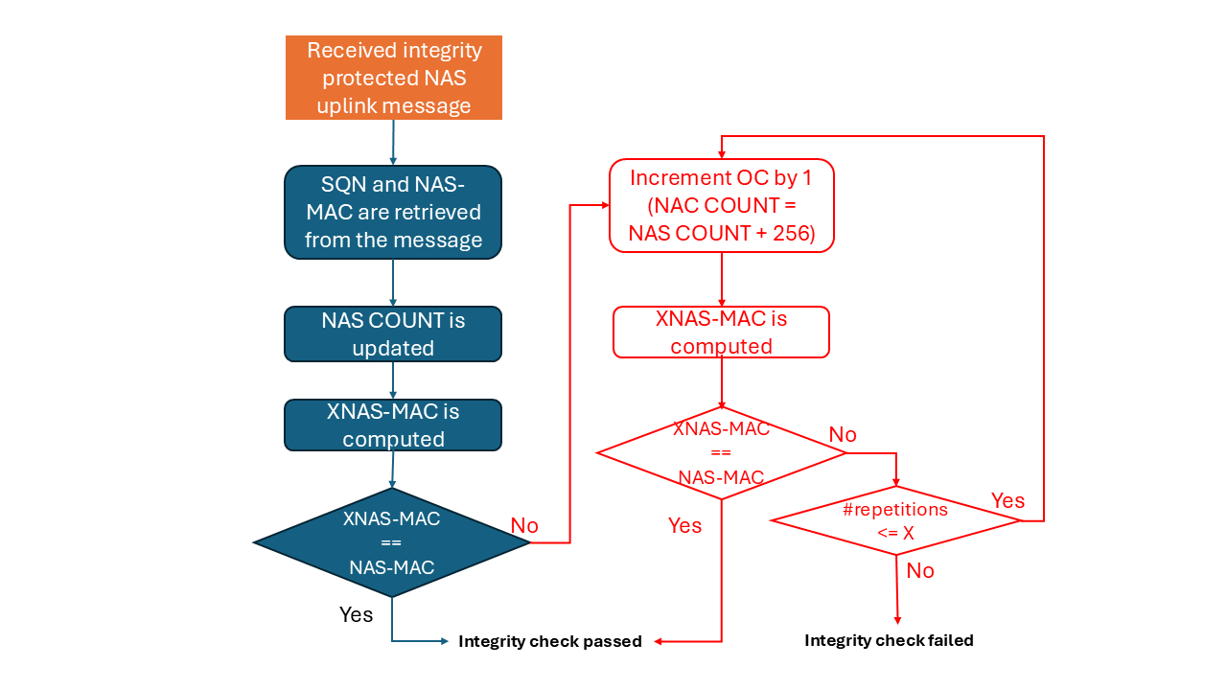
Figure 6.8.2.1-1: Handling of UL NAS OC in the MME-onboard.

6.8.2.2 Downlink case
Figure 6.8.2.2-1 shows the steps taken by the UE. Changes introduced by this solution are marked in red.
- Upon receiving an integrity protected NAS downlink message, the UE retrieves the SQN and the NAS message authentication code (NAS-MAC) which are then used to compute the expected NAS message authentication code (XNAS-MAC) according to 3GPP TS 33.401 clause 8.1 and Annex B.2. Furthermore, the DL NAS Count is increased according to 3GPP TS 24.301 clause 4.4.3.
- The computed XNAS-MAC is compared with the NAS-MAC received in the NAS integrity protected message.
- If the two codes match up, the integrity check is successful and the UE can process the downlink NAS message.
- If the two codes do not match up, the NW has indicated the UE that “NAS counters synchronization relaxation” is enabled and the SatelliteID of the current serving satellite is different from the SatelliteID of the previous serving satellite, the UE decreases the UL OC by 1 which means decreasing the UL NAS Count by 256 units.
- The XNAS-MAC is computed again and compared with the NAS-MAC. If the two codes match up, step c) is executed. Otherwise, step d) is executed.

Note that steps d) and e) are repeated up to a number X of times. If the number of attempts exceeds X, the integrity check fails and the NAS message is discarded.
A successful integrity check also indicates that the DL NAS OC has been correctly estimated and that the MME-onboard and the UE are aligned, i.e., the DL NAS OC stored by the MME-onboard matches the DL NAS OC stored by the UE.
SatelliteID is an identifier uniquely indicating an MME-onboard. The SatelliteID identifier of a given satellite is broadcast by the eNB within the SIB31 and the SatelliteID identifiers of the satellites that might be serving a given UE are included within the S&F Monitoring List, which is sent by the MME to indicate the satellite(s) that the UE may (re)-attempt NAS procedures (TS 23.401 clause 4.13.9.1).
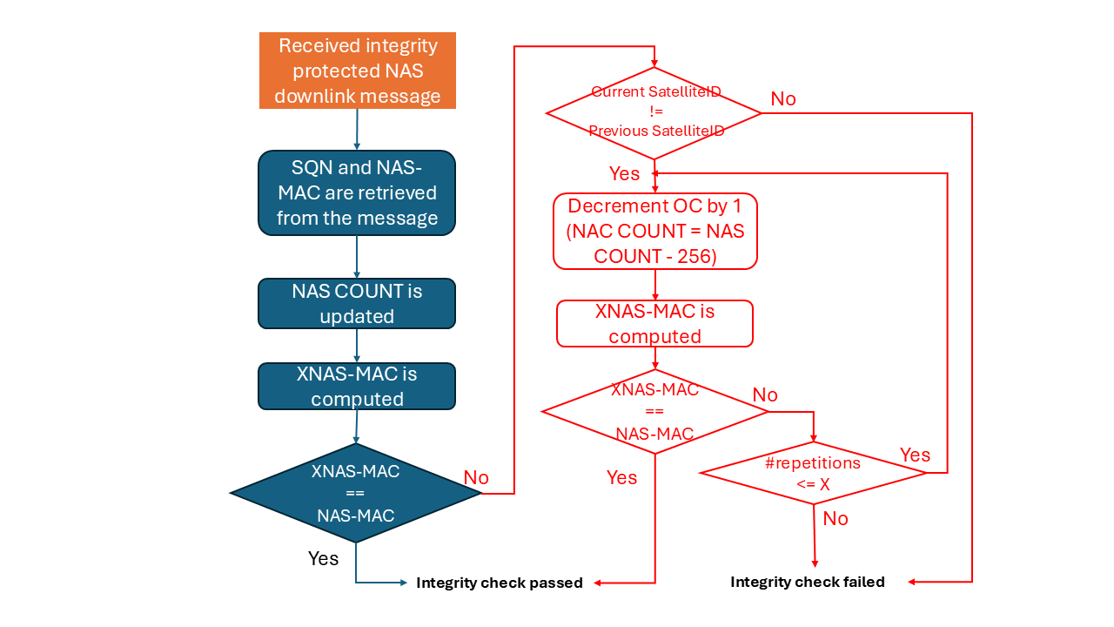
Figure 6.8.2.2-1: Handling of DL NAS OC in the UE.

6.8.2.3 Considerations on the range of NAS counters deviation between satellites
When “NAS counters synchronization relaxation” is enabled, to avoid the NAS counters in each of the MME-onboard(s) to deviate much between them, UE context synchronisation across satellites to update the NAS counters can still be performed by the network from time to time as per NW implementation policy (e.g., periodically or when deviation/drift exceeds a given range of NAS values). This synchronisation of the NAS counters across satellites is related to the maximum number X of repetitions that the algorithm should handle (i.e., the less frequent synchronisation takes places, the higher should be the number X of repetitions).
The allowed maximum number of repetitions impacts in the amount of processing resources to handle NAS messages. To limit the resources taken for repeating the integrity verification, the number X of repetitions should be kept small (e.g., 1 < X < 4). For instance, with X=3, a maximum discrepancy of 256*3=768 units is tolerated, which could be already a reasonable margin in a dense satellite constellation, assuming infrequent IoT packet exchange. For sparse satellite constellations, X can be even smaller since the probability of NAS COUNT wrap-around during a satellite revisit period is lower.

6.8.2.4 Message sequence
Figure 6.8.2.4-1 provides an illustrative message sequence of the proposed solution. The sequence considers a system of two satellites (Sat#A and Sat#B) utilizing the split-MME architecture. It covers the entire process, starting from the triggering of the initial attach and default PDN connectivity request through to data transfer across successive satellite coverage windows. The message sequence considers a UE using CP CIoT Optimization, for which there is no requirement to establish AS security.
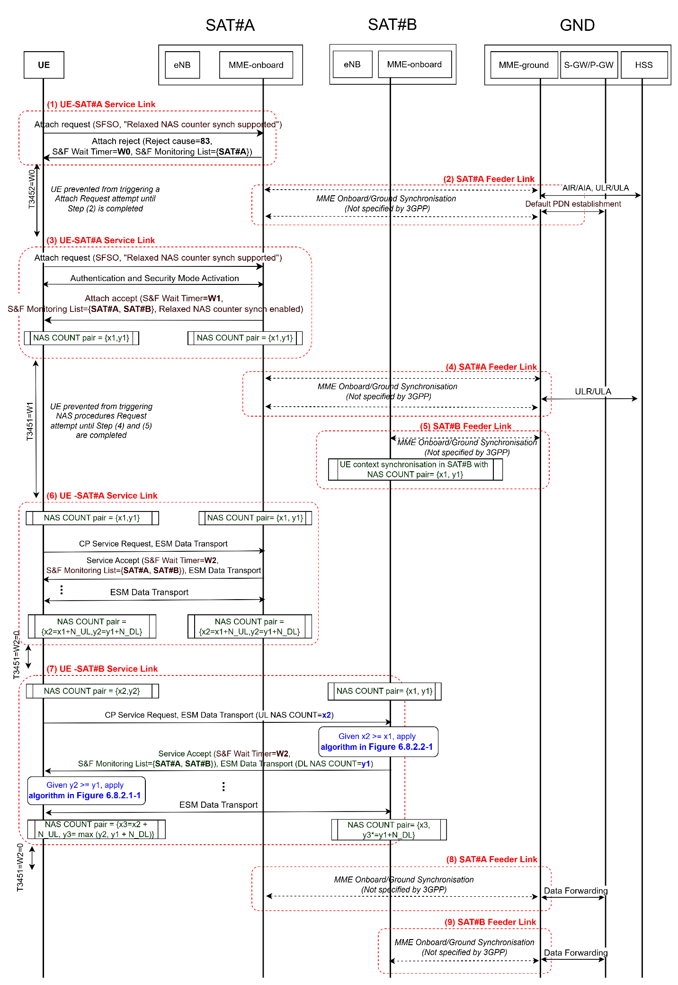
Figure 6.8.2.3-1: Message sequence illustration for NAS counter synchronisation relaxation solution
Step (1): UE-SAT#A Service Link
- The UE sends an Attach Request along with a PDN connectivity request to SAT#A. The Attach Request is assumed to include the SFSO (S&F satellite operation supported) bit in the UE network capability IE, as specified in Rel-19, plus a new UE network capability indicating support for “NAS counters synchronization relaxation”.
- Assuming the on-board MME in SAT#1 lacks the context to authenticate the UE, SAT#A sends an Attach Reject with reject cause #83 ("Procedure cannot be completed due to unavailable feeder link while MME is operating in S&F mode"). The Attach Reject includes an S&F Monitoring List={SAT#A}, informing the UE which satellites the network expects a reattempt from to complete the procedure, and an S&F Timer=W0, preventing the UE from triggering such a reattempt before the network has been able to upload the UE context for authentication into the serving satellites (SAT#A in this case).
Step (2): SAT#A Feeder Link
- Via on-board MME and ground MME synchronization (a procedure not specified by 3GPP, as stated in Annex O.2 of TS 23.401), the ground MME is made aware of the Attach Request in Step (1). It then triggers an AIR/AIA (Authentication Information Request/Answer) exchange for Authentication Vector (AV) retrieval and a ULR/ULA (Update Location Request/Answer) exchange, indicating to the HSS the provisional nature of the location update, as established in 4.13.9 of TS 23.401. The ground MME also triggers the PDN connection establishment steps toward the S-GW/P-GW.
- Once these procedures are completed, the ground MME uploads the UE context to the on-board MME, providing the necessary data for the UE to complete the initial attach procedure in the next coverage window.
Step (3): UE-SAT#A Service Link
- The UE sends the Attach Request with a PDN connectivity request to SAT#A. As in Step (1), this includes the SFSO and the new “NAS counters synchronization relaxation” indications.
- Given that the UE context is now present, the on-board MME in SAT#1 can establish NAS security using existing mechanisms defined in TS 33.401 and successfully complete the attach. In this case, the Attach Accept provides the UE with an S&F Monitoring List={SAT#A, SAT#B}, informing the UE which satellites the network expects to maintain the updated UE context, and an S&F Timer=W1, instructing the UE not to trigger new NAS procedures until the network has completed the context synchronization across the serving satellites (SAT#A and SAT#B in this example).
- As a result of this interaction, the NAS COUNT values for SAT#A increase to, for example, {x1, y1}.
Step (4): SAT#A Feeder Link
- Via on-board and ground MME synchronization, the ground MME is made aware of the successful attach completion in Step (3) and retrieves the full UE context from SAT#A (NAS keys, NAS COUNT pair, etc.).
- The ground MME then completes the final ULR/ULA exchange to finalize the location update.
Step (5): SAT#B Feeder Link
- Via on-board and ground MME synchronization, the ground MME uploads and synchronizes the recently created UE context to SAT#B (including NAS keys, NAS COUNT pair, etc.), allowing the UE to be served by this satellite.
Step (6): UE-SAT#A Service Link
- Data transfer is performed in this coverage window. For example, the UE triggers a Control Plane Service Request, with data encapsulated in an ESM data transport container. A Service Accept is expected from SAT#A, given that a valid UE context is available. Multiple successive ESM data transport exchanges may follow, increasing the NAS COUNT pair from {x1, y1} to {x2=x1+N_UL, y2=x2+N_DL}, where N_UL and N_DL represent the number of NAS message exchanges in the uplink and downlink, respectively.
- The Service Accept may also update the S&F Monitoring List and the S&F Timer (W1). If “NAS counters synchronization relaxation” is supported, W1 can be set to zero, as the UE can be served by SAT#B in Step (7) without the network needing to synchronize NAS COUNT values {x2, y2} to SAT#B first. Otherwise, W1 must be set to prevent NAS procedures with SAT#B until synchronization is complete.
Step (7): UE-SAT#B Service Link
- Data transfer is performed in this coverage window with SAT#B. In contrast to Step (6), the NAS COUNT pairs between SAT#B and the UE are not initially aligned; therefore, the algorithms described in previous sections must be applied.
- Assuming that the deviation between NAS COUNT pairs was less than the maximum allowed (X), data transfer can still be successfully performed.
- At the end of the pass, UL NAS COUNT in SAT#B and UL NAS COUNT in the UE gets re-aligned. This is represented by the value x3 in the figure, which corresponds to x2 plus the number of uplink NAS messages exchanged in this pass (N_UL).
- In contrast, DL NAS COUNT in SAT#B (y3*) and DL NAS COUNT in the UE (y3) may still show some deviation. This occurs because the DL NAS COUNT in SAT#B is increased by the number of DL message exchanges (y3*=y1+N_DL) which may still be lower than the value of DL NAS COUNT initially stored in the UE (y2). In such a case, the UE retains the highest value (y3= max (y2, y1 + N_DL)).
- As in Step (6), the S&F Wait Timer can be set to zero, allowing the UE to use any forthcoming coverage from SAT#A and SAT#B without further re-synchronization of the NAS counters on the network side.
Steps (8) & (9): SAT#A / SAT#B Feeder Link
- Data stored in SAT#A and SAT#B is downloaded to the ground MME and forwarded to the S-GW/P-GW.

6.8.3 Evaluation

The following impacts are identified:
- The UE's handling of the Downlink (DL) NAS OC must account for scenarios where the DL NAS OC stored in the UE from interactions with a previous satellite may be up to X units lower than the DL NAS OC used by the current serving satellite.
- The on-board MME's handling of the Uplink (UL) NAS OC must account for scenarios where the UL NAS OC used by the UE may be up to X units higher than the UL NAS OC stored in the MME-onboard.
- To ensure backward compatibility, new network and UE capability indications are required to signal support for S&F satellite operations with relaxed NAS COUNT synchronization between serving satellites.
Regarding the potential impact of accepting a range of NAS counters on the overall security of the 3GPP system:
- Uplink: This is not considered to result in an additional security risk. Since the NAS COUNT is only incremented, an attacker cannot successfully perform a NAS replay attack using a packet with a lower NAS COUNT.
- Downlink: The situation differs as an attacker could reuse an old NAS COUNT and successfully perform a NAS replay attack. However, the condition “current-SatelliteID is different from previous-SatelliteID” is intended to mitigate such an attack.
Editor's Note: Further evaluation is FFS.

6.9 Solution #9: Secure NAS messages via one pair of COUNTs

6.9.1 Introduction
This solution addresses “Key issue #1: Authenticated UE to exchange NAS messages with multiple satellites in split-MME architecture”.
For MME-split architecture in S&F mode, UE could interact with more than one satellites. The NAS COUNTs are not synchronized across multiple satellites. However, the UE has the latest NAS COUNTs. This solution proposes that the UE provides the latest NAS COUNTs to MME-onboard, which can realize NAS COUNTs synchronization.

6.9.2 Solution details
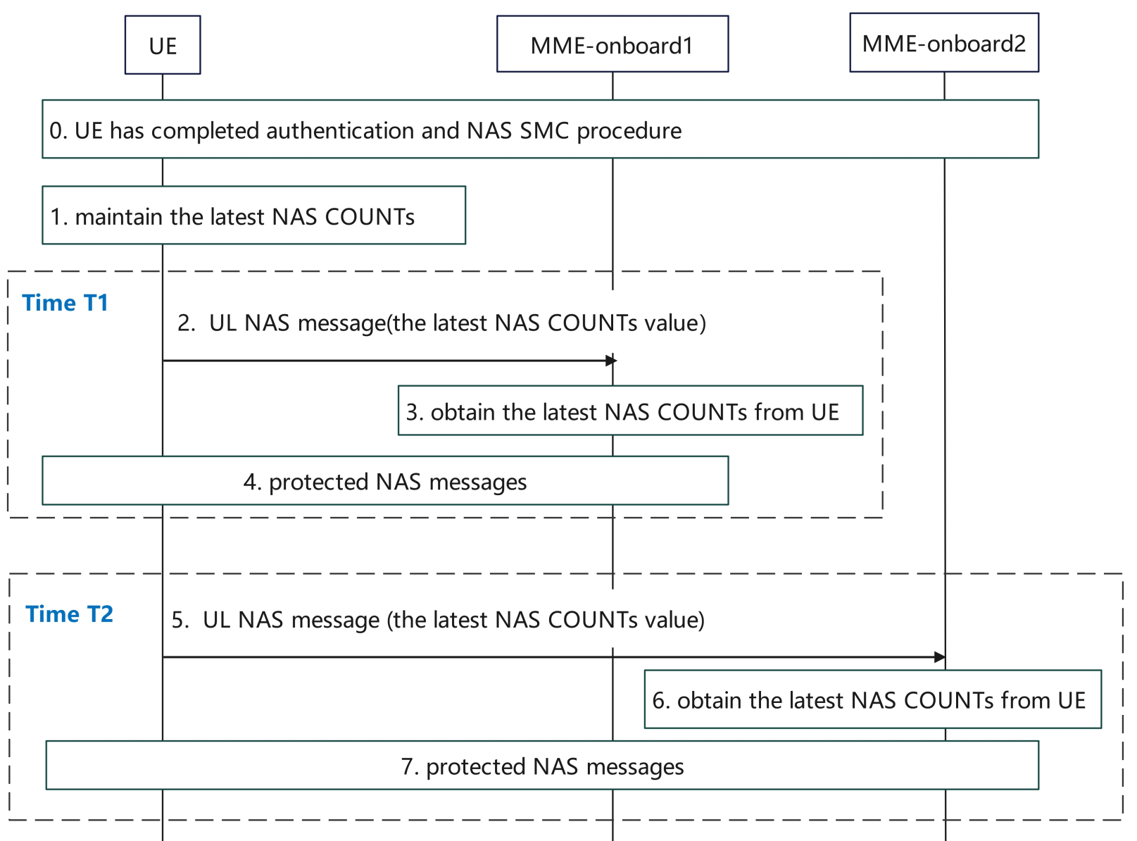
Figure 6.9.2 Secure NAS messages via one pair of COUNTs
- The UE has completed authentication and NAS SMC procedure with an MME-onboard.
- The UE maintains the latest NAS COUNTs, including the UL NAS COUNT and DL NAS COUNT. NAS COUNT is constructed by NAS OVERFLOW and NAS SQN.
- At Time T1, the UE starts to communicate with MME-onboard1. The first UL NAS message includes the latest value of UL NAS COUNT and the latest value of DL NAS COUNT. The latest values of NAS COUNTs are integrity protected. To prevent replay attack, satellite ID is used as an input to integrity protect the NAS message.
- MME-onboard1 could obtain latest NAS COUNTs from UE. With the latest value of UL NAS COUNT, the MME-onboard1 verifies the integrity of NAS message received from step2. If verified successful, the MME-onboard1 obtains the latest value of UL NAS COUNT and the latest value of DL NAS COUNT.
Editor’s Note: How DL NAS COUNT is used when DL NAS COUNT on MME is higher than the one from UE.
- The UE and MME-onboard1 interact with protected NAS messages based on the latest NAS COUNT values.
5-7. At Time T2, the UE starts to communicate with MME-onboard2. These steps are similar with steps 2-4.

6.9.3 Evaluation
This solution addresses the Key Issue #1, and it applies for S&F operations with multiple satellites.
This solution introduces extra overhead for UE to send additional parameter to MME.

6.10 Solution #10: NAS keys isolation in S&F operations

6.10.1 Introduction
This solution addresses Key Issue #1: Authenticated UE to exchange NAS messages with multiple satellites in split-MME architecture.
According to Annex N.2 of TS 33.401, a typical S&F authentication and data transmission procedure is:
- The MME-ground provides authentication vectors to one or multiple satellites.
- A MME-onboard authenticates the UE and establishes UE context (including UE security context) for the UE.
- The MME-onboard provides the UE context to the MME-ground.
- The MME-ground may provide the UE context to one or multiple satellites expected to communicate with the UE.
This solution updates step 4 in the previous procedure to provide different NAS keys to the satellites. The basic principle is that the MME-ground will use a secret parameter shared only between the MME ground and the UE to generate different NAS keys for each satellite.
In addition, the satellite ID used by RAN is 8 bits and can only identify 256 satellites. The satellite ID used by OMA is NORAD ID, which is a 5-digit number. For this reason, a dedicated message is required to provide the satellite identifier (NORAD ID) to the UE.

6.10.2 Solution details
The NAS keys isolation procedure in S&F operations is shown in the following figure.
Figure 6.10.2-1: NAS keys isolation procedure in S&F operations
- The secret parameter for NAS key derivation is pre-configured in the UE and the Network.
Editor’s Note: Whether and how the secret parameter is used is FFS.
- The MME-ground provides authentication vectors to the MME-onboards in satellites in the S&F Monitoring List.
The MME-onboard authenticates the UE and generates UE context (including UE security context) when service link is available.
The MME-onboard provides the UE context to the MME-ground when the feeder link is available.
- The MME-ground derives NAS keys (NASint, NASenc) using Kasme, Satellite ID (NORAD ID format) and the secret parameter shared only between the UE and network.
- The MME-ground provides the UE security context specifically generated for the target satellite to the MME-onboard in the target satellite. The UE security context includes the newly generated NASint key and NASenc key for the satellite.
- The UE connects to the satellite when service link is available.
- The satellite provides its satellite ID (NORAD ID) to the UE.
- The UE uses the same method as the network to generate a specific UE context for this satellite, or if it already exists, retrieves the existing security context for that satellite.
- The UE exchanges data with the satellite via secured NAS messages.
- The UE stores the security context for this satellite, and the satellite stores the UE security context for the UE.
Editor’s Note: How NAS COUNT Sync can be achieved without performing UE key negotiation with multiple satellites is FFS.

6.10.3 Evaluation
TBD.

6.11 Solution #11: Solution to the NAS key stream re-use issue during S&F operations

6.11.1 Introduction
The solution addresses Key Issue #1.
The solution is based on two new mechanisms:
- The Satellite ID obtained from SIB31 is used as a separation parameter in the COUNT input parameter as described in Solution #2. This prevents an attacker from replaying messages and masquerading as if they were from the UE or from an MME onboard a different satellite.
- The DL NAS COUNT value stored in the MME side is set to be no less than the latest received and validated UL NAS COUNT value received from the UE. This guarantees freshness of the values on both the UE and the MME side so no valid messages are discarded due to outdated stored values on MME. To achieve this the NAS OVERFLOW value is included in the initial message.
The solution does not require neither multiple NAS COUNT pairs nor new keys on the UE or the MME onboard.
The motivation for this NAS COUNT handling is that during S&F operations, the UE will always have the latest values of the NAS COUNTs. Consequently, when moving to a new MME-onboard that the UE did not communicate with before, the UE would end up discarding the downlink messages because of the included outdated NAS SQN values. This is why this new NAS COUNT handling is required.
Furthermore, during communication with one of the MME-onboards, there is a risk that the NAS OVERFLOW is incremented several times. Therefore, it is included as well in the initial NAS message. This is to avoid an integrity check failure due to an outdated NAS OVERFLOW value on the MME side.

6.11.2 Solution details

6.11.2.1 Key stream separation
As described in Solution #2, it is proposed to concatenate the Satellite ID parameter when forming the COUNT input to the NAS algorithms. The Satellite ID is an 8-bit long identifier that uniquely maps to the MME onboard as specified in 3GPP TS 24.301 [4]. The Satellite ID is broadcast by eNB in SIB31.
COUNT: = Satellite ID || NAS OVERFLOW || NAS SQN
This handling is performed on the UE and the MME side. The UE acquires the ID value from SIB31, while the MME is assumed to be preconfigured in advance with the value. All other related security parameters are unchanged and are handled as described in 3GPP TS 33.401 [3].
NOTE: The satellite ID is not stored as part of the UL/DL NAS COUNT in the UE security context.
Using the Satellite ID parameter when forming the COUNT input provides cryptographic separations between the protected messages pertaining to different satellites. Consequently, an attacker cannot replay old and valid downlink messages originating from a given satellite to pretend that they are from another one. Similarly, an attacker cannot replay old and valid uplink messages from the UE intended to different satellites.

6.11.2.2 NAS COUNT synchronization
This solution uses a single NAS COUNT pair on the UE and the MMEs on board. The handling of the NAS COUNT stored values differs as follows.
When the UE is about to trigger NAS communication with an MME via for example a service request, the UE sets the UL COUNT value to the max among the stored DL and UL COUNT values. The UE then proceeds with the construction of the protected message but includes also the NAS OVERFLOW in clear in addition to the NAS SQN. The UE then increments the stored UL COUNT value.
When the MME receives an initial NAS message, a similar handling is required for the stored DL COUNT value. The MME constructs the UL COUNT value using both the received SQN and OVERFLOW values. MME compares this constructed value with the stored one. In case of a successful integrity verification, the MME updates the stored UL COUNT value. The MME also sets the stored DL COUNT value to the maximum of its stored DL and UL COUNT values. The MME proceeds with the response if any without any new handling.
Observe that this handling is only required for the initial NAS message every time the UE moves to a different MME-onboard. The subsequent NAS messages with the same MME-onboard are handled as per 3GPP TS 33.401 [3]. Figure 6.11.2.2-1 illustrates this new handling.
Figure 6.11.2.2-1: NAS UL/DL COUNT synchronization when UE switches to a new satellite

6.11.3 Evaluation
The solution addresses the requirements of Key Issue #1.
The solution introduces the Satellite ID when forming the COUNT parameter to guarantee separation. The solution also proposes a new handling of the store COUNT values both on the network and the UE side to ensure synchronization. The solution requires also the inclusion of the NAS OVERFLOW value in the initial NAS message. This new handling is only required for the initial NAS message.
The usage of the Satellite ID together with the inclusion of the NAS OVERFLOW value in the initial message is a new capability that requires new means for support indication and activation. The solution does not take any stand on that.
The solution has impact on the UE and the MME. The solution does not require neither multiple NAS COUNT pairs nor new keys.
The NAS COUNT handling in this solution may lead to a slightly earlier NAS COUNT wrap around compared to the normal NAS COUNT handling.
Editor’s Note: Further evaluation is FFS.

6.Y Solution #Y: <Solution Name>

6.Y.1 Introduction
Editor’s Note: Each solution should list the key issues being addressed.

6.Y.2 Solution details

6.Y.3 Evaluation
Editor’s Note: Each solution should motivate how the potential security requirements of the key issues being addressed are fulfilled.

7 Conclusions

7.Z Key Issue #Z: <Key Issue Name>
Editor’s Note: This clause contains the agreed conclusions of Key Issue #Z.

Annex <A>:
<Informative annex title for a Technical Report>

Annex <X>:
Change history
Change history
Date | Meeting | TDoc | CR | Rev | Cat | Subject/Comment | New version
2025-10 | SA3#124 | S3-253723 |  |  |  | Incorporate TR skeleton, new Key Issue and new solutions | 0.1.0
2025-11 | SA3#125 | S3-254540 |  |  |  | Incorporate solution updates | 0.2.0
2026-02 | SA3#126 | S3‑260831 |  |  |  | Incorporate solution updates | 0.3.0

