3GPP TR 33.785 V0.2.0 (2025-10)
Technical Report

3rd Generation Partnership Project;
Technical Specification Group Services and System Aspects;
Study on Security for Core Network Enhanced Support for Artificial Intelligence (AI) / Machine Learning (ML) Phase 2
(Release 20)
The present document has been developed within the 3rd Generation Partnership Project (3GPP TM) and may be further elaborated for the purposes of 3GPP.
The present document has not been subject to any approval process by the 3GPP Organizational Partners and shall not be implemented.
This Specification is provided for future development work within 3GPP only. The Organizational Partners accept no liability for any use of this Specification.
Specifications and Reports for implementation of the 3GPP TM system should be obtained via the 3GPP Organizational Partners' Publications Offices.

3GPP
Postal address

3GPP support office address
650 Route des Lucioles - Sophia Antipolis
Valbonne - FRANCE
Tel.: +33 4 92 94 42 00 Fax: +33 4 93 65 47 16
Internet
https://www.3gpp.org

Copyright Notification
No part may be reproduced except as authorized by written permission.
The copyright and the foregoing restriction extend to reproduction in all media.

© 2025, 3GPP Organizational Partners (ARIB, ATIS, CCSA, ETSI, TSDSI, TTA, TTC).
All rights reserved.

UMTS™ is a Trade Mark of ETSI registered for the benefit of its members
3GPP™ is a Trade Mark of ETSI registered for the benefit of its Members and of the 3GPP Organizational Partners
LTE™ is a Trade Mark of ETSI registered for the benefit of its Members and of the 3GPP Organizational Partners
GSM® and the GSM logo are registered and owned by the GSM Association

Contents
Foreword 4
1 Scope 6
2 References 6
3 Definitions of terms, symbols and abbreviations 6
3.1 Terms 6
3.2 Symbols 6
3.3 Abbreviations 7
4 Overview 7
5 Key issues 7
5.1 Key Issue #1: Security of UE connection setup with Data Collection NF 7
5.1.1 Key issue details 7
5.1.2 Security threats 7
5.1.3 Potential security requirements 8
5.2 Key Issue #2: Security, and Authorization for Exposure of UE Data towards OTT Servers 8
5.2.1 Key issue details 8
5.2.2 Security threats 8
5.2.3 Potential security requirements 8
6 Solutions 8
6.1 Mapping of solutions to key issues 9
6.2 Solution #1: Security of UE connection setup with Data Collection NF 9
6.2.1 Introduction 9
6.2.2 Solution details 9
6.2.3 Evaluation 10
6.3 Solution #2: Security for Data Collection using a DCF 10
6.3.1 Introduction 10
6.3.2 Solution details 10
6.3.3 Evaluation 11
6.4 Solution #3: Security of connection between UE and Data Collection NF 11
6.4.1 Introduction 11
6.4.2 Solution details 11
6.4.3 Evaluation 11
6.5 Solution #4: New solution for Security of UE connection setup with Data collection NF 11
6.5.1 Introduction 11
6.5.2 Solution details 12
6.5.3 Evaluation 12
6.Y Solution #Y: <Solution Name> 12
6.Y.1 Introduction 12
6.Y.2 Solution details 13
6.Y.3 Evaluation 13
7 Conclusions 13
Annex A: Change history 14

Foreword
This Technical Report has been produced by the 3rd Generation Partnership Project (3GPP).
The contents of the present document are subject to continuing work within the TSG and may change following formal TSG approval. Should the TSG modify the contents of the present document, it will be re-released by the TSG with an identifying change of release date and an increase in version number as follows:
Version x.y.z
where:
x the first digit:
1 presented to TSG for information;
2 presented to TSG for approval;
3 or greater indicates TSG approved document under change control.
y the second digit is incremented for all changes of substance, i.e. technical enhancements, corrections, updates, etc.
z the third digit is incremented when editorial only changes have been incorporated in the document.
In the present document, modal verbs have the following meanings:
shall indicates a mandatory requirement to do something
shall not indicates an interdiction (prohibition) to do something
The constructions "shall" and "shall not" are confined to the context of normative provisions, and do not appear in Technical Reports.
The constructions "must" and "must not" are not used as substitutes for "shall" and "shall not". Their use is avoided insofar as possible, and they are not used in a normative context except in a direct citation from an external, referenced, non-3GPP document, or so as to maintain continuity of style when extending or modifying the provisions of such a referenced document.
should indicates a recommendation to do something
should not indicates a recommendation not to do something
may indicates permission to do something
need not indicates permission not to do something
The construction "may not" is ambiguous and is not used in normative elements. The unambiguous constructions "might not" or "shall not" are used instead, depending upon the meaning intended.
can indicates that something is possible
cannot indicates that something is impossible
The constructions "can" and "cannot" are not substitutes for "may" and "need not".
will indicates that something is certain or expected to happen as a result of action taken by an agency the behaviour of which is outside the scope of the present document
will not indicates that something is certain or expected not to happen as a result of action taken by an agency the behaviour of which is outside the scope of the present document
might indicates a likelihood that something will happen as a result of action taken by some agency the behaviour of which is outside the scope of the present document
might not indicates a likelihood that something will not happen as a result of action taken by some agency the behaviour of which is outside the scope of the present document
In addition:
is (or any other verb in the indicative mood) indicates a statement of fact
is not (or any other negative verb in the indicative mood) indicates a statement of fact
The constructions "is" and "is not" do not indicate requirements.

Scope

The present document investigates security and privacy for transfer, collection and exposure of UE-level data to support AIML Enhancement Ph2 based on the TR 23.700-04 [2].
Specifically, this document:
- Studies the security and privacy aspects on standardized transfer of standardized data over UP for UE data collection to meet requirements for AI/ML for NR air interface operation with UE-side model training.

2 References
The following documents contain provisions which, through reference in this text, constitute provisions of the present document.
- References are either specific (identified by date of publication, edition number, version number, etc.) or non-specific.
- For a specific reference, subsequent revisions do not apply.
- For a non-specific reference, the latest version applies. In the case of a reference to a 3GPP document (including a GSM document), a non-specific reference implicitly refers to the latest version of that document in the same Release as the present document.
[1] 3GPP TR 21.905: "Vocabulary for 3GPP Specifications".
[2] 3GPP TR 23.700-04: "Study on Core Network Enhanced Support for Artificial Intelligence (AI)/Machine Learning (ML)".
[3] 3GPP TS 33.501: "Security architecture and procedures for 5G system".
[4] 3GPP TS 33.535: "Authentication and Key Management for Applications (AKMA) based on 3GPP credentials in the 5G System (5GS)".
[5] 3GPP TS 33.210: "Network Domain Security (NDS); IP network layer security".

3 Definitions of terms, symbols and abbreviations

3.1 Terms
For the purposes of the present document, the terms given in TR 21.905 [1] and the following apply. A term defined in the present document takes precedence over the definition of the same term, if any, in TR 21.905 [1].
example: text used to clarify abstract rules by applying them literally.

3.2 Symbols
For the purposes of the present document, the following symbols apply:
<symbol> <Explanation>

3.3 Abbreviations
For the purposes of the present document, the abbreviations given in TR 21.905 [1] and the following apply. An abbreviation defined in the present document takes precedence over the definition of the same abbreviation, if any, in TR 21.905 [1].
<ABBREVIATION> <Expansion>

4 Overview
TR 23.700-04 [2] studies transfer of standardized data over UP for UE data collection to meet requirements for AI/ML for NR air interface operation with UE-side model training, all the architecture assumptions and architecture requirements defined in TR 23.700-04 [2] are also applicable to the present document, and any security impact is documented in the present document.

5 Key issues
Editor’s Note: This clause contains all the key issues identified during the study.

5.1 Key Issue #1: Security of UE connection setup with Data Collection NF

5.1.1 Key issue details
The architecture requirement in clause 4.2 of TS 23.700-04 [2] is that MNO has full controllability and visibility for standardized data. That means the training data between UE and the 5G core will be standardized and it is visible to 5G core and MNO will be data controller.
The key issue aims to address the security issues, such as authentication and authorization for the UE during the connection setup with the data collection network function (Naming and role of data collection function is TBD and subject to progress of TR 23.700-04 [2]). This will ensure only legit and authorized UE are able to share its data towards the Data collection NF.
Another aspect is to address the security issues, ensuring integrity and confidentiality of the UE related data between UE towards the 5GC Data collection NF as studied in KI#1 of TR 23.700-04 [2] to meet requirements for AI/ML for NR air interface operation with UE-side model training.
So, the focus is to identify the means to authenticate and authorize the connection setup between UE and NF before the data transmission take place and to study security of the communication between UE and data collection NF during data transmission.
Editor’s Note: UE to 5GC interaction is ffs depending on progress by SA2.

5.1.2 Security threats
Lack of authentication and authorization may lead to unauthorized access to network services.
Lack of confidentiality, integrity protection in collecting UE related data can lead to disclosure and tampering of UE related information.
Tampering of UE related data in transit can also impact the quality of training data towards 5GC data collection NF and subsequently to external OTT servers.
Lack of user consent may lead to inadvertent UE data disclosure.

5.1.3 Potential security requirements
The 5GS should support authentication and authorization between UE and data collection NF before data transmission takes place.
Editor’s Note: Authentication and authorization between UE and data collection NF is ffs depending on progress on the architecture aspects by SA2.
The 5GS should support confidentiality, integrity and replay protection for data in transit between UE and data collection NF.
The 5GS should support user consent mechanism for data collection by the network depending on the local regulations and operator policies.
Editor’s note: whether user consent is applicable or not will be decided by SA3 based on SA2 progress.

5.2 Key Issue #2: Security, and Authorization for Exposure of UE Data towards OTT Servers

5.2.1 Key issue details
As studied in TR 23.700-04 [2], training data for AI/ML-based NR air interface operation with UE-side model training may be transferred via the 5G Core (5GC) and then exposed to external OTT servers. The exposure of such UE-related data outside the 3GPP domain introduces security risks that need to be addressed at the exposure interface (e.g., via NEF).
The exposure interface requires mechanisms to:
- Authenticate OTT servers before any data exposure.
- Authorize and apply access control to restrict exposed data to what is necessary for the OTT server.
- Provide confidentiality, integrity, and replay protection of the exposed data during transport.
- Ensure that exposure of UE-related data complies with user consent.

5.2.2 Security threats
Unauthenticated or impersonating OTT servers could obtain sensitive UE-related data.
Without authorization, OTT servers can abuse UE-related data exposure services.
Leakage, tampering, or replay of UE-related data at the NEF and OTT/AF interface could compromise integrity, confidentiality.
Exposure of UE information without proper consent may violate regulations and create liabilities for the MNO.

5.2.3 Potential security requirements
The 5GS shall support mutual authentication between the NEF and OTT/AF servers handling UE-related data.
The 5GS shall support authorization mechanisms for services related to exposure of UE-related data to the OTT server.
The 5GS shall support confidentiality, integrity, and replay protection for UE-related data during transfer between NEF and OTT/AF.

6 Solutions
Editor’s Note: This clause contains the proposed solutions addressing the identified key issues.

6.1 Mapping of solutions to key issues
Editor’s Note: This clause captures mapping between key issues and solutions.
Table 6.1-1: Mapping of solutions to key issues
 | Key Issues
Solutions | #1 | #2
#1 | X
#2 | X
#3 | X
#4 | X

6.2 Solution #1: Security of UE connection setup with Data Collection NF

6.2.1 Introduction
This solution addresses requirements of key issue #1.
For authorization and user consent check between UE and data collection NF, it proposes that the entity who selects UE for data collection is deemed as enforcement point. Especially for user consent check, the existing mechanism can be reused.
For authentication and communication protection, it proposes that 3GPP network sends security parameters (e.g. PSK) to the UE in protected RRC/NAS message and the UE uses the security parameters to establish secure connection (e.g. TLS) with the DCF for UP data transferring.

6.2.2 Solution details
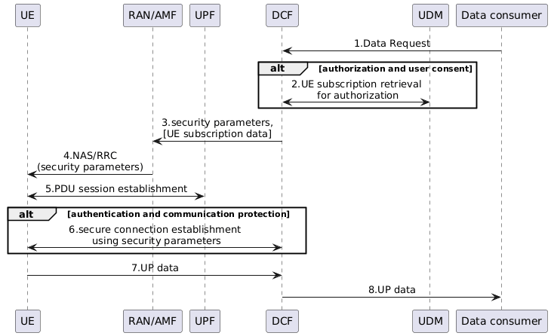
Figure 6.2.2-1: Security of UE connection setup with Data Collection NF
1. Data consumer (e.g. UE model training entity server) requests UE data collection to DCF.
2. DCF retrieves UE subscription data from UDM. The subscription data includes:
a) User consent data: existing user consent parameters can be reused.
b) Authorization profile: whether UE is allowed for exposing specific data to specific data consumer.
The DCF can be enforcement point for authorization and user consent check if it decides that DCF is used for UE selection for data collection.
3. The DCF sends security parameters (e.g. PSK) to the RAN/AMF. The DCF may also send UE subscription data to the RAN/AMF to enforce the authorization and user consent check if it decides that RAN/AMF is used for UE selection for data collection.
4. The RAN/AMF sends security parameters to the UE. The security parameters are protected by RRC/NAS mechanism.
5. The UE establishes a PDU session as depicted in clause 7.1.1 of TR 23.700-04 [2].
6. The UE establishes a secure connection using the security parameters to the DCF, e.g. the UE uses PSK to establish a secure TLS connection with the DCF.
7. The UE reports UP data in the secure connection to the DCF.
8. The DCF reports UP data to the Data consumer.
Editor's note: Aspect related to user consent its application and enforcement in any form for UE data collection is FFS.
Editor's note: Applicability and distribution of related security parameter (i.e. PSK) for the purpose of secure channel establishment or applicability of UE subscription data and its distribution to AMF/RAN in any form is FFS.

6.2.3 Evaluation
TBA
Editor's note: The evaluation is made based on SA2 conclusion.

6.3 Solution #2: Security for Data Collection using a DCF

6.3.1 Introduction
This solution addresses Key Issue #1.
This solution builds on TR 23.700-04 (for the standardized transfer of standardized data over UP for UE-side data collection) and introduces security enhancements in the 5GS for secure UE connection setup and data transfer with a Data Collection Function (DCF).

6.3.2 Solution details
Architecture scope and roles
- DCF in the MNO domain manages Data Collection Profiles (DCPs) and orchestrates UE data collection and transfer,
Security functions
1) Authentication and session protection between UE and DCF
- The UE establishes a secure association with the DCF using shared key derived from network credentials. Transport security (e.g., TLS) is bound to the shared key. Options for shared key derivation are:
- Option #1: AKMA-based keys (TS 33.535 [4]). DCF acts as a trusted AF, and obtains KAF from the AAnF over SBI.
Editor's note: The role of DCF acting as AF is FFS needs alignment with SA2.
- Option #2: K_{SEAF} or K_{AMF} derived shared key. DCF obtains the shared key from AMF/SEAF over SBI.
Editor's note: How shared key derivation and service operations for exchange of shared key between AMF/SEAF and DCF (option #2) are FFS.
2) UE authorization and policy enforcement
- The DCF authorizes a UE to participate per DCP, using subscription, consent, and operator policy.
Editor's note: Whether and how DCP is applicable is FFS and depends on SA2.
3) Consent enforcement inside the Core Network
- The DCF acts as the consent enforcement point for data collection from the UE, i.e., checks consent from UDM/UDR for permissions, as per TS 33.501 [3], Annex V.
Editor's note: Whether and how user consent exposure applies will be decided by SA3 based on SA6 progress.

6.3.3 Evaluation
Editor's note: Evaluation is FFS.

6.4 Solution #3: Security of connection between UE and Data Collection NF

6.4.1 Introduction
This solution address KI#1 Security of UE connection setup with Data Collection NF by reusing the existing TLS based mechanism.

6.4.2 Solution details
The UE establishes the user plane connection to the Data Collection NF, to protect the interface, the TLS based mechanism is supported.
Editor's note: The detail of the TLS based mechanism is FFS.

6.4.3 Evaluation
Editor's note: Evaluation is FFS.

6.5 Solution #4: New solution for Security of UE connection setup with Data collection NF

6.5.1 Introduction
This solution addresses requirements of key issue #1: "Security of UE connection setup with Data collection NF", particularly by hop-by-hop security. For authorization and user consent check between UE and data collection NF, it proposes detailed authorization checks against UE subscription data and operator policies at the data collection NF (DCF).

6.5.2 Solution details
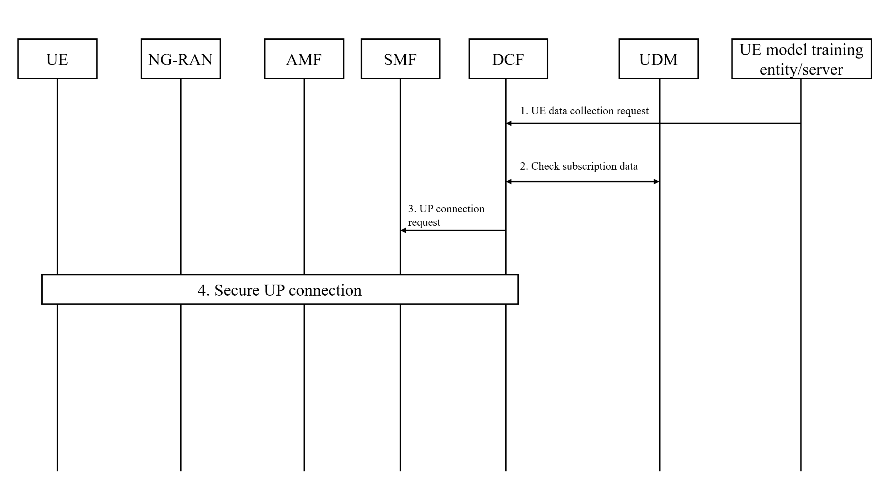
Figure 6.5.2-1: Security of UE connection setup with Data Collection NF
1. The UE model training entity/server sends a request to the DCF to collect UE data for UE side model training.
2. The DCF checks subscription data for UE data collection and transfer from the UDM.
3. After successful authorization and user consent check, UE and UPF, DCF sends a request to SMF to establish a secure UP connection.
4. The procedure of secure UP connection shall reuse existing UP security mechanisms from TS 33.501 [3] between UE and gNB, reuse exiting NDS/IP specified in TS 33.210 [5] between gNB and DCF.
Editor's note: The authentication between UE and data collection NF is FFS.
Editor's note: Aspect related to user consent its application and enforcement in any form for UE data collection is FFS.
Editor's note: How the solution covers all the requirements of KI#1 is FFS.
Editor's note: How the UE perform data collection and its dependency on the solution is subject to SA2 progress.

6.5.3 Evaluation
TBD

6.Y Solution #Y: <Solution Name>

6.Y.1 Introduction
Editor’s Note: Each solution should list the key issues being addressed.

6.Y.2 Solution details

6.Y.3 Evaluation
Editor’s Note: Each solution should motivate how the potential security requirements of the key issues being addressed are fulfilled.

7 Conclusions
Editor’s Note: This clause captures the conclusions of this study.

Annex A:
Change history

Change history
Date | Meeting | TDoc | CR | Rev | Cat | Subject/Comment | New version
2025-08 | SA3#123 | S3-253064 |  |  |  | S3-252564, S3-252988, S3-252990 for endorsed TR skeleton, overview and new key issue | 0.0.0
2025-10 | SA3#124 | S3-253259 |  |  |  | Create TR 33.785 based on S3-253064 | 0.1.1
2025-10 | SA3#124 | S3-253703 |  |  |  | S3-253702, S3-253704, S3-253706, S3-253707, S3-253708, S3-253709, S3-253710 for new key issue and new solutions | 0.2.0

