3GPP TSG-SA3 Meeting #117 S3-24xxxx
Maastricht, Netherlands 19 - 23 August 2024

Source: Huawei, HiSilicon

Title: Discussion paper on LTM solutions

Document for: Endorsement
Agenda Item: 4.12

1 Decision/action requested
It is proposed to endorse the proposal raised by this discussion paper.

2 References
[1] R2-2404037, LS on security handling for inter-CU LTM in non-DC cases, RAN2.

3 Rationale

3.1 Background
LTM (L1/L2 Triggered Mobility) was introduced in Rel-18 for the intra-CU scenario. In Rel-19, the scope is extended to inter-CU to support low latency and low interruption cell switch in broad areas. In this contribution, we discuss the scenarios, the procedures of inter-CU LTM, and issues specific to subsequent inter-CU LTM.

3.2 Analysis
How to update the security key is one issue to be solved for subsequent inter-CU LTM. RAN2 listed some potential options and sent the options to SA3 [3] to ask the feasibility from security perspective. The description to the potential solutions in the LS is mainly from UE perspective. In fact, network side procedures should also be considered.
R2-2404037, LS on security handling for inter-CU LTM in non-DC cases
Option 1: Use a new information in MAC CE to deliver the security information. Whether the UE uses horizontal or vertical key derivation is derived from this new information in MAC CE (which is currently, neither integrity protected nor ciphered).
Option 1A: the NCC value to be used at inter-CU LTM execution is included in the LTM cell switch command MAC CE.
Option 1B: the UE is preconfigured with a list of NCC values in a ciphered and integrity protected RRC message and the index of an NCC value in the list is included in the LTM cell switch command MAC CE.

Option 2: Similar to Rel-18 S-CPAC key update mechanism, the UE is preconfigured from the source gNB with a list of NCC values per CU using RRC signalling (that is both integrity protected and ciphered). It is expected that the participating gNBs (CUs) would need to be aware of the list and how the UE applies the list during LTM cell switches:
Option 2A: UE chooses the first unused NCC for the target CU upon inter-CU LTM execution.
Option 2B: As an alternative to choosing the next unused NCC (as in option 2A), horizontal key derivation is used in this option if the LTM cell switch is between the same two CUs.

Option 3: After the execution of inter-CU LTM cell switch, the participating gNBs are expected to be updated with new K-gNB* to be used for the next inter-CU LTM cell switch. The UE and CN are aware of how the UE would use the next NCC value.
Option 3A: The UE determines the following NCC value to use by itself (e.g., increase by 1) after subsequent inter-CU LTM execution.
Option 3B: UE is pre-configured by the CN (via source gNB RRC signalling) with a list of NCC values and the UE chooses the first unused NCC value as the next NCC value.

Option 4: After every inter-CU LTM cell switch execution, the UE is provided via RRC signalling with the NCC value to be used by the UE for key derivation at the next inter-CU LTM cell switch.
- Option1 and Option 4:
In the above Option 1 and Option 4, when the UE switches to a new gNB, the legacy path switch procedure is still used to switch the DL GTP-U tunnel from (UPF to source gNB) to (UPF to target gNB). In the path switch procedure, the AMF provides an (NH, NCC) pair to the target gNB. Then, the target gNB derives K_{gNB} * for each candidate configuration and provides it to the controlling gNB and sends the NCC to the UE.
The procedures are shown in the figure below:
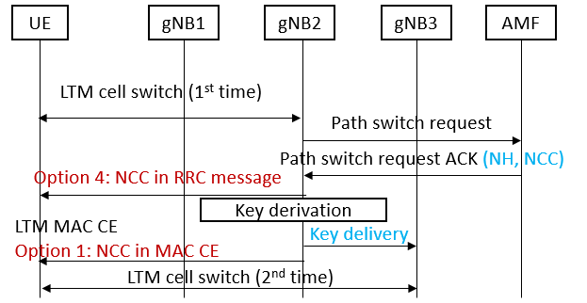
Figure 1: Security key update option 1 and option 4
Observation 1: The solutions for option1 and option4 have minimal impact on the existing procedure.
- Option 2:
In the above Option 2A, at the LTM pre-configuration, each candidate gNB needs to establish an NG connection with the AMF for a UE, so that the candidate gNBs can receive multiple NCC values in advance. Then, the candidate gNBs provide the received NCC values to the source gNB and the source gNB sends them to the UE, e.g., when it provides the candidate LTM configurations. When the UE switches to a new gNB, path switch is still needed to switch the DL GTP-U tunnel from (UPF to source gNB) to (UPF to target gNB), but the (NH, NCC) pair needs not be provided from the AMF to the target gNB, because it was already provided.
The procedure is shown in the figure below:
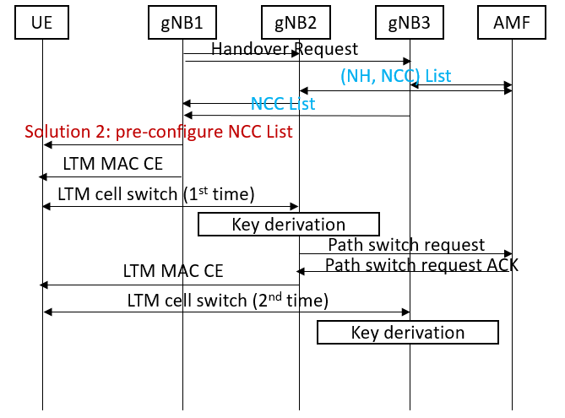
Figure 2: Security key update option 2
For such solution, how NH-NCC list provided from AMF to gNB requires new procedures in network. For each gNB, different NCC-NH list should be configured. In addition, how UE maintaining the NCC-NH list and taking them into use also introduce a lot of works.
Observation 2: The solutions for option2 have large impact to both UE and network side.
- Option 3
With respect to the above Option 3, it is not clear about the network side procedures. In addition, how to sync up the NCC in UE side and network side is also unclear.
Observation 3: The solutions for option3 are unclear, which may not be feasible.

4 Detailed proposal
According to analysis above, we have the following observations:
Observation 1: The solutions for option1 and option4 have minimal impact on the existing procedure.
Observation 2: The solutions for option2 have large impact to both UE and network side.
Observation 3: The solutions for option3 are unclear, which may not be feasible.
Based on the observations, we propose:
Proposal 1: It is proposed to focus on the discussion on solutions for option1 and option4.

