**3GPP TSG-SA3 Meeting #114e *ad-hoc S3-240015***

Electronic meeting, online, 22 - 26 January 2024

**Source: Federal Office for Information Security (BSI)**

**Title: Discussion on PCF-Specific SCAS Test Cases**

**Document for: Discussion/Agreement**

**Agenda Item: 4.1.1**

# 1 Decision/action requested

***This contribution discusses the possibilities of PCF-specific SCAS test cases.***

# 2 References

[1] 3GPP TS 29.513 Policy and Charging Control signalling flows and QoS parameter mapping

[2] 3GPP TS 29.514 Policy Authorization

[3]   3GPP TS 29.534 Access and Mobility (AM) Policy Authorization

[4]   3GPP TS 29.507 Access and Mobility (AM) Policy Control

[5]   3GPP TS 29.501 Background Data Transfer (BDT) Policy Control

[6]   3GPP TS 29.523 Policy Control Event Exposure

[7]   3GPP TS 29.525 UE Policy Control

[8] 3GPP TS 33.528 Security Assurance Specification (SCAS) for Policy Control Function (PCF)

[9] 3GPP TR 33.916 Security Assurance Methodology (SECAM) for 3GPP network products

[10] 3GPP TS 33.501 Security architecture and procedures for 5G system

[11] 3GPP TS 33.117 Catalogue of general security assurance requirements

# 3 Rationale

The PCF plays a vital role in the security procedure by controlling and maintaining various security-relevant policies in the 5G SA network. SCAS_5G_PCF aims to study the role of PCF security requirements in the 5G core network and examines attempts for specific SCAS test cases regarding the PCF network function. Hence, the PCF has interfaces with numerous consuming and a handful of providing network functions, as illustrated below.

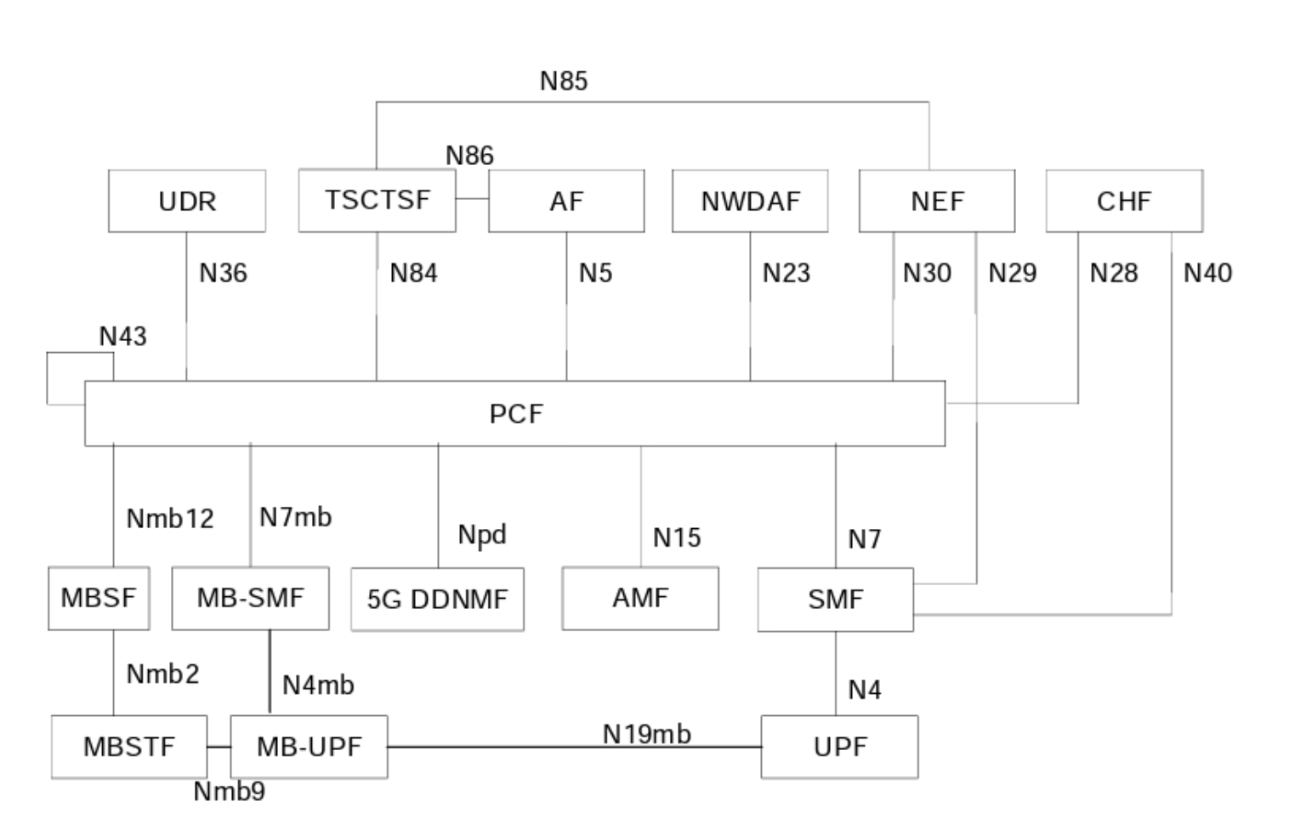

In particular the following Interface definitions are of interest:

* Policy and Charging Control signalling flows and QoS parameter mapping [1]
* Policy Authorization [2]
* Access and Mobility (AM) Policy Authorization [3]
* Access and Mobility (AM) Policy Control [4]
* Background Data Transfer (BDT) Policy Control [5]
* Policy Control Event Exposure [6]
* UE Policy Control [7]

During our analysis, it became apparent that the PCF performs a maintenance function. This means that policies are stored and received by a similar network function type (NFType). For instance, the AM Policy Authorization and AM Policy Control functions are specifically designed for use by the AMF. With this in mind, we have considered two attacker models. One model involves an attacker who has direct access to the PCF, the other one assumes an attacker who uses a network function with PCF access as an intermediate node.

In the first case, the attacker must behave as a network function with access to the PCF via one of the mentioned network interfaces. However, this type of attack is prevented by the security definitions in TS 33.501 [10], such as TLS and OAuth2.0. Since these requirements are not exclusive to the PCF, they are already reflected in the general SCAS test cases of TS 33.117 [11].

In the second scenario, the attacker has access to one of the network functions that are allowed to communicate with the PCF (e.g. by taking control of a genuine AMF). Therefore, the attacker can manipulate any communication between these two NFs and potentially trigger the PCF to perform unwanted actions. However, we assume that the network functions that access the PCF operate correctly. This assumption shifts the responsibility to those network functions, which must be implemented and tested properly (via SCAS).

Therefore, at this time, we were not able to identify any specific test cases for the PCF.

Recommendations:

(R1) No specific test cases for the PCF shall be included in the 3GPP TS 33.528 [8]

# 4 Detailed proposal

Regarding the analysis outlined in the Rationale above, BSI's proposal is to agree on the current PCF SCAS (TS 33.528 V0.3.0) as being 80% ready and thus version v18.1.0 of PCF SCAS (without specific test-cases, using references to TS 33.117 alone).