3GPP TS 23.247 V0.2.0 (2021-04)
Technical Specification
3rd Generation Partnership Project;
Technical Specification Group Services and System Aspects;
Architectural enhancements for
5G multicast-broadcast services;
Stage 2;
(Release 17)


The present document has been developed within the 3rd Generation Partnership Project (3GPP TM) and may be further elaborated for the purposes of 3GPP..
The present document has not been subject to any approval process by the 3GPP Organizational Partners and shall not be implemented.
This Specification is provided for future development work within 3GPP only. The Organizational Partners accept no liability for any use of this Specification.
Specifications and Reports for implementation of the 3GPP TM system should be obtained via the 3GPP Organizational Partners' Publications Offices.

Keywords
3GPP, 5G, Architecture, Broadcast, Multicast
3GPP
Postal address

3GPP support office address
650 Route des Lucioles - Sophia Antipolis
Valbonne - FRANCE
Tel.: +33 4 92 94 42 00 Fax: +33 4 93 65 47 16
Internet
http://www.3gpp.org
Copyright Notification
No part may be reproduced except as authorized by written permission.
The copyright and the foregoing restriction extend to reproduction in all media.

© 2021, 3GPP Organizational Partners (ARIB, ATIS, CCSA, ETSI, TSDSI, TTA, TTC).
All rights reserved.

UMTS™ is a Trade Mark of ETSI registered for the benefit of its members
3GPP™ is a Trade Mark of ETSI registered for the benefit of its Members and of the 3GPP Organizational Partners
LTE™ is a Trade Mark of ETSI registered for the benefit of its Members and of the 3GPP Organizational Partners
GSM® and the GSM logo are registered and owned by the GSM Association
Contents
Foreword 5
1 Scope 7
2 References 7
3 Definitions of terms and abbreviations 7
3.1 Terms 7
3.2 Abbreviations 8
4 General Concept 8
4.1 Principles of multicast and broadcast communication 8
4.2 MB service provisioning 9
4.2.1 Multicast data provisioning 9
4.2.2 Broadcast data provisioning 10
5 Architecture model 12
5.1 General architecture 12
5.2 Architecture for interworking with EPS 13
5.3 Reference point and functional entities 13
5.3.1 Reference point 13
5.3.2 Functional entities 13
5.3.2.1 PCF 13
5.3.2.2 MB-SMF 14
5.3.2.3 SMF 14
5.3.2.4 MB-UPF 14
5.3.2.5 UPF 14
5.3.2.6 AMF 15
5.3.2.7 NG-RAN 15
5.3.2.8 UE 15
5.3.2.9 AF 15
5.3.2.10 NEF 15
5.3.2.11 MBSF 15
5.3.2.12 MBSTF 16
5.3.2.13 UDM 16
5.3.2.14 UDR 16
6 Functionalities and features 16
6.1 Authorization to MBS service 16
6.2 Local MBS service 17
6.3 Mobility support of MBS service 17
6.4 Subscription to Multicast and Broadcast services 18
6.5 Identifiers 18
6.5.1 MBS Session ID 18
6.5.2 Temporary Mobile Group Identity 18
6.6 QoS Handling for Multicast and Broadcast services 18
6.7 User plane Management 19
6.8 Interworking with MBMS over E-UTRAN for public safety services 19
6.9 MBS Session and Service Context 19
7 MBS procedures 20
7.1 Common procedure for Multicast and Broadcast 20
7.1.1 Configuration for MBS 20
7.1.2 MB-SMF discovery and selection for multicast/broadcast session 23
7.2 MBS procedures for multicast Session 23
7.2.1 MBS join and Session establishment procedure 23
7.2.1.1 General 23
7.2.1.2 Establishment of a PDU Session that can be associated with multicast session(s) 23
7.2.1.3 MBS join and Session establishment procedure 24
7.2.1.4 MBS join and Session establishment procedure involving MBSF 25
7.3 MBS procedures for broadcast Session 25
7.3.1 MBS Session Establishment for Broadcast 25
7.3.2 MBS Session Release for Broadcast 28
7.3.3 MBS Session Update for Broadcast 30
7.3.4 Support for Local Broadcast Service and Location-dependent Broadcast Service 31
7.4 MBS procedures for inter System Mobility 31
8 Control and user plane stacks 32
8.1 Control plane for Multicast and Broadcast services 32
8.2 User plane for Multicast and Broadcast services 32
9 Network Function Services 32
Annex A (Normative): Configuration options at Service and/or Application for MBS 33
Annex B (Informative): Change history 35

Foreword
This Technical Specification has been produced by the 3rd Generation Partnership Project (3GPP).
The contents of the present document are subject to continuing work within the TSG and may change following formal TSG approval. Should the TSG modify the contents of the present document, it will be re-released by the TSG with an identifying change of release date and an increase in version number as follows:
Version x.y.z
where:
x the first digit:
1 presented to TSG for information;
2 presented to TSG for approval;
3 or greater indicates TSG approved document under change control.
y the second digit is incremented for all changes of substance, i.e. technical enhancements, corrections, updates, etc.
z the third digit is incremented when editorial only changes have been incorporated in the document.
In the present document, modal verbs have the following meanings:
shall indicates a mandatory requirement to do something
shall not indicates an interdiction (prohibition) to do something
The constructions "shall" and "shall not" are confined to the context of normative provisions, and do not appear in Technical Reports.
The constructions "must" and "must not" are not used as substitutes for "shall" and "shall not". Their use is avoided insofar as possible, and they are not used in a normative context except in a direct citation from an external, referenced, non-3GPP document, or so as to maintain continuity of style when extending or modifying the provisions of such a referenced document.
should indicates a recommendation to do something
should not indicates a recommendation not to do something
may indicates permission to do something
need not indicates permission not to do something
The construction "may not" is ambiguous and is not used in normative elements. The unambiguous constructions "might not" or "shall not" are used instead, depending upon the meaning intended.
can indicates that something is possible
cannot indicates that something is impossible
The constructions "can" and "cannot" are not substitutes for "may" and "need not".
will indicates that something is certain or expected to happen as a result of action taken by an agency the behaviour of which is outside the scope of the present document
will not indicates that something is certain or expected not to happen as a result of action taken by an agency the behaviour of which is outside the scope of the present document
might indicates a likelihood that something will happen as a result of action taken by some agency the behaviour of which is outside the scope of the present document
might not indicates a likelihood that something will not happen as a result of action taken by some agency the behaviour of which is outside the scope of the present document
In addition:
is (or any other verb in the indicative mood) indicates a statement of fact
is not (or any other negative verb in the indicative mood) indicates a statement of fact
The constructions "is" and "is not" do not indicate requirements.

1 Scope
The present document specifies architectural enhancements to the 5G system using NR to support multicast and broadcast communication services, complying to the requirements in TS 22.146 [2], TS 22.246 [3] and TS 22.261 [4]. This document encompasses support for functions such as how to deliver multicast and broadcast communications including support within certain location areas, mobility, MBS session management and QoS.
The present document also covers interworking with E-UTRAN and EPC based eMBMS for Public Safety (e.g. MCX services).

2 References
The following documents contain provisions which, through reference in this text, constitute provisions of the present document.
- References are either specific (identified by date of publication, edition number, version number, etc.) or non-specific.
- For a specific reference, subsequent revisions do not apply.
- For a non-specific reference, the latest version applies. In the case of a reference to a 3GPP document (including a GSM document), a non-specific reference implicitly refers to the latest version of that document in the same Release as the present document.
[1] 3GPP TR 21.905: "Vocabulary for 3GPP Specifications".
[2] 3GPP TS 22.146: "Multimedia Broadcast/Multicast Service (MBMS); Stage 1".
[3] 3GPP TS 22.246: "Multimedia Broadcast/Multicast Service (MBMS) user services; Stage 1".
[4] 3GPP TS 22.261: "Service requirements for the 5G system".
[5] 3GPP TS 23.501: "System architecture for the 5G System (5GS)".
[6] 3GPP TS 23.502: "Procedures for the 5G System; Stage 2".
[7] 3GPP TS 23.503: "Policy and charging control framework for the 5G System (5GS); Stage 2".
[8] 3GPP TS 23.246: "Multimedia Broadcast/Multicast Service (MBMS); Architecture and functional description".
[9] 3GPP TS 38.300: "NR; Overall description; Stage-2".
[10] 3GPP TS 23.468: "Group Communication System Enablers for LTE (GCSE_LTE)".
[11] 3GPP TS 26.348: "Northbound Application Programming Interface (API) for Multimedia Broadcast/Multicast Service (MBMS) at the xMB reference point".
[12] 3GPP TS 23.003: "Numbering, Addressing and Identification".
[13] 3GPP TS 26.346: "MBMS: Protocols and Codecs".
[14] 3GPP TR 23.757: "Study on architectural enhancements for 5G multicast-broadcast services".

3 Definitions of terms and abbreviations

3.1 Terms
For the purposes of the present document, the terms and definitions defined in TR 21.905 [1] and the following apply:
5GC Individual MBS traffic delivery: 5G CN receives a single copy of MBS data packets and delivers separate copies of those MBS data packets to individual UEs via per-UE PDU sessions, hence for each such UE one PDU session is required to be associated with a multicast session.
5GC shared MBS traffic delivery: 5G CN receives a single copy of MBS data packets and delivers a single copy of those MBS data packets to a RAN node.
Broadcast communication service: A 5GS communication service in which the same service and the same specific content data are provided simultaneously to all UEs in a geographical area (i.e., all UEs in the broadcast coverage area are authorized to receive the data).
NOTE 1: For the broadcast communication service, the content provider and network may not be aware whether the authorized UEs are actually receiving the data being delivered.
Broadcast MBS session: An MBS session to deliver the broadcast communication service. A broadcast MBS session is characterised by the content to send and the geographical area where to distribute it.
Broadcast service area: The area within which data of one or multiple Broadcast session(s) are sent.
MBS QoS Flow: The finest granularity for QoS forwarding treatment for MBS data. Providing different QoS forwarding treatment requires separate MBS QoS Flows in 5GS supporting 5MBS.
MBS Service Announcement: Mechanism to allow users to be informed about the available MBS services.
MBS session: A multicast session or a broadcast session.
Multicast communication service: A 5GS communication service in which the same service and the same specific content data are provided simultaneously to a dedicated set of UEs (i.e., not all UEs in the multicast coverage are authorized to receive the data).
NOTE 2: For multicast communication service, the content provider and network can be aware whether the authorized UEs are actually receiving the data being delivered.
Multicast MBS session: An MBS session to deliver the multicast communication service. A multicast MBS session is characterised by the content to send, by the list of UEs that may receive the service and optionally by a multicast area where to distribute it.
Multicast service area: The area within which data of one or multiple Multicast session(s) may be sent.

3.2 Abbreviations
For the purposes of the present document, the abbreviations given in TR 21.905 [1], TS 23.501 [5] and the following apply. An abbreviation defined in the present document takes precedence over the definition of the same abbreviation, if any, in TR 21.905 [1].
MBS Multicast/Broadcast Service.
MB-SMF Multicast/Broadcast Session Management Function
MBSF Multicast/Broadcast Service Function
MBSTF Multicast/Broadcast Service Transport Function

4 General Concept

4.1 Principles of multicast and broadcast communication
Editor's note: It is FFS whether the text below will be moved to a different clause of the TS.
The following service levels for the multicast communication service are defined:
NOTE 1: Transport Only mode and Full-Service mode of operation as defined in TS 23.246 [8] differ from the service levels defined here.
- Basic service level. The following requirements are defined:
- Media transported transparently through the 5GS.
- Request to receive the multicast service.
- Packet distribution from the 5GS ingress to (R)AN node(s).
- Data delivery from (R)AN node(s) to the UE.
- Enhanced service level, with additional requirements on top of basic service level. Different requirements out of the set below may be necessary to address each use case:
- Local MBS service.
- User authentication and authorization.
NOTE 2: User authentication and authorization can be done by 5GS or AF or both, or even not needed for a multicast communication service.
- Explicit configuration of multicast session by network function external to the 5GS including Group member management.
- Enhanced QoS support.
NOTE 3: 5G MBS can provide different QoS other than default QoS for different multicast groups.
The 5GC Shared MBS traffic delivery method is required in all 5G MBS deployments. The 5GC Individual MBS traffic delivery method is required to enable mobility when there is an NG-RAN deployment with non-homogeneous support of 5G MBS.
Editor's note: The above description of requirements may change during the normative phase.

4.2 MB service provisioning

4.2.1 Multicast data provisioning
Multicast data provisioning is enabled by certain procedures that are illustrated in the Figure below.
MBS Session Configuration & Service Announcement
UE Session Join
Session Establishment
Data Transfer
UE Session Leave
Session Release
Figure 4.2.1-1: Phases of Multicast data provisioning
Editor's note: It is FFS about whether the order of “Service Announcement”, “UE Session Join”, “Session Establishment” need to be adjusted, depending on the discussion “UE join will be rejected if session is not established”
Editor's note: It is FFS about whether “Session Activate” and “Session Inactivate” need to be introduced, due to session can be established in inactive state.
The following phases are performed for a specific UE:
- UE Session Join: UE Session Join is the process by which a UE joins an MBS Session, i.e. the UE indicates to 5GC that such UE wants to receive Multicast data identified by a specific MBS Session ID.
- UE Session Leave: UE Session Leave is the process by which a UE leaves a MBS Session, i.e. the UE no longer wants to receive Multicast data identified by a specific MBS Session ID.
The following phases are performed for a specific service:
- MBS Session Configuration: MBS Session Configuration is used by the AF to configure the MBS Session towards 5GC, which may also include TMGI allocation procedure. This step is optional.
- Service announcement: Service announcement is used to information toward UEs about the service required for service reception (e.g., IP multicast address(es)) and possibly other service related parameters (e.g. service start time). This step is optional.
- Session Establishment: Session Establishment is the point at which the transmission resources need to be established for transmitting the DL Multicast data between 5GC and NG-RAN. Session Establishment is triggered by the first accepted UE Join request.
- Data transfer: It is the phase when Multicast data are transferred to the UEs.
- Session Release: It is the point at which there will be no more need to transmit Multicast data. At Session Release, the resources in 5GS are released.
The phase of Multicast data provisioning is illustrated with the following example of timeline:
Time
UE 1 events
UE 2 events
Data volume received by the UEs
Multicast Session
Session Join
Session Leave
Session Join
Session Leave
Service Announcement
Session Establishment
Session Release
Data Transfer
Data Transfer
Data Transfer
Session existing period
Data sent to UE1
Data sent to UE1 and UE2
Data sent to UE1 and UE2
Data sent to UE1
Figure 4.2.1-2: Multicast service timeline example
Editor's note: Details of the timeline is FFS.

4.2.2 Broadcast data provisioning
An example for the phases of broadcast data provisioning is described in the figure below:
MBS Session Configuration & Service Announcement
Session Establishment
Data Transfer
Session Release
Figure 4.2.2-1: Phases of Broadcast data provisioning
The following phases are performed for a specific service:
- MBS Session Configuration: MBS Session Configuration is used by the AF to configure the MBS Session towards 5GC, which may also include TMGI allocation procedure.
- Service announcement: Service announcement is used to distribute information towards UEs about the service required for service reception (e.g., IP multicast address(es)) and possibly other service related parameters (e.g. service start time). This step is optional.
- Session Establishment: Session Establishment is the point at which the transmission resources need to be established for transmitting the DL Broadcast data between 5GC and NG-RAN. Session Establishment follows Session Start, which is triggered by the request from AF.
- Data transfer: It is the phase when broadcast data are transferred in the air interface.
- Session Release: It is the point at which there will be no more need to transmit Broadcast data. At Session Release, the resources in 5GS are released.
The phase of Broadcast data provisioning is illustrated with the following example of timeline:
Time
UE 1 events
UE 2 events
Data volume received by the UEs
Broadcast Session
UE1 service activation
UE1 service de-activation
UE2 service activation
UE2 service de-activation
Service Announcement
Session Establishment
Session Release
Data Transfer
Data Transfer
Data Transfer
Session existing period
Broadcast of Data, received by any UE which is present
Broadcast of Data, received by any UE which is present
Broadcast of Data, received by any UE which is present
Figure 4.2.2-2: Broadcast service timeline
Editor's note: Details of the timeline is FFS.

4.2.3 Multicast session state model
The following states are defined for the multicast session:
- Configured state: Some information about the multicast session is configured, but no resources are reserved and no multicast data can be transmitted. For instance, TMGIs can be allocated but no complete session information is provided. UEs may be allowed to join (subject to authorization check and configuration), but the first accepted UE join request will trigger the multicast session establishment.
NOTE 1: The SMF is not involved while the multicast session is in configured state, but this state affects the MB-SMF
NOTE 2: There may be several sub-states in the configured state, e.g. only TMGIs requested, or full information about the multicast session provided.
- Active state: Established multicast session is in active state. UEs are allowed to join the multicast session (subject to authorization check). 5GC resources for the multicast session are reserved for UEs that joined the multicast session. Corresponding radio resources are reserved depending on participating UE locations. Multicast data can be transmitted to UEs that joined the multicast session.
- Inactive state: Established multicast session in inactive state. No multicast data are transmitted. UEs that joined the multicast session may be in CM CONNECTED or CM IDLE state. UEs are allowed to join the multicast session (subject to authorization check).
The following state transition procedures are defined:
- Multicast Session Configuration: The AF can provide information about the multicast session and/or request the allocation of a TMGI. Alternatively, there is network-internal configuration of the multicast session. No resources or only resources at MB-SMF, NEF and MB-UPF are reserved and no multicast data are transmitted. The configuration may indicate whether the multicast session may be established in active or inactive state and when a multicast session can become inactive. The AF may provide configuration in several steps, e.g. to first request TMGIs and then provide full information about the multicast session and allow it to be established.
- Multicast Session Establishment: When the join request of the first UE in the multicast session is accepted, the multicast session is established either in inactive or active state, depending on configuration. 5GC resources for the multicast session are being reserved.
- Multicast Session Activation: State transition from inactive to active multicast session. CM IDLE UEs that joined the multicast session are paged. Activation can be triggered by AF request or reception of multicast data.
- Multicast Session Deactivation: State transition from active to inactive multicast session. Deactivation can be triggered by AF request or no reception of multicast data.
- Multicast Session Release: All resources for the multicast session are released in both 5GC nodes and RAN nodes, UEs that joined the multicast session are notified. The release is possible for an active or inactive multicast session. The release may be combined with the deconfiguration of a multicast session. The release may be triggered by an AF request or by the last UE leaving the multicast session.
- Multicast Session Deconfiguration: All information about the multicast session is removed from the 5GC and TMGIs are deallocated.
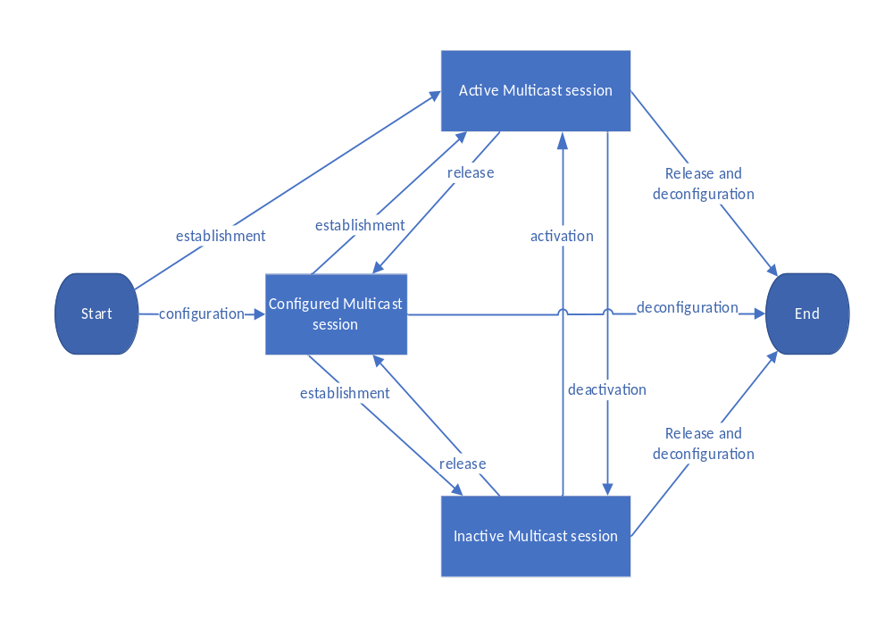
Figure 4.2.3-1: Multicast session states and state transitions
Editor's note: The multicast session state machine describes the states in 5GC. It is FFS whether and how it can be refined to the state machines in each NF (e.g. different state machines in SMF and MB-SMF).

5 Architecture model

5.1 General architecture

Figure 5.1-1 depicts the 5G MBS reference architecture. Service-based interfaces are used within the Control Plane.
Multicast-broadcast service for roaming is not supported in this release.
Interaction between multicast-broadcast service and support of deployments topologies with specific SMF Service Areas is not specified in this release.
Editor's note: It is FFS whether to document those limitations of this release in the scope or general clause instead.
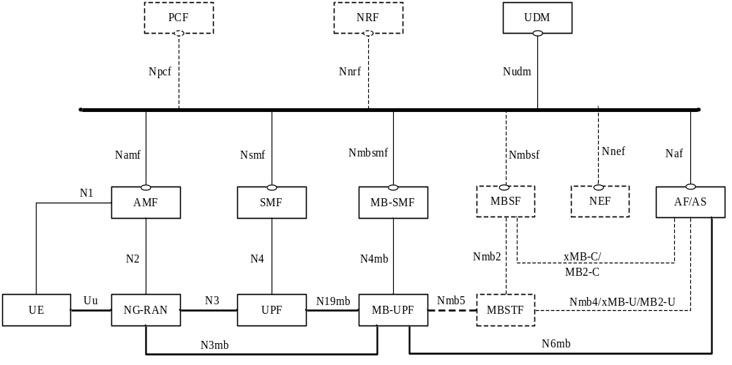
Figure 5.1-1: 5G MBS system architecture
NOTE 1: The MBSF is optional and may be collocated with the NEF or AF/AS, and the MBSTF is an optional network function.
NOTE 2: The existing service based interfaces of Nnrf, Nudm, and Nsmf are enhanced to support 5G MBS. The existing service based interfaces of Npcf and Nnef are enhanced to support 5G MBS; their usage depends on deployment.
NOTE 3: xMB-C/MB2-C and xMB-U/MB2-U are intended for legacy AS.
Editor's note: Which NF is used to store service parameters, including serving MB-SMF information will be updated in future versions.
Figure 5.1-2 depicts the 5G MBS system architecture using the reference point representation showing how various network functions interact with each other.
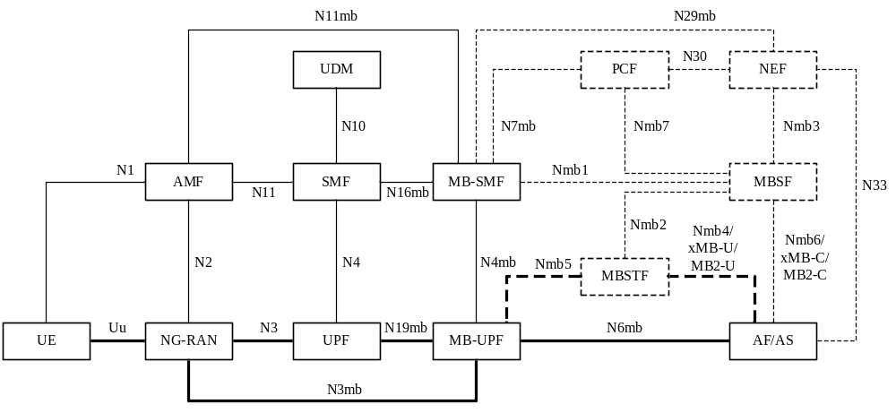
Figure 5.1-2: 5G MBS system architecture in reference point representation
NOTE 3: The existing reference points of N1, N2, N11 are enhanced to support 5G MBS.

5.2 Architecture for interworking with EPS

5.3 Reference point and functional entities

5.3.1 Reference point
The 5MBS System Architecture contains the following new reference points:
N3mb: Reference point between the (R)AN and the MB-UPF.
N4mb: Reference point between the MB-SMF and the MB-UPF.
N6mb: Reference point between the MB-UPF and the AF/AS.
N7mb: Reference point between the MB-SMF and the PCF.
N11mb: Reference point between the AMF and the MB-SMF.
N16mb: Reference point between the SMF and the MB-SMF.
N19mb: Reference Point between the UPF and the MB-UPF.
N29mb: Reference point between the MB-SMF and the NEF.
Nmb1: Reference point between the MB-SMF and the MBSF.
Nmb2: Reference point between the MBSF and the MBSTF.
Nmb3: Reference point between the MBSF and the NEF.
Nmb4: Reference point between the MBSTF and the AF.
Nmb5: Reference point between the MB-UPF and the MBSTF.
Nmb6: Reference point between the MBSF and the AF.
Nmb7: Reference point between the MBSF and the PCF
Editor's note: The Nmb7 reference point is FFS.
Editor's note: Whether N6mb and Nmb5 are with the same functionalities or not is FFS.

The 5MBS System Architecture reuses the existing reference points of N1, N2, N10, N11, and N33 with enhancement to support 5G MBS.

5.3.2 Functional entities
Editor's Note: functional entities and functional requirement are not completed.

5.3.2.1 PCF
The PCF performs the following functions to support 5MBS if dynamic PCC for 5MBS is needed:
- Supporting QoS handling for MBS Session.
- Providing policy information regarding the MBS Session to MB-SMF for authorizing the related QoS profiles.
- Interacting with UDR for QoS information retrieval.
Editor's Note: The following is ffs: The PCF receives MB service information from AF, NEF or MBSF

5.3.2.2 MB-SMF
The MB-SMF performs the following functions to support 5MBS:
- General for multicast and broadcast sessions:
- Supporting MBS session management (including QoS control).
- Configuring the MB-UPF for multicast and broadcast flows transport based on the policy rules for multicast and broadcast services from PCF or local policy.
- Specific for broadcast sessions:
- Interacting with RAN (via AMF) to control data transport using 5GC Shared MBS traffic delivery method.
- Specific for multicast sessions:
- Interacting with SMF to modify PDU Session associated with 5MBS.
- Interacting with RAN (via AMF and SMF) to establish data transmission resources between MB-UPF and RAN nodes for 5GC Shared MBS traffic delivery method.
- Controlling multicast data transport using 5GC Individual MBS traffic delivery method.

5.3.2.3 SMF
Editor’s note: Whether AMF or SMF discovers MB-SMF is FFS.
The SMF performs the following functions to support 5MBS:
- Discovering MB-SMF for multicast session.
- Authorizing multicast session join operation if needed.
- Interacting with MB-SMF to obtain and manage multicast session context.
- Interacting with RAN for shared data transmission resource establishment.
NOTE: SMF and MB-SMF may be co-located or deployed separately.

5.3.2.4 MB-UPF
The MB-UPF performs the following functions to support 5MBS:
- General for multicast and broadcast sessions:
- Packet filtering of incoming downlink packets for multicast and broadcast flows.
- QoS enforcement (MFBR) and counting/reporting based on existing means.
- Interaction with MB-SMF for receiving multicast and broadcast data.
- Delivery of multicast and broadcast data to RAN nodes for 5GC Shared MBS traffic delivery method.
- Specific for multicast sessions:
- Delivery of multicast data to UPF for 5GC Individual MBS traffic delivery method.

5.3.2.5 UPF
The UPF performs the following functions to support 5MBS:
- Interacting with SMF for receiving multicast data from MB-UPF for 5GC Individual MBS traffic delivery method.
- Delivering multicast data to UEs via PDU Session for 5GC Individual MBS traffic delivery method.
NOTE: UPF and MB-UPF may be co-located or deployed separately.

5.3.2.6 AMF
Editor’s note: Whether more functionalities are required is FFS.
The AMF performs the following functions to support 5MBS:
- Signalling with NG-RAN and MB-SMF for MBS Session management.
- Selection of NG-RANs for notification of multicast session activation toward UEs in CM-IDLE state.
- Selection of NG-RANs for broadcast.

5.3.2.7 NG-RAN
The NG-RAN performs the following functions to support 5MBS:
- Management of MBS QoS flows via N2.
- Delivery of MBS data packets from 5GC shared for multiple UEs over radio using PTM or PTP.
- Configuration of UE for MBS QoS flow reception at AS layer.
- Control switching between PTM and PTP delivery per UE.
- Support for multicast sessions continuity during Xn Handover and N2 Handover.
- Support notification of multicast session activation over radio toward UEs in CM-IDLE state.

5.3.2.8 UE
The UE may perform the following functions to support 5MBS:
- Reception of multicast data using PTM/PTP.
- Reception of multicast and broadcast data using PTM.
- Handling of incoming MBS QoS flows.
- Support of signalling for joining and leaving multicast session.
- 5MBS resource management support at AS layer.
- Reception of notification in CM-IDLE state from 5GS for multicast data transmission.

5.3.2.9 AF
The AF performs the following functions to support 5MBS:
- Requesting multicast or broadcast service from the 5GC by providing service information including QoS requirement to 5GC.
- Instructing MBS session operation towards 5GC if needed.
- Interacting with NEF for MBS related service exposure.

5.3.2.10 NEF
The NEF performs the following functions to support 5MBS:
- Providing an interface to AFs for 5MBS procedures including service provisioning, MBS session and QoS management.
- Interacting with AF and MB-SMF for MBS session operations, determination of transport parameters, and session transport.
- Selection of serving MB-SMF for an MBS Session.

5.3.2.11 MBSF
The MBSF performs the following functions to support 5MBS:
- Service level functionality to support 5MBS, and interworking with LTE MBMS
- Interacting with AF and MB-SMF for MBS session operations, determination of transport parameters, and session transport.
- Selection of serving MB-SMF for an MBS Session.
- Controlling MBSTF if the MBSTF is used.
- Determination of sender IP multicast address for the MBS session if IP multicast address is sourced by MBSTF.
NOTE: MBSF functionality related to service and MBS data handling (e.g. encoding) is to be determined with SA WG4.

5.3.2.12 MBSTF
The MBSTF performs the following functions to support 5MBS if deployed:
- Media anchor for MBS data traffic if needed.
- Sourcing of IP Multicast if needed.
- Generic packet transport functionalities available to any IP multicast enabled application such as framing, multiple flows, packet FEC (encoding).
- Multicast/broadcast delivery of input files as objects or object flows.
NOTE: MBSTF functionality related to MBS data handling (e.g. encoding) is to be determined with SA4.

5.3.2.13 UDM
The UDM performs the following functions to support 5MBS:
- Support management of subscription for authorization for multicast sessions.

5.3.2.14 UDR
The UDR performs the following functions to support 5MBS if deployed:

- Support management of UE authorization information for multicast session.

5.3.2.15 NRF
The NRF performs the following functions to support 5MBS:
- Support management of MB-SMF information serving multicast sessions.

6 Functionalities and features

6.1 Authorization to MBS service

6.1.1 AF/AS authorization to the service for multicast and broadcast
The AF/AS should be authorized by the 5GC for delivering MBS data to the 5GC and/or interacting with the 5GC. For signalling exchange with the 5GC, the NEF or MBSF perform authorization to the external AF for determination of whether the interaction with the 5GC is allowed or not.

6.1.2 UE authorization to the service for multicast
The UE authorization for multicast services may be at the following levels:
- Whether a UE is authorized to receive any Multicast MBS session data at all.
- Whether and how a UE is authorized to receive a particular multicast service:
- A multicast session may be open to any UEs and no authorization is needed;
NOTE 1: UE authorization for a specific multicast session can be implicitly performed when UE is configured for a specific multicast session, e.g. via Service Announcement for public safety use case.
NOTE 2: UE’s authorization on whether it is authorized to receive any Multicast MBS session data takes precedence over the other authorization information, if any. E.g., if the UE is not authorized to receive Multicast MBS session data, network will not send the data to the UE even if the Multicast MBS session is open to any UEs.
- A multicast session requires the 5GS to authorize the UE based on authorization information, e.g. preconfigured, or provided by the AF;
Editor's note: Whether and how the 5GC supports authentication/authorization for the UE access the multicast services performed by a Content Provider is FFS.
The procedure for UE authorization is described in clause 7.2.4.

6.2 Local MBS service
A Local MBS service is an MBS service provided in one or several MBS service area(s). An MBS service area is identified by a cell list or a tracking area list. Only UEs within the MBS service area may receive content data, while UEs outside the MBS service area are not allowed to receive location specific content. For multicast communication, UEs outside the MBS service area are not allowed to join the MBS service, and the network shall not deliver location specific content anymore to the UEs moving out of the MBS service area. The UE shall be able to obtain service area information of the local multicast service via MBS service announcement or via NAS signalling (Join Accept/Reject including Cell ID list or TAI list). If the UE join procedure fails due to the UE being outside the multicast service area, the UE does not attempt to join the multicast session again until the UE moves inside the multicast service area. When the join succeeds, if the multicast session is deactivated, the UE does not perform monitoring the session activation notification and any other information related to the multicast session identified by an MBS Session ID over the radio if outside the multicast service area
A location dependent MBS is a local MBS that is provided in several MBS service areas. The location dependent MBS service enables distribution of different content data to different MBS service areas. The same MBS Session ID is used but a different area session ID is used for each MBS servicearea. The area session ID is used, in combination with MBS Session ID, to uniquely identify the servive area specific part of the MBS service within 5GS. The network supports the location-dependent content distribution for the location dependent MBS services, while UEs are only aware of the MBS service. When UEs move to a new MBS service area, content data from the new MBS service area shall be delivered to the UE, and the network ceases to deliver the content data from the old MBS service areas to the UE.
Information about different MBS service areas for a location dependent MBS service may be provided by one or several AFs or may be configured. Different ingress points for location dependent points for the MBS session are supported for different MBS service area dependent content of the MBS session; different MB-SMFs and/or MP-UPF may be assigned for different MBS service areas in an MBS session.
The area session ID is allocated by MB-SMF in MBS Session Establishment procedure. MB-SMF allocates area session ID for each MBS services area which is unique within the MBS session. MB-SMF needs to further ensure there is no MBS service area overlapping with other MBS service areas that share the same MBS session ID.
NOTE 1: In this release, deployments topologies with specific SMF Service Areas are not supported, as a result, location dependent service using multicast communication is not supported when a UE moves outside its SMF service area.
NOTE 2: For location dependent service provided in different MBS service areas within the same SMF service area, it is assumed that one MB-SMF is used for an MBS Session.
NOTE 3: An example of Location-dependent MBS is a nationwide weather forecast service with local weather reports.
NOTE 4: Area Session ID is equivalent to Flow ID as specified in TS 23.246 [8].

6.3 Mobility support of MBS service

6.3.1 Mobility of Multicast MBS session

The mobility of multicast MBS service is supported when:
- The UE moves from a NG-RAN node that supports MBS to a target NG-RAN node that supports MBS; or
- The UE moves from a NG-RAN node that supports MBS to a target NG-RAN node that does not support MBS and vice versa.
During the mobility from a NG-RAN node that supports MBS to a target NG-RAN node that supports MBS, or from a NG-RAN node that supports MBS to a target NG-RAN node that does not support MBS, minimization of data loss should be supported.
Editor's note: How to support the minimization of data loss is for RAN WG to decide.
To support Handover from NG-RAN node that supports MBS to a target NG-RAN node that supports MBS:
- If the shared delivery for the MBS session has not been established towards target NG-RAN, the target NG-RAN establishes the shared delivery for the MBS Session with MB-SMF and MB-UPF.
To support Handover from NG-RAN node that supports MBS to a target NG-RAN node that does not support MBS:
- mapping information about unicast QoS flows for multicast data transmission and the information of associated multicast QoS flows are provided to the NG-RAN node. This is already performed during the PDU session modification procedure for the PDU session associated with the MBS session when the UE Joins into the MBS Session;
- during the handover procedure, the delivery method is switched from 5GC Shared MBS traffic delivery method to 5GC Individual MBS traffic delivery method, i.e. the N3 tunnel of the PDU Session for 5GC Individual MBS traffic delivery needs to be activated towards the target NG-RAN node. The SMF realizes that the target NG-RAN node does not support MBS.
- the SMF and the MB-SMF shall activate the GTP tunnel between the UPF and the MB-UPF for 5GC Individual MBS traffic delivery method, if needed.
To support Handover from a NG-RAN node that does not support MBS to a target NG-RAN node that supports MBS:
- The PDU sessions, including the one associated with the MBS session and used for 5GC Individual MBS traffic delivery, are handed over to the target NG-RAN node.
- the 5GC terminates the 5GC Individual MBS traffic delivery method after handover procedure.

6.3.2 Mobility of Broadcast MBS session
The UE receives the same Broadcast MBS service in the target NG-RAN if the same MBS session is established with 5GC Shared MBS traffic delivery method in the target NG-RAN node.
NOTE: When the UE moves out the Broadcast MBS service area, how the UE get the same content via application level is out scope of 3GPP.

6.4 Subscription to multicast services
The user's profile in the UDM contains the subscription information to give the user permission to use multicast services.
At any time, the operator may change the subscription for multicast services in user's profile in the UDM.
The user may have following subscription for multicast services:
- Allowed to join any multicast service;
- Allowed to join the indicated specific multicast service(s).
Editor`s note: It is ffs how to express that some multicast services are allowed to be accessed by any user and others only by a restricted set of users. It is ffs if the information about users allowed to join a multicast service should be organized per multicast service instead of per user.
The MBS subscription data is provided by the UDM to the SMF during PDU session establishment as defined in clause 4.3.2.2.1 of TS 23.502 [6] using Nudm_SDM service for Subscription data type "UE context in SMF data".
The SMF selection subscription data is provided by the UDM to the AMF as described in clause 4.2.2.2 of TS 23.502 [6].
Editor`s note: It is ffs if the SMF selection subscription data need to be extended.

6.5 Identifiers

6.5.1 MBS Session ID
The MBS session ID is used to identify a MBS Multicast/Broadcast Session throughout the 5G system transport on external interface towards AF and between AF and UE, and towards the UE.
MBS Session ID may have the following types:
- TMGI (for MBS broadcast and MBS multicast Session),
- source specific IP multicast address (for MBS multicast Session).
If an MBS multicast session is provided within an SNPN, the MBS multicast session can still be identified by a (globally unique) source specific IP multicast address or TMGI. In 5GS internal signalling the PLMN ID, included in TMGI, is complemented with the NID to identify an SNPN.
Source specific IP multicast address or TMGI may be used as MBS Session ID in NAS messages exchange between a UE and a CN when the UE requests to join/leave a multicast session.
For MBS multicast sessions that the UE joined with a source specific IP multicast address, a TMGI is also allocated by 5GC and is sent to the UE and used in other signalling messages between RAN, CN and UE.
The UE shall be able to obtain at least one MBS Session ID via MBS service announcement.
For MBS multicast Session, a source specific IP multicast address can be assigned by 5GC or an external network.

6.5.2 Temporary Mobile Group Identity
TMGI (Temporary Mobile Group Identity) is defined in TS 23.003 [12] and is used to be able to identify a broadcast MBS Session or a multicast MBS Session.
In SNPN (Stand-alone Non-Public Network), TMGI is used together with NID (Network Identifier) in TS 23.003 [12] together identify an MBS Session.

6.5.3 Source Specific IP Multicast Address
The source specific IP multicast address consists two IP addresses, one is an IP unicast address used as source address in IP packets for identifying the source of the multicast service, the other is an IP multicast address used as destination address in related IP packets for identifying a multicast service associated with the source.
An MBS Session may be identified by a source specific IP multicast addresses where the source address indicates the AF/AS.
NOTE: The 5GS may use another source specific IP multicast address internally by 5GC and RAN for an MBS Session that the source indicates the MBS Session Anchor, i.e., MB-UPF.

6.6 QoS Handling for Multicast and Broadcast services
For MBS services, the network shall support QoS control per MBS session.
The 5G QoS model and parameters as defined in TS 23.501 [5] clause 5.7 also apply to MBS services with the following differences:
- Reflective QoS is not applicable;
- Wireline access network specific 5G QoS parameters do not apply to MBS services;
- Alternative QoS Profile is not applicable;
- QoS Notification Control is not applicable;
- UE AMBR is not applicable;
- Session-AMBR if provided is enforced at MB-UPF but not communicated to NG-RAN.
NOTE: Whether Session-AMBR is required in addition to the MBS service data flow bit rate is determined by operator policy and/or agreement with the service provider.
- For broadcast services, the QoS rule and associated QoS Flow level QoS parameters are not provided to UE.
The network shall support one or multiple QoS flows, which can be either GBR or non-GBR, for an MBS session.
If 5GC Individual MBS traffic delivery method is used to deliver multicast data packets, the network may use dedicated QoS Flows for multicast data packets in a PDU session.
The MB-SMF may obtain MBS QoS information from the AF or from PCF when dynamic PCC is deployed. When an MBS session is started, the AF (directly or via the NEF) may provide MBS session description including QoS requirements to the MB-SMF. If dynamic PCC is deployed, based on policy rules from the PCF for the MBS session, the MB-SMF determines the QoS profiles and QoS for N4 rules for the MBS session with QoS parameters of the MBS QoS flows, and provides related information to the RAN and the MB-UPF respectively.

6.7 User plane management
The MB-UPF acts as the MBS Session Anchor of an MBS session, and if the MBSTF is involved in the MBS session, then the MBSTF acts as the media anchor of the MBS traffic. The MB-UPF receives only one copy of MBS data packets from AF or MBSTF.
The user plane between MBSTF and MB-UPF, or between MB-UPF and AF, uses inter-node tunnel if the transport network does not support multicast transport, and otherwise either multicast transport or inter-node tunnel (depending on application and capabilities of control interface), The user plane between MBSTF and AF may use inter-node tunnel, multicast or other means (e.g., HTTP download from external CDN). In case inter-node tunnel is used, after receiving the downlink MBS data, the MB-UPF forwards the downlink MBS data without the outer IP header and tunnel header information.
The user plane path from the MB-UPF to RAN nodes (for shared delivery) and UPFs (for individual delivery) use a common GTP-U tunnel or multiple GTP-U tunnels per MBS session. If multicast transport is not used in the underlying transport network, the transport layer destination is IP address per the RAN/UPF node, each RAN/UPF node allocates the tunnel separately and multiple GTP-U tunnels are used. If multicast transport is used in the underlying transport network, a common GTP-U tunnel is used for both RAN and UPF nodes, the GTP-U tunnel is identified by a common tunnel ID and an IP multicast address as the transport layer destination, both assigned by 5GC.
The above is depicted in Figure 6.7-1.
MB-UPF
Incoming MBS traffic
NG-RAN 1
NG-RAN 2
NG-RAN 3
Broadcast or 5GC Shared MBS traffic delivery
UPF
5GC Individual MBS traffic delivery
UE 1
PDU Session a of UE 3
PDU Session b of UE 4
MB-N19 transmission
UE 2
UE 3
UE 4
PTP (only for multicast) or PTM over radio
MB-N3 transmission
Figure 6.7-1: Schematic showing user plane data transmission

6.8 Interworking with MBMS over E-UTRAN for public safety services
In order to minimize the interruption of services, upon mobility from NR/5GC to E-UTRAN/EPC, the following applies:
- If the same multicast service is provided via eMBMS in target E-UTRAN, the session context for multicast service transferring is not handover to E-UTRAN during mobility from 5GS to EPS, i.e. the EPS bearer context associated with the MBS session is not transferred to EPS network. UE releases the related EPS bearer(s) and the associated MBS session context locally. After handover, the UE is connected to the target E-UTRAN, the UE starts to receive the service via eMBMS.
- If the same multicast service is not provided via eMBMS in target E-UTRAN, during handover from 5GS to EPS procedure, the 5GC shared MBS traffic delivery method is switched to Individual MBS traffic delivery over EPS. The unicast QoS flow(s) corresponding to the multicast QoS flow(s) of the MBS session are mapped to EPS bearer(s).
In order to minimize the interruption of services, upon mobility from E-UTRAN/EPC to NR/5GC, the following applies:
- Before EPS to 5GS mobility, the application may trigger the switching the service receiving from eMBMS to Individual MBS traffic delivery over EPS. The AF provides the MBS Session ID (i.e. the TMGI or multicast IP address) as part of service information to PCF to trigger EPS bearer resource allocation for the service. Based on the received MBS Session ID, the SMF+PGW-C link the established EPS bearer(s) with the indicated MBS session.
- If the UE receives the service via the Individual MBS traffic delivery over EPS, the Individual MBS traffic delivery over EPS is switched to 5GC Individual MBS traffic delivery method during handover from EPS to 5GS procedure. After handover, the SMF+PGW-C switches the 5GC Individual MBS traffic delivery method to 5GC shared MBS traffic delivery method if the target NG-RAN supports 5G MBS.
- If the UE receives the service via eMBMS in source E-UTRAN, after handover from EPS to 5GS, the UE may join the 5MBS Session directly without reporting the UE is out of eMBMS service to AF.

6.9 MBS Session and Service Context

6.9.1 MBS Session/Service Context

The MBS Session Context contains all information describing a particular MBS session in the 5GS and is created in each node involved in the delivery of the MBS data.
The content of the MBS Multicast Session Context is described in Table 6.9.1-1.

Table 6.9.1-1: Multicast MBS Session context
Parameter | Description | NG-RAN | MB-SMF | SMF
Session mode | broadcast or multicast mode | X | X
State | State of MBS session 'Configured multicast session' |  | X
State | State of MBS session ('Active multicast session' or 'Inactive multicast session') | X | X

SSM (source specific IP multicast address) | IP multicast address identifying the MBS session described by this MBS Session Context. |  | X  (note 1) | X  (note 1)
TMGI | Temporary Mobile Group Identity allocated to the MBS Session. | X | X | x
Area Session Identifier | Location dependent part of the MBS session. When present, the Area Session Identifier together with the TMGI uniquely identify the MBS Session Context. | X  (note 1) | X  (note 1) | X  (note 1)
MB-SMF | The MB-SMF that handles the MBS session. |  |  | X
QoS | Quality of Service required for the MBS Qos flow. | X | X | X
MBS Service Area | Area over which the MBS session has to be distributed. | X  (note 1) | X  (note 1) | X  (note 1)
UEs in multicast session | UEs hosted by the node that have joined the multicast session. | X |  | X
IP multicast and Source address for distribution | IP addresses identifying the SSM transport used for shared delivery user plane distribution between MB-UPF and NG-RAN | X (note 1) | X (note 1) | X  (note 1)
IP unicast address for distribution | IP addresses identifying the unicast transport used for user plane distribution between NG-RAN and MB-UPF | X (note 1) | X (note 1) | X  (note 1)
NOTE 1: It is an optional parameter.

In Broadcast MBMS mode, an MBS Session Context is created in the NG-RAN, AMF, MB-SMF and MBSF as a result of the MBS Session Start procedure.
The content of the Broadcast MBS Session Context is described in Table 6.9.1-2.
Table 6.9.1-2: Broadcast MBS Session context
Parameter | Description | NG-RAN | AMF | MB-SMF
Session mode | broadcast or multicast mode | X |  | X
TMGI | Temporary Mobile Group Identity allocated to the MBS Session. | X | X | X
Area Session Identifier | Location dependent part of the MBS Session. When present, the Area Session Identifier together with the TMGI uniquely identify the MBS Session Context. | X  (note 1) | X  (note 1) | X  (note 1)
AMF | The AMF(s) which are selected for the MBS session |  |  | X
QoS parameters | Quality of Service required for the MBS Session. | X |  | X
MBS Service Area | Area over which the MBS bearer service has to be distributed. | X | X | X
IP multicast address and IP Source address for distribution | IP addresses identifying the SSM transport used for user plane distribution between MB-UPF and NG-RAN when the IP multicast transport is used. | X  (note 1) |  | X  (note 1)
NG-RAN IP Address and TEID for User Plane | The IP address and TEID of NG-RAN used for the user plane between NG-RAN and MB-UPF when Point to Point tunnel is used. | X  (note 1) |  | X  (note 1)
List of cell ID(s) | Cell(s) for which the MBS service may be distributed. | X | X | X
NOTE 1: It is an optional parameter.

6.10 Policy control for Multicast and Broadcast services
The policy and charging control framework as defined in TS 23.503 [7] applies to Multicast and Broadcast services in the following aspects:
Editor’s note: Whether session binding is applicable for MBS Session policy is FFS.
- QoS Flow binding: For an MBS Session, QoS Flow binding is the association of a PCC rule to a QoS Flow within an MBS Session. The MB-SMF performs QoS Flow binding for an MBS Session in the same way as the SMF for a PDU Session.
Editor’s Note: It is FFS whether any other aspects or differences compared to existing PCC framework are required for MBS policy control.

6.11 Service Announcement
Service Announcement provides the UE with descriptions specifying the multicast or broadcast services to be delivered as part of MBS Session.
The Service Announcement includes the MBS Session ID(s), which is represented by TMGI or a Source Specific IP Multicast Address, for the service. When the MBS Session ID is Source Specific IP Multicast Address, the Service Announcement may include the PLMN ID of the PLMN in which the service is delivered.
The Service Announcement may include an MBS Session Type, which indicates whether the MBS Session for the service is multicast or broadcast.
For local MBS service, the Service Announcement may include the MBS service area information.
If the MBS Session is multicast, the Service Announcement may include the DNN and S-NSSAI of the PDU Session that the UE uses to join the MBS Session for the service via the PLMN.
The Service Announcement may be provided to UE by AF or MBSF.
Editor’s Note: Other entities that can send Service Announcement to UE is FFS, and whether DNN and S-NSSAI of the PDU Session that the UE uses to join the MBS Session for the service via the PLMN are required in the Service Announcement is FFS.
Editor’s Note: The details of Service Announcement will be defined with coordination with SA4/SA6, including which information is aware by UE.

7 MBS procedures

7.1 Common procedure for Multicast and Broadcast

7.1.1 Configuration for MBS Session
Editor's note: The heading and content needs to be revisited.

7.1.1.1 Initial MBS session configuration
The configuration steps for MBS Session are used by the AF to start the MBS Session towards 5GC and consist of TMGI allocation and MBS session start procedures, and they apply to both multicast and broadcast communications unless otherwise stated. MBS session establishment/activation procedure may follow the MBS session configuration procedure per its service type (multicast or broadcast service) to reserve resources towards NG-RAN.
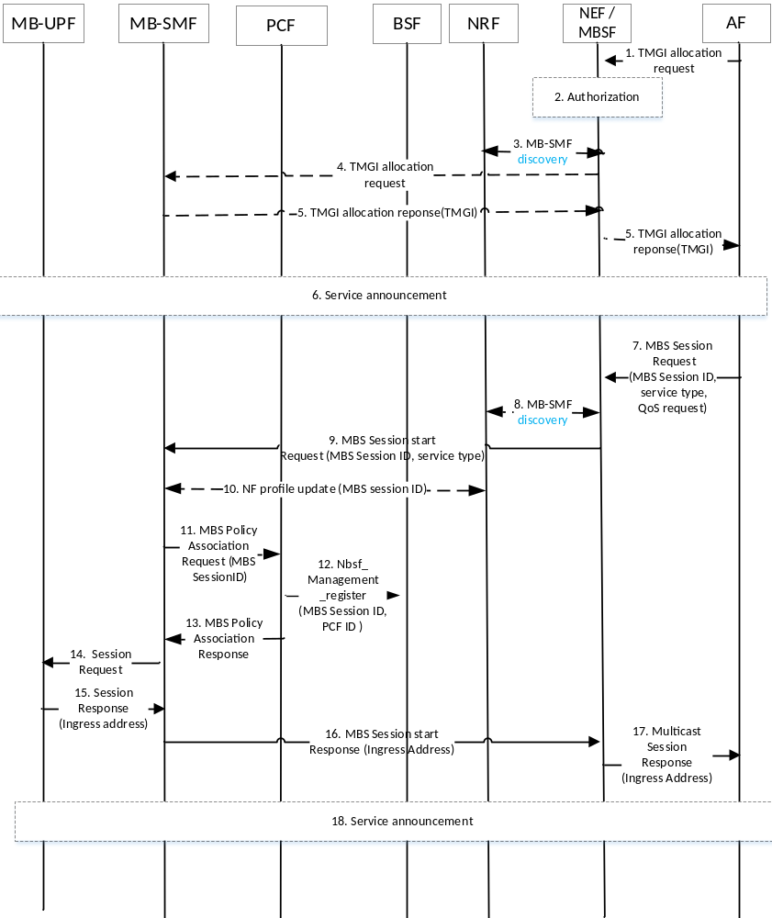
Figure 7.1.1.1-1: Configuration for MBS Session
Editor´s note: MBSTF could optionally be in the user plane and the call flow should be updated to also cover that possibility.
Editor's note: The services and messages used in this procedure are FFS.
Steps 1 to 5 are optional and only applicable if TMGI is used as MBS Session ID and required to be pre-allocated.
1. AF sends Allocate TMGI Request () message to NEF/MBSF to request allocation of a TMGI to identify a new MBS session.
NOTE 1: Depending on the configuration, MB-SMF may receive requests from AF directly, or via NEF, or via MBSF, or via NEF and MBSF.
2. AF checks authorization of AF.
3. NEF/MBSF discovers and selects an MB-SMF using NRF or based on local configuration, and then sends an Allocate TMGI Request () message to the MB-SMF.
4. MB-SMF allocates a TMGI and returns the TMGI to the NEF/MBSF.
5. The NEF or MBSF responds to the AF by sending an Allocate TMGI Response (TMGI) message.
6. The AF may perform a Service Announcement towards UEs. The AF informs UEs about MBS Session information with MBS Session ID, e.g., TMGI, source specific multicast address, and possibly other information e.g., MBS service area, session description information, etc.
The MBS service area information can be Cell ID list, TAI list, geographical area information or civic address information. Amongst them, Cell ID list and TAI list shall only be used by AFs who reside in trust domain, and when the AFs are aware of such information.
The UE needs to be aware if the service is broadcast or multicast to decide if JOIN is to be performed.
Editor's note: How to do service announcements requires SA WG4 /WG6 coordination.
7. AF of content provider may provide contents for an MBS session (possibly providing information for a previously allocated TMGI; e.g. service type of either multicast service or broadcast service) to NEF. If step 1-4 has not been executed before, the AF may provide a source specific multicast address or it may request that the network allocates an identifier for the MBS session (i.e., TMGI) and its service type of either multicast service or broadcast service. MBS information may further include QoS requirements, UE authorization information (e.g. a GPSI or an External Group Id or a UE ID to identify UEs authorized to join the multicast service), MBS service area (see step 6 for detail) identifying the service scope.
If geographical area information or civic address information was provided by the AF as MBS service area, NEF/MBSF translates the MBS service area to Cell ID list or TAI list.
Editor's note: What other information is to be sent by AF is FFS.
NEF/MBSF checks authorization of content provider.
8. NEF/MBSF discovers MB-SMF candidates and selects MB-SMF as ingress control node, possibly based on location area.
9. NEF/MBSF requests MB-SMF to reserve ingress resources for a MBS distribution session and provides MBS Session ID or request allocation, and indicate its service type (either multicast service or broadcast service). It also indicates if the allocation of an ingress transport address is requested.
The MBS service area is provided by NEF/MBSF to the MB-SMF if provided by the AF in step 7.
10. MB-SMF updates NF profile to NRF with the serving MBS Session ID.
11. [Optional] The MB-SMF sends SM MBS Policy Association Request to MB-PCF with the MBS Session ID, AF Identifier, and the QoS requirements.
12. [Optional] The MB-PCF registers at the BSF that it handles the multicast session. It provides an identifier that the policy association is for multicast and the MBS Session ID, it own PCF ID and optionally its PCF set ID.
13. [Optional] The MB-PCF responds with SM MBS Policy Association Response with policies for the MBS Session ID.
In addition, determines whether the request is authorized.
If the request is authorized, the PCF derives the required QoS parameters based on the information provided by the NEF and determines whether this QoS is allowed (according to the PCF configuration for this Application), and notifies the result to the MB-SMF. The PCF notifies the MB-SMF whether the transmission resources corresponding to the QoS request are established or not.
If the request is not authorized, the required QoS is not allowed, or transmission resources are not established, MB-SMF responds to the NEF in step 16 with a Result value indicating the failure cause, and NEF further notifies AF in step 17.
14. MB-SMF selects the MB-UPF and requests it to reserve user plane ingress resources. If multicast transport of the MBS data towards RAN nodes is to be used, the MB-SMF also request the MB-UPF to reserve for the outgoing data a tunnel endpoint and the related identifiers (source IP address, source specific multicast address and GTP Tunnel ID) and to forward data received at the user plane ingress resource using that tunnel endpoint.
If ingress address is not requested, the MB-SMF configure MB-UPF to handle the multicast data distribution and request the MB-UPF to join the multicast tree towards the content provider. MB-UPF can also join the distribution tree of the content provider in the subsequent procedures e.g., session establishment procedure.
15. If requested, MB-UPF selects an ingress address (IP address and port) and a tunnel endpoint for the outgoing data and provides it to MB-SMF.
16. MB-SMF indicates the possibly allocated ingress address to the NEF/MBSF. MB-SMF may include TMGI if it is allocated in step 9. It also indicates the success or failure of reserving transmission resources.
17. The NEF/MBSF-C indicates the possibly allocated ingress address and other parameters (e.g. TMGI) to the AF.
18. Same as step 6. The AF may also perform a service announcement at this stage.

7.1.1.2 removal of MBS session configuration
The removal of configuration steps for MBS Session are used by the AF to stop the MBS Session towards 5GC and consist of TMGI de-allocation and session stop procedures, and they apply to both multicast and broadcast communications unless otherwise stated. MBS session release/deactivation procedure may follow removal of the MBS session configuration to release the reserved resources toward NG-RAN.
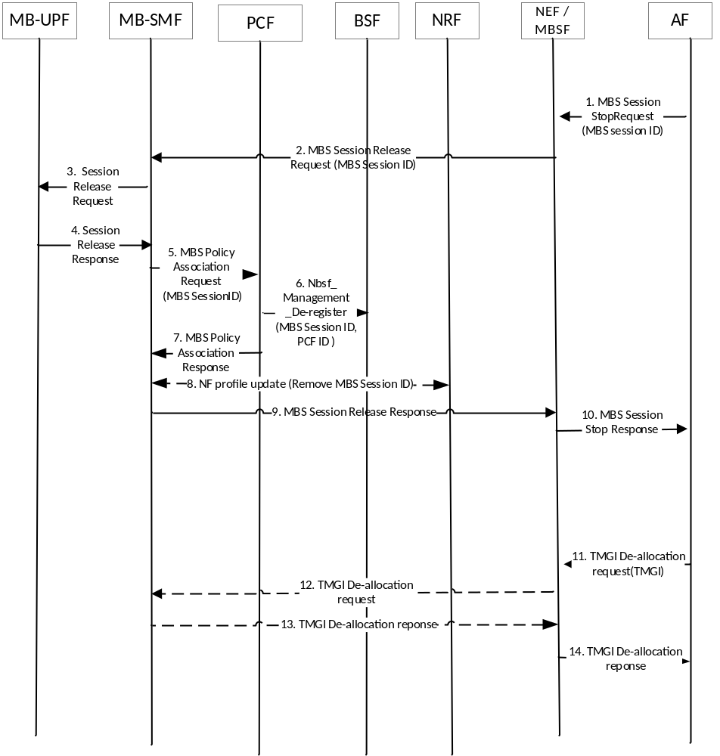
Figure 7.1.1:2-1: Removal of configuration for MBS Session
Editor´s note: MBSTF could optionally be in the user plane and the call flow should be updated and aligned with the MBS session configuration procedure.
Editor's note: The services and messages used in this procedure are FFS.
Editor's note: Additional interaction between AF/NEF and PCF are ffs.
- AF of content provider may request stop contents for the MBS session (MBS Session ID) to NEF.
2. NEF/MBSF requests MB-SMF to release ingress resources for the MBS distribution session.
3/4. MB-SMF requests the MB-UPF to release user plane ingress resources.
5. [Optional] The MB-SMF sends MBS Policy Association Termination Request to PCF.
6. [Optional] The PCF de-registers at the BSF that it handles the multicast session.
7. [Optional] The PCF responds with MBS Policy Association Termination Response.
8. [Conditional] If MB-SMF configured the profile with an MBS session ID when the MBS session was configured, the MB-SMF updates its NF profile at NRF to release the MBS Session ID.
9. MB-SMF responds to the NEF/MBSF.
10. The NEF/MBSF responds to the AF.
11/12. [Optional] AF requests NEF/MBSF to de-allocate TMGI(s), and NEF/MBSF forwards request to MB-SMF
NOTE 1: Depending on the configuration, MB-SMF may receive requests from AF directly, or via NEF, or via MBSF, or via NEF and MBSF.
13/14. The MB-SMF responds to the NEF or MBSF and to the AF by sending a de-allocate TMGI Response message.

7.1.2 MB-SMF discovery and selection for multicast/broadcast session
To facilitate the MB-SMF discovery/selection for one multicast/broadcast session, the following mechanism is used:
- The MB-SMF registers its capability related to multicast/broadcast session management (e.g. S-NSSAI(s) and the associated NSI ID(s) (if available), DNN(s), TMGI range or TMGI(s), service area) as part of its profile to the NRF by invoking Nnrf_NFManagement_NFRegister. In addition, when an multicast session is configured, the MB-SMF updates its profile towards the NRF with the MBSsession ID (i.e. TMGI or source specific IP multicast address).
- When the UE joins the multicast session via PDU session modification procedures, the SMF serving the PDU session invokes the Nnrf_NFDiscovery_Request including the multicast session ID provided by the UE and optionally other information, i.e. the S-NSSAI and the associated NSI ID (if available), DNN, etc., to query the NRF for MB-SMF information. Based on the MBS session ID and other information for query, the NRF decides whether an MB-SMF serving the MBS session exists. If so, the NRF provides in Nnrf_NFDiscovery_Response the information of the MB-SMF currently serving the MBS session. The SMF serving the PDU session selects the MB-SMF currently serving the multicast MBS session, based on the MB-SMF information provided by the NRF. For local MBS services, the SMF takes MB-SMF service area, UE location into account when selecting the MB-SMF. If no MB-SMF serving the multicast session exists, the NRF provides MB-SMF profiles based on the other query information
- When the multicast session context is deleted from the MB-SMF, e.g. due to MBS session release, the MB-SMF updates its profile towards the NRF, i.e., removing the MBS session ID which is no longer served by the MB-SMF.
- During MBS session configuration procedures, unless the MB-SMF information is available by other means, e.g. locally configured in the NEF/MBSF/AF, the NEF/MBSF/AF queries the NRF with information of the multicast/broadcast session (e.g. S-NSSAI(s) and the associated NSI ID(s) (if available), DNN(s)), and selects the MB-SMF(s) based on the MB-SMF information provided by the NRF. For local MBS services, the NEF/MBSF/AF takes MB-SMF service area into account when selecting the MB-SMF(s).

7.2 MBS procedures for multicast Session

7.2.1 MBS join and Session establishment procedure

7.2.1.1 General
Session Join procedure is used by UEs to inform the 5GC of the UE interest in an MBS Session. The user plane management is described in clause 6.6.
Editor's note: Whether UE join triggers MBS Session Establishment is FFS.

7.2.1.2 Establishment of a PDU Session that can be associated with multicast session(s)
A PDU Session associated with multicast session(s) is established using the procedures as specified in TS 23.502 [6] clause 4.3.2.2 with the following differences:
- In step 1, in the NAS Message to the AMF, the UE includes an indication of establishing a PDU Session associated with multicast session(s);
Editor's note: Whether an explicit indication of establishing a PDU Session associated with multicast session(s) is required is FFS. For example, an S-NSSAI or DNN supporting multicast services may be used instead.
- In step 2, based on the indication of establishing a PDU Session associated with multicast session(s), the AMF selects an SMF capable of handling multicast sessions based on locally configured data or a corresponding SMF capability stored in the NRF. For indirect discovery, the AMF requests the SCP to select an SMF capable of handling multicast sessions.

7.2.1.3 MBS join and Session establishment procedure
The following steps are executed before the UE requests to join the MBS session:
- The MBS Session has been configured.
- The UE registers in the PLMN and establishes a PDU session.
- The UE has known at least the MBS Session ID of a multicast group that the UE can join, e.g. via announcement.
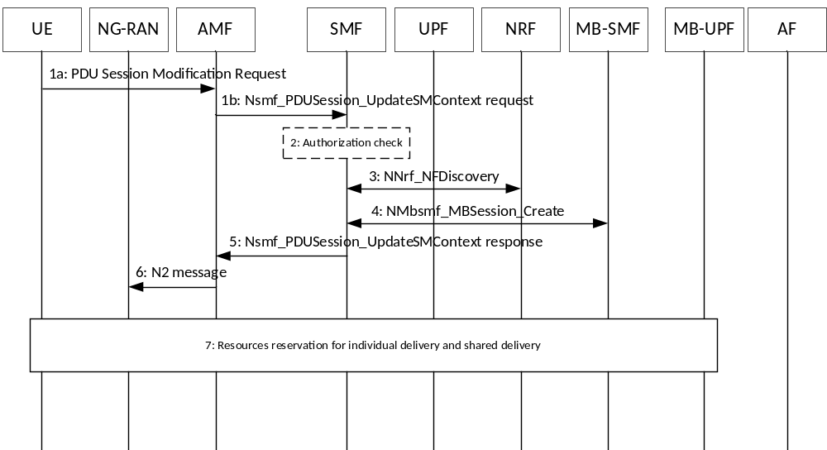
Figure 7.2.1.3-1: PDU Session modification for multicast
1. To join the multicast group, the UE sends the PDU Session Modification Request (MBS Session ID). MBS Session ID indicates the multicast group that UE wants to join.
2. Per the received MBS Session ID, the SMF recognize this is MBS Session join request. The SMF authorizes MBS Session join request, see clause 6.1.1.
3. If SMF has no information about the multicast context for the indicated MBS Session, SMF checks at the NRF whether a multicast context for the indicated MBS Session exists in the system, by using Nnrf_NFDiscovery request (MBS Session ID). If a multicast context already exists in the NRF, the NRF responses with Nnrf_NFDiscovery response (MB-SMF ID).
Editor's note: Whether SMF acting as the MB-SMF is needed and how it works if needed is FFS.
Editor's note: More consideration on how to prevent denial of service attack type situation when first UE joining the multicast group, triggers the MB-UPF to join the multicast tree towards the content provider is FFS.
4. By using Nsmf_MBSSession_Create request (MBS Session ID), SMF interacts with MB SMF to retrieve multicast QoS flow information of the indicated MBS session.
5. SMF responds to AMF through Nsmf_PDUSession_UpdateSMContext response(N2 SM information (PDU Session ID, MBS Session ID, MB-SMF ID, multicast QoS flow information, updated PDU Session information, mapping between unicast QoS flow and multicast QoS flow information), N1 SM container (PDU Session Modification Command) to:
- create a MBS session context for the indicated MBS session in the RAN, if it does not exist already; and
- inform about the relation including the mapping information between the multicast context and the UE's PDU session to RAN.
Based on operator policy, the SMF may prepare for individual delivery fall-back. The SMF maps the received QoS information of the multicast QoS Flow into PDU Session's QoS Flow information, and includes the information of the QoS Flows and the mapping information about the QoS Flows in the SM information sent to RAN.
Editor's note: Details information included in N2 SM information will be aligned with RAN WG3.
Editor's note: Whether it needs to inform about the relation including the mapping information between the multicast context and the UE's PDU session to UE is FFS.
6. The N2 message, which includes the PDU session modification command information is sent to the RAN.
If the MBS is not supported by NG-RAN, 5GC individual MBS traffic delivery may be used. Otherwise, 5GC shared MBS traffic delivery is adopted.
Editor's note: How the NG-RAN's 5MBS capability is made known is FFS.
The NG-RAN uses the MBS Session ID to determine that the PDU Session Modification procedures corresponds to the indicated multicast session.
If the multicast QoS information is received, the associated unicast QoS flow information is not used to allocate the radio resource.
NOTE: It is NG-RAN that decides whether radio resource is allocated or not.
When the NG-RAN receives an MBS Session ID but MBS Session context does not exist for that MBS Session ID, the NG-RAN use the included MBS Session QoS information to allocate resources to serve this multicast session. Otherwise the indicated MBS Session has been established before. The NG-RAN can use those allocated resource for MBS Session data packet transferring to UE.
7. The RAN, AMF, SMF, and MB-SMF performs resources reservation for individual delivery and shared delivery. The SMF obtains the 5MBS capability of target NG-RAN via the accepted QFI information and determines the delivery mode between 5GC and RAN.
Editor's note: Details of establishing the tunnel of 5GC Shared MBS traffic delivery and 5GC Individual MBS traffic delivery is FFS.

7.2.1.4 MBS join and Session establishment procedure involving MBSF
Editor's note: Details are FFS.

7.2.2 MBS leave and Session release procedure

7.2.2.1 General
Session Leave procedure is used by UEs or Application to inform the 5GC of the UE leaving an MBS Session. The user plane management is described in clause 6.6.

7.2.2.2 MBS session Leave
When the UE determines to leave the Multicast MBS Service, it shall send PDU session Modification request to inform the 5GC the leaving operation. The Fig 7.2.2.2-1 describes the procedure.

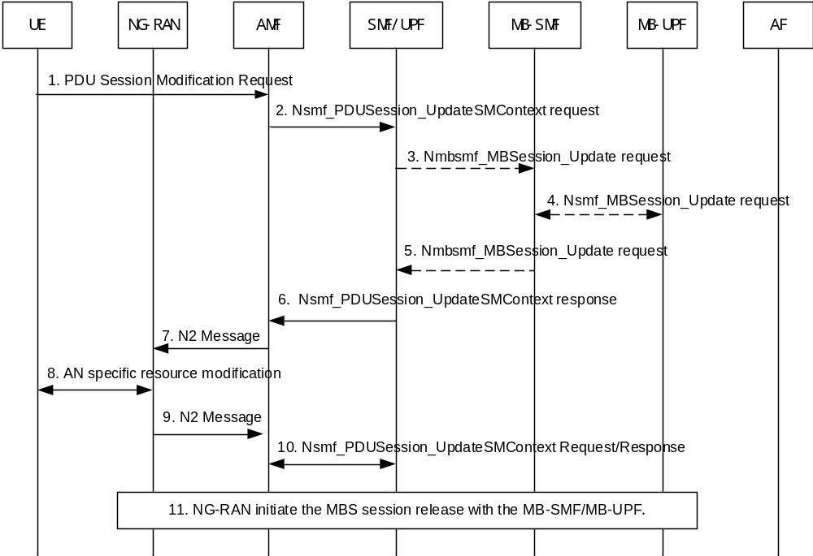
Figure 7.2.2.2-1: UE initiated multicast MBS session leave
1. The UE sends the PDU Session Modification Request when the UE determine to leave the Multicast MBS Service. The Request carries the MBS session ID which the UE want to leave.
2. The AMF invokes Nsmf_PDUSession_UpdateSMContext to SMF. The MBS session leaving information (i.e. leave indication, MBS session ID).
3. [conditional] If the UE is the last UE served with 5GC Individual MBS traffic delivery method in this SMF for this MBS session and the SMF is not collocated with the MB-SMF, the SMF configures the UPF to stop receiving multicast data from the MB-UPF and invokes Nsmf_MBSession_Update Request (MBS session ID) to release the tunnel between UPF and MB-UPF for this MBS session.
4. [conditional] If the tunnel between UPF and MB-SMF shall be released, the MB-SMF request to MB-UPF to release the tunnel.
5. [conditional] The MB-SMF responds to SMF for step 3.
6. The SMF responds (PDU Session ID, N2 SM information, N1 SM container). In the N2 SM information, the SMF informs the NG-RAN to remove the UE from this MBS session if 5GC Shared MBS traffic delivery method is used.
In the N2 SM information, the SMF also informs the NG-RAN to release the Qos flow which carry or intend to carry the Multicast MBS traffic as defined in TS 23502 [6] clause 4.3.3.2.
7. The AMF send N2 message (N2 SM information, N1 SM container) to the NG-RAN
8. The NG-RAN performs the necessary AN-specific resource modification procedure toward the UE and transports the N1 SM container received in step 8 to the UE.
9. The NG-RAN remove the UE from this MBS session and sends a N2 message to the AMF.
10. The AMF transfers the N2 message received in step 9 to the SMF via the Nsmf_PDUSession_UpdateSMContext service operation.
The SMF removes the UE from the MBS Session.
11. If the UE is the last UE in this RAN node for this MBS session, the NG-RAN release MBS session between NG-RAN and MB-UPF.

7.2.3 Mobility Procedures for 5MBS

7.2.3.1 General
UE may move from one NG-RAN node to another NG-RAN node after UE has joined the MB Session. There are various mobility scenarios possible, depending on whether one of the involved NG-RAN nodes supports 5G MBS.
During an active MBS Session, mobility between an NG-RAN supporting 5G MBS and an NG-RAN node not supporting 5G MBS requires the mobility procedure to provide the appropriate MBS traffic delivery method at the target NG-RAN node.

7.2.3.2 Xn based handover
Editor’s Note: Details for Xn based handover will be aligned with RAN WGs.
This clause describes an Xn based handover with MBS traffic delivered to the UE at the source gNB supporting 5G MBS.
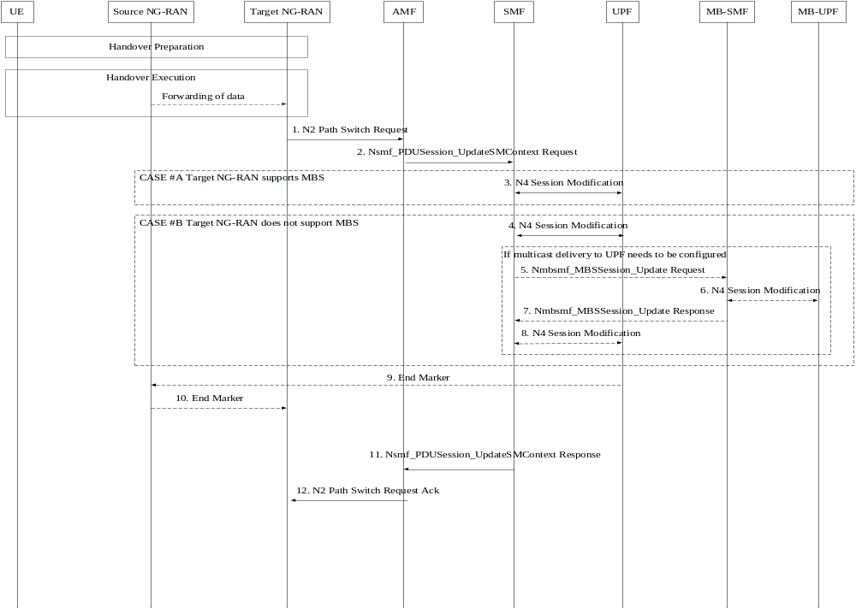
Figure 7.2.3.2-1: Xn based handover with MBS Session
The following additions apply compared to clause 4.9.1.2 of TS 23.502 [6]:
Before Handover
The source NG RAN has been provided with MBS Session Resource information (including the MBS Session ID and multicast QoS flow information) and the UE Context information contains an mapping information within the PDU Session Resource associated with the MBS Session Resource, e.g..including mapped unicast QoS Flows associated with the multicast QoS flow(s) of the MBS Session Resource.
Handover Preparation phase.
At Xn handover, the target NG-RAN is provided with information which causes:
- a 5G MBS non-supporting target NG-RAN node to prepare unicast resources according to unicast information;
- a 5G MBS supporting target NG-RAN node to allocate to the UE shared NG-RAN resources according to the MBS session information;

1. Target NG-RAN to AMF: the target NG-RAN sends N2 Path Switch Request to AMF.
The N2 SM message includes sufficient information to allow the SMF to know whether the target NG-RAN node supports 5G MBS and whether MBS Session Resources (in case the target NG-RAN node supports 5G MBS) or PDU Session Resources to support 5GC individual MBS traffic delivery have been established in the target NG-RAN for the UE.
Editor’s Note: details to be added, if necessary, during stage 3 phase in RAN WGs.
Based on the received N2 SM message, the SMF can differentiate two cases:
Case A) The target NG-RAN supports 5G MBS. Step 3 applies and steps 4~8 are skipped.
- SMF to UPF: The SMF invokes N4 Session Modification procedure with the UPF (PSA) only for unicast PDU Session.

Case B) The target NG-RAN does not support 5G MBS and the UPF is not yet configured to forward multicast data via unicast, steps 4 to 8 apply.
- SMF to UPF (PSA): The SMF invokes N4 Session Modification procedure with UPF (PSA), the SMF instructs the UPF (PSA) to forward the multicast data received from the MB-UPF via the mapped unicast QoS flow(s) of the PDU Session. The SMF provides the mapping information between the multicast QFI and the corresponding unicast QFI of the multicast QFI in the PDU Session to the UPF (PSA), the UPF (PSA) forwards the multicast data via the PDU session based on the mapping information. If the delivery tunnel for the MBS session from MB-UPF to UPF is not established yet, the SMF instructs the UPF (PSA) to allocate a tunnel endpoint for the reception of multicast data from the MB-UPF.
If delivery of the multicast data from MB-UPF to UPF needs to be configured, steps 5 to 8 apply.
- SMF to MB-SMF: The SMF invokes a Nmbsmf_MBSSession_Update (MBS session ID, SMF ID, DL tunnel info) request service operation to MB-SMF to establish the shared tunnel between the UPF(PSA) and MB-UPF.
- MB-SMF to MB-UPF: The MB-SMF configures the MB-UPF with the received DL tunnel Info and instructs the MB-UPF to forward data of the MBS session to the UPF (PSA) via the tunnel. The MB-UPF starts to forward data of the MBS session to the UPF (PSA).
- MB-SMF to SMF: The MB-SMF responds to SMF through Nmbsmf_MBSSession_Update response. If multicast data are transported via multicast, the MB-SMF provides endpoint information (e.g., the Common-TEID) including the transport multicast address.
- SMF to UPF (PSA): The SMF invokes an N4 Session Modification procedure with the UPF (PSA). If multicast data are transported via multicast, the SMF provides endpoint information including the transport multicast address to the UPF (PSA) and the UPF (PSA) sends IGMP Join in order to receive data from the MB-UPF.
- /10. Editor’s Note: details on data forwarding, if applicable, needs to wait for RAN WGs.

7.2.3.3 N2 based handover
Editor’s Note: Details for N2 based handover should be aligned with RAN WG.
Editor’s Note: Procedure for multicast delivery resource establishment is FFS.
This clause describes the N2 based handover with the MBS Session established at the source 5G MBS-supporting NG-RAN.
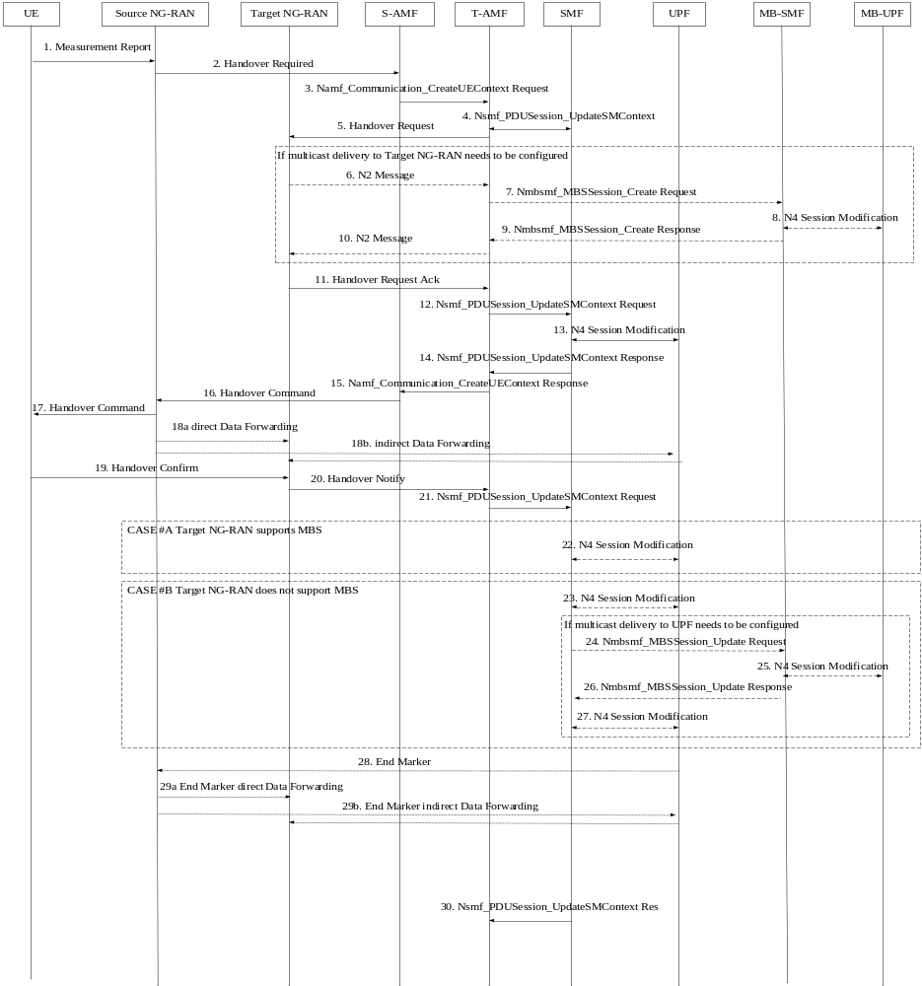Figure 7.2.3.3-1: N2 based handover with MBS Session
The following additions apply compared to clause 4.9.1.3 of TS 23.502 [8]):
- Source NG-RAN to S-AMF: Handover Required (RAN container (associated PDU session information)).
- SMF to T-AMF: The T-AMF is provided with associated PDU Session information.
- T-AMF to Target NG-RAN: The Target NG-RAN prepares the radio resource based on the received information.
- If the target NG-RAN does not support 5G MBS, the MBS Session information is not used. The target NG-RAN uses the associated mapping PDU Session information to allocate resource to deliver MBS data. The MBS data are transmitted as one of the QoS flows within the unicast PDU Session.
If the target NG-RAN supports 5G MBS, the target NG-RAN uses the MBS Session information to allocate resource to deliver the MBS data. If Target NG-RAN supports 5G MBS and the MBS delivery for the indicated MBS Session has not yet been established towards target NG-RAN, the target NG-RAN allocates the shared downlink tunnel information for receiving the MBS data from 5GC and steps 6 to 10 apply:
- Target NG-RAN to AMF: Target NG-RAN node selects the AMF to reach MB-SMF and signals a multicast session distribution request towards AMF via the N2 Message (MBS Session ID). If the RAN node is configured to use a unicast transport for multicast distribution sessions, it allocates a downlink tunnel ID (an IP address and a GTP-U TEID) for the reception of the multicast distribution session and indicates the downlink tunnel information in the request.
- AMF to MB-SMF: AMF invokes the Nmbsmf_MBSSession_Create Request (MBS session ID, [DL tunnel info]) Request towards the MB-SMF to establish the multicast distribution towards AMF.
- MB-SMF to MB-UPF: MB-SMF invokes the N4 Session Modification procedure with MB-UPF. For unicast transport of the multicast distribution session, MB-SMF configures MB-UPF to transmit the multicast distribution session towards target NG-RAN node (using the received IP address and a GTP-U TEID).
- MB-SMF to AMF: MB-SMF responds to AMF through the Nmbsmf_MBSSession_Create Response. For multicast transport of the multicast distribution, it indicates in the downlink tunnel information and the multicast address for the multicast session.
- AMF to Target NG-RAN: AMF provides multicast session distribution response to Target NG-RAN node via the N2 Message.
- Target NG-RAN to T-AMF: The target NG-RAN sends Handover Request Ack to T-AMF.
- The N2 SM message includes sufficient information to allow the SMF to know whether the target NG-RAN node supports 5G MBS and whether MBS Session Resources (in case the target NG-RAN node supports 5G MBS) have been established or PDU Session Resources to support 5GC individual MBS traffic delivery have been prepared in the target NG-RAN for the UE.
Editor’s Note: How the NG-RAN's 5MBS capability is made known is FFS.
Editor’s Note: details on data forwarding in step 13, if applicable, needs to wait for RAN WGs.
Editor’s Note: details on data forwarding in step 18, if applicable, needs to wait for RAN WGs.
- T-AMF to SMF: The AMF invokes Nsmf_PDUSession_UpdateSMContext request towards SMF, the message includes the received N2 SM message.

Based on the received N2 SM message, the SMF can differentiate two cases:
Case A) The Target NG-RAN supports 5G MBS. Step 22 applies and steps 23~29 are skipped.
- SMF to UPF (PSA): The SMF invokes N4 Session Modification procedure with the UPF (PSA) only for unicast PDU Session. The SMF instructs the UPF to send the end marker packet towards the source NG-RAN and to send subsequent packets towards the target NG-RAN within the unicast PDU Session.
Case B) The target NG-RAN does not support 5G MBS. If the UPF (PSA) is not yet configured to forward multicast data via unicast, steps 23 to 29 apply.
- SMF to UPF: The SMF may invokes N4 Session Modification procedure with UPF (PSA), the SMF instructs the UPF (PSA) to forward the multicast data received from the MB-UPF via the mapped unicast QoS Flow(s) of the PDU Session within the unicast PDU(i.e., 5GC Individual MBS traffic delivery method will be used). The SMF provides the mapping information between the multicast QFI and the corresponding mapped unicast QFI to the UPF (PSA), the UPF (PSA) forwards the multicast data via the PDU session based on the mapping information. If the delivery tunnel for the MBS session from MB-SMF to UPF is not established yet, the SMF instructs the UPF (PSA) to allocate a tunnel endpoint for the reception of multicast data from the MB-UPF.

If delivery of the multicast data from MB-UPF to UPF needs to be configured, steps 24 to 27 apply.
- SMF to MB-SMF: The SMF invokes a Nmbsmf_MBSSession_Update (MBS session ID, SMF ID, DL tunnel info) request service operation to MB-SMF to establish the shared tunnel between the UPF(PSA) and MB-UPF.
- MB-SMF to MB-UPF: The MB-SMF configures the MB-UPF with the received DL tunnel Info and instructs the MB-UPF to forward data of the MBS session to the UPF (PSA) via the tunnel. The MB-UPF starts to forward data of the MBS session to the UPF (PSA).
- MB-SMF to SMF: The MB-SMF responds to SMF through Nmbsmf_MBSSession_Update response. If multicast data are transported via multicast, the MB-SMF provides endpoint information (e.g., the Common-TEID) including the transport multicast address.
- SMF to UPF (PSA): The SMF invokes an N4 Session Modification procedure with the UPF (PSA). If multicast data are transported via multicast, the SMF provides endpoint information including the transport multicast address to the UPF (PSA) and the UPF (PSA) sends IGMP Join in order to receive data from the MB-UPF.

7.2.3.4 X2/N2 based handover

7.2.3.5 Minimization of data loss
Editor’s Note: Details for how to minimize data loss between the source NG-RAN node and the target NG-RAN node should be aligned with 3GPP RAN WGs.

7.2.4 Support of Local multicast service

7.2.4.1 General
The procedures for Local multicast service contains the ones for Local multicast service with the location-dependent content, and the ones for limited local multicast service distribution, as described in clause 6.2.

7.2.4.2 Support of Local multicast service with the location-dependent content

7.2.4.2.1 Multicast context and Multicast flow setup/modification via PDU Session Modification procedure
Editor's Note: Detailed additions to Multicast context and Multicast flow setup/modification via PDU Session Modification procedure are FFS.
The Multicast context and Multicast flow setup/modification for the UE is performed as defined in section 7.2.1 with the following additions:
- If the configuration for MBS Session in 7.1.1 is used:
- the NEF selects MB-SMF as ingress node for the location area and stores related information in the UDR;
- If the MBS Session is only available in certain location area(s), the location area can be indicated via Service Announcement.
- When SMF requests multicast context via Nnrf_NFDiscovery request (MBS Session ID), the NRF provides information about location areas stored within the multicast context, via Nnrf_NFDiscovery response (MB-SMF ID, Area Session ID, location area). The SMF selects location dependent multicast context information based on the location area where the UE is residing.
- If SMF has no information about the multicast context for the indicated MBS Session ID and Area Session ID, SMF interacts with MB-SMF to retrieve QoS information of the multicast QoS flow(s) for the MBS Session ID and Area Session ID.
- SMF requests the AMF to transfer a message to the RAN node using The Nsmf_PDUSession_UpdateSMContext (Area Session ID, location area) to transfer the multicast info to RAN node additionally includes the Area Session ID and location area.
- The RAN uses the received MBS Session ID and Area Session ID to determine the localized multicast distribution context and whether the user plane for the multicast group/context and location area distribution is already established.
Editor's note: Services mentioned in this clause needs to be updated to match the agreements on clause 9 and other clauses.

7.2.4.2.2 Configuration for local MBS
Editor's Note: Further details of are FFS.
For local MBS, the configuration procedure for the UE is optional and performed as defined in section 7.1.1 with the following additions:
- Multiple AFs may register for the same multicast session but different location areas. NEF selects MB-SMF as ingress control node.
- If presented, the NEF maps possible external identifiers for location areas to network-internal identifiers (e.g. list of cells, TAIs).
- NEF requests storage of multicast session at NRF and provides multicast session ID, selected MB-SMF ID and location area.
- MB-SMF allocates Area Session ID.
- The policy of Multicast session is determined based on MBS session ID, Area Session ID, and location area.
- The MB-SMF may select the MB-UPF based on the location area.

7.2.4.2.3 Handover procedure
Editor's Note: Further details for Handover procedure are FFS.
The Handover procedure for the UE is performed as defined in section 7.2.3 with the following additions:
- Before the Handover, The UE is camping at Source RAN and receiving multicast data corresponding to the MBS Session ID and Area Session ID.
- Source RAN includes MBS Session ID, Area Session ID and location area to the Target RAN.
- Target RAN determines whether to establish the forwarding resources and multicast distribution for MBS Session ID and Area Session ID provided by Source RAN, based on MBS Session ID, Area Session ID and location area. To determine the forwarding resources for location-dependent contents delivery, Target RAN may only check whether or not the location area ID is the same if Target RAN already established the session context of the multicast session ID.
- Target RAN responses to Source RAN, with the accepted MBS Session ID and Area Session ID. When Target RAN supports multicast but the UE is no longer in the location area, Target RAN rejects to handover the multicast session with a cause indication.

7.2.4.3 Support of multicast service available within a limited area

7.2.4.3.1 Local MBS service area information provided by AF
For local multicast services, the AF provides MBS service area information to the UE and the 5GC as specified in clause 7.1.1 with the following differences and clarifications:
- In step 6 and step 18 for a Service Announcement, the AF provides MBS service area information to the UE. The local MBS service indication may be included to indicate that this multicast service is local service.
- In step 7, the MBS service area information for a multicast session is provided by the AF.

7.2.4.3.2 MBS join and Session establishment procedure for multicast service available within a limited area
For the case that the multicast service is only available within a limited area, the UEs outside the MBS service area are not allowed to join the multicast service.
The MBS join and Session establishment for multicast service available within a limited area are performed as specified in clause 7.2.1.3 with the following differences and clarifications:
- The local multicast session has been configured where the AF provided the MBS service area information as specified in clause 7.2.4.3.1.
- The UE has information about local multicast service including MBS service area and local MBS service indication via Service Announcement as specified in clause 7.2.4.3.1.
- In step 1, if the UE determines that it is in the MBS service area based on the information about local multicast service obtained via Service Announcement, the UE sends the PDU Session Modification Request (MBS Session ID) to join the multicast group. If the UE determines that it is outside the MBS service area, the UE does not send the Join Request.
- In step 4, the SMF obtains the MBS service area (i.e. Cell ID list or TAI list) of the indicated MBS session from the MB-SMF.
- In step 5, the SMF checks whether the UE is inside or outside the MBS service area.
- If the SMF detects that the UE is inside the MBS service area, the SMF sends a Join Accept as a response to the Join Request.
- If the SMF detects that the UE is outside the MBS service area, the SMF sends a Join Reject to the UE indicating that the MBS join is rejected. The Joint Reject includes the reject reason (outside of local service area) and the MBS service area (i.e. Cell ID list or TAI list).
In this case, the MBS Session establishment (i.e. resources establishment for MBS traffic delivery) for the UE is not performed.
NOTE 1: There may be the case that the UE determines that it is inside the MBS service area based on the geographical area information or civic address information as MBS service area information provided by the AF, so sends a Join Request but the UE is outside the MBS service area.
NOTE 2: Which SM NAS message is used to deliver the Join Reject (e.g. PDU Session Modification Reject) is defined in stage 3 specifications.
- For the UE that received the Join Reject from the SMF, later, if the UE detects that it is inside the MBS service area based on the MBS service area provided in the Join Reject, the UE sends the PDU Session Modification Request (MBS Session ID) to join the multicast group.

7.3 MBS procedures for broadcast Session
Editor's note: The content needs to be revisited.

7.3.1 MBS Session Establishment for Broadcast
The MBS Session Establishment may consist of two steps: TMGI Allocation and MBS Session Start. It is possible for AF to allocate TMGI once but activate MBS Session for multiple times. A combined procedure to perform both TMGI allocation and MBS Session activation may be available.
The TMGI Allocation is used by AF to obtain the MBS Session ID (i.e. TMGI) and perform service announcement towards UEs.
The MBS Session Activation is used by the AF to activate an MBS Session and start transmission of MBS data. During the MBS Session Establishment procedure for Broadcast, resources for the MBS Session are set up in the MB-UPF and in the NG-RAN. The MBS Session Start can be used if TMGI has not been allocated. In this case, MB-SMF will allocate a unique TMGI for the AF and then activate the MBS Session.
NOTE 1: When the multicast transport between NG-RAN and MB-UPF is described below, source specific multicasting is assumed. That is, the parameter "LL MC address" is assumed to be accompanied by a "Source host address" parameter in the descriptions below.
To receive the data of broadcast communication service, the UE is either preconfigured with needed configuration (e.g. USD) for the UE to receive MB service, or provisioned with the configuration of broadcast session on application level (the configuration may for instance be performed using SIP signalling, or methods described in TS 26.346 [13]). If the needed configuration is pre-configured, the UE does not need to interact with network.
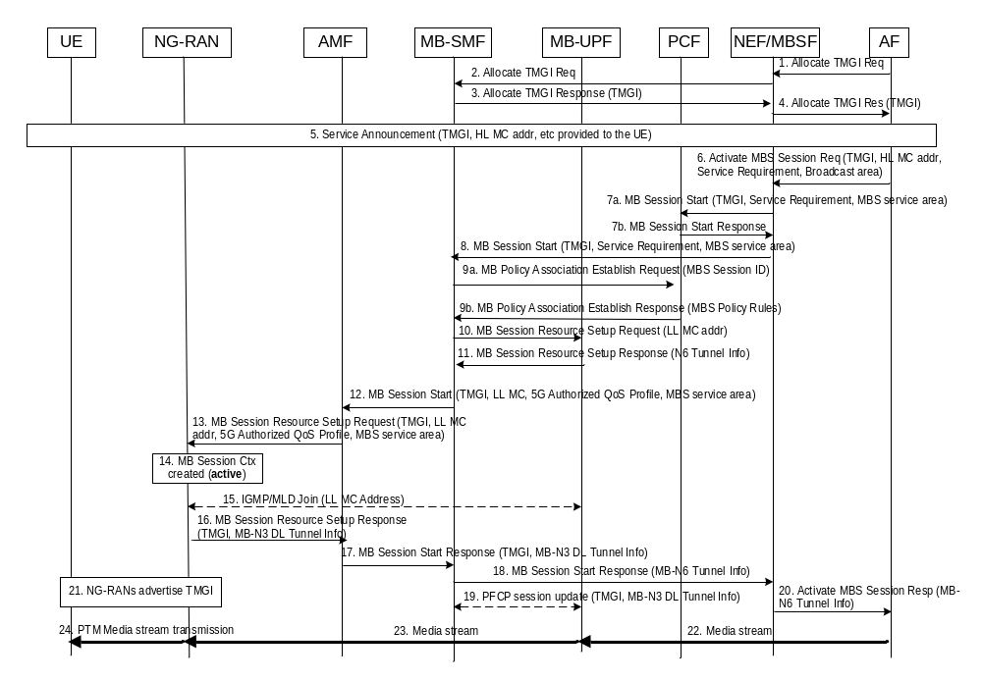
Figure 7.3.1-1: MBS Session Establishment for Broadcast
Editor´s note: MBSTF could optionally be in the user plane and the call flow should be updated to also cover that possibility.
Editor's note: The services and messages used in this procedure are FFS.
1. AF sends Allocate TMGI Request () message to NEF/MBSF to request allocation of a TMGI to identify a new group.
NOTE 2: Depends on the configuration, MB-SMF may receive requests from AF directly, or via NEF, or via MBSF, or via NEF and MBSF
2. NEF/MBSF discovers and selects an MB-SMF using NRF or based on local configuration, and then sends an Allocate TMGI Request () message to the MB-SMF.
3. MB-SMF allocates a TMGI and returns the TMGI to the NEF/MBSF.
4. The NEF or MBSF responds to the AF by sending a Allocate TMGI Response (TMGI) message.
5. The AF performs Service Announcement towards UE. The AF informs UEs about MBS Session information with TMGI, Higher Layer Multicast IP address (HL MC Address), MBS service area, session description information, etc.
The UE knows broadcast service from service announcement.
Editor's note: How to include broadcast info in the service announcements requires SA WG4/WG6 coordination.
6. The AF requests activation of an MBS Session by sending an Activate MBS Session Request (TMGI, HL MC Address, Service Requirement, broadcast area) message to the NEF/MBSF. The AF has allocated a Higher Layer IP Multicast Address (HL MC Address). Service Requirement for the MBS Session may be included. If multiple MBS QoS Flows are expected to be established, then the AF needs to provide different packet filters and associated service requirement. Broadcast area is used to indicate the coverage of the broadcast session.
If dynamic PCC is deployed, the steps 7a,7b, 9a and 9b are executed.
7a. The NEF or MBSF checks if the input parameters e.g. HL MC address are valid. The MBSF may decide to do application/transport layer treatment (e.g. adding FEC, MBS media transcoding) and change the MBS QoS Requirements from the AF. The NEF/MBSF sends an MBS Session Start (TMGI, Service Requirement, MBS service area) message to the PCF.
7b. The PCF responses to the NEF/MBSF.
8. The NEF or MBSF checks if the input parameters e.g. HL MC address are valid. NEF/MBSF sends an MBS Session Start (TMGI, PCF ID) message to the MB-SMF.
Editor's note: How to find MB-SMF is FFS.
The NEF may further convert the broadcast area, which can be defined in external format, to MBS service area. The MBS service area can be represented by cell list or TAI list.
9a. [Optional] MB-SMF sends the TMGI for the MBS Session and the Service Requirement to the MB-PCF.
9b. [Optional] The MB-PCF returns the PCC rule for the MBS Session, which the MB-SMF uses as the 5G Authorized QoS Profile for the MBS Session. If multiple MBS service requirements are received, then MB-PCF will provide multiple 5G Authorized QoS Profiles.
10. MB-SMF sets up the N6 resources for the MBS Session in the MB-UPF and the N3 resources for transport multicast tunnelling using the LL MC address allocated for the TMGI.
Optionally Media reception in MB-UPF is un-tunnelled, in which case the MB-SMF also provides the HL MC Address so that the MB-UPF can send IGMP/MLD join and receive the (un-tunnelled) IP Multicast Media stream.
11. If N6 tunnelling is used, the MB-UPF allocates N6 tunnel information (e.g. UDP port and IP address) and returns to the MB-SMF.
If multiple MBS QoS Flows are established, the MB-UPF map the downlink MBS data to the MBS QoS Flow based on the packet filters which could be HL MC address and ports, or unicast UDP tunnel info.
12. The MB-SMF may use NRF to discover the AMF(s) based on the MBS service area and select the appropriate one(s). Then the MB-SMF sends the MBS Session Start Request (TMGI, LL MC Address and source host address, 5G Authorized QoS Profile, MBS service area) messages to the selected AMF(s) in parallel.
Editor´s note: Providing address information at this stage is FFS. Reusing the multicast signalling from NG-RAN to MB-SMF to set up shared delivery could be an alternative.
13. The AMF sends an MBS Session Resource Setup Request (TMGI, LL MC and source host address, 5G Authorized QoS Profile) message to all NG-RANs in the MBS service area. The AMF may include the MBS service area.
14. NG-RAN creates an MBS Broadcast Session Context (if it not already exists), stores the TMGI, the QoS Profile in the MBS Session Context. The LL MC Address and Source Host Address are optional parameters and only provided by MB-SMF to NG-RAN if MB-N3 multicast transport is configured to be used in the 5GC.
Editor´s note: It also requires further study if AMF IDs need to be stored.
Editor´s note: Steps 15 to 17 are FFS. Are several MBS session start responses for different NG RAN nodes permissible in step 17 or is information from several RAN nodes combined in one response? Reusing the multicast signalling to set up shared delivery could be an alternative
15. If NG-RAN prefers to use MB-N3 multicast transport (and if LL MC Address is available in NG-RAN), the NG-RAN joins the multicast group (i.e. LL MC Address).
If NG-RAN prefers to use MB-N3 point-to-point transport (or if the LL MC Address is not available in NG-RAN) between the NG-RAN and MB-UPF, NG-RAN provides its MB-N3 DL Tunnel Info.
16. The NG-RAN reports successful establishment of the MBS Session resources (which may include multiple MBS QoS Flows) by sending MBS Session Resource Setup Response (TMGI, MB-N3 DL Tunnel Info) message(s) to the AMF. MB-N3 DL Tunnel Info is only available when point-to-point transport applies between MB-UPF and NG-RAN.
17. The AMF sends MBS Session Start Response (TMGI, MB-N3 DL Tunnel Info) to the MB-SMF. The AMF should respond success when it receives the first success response form the NG-RAN(s). And if all NG-RAN(s) report failure, the AMF should respond failure.
18. The MB-SMF sends the MBS Session Start Response (TMGI) message to the NEF/MBSF. N6 Tunnel info is included in the response if N6 tunnelling is used. The MB-SMF should respond success when it receives the first success response form the AMF(s). And if all AMF(s) report failure, the MB-SMF should respond failure.
NOTE 3: Step 18 can be performed in parallel with step 12.
19. If MB-N3 point-to-point transport is to be used (i.e. MB-N3 DL Tunnel Info is present in the MBS Session Start Response message from AMF), the MB-SMF sends a session update request (an N4 request) to the MB-UPF to allocate the MB-N3 point-to-point transport tunnel for a replicated MBS stream for the MBS Session. Otherwise, step 19 can be skipped.
20. The NEF/MBSF sends an Activate MBS Session Response including the MB-N6 Tunnel Info to the AF.

21. NG-RAN advertises the TMGI representing the MBS service over radio interface. Step 21 can take place in parallel with step 16.
22. The AF starts transmitting the DL media stream to MB-UPF using the MB-N6 Tunnel Info, or optionally un-tunnelled i.e. as an IP multicast stream using the HL MC address.
23. The MB-UPF transmits the media stream to NG-RAN via MB-N3 multicast transport or point-to-point transport.
24. The NG-RAN transmits the received DL media stream using DL PTM resources.

7.3.2 MBS Session Release for Broadcast
The MBS Session Release for broadcast may consist of two steps: MBS Session Deactivation and TMGI De-allocation. If the dynamic PCC is not deployed, it is possible for AF to deactivate MBS Session but kept TMGI allocated. A combined step may be used to perform Deactivate MBS Session and TMGI De-allocation. If the dynamic PCC is deployed, the MBS Session is released when the MBS Policy Association is released, then the TMGI is also released.
The MBS Session Deactivation procedure is used to stop media delivery for an MBS session i.e. to all UEs in a group defined by a TMGI. The MBS session may be activated again. The resources in the NG-RAN and 5GC are however released and the MBS Session Contexts in 5GC and NG-RAN are deleted.
The TMGI De-allocation procedure is used to release TMGI allocated for AF. The TMGI De-allocation procedure can be used no matter whether the MBS Session has been deactivated or not. If not, the MBS session will be deactivated prior to the TMGI de-allocation.
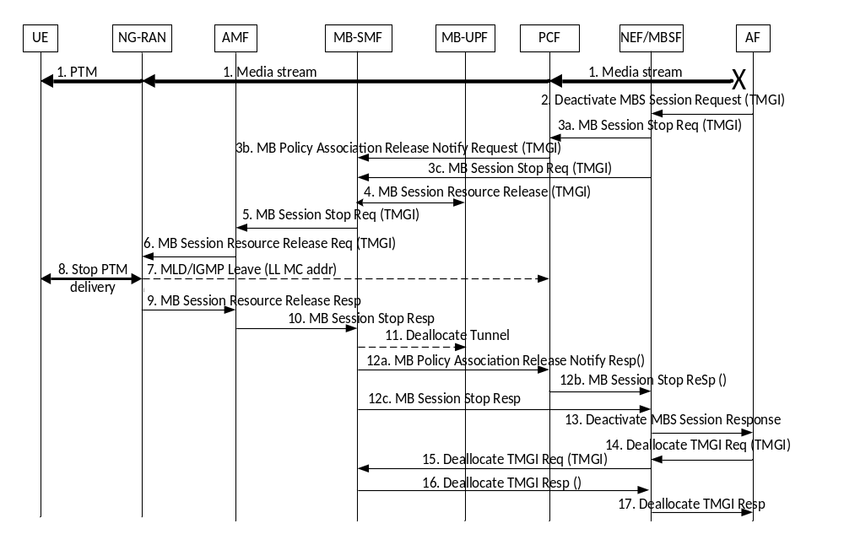
Figure 7.3.2-1: MBS Session Release for Broadcast
1. The AF may stop the media stream before sending the Deactivate MBS Session Request (TMGI) message to the 3GPP network.
2. The AF sends a Deactivate MBS Session Request (TMGI) message to the NEF/MBSF.
If dynamic PCC is deployed, the steps 3c and 12c are skipped, otherwise, the steps 3a, 3b, 12a and 12b are skipped.
3a. The NEF/MBSF sends an MBS Session Stop Request (TMGI) message to the PCF that handles the Policy of the MBS Session.
3b. The PCF sends message to MB-SMF to release the MBS Policy Association.
3c. The NEF/MBSF sends an MBS Session Stop Request (TMGI) message to the MB-SMF that handles the MBS Session.
4. The MB-SMF request the MB-UPF to release the resources allocated for the MBS Session (e.g. designated by the TMGI), including the N6 tunnel. The MB-UPF responds to the MB-SMF when resources are released.
5. MB-SMF sends an MBS Session Stop Request (TMGI) message to the AMF(s) that has been involved in the MBS Session.
Editor´s note: It is FFS if the MB-SMF needs stores the AMFs or can select AMFs based on service area and forwards the service area to AMFs to avoid that AMF needs to maintain information about broadcast session.
6. The AMF sends an MBS Session Resource Release Request (TMGI) message to all RAN nodes that have been involved. If a NG-RAN node receives multiple MBS Session Resource Release Request messages for the same TMGI (e.g. from several AMFs the NG-RAN is connected to), NG-RAN only performs step 7 and step 8 once.
Editor´s note: It is FFS if the RAN nodes are stored in the AMFs or selected based on service area.
7. The NG-RAN stops the PTM transmission.
8. If MB-N3 multicast transport has been used, the NG-RAN sends a Leave message (LL MC Address) to stop the media stream to this NG-RAN node. If MB-N3 point-to-point transport has been used, the NG-RAN release its MB-N3 Tunnel Info. NG-RAN deletes its MBS Session Context.

9. The NG-RAN reports successful release of resources for the MBS Session by sending MBS Session Resource Release Response (TMGI) message(s) to the AMF(s).
10. The AMF sends MBS Session Stop Response (TMGI) to the MB-SMF.
11. If MB-N3 point-to-point transport has been used for any NG-RAN node, and if not already done for this MBS Session, the MB-SMF repeats sending N4 requests to the MB-UPF to deallocate all MB-N3 point-to-point transport tunnels used for the MBS Session.
12a.The MB-SMF sends the MBS Policy Association Release Notify Response (TMGI) message to the PCF.
12b.The PCF sends the MBS Session Stop Response (TMGI) message to the NEF/MBSF.
12c. The MB-SMF sends the MBS Session Stop Response (TMGI) message to the NEF/MBSF.
13. The NEF/MBSF sends a Deactivate MBS Session Response (TMGI) to the AF.
14. The AF sends a Deallocate TMGI Request (TMGI) message to the NEF/MBSF.
15. The NEF/MBSF sends a Deallocate TMGI Request (TMGI) message to the MB-SMF(s) that has been involved in the MBS Session.
16. The MB-SMF release the TMGI for the AF and sends the Deallocate TMGI Response (TMGI) message to the NEF/MBSF.
17. The NEF/MBSF sends a Deallocate TMGI Response (TMGI) to the AF.

7.3.3 MBS Session Update for Broadcast
The MBS Session Update for broadcast is used by the AF to update the broadcast area or service requirements of the MBS Session.
Editor´s note: MBSTF could optionally be in the user plane and the call flow should be updated to also cover that possibility.
Editor's note: It is FFS whether there is any other parameters of service requirements need to be updated except for ARP.
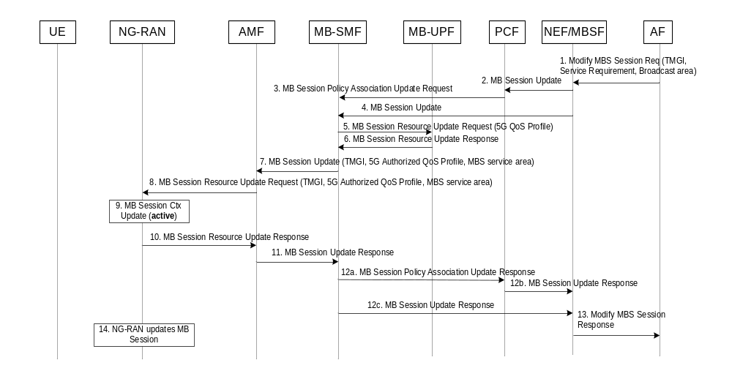
Figure 7.3.3-1: MBS Session Update for Broadcast
1. The AF sends Modify MBS Session Request to the NEF/MBSF with TMGI. The AF may adjust service requirement and/or broadcast area.
If dynamic PCC is deployed, the steps 4 and 12c are skipped, otherwise, the steps 2,3, 12a and 12b are skipped.
2. The MBSF may decide to do application/transport layer treatment (e.g. adding FEC, MBS media transcoding) and change the MBS QoS Requirements from the AF. The NEF/MBSF sends the MB Session Update (TMGI, MBS QoS Requirements, MBS service area) to the PCF. he NEF/MBSF may need to translate the broadcast area to MBS service area if it is provided in external format.
3. The PCF sends the MB Session Policy Association Update Request (TMGI, 5G QoS Profile, MBS service area) to the MB-SMF.
4. The NEF/MBSF sends MBS Session Update to the MB-SMF. The NEF/MBSF may need to translate the broadcast area to MBS service area if it is provided in external format.

5. If there is service requirement update, MB-SMF sends the updated 5G QoS Profile to the MB-UPF.
6. The MB-UPF applies the updated 5G QoS Profile and respond MB-SMF.
7. The MB-SMF sends MBS Session Update to the AMFs with TMGI, the updated 5G QoS Profile and the updated MBS service area.
Depending on the change of the MBS service area, the MB-SMF may send MBS Session Start to some AMFs in the new MBS service area and MBS Session Stop to some other AMFs in the old MBS service area.
Editor´s note: It is FFS if the MB-SMF needs stores the AMFs or can select AMFs based on service area and forwards the service area to AMFs to avoid that AMF needs to maintain information about broadcast session.
8. The AMF sends MBS Session Resource Update to NG-RANs with TMGI, the updated 5G QoS Profile and the updated MBS service area.
Depending on the change of the MBS service area, the AMF may send MBS Session Resource Setup to some NG-RANs in new MBS service area and MBS Session Resource Release to some other NG-RANs in old MBS service area.
Editor´s note: It is FFS if the RAN nodes are stored in the AMFs or selected based on service area.
9. The NG-RAN updates MBS Session Context.
10. The NG-RAN sends MBS Session Resource Update Response to the AMF.
11. The AMF sends MBS Session Update Response to the MB-SMF
12a. The MB-SMF sends MBS Session Policy Association Update Response to the PCF
12b. The PCF sends MBS Session Update Response to the NEF/MBSF
12c. The MB-SMF sends MBS Session Update Response to the NEF/MBSF
13. The NEF/MBSF sends Modify MBS Session Response to the AF.

14. The NG-RAN updates the MBS Session. It takes place in parallel with step 10 to step 13.

7.3.4 Support for Local Broadcast Service and Location-dependent Broadcast Service
Editor's note: This clause needs a revisit, e.g. the content can be moved to clause 7.2.1 where the steps are described.
Local broadcast service and location-dependent broadcast service are described in clause 6.2. For broadcast sessions, MBS service area is always required.

7.3.5 MBS Session Delivery Status Indication for Broadcast
The MBS Session Delivery Status Indication for broadcast is used by the MB-SMF to notify the AF/AS of conditions affecting the delivery of the MBS session (e.g. MBS session activated, MBS session terminated, etc.). The occurrence of the indicated condition may have been detected at the MB-SMF or may have been reported to the MB-SMF by other entities involved in the MBS session delivery.

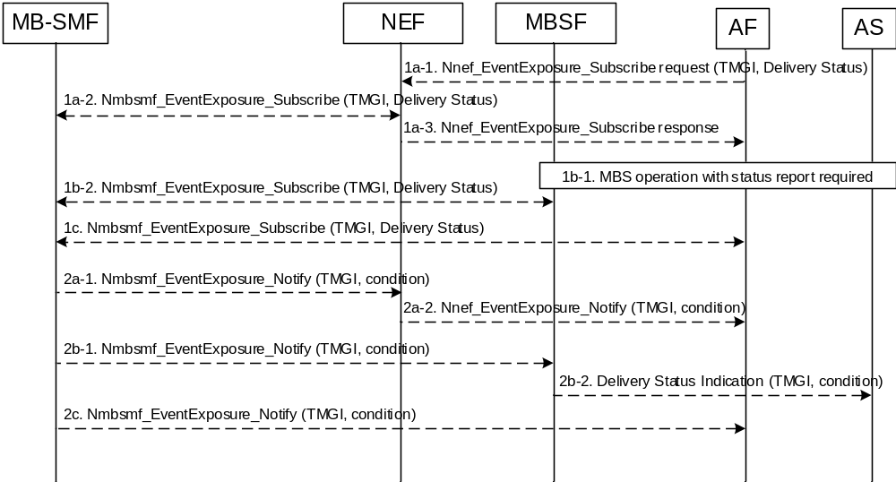
Figure 7.3.X-1: MBS Session Delivery Status Indication for Broadcast
- The external AF subscribes event for delivery status towards the NEF, and the NEF subscribes corresponding event towards the MB-SMF(step 1a), or the legacy AS request status report towards the MBSF, and the MBSF subscribes event for delivery status towards the MB-SMF(step 1b), or the internal AF subscribs event for delivery status towards the MB-SMF(step 1c).
- The MB-SMF notifies the TMGI and the event towards the NEF, and the NEF notifies the TMGI and corresponding event towards the external AF(step 2a), or the MB-SMF notifies the TMGI and the event towards the MBSF, and the MBSF sends Delivery Status Indication to legacy AS with the TMGI and the corresponding event(step 2b), or the MB-SMF notifies the TMGI and the event towards the internal AF(step 2c).
Editor’s note: whether more events are needed in the delivery status notification are FFS.

7.4 MBS procedures for inter System Mobility

8 Control and user plane stacks

8.1 Control plane for Multicast and Broadcast services

8.2 User plane for Multicast and Broadcast services

9 Network Function Services
Editor's note: The NF and associating services are FFS.

Annex A (Normative):
Configuration options at Service and/or Application for MBS
Editor's note: The current version may not fully reflect modifications in TR 23.757 [14] during SA2#143.
Figure A-1 provides the reference architecture with all configuration variants for Application Function interaction with 5G Core Network, usage of NEF or MBSF in the control plane, and usage of N6, MB2-U or xMB-U in user plane.
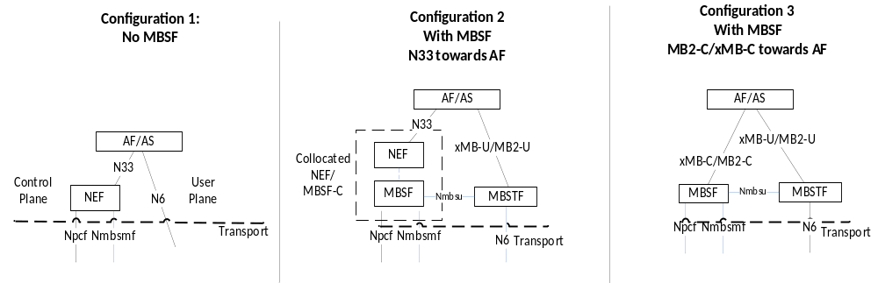
Figure A-1: Configuration options at Service and/or Application
The following characteristics describe each of the Configuration options:
- Configuration Option 1: No MBSF:
- This configuration is used for Transport Only Mode, when the Multicast service or Broadcast service does not require service layer interworking with LTE MBMS.
- The control plane entry point for the Application Function outside the trusted domain towards 5GC to request establishment of an MBS session is the NEF via N33.
- An application function within the trusted domain can directly use the Npcf and Nmbsmf service based interfaces. In this case some NEF functionality related to PCF and MB-SMF interaction is incorporated in AF.
NOTE: Application function within the trusted domain selects MB-SMF based on e.g. its local configuration, or query NRF based on location, etc.
- The user plane entry point for the Application Function towards 5GC is the MB-UPF via N6.
- Configuration Option 2: MBSF, N33 towards AF:
- This configuration may be used for Service Mode, or when interworking with LTE MBMS is required.
- The control plane entry point from the Application Function to request establishment of an MBS session is the NEF via N33.
- The user plane entry point for the Application Function towards 5GC is the MBSTF via MB2-U or xMB-U.
- The NEF and MBSF may be collocated.
- If the MBSF is not collocated with the NEF, the reference point between the NEF and MBSF is MB2-C or xMB-C.
- An application function within the trusted domain may be collocated with MBSF.
- Configuration Option 3: MBSF, MB2-C/xMB-C towards AF:
- This configuration may be used for Service Mode (xMB-C only), or when interworking with LTE MBMS is required (MB2-C or xMB-C).
- The control plane entry point from the Application Function to request establishment of an MBS session is the MBSF via MB2-C or xMB-C.
- The user plane entry point for the Application Function is the MBSTF via MB2-U or xMB-U.
For service mode, MBSF shall be used, i.e. either Configuration 2 or Configuration 3 shall be used. The MBSF may decide to service/transport layer changes on the MBS data (e.g. including the FEC or MBS data transcoding).
For Transport Only mode:
- If interworking with LTE MBMS at 5GC is required for the service, MBSF and MBSTF shall be used, i.e. either Configuration 2 or Configuration 3 shall be used.
NOTE: Interworking providing by AF is out of scope of this specification.
- If interworking with LTE MBMS is not required for the service, MBSF and MBSTF are optional.
MBSTF shall be used when MBSF is used.
Any particular deployment may support any combination of these configurations.

Annex B (Informative):
Change history
Change history
Date | Meeting | TDoc | CR | Rev | Cat | Subject/Comment | New version
2021-03 | SA2#143E | S2-2101423 | - | - | - | TS skeleton approved at S2#143E | 0.0.0
2021-03 | SA2#143E |  |  |  |  | Inclusion of documents agreed in SA2#143E:  S2-2101424, S2-2101425, S2-2101426, S2-2101427, S2-2101113, S2-2101428, S2-2100381, S2-2101429, S2-2101430, S2-2101118, S2-2101431, S2-2101432, S2-2101433, S2-2101114, S2-2101120, S2-2101434, S2-2101435, S2-2101115 | 0.1.0
2021-04 | SA2#144E |  |  |  |  | Inclusion of documents agreed in SA2#143E:  S2-2103526, S2-2103527, S2-2103071, S2-2103529, S2-2103530, S2-2103531, S2-2103556, S2-2103532, S2-2103533, S2-2103557, S2-2103534, S2-2103535, S2-2103072, S2-2103538, S2-2103539, S2-2103540, S2-2103541, S2-2103073, S2-2103543, S2-2103544, S2-2102339, S2-2102388, S2-2103545, S2-2103546, S2-2103547, S2-2103548, S2-2102729, S2-2102730 | 0.2.0

