3GPP TR 23.793 V0.7.0 (2018-08)
Technical Report
3rd Generation Partnership Project;
Technical Specification Group Services and System Aspects;
Study on Access Traffic Steering, Switching and
Splitting support in the 5G system architecture
(Release 16)


The present document has been developed within the 3rd Generation Partnership Project (3GPP TM) and may be further elaborated for the purposes of 3GPP.
The present document has not been subject to any approval process by the 3GPP Organizational Partners and shall not be implemented.
This Report is provided for future development work within 3GPP only. The Organizational Partners accept no liability for any use of this Specification.
Specifications and Reports for implementation of the 3GPP TM system should be obtained via the 3GPP Organizational Partners' Publications Offices.

Keywords
3GPP, Architecture, 5G, traffic steering, switching, splitting
3GPP
Postal address

3GPP support office address
650 Route des Lucioles - Sophia Antipolis
Valbonne - FRANCE
Tel.: +33 4 92 94 42 00 Fax: +33 4 93 65 47 16
Internet
http://www.3gpp.org
Copyright Notification
No part may be reproduced except as authorized by written permission.
The copyright and the foregoing restriction extend to reproduction in all media.

© 2018, 3GPP Organizational Partners (ARIB, ATIS, CCSA, ETSI, TSDSI, TTA, TTC).
All rights reserved.

UMTS™ is a Trade Mark of ETSI registered for the benefit of its members
3GPP™ is a Trade Mark of ETSI registered for the benefit of its Members and of the 3GPP Organizational Partners
LTE™ is a Trade Mark of ETSI registered for the benefit of its Members and of the 3GPP Organizational Partners
GSM® and the GSM logo are registered and owned by the GSM Association
Contents
Foreword 8
1 Scope 9
2 References 9
3 Definitions, symbols and abbreviations 10
3.1 Definitions 10
3.2 Abbreviations 11
4 Architectural requirements and assumptions 11
4.1 Architectural requirements 11
4.2 Architectural assumptions 11
5 Key issues 11
5.1 Key issue#1: Overall Architecture for traffic Steering/switching/splitting between Multiple Accesses 11
5.1.1 Descriptions: User plane aspects 11
5.1.2 Descriptions: Control Plane aspects 12
5.2 Key Issue#2: Steering between Multiple Accesses 12
5.2.1 Descriptions 12
5.3 Key Issue#3: Switching between Multiple Accesses 12
5.3.1 Descriptions 12
5.4 Key Issue#4: Splitting Over Multiple Accesses 12
5.4.1 Descriptions 12
5.5 Key Issue#5: Multi-access PDU sessions (Un-trusted access) 13
5.5.1 Descriptions 13
5.6 Key Issue #6: Key issue on differentiation of 3GPP RATs in ATSSS rule 14
5.6.1 Descriptions 14
6 Solutions 14
6.1 Solution 1: Proposed architecture framework for ATSSS 14
6.1.1 General 16
6.1.2 Functional Description 17
6.1.3 MA PDU and URSP 17
6.1.4 Architecture Description 19
6.1.5 Procedures 20
6.1.5.1 Multi Access PDU Session Establishment Procedure 20
6.1.5.2 User Plane Configuration between UE-AT3SF and UPu-AT3SF 20
6.1.5.2.1 AT3SF Session Termination Procedure 22
6.1.5.3 Access Measurement Report Procedure 22
6.1.5.4 Round Trip Time (RTT) Evaluation Procedure 24
6.1.6 Control Plane Protocol Stack between UE-AT3SF and UPc-AT3SF 24
6.1.7 User Plane Protocol Stack options between UE-AT3SF and UPu-AT3SF 25
6.1.7.1 User Plane Convergence Method based on NULL Tunneling 25
6.1.7.1.5 Traffic Distribution 26
6.1.7.1.6 MTU considerations 26
6.1.7.2 User Plane Convergence Method based on GRE tunneling 26
6.1.7.3 User Plane Convergence Method using L3 Generic Multi-Access Solutions (GMA) 27
6.1.7.4 User Plane Convergence Method using L4 Multipath Solutions (MP-TCP, MP-QUIC, SCTP, UDP generic) 28
6.1.7.4.1 Traffic distribution with MP-TCP 31
6.1.7.4.1.1 Traffic distribution over multi access using MP-TCP tunnel between the UE and UPu-AT3SF 31
6.1.7.4.1.1.1 Usability 31
6.1.7.4.1.1.2 IP addressing 31
6.1.7.4.1.2 Traffic distribution over multi access using MP-TCP proxy at UPu-AT3SF. 31
6.1.7.4.1.2.1 Usability 31
6.1.7.4.1.2.2 IP addressing 31
6.1.7.4.2 Traffic distribution with MP-QUIC 31
6.1.7.4.2.1 Traffic distribution over multi access using MP-QUIC tunnel between the UE and UPu-AT3SF 31
6.1.7.4.2.1.1 Usability 31
6.1.7.4.2.1.2 IP addressing 31
6.1.8 Impacts On Existing Entities and Interfaces 32
6.2 Solution 2: Support of Multi-Access PDU Sessions 32
6.2.1 General 32
6.2.2 Establishment of Multi-Access PDU session with multiple PDU Session IDs 33
6.2.2.1 Separate Establishment 33
6.2.2.2 Combined Establishment 33
6.2.3.1 Separate Establishment 35
6.2.3.2 Combined Establishment 37
6.2.4 NW-Requested MA-PDU Session Establishment 39
6.2.5 Modify a Multi-Access PDU Session to single-access PDU session 41
6.2.6 Modification of Multi-Access PDU session 42
6.2.7 Release of a Multi-Access PDU Session 44
6.3 Solution 3: TFCP (Traffic Flow Control Protocol) based architecture framework for ATSSS 45
6.3.1 Architecture framework Description 45
6.3.1.1 ATSSS Policy Control function description 46
6.3.1.2 ATSSS Policy Enforcement function description 47
6.3.1.3 ATSSS Traffic Control function description 48
6.3.1.4 ATSSS path performance measurement function description 50
6.3.2 Protocol Stacks 51
6.3.3 PDU Session Establishment Procedure 51
6.3.4 PDU Session Modification procedure 54
6.3.5 ATSSS Execution Procedure 56
6.3.6 Solution evaluation 59
6.3.6.1 Impacts on existing entities and interfaces 59
6.4 Solution 4: Policy for Access Traffic Steering, Switching and Splitting 59
6.4.1 General 59
6.4.2 Content of ATSSS Policy 61
6.4.3 Traffic Distribution based on ATSSS Policy 63
6.5 Solution 5: Multipath TCP (MPTCP) proxy architecture 63
6.5.1 General 63
6.5.2 MPTCP proxy 64
6.5.3 Addition of MPTCP proxy to 5GC 64
6.5.4 MPTCP PDU session establishment procedure 65
6.5.5 ATSSS rules for MPTCP PDU Session 68
6.6 Solution 6: Architecture framework with ATSSS rules via NAS and generic user plane Reporting Control Protocol 70
6.6.1 Architecture framework Description 70
6.6.2 Functional Description 70
6.6.3 Procedures 71
6.6.3.1 ATSSS Policy Control (via NAS) 71
6.6.3.2 Measurement Configuration and Reporting Control Procedure (via User Plane) 72
6.6.3.3 Control plane protocol stack between UE-AT3SF and UP-AT3SF 74
6.6.4 Impacts on existing entities and interfaces 75
6.7 Solution 7: Traffic Steering using Access Network Performance Measurements 76
6.7.1 General 76
6.7.2 Reference Architecture 77
6.7.3 Procedures 78
6.7.3.1 Procedure with Standalone PMF 78
6.7.3.2 Procedure with PMF collocated with UPF 80
6.8 Solution 8: ATSSS rules for supporting 3GPP RAT differentiation 81
6.8.1 General 81
6.9 Solution 9: Solution for the UL CL case on the Multi-access PDU sessions 82
6.9.2 Architecture description 83
6.9.3 PDU session Establishment Procedure with additional UL CL and PDU session Anchor 84
6.9.3.1 Establishment of Multi-Access PDU session with UL CL based on the solution 3 architecture framework 84
6.9.4 Insert UL CL and additional PDU Session Anchor after PDU Session Establishment 87
6.9.4.1 Insert UL CL to both 3GPP access and Non-3GPP access 87
6.9.4.2 Insert UL CL to a single access 88
6.10 Solution 10: ATSSS Solution using a MA-PDU Session 89
6.10.1 General 89
6.10.2 Reference Architecture 89
6.10.3 Functional Description 89
6.11 Solution 11: Interworking for Multi-Access PDU Session 93
6.11.1 General 93
6.11.2 Functional Description 93
6.11.2.1 Interworking with N26 from EPC to 5GC 93
6.11.2.2 Interworking without N26 from EPC to 5GC 95
6.11.2.3 Interworking with N26 from 5GS to EPS 95
6.11.2.4 Interworking without N26 from 5GS to EPS 95
6.11.3 Solution evaluation 95
6.11.3.1 Impacts on existing entities and interfaces 95
7 Conclusions 95
Annex A: Change history 99

Foreword
This Technical Report has been produced by the 3rd Generation Partnership Project (3GPP).
The contents of the present document are subject to continuing work within the TSG and may change following formal TSG approval. Should the TSG modify the contents of the present document, it will be re-released by the TSG with an identifying change of release date and an increase in version number as follows:
Version x.y.z
where:
x the first digit:
1 presented to TSG for information;
2 presented to TSG for approval;
3 or greater indicates TSG approved document under change control.
y the second digit is incremented for all changes of substance, i.e. technical enhancements, corrections, updates, etc.
z the third digit is incremented when editorial only changes have been incorporated in the document.

1 Scope
The purpose of this document is to study how the 5G System (5GS) can be extended in order to support Access Traffic Steering, Switching and Splitting (ATSSS) between 3GPP and non-3GPP access networks. In particular, this document considers solutions that specify the following:
- How the 5GC and the 5G UE can support multi-access traffic steering (as defined in clause 3.1) between 3GPP and non-3GPP accesses.
- How the 5G Core network and the 5G UE can support multi-access traffic switching (as defined in clause 3.1) between 3GPP and non-3GPP accesses. This includes the conditions that can trigger the switching of data traffic to a new access type.
- How the 5G Core network and the 5G UE can support multi-access traffic splitting (as defined in clause 3.1) between 3GPP and non-3GPP accesses (multi access PDU session). This includes the conditions that can trigger the splitting of data traffic across multiple accesses.
- How the multi-access traffic steering, switching and splitting (ATSSS) can be taken into account by the charging framework in order e.g. to enable the network operator to differentiate charging for data traffic that is switched and/or split between 3GPP and non-3GPP accesses.
- How the policy framework can be extended in order to support the requirements for ATSSS.
- How ATSSS can be supported by using multi-access PDU sessions (as defined in clause 3.1). ATSSS solutions not requiring multi-access PDU sessions can also be considered.
- How to handle issues related to ATSSS that may occur when the UE moves between EPC and 5GC.
The scope of this document excludes the following aspects:
- Changes to the charging framework are not considered. However, it may be considered what information needs to be provided to the charging framework in order to charge traffic that is switched and/or split between 3GPP and non-3GPP accesses.
- ATSSS procedures that may be applied in the NG-RAN are not considered. The study is restricted only to ATSSS procedures applied in the 5G core network.
- 5GS enhancements to support trusted non-3GPP access networks are not considered.
- 5GS enhancements to support wireline access networks are not considered.
All solutions in this document should be based on and aligned with the 5GS Phase-1 normative work including work on policy management, as documented in TS 23.501[5], TS 23.502[6] and TS 23.503[7].
The study in this document is organized into two phases:
- Initially, the study considers ATSSS solutions that enable traffic selection, switching and splitting between NG-RAN and untrusted non-3GPP access networks.
- Subsequently, after the 5GS architecture is enhanced to support trusted non-3GPP access networks, the study will also consider ATSSS solutions that enable traffic selection, switching and splitting between NG-RAN and trusted non-3GPP access networks.

2 References
The following documents contain provisions which, through reference in this text, constitute provisions of the present document.
- References are either specific (identified by date of publication, edition number, version number, etc.) or non-specific.
- For a specific reference, subsequent revisions do not apply.
- For a non-specific reference, the latest version applies. In the case of a reference to a 3GPP document (including a GSM document), a non-specific reference implicitly refers to the latest version of that document in the same Release as the present document.
[1] 3GPP TR 21.905: "Vocabulary for 3GPP Specifications".
[2] 3GPP TS 23.402: "Architecture enhancements for non-3GPP accesses".
[3] IEEE Std 802.11-2012: "IEEE Standard for Information technology - Telecommunications and information exchange between systems - Local and metropolitan area networks - Specific requirements - Part 11: Wireless LAN Medium Access Control (MAC) and Physical Layer (PHY) Specifications".
[4] 3GPP TS 23.139: "3GPP system - fixed broadband access network interworking".
[5] 3GPP TS 23.501: "System Architecture for the 5G System; Stage 2".
[6] 3GPP TS 23.502: "Procedures for the 5G System; Stage 2".
[7] 3GPP TS 23.503: "Policy and Charging Control Framework for the 5G System; Stage 2".
[8] draft-ietf-mptcp-rfc6824bis-10: "TCP Extensions for Multipath Operation with Multiple Addresses".
Editor's note: The above document cannot be formally referenced until it is published as an RFC.
[9] RFC 1928: "SOCKS Protocol Version 5".
[10] draft-olteanu-intarea-socks-6-02: "SOCKS Protocol Version 6".
Editor's note: The above document cannot be formally referenced until it is published as an RFC.
[11] 3GPP TS 38.215: "Physical layer measurements".
[12] 3GPP TS 38.300: "NR and NG-RAN Overall Description".
[13] 3GPP TS 36.300: "Evolved Universal Terrestrial Radio Access (E-UTRA) and Evolved Universal Terrestrial Radio Access Network (E-UTRAN) Overall Description".
[14] IETF RFC 1323: "TCP Extensions for High Performance".

3 Definitions, symbols and abbreviations

3.1 Definitions
For the purposes of the present document, the terms and definitions given in TS 23.501 [5] and the following apply.
Access Traffic Steering: The procedure that selects an access network for a new data flow and transfers the traffic of this data flow over the selected access network. Access traffic steering is applicable between 3GPP and non-3GPP accesses.
Access Traffic Switching: The procedure that moves all traffic of an ongoing data flow from one access network to another access network in a way that maintains the continuity of the data flow. Access traffic switching is applicable between 3GPP and non-3GPP accesses.
Access Traffic Splitting: The procedure that splits the traffic of a data flow across multiple access networks. When traffic splitting is applied to a data flow, some traffic of the data flow is transferred via one access and some other traffic of the same data flow is transferred via another access. Access traffic splitting is applicable between 3GPP and non-3GPP accesses.
Multi-Access PDU Session: A PDU session whose traffic can be sent over 3GPP access, or over non-3GPP access, or over both accesses.

3.2 Abbreviations
For the purposes of the present document, the abbreviations given in TR 21.905 [1], TS 23.501 [5], TS 23.502 [6], TS 23.503 [7] and the following apply. An abbreviation defined in the present document takes precedence over the definition of the same abbreviation, if any, in TR 21.905 [1].
ATSSS Access Traffic Steering, Switching and Splitting
AT3SF Access Traffic Steering, Switching and Splitting Function
MA-PDU Multi-Access Packet Data Unit
TFCP Traffic Flow Control Protocol

4 Architectural requirements and assumptions

4.1 Architectural requirements

4.2 Architectural assumptions

5 Key issues

5.1 Key issue#1: Overall Architecture for traffic Steering/switching/splitting between Multiple Accesses

5.1.1 Descriptions: User plane aspects
This KI addresses the overall User plane architecture including the potential impacts to NF (e.g. UPF) and to interfaces (e.g.N4), etc., including following points:
1. Should the same access be used to send a data flow DL and to send the same data flow UL? Should a data flow use the same access UL and DL?
2. What is the granularity with which traffic can be split (per SDF / per IP flow / per packet etc.)? What are the impacts of the split granularity to the entities handling the User Plane?
3. Whether the UE, the network or both can decide to switch / split / steer a data flow across 3GPP access and non-3GPP access?
4. If the network can take decisions to steer/ switch/split DL Data flows, what information does it need to take proper decision. How can this information be provided to the NF taking decisions to steer/ switch/split DL Data flows?
5. Are there any impacts between UP transport related with ATSSS and QoS enforcement in 5GC?
6. When a data flow has been switched or split, can this have impact on the dataflow integrity? (data loss and disordering).
7. Whether and how the service continuity or the service interruption is considered/guaranteed when performing steering or switching or splitting?

5.1.2 Descriptions: Control Plane aspects
The control plane aspects in the overall architecture for traffic steering/switching/splitting comprise:
- If all or some ATSSS rules need to be sent to the UE, whether they are sent via NAS or via user plane. In other words, is it needed to update some ATSSS rules frequently during the life of a PDU session?
- If it is deemed useful that traffic steering/switching/splitting decisions are taken independently for uplink and downlink, whether the measurement reports from the UE to the network (for downlink traffic steering/switching/splitting decisions by the network) should use control plane (i.e. NAS) or user plane.

5.2 Key Issue#2: Steering between Multiple Accesses

5.2.1 Descriptions
1. What are the criteria used by the UE or by the network to take a steering decision on a data flow?
NOTE: The architecture on how to provide ATSSS policies from the network to the UE is studied as part of another KI.
2. Should the PCF be informed of the steering decision? If yes, what information should be provided to the PCF?
3. Should the charging framework be informed of the steering decision? If yes, what information should be provided to the charging framework for enabling appropriate charging?
4. What is the relationship between ATSSS steering policy and other UE policies e.g. URSP?

5.3 Key Issue#3: Switching between Multiple Accesses

5.3.1 Descriptions
1. What are the criteria used by the UE or by the network to take a switching decision on a data flow?
NOTE: The architecture on how to provide ATSSS policies from the network to the UE is studied as part of another KI.
2. How does the network trigger the switching decision for existing DL data flows?
3. Should the PCF be informed of the switching decision? If yes, what information should be provided to the PCF?
4. Should the charging framework be informed of the switching decision? If yes, what information should be provided to the charging framework for enabling appropriate charging?

5.4 Key Issue#4: Splitting Over Multiple Accesses

5.4.1 Descriptions
1. What are the criteria used by the UE (including CPE) or by the network to take a splitting and restoring decision?
NOTE: The architecture on how to provide ATSSS policies from the network to the UE is studied as part of another KI.
2. Should the PCF be informed of the splitting decision? If yes, what information should be provided to the PCF?
3. Should the charging framework be informed of the splitting decision? If yes, what information should be provided to the charging framework for enabling appropriate charging?
4. How can the ATSSS traffic spliting solution interwork with application layer solutions for traffic splitting?

5.5 Key Issue#5: Multi-access PDU sessions (Un-trusted access)

5.5.1 Descriptions
This KI aims at studying multi-access PDU sessions i.e. PDU sessions that may simultaneously use a 3GPP and a N3GPP access. The KI will study:
1. Can a non-IP session type PDU sessions take advantage of the multi-access PDU session feature? If yes when? (the Ethernet and the Unstructured PDU session types could correspond to different answers)
2. How can the UE and the network negotiate the support of multi-access PDU session? Is the multi-access PDU session subject to subscription?
3. The signalling procedure for establishing/modifying/terminating a multi-access PDU session: e.g.
a. How can the UE or network add / remove an access ("leg") to a multi-access PDU session (How to extend a single-access PDU session to make a multi-access PDU session / How to turn a multi-access PDU session back into a single-access one)?
NOTE: Considering the case where the UE is using both (3GPP / N3GPP) accesses when establishing the PDU session and the case where it gets usage of a second (3GPP / N3GPP) access after having established the PDU session.
b. How to modify a multi-access PDU session?
c. How to release a multi-access PDU session?
4. Which of the UE and of the network can decide on the mapping between UE's IP flows and UE's serving access legs?
a. How can the mapping between data (e.g. IP) flows and access legs be negotiated between the UE and the 5GC?
5. Any potential impacts of multi-access PDU session on UPF selection.
6. Any relationship between multi-access PDU session and slicing.
7. Any relationship between multi-access PDU session and roaming including following cases:
a. The 3GPP access and non-3GPP access are located in the same PLMN, and
b. the 3GPP access and non-3GPP access are located in the different PLMNs.
8. Whether multi-homing is supported for a multi-access PDU session? And if yes, how should multi-homing be operated for a multi-access PDU session?
9. Whether Usage of an UL Classifier is supported for multi-access PDU Session? And if yes, how should the PDU session with UL Classifier be operated for a multi-access PDU session, e.g. whether the UL Classifier should be inserted to the two accesses of the PDU Session or only one of the two accesses of the PDU Session?
10. What happens to a multi access PDU session in scenarios of interworking with EPC (e.g. when the UE moves to EPC during the interworking scenario )? This includes:
a. How can a PDN connection over EPC that is moved to 5GC benefit from the multi-access PDU session feature when moved to 5GC?
b. Considering UE is in single-registration mode and the UE in dual-registration mode.
NOTE: The content of the ATSSS policies is studied in other KI.

5.6 Key Issue #6: Key issue on differentiation of 3GPP RATs in ATSSS rule

5.6.1 Descriptions
In EPS, when a UE has multi-access PDN connection, NBIFOM routing rule is used to select an access network to send traffic. In the routing rule access type is defined 3GPP access or non-3GPP access. This restricts the ability for the operator to provide policies that favour a specific 3GPP RAT over another one with respect to the non-3GPP preference.
This key issue studies whether and how to provide relative priorities for 3GPP RATs with respect to the non-3GPP access in ATSSS rule.

6 Solutions

6.1 Solution 1: Proposed architecture framework for ATSSS
In terms of architecture requirements for this solution, the proposed ATSSS architecture framework:
1. Shall support untrusted non-3GPP access, NG-RAN and E-UTRAN. GERAN and UTRAN are not supported. As part of untrusted non-3GPP access, WLAN access shall be supported.
2. Shall support simultaneous connections of an UE via multiple access technologies.
3. Shall support separation of control and user plane functions.
4. Shall support IP (IPv4 & IPv6) and Ethernet PDU session types
5. Shall reuse and align with Release 15 architecture, reference points and functional capabilities in 5GS as stated in TS 23.501 [5] and the procedures as stated in TS 23.502 [6] as much as possible.
6. Shall support roaming. As part of roaming, the architecture shall support both local breakout and home routing scenarios.
7. Remote host resides at DN (beyond N6) is not aware of traffic steering, switching and splitting operations in 5GS.
8. May support traffic usage reports from UE and ATSSS user plane entity to the ATSSS control plane of the core network to enable ATSSS control plane to get an end-to-end view of traffic performance over multiple access networks in order to dynamically manage ATSSS operations over these accesses.
NOTE: Network that support ATSSS can continue to provide ATSSS functionality if traffic usage report is not provided by UE and ATSSS user plane entity.
Figure 6.1-1 depicts the initial high level ATSSS architecture for the non-roaming case.
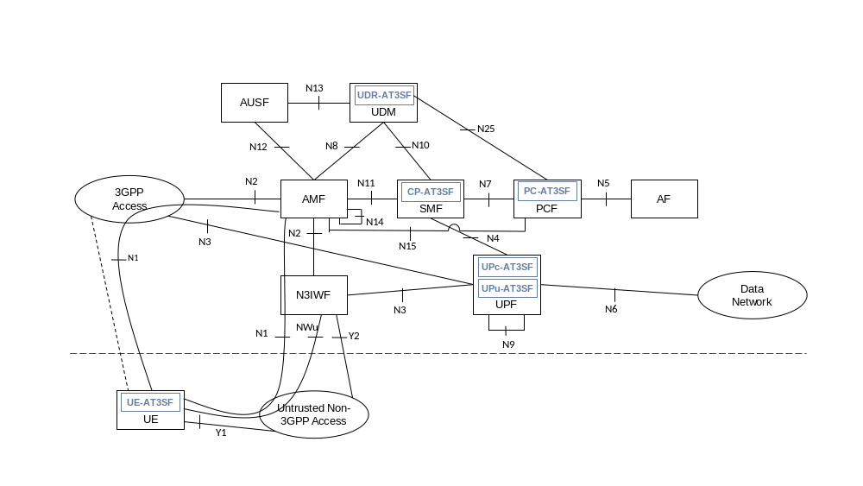
Figure 6.1-1: Initial high level view of non-roaming ATSSS architecture
The following Figure 6.1-2 depicts the ATSSS roaming architecture in the case of LBO with N3IWF in the same PLMN as 3GPP access (assumed AF resides in VPLMN).
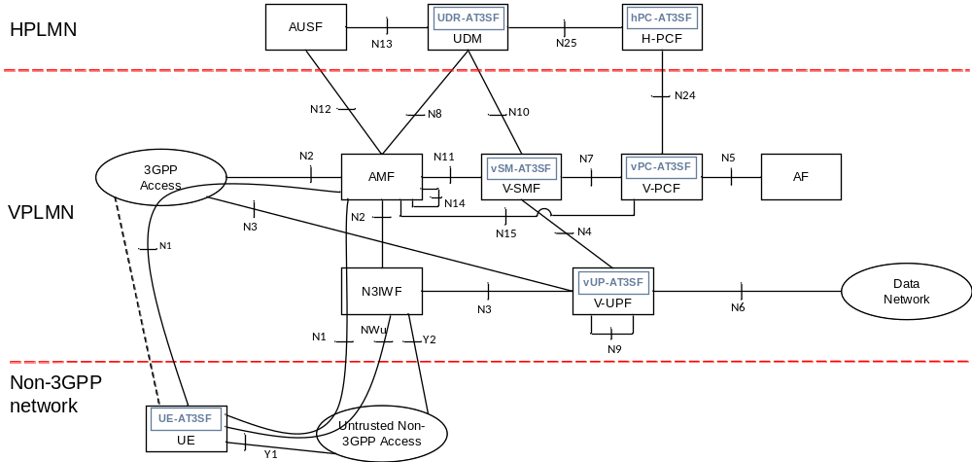
Figure 6.1-2: Roaming ATSSS architecture - LBO scenario with N3IWF in same the PLMN as 3GPP access (assuming AF resides in VPLMN)
The following Figure 6.1-3 depicts the ATSSS roaming architecture in the case of HR with N3IWF in the same PLMN as 3GPP access.
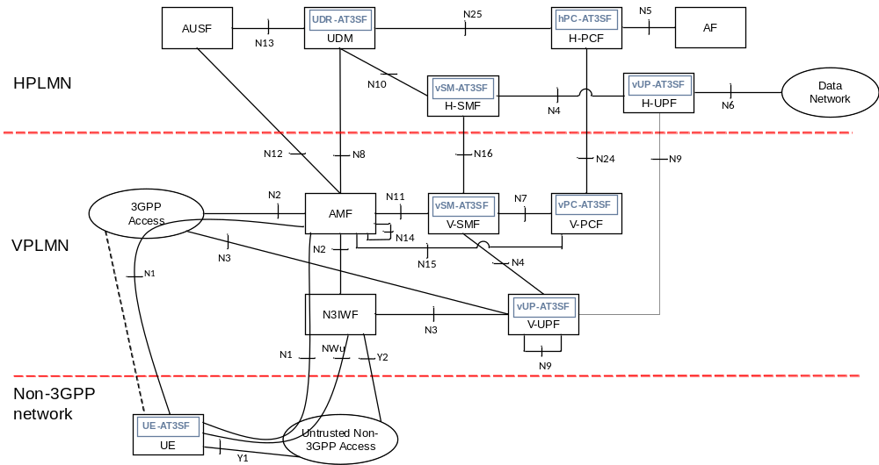
Figure 6.1-3: Roaming ATSSS architecture - HR scenario with N3IWF in same the PLMN as 3GPP access

6.1.1 General
This solution supports Multi-Access (MA PDU). A MA PDU is a type of PDU session that allows application to send/receive traffic either over 3GPP access, or non-3GPP access, or both accesses simultaneously. A MA PDU session comprises of a PDU session over 3GPP access and a "linked" PDU session over non-3GPP access, or vice versa. Each of the PDU sessions may have its own set of UPFs, but both PDU sessions share a common PDU session anchor (PSA) as shown in Figure 6.1.1-1. For MA PDU session, applications in UE and the N6 host server are not aware of traffic split across multiple accesses.
Editor's note: Support for UL CL and multi-homing in (optional) intermediate UPF is FFS.
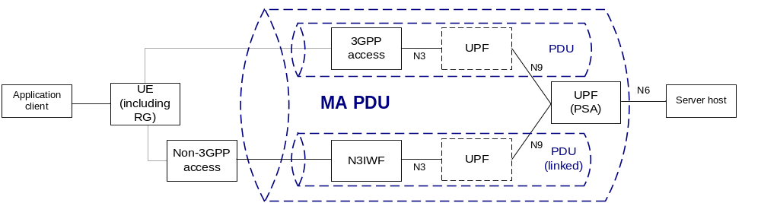
Figure 6.1.1-1: MA PDU session
The PDU session and linked PDU session of a MA PDU session share the following attributes:
1. DNN
2. SSC mode
3. S-NSSAI
4. PDU session type (IPv4, IPv6 or Ethernet)
5. IP address (for IPv4 and IPv6 PDU session type)

6.1.2 Functional Description
The ATSSS architecture contains the following functional elements:
- User Data Repository for Access Traffic Steering Switching and Splitting Function (UDR-AT3SF)
UDR AT3SF holds UE ATSSS subscription data for operator service and user profiles. This functionality is supported by the UDR in 5GS.
- Policy Control Access Traffic Steering Switching and Splitting Function (PC-AT3SF)
PC-AT3SF defines ATSSS policies according to the application-specific information provided by the AF (via N5), access information/notification provided by the AMF (via N15), UE ATSSS subscription and user profiles provided by the UDR-AT3SF (via N25), network local policy or any combination of them. The PC AT3SF may also take input from Network Data Analytics (NWDA) into consideration to generate or modify ATSSS policies. The PC-AT3SF can provide ATSSS rules to UE-ATS3F as described in clause 6.1.4.
- Session Management Access Traffic Steering Switching and Splitting Function (SM-AT3SF)
SM-AT3SF is the main control plane function of the ATSSS architecture which is supported by the SMF. It is responsible for ATSSS policy enforcement and session management of all PDU sessions between 5GC and UE. SM-AT3SF can receive the ATSSS policies from PC-AT3SF via N7 and generates ATSSS rules to control the behaviour of ATSSS traffic by conveying ATSSS rules to UP-AT3SF over N4. SM-AT3SF may also receive access link information (e.g. access restriction, mobility status) from the AMF for all access legs as inputs to manage ATSSS behaviour. The SM-AT3SF can provide ATSSS PDU session related policies to UE-ATS3F during PDU session establishment and PDU session modification, as well as receive traffic usage reports from the UE and SM-AT3SF for dynamic ATSSS operations. Based on the traffic usage reports, SM-AT3SF may send commands (e.g., change access or access forbidden) to UE-AT3SF and UP-AT3SF via N1 and N4, respectively to optimise ATSSS behaviour.
- User Plane Access Traffic Steering Switching and Splitting Function (UP-AT3SF)
UP AT3SF has a data plane component (UPu-AT3SF) and a control plane component (UPc-AT3SF). UPu-AT3SF is supported by PDU session anchor representing the UP anchor point for all ATSSS traffic and presents a single IP address towards DN via N6. It is responsible for ATSSS policy rule enforcement in the UP of the core network.
UPc-AT3SF requests, receives and processes traffic usage reports from the UE (if available) as indicated by the SM-AT3SF via N4. It is responsible for setting up the multi access connectivity through UPu-AT3SF and steering/splitting the traffic over available accesses based on path quality estimation, network access measurement reports and network policies provided by the SM-AT3SF via N4 interface.
- UE Access Traffic Steering Switching and Splitting Function (UE-AT3SF)
ATSSS policy rule enforcement at the UE for UE-initiated traffic (UL). It may also generate traffic reports to be sent to the SM-AT3SF at the request of UPc-AT3SF.
In order to support ATSSS, it is essential that UDR AT3SF, PC-AT3SF, SM AT3SF and UP AT3SF are supported by UDR, PCF, SMF and UPF respectively in 5GS. ATSSS capability may be discovered during initial PDU Session Establishment and inter-PLMN mobility procedures where these network functions indicate its support. If one of these network functions indicates no support for ATSSS capability, corresponding PDU session will not have ATSSS support.

6.1.3 MA PDU and URSP
In Rel-15, UE is responsible for establishing new PDU session(s) based on URSP provided by the network (PCF) and/or preconfigured in the UE as described in TS 23.503 [7] clause 6.6.2. As such, URSP provides SDF level steering capability for UE to establish new PDU session(s) over the preferred access network based on traffic descriptor and rule precedence.
As shown in Figure 6.1.3-1, the URSP approach can be extended to support MA PDU session in the UE. This can be done by adding a new field in the Route Selection Descriptor to specify what kind of PDU session (PDU or MA PDU) should be established for the matching application (see Table 6.1.3-1).
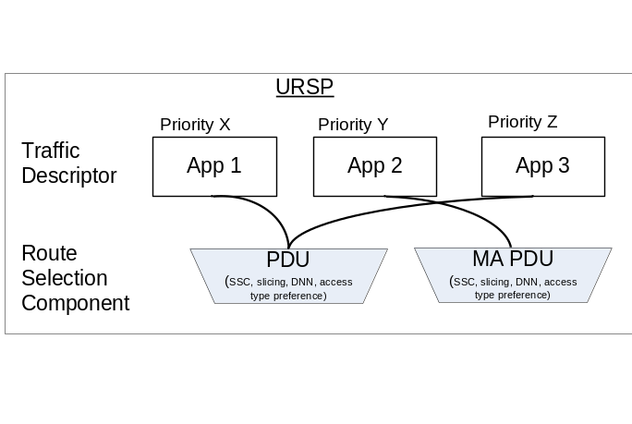
Figure 6.1.3-1: URSP can be extended to support for MA PDU session type. In this example, UE will establish regular PDU session(s) for App1 & 3, and MA PDU session for App 2
Table 6.1.3-1: URSP Rule (from TS 23.503 [7] table 6.6.2-1)
Information name | Description | Category | PCF permitted to modify in a UE context | Scope
Rule Precedence | Determines the order the URSP rule is enforced in the UE. | Mandatory  (NOTE 1) | Yes | UE context
Traffic descriptor | This part defines the traffic descriptors for the policy
Application identifiers | Application identifier(s) | Optional
IP descriptors | IP 3 tuple(s) (destination IP address or IPv6 network prefix, destination port number, protocol ID of the protocol above IP) | Optional | Yes | UE context
Non-IP descriptors | Descriptor(s) for non-IP traffic | Optional | Yes | UE context
Route Selection descriptor | The components for Route selection (see table 6.6.2-2) | Mandatory
NOTE 1: Rules in a URSP shall have different precedence values.

Table 6.1.3-2: Extension of Route Selection Descriptor (from TS 23.503 [7] table 6.6.2-2) to support MA PDU
Information name | Description | Category | PCF permitted to modify in a UE context | Scope
Route selection components | This part defines the route selection components | Mandatory  (NOTE 1)
SSC Mode Selection |  | Optional | Yes | UE context
Network Slice Selection |  | Optional | Yes | UE context
DNN Selection |  | Optional | Yes | UE context
Non-seamless Offload indication | Indicates if the traffic of the matching application is to be offloaded to non-3GPP access outside of a PDU Session. | Optional | Yes | UE context
Access Type preference | Indicates the preferred Access Type (3GPP or non-3GPP) when the UE establishes a PDU Session for the matching application. | Optional | Yes | UE context
PDU Session Type | Indicates whether PDU or MA PDU session should be established | Optional | Yes | UE context
NOTE 1: At least one of the route selection component shall be present

6.1.4 Architecture Description
The interactions between AT3SF's of UE, UPF, SMF and PCF are shown in Figure 6.1.4-1.
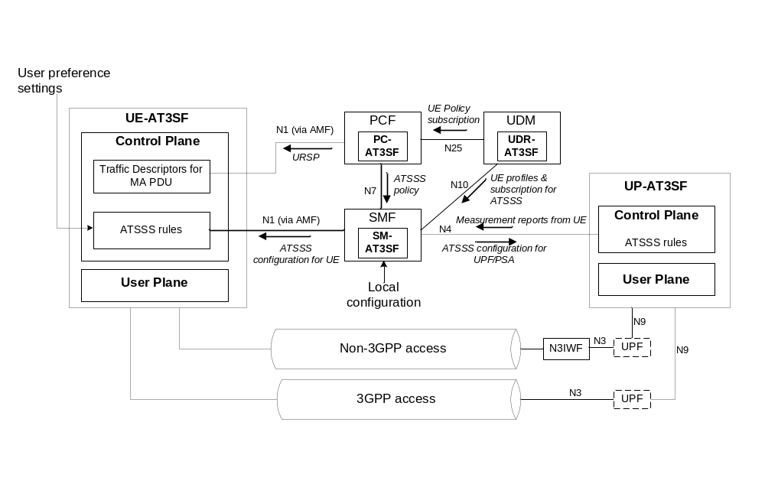
Figure 6.1.4-1: Interaction between AT3SF's of UE, SMF, PCF & UPF
5GS can implement ATSSS for MA PDU session according to PCF policy, user preference settings and link performance of 3GPP & non-3GPP access networks as shown in Figure 6.1.4-1. clause 6.1.3 already describes SDF level traffic steering in URSP to enable a UE to identify the need of MA PDU session based on Traffic Descriptor.
When MA PDU session is invoked by the UE, further traffic steering, switching and splitting policy can be provided by the PC-AT3SF to SM-AT3SF during MA PDU session establishment. SM-AT3SF is responsible for mapping the policy into ATSSS configurations towards the UE-AT3SF (via N1) and UP-AT3SF (via N4). The SM-AT3SF may also consider local configuration when deriving ATSSS configurations. Based on these configurations, the UE and UPF/PSA can determine the appropriate access networks to use for ATSSS operations. Some examples of ATSSS configurations provided by SM AT3SF can be shown as follows:
- Load balance - traffic is split over both accesses for equal or weighted distribution.
- Hot-standby - traffic is steer to the least cost access (e.g. WLAN) and switch to the other access when the least cost access is no longer available or its link condition falls below certain performance thresholds based on for example link quality, throughput, latency, packet loss, etc.
- Top up - traffic is steer to least cost access (e.g. WLAN) and if needed split across both accesses when the performance criteria of the least cost access falls below certain performance thresholds based on for example link quality, throughput, latency, packet loss, etc.
- Least loaded - traffic is steer to the least loaded access and switch to the other access when the least loaded access is no longer available or its link condition falls below certain performance thresholds based on for example link quality, throughput, latency, packet loss, etc.
- Best performance - traffic is steer to the best performing access based on traffic measurements and switch to the other access the best performing access is no longer available.
Based on ATSSS configurations provided by the SM-AT3SF and optionally user preference settings, the UE-AT3SF derives the ATSSS rules for MA PDU session data in the UL direction. Similarly, the UP-AT3SF derives the ATSSS rules for MA PDU session data in the DL direction based on ATSSS configurations received from SM-AT3SF.
Editor's note: The mapping of ATSSS configurations to ATSSS rules in UE-AT3SF and UP-AT3SF are FFS.
Editor's note: The enforcement of ATSSS rules in UE-AT3SF and UP-AT3SF to support traffic splitting is FFS.

6.1.5 Procedures

6.1.5.1 Multi Access PDU Session Establishment Procedure
In this case, theMA-PDU is using two child PDU sessions which are established with two separate PDU session establishment procedures as it is shown in clause 6.2.2.1. At the completion of the first PDU session setup the UE is also provided with the IP address of the UPFc-AT3SF.
Once the multi-access PDU connectivity is setup or when the UE detects changes in the link status (the link is up or down or IP address change, etc.) the user plane configuration is setup between UE and UPF-AT3SF as detailed in clause 6.1.5.2.
NOTE: The details of the communications between the UE and UPF-AT3SF are FFS.

6.1.5.2 User Plane Configuration between UE-AT3SF and UPu-AT3SF
The user plane configuration procedure consists of the following key steps detailed in Figure 6.1.5.2-1.
The procedure may be either terminal or network initiated and it follows Steps 1-23 in Figure 6.1.5.1-1 for setting up a MA-PDU.
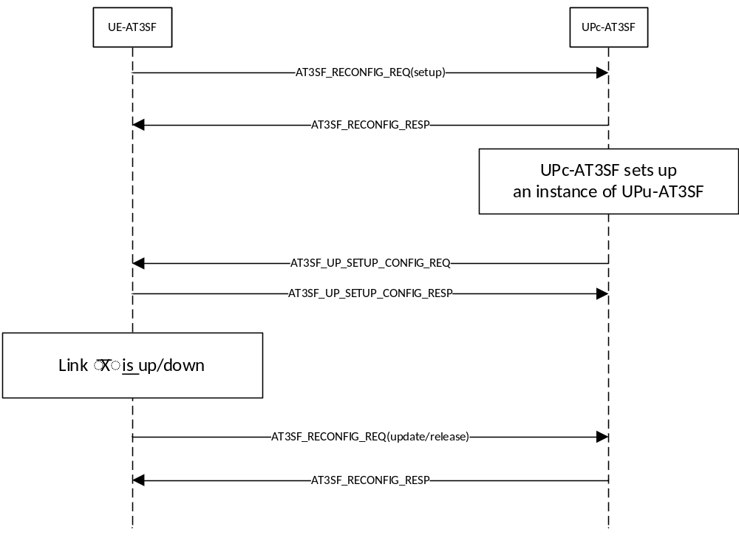
Figure 6.1.5.2-1: AT3SF Control Procedure for UP Configuration
Once the UE-AT3SF sets up multi-access PDU connectivity or when it detects changes in the link status (the link is up or down or IP address change, etc.) it sends a AT3SF_RECONFIG_REQ message to setup/release/update the multi access session. The message should include the following information:
1. Session Identifier: an unique identifier of the session.
2. Action Type (eg. Setup, Release, Update).
3. Link information including:
a. IP address of the connection.
b. Connection Type (eg. NR, WLAN, etc.).
UPc-AT3ASF is responsible in setting up the user plane protocol to be used in between the UPu-TA3SF and UE-AT3SF and it informs the UE-AT3SF client of the user plane protocols to setup at the client and the parameters to be used in connecting to the UPu-AT3SF.
Each instance of the UPu-AT3SF is responsible for one anchor connection. The AT3SF_UP_SETUP_CONFIG_REQ message is used to create one or more UPu-AT3SF instances and it includes the following parameters:
1. Anchor Connection ID (eg. IP address or other identifier for one end point of the connection).
2. Convergence Method: e.g. Loose Aggregation, GRE Aggregation, MP-TCP Proxy, MP-QUIC Proxy, etc.
In Loose Aggregation packets of the same QoS Flow may be sent over both accesses without the need of packet reordering at the receiving side.
3. Convergence Method Parameters: Proxy IP Address, Proxy IP Port(s).
4. Delivery Connection(s): Connection ID, Connection Type (eg. NR, WLAN, etc.), Transport Method (eg UDP tunnel, IPSec Tunnel with NULL encryption, etc.), Transport Method Parameters (eg. Tunnel endpoint IP address and port).
For example when NR and WLAN are two user plane accesses, UPc-AT3ASF may convey to the UE-AT3ASF that IPSec with NULL encryption needs to be setup as a transport method between the UE-AT3ASF and UPu-AT3ASF.
When the anchor does not need to provide traffic aggregation over multiple accesses with strict in order packet delivery, no Transport Method needs to be specified.
When the UP setup configuration indicates MP-TCP Proxy as the Convergence Method, then the request maust include the IP address and port number of the MP-TCP proxy.
Once the UP protocols are configured UE-AT3ASF informs the UPc-AT3ASF using the AT3ASF_UP_SETUP_CONFIG_CNF message. This message contains:
1. Session Identifier.
2. Convergence Method.
3. Delivery Connection(s).

6.1.5.2.1 AT3SF Session Termination Procedure
This procedure may be initiated either by the terminal(UE-AT3SF) or the network (UPc-AT3SF) by either one of the peers sending AT3SF_SESSION_TERMINATE_REQ to the other peer. The receiving peer shall acknowledge the termination with a AT3SF_SESSION_TERMINATE_RESP message. The two messages shall contain the session ID and the reason of termination.

6.1.5.3 Access Measurement Report Procedure
Editor's note: The use of the access metrics at the UPc-AT3SF is FFS.
Measurement reports may be delivered, on request from the network (UPc-AT3SF) when certain threshold levels for the value of the measurements are reached. The UPc-AT3SF configures the UE-AT3SF with regard to the type of measurements to be executed as indicated in Figure 6.1.5.2.-1.
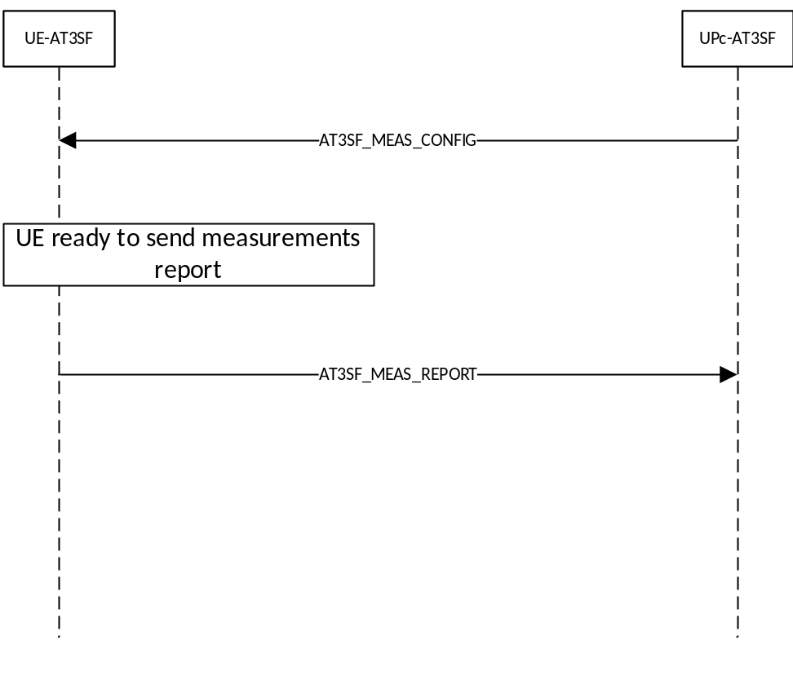
Figure 6.1.5.3-1: UE-AT3SF Measurement configuration and reporting procedure
What information should be included in the traffic reports and how they are measured?
UPc-AT3SF configures UE-AT3SF with the different parameters (e.g. radio link information) and the associated thresholds at which the reports shall be generated. The AT3SF_MEAS_CONFIG contains the Connection type (e.g. WLAN, 5G-NA, etc.) and a set of parameters specific to each connection type and a timer value during which the measured values should fulfil the threshold conditions before the measurement report.
When the connection type is 5G-AN the following threshold parameters may be provided:
a. The RSRP threshold (in dBm), both low and high;
b. The RSRQ threshold (in dBm), both low and high.
When the connection type is WLAN the following threshold parameters may be provided:
a. The WLAN channel utilization (BSS load) threshold, both low and high.
b. The downlink backhaul available bandwidth threshold, both low and high.
c. The uplink backhaul available bandwidth threshold, both low and high.
d. The beacon RSSI threshold, both low and high.
Each measurement report (AT3SF_MEAS_REPORT) includes the connection type together with a set of measured parameters.
When the connection type is 5G-AN the measured parameters are:
a. The RSRP value (in dBm) of serving 5G-AN;
b. The RSRQ value (in dBm) of serving 5G-AN.
When the connection type is WLAN the following threshold parameters may be provided:
a. The WLAN channel utilization (BSS load).
b. The downlink backhaul available bandwidth.
c. The uplink backhaul available bandwidth.
d. The average beacon RSSI.

6.1.5.4 Round Trip Time (RTT) Evaluation Procedure
This procedure is executed under the control of the UPc-AT3SF on the access for which RTT is to be evaluated. The UPc-AT3SF sends a PING_REQ to the terminal over the chosen access. The terminal device is expected to answer as soon as possible with a PING_REQ that carries the same identifier that was received in the PING_REQ. On the receive of the PING_RESP, the UPc-AT3SF determines the updated value of the RTT of the associated link. The procedure to determine the updated value of the UPc-AT3SF it is left to the UPc-AT3SF implementation. The RTT evaluation procedure is described in Figure 6.1.5.4-1.
It is left to implementation the type of QoS to be applied to the messages being used.
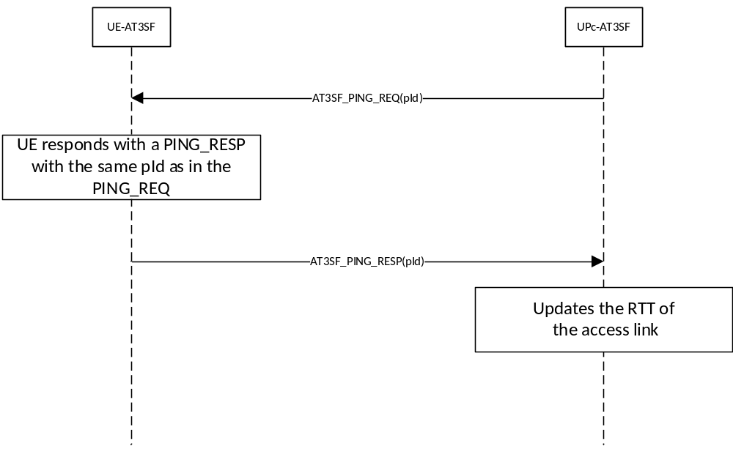
Figure 6.1.5.4-1: UE-AT3SF RTT evaluation procedure

6.1.6 Control Plane Protocol Stack between UE-AT3SF and UPc-AT3SF
The connection between the UE-AT3SF and the UPc-AT3SF is assumed to be secure over both non-3GPP access as well as over the 3GPP access. Multi Access Control Management (MACM) is responsible to implement the exchange of control plane messages between the UE-AT3SF and UPc-AT3SF.
The following protocol stack is used for the control message exchange between UE-AT3SF and the UPc-AT3SF. The messages are carried over UDP in IP between MACM on UE-AT3SF and UPc-AT3SF as it is shown in Figure 6.1.3-1 independent of the access ( 5G-AN, non-3gpp access, etc.).
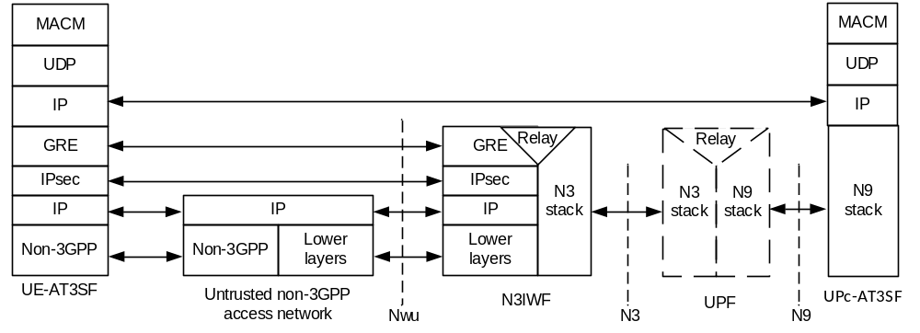
a: UDP based Control Plane Protocol Stack over non-3GPP access
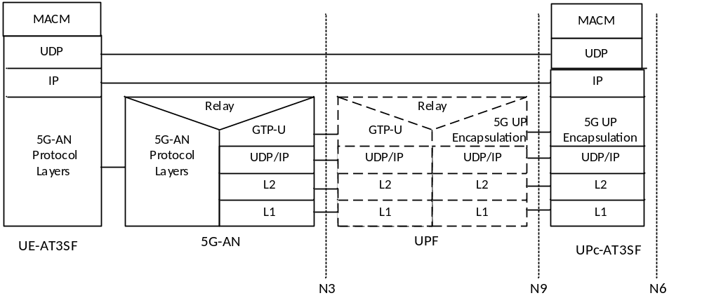
b: UDP based Control Plane Protocol Stack over 5G-AN
Figure 6.1.6-1: Control Plane Protocol Stack between UE-AT3SF and UPc-AT3SF

6.1.7 User Plane Protocol Stack options between UE-AT3SF and UPu-AT3SF
Multiple access methods are available between the UE-AT3SF and the UPu-AT3SF. This methods are negotiated between the two peers.

6.1.7.1 User Plane Convergence Method based on NULL Tunneling
This methods allows traffic aggregation over the available accesses at the level of an IP flow. This solution guarantees that at any moment in time there are no packets of the same fully specified IP flow over both available accesses. This solution does not require any reordering on the receiving side while still allows aggregation of traffic over both accesses at an IP flow level.
The associated user plane protocol stack is shown in Figure 6.1.7.1-1.
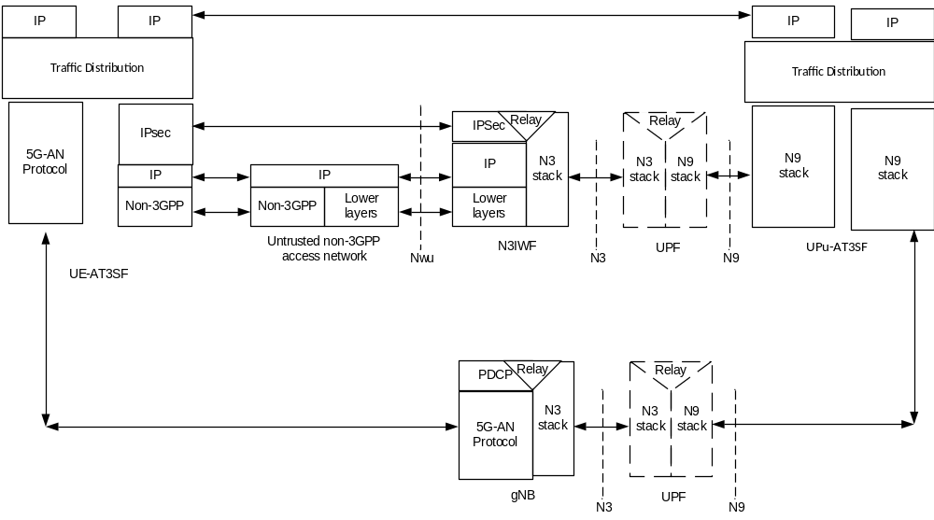
Figure 6.1.7.1-1: User Plane Protocol Stack with NULL tunnel between UE-AT3SF and UPu-AT3SF

6.1.7.1.5 Traffic Distribution
In this solution the UPu-AT3SF or the UE distributes the traffic based on ATSSS rules implementing different policies described in Section 6.1.4.
The downstream traffic is hashed on a flow basis using a hash function based on the 5tuple. All packets of the same flow are sent over the same access to avoid reordering. As a result on the receiving of a downlink packet at the UPu-AT3SF a hash function is computed using the 5 tuple to identify the associated entry of the flow in a lookup table. If the entry indicates that another packet of the same flow was processed less than 2*RTT ago, then the packet is going to be sent on the same access as the previous packet of this flow and update the time value of its entry in the lookup table. If there is no packet of this flow that was processed for this flow in the laast 2*RTT interval, then the UPu-AT3SF decides the outgoing access based on the associated ATSSS policy for this flow.
On the UE side a potential implementation would allow the UE to decide the access to be used for a UL packet by using the same access on which it received packets of the same flow. In order to avoid packet reordering at the UPu-AT3SF side, the packet of the same flow may use a different access only if there is no packet of the same flow sent over the other access in the last 2*RTT.

6.1.7.1.6 MTU considerations
This solution does not introduces any extra requirements on the MTU or fragmentation issues on the path from the UE to the UPu-AT3SF as it makes use of the existent transport over each access with no changes.

6.1.7.2 User Plane Convergence Method based on GRE tunneling
This method allows transport of the PDN PDUs across both accesses in a GRE Tunnel. The GRE tunnels are setup over both accesses between the UE-AT3SF and UPu-AT3SF using the control plane signalling between the UE-AT3SF and UPc-AT3SF.
This method allows in order PDN PDUs delivery and it may be applied to any PDN type.
The associated user plane protocol stack is shown in Figure 6.1.7.2-1.
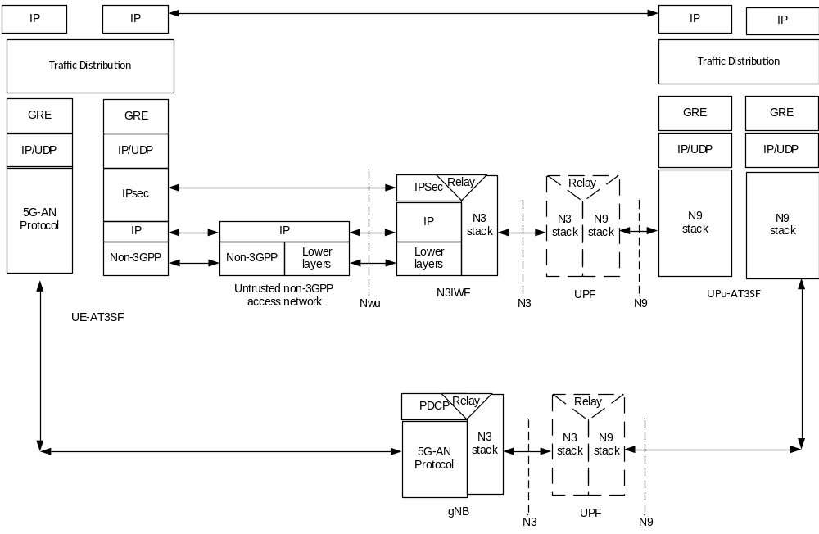
Figure 6.1.7.2-1: User Plane Protocol Stack with GRE tunnel between UE-AT3SF and UPu-AT3SF

6.1.7.3 User Plane Convergence Method using L3 Generic Multi-Access Solutions (GMA)
This method allows transport of the PDN PDUs across both accesses between the UE-AT3SF and UPu-AT3SF, which supports trailer-based GMA convergence protocol sublayer below traffic distribution.
This GMA convergence method avoids the use of IP-over-IP tunnelling solution (GRE), and the GMA protocol appends a trailer with control information which is used to carry necessary info, e.g. Sequence Number, for IP packets splitting and reordering, etc.
To apply GMA protocol, the original Protocol Type value of the IP packet is stored in the GMA trailer and Protocol Type field of the IP header can be set to a special value as an indication of the presence of the GMA trailer, Length field and Checksum field in the IP header are recalculated with the GMA trailer.
This method allows in order PDN PDUs delivery and it may be applied to any PDN type.
The associated user plane protocol stack is shown in Figure 6.1.7.3-1.
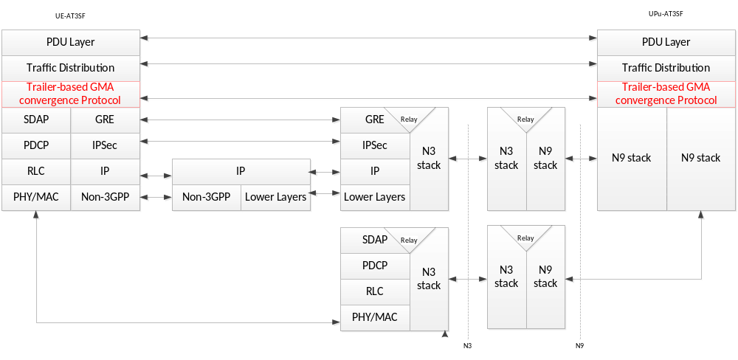
Figure 6.1.7.3-1: User Plane Protocol Stack with Trailer-based GMA protocol between UE-AT3SF and UPu-AT3SF

6.1.7.4 User Plane Convergence Method using L4 Multipath Solutions (MP-TCP, MP-QUIC, SCTP, UDP generic)
This method allows transport of the IP PDUs across both accesses between the UE-AT3SF and UPu-AT3SF. It uses a Layer 4 multipath transport service enabling IP flows to use multiple paths simultaneously.
The L4 multipath transport service may use either MPTCP, MP-QUIC, SCTP or UDP generic. MP-TCP sets up multiple TCP subflows over the different access networks, MP-QUIC several UDP flows, SCTP several SCTP flows and the UDP generic approach several UDP flows. UE-AT3SF and UP-AT3SF are responsible for managing the MP-TCP/MP-QUIC Hybrid Access paths, including establishment and tear down.
The peers may terminate the end user layer 4 sessions before transporting the data over the access paths, effectively executing a proxy function for these end user sessions.
One or more IP addresses may be allocated, if needed, on the UPFu-AT3SF to differentiate between the flows over both accesses. Other mechanisms to provide such a differentiation are precluded. The subsequent assigned IP addresses are pushed to the peers of the layer 4 sessions using internal messages of either MP-TCP, MP-QUIC, SCTP or UDP generic (e.g. ADD_ADDRESS for MP-TCP).
The associated user plane protocol stack is shown in Figure 6.1.7.4-1.
a) MPTCP transport.
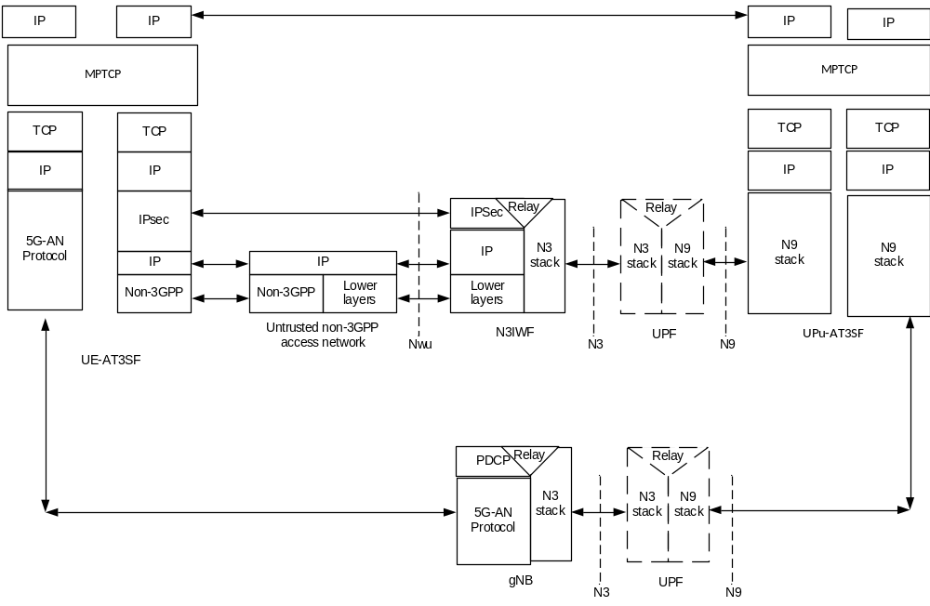
Figure 6.1.7.4-1a: User Plane Protocol Stack with L4 Multipath between UE-AT3SF and UPu-AT3SF
b) MP-QUIC transport.
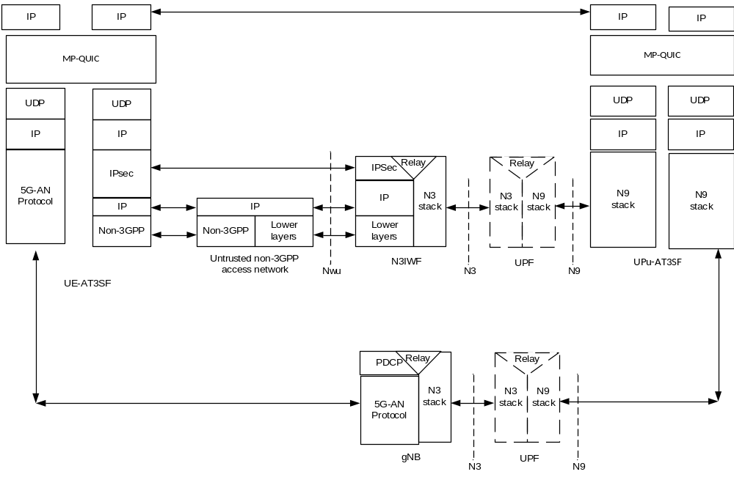
Figure 6.1.7.4-1b: User Plane Protocol Stack with L4 Multipath between UE-AT3SF and UPu-AT3SF
c) SCTP transport.
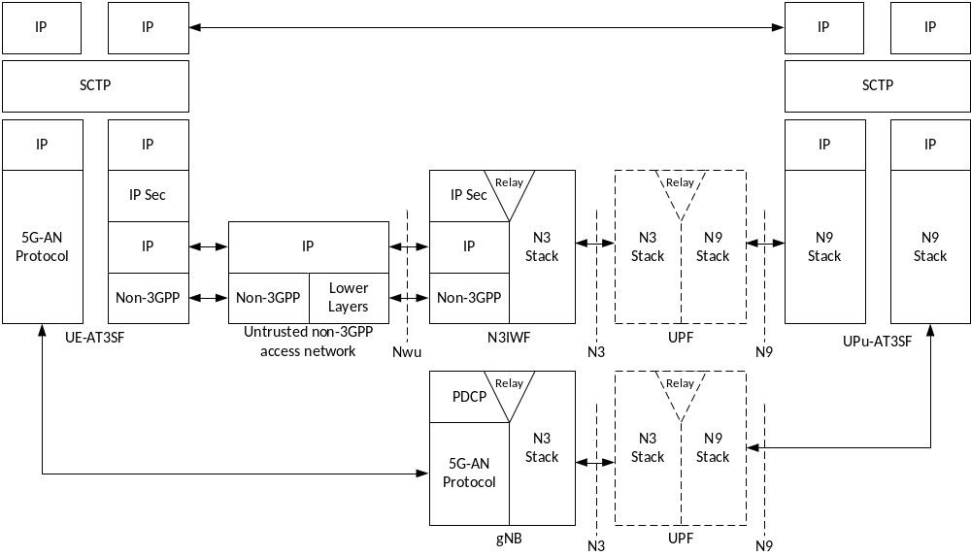
Figure 6.1.7.4-1c: User Plane Protocol Stack with L4 Multipath between UE-AT3SF and UPu-AT3SF
d) UDP generic transport.
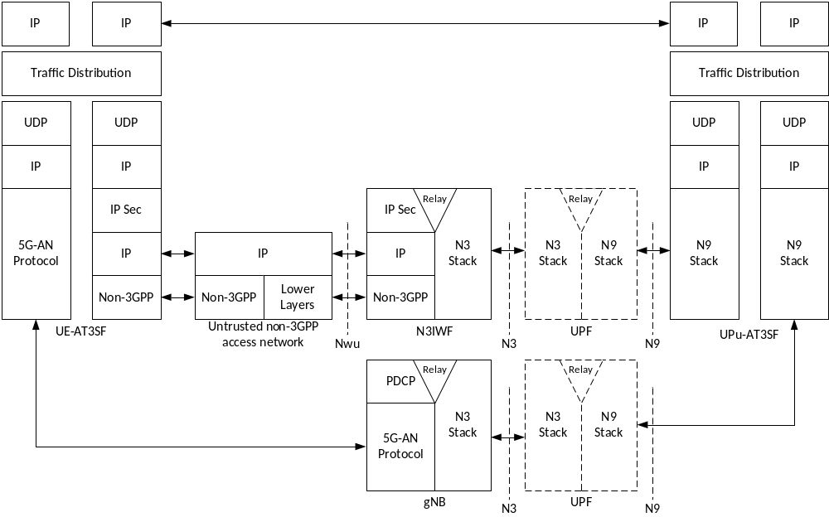
Figure 6.1.7.4-1d: User Plane Protocol Stack with L4 Multipath between UE-AT3SF and UPu-AT3SF

6.1.7.4.1 Traffic distribution with MP-TCP

6.1.7.4.1.1 Traffic distribution over multi access using MP-TCP tunnel between the UE and UPu-AT3SF
In this mode of operation MP-TCP is used as a tunnelling transport between the UE-AT3SF and UPu-AT3SF. This solution enables different flows (eg: IP flows) to/from the UE to use multiple paths between UE-AT3SF and UPu-AT3SF. The MP-TCP multipath service between UE-AT3SF and UPu-AT3SF may set up multiple TCP subflows over the different accesses and uses the real time flow control mechanism natively provided for each TCP subflow. The MP-TCP service provides packet reordering at each side and it guarantees reliable in order packet delivery for both DL and UL traffic.

6.1.7.4.1.1.1 Usability
This solution can be used for any PDN type and it guarantees in order reliable packet delivery between UE-AT3SF and UPu-AT3SF. Because of the reordering procedure at the end nodes of the MPTCP tunnel, this solution may not be suitable for real time traffic with tight latency requirements.

6.1.7.4.1.1.2 IP addressing
In this solution the UE-AT3SF is assigned with the IP address values to be used over each access. The UPu-AT3SF makes use of a single IP address for the MP-TCP tunnel. These IP address values are provided to the UE-AT3SF by the UPc-AT3SF.

6.1.7.4.1.2 Traffic distribution over multi access using MP-TCP proxy at UPu-AT3SF.
This solution applies only to the IP type PDNs and addresses TCP traffic only. The UE-AT3SF is using MP-TCP layer functionality available at the UE.

6.1.7.4.1.2.1 Usability
This solution applies to TCP traffic flows only. The TCP flows that are aggregated over both access are identified at the UE using ATSSS rules.

6.1.7.4.1.2.2 IP addressing
Same as in 6.1.7.4.1.1.2.

6.1.7.4.2 Traffic distribution with MP-QUIC

6.1.7.4.2.1 Traffic distribution over multi access using MP-QUIC tunnel between the UE and UPu-AT3SF
In this mode of operation MP-QUIC is used as a tunnelling transport between the UE-AT3SF and UPu-AT3SF. This solution enables different flows (e.g. IP flows) to use multiple paths between UE-AT3SF and UPu-AT3SF. The MP-QUIC multipath service between UE-AT3SF and UPu-AT3SF sets up multiple encrypted streams over the different accesses. The MP-QUIC service provides packet reordering at each side and it also guarantees reliable in order packet delivery for both DL and UL traffic.

6.1.7.4.2.1.1 Usability
This solution can be used for any PDN type and it guarantees in order reliable packet delivery between UE-AT3SF and UPu-AT3SF. Because of the reordering procedure at the end nodes of the MP-QUIC tunnel, this solution may not be suitable for real time traffic with tight latency requirements.

6.1.7.4.2.1.2 IP addressing
In this solution the UE-AT3SF is assigned with the IP address values to be used over each access. The UPu-AT3SF makes use of a single IP address for the MP-QUIC tunnel. These IP address values are provided to the UE-AT3SF by the UPc-AT3SF.

6.1.8 Impacts On Existing Entities and Interfaces
This solution will impact the following entities in 5GS:
- SMF.
- PCF.
- UDM.
- UPF.
- UE.
Editor's note: The impact on existing entities and interfaces is FFS.

6.2 Solution 2: Support of Multi-Access PDU Sessions

6.2.1 General
A Multi-Access PDU (MA-PDU) session is created by bundling together two separate PDU sessions, which are established over different accesses.
An MA-PDU session is schematically illustrated in the figure below. It is composed of two PDU sessions, referred to as "child PDU sessions"; one established over 3GPP access and the other established over untrusted non-3GPP access (e.g. a WLAN AN).
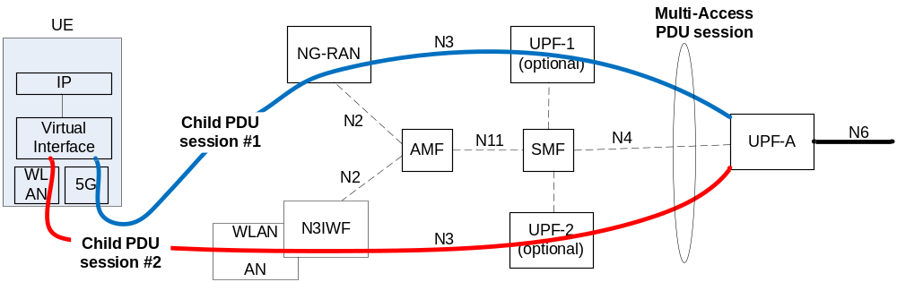
Figure 6.2.1-1: Illustration of a Multi-Access PDU session with two child PDU sessions
The child PDU sessions of a MA-PDU session share the following characteristics:
(i) a common DNN;
(ii) a common UPF anchor (UPF-A);
(iii) a common PDU type (e.g. IPv6);
(iv) common IP address(es);
(v) a common SSC mode; and
(vi) a common S-NSSAI.
An MA-PDU session realizes a multi-path data link between the UE and an UPF-A, as shown in the figure 6.2.1-1. It operates below the IP layer and it is transparent to the IP layer and all layers above the IP layer.
As discussed in the next clause, a MA-PDU session can be established with one of the following procedures:
(i) Established with two separate PDU session establishment procedures; one of each child PDU session. This is called "separate establishment".
(ii) Established with a single MA-PDU session establishment procedure, where the two child PDU sessions are established in parallel. This is called "combined establishment".
The child PDU sessions established with any of the above procedures have the same IP address.
After a MA-PDU session is established, SM signalling related to this MA-PDU session (e.g. for modification or removal of a child PDU session, etc.) can be conducted over any of the available accesses of the MA-PDU session.
It is expected that the UE discovers the support of ATSSS for a PDU session upon attempting to establish the MA-PDU session.
The UE may determine to establish a Multi-Access PDU session based on
- The configured policy in the UE may indicate whether multi-access is preferred when a PDU session is triggered;
Editor's note: Any other information (e.g. network support of MA-PDU per S-NSSAI or per DNN) is FFS.

6.2.2 Establishment of Multi-Access PDU session with multiple PDU Session IDs

6.2.2.1 Separate Establishment
In this case, the two child PDU sessions are established with two separate PDU session establishment procedures. For instance, the UE may establish first the PDU session over 3GPP access and, later, after it connects to a WLAN and establishes a signalling IPsec SA with the N3IWF, the UE may establish also the PDU session over non-3GPP access. The two PDU sessions are linked together and they become child PDU sessions of a MA-PDU session.
To support the separate establishment, the existing "UE Requested PDU session establishment" procedure, as specified in TS 23.502, clause 4.3.2.2, can be used for each child PDU session. However, when the second child PDU session is established, then:
- A "linked" PDU session should be provided to 5GC that refers to an existing PDU session. The 5GC shall link the second PDU session with the referred "linked" PDU session and designate them as child PDU sessions of the same MA-PDU session.
- Since a "linked" PDU session is provided to 5GC, there is no need for the UE to request specific values for the DNN, S-NSSAI, SSC Mode, PDU type, etc. The second PDU session shall inherit all these values from the "linked" PDU session.
- The Request Type could indicate "Initial Request". When the 5GC receives a PDU Session Establishment Request with a "linked" PDU and with Request Type="Initial Request", then the 5GC interprets that as a request create a MA-PDU session by linking the requested PDU session with the existing "linked" PDU session. Alternatively, a new Request Type could be specified if the "Initial Request" is not appropriate.
Editor's note: Additional changes to the existing "UE Requested PDU session establishment" procedure are FFS.

6.2.2.2 Combined Establishment
In this case, the two child PDU sessions are established in parallel with a single procedure called "UE Requested MA-PDU session establishment" procedure. This is useful when the UE decides to establish an MA-PDU session while it is already registered to 5GC via both accesses. Instead of the UE initiating two separate PDU session establishment procedures, the UE initiates one MA-PDU session establishment procedure which results in the establishment of two child PDU sessions. The key advantage of the MA-PDU session establishment (versus the separate establishment of two PDU sessions) is less signalling over the air interface, less signalling over network interfaces, as well as fewer procedures in the UE and, thus, less battery consumption.
Editor's note: The advantages of the combined establishment versus the separate establishment should be further analyzed, considering also failure scenarios.
The figure below shows a high-level procedure of the combined establishment, i.e. it shows a "UE Requested MA-PDU session establishment" procedure.
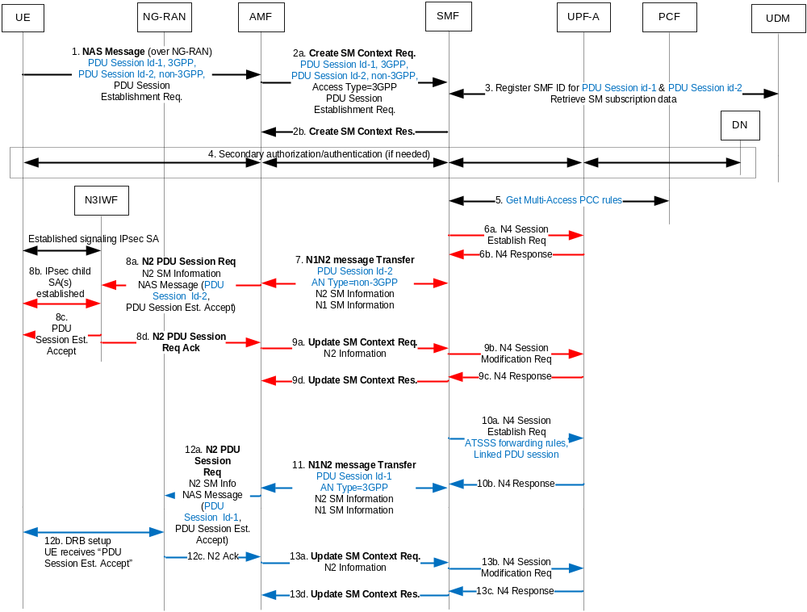
Figure 6.2.2.2-1: Overview of the UE Requested MA-PDU Session Establishment
1. The UE initiates the "UE Requested PDU Session Establishment" procedure as specified in TS 23.502 [6], clause 4.3.2.2, but it provides two different PDU Session Ids: one for the child PDU session over 3GPP access (PDU session Id-1) and another for the child PDU session over non-3GPP access (PDU session Id-2). The Request Type indicates "Initial request".
Editor's note: It is FFS if it is better to provide a single PDU session Id (instead of two) and an MA-PDU indicator.
2. The AMF selects an SMF and sends to SMF an Nsmf_PDUSession_CreateSMContext Request containing both PDU session ids and their associated AN types.
3. The SMF registers with the UDM and indicates that it handles both PDU session Id-1 and PDU session Id-2.
4. If needed, the secondary authorization/authentication procedure takes place, as specified in TS 23.502, clause 4.3.2.3.
5. If dynamic PCC is deployed, the SMF selects a PCF and retrieves the default Multi-Access PCC rules from PCF. The Multi-Access PCC rules include QoS rules for each child PDU session and include ATSSS rules that indicate how traffic within the MA-PDU session should be routed across the two child PDU sessions. Different QoS flows may be assigned to the child PDU sessions established over different accesses.
6-9. The user-plane of the child PDU session over untrusted non-3GPP access is established.
- In step 7 the SMF indicates to AMF that the transfer of N1/N2 information should take place over non-3GPP access.
- In step 8 the normal steps of an N2 PDU session establishment over untrusted non-3GPP access are carried out. The UE receives a PDU Session Establishment Accept message containing the PDU session Id-2 and, thus, the UE determines that the child PDU session over non-3GPP access is established. The UE receives also the default QoS rules to be applied over non-3GPP access.
10-13. The user-plane of the child PDU session over 3GPP access is established.
- In step 10 the SMF provides a "linked PDU session" identity to UPF so that the UPF links this PDU session with the one established in step 6. The UPF considers both PDU sessions as part of the same MA-PDU session. The SMF also provides ATSSS forwarding rules to UPF that indicate how downlink traffic should be routed across the two child PDU sessions. The ATSSS forwarding rules are derived based on the Multi-Access PCC rules provided by PCF.
- In step 11 the SMF indicates to AMF that the transfer of N1/N2 information should take place over 3GPP access.
- In step 12 the normal steps of an N2 PDU session establishment over 3GPP access are carried out. The UE receives a PDU Session Establishment Accept message containing the PDU session Id-1 and, thus, the UE determines that the child PDU session over 3GPP access is established. The UE receives also the default QoS rules to be applied over 3GPP access.
- In addition, in step 12 the UE may receive ATSSS forwarding rules that indicate how uplink traffic should be routed across the two child PDU sessions.
NOTE: The steps 6-9 and 10-13 in the figure 6.2.2.2-1 (i.e. the two N2 PDU Session Establishment procedures) can be executed in parallel.
Editor's note: It is FFS whether it is better to send one PDU Session Establishment Accept message to UE instead of two, as depicted above in steps 8c and 12b.
Editor's note: Further details of the "UE Requested MA-PDU session establishment" procedure (including PCC, QoS, handover and user-plane aspects) are FFS.

6.2.3 Establishment of Multi-Access PDU session with a single PDU Session ID

6.2.3.1 Separate Establishment
In this case, the two child PDU sessions are established with two separate PDU session establishment procedures. For instance, the UE may establish first the PDU session over 3GPP access and, later, after it connects to a WLAN and establishes a signalling IPsec SA with the N3IWF, the UE may establish also the PDU session over non-3GPP access.
To support the separate establishment, the existing "UE Requested PDU session establishment" procedure, as specified in TS 23.502, clause 4.3.2.2, can be used for each child PDU session. However, when the second child PDU session is established, then:
- A PDU Session ID should be provided to 5GC in the PDU Session ID IE that refers to an existing PDU session. The 5GC shall link the second PDU session with the referred PDU session identified by the PDU Session ID and designate them as child PDU sessions of the same MA-PDU session.
- The PDU Session Establishment Request message should include an MA-PDU Request flag and Request Type="Existing PDU Session". When the 5GC receives this PDU Session Establishment Request, the 5GC interprets that as a request to create a MA-PDU session by linking the requested PDU session with the existing PDU session.
An overview of the separate establishment procedure for a MA-PDU session is shown in the figure below. In this figure, the child PDU session over 3GPP access is established first and the child PDU session over non-3GPP is added subsequently (e.g. after the UE connects to an untrusted non-3GPP access network).
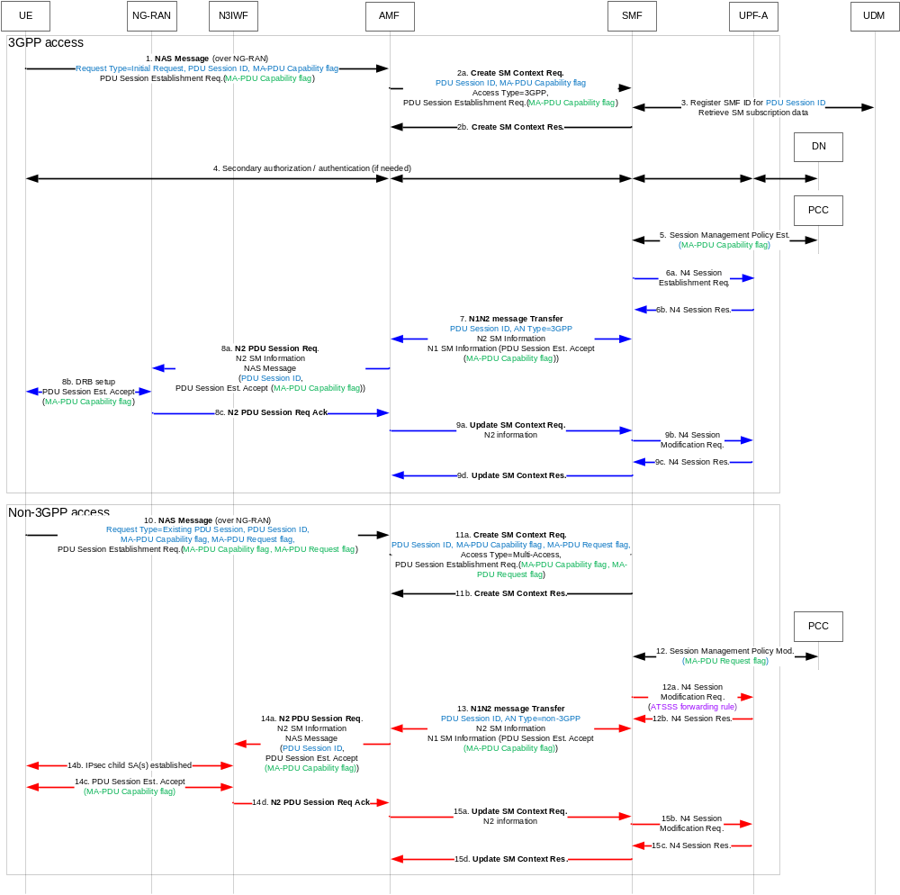
Figure 6.2.3.1-1: Overview of the UE Requested MA-PDU Session Establishment (Separate Establishment)
0. If the UE is not registered via 3GPP access, the UE initiates Registration procedure via 3GPP access as described in TS 23.502 [6].
1. The UE sends a PDU Session Establishment Request message with a new PDU Session ID and Request Type = "initial request". The UE also includes an MA-PDU Capability flag to indicate to the network that it can support MA-PDU sessions.
2. The AMF selects an SMF as described in clause 4.3.2.2.3. In this step, the AMF stores Access Type of the PDU Session = "3GPP access". When the AMF received the MA-PDU Capability flag and it supports MA-PDU sessions, it includes an MA-PDU Capability flag in the Nsmf_PDUSession_CreateSMContext Request message sent to SMF.
3. The SMF registers with the UDM.
4. If needed, the secondary authorization/authentication procedure takes place, as specified in TS 23.502, clause 4.3.2.3.
5. If the UE has sent an MA-PDU Capability flag and both the AMF and the SMF support MA-PDU sessions, the SMF sends an MA-PDU Capability flag to PCF when it performs Session Management Policy Establishment procedure. The PCF decides whether the MA-PDU session is allowed or not based on operator policy and subscription.
6-9. If the PCF permits the use of MA-PDU procedures for the requested PDU session (e.g. to later establish another child PDU over non-3GPP access), the SMF sends a PDU Session Establishment Accept message with a MA-PDU Capability flag to inform the UE that the network can support MA-PDU procedures for this PDU session. Otherwise, the SMF may accept the PDU Session establishment but does not include the MA-PDU Capability flag in the PDU Session Establishment Accept message.
If the MA-PDU Capability flag is received by the UE, the UE may later add another child PDU session to the existing PDU session with the steps below.
10. If the UE is not registered via non-3GPP access, the UE initiates Registration via non-3GPP access as described in TS 23.502 [6]. The UE sends PDU Session Establishment Request message with PDU Session ID allocated in step 1, Request Type = "Existing PDU Session", MA-PDU Request flag and includes the same PDU Session parameters (e.g. S-NSSAI, DNN, PDU Session Type, SSC mode, PDU Session ID) used with the PDU Session established via 3GPP access. In the MM NAS message, the UE includes MA-PDU Request flag.
11. The AMF selects the same SMF selected in step 2 based on Request Type = "Existing PDU Session". In this step, the AMF updates the Access Type of the PDU Session to "Multi-Access". When the AMF received MA-PDU Capability flag and it support MA-PDU sessions, it includes MA-PDU Capability flag in the Nsmf_PDUSession_CreateSMContext Request message sent to SMF.
NOTE: The AMF may reject this request if the AMF cannot select the same SMF, e.g. 3GPP PDU Session is established as a roaming with LBO but the UE is registered in HPLMN via non-3GPP access.
12. If the UE has sent an MA-PDU Request flag and the AMF and the SMF supports MA-PDU sessions, the SMF sends an MA-PDU Request flag and associated access information to PCF when it performs Session Management Policy Modification procedure. The PCF decides whether the requested PDU session can be added to the existing PDU session based on operator policy and subscription.
When the SMF performs N4 modification, the SMF includes MA-PDU Request flag to indicate that the PDU Session is a MA-PDU session.
13-15. If the PCF did not permit the establishment of a MA-PDU Session, the SMF rejects the PDU session establishment request sent by the UE over non-3GPP access.

6.2.3.2 Combined Establishment
In this case, the two child PDU sessions are established in parallel with a single procedure called "UE Requested MA-PDU session establishment" procedure. This is useful when the UE decides to establish an MA-PDU session while it is already registered to 5GC via both accesses in the same PLMN. If a UE is registered to different PLMNs over 3GPP and non-3GPP accesses, the UE shall not use this procedure. Such UE can use the Separate Establishment procedure described in clause 6.2.2.1.
Instead of the UE initiating two separate PDU session establishment procedures, the UE initiates one MA-PDU session establishment procedure which results in the establishment of two child PDU sessions. The key advantage of the MA-PDU session establishment (versus the separate establishment of two PDU sessions) is less signalling over the air interface, less signalling over network interfaces, as well as fewer procedures in the UE and, thus, less battery consumption.
Editor's note: The advantages of the combined establishment versus the separate establishment should be further analyzed, considering also failure scenarios.
The figure below shows a high-level procedure of the combined establishment, i.e. it shows a "UE Requested MA-PDU session establishment" procedure.
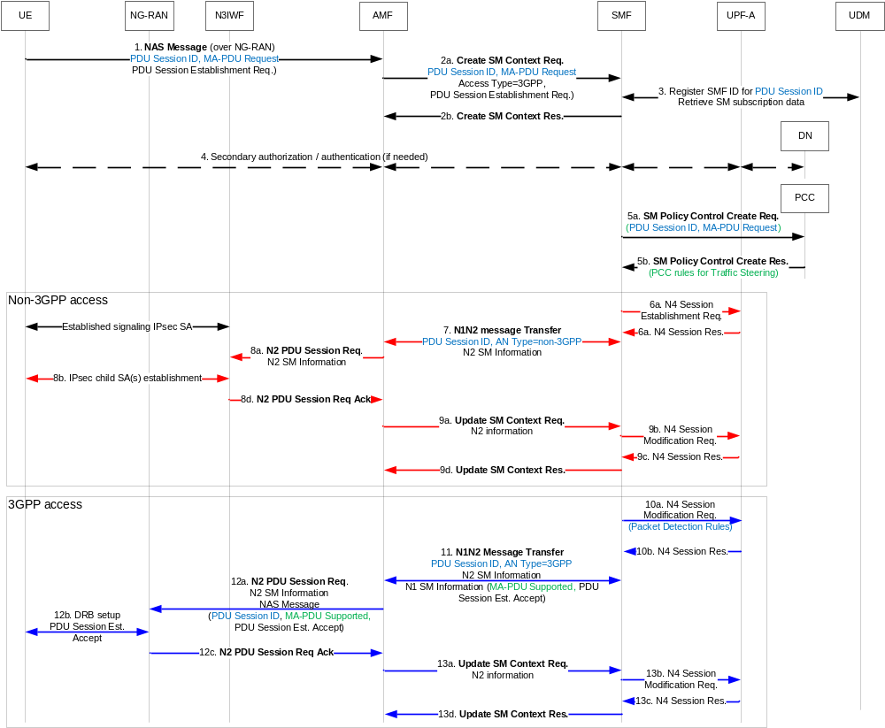
Figure 6.2.3.2-1: Overview of the UE Requested MA-PDU Session Establishment (Combined Establishment)
0. The UE is Registered via 3GPP access and non-3GPP access in the same PLMN and the allowed NSSAIs received over the two accesses overlap (i.e. there is at least one S-NSSAI allowed on both accesses).
1. The UE initiates the "UE Requested PDU Session Establishment" procedure as specified in TS 23.502 [6], clause 4.3.2.2, and sends a NAS UL Transport message that includes a single PDU Session ID, Request Type = "initial request", a MA-PDU Request indication and a PDU Session Establishment Request. The MA-PDU Request indication and the Request Type = "initial request", indicates that this PDU Session Establishment Request is to establish a Multi-Access PDU Session using a Combined Establishment procedure. If the UE requests an S-NSSAI, it shall request an S-NSSAI that is allowed on both accesses.
2. The AMF selects an SMF and sends to SMF an Nsmf_PDUSession_CreateSMContext Request. If the AMF received the MA-PDU Request indication and it supports MA-PDU sessions, it includes the MA-PDU Request indication in the Nsmf_PDUSession_CreateSMContext Request message sent to the SMF.
If the AMF receives an initial request message with MA-PDU Request flag but the UE is registered via only one access, or the requested S-NSSAI is not allowed on both accesses, the AMF rejects the UE request.
3. The SMF registers with the UDM .
4. If needed, the secondary authorization/authentication procedure takes place, as specified in TS 23.502, clause 4.3.2.3.
5. If dynamic PCC is deployed, the UE sent the MA-PDU Request indication, and both the AMF and the SMF support MA-PDU sessions, then the SMF sends an MA-PDU Request indication and associated access information to PCF in the SM Policy Control Create message. The PCF decides whether the MA-PDU session is allowed or not based on operator policy and subscription.
The SMF receives from PCF PCC rules and the Session rule(s) (including the default QoS and the AMBR for each access) for the MA-PDU session. The PCC rules may include rules for traffic steering and QoS rules for 3GPP access and non-3GPP access . Based on the received rules for traffic steering, the SMF derives ATSSS rules for the UE that indicate how uplink traffic of the MA-PDU session should be routed across the two accesses. Different QoS flows may be assigned to the different accesses of the MA-PDU session.
6-9. The user-plane over untrusted non-3GPP access is established.
- In step 7 the SMF indicates to AMF that the transfer of N1/N2 information should take place over non-3GPP access.
- In step 8 the normal steps of an N2 PDU session establishment over untrusted non-3GPP access are carried out.
10-13. The user-plane over 3GPP access is established.
- The SMF provides the Packet Detection rules to UPF. These rules indicate how the downlink traffic of the MA-PDU session should be routed across the two accesses. The Packet Detection rules are derived based on the PCC rules for traffic steering provided by PCF.
- In step 11 the SMF indicates to AMF that the transfer of N1/N2 information should take place over 3GPP access. The SMF include MA-PDU Supported indication to the N1N2 Message Transfer request to indicate that the MA-PDU session is established successfully.
- In step 12 the normal steps of an N2 PDU session establishment over 3GPP access are carried out. The UE receives a PDU Session Establishment Accept, the PDU Session ID, and the MA-PDU Supported indication. The UE determines that the MA-PDU session is established successfully when it receives the MA-PDU Capability flag and user-plane resources on both accesses have been established.
- In addition, in step 12 the UE may receive the ATSSS rules derived by SMF that indicate how uplink traffic should be routed across the two accesses.

6.2.4 NW-Requested MA-PDU Session Establishment
In some scenarios, it would be beneficial for 5GC to decide that a single-access PDU session requested by the UE should be established as a multi-access PDU session (assuming that the UE is registered over 3GPP and non-3GPP accesses to the same PLMN). This decision may be made when e.g. the SMF wants to offload some traffic of the requested PDU session to non-3GPP access. For example, when the UE requests to establish a single-access PDU session over 3GPP access to the Internet DNN, the SMF may decide to establish instead a MA-PDU session to the Internet DNN so that some Internet traffic can be offloaded to non-3GPP access.
To enable such scenarios, the procedure shown in the figure below can be used. The network elements shown in this figure and the child PDU sessions (red and blue) correspond to the network elements and the child PDU sessions shown in figure 6.2.1-1.
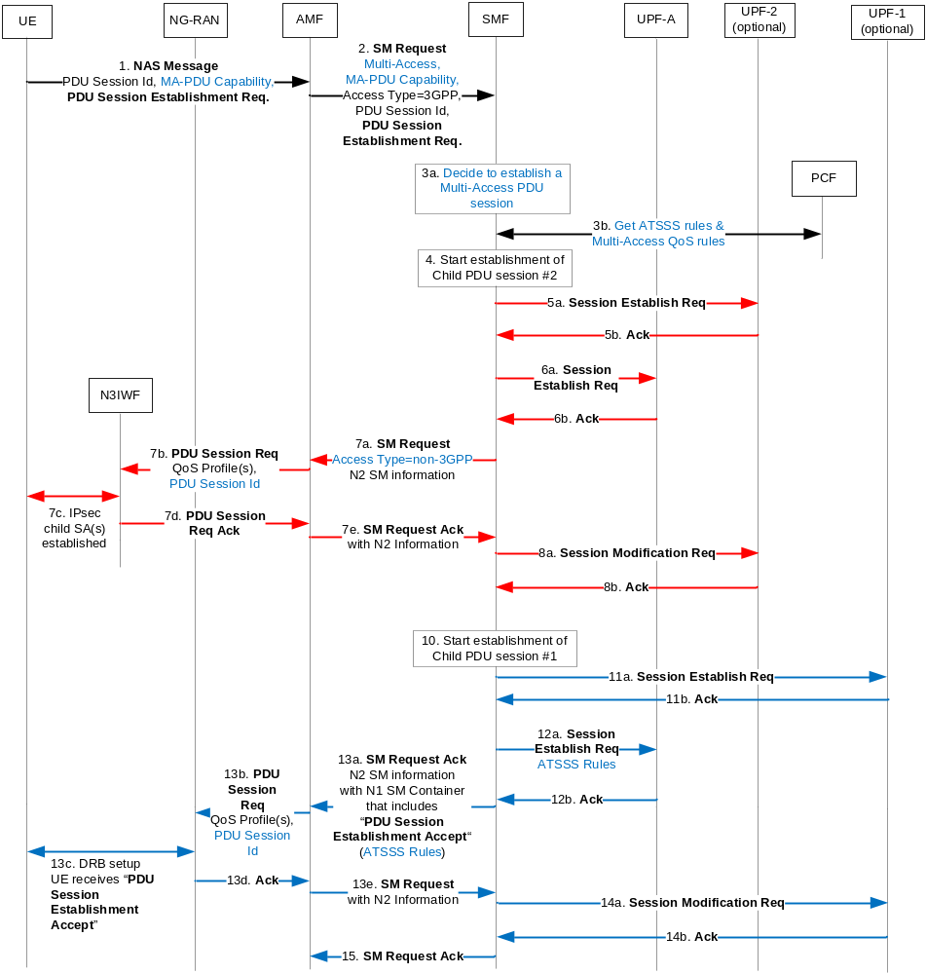
Figure 6.2.4-1: Overview of the NW-Requested MA-PDU Session Establishment
1. The UE sends over 3GPP access a NAS message to AMF in order to request a single-access PDU session over 3GPP access and provides the PDU session identity (id) and other related information, e.g. the requested DNN, the requested slice type, etc. The UE also provides a MA-PDU Capability flag to indicate that it supports MA-PDU sessions (although the UE does not request a MA-PDU session). The UE decides to request a single-access PDU session due to e.g. configured URSP rules or other information in the UE.
2. The AMF selects an SMF, sends an SM Request message to SMF and includes a Multi-Access parameter to indicate to SMF that the UE is connected both to 3GPP access and to non-3GPP access. In addition, the AMF includes a MA-PDU Capability flag to indicate to SMF that the UE and the AMF can both support MA-PDU session procedures.
Editor's note: It is FFS if the AMF should select a SMF that supports MA-PDU sessions, if the AMF knows that the UE is simultaneously registered via both accesses and the UE can support MA-PDU sessions.
3a. If the selected SMF supports MA-PDU sessions, then the SMF may decide (based on the received Multi-Access parameter and the MA-PDU Capability flag) to establish a MA-PDU session instead of the single-access PDU session requested by the UE. Before taking this decision, the SMF may interact with the UDM to determine if the UE's subscription allows the establishment of an MA-PDU session to the requested DNN. In addition, the SMF may decide to establish an MA-PDU session based on information retrieved from PCF in step 3b. In this case, the decision to establish a MA-PDU session is taken after step 3b.3b. The SMF interacts with PCF (e.g. establishes a new PDU-CAN session) and may retrieve ATSSS rules that should be applied at the UE and at the UPF anchor to determine how to steer uplink and downlink traffic respectively across the two child PDU sessions. The SMF may also retrieve from PCF multi-access QoS rules, i.e. QoS rules that should be applied over 3GPP access and QoS rules that should be applied over non-3GPP access. The PCF provides separate QoS rules for each access.
4-8. The SMF establishes a child PDU session over non-3GPP access.
In step 7b, the N3IWF receives the QoS profile(s) to be applied over non-3GPP access, each one determined from the QoS rules to be applied over non-3GPP access, provided by PCF in step 3b. In addition, in step 7b the N3IWF receives the PDU session id that was provided by UE in step 1. In step 7c, one or more child IPsec SAs are established between the UE and N3IWF. Based on the received PDU session id the UE determines that these child IPsec SAs are part of the PDU Session requested in step 1. In other words, the UE determines that the network has decided to establish a MA-PDU session instead of the requested single-access PDU session.
10-15. The SMF establishes the child PDU session over 3GPP access.
Again, based on the PDU session id received by the UE, the UE determines that the established user-plane resources over 3GPP access are part of the MA-PDU session that the network decided to establish. The UE receives a PDU Session Establishment Accept message over 3GPP access, which completes the signaling procedure for the NW-Requested MA-PDU session establishment. In step 13c, the UE receives the QoS rules for both accesses.
Editor's note: It is FFS how the UE is informed that the network has established a multi-access PDU session instead of the single-access PDU session requested by the UE. The flow above assumes that the UE is informed by receiving the same PDU session id when the user plane is established on both accesses. However, additional information may be needed, such as an indication in the PDU Session Establishment Accept message.

6.2.5 Modify a Multi-Access PDU Session to single-access PDU session
For a single session ID Multi-Access PDU session, as established through the procedure in 6.2.3, the UE or the NW may initiate PDU Session Modification procedure to turn it back to a normal single-access PDU session. This procedure may be used e.g. when the UE's Allowed NSSAI changes for one of the access types such that the UE is only allowed to have a PDU session on one of the access types. In this scenario, the UE may modify the multi-access PDU Session to a single-access PDU session to keep the session on the access (either 3GPP or non-3GPP) on which the S-NSSAI is still allowed.
Editor's note: Other use cases to modify a multi-access PDU session to single-access PDU session are FFS.
Editor's note: It is FFS whether the implicit release or network initiated release of one of the PDU session legs is possible to satisfy the scenario when the change in S-NSSAI triggers the modification of a multi-access PDU session to a single access PDU session.
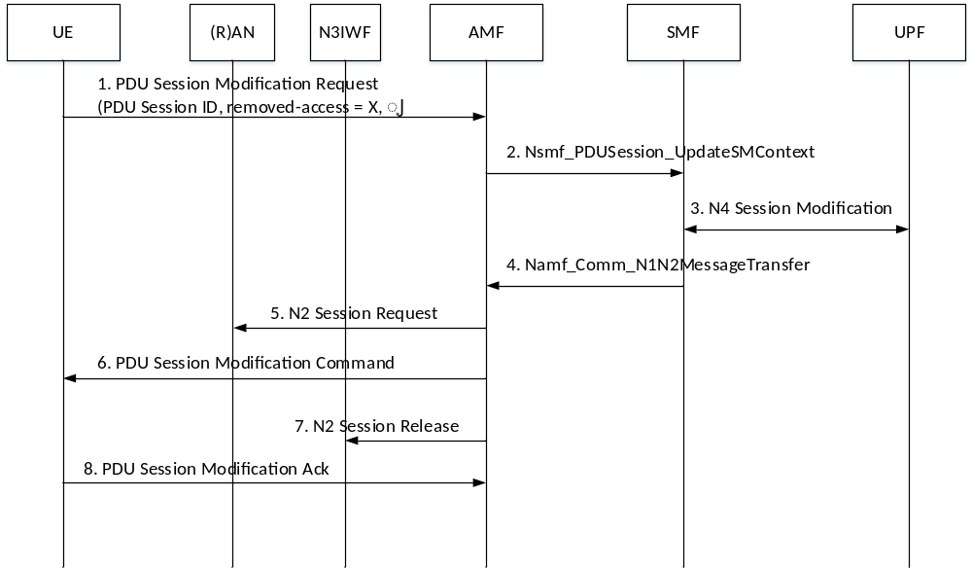
Figure 6.2.5-1: UE initiated removal of an access from Multi-Access PDU Session
1. The UE initiates the PDU Session Modification procedure to remove one access from a Multi-Access PDU Session. In the modification request the UE indicates the Session ID of the Multi-access PDU and the purpose is to remove an access leg, e.g. 3GPP access or Non-3GPP access. The modification request may be triggered by the events such as the disconnection from the access, or the performance of the access link deteriorated.
2. The AMF invokes the Nsmf_PDUSession_UpdateSMContext service of the SMF and indicates the Session ID of the Multi-access PDU and the access type that needs to be removed.
3. The SMF initiates N4 Session Modification procedure with the UPFs that are associated with the access to be removed, to switch the traffic flows to the remaining access.
4. The SMF invokes the Namf_Communication_N1N2MessageTransfer service to send the N1 message (PDU Session Modification Command) and the N2 messages (N2 Session Request for the remaining access network and N2 Session Release for the access to be removed).
5. The AMF forwards the N2 Session Request to the AN of the remaining access so the AN can reconfigure the access-specific resources.
6. The AMF forwards the PDU Session Modification Command message to the UE to align the PDU session context and reconfigure the related QoS rules, etc.
7. The AMF forwards the N2 Session Release to the AN of the access to be removed.
8. The UE acknowledges the PDU Session Modification Command.
The UE may also request the removal of Non-3GPP access through the Service Request procedure. If a Multi-access PDU Session is included in the PDU Session List to be activated and the UE determines it wants to change it to single-access PDU session, it may include a "single access" or "remove Non-3GPP access" indication for the corresponding PDU Session in the Service Request message. The rest of the procedure is similar to what is described in Figure 6.2.5-1.

6.2.6 Modification of Multi-Access PDU session
The procedure is used when the UE or the network requests access traffic Steering or Switching or Splitting between 3GPP and non-3GPP accesses by referring to the ATSSS preference. ATSSS preference is part of the ATSSS Rules and is used to indicate the preferred access type to transfer the particular data flow.
The UE or network requested MA-PDU Session Modification procedure is depicted in figure 6.2.6-1.
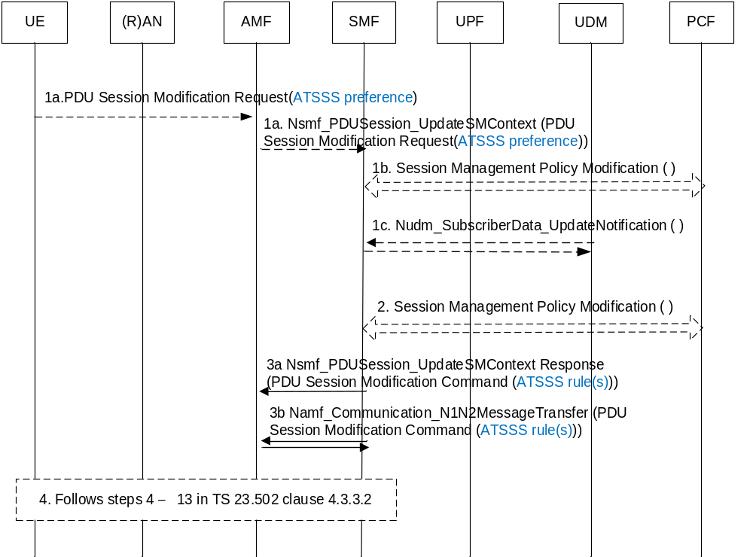
Figure 6.2.6-1: UE or network requested MA-PDU Session Modification
1. The procedure may be triggered by following events:
1a. (UE initiated modification) The UE initiates the PDU Session Modification procedure by the transmission of an NAS message (N1 SM container (PDU Session Modification Request (ATSSS preference)), PDU Session ID). The AMF invokes Nsmf_PDUSession_ UpdateSMContext (PDU Session ID, N1 SM container (PDU Session Modification Request (ATSSS preference))). The UE derives the ATSSS preference based on the ATSSS policy created by the PCF during the establishment of the MA-PDU session as defined in clause 6.4.2. In addition, the ATSSS preference may also be derived from network measurement parameters as defined in the Solution 6 or 7.
Editor's note: The exact details of ATSSS preference is FFS.
1b. (SMF requested modification) The PCF performs a PCF initiated SM Policy Association Modification procedure as defined in TS 23.502 [6] clause 4.16.5.2 to notify SMF about the modification of ATSSS policies.
1c. (SMF requested modification) The UDM updates the subscription data of SMF regarding ATSSS by Nudm_SDM_Notification (SUPI, Session Management Subscription Data). The SMF updates the Session Management Subscription Data and acknowledges the UDM by returning an Ack with (SUPI).
2. The SMF may need to report some subscribed event to the PCF by performing an SMF initiated SM Policy Association Modification procedure as defined in clause 4.16.5.1
3a. For UE initiated modification, the SMF responds to the AMF through Nsmf_PDUSession_UpdateSMContext (N2 SM information (PDU Session ID), N1 SM container (PDU Session Modification Command (PDU Session ID, ATSSS rule(s)))).
3b. For SMF requested modification, the SMF invokes Namf_Communication_N1N2MessageTransfer (N2 SM information (PDU Session ID), N1 SM container (PDU Session Modification Command (PDU Session ID, ATSSS rule(s)))).
4. Steps 4 - 13 specified in TS 23.502 [6] clause 4.3.3.2 are executed.

6.2.7 Release of a Multi-Access PDU Session
A Multi-Access PDU session may be requested by UE or 5GC to release completely or release partial resource (i.e., release one of child PDU sessions within the MA-PDU session). In a PDU session release procedure in TS 23.502 [6] clause 4.3.4 for 3GPP access and clause 4.12.7 for N3GPP access, SMF shall take care of the two resources to be release:
(a) the IP addresses/Prefixes allocated for an IP-based PDU session; and
(b) any UPF resource (including N3/N9 termination).
However, for a MA-PDU session release operations, it has two conditions:
1) An existing MA-PDU session is asked to release of one of child PDU sessions within it.
2) An existing MA-PDU session is asked to completely release all of child PDU sessions within it.
For condition 1), since UE still has at least one on-going PDU session, SMF will maintain the IP addresses/Prefixes for the UE and release the PDU session on the required access. For condition 2), since all related PDU Sessions within the MA-PDU Session needs to be released, SMF will release all resources including the IP addresses/Prefixes and any UPF resource (including N3/N9).
The current PDU Session Release procedures for 3GPP and N3GPP accesses in TS 23.502 [6] can be used to support the MA-PDU Session Release conditions (i.e., Conditions 1 and 2). However, SMF needs to take care whether all resources need to be released or partial resource needs to be released. In order not to have impact on current procedures, SMF needs to know whether the current PDU Session release request is for condition 1 or for condition 2.
In the following procedure, it is modified from clauses 4.3.4 and 4.12.7 in TS 23.502 [6].
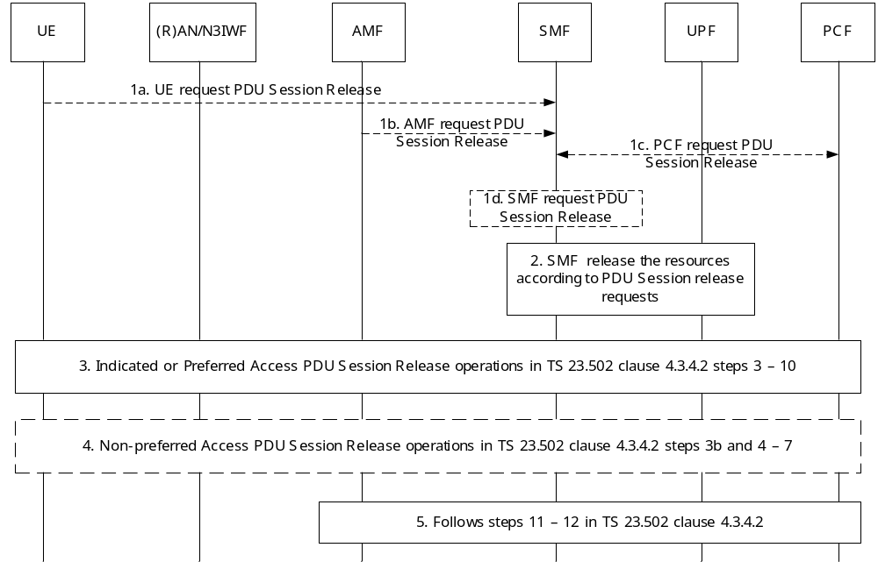
Figure 6.2.7-1: MA-PDU Session Release Procedure
1. The MA-PDU Session Release procedure is triggered by one of the following events:
1a. UE request PDU Session Release
1b. AMF request PDU Session Release
1c. PCF request PDU Session Release
1d. SMF request PDU Session Release
However, for all release requests by UE or by Network shall indicate which PDU Session ID on which Access Type within a MA-PDU Session are going to release. Access Type indicates whether the MA-PDU Session Release procedure applies to the 3GPP access, to the non-3GPP access, or to both accesses. In case of both accesses, all resources of this PDU Session will be released.
2. When SMF receives the PDU Session Release Request, it will release all resources or partial resource according to the indication from one of the events.
3. Steps 3 - 10 specified in TS 23.502 [6] clause 4.3.4.2 are executed over an access. The access can be either an indicated access (3GPP/N3GPP access) by the UE or the Network, or a preferred access (e.g., 3GPP access) in the case of both accesses in step 1. Additionally, Access Type is transferred between the AMF and the SMF to indicate the access to be released.
4. Steps 3b and 4 - 7 specified in TS 23.502 [6] clause 4.3.4.2 are executed over a non-preferred access (e.g., non-3GPP access). If Access Type is either the 3GPP access or the non-3GPP access in step 1 for the condition 1, this step is skipped. Otherwise, this step is performed over a non-preferred access in the condition 2. Access Type is also transferred between the AMF and the SMF in this step as the step 3. The "skip indicator" from the SMF tells the AMF whether it may skip sending the N1 SM container (PDU Session Release Command) to the UE.
SMF needs to generate one PDU Session Release Command message including the access type information if this MA-PDU Session is established with one single PDU Session ID described in clause 6.2.3. When UE receives this PDU Session Release Command message, it knows which access leg(s) of this MA-PDU Session it needs to perform the release operations.
5. Steps 11 - 12 specified in TS 23.502 [6] clause 4.3.4.2 are executed.

6.3 Solution 3: TFCP (Traffic Flow Control Protocol) based architecture framework for ATSSS
In terms of architecture requirements for this solution, the proposed ATSSS architecture framework.

6.3.1 Architecture framework Description
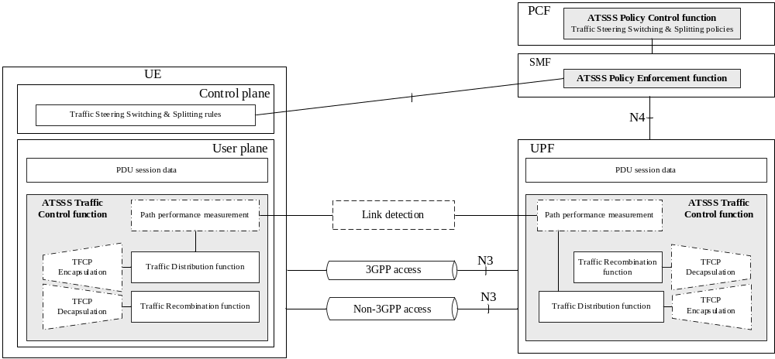
Figure 6.3.1-1: ATSSS architecture

6.3.1.1 ATSSS Policy Control function description
The ATSSS Policy Control function in PCF defines the following policies according to the application-specific information, the UE subscription data, user preference, local policy or any combination of them:
- Traffic steering policy: This rule is used to select an access when initiating a new data flow.
- Traffic switching policy: This rule is used to determine when a data flow should be moved from 3GPP to non-3GPP or vice versa.
- Traffic splitting policy: This rule is used to determine when a data flow should be split across 3GPP and non-3GPP.
The above policies may determine the appropriate access by the following principle, for example:
- Least loaded First: The least loaded path is selected to forward traffic. For example, in traffic steering policy, the least loaded path is selected to initiate a new data flow.
- Best performance First: The best performance path is selected to forward traffic, applicable for the traffic steering policy, or the traffic switching policy.
- Load balance: Traffic is split on both access paths, allowing for equal or unequal traffic distribution, e.g. based on weights.
- Traffic/Application type: Special traffic types or applications are bound to a given access path, as defined by the user or the operator.
- User location information: Traffic is steered or switched to 3GPP or non-3GPP network at the specific location, e.g. non-3GPP is provided higher priority at home or at office.
Editor's note: It is FFS if any of the above example aspects needs to be standardized.
Editor's note: Whether path performance measurement impacts the traffic distribution are FFS.
The PCF sends the PCC policy to the SMF including the ATSSS policy. As the extension of the ATSSS policy, it may include the following new parameters to PCC rule:
- Access Technology
- Routing Factor (optional)
- Second Access Technology (optional)
- Routing Factor (optional)
The presence of both access technology means that this PCC rule is applicable for both accesses. It may because this PCC rule is independent on the access technology, or it already includes both access specific rules. For example, one traffic flow can be transported via 3GPP or/and non-3GPP access, and the PCC rule such as the QoS policy or the charging policy are the same no matter what is the access technology used for this traffic, then this PCC rule can include both 3GPP and non-3GPP access technology in the ATSSS policy. Another example, if only the charging method is different for the differnet access, this PCC rule may include both charging method for 3GPP and non-3GPP separately, then this PCC rule may include both access technology in the ATSSS policy.
The Routing Factor shows the traffic distribution ratio on each access technology when both accesses are applicable for the traffic flow. It may be decided by PCF based on the character of the service. For example, the operator may want the IPTV service mainly transported via the wireline access, it then defines that the Routing Factor for wireline access is at least 80% (NOTE 1). In this way, the 3GPP access as the second access technology can provide some available resource, e.g. no more than 20% (NOTE 1), and avoid excessive traffic flow impacting on the 3GPP access, especially when the fixed access failed.
NOTE: The exact Routing Factor values do not mandate it shall be enforced based on traffic splitting per packet. For example, a Routing Factor as "3GPP access : non3GPP = no more than 20% : at least 80%" can be executed as "3GPP access : non3GPP access = 0% : 100%" if the traffic splitting per packet is not supported or enforced.

6.3.1.2 ATSSS Policy Enforcement function description
The ATSSS Policy Enforcement function in SMF is responsible for ATSSS policies enforcement and session management of all PDU sessions between 5GC and UE. Policy Enforcement function can receive the ATSSS policies from PCF via N7 and generates ATSSS rules to control the traffic by conveying ATSSS rules to UPF over N4. The Policy Enforcement function can also provide ATSSS PDU session related rules to UE during PDU session establishment and PDU session modification.
The definition of the ATSSS rule can be included in the QoS rule. For each QoS rule, it contains the QoS rule identifier, the QFI of the QoS Flow, the Packet Filter Set of the UL part of the SDF template, and the QoS rule precedence value set to the precedence value of the PCC rule from which the QoS rule is generated. The SMF creates the ATSSS rules based on the PCC rules, and add this ATSSS rule to QoS rule which is generated by the same PCC rule.
The QoS rule with the ATSSS rule extension contains the following new parameters:
- Access Technology
- Routing Factor (optional)
- Second Access Technology (optional)
- Routing Factor (optional)
The Routing Factor shows the traffic distribution ratio on each access technology, when both accesses are applicable for the traffic flows defined in the QoS rule. The execution of Routing Factor on UE is implementation specific. For example, the routing ratio can be implemented as the bandwidth value (see NOTE 1). If the Routing Factor is set to " NULL", it means the traffic splitting ratio via 3GPP and non3GPP access is flexibly decided by the UE side.
NOTE: For example, when the guaranteed bitrate=150Mbps for the packet flows, and the routing ratio= 4:1 for non-3GPP and 3GPP access, the UE could use 120Mbps via non-3GPP and 30Mbps via 3GPP. It means a traffic flow with the bandwidth no more than 30Mbps can be transported via 3GPP or non-3GPP access. A traffic flow bandwidth exceed 30Mbps can be transported via non-3GPP access or both accesses simultaneously.
Some instances for the QoS rule extension as follow:

- QoS rule ID=1  - QoS priority = A  - Operation Code = Create  - Packet Filter list  - IPaddress=10.142.15.3  - PortNumber=xx.  - QoS parameters:  - 5QI  - guaranteed bitrate =150 Mbps  - QoS flow ID: QFI=1  - ATSSS Rule :  - Access Technology =3GPP access | - QoS rule ID=2  - QoS priority = B  - Operation Code = Create  - Packet Filter list  - IPaddress=123.180.20.5  - QoS parameters:  - 5QI  - guaranteed bitrate =150 Mbps  - QoS flow ID: QFI=2  - ATSSS Rule :  - Access Technology =NG RAN  - Factor =20%  - Second Access Technology = Fixed  - Factor =80% | - QoS rule ID=3  - QoS priority = C  - Operation Code = Create  - Packet Filter list  - Application ID= Internet  - PortNumber=80.  - QoS parameters:  - 5QI  - QoS flow ID: QFI=3  - ATSSS Rule :  - Access Technology =NG RAN  - Factor =NULL  - Second Access Technology = WLAN  - Factor =NULL

NOTE 1: QoS Rule 1 and Rule 2 are applicable for GBR or non GBR flow. QoS Rule 3 is only applicable for non GBR flow. For the QoS Rule 3, the Routing Factor is flexible based on the link performance measured by UE (UL).
NOTE 2: In the traffic splitting case, QoS Rule 1 is only used for traffic splitting per traffic flow. QoS Rule 2 and QoS rule 3 can be used for traffic splitting per traffic flow or per packet.
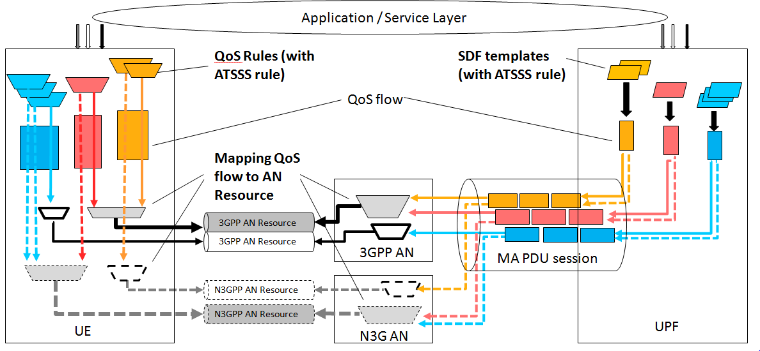
Figure 6.3.1.2-1: The traffic splitting based on the QoS rule (with ATSSS rule)
Editor's note: It is FFS if extending QoS rule to include ATSSS rule has any impact on the existing QoS model.

6.3.1.3 ATSSS Traffic Control function description
The ATSSS Traffic Control function contains the following functionality:
- Traffic Distribution function: Distribute traffic onto the appropriate 3GPP or non-3GPP access path.
The Traffic Distribution function forwards the traffic either over the 3GPP or non-3GPP access or both. It determines which path may be used for an incoming packet given traffic distribution based on the ATSSS rules and the state of the network. More specifically, the ATSSS rules are from the SMF as defined in clause 6.3.1.2, the performance of each access path is reported by the Path Performance measurement function.
- Traffic Recombination function: Recombine traffic flows received from the 3GPP and non3GPP access.
The Traffic Recombination function receives the traffic from both 3GPP and non-3GPP access. This function provides reordering of potential out of order packets based on the sequence number in the TFCP layer. The sequence number defined in TFCP header includes single, double or triple series numbers A, B-A or C-B-A. The number A shows the sequence number per PDU session, per QoS flow, or per traffic flow. The optional number B distinguishes the packets belonging to the different traffic flow. The number C shows the sequence number per access if the detection of access level data loss is necessary.
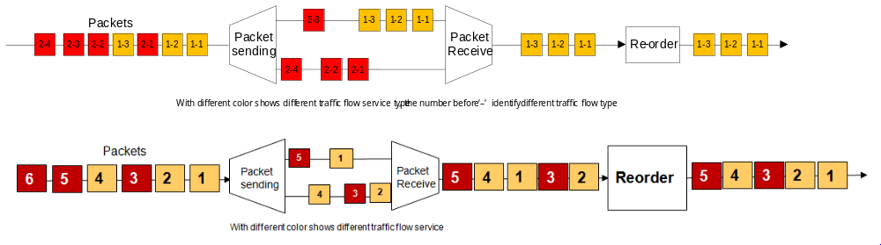
Figure 6.3.1.3-1: The usage of the sequence number in TFCP header
Editor's note: the impact of reordering procedure on QoS is FFS (e.g. on different traffic classes)
The Traffic Recombination function sets a buffer memory for the TFCP traffic flow. The length of the buffer is implementation specific. The received packets belong to the same TFCP traffic flow shall be reordered in the buffer based on the sequence number carried in the TFCP header. If a timer T (implementation dependent, e.g. related with the Max{RTT-3GPP access, RTT-non3GPP access}) elapses before the packet is received, this packet is treated as lost. If the received packet sequence number is smaller than the smallest sequence number stored in the buffer, or there is packet with the same sequence number already existing in the buffer, the latter received packet is treated as the replicated and discarded.
In the buffer, the maximum reordering time is equal to the timer T, i.e. the received packet waits time T for the former missing ones before outputted from the buffer. The Traffic Recombination function ensures that the packet transmission time (RTT/2) plus maximum reordering time T satisfies the Packet Delay Budget defined in the QoS. For the bandwidth, especially for the high latency and high bandwidth non-GBR/GBR service (e.g. video, TCP-based flows as defined in TS 23.501 [5], Table 5.7.4-1), transmission via both accesses can achieve more bandwidth with the proper algorithm (NOTE 1).
NOTE 1: For example, the UE or the UPF may trigger the traffic splitting per packet for non-GBR service when the RTT on both accesses are on the same level, e.g. RTT1 for 3GPP is 20ms, RTT2 for non-3GPP is 25ms. The sender may gradually increase the bandwidth on each access until the RTT for this access is impacted or close to the latency threshold, e.g. 100Mbps with RTT1=20ms for 3GPP access, 200Mbps with RTT2=25ms for non-3GPP access, then keeping the routing ratio 3GPP:non-3GPP =1:2 to obtain 300Mbps with RTT=25ms.
- Path Performance measurement function: Monitor the performance of the available path and report this information to the Traffic Distribution function.
The Path Performance Measurement function provides input to the Traffic Distribution function about the path performance information. The path performance is notified via control plane by the traffic usage report. The path performance may be measured by bandwidth, loss rate or/and latency.
- TFCP Encapsulation/Decapsulation function: Encapsulate/Decapsulate the TFCP header.
The TFCP Encapsulation/Decapsulation function adds or removes the TFCP header for the PDU session data. The TFCP layer may be subjected to per PDU session QoS flow, or per Packet Filter according to the different requirement. The TFCP tunnel is added when the multi-access for the PDU session is established (NOTE 2, NOTE 3). According to sequence of packets received from the upper layer, the packet Encapsulation function set the sequence number in the TFCP header.
NOTE 2: For the ongoing traffic, when the TFCP tunnel is added later, the End Marker packet can be used to distinguish the former packets without the TFCP header and the latter packets with the TFCP header . When the TFCP tunnel is removed, the End Marker can still be used to distinguish the former packets with TFCP header and the latter packets without TFCP header.
NOTE 3: If the TFCP tunnel is needed for single-access PDU session in future, such as detecting the link performance, this solution can also support the TFCP tunnel established at the very beginning of the PDU session establishment procedure.

6.3.1.4 ATSSS path performance measurement function description
The performance of the available path is measured and reported to the Traffic Distribution function by the Path Performance Measurement function. The path performance measurement function is deployed in the UE and the UPF, which means both the UE and the UPF could initiate the path performance measurement, and the measurement result is used for traffic distribution determination.
The performance measurement parameters includes access agnostic parameters and access specific parameters (optional). The access agnostic parameters includes the RTT, jitter, and packet loss ratio parameters, which could be used to justify the path performance of 3GPP access and Non 3GPP access respectively. The access specific parameters includes the parameters which could be used to verify the load or signal strength of each access, e.g. the RSRP/RSRQ for 3GPP access, and the available bandwidth for Non 3GPP access (e.g. WLAN AP). Besides, the performance measurement policies, e.g. access type for measurement, measurement period, report threshold and/or report period, are also included in the performance measurement parameters.
Editor's note: How the jitter, packet loss ratio and load for each link can be evaluated are FFS.
The measurement granularity could be per PDU session or per QoS flow for each access. During the PDU session establishment/modification procedure, the SMF provides path performance measurement parameters for the PDU session or QoS flows, traffic of which is potentially to be distributed, to the UE in the PDU session establishment/ modification Accept via NAS message. Besides, the SMF also provides the PDU session ID or QFI along with path performance measurement parameters to indicate to the UE to bind the path performance measurement parameters with the corresponding PDU session or the QoS flow to be measured.
After receiving the performance measurement parameters for the PDU session or the QoS flow to be measured, the UE initiates path performance measurement for the PDU session or QoS flow based on the path performance measurement policy:
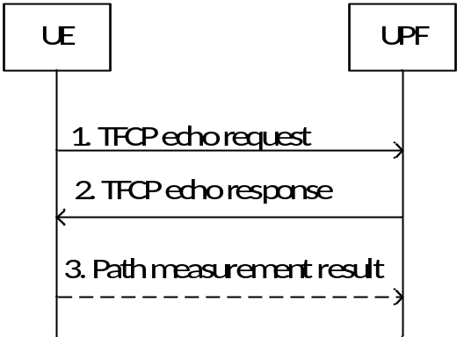
Figure 6.3.1.4-1: Path performance measurement on UE side
- Access agnostic performance measurement: The UE generates the TFCP echo request message based on the measurement period, and sends the TFCP echo request message via the 3GPP access and/or Non 3GPP access periodically. When the UPF receives the TFCP echo request message from the 3GPP and/or Non 3GPP access node respectively, the UPF generates the TFCP echo response message and sends back via the corresponding access node. The RTT and jitter could be measured via the TFCP echo request/response messages. Besides, the UE and the UPF could exchange the sending and receiving packet data statistics to get the packet loss ratio result.
NOTE: The measurement traffic per QoS flow can be implemented in a way without impact on the link performance for the QoS flow, e.g. the interval of sending TFCP echo request/response message pair for path performance measurement can be set to a couple of minutes. Since the link performance would not deteriorates gradually, interval set to minutes(s) for path performance detection should be enough for ATSSS.
- Access specific performance measurement (optional): The UE can measure the radio signal strength for the 3GPP access and the available bandwidth of Non 3GPP access.
Based on the report threshold or period of performance measurement parameters, the UE could provide the measurement result to the UPF as described in the step 3 of Figure 6.3.1.4-1, via user plane directly or via control plane to SMF and then from SMF to the UPF.
Editor's note: Whether the UPF needs to initiate path performance measurement is FFS.

6.3.2 Protocol Stacks
This clause illustrates the protocol stack for the User plane transport related with a PDU Session. In this solution, traffic between the UE and the UPF is tunnelled via a TFCP layer.
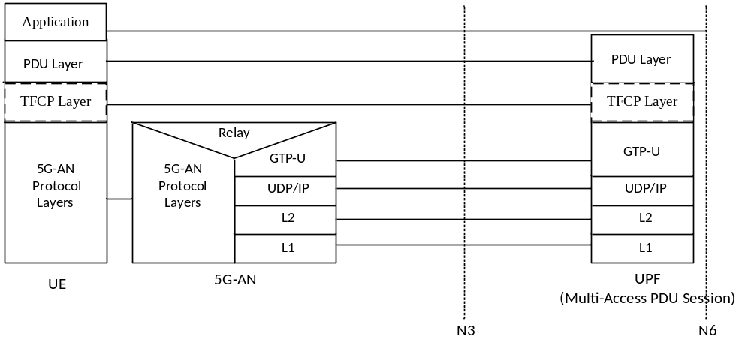
Figure 6.3.2-1: User Plane Protocol Stack for 3GPP access
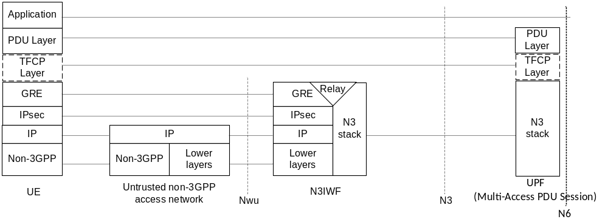
Figure 6.3.2-2: User Plane Protocol Stack for non-3GPP access

6.3.3 PDU Session Establishment Procedure
This procedure describes how the UE triggers PDU Session establishment via both 3GPP and non-3GPP access. More specifically, it covers the following scenarios:
- Scenario 1: one PDU Session is already established via one access, then the UE triggers to add an additional access to the existing PDU Session.
- Scenario 2: UE triggers to establish a PDU Session supporting multi-access, i.e. establish Multi-access PDU Session (e.g. via both 3GPP and Non 3GPP accesses) in one procedure.
NOTE: The above Scenario 1 is very similar as NBIFOM in EPC.
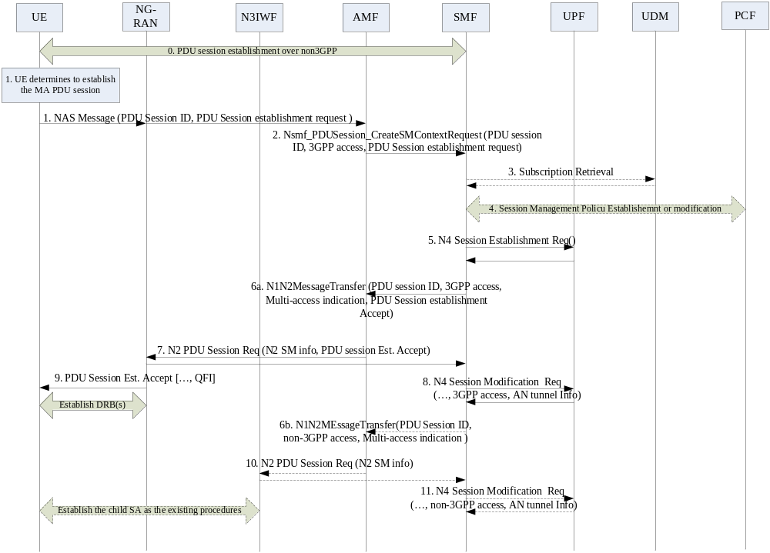
Figure 6.3.3-1: Multi-Access PDU Session establishment procedure with TFCP tunnel
0. UE is registered to 5GC via 3GPP and non-3GPP access. The UE may have established one PDU Session via 3GPP or non-3GPP access, as specified in TS 23.502 [6] clause 4.3.2.2 or clause 4.12.5.
1. The UE determines to establish a multi-access PDU Session based on the policy. The UE may add an additional access to the existing PDU Session or trigger a new PDU Session establishment procedure to establish the multi-access PDU Session. To be specific, the UE sends NAS Message to AMF including PDU Session ID, request type, and PDU Session Establishment Request message.
- If the UE decides to add an additional access to the existing PDU Session, the UE sets the request type to "Existing PDU Session". In the PDU Session Establishment Request message, the UE sends a multi-access indication to request the multi-access PDU Session. In addition, if the UE determines to establish the TFCP tunnel in this PDU Session, the UE allocates the TFCP tunnel Info and sends it to the SMF in the PDU Session Establishment Request message. Additionally, the UE indicates the TFCP tunnel subjected to per PDU session, per QoS flow or per Packet Filter by sending the TFCP indication binding with the PDU session ID, QFI or Facket Filters. This TFCP indication shows that the UE requests to add the TFCP header for packets belonging to this PDU session, or QoS flow, or Packet Filter.
NOTE: The contents of the TFCP tunnel info depend on the definition of TFCP protocol. For example, if the GRE protocol is used as the TFCP layer, the TFCP tunnel Info can be the GRE key.
- If the UE decides to establish a new PDU Session for multi-access, the UE sets the request type to "Initial Request". The other handling is the same as the above one.
2. The AMF sends Nsmf_PDUSession_CreateSMContext Request to the SMF including the PDU Session Establishment Request message.
- If request type indicates "Existing PDU Session", the AMF selects the same SMF serving the PDU Session identified by the PDU Session ID received in the request.
Editor's note: It is FFS when the existing SMF cannot support multi-access PDU Session.
- If request type indicates "Initial Request", the AMF selects an SMF that supports multi-access PDU Session.
3. If Request Type indicates "Initial request"and if the SMF has not yet registered for this PDU Session ID, then the SMF registers with the UDM. If Session Management Subscription data is not available, then SMF retrieves the Session Management Subscription data. The SMF may check the validity of the UE request based on the subscription data and network policy.
4. The SMF performs a Session Management Policy Establishment procedure or a Session Management Policy Modification procedure with the PCF. The PCF may determine whether the UE is allowed to establish the MA-PDU session. The PCF determines the ATSSS policy and send the ATSSS policy to the SMF.
5. If allowed, the SMF selects the UPF and sends N4 Session Establishment Request/Modification Request message to the selected UPF. For the existing PDU Session, if there are more than one serving UPFs, the SMF selects N3 UPF or anchor UPF to send the N4 Session Modification Request message.
The SMF sends N4 Session Establishment/Modification Request to the UPF. If the UE requested to use the TFCP tunnel and the network supports the TFCP protocol, the SMF authorized to establish the TFCP tunnel. If UPF TFCP Tunnel Info is allocated by the SMF, the UPF TFCP Tunnel Info, UE TFCP Tunnel Info and the corresponding QoS flow Info are provided to UPF in this step. If UPF TFCP Tunnel Info is allocated by the UPF, the SMF sends UE TFCP Tunnel Info and the corresponding QoS flow Info to the UPF. The UPF TFCP Tunnel Info is provided to SMF in the response message. Additionally, the SMF indicates the TFCP tunnel applicable for per PDU session, per QoS flow or per Packet Filter.
6a-6b. The SMF invokes the single or both separate N2 PDU Session establishment procedures according to Multi-Access indication and the request type.
- If the request type indicates "Existing PDU Session", the SMF only performs step 5a. The SMF sends Namf_Communication_N1N2MessageTransfer to the AMF including the Multi-Access indication, N2 SM information, 3GPP access and PDU Session establishment Accept message. The Multi-Access indication notifies the AMF that it is the Multi-Access PDU Session. The PDU Session establishment Accept message is included in this message based on the 3GPP access type received in the step2. The SMF also indicates 3GPP access as the target access in the message. In the PDU Session Establishment Accept message, it includes the QoS Rule(s) with 3GPP or/and non-3GPP access type. The access type(s) included in the Authorized QoS Rule indicate the authorized access type used for the traffic flows matching this QoS Rule. Optionally, when both 3GPP and non-3GPP are allowed by this QoS rule, it may include the Routing Factor for every access, as specified in subclause 6.3.1.2.
- If the request type indicates "Initial Request", the SMF performs step 5a and 5b. In step 5b, the SMF sends Namf_Communication_N1N2MessageTransfer to the AMF including the Multi-Access indication, Non-3GPP access and N2 SM information.
The SMF sends the N2 SM information (PDU Session ID, QFI(s), QoS Profile(s)) to the NG-RAN or/and N3IWF. The QoS Profile(s) is calculated from the information provided by the PCF. If there is Routing Factor defined for some Packet Filters, the creation of the QoS profile(s) for NG-RAN or/and N3IWF is as below:
- For non-GBR QoS flow: No impact, the same as the existing procedure.
- For GBR QoS flow: The QoS profile(s) for one access needs to be calculated according to the QoS parameters related with this access type. For example, there are Packet Filters 1, Packet Filters 2 and Packet Filters 3 bound to one QoS flow, and the GFBR=45Mbps. More specific:
- Packet Filters 1: guaranteed bitrate =5Mbps, access type=3GPP access.
- Packet Filters 2: guaranteed bitrate =10Mbps, access type = non 3GPP access.
- Packet Filters 3: guaranteed bitrate =30Mbps, access type =3GPP, routing ratio =20%; Second access type =non-3GPP, routing ratio=80%.
QoS profile for 3GPP access: guaranteed bitrate = (QoS rule 1= 5) + (QoS rule 3=30*0.2) =11Mbps.
QoS profile for non-3GPP access: guaranteed bitrate = (QoS rule 2=10) + (QoS rule 3=30*0.8) =34Mbps.
The AMF marks this PDU Session as Multi-Access PDU Session according to the Multi-Access indication received from SMF.
7. The AMF initiates N2 session procedures towards 3GPP RAN, and forwards the RAN tunnel Info to the UE.
8. The SMF sends the RAN tunnel Info and 3GPP access type to the selected UPF in step 3.
9. The 5G RAN forwards the PDU Session establishment Accept message to the UE. The existing of the UPF TFCP tunnel Info and TFCP indication with the binding PDU session ID, or QoS flow Info or Packet Filter included in the PDU Session Establishment Accept message indicates the successful establishment of the TFCP tunnel.
10. The AMF initiates N2 session procedures towards N3IWF, and forwards the N3IWF tunnel Info to the SMF.
11. The SMF sends the N3IWF tunnel Info and Non-3GPP access type to the selected UPF in step 3. The UPF stored both access tunnel information and the binding access type for this Multi-Access PDU Session. This binding relationship can be used when performing the traffic splitting or switching in user plane.
In user plane, the UE and the UPF detect the existing of TFCP header based on the following information:
- per PDU session: all the packets transported via one PDU session include the TFCP header. The TFCP packets can be identified by the GTP-U tunnel for this PDU session.
- per QoS flow: all the packets transported via one QoS flow use the TFCP header. The UE and the UPF identify the TFCP packets based on the QFI included in the SDAP and GTP-U layer.
- per traffic flow: all the packets belonging to this traffic flow have TFCP header. In order to differentiate the TFCP packets from other packets in the same QoS flow, the UE and the UPF create a TFCP indication in the SDAP or GTP-U layer for the inner data with TFCP encapsulation.
NOTE: The TFCP indication added to SDAP will occupy one bit of the SDAP header.

6.3.4 PDU Session Modification procedure
This procedure can be used in the following scenarios:
- UE or network requested traffic steering in 3GPP or non-3GPP access;
- UE or network requested traffic switching from 3GPP to non-3GPP access and vice versa;
- UE or network requested traffic splitting in 3GPP and non-3GPP access.
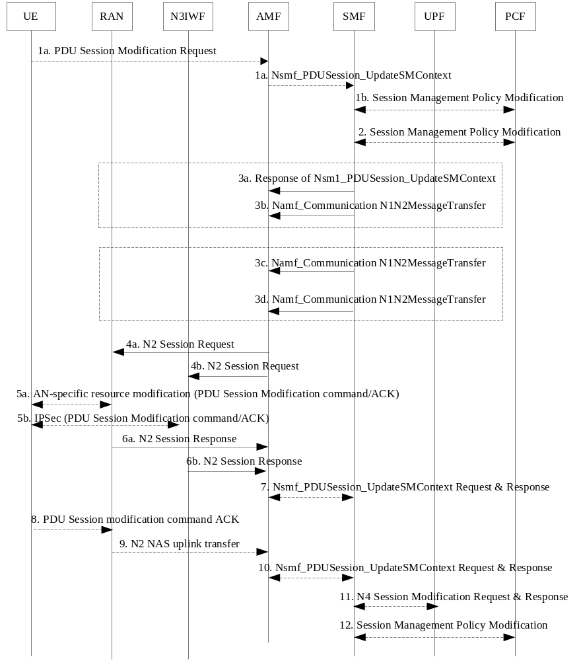
Figure 6.3.4-1: Multi-Access PDU Session Modification procedure
1a. (UE requested modification) This procedure may be triggered by UE transmission of a PDU Session Modification Request message to the AMF. The UE sends the Packet Filters, Operation, requested QoS, and the requested access type(s). The requested access type indicates 3GPP access or non-3GPP access or both accesses.
UE may send the PDU Session Modification Request message via 3GPP access or non-3GPP access. For traffic steering/switching/splitting, the UE may include Packet Filters targeting in 3GPP access or/and Packet Filters targeting in non-3GPP access in one PDU session modification request message. If the UE decided to initiate the TFCP encapsulation for the following cases, the UE indicates the TFCP tunnel subjected to per QoS flow or per Packet Filter by sending the TFCP indication binding with the QFI or Packet Filters.
- Steering: when the loss ratio is higher in one access, redundancy steering can be applied. The requested access type sent in the ATSSS rule includes 3GPP and non-3GPP with the routing factors 100% on both sides. The convergence TFCP tunnel is established to support the packet reordering and the replication packet elimination.
- Switching: when the link performance via the current access is deteriorated, the traffic should be moved to the other access. The packets are replicated via both accesses during the traffic switching execution phase in order to lower the transmission delay and the loss ratio. The temporary convergence TFCP tunnel is used to perform the packet reordering and the replication packet elimination in the traffic switching execution phase.
- Splitting: when only one access cannot satisfy the bandwidth requirement, the traffic splitting per packet is initiated. The convergence TFCP tunnel can provide sufficient resource taking advantage on both accesses.
1b. (Network requested modification) The PCF performs a Session Management Policy Modification procedure to notify the SMF about the ATSSS policy. This may be triggered by the update of ATSSS policy or upon AF requests. If the SMF decided to initiate the TFCP encapsulation based on the ATSSS policy or the similar cases as defined in 1a, the SMF indicates the TFCP indication binding with the QFI or Packet Filters in the PDU session Modification Command message.
2. (UE requested modification) The SMF notifies the PCF about the requested or updated Routing information. The PCF authorizes the Routing information, generates PCC rule including the ATSSS policy and send it to the SMF.
3a-3b. (UE requested modification) The SMF acknowledges the authorized QoS rule including the ATSSS rule by sending the N1 SM container to the UE. The Packet Filters, Authorized QoS, Authorized access type(s) are included in the Authorized QoS rule.
If there are QoS profile(s) updated for the other access, the SMF sends the updated N2 SM information (PDU Session ID, QFI(s), QoS Profile(s)) to NG-RAN or N3IWF via Namf_Communication_N1N2MessageTransfer message.
3c-3d. (Network requested modification) The SMF generates QoS rules including the ATSSS rules based on the ATSSS policy received from the PCF. The SMF may invoke two N1N2MessageTransfer for traffic in each access separately. The QoS rules are included in one Namf_Communication_N1N2MessageTransfer message via one access.
4a. The AMF sends N2 Session Request to the NG-RAN, including the PDU session modification command message if received from SMF and N2 SM information containers for 3GPP access.
4b. The AMF sends N2 Session Request to the N3IWF, including the PDU session modification command message if received from SMF and N2 SM information containers for non-3GPP access.
5a-5b. The NG-RAN or N3IWF forwards the PDU session Modification Command to the UE, including the Authorized QoS rules. For non-3GPP access, there may be IPSec update procedures as defined in TS 23.502 [6] clause 4.12.6 steps from 4a to 4d. If the TFCP tunnel is requested by UE in step1a, the TFCP indication with the binding QoS flow Info or Packet Filter included in the PDU session Modification Command message indicates the successful establishment of the TFCP tunnel.
6. The NG-RAN or/and N3IWF may acknowledge N2 PDU Session Request by sending a N2 PDU Session Response to the AMF.
7. The AMF forwards the N2 SM information to the SMF.
8 The UE acknowledges the PDU Session Modification Command by sending a NAS message (PDU Session ID, N1 SM container (PDU Session Modification Command Ack)) message. For network requested modification procedure, the UE includes the acknowledgement of the QoS rule including the ATSSS rule and the establishment of the TFCP tunnel in this step.
9-11. The same as the existing procedures described in TS 23.502 [6] clause 4.3.3. If the TFCP tunnel is established, the SMF indicates the TFCP tunnel applicable for per QoS flow or per Packet Filter in step 11 to the UPF.

6.3.5 ATSSS Execution Procedure
The ATSSS execution procedure descripts how the ATSSS is executed based on the link quality detection and feedback. The UPF or the UE performs link detection and provides the measurement result to the SMF via control plane, the SMF updates the ATSSS rule based on the received measurement results from the UPF or the UE and configures the updated ATSSS rule to the UE or the UPF. The UE or the UPF apply the updated ATSSS rule. The detailed call flow can be illustrated in the following procedures, representing the downlink and uplink procedure independently.
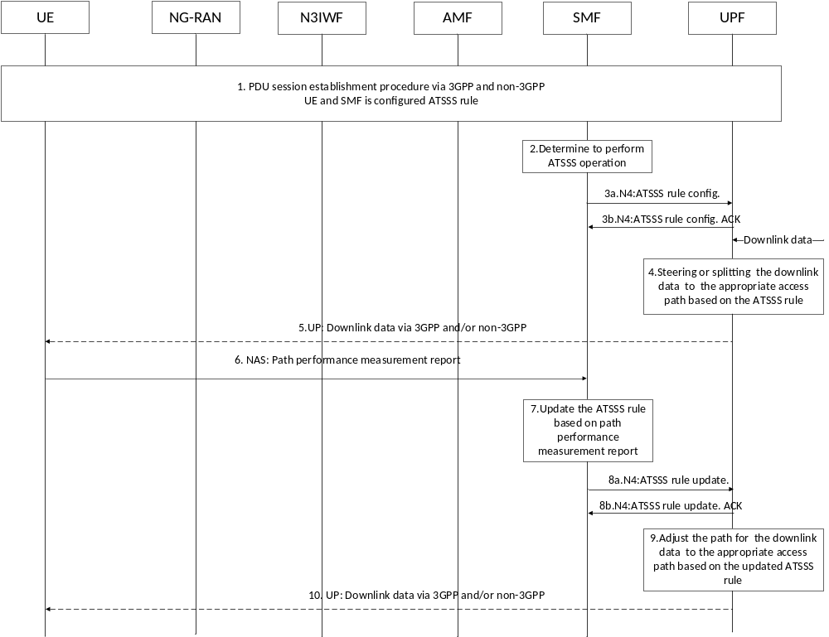
Figure 6.3.5-1: Downlink ATSSS execution procedure
The procedure is applied for ATSSS execution, in which the UPF implements the ATSSS operation (steering, switching, splitting) based on the ATSSS rule and the status of the network. In this procedure, it is assumed that UE has already established PDU sessions over 3GPP and non-3GPP access.
1. UE establishes the PDU sessions over 3GPP and non-3GPP access. And the ATSSS rule is configured at the UE and SMF.
2. The ATSSS control functionality entity in the SMF determines to perform ATSSS operation.
3. SMF configures the ATSSS rule and operation command to the UPF.
4. UPF executes the ATSSS rule, when downlink data arrives, the UPF entity determines the appropriate access path based on the ATSSS rule.
5. UPF sends the downlink data to the UE via the selected access path.
6. UE performs path performance measurement for each access path, e.g. the data loss rate, latency, the radio signal quality and reports the results to the SMF via SM-NAS signalling based on the configured reporting condition.
7. SMF updates the ATSSS rule considering UE feedback;
8. SMF sends the updated ATSSS rule to the UPF;
9. UPF implements the updated ATSSS rule and may adjust the access path for the service; e.g. switching the path from one access to another one or start/stop splitting operation for the uplink data based on the updated ATSSS rule;
10. UPF sends the downlink data to the UE via the adjusted access path.
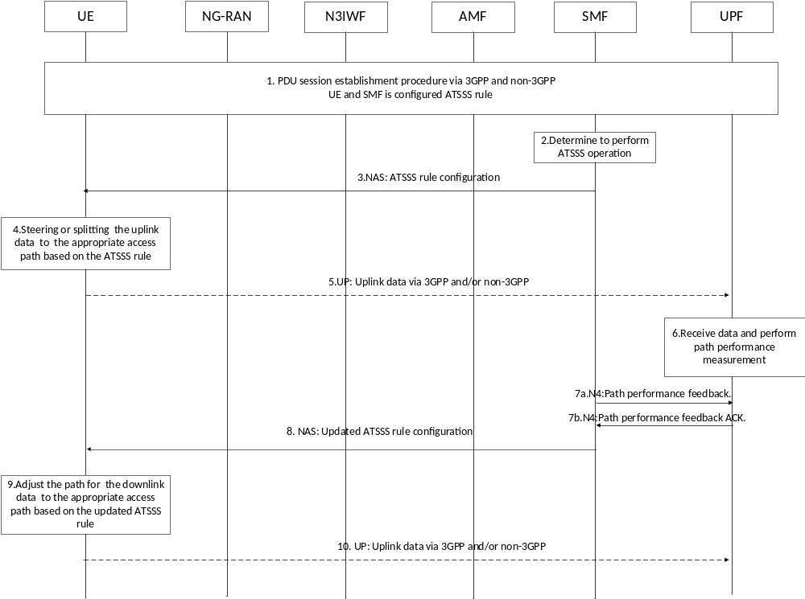
Figure 6.3.5-2: Uplink ATSSS execution procedure
The procedure is applied for ATSSS operation uplink transmission, in which the UE implements the ATSSS operation based on the ATSSS rule and the status of the network. In this procedure, it is assumed that UE has already established PDU sessions over 3GPP and non-3GPP access.
1. UE establishes the PDU sessions over 3GPP and non-3GPP access. And the ATSSS policy is configured at the UE and SMF.
2. The ATSSS control functionality entity in the SMF determines to perform ATSSS operation.
3. SMF configures the ATSSS rule and operation command to the UE.
4. The TFCP entity in the UE implements ATSSS rule, and when uplink data arrives, the UE entity determines the appropriate access path based on the ATSSS rule.
5. UE sends the uplink data to the UPF via the selected access path.
6. UPF performs path performance measurement, e.g. the data loss rate, latency and reports the results to the SMF based on the configured report condition.
7-8. SMF updates the ATSSS rule based on UPF feedback and provides the updated ATSSS rule to the UE;
9. UE implements the updated ATSSS rule and may adjust the access path for the service, e.g. switching the path from one access to another one or start/stop splitting operation for the uplink data based on the updated ATSSS rule;
10. UE sends the uplink data to the UPF via the adjusted access path.

6.3.6 Solution evaluation

6.3.6.1 Impacts on existing entities and interfaces
TFCP part of the solution has impact on both UE and UPF. It increases the whole packet size transported by TFCP with addition of the TFCP Tunnel Info to each packet header. In order to minimize the impact on user plane performance, the TFCP layer could be added per packet filter, per QoS flow or per PDU session dynamically when it is needed. This may impact the performance of the User Plane.

6.4 Solution 4: Policy for Access Traffic Steering, Switching and Splitting

6.4.1 General
This solution assumes that the access traffic steering, switching and splitting decisions for a MA-PDU session are based on policy (called ATSSS policy) that is provisioned in the UE and in the UPF. The ATSSS policy is created by the PCF during the establishment of a MA-PDU session. Under this assumption, the solution specifies:
(a) The contents of the ATSSS policy; and
(b) How the ATSSS policy can be applied for deciding how to distribute the traffic of a MA-PDU session.
The traffic of the MA-PDU session could be distributed across the two accesses of the MA-PDU session by using different steering modes (or "steering strategies"). Some of these steering modes are discussed in the table below.
NOTE 1: The steering modes discussed in this clause can be used for (i) access traffic steering, (ii) access traffic switching and (iii) access traffic splitting, as defined in clause 3.1 ("Definitions"). However, for simplicity they are called "steering" modes.
NOTE 2: Each steering mode in the table below can be applied either for a specific data flow or for the entire traffic of a MA-PDU session.
Table 6.4.1-1: Steering modes for traffic distribution in a MA-PDU session
 | Steering Mode | Comments
#1 | 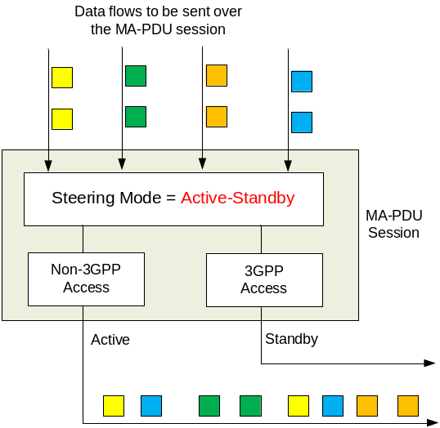 | Active-Standby steering: All (or some of) the traffic of the MA-PDU session is sent to one access only, which is called the "Active" access. The other access serves as a "standby" access and takes traffic only when the active access becomes unavailable. When the active access becomes available again, the traffic is transferred to the active access.  The active access can be defined when the MA-PDU session is established and can either (a) remain the same during the lifetime of the MA-PDU session or (b) can change during the lifetime of the MA-PDU session.  - Benefit: The MA-PDU session can provide enhanced continuity. Traffic can be switched from the active access to the standby access and vice versa with minimum or no signalling.  - Complexity: Small.
#2 | 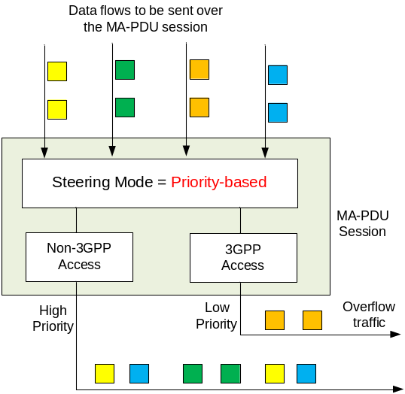 | Priority-based steering: The two accesses are assigned a priority, e.g. during the establishment of the MA-PDU session. All traffic (or some) of the MA-PDU session is sent to the high priority access. When congestion arises on the high priority access, new data flows (the "overflow" traffic) are sent to the low priority access. In addition, when the high priority access becomes unavailable, all traffic is switched to the low priority access.  If needed, it could be possible to change the priorities of the accesses during the lifetime of the MA-PDU session.  - Benefit: The MA-PDU session can provide enhanced continuity and increased bandwidth (because both accesses can be used simultaneously).  - Complexity: Requires the UE and/or the network to determine when congestion arises on the high priority access. This may be a complex task.
#3 | 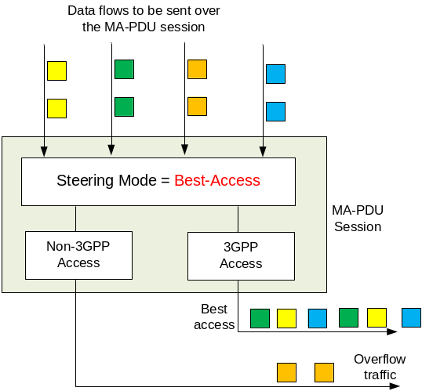 | Best-Access steering: The same as the Priority-based steering but with the following difference: The high priority access is the one that can provide the best performance, e.g. the one with the smallest RTT. In this case, the high priority access is not pre-defined (as in Priority-based steering) but it is estimated in real-time and can change dynamically.  - Benefit: The MA-PDU session can provide enhanced continuity, increased bandwidth and better performance (compared to Priority-based).  - Complexity: Requires the UE and/or the network to estimate the best access and to determine when congestion arises on the best access. This may be a complex task.  NOTE: The best access could be estimated by the network by using Access Measurements as those considered in Solution 1 (see TR 23.793, clause 6.1.2.1) or by using a Path Performance measurement function as the one considered in Solution 3 (see TR 23.793, clause 6.1.2.1).
#4 | 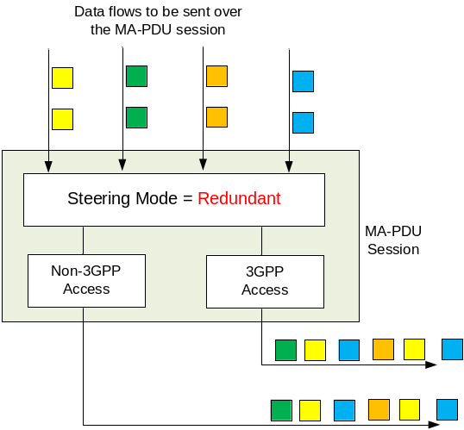 | Redundant steering: All (or some) data flows are transmitted on both accesses in order to increase reliability.  - Benefit: The MA-PDU session can provide very high data reliability (i.e. very small packet error rate) and session continuity.  - Complexity: High - The receiving side should be able to detect and discard duplicate packets. For this purpose, the sending side could append sequence numbers to the transmitted packets. In addition, to provide in-sequence delivery, the receiving side should be able to buffer and re-order the received packets.
#5 | 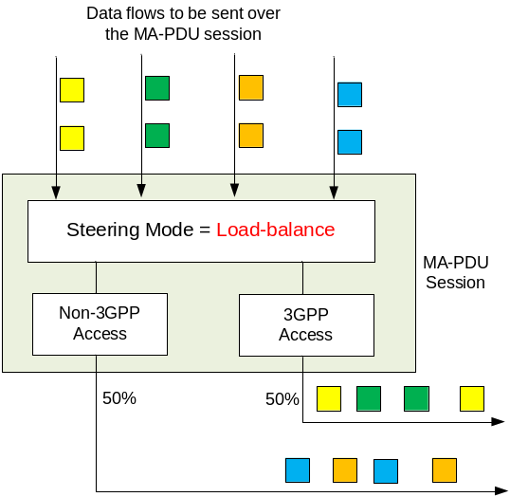 | Load-balance steering: Each access receives a percentage of the data flows transmitted via the MA-PDU session. Each access is assigned a weight factor (e.g. 50%) and receives a percentage of the MA-PDU session traffic corresponding to this factor.  In a 50/50 load-balancing, the overall traffic of the MA-PDU session is equally split across the two accesses. In an 80/20 load-balancing, about 80% of the overall traffic is sent on one access and 20% on the other access.  - Benefits: The MA-PDU session can provide bandwidth aggregation with a certain load balancing ratio.  - Complexity: Relatively small - There is no need to assess the transmission performance on every access.

Editor's note: Whether additional steering modes should be considered is FFS.
In the context of ATSSS, the Active-Standby steering mode (#1) should be supported as it provides benefits and minimum complexity. Note that the Active-Standby steering mode can be applied to all or to some of the traffic of a MA-PDU session. For example, applying Active-Standby steering to TCP/port 1234 traffic means that this traffic should be transferred on the Active access, if available, or on the Standby access, when the Active access is unavailable. It is possible also to define no Standby access, in which case the traffic is restricted to one access only and it is forbidden on the other access.
Editor's note: Steering modes #2-#5 should be further evaluated especially in terms of complexity before deciding to support them for ATSSS or not.

6.4.2 Content of ATSSS Policy
The steering modes discussed above could be applied in a MA-PDU session by enforcing the appropriate ATSSS policy for the MA-PDU session. For example, during the establishment of an MA-PDU session, the PCF in the network could create the ATSSS policy for the MA-PDU, which could then be transferred to UE for uplink traffic steering and to UPF for downlink traffic steering.
The ATSSS policy includes a prioritized list of ATSSS rules and each ATSSS rule includes a steering mode that should be applied to the traffic matching this rule. For example, the ATSSS policy for a MA-PDU session could contain:
First ATSSS rule (priority 1):
- Traffic filter: Traffic of App-X.
- Steering mode: Active-Standby steering; Active access: 3GPP, Standby access: non-3GPP.
Second ATSSS rule (priority 2):
- Traffic filter: TCP traffic with destination IP address 10.10.0.1.
- Steering mode: Active-Standby steering; Active access: 3GPP, Standby access: None.
Default ATSSS rule (least priority):
- Traffic filter: All traffic.
- Steering mode: Active-Standby steering; Active access: non-3GPP, Standby access: 3GPP.
The first ATSSS rule steers the traffic of App-X to 3GPP access, if available; if not available, it steers the traffic to non-3GPP access. The second ATSSS rule steers the TCP traffic with destination IP address 10.10.0.1 to 3GPP access only. Since no standby access is defined, this traffic cannot be transferred over non-3GPP access, even when the 3GPP access becomes unavailable. The default ATSSS rule steers the rest of the traffic to non-3GPP, if available; if not available, it is steered to 3GPP access.
If more steering modes are supported, then more advanced ATSSS rules could be constructed and more advanced traffic steering strategies could be enforced. Below we provide a few examples.
Example 1: If the operator has deployed a video streaming server at address 10.10.0.2, then the streaming traffic between the UE and this server could be load-balanced across 3GPP and non-3GPP access with the following ATSSS rule:
ATSSS rule (priority x):
- Traffic filter: UDP traffic to IP address 10.10.0.2.
- Steering mode: Load-balanced steering; 3GPP access: 30%, non-3GPP access: 70%.
Example 2: If the network should provide very small packet error rate (i.e. high reliability) when the UE communicates with an application server over TCP/port 1234, then the following ATSSS rule could be provisioned:
ATSSS rule (priority x):
- Traffic filter: TCP traffic to port 1234.
- Steering mode: Redundant steering.
Example 3: If all the traffic sent over a MA-PDU session should be transferred with the best possible performance, then the following ATSSS rule could be provisioned:
Default ATSSS rule:
- Traffic filter: All traffic.
- Steering mode: Best-access steering.
Example 4: If all the traffic of a MA-PDU session should be offloaded to non-3GPP access but avoid congestion over non-3GPP access to severely impact the performance, then the following ATSSS rule could be provisioned:
Default ATSSS rule:
- Traffic filter: All traffic.
- Steering mode: Priority-based steering; High-priority: non-3GPP, Low-priority: 3GPP.

6.4.3 Traffic Distribution based on ATSSS Policy
The figure below shows how the UE or the UPF can apply the provisioned ATSSS rules for deciding how to distribute the traffic of a MA-PDU session across the 3GPP and the non-3GPP accesses. The ATSSS rules shown in this figure are example rules that aim to explain how they can be used for selecting the access on which a data flow should be transmitted.
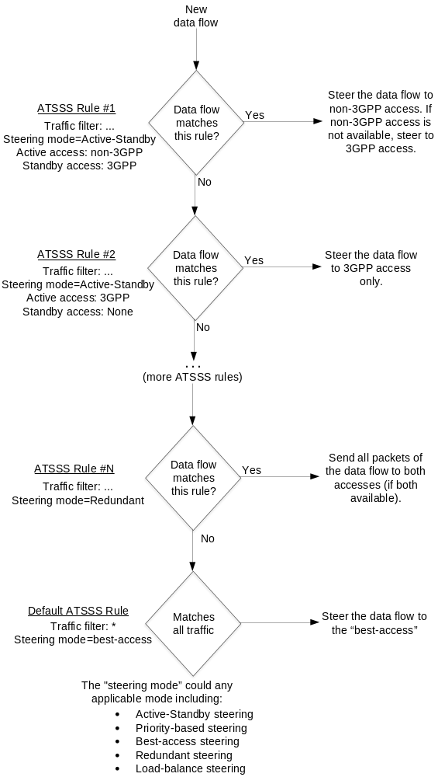
Figure 6.4.3-1: Applying ATSSS rules for deciding how to distribute the traffic of a MA-PDU session

6.5 Solution 5: Multipath TCP (MPTCP) proxy architecture

6.5.1 General
This solution addresses Key Issues #1 and #4.
Multipath TCP (MPTCP) defined in [8] is a set of extensions to regular TCP to provide a Multipath TCP service, which enables a transport connection to operate across multiple paths simultaneously.
MPTCP defines how to setup multiple paths ("subflows"), manage these subflows, reassemble of data and terminate sessions.
The simultaneous use of multiple disjoint (or partially disjoint) paths across the network increases the resilience of the connectivity by providing multiple paths, protects UEs from the failure of one path, and it also increases the efficiency of the resource usage, and thus increases the network capacity available to UEs.

6.5.2 MPTCP proxy
When communicating with traditional TCP servers, MPTCP capable devices have to fall back to traditional TCP and cannot fully utilize their MPTCP capability. In order to support the use of MPTCP session between an MPTCP host and a TCP host, or to help to aggregate MPTCP subflows, an MPTCP proxy needs to be introduced.
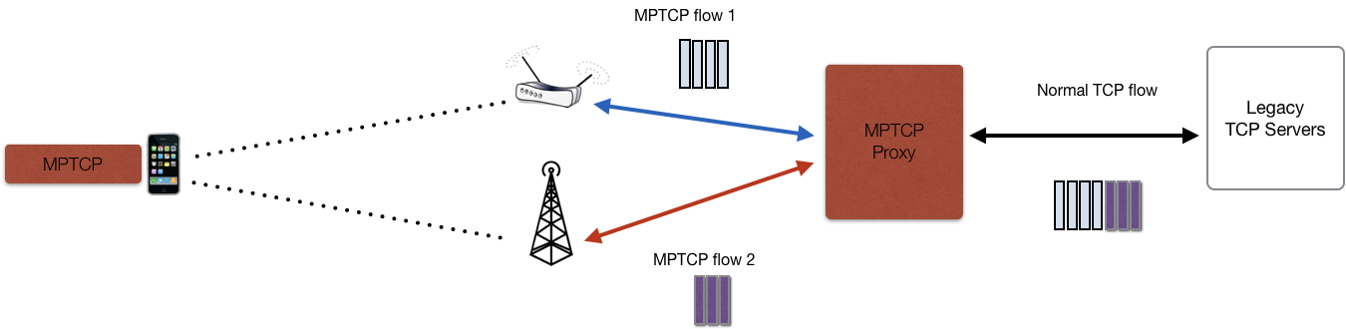
Figure 6.5.2-1: Illustration of an MPTCP proxy
The MPTCP proxy makes it possible to achieve the benefits of MPTCP for access aggregation and route selection without requiring MPTCP support in all TCP servers.

6.5.3 Addition of MPTCP proxy to 5GC
In order to introduce the MPTCP proxy to 5GC and allow 3GPP UEs to make use of the MPTCP capability, the UPF shall incorporate the MPTCP proxy functionality for the PDU session.
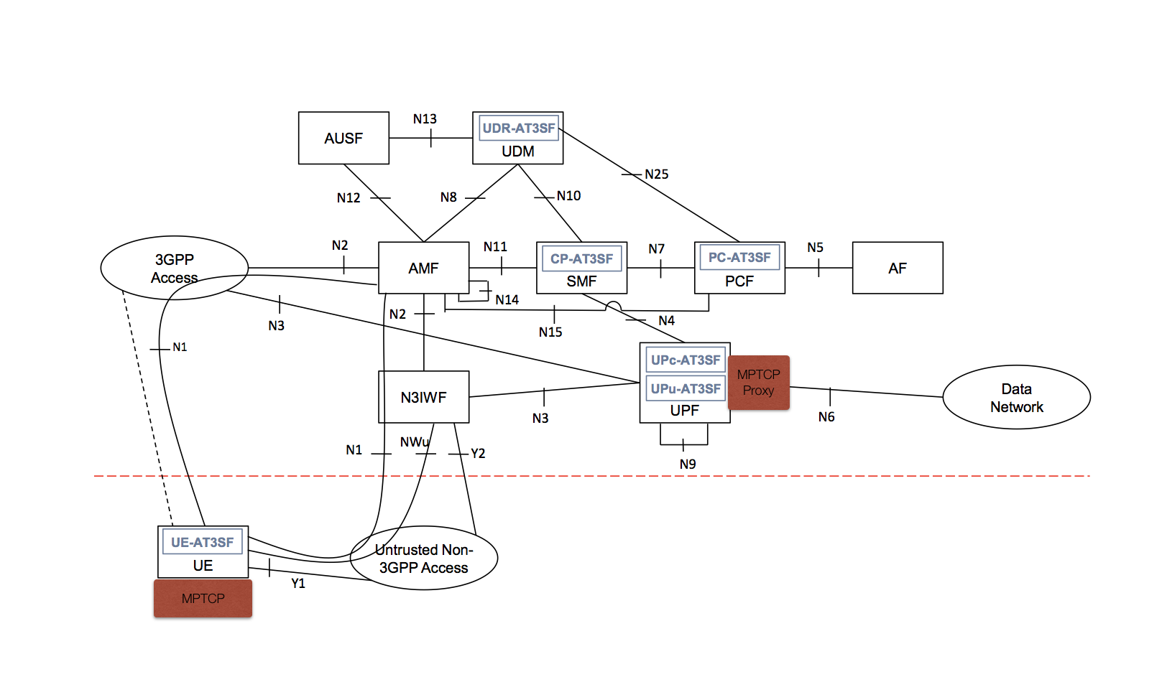
Figure 6.5.3-1: Addition of MPTCP proxy to 5GC
The MPTCP proxy shall implement at least one of the following protocol options to communicate with the UE:
1. SOCKS v4 or v5 Proxy [9];
- Advantages: Well-known, well-supported.
- Disadvantages: Additional connection-setup latency, protocol chattiness.

2. Transport converter [11];
- Advantage: Well supported (adopted by the IETF TCPM (TCP Maintenance) Working Group), designed specifically for the MPTCP use case, provides 0-RTT protocol conversion service, no overhead, can support other TCP conversion services such as TCPinc.
- Disadvantage: IETF standardization process is ongoing (milestone Dec 2018).

6.5.4 MPTCP PDU session establishment procedure
This solution supports the Multi-Access PDU session establishment defined in section 6.2. Each of the PDU sessions may have its own set of UPFs, but both child PDU sessions share a common PDU session anchor (PSA).
This procedure is based on the procedure defined in section 6.2.2.2 with the following exceptions:
1. The UE requests the network to select an MPTCP proxy on the user plane;
2. The MPTCP proxy address is transported back to the UE;
3. The child PDU sessions do not share a common IP address but they are allocated separate IP addresses.
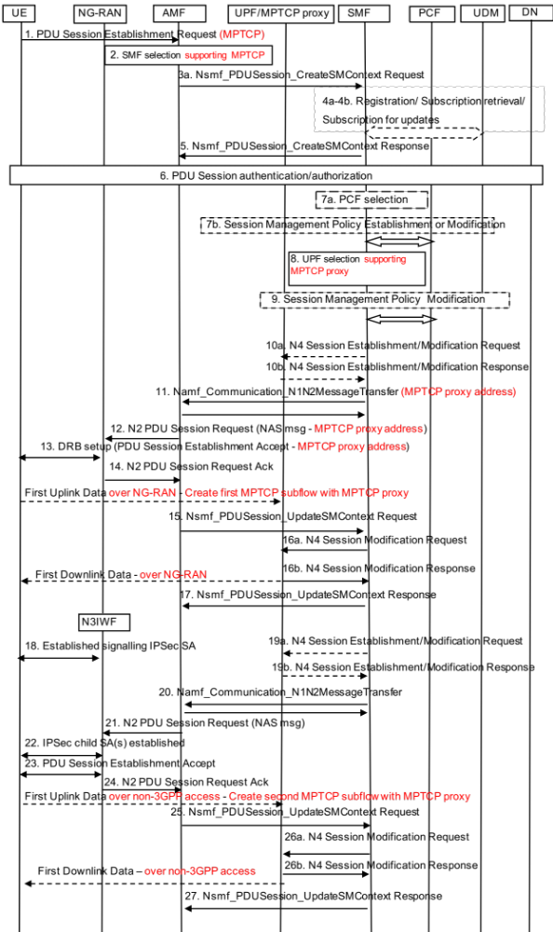
Figure 6.5.4-1: UE-requested MPTCP PDU Session Establishment for non-roaming and roaming with local breakout
Editor's note: It is FFS whether instead of the above PDU session setup procedure the UE could setup two independent PDU sessions for MPTCP procedures as defined in clause 6.2.2.1. In this case it is also FFS how the UE receives the address of the MPTCP proxy.
1. The UE initiates the "UE Requested PDU Session Establishment" procedure as specified in TS 23.502 [6] clause 4.3.2.2.1 on 3GPP access with an additional preference to establish an MPTCP PDU Session. The UE can also first initiate the PDU Session Establishment procedure on untrusted non-3GPP access.
2. If the network supports MPTCP procedures, the AMF selects an SMF that supports MPTCP procedures.
3. The AMF sends an Nsmf_PDUSession_CreateSMContext Request to SMF.
4. The SMF registers with the UDM.
5. The SMF sends an Nsmf_PDUSession_CreateSMContext Response to AMF.
6. Optional Secondary authorization/authentication.
7a. If dynamic PCC is deployed, the SMF performs PCF selection.
7b. The SMF may perform a Session Management Policy Establishment.
8. The SMF selects an UPF that incorporates an MPTCP proxy functionality.
9. SMF may perform a Session Management Policy Modification procedure.
10-17. The user plane of the PDU session over 3GPP access is established and the UE creates the first MPTCP subflow over the 3GPP access. The first MPTCP subflow can also be created over the non-3GPP access once the PDU Session is established over the untrusted non-3GPP access.
- In step 11, the SMF indicates to AMF the MPTCP proxy address along with the list of protocols the MPTCP proxy supports (SOCKSv4, v5 or Transport converter).

- In step 13, the UE receives a PDU Session Establishment Accept message containing the MPTCP proxy address (if the network supports MPTCP procedures) along with the list protocols the MPTCP proxy supports, thus, the UE determines that the MPTCP PDU session over 3GPP access is established and selects one protocol to contact the MPTCP proxy from the protocol options provided by the network.
19-27. The user-plane of the PDU session over untrusted non-3GPP access is established and the UE creates an additional MPTCP subflow over the untrusted non-3GPP access.
NOTE: The steps 10-17 and 19-27 can be executed in parallel.

6.5.5 ATSSS rules for MPTCP PDU Session
In Rel-15, the UE is responsible for establishing new PDU session(s) based on URSP rules provided by the network (PCF) and/or preconfigured in the UE as described in TS 23.503 [7] clause 6.6.2. As such, URSP rules provide SDF level steering capability for UE to establish new PDU session(s) over the preferred access network based on traffic descriptor and rule precedence.
The steering decision is performed by taking into account the congestion and delay information of the individual TCP subflows of the MPTCP connection. The UE may also take into account Access Measurement Reports, as defined in
subclause 6.1.5.3 or 6.6.3.2, to complement the steering and path-management decisions.
The ATSSS rules defined by this solution are extension of the URSP rules described in TS 23.503 [7] section 6.6.2. The following new fields are created:
- The MPTCP PDU Session field in the Route Selection Descriptor specifies whether the type of the PDU session is an MPTCP PDU session to be established for the matching application;
- In case of an MPTCP PDU session:
- The Allowed MPTCP Service Type(s) field specifies the MPTCP Service Type(s) that are allowed for the MPTCP PDU session:
- Handover MPTCP Service Type: An MPTCP service that provides seamless handover between non-3GPP and 3GPP access in order to preserve the connection. If the rule specifies Handover MPTCP Service Type, Interactive and Aggregate Service Types shall not be present;
- Interactive MPTCP Service Type: A service whereby Multipath TCP attempts to use the lowest-latency interface. If the rule specifies Interactive MPTCP Service Type, Handover MPTCP Service Type may be present but Aggregate Service Type shall not be present; or
- Aggregate MPTCP Service Type: An MPTCP service that aggregates the capacities of the access networks in an attempt to increase throughput and minimize latency. If the rule specifies Aggregate MPTCP Service Type, Handover and Interactive MPTCP Service Types may be present as well;
- If present, in case of WLAN access, the Limited SSID(s) for MPTCP PDU Session field specifies a list of SSID(s) that are allowed on the WLAN access for the MPTCP PDU Session;
The PCF may select the ATSSS rules applicable for each UE based on local configuration and operator policies taking into consideration e.g. UE location or time of the day.
The PCF may provide the ATSSS rules at the initial Registration procedure, or when the operator policies indicate that the conditions for updating the UE are met, i.e. at change of UE location or at mobility with change the AMF, or at any time, as defined in TS 23.502 [6]. Operator defined policies in the PCF may depend on input data such as UE location, time of day, information provided by other NFs, etc.

Table 6.5.5-1: UE Route Selection Policy (from TS 23.503 [7] table 6.6.2.1-1)
Information name | Description | Category | PCF permitted to modify in a URSP | Scope
URSP rules | 1 or more URSP rules as specified in table 6.6.2.1-2 | Mandatory | Yes | UE context

Table 6.5.5-2: UE Route Selection Policy Rule (from TS 23.503 [7] table 6.6.2.1-2)
Information name | Description |  | Category |  | PCF permitted to modify in a UE context |  | Scope
Rule Precedence | Determines the order the URSP rule is enforced in the UE. |  | Mandatory  (NOTE 1) |  | Yes |  | UE context
Traffic descriptor | This part defines the traffic descriptors for the policy
Application identifiers | Application identifier(s) |  | Optional
IP descriptors | IP 3 tuple(s) (destination IP address or IPv6 network prefix, destination port number, protocol ID of the protocol above IP) |  | Optional |  | Yes |  | UE context
Non-IP descriptors | Descriptor(s) for non-IP traffic |  | Optional |  | Yes |  | UE context
DNN |  | This is the DNN information provided by the application |  | Optional |  | Yes |  | UE context
List of Route Selection Descriptors | A list of Route Selection Descriptors. The components of a Route Selection Descriptor are described in table 6.6.2.1-3 |  | Mandatory
NOTE 1: Rules in a URSP shall have different precedence values.

Table 6.5.5-3: : Route Selection Descriptor (from TS 23.503 [7] table 6.6.2.1-3)
Information name | Description | Category | PCF permitted to modify in a UE context | Scope
Route Selection Descriptor Precedence | Determines the order in which the Route Selection Descriptors are to be applied. | Mandatory  (NOTE 1) | Yes | UE context
Route selection components | This part defines the route selection components | Mandatory  (NOTE 2)
SSC Mode Selection | One single value of SSC mode. | Optional | Yes | UE context
Network Slice Selection | Either a single value or a list of values of S-NSSAI(s). | Optional | Yes | UE context
DNN Selection | Either a single value or a list of values of DNN(s). | Optional | Yes | UE context
PDU Session Type Selection | One single value PDU Session Type | Optional | Yes | UE context
Non-seamless Offload indication | Indicates if the traffic of the matching application is to be offloaded to non-3GPP access outside of a PDU Session. | Optional  (NOTE 3) | Yes | UE context
Access Type preference | Indicates the preferred Access Type (3GPP or non-3GPP) when the UE establishes a PDU Session for the matching application. | Optional | Yes | UE context
MPTCP PDU Session | Indicates whether the type of the PDU session is MPTCP PDU session type or not. | Mandatory  (NOTE 4) | No | UE context
Allowed MPTCP Service Type(s) | Either a single value or a list of values of Allowed MPTCP Service Type(s). Possible values: Handover, Interactive, Aggregation. | Optional  (NOTE 5) | Yes | UE context
Limited SSID(s) for MPTCP PDU Session | If present, in case of WLAN access, it indicates a list of SSID(s) that are allowed for the MPTCP PDU Session Type. | Optional  (NOTE 5) | Yes | UE context
NOTE 1: Every Route Selection Descriptor in the list shall have a different precedence value.
NOTE 2: At least one of the route selection component shall be present.
NOTE 3: If this indication is present in a Route Selection Descriptor, no other components shall be included in the Route Selection Descriptor.
NOTE 4: For the MPTCP PDU Session, the Non-seamless Offload indication and the Access Type preference components shall not be included in the Route Selection Descriptor.
NOTE 5: This component shall only be present for the MPTCP PDU Session.

6.6 Solution 6: Architecture framework with ATSSS rules via NAS and generic user plane Reporting Control Protocol

6.6.1 Architecture framework Description
In terms of architecture requirements for this solution, the proposed ATSSS architecture framework is similar to solution #1 as described in clause 6.1.

6.6.2 Functional Description
The architecture is similar to solution #1 as described in 6.1.1, with the following entities:
- User Data Repository for Access Traffic Steering Switching and Splitting Function (UDR-AT3SF).
- Policy Control Access Traffic Steering Switching and Splitting Function (PC-AT3SF).
- Session Management Access Traffic Steering Switching and Splitting Function (SM-AT3SF).
- User Plane Access Traffic Steering Switching and Splitting Function (UP-AT3SF).
- UE Access Traffic Steering Switching and Splitting Function (UE-AT3SF).
UP-AT3SF to CP-AT3SF: UP-AT3SF at the Anchor UPF (other UPF are transparent) is the entity that decides which access a IP flow shall use or be moved to.
The solution consists in:
- carrying all ATSSS rules via NAS including convergence method. This differs from solution #1, where convergence methods can be changed via user plane (new MACM protocol in clause 6.1.6);
- carrying Measurement Thresholds and Measurement Reporting over the user plane (that require fast steering/splitting decisions).
The protocol between the UE and the UP-AT3SF at the Anchor UPF ("Generic Reporting Control Protocol") allows the network to configure measurement thresholds and reporting timers in the UE, and the UE to send the measurement reports to UP-AT3SF.
A Data Flow defined by a set of TFTs can be split on both accesses, but all packets of an IP flow are sent on a single access. This does not preclude an IP flow to be switched to the other access if needed due to e.g. path quality. Hence, no sequence numbering is proposed in this solution.

6.6.3 Procedures

6.6.3.1 ATSSS Policy Control (via NAS)
ATSSS policies for UL traffic are carried from PCF to UE over existing NAS SM procedures when a new PDU session is established or modified. ATSSS policies for DL traffic are carried from PCF to UPF via SMF.
ATSSS policies for a certain data flow (SDF or PDU session) contain:
- the TFT corresponding to the traffic to which the policies apply, and
- if there is a preferred access ,
- the preferred access type (3GPP access / non-3GPP access) or an indication stating that the preferred access is the one with the lowest RTT or is the least loaded one, etc,
- an indication on whether fall-back access is allowed or not, and
- an indication on whether overflow is allowed or not
- or, if there is no preferred access, the traffic load distribution to apply between accesses. Each access is assigned a weight factor (e.g. 50%) and receives a percentage of the SDF/PDU session traffic corresponding to this factor.
ATSSS policies may also contain information about the splitting/switching method for the data flow:
- An indication on the allowed Convergence Method (e.g. Null Aggregation, GRE Aggregation, MP-TCP Proxy, MP-QUIC Proxy, etc) and the associated Convergence Method Parameters,

- the Transport Method (e.g. UDP tunnel, IPSec Tunnel with NULL encryption, etc.),
- the Transport Method Parameters (e.g. Tunnel endpoint IP address and port) via NAS, and
- the IP address and UDP port of the UP-AT3SF.

6.6.3.2 Measurement Configuration and Reporting Control Procedure (via User Plane)
This procedure describes how and when the network configures measurement thresholds and reporting timers in the UE, and how and when the UE sends the measurement reports to the network, using the Generic Reporting Control Protocol (GRCP).
As in the user plane, GRCP messages are integrity protected over the radio (at PDCP layer in 3GPP access and at IPsec layer in non-3GPP access). It is assumed that the RAN and the N3IWF are trusted and connected to the CN nodes in a secure way.

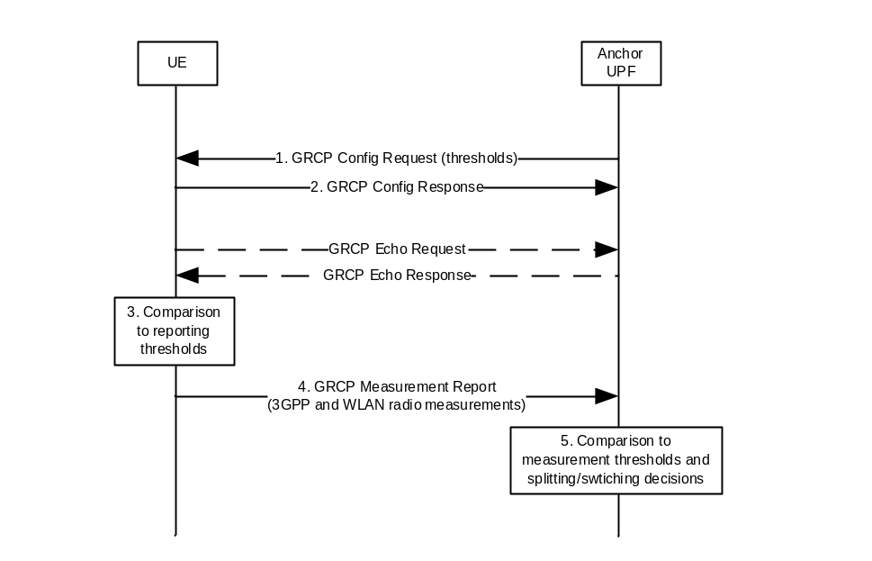
Figure 6.6.3.2-1: UE-AT3SF measurement configuration and reporting procedure
1. UP-AT3SF at the Anchor UPF sends GRCP Config Request (list of (threshold low, threshold high, reporting period)) to the UE. This is performed at least when the user plane is established, hence triggered by SMF. The UP-AT3SF may also send GRCP Config Request at any point in time when the UE is in connected mode.
There may be one or several sets of (threshold low, threshold high, reporting period). This allows the network to adjust the reporting period.
2. The UE acknowledges with GRCP Config Response. Repetitions may occur if the UE does not acknowledge, but this is a stage 3 matter.
3. The UE performs appropriate measurements and compare them to configured “reporting thresholds”.
4. The UE sends AARCP Measurement Report (access type, set of measurements) to the UP-AT3SF. When a threshold low/high is reached, the UE adapts its measurement reporting period.
5. UP-AT3SF compares the measurements received from the UE with corresponding "measurement thresholds" configured in the UP-AT3SF by the operator and determines how to split/switch the downlink traffic according to ATSSS rules related to PDU session and data flow filters.
The GRCP Measurement Reports are sent over the best access to avoid retransmissions and high transmission power when the UE is at the edge of the cell in that access.
The measurements need to be independent from the UE implementation, in order to avoid two UEs in same radio conditions to report different measurement values. Measurements can be for example:
- Round Trip Time. There is no need to report such measurement because it is measurable directly by the UPF.
A first alternative is to calculate RTT from a TCP flow between two hosts, by using TCP timestamps option per IETF RFC 1323 [11] which is commonly used by both end hosts on a connection to refine the RTT to improve the performance of TCP in the presence of loss. The TCP stack also maintains the variance in the measured RTT, the RTTVAR.
Another alternative would be to specify GRCP Echo Request and GRCP Echo Response to be exchanged between the UE and the network. This measurement may be used by UP-AT3SF for certain applications that are sensitive to latency. UP-AT3SF can also use the RTT variation to detect that the access is degrading but this should be taken with care as it will happen at cell changes.
- the received power/quality, e.g. CSI-RSRP/CSI-RSRQ for NR 3GPP access, E-UTRA RSRP / E-UTRA RSRQ for E-UTRAN and IEEE 802.11 WLAN RSSI for WLAN as defined in TS 38.215 [8]).
- the downlink backhaul data rate and the WLAN channel utilization (defined in IEEE 802.11 [3]) as specified in TS 36.300 [9].

The corresponding "reporting thresholds" in the UE are:
- For the received power thresholds: the minimum E-UTRAN/NR signal strength thresholds (RSRP and RSRQ for 3GPP access) and the minimum WLAN signal strength (Beacon RSSI), as defined in TS 36.300 [9] and TS 38.215 [8].
- For the WLAN load measurements thresholds: maximum WLAN channel utilization threshold and minimum WLAN backhaul data rate threshold.
- For each above reporting threshold, the reporting frequency when the threshold is reached.
There can be several threshold values for a given type, with different reporting frequencies. For example:
- RSRP > -90dBm; reporting frequency = 30 seconds.
- RSRP < -90 dBm; reporting frequency = 5 seconds.
- RSRP < -110 dBm; reporting frequency = 1 second.
The corresponding "measurement thresholds" in the UP-AT3SF are:
- For the received power thresholds: the minimum E-UTRAN/NR signal strength thresholds (RSRP and RSRQ for 3GPP access) and the minimum WLAN signal strength (Beacon RSSI), as defined in TS 36.300 [9] and TS 38.215 [8].
- For the WLAN load measurements thresholds: maximum WLAN channel utilization threshold and minimum WLAN backhaul data rate threshold.
The reporting thresholds in the UE, as well as the measurement thresholds in the UP-AT3SF, are intended to be configured by the operator to the same value for all UEs. They allow the UPF/UE to decide whether to add/remove data flow(s) to/from WLAN

6.6.3.3 Control plane protocol stack between UE-AT3SF and UP-AT3SF

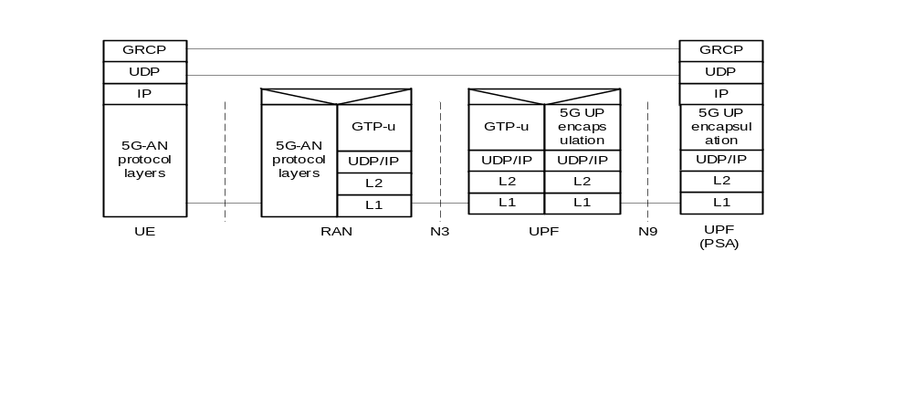
Figure 6.6.3.3-1: UE-AT3SF UP-AT3SF control plane for 3GPP access

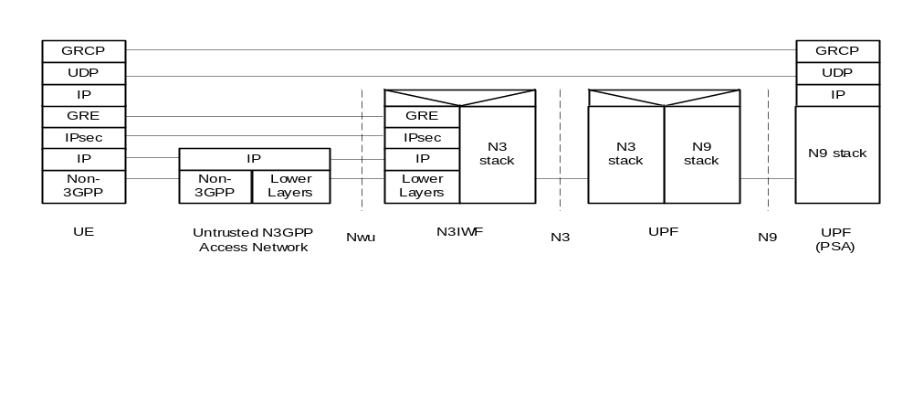
Figure 6.6.3.3-2: UE-AT3SF UP-AT3SF control plane for non-3GPP access

6.6.4 Impacts on existing entities and interfaces
This solution impacts the following entities in 5GS:
- SMF
- PCF
- UDM
- UPF
- UE

6.7 Solution 7: Traffic Steering using Access Network Performance Measurements

6.7.1 General
The solution specified in this clause (a) enables the UE, after establishing a MA-PDU session, to measure the "Access Network Performance" (ANP) parameters (e.g. Throughput, Delay, Loss Rate and possibly other parameters, such as the Jitter) on 3GPP and non-3GPP accesses, and (b) to apply steering rules that depend on the measured ANP parameters. For example, the UE could apply the steering rule: "Route traffic with destination 10.10.1.2 to the access with the highest Throughput" or "Route traffic of App-X to 3GPP access, if Delay on 3GPP access < 20ms".
The key aspects of this solution are summarized below:
1. During the MA-PDU session establishment, the UE is provided with Measurement Assistance policy, which defines how the UE can measure certain parameters on the 3GPP and non-3GPP accesses, including the Throughput, the Delay and the Loss rate. These parameters are referred to as "Access Network Performance" (ANP) parameters. The Measurement Assistance policy received by the UE may indicate:
- The IP address and port of a network function, with which the UE can initiate measurement sessions. This function is referred to as Performance Measurement Function (PMF) and may be a standalone function, or a function collocated with the UPF.
- The protocol to use for the measurements, e.g. UDP, TCP, etc.
- The maximum duration and/or the maximum number of bytes to transmit during a measurement session.
- How frequently the UE should attempt to initiate a measurement session on a specific access.
NOTE: A "measurement session" is an IP communication session between the UE and the PMF used to measure the ANP parameters. It should not be confused with a PDU session.
2. After the MA-PDU session is established, the UE employs the received Measurement Assistance policy to initiate measurement sessions with a PMF and to determine the ANP parameters on the 3GPP and non-3GPP accesses.
3. During the MA-PDU session establishment, the UE is also provided with ATSSS rules that determine how the uplink traffic of the MA-PDU session should be distributed across the 3GPP and non-3GPP accesses. An ATSSS rule may contain specific ANP parameters (i.e. Delay, Throughput and Loss Rate). Examples of such ATSSS rules include:
- "Route traffic of App-A to the access with the smallest Loss Rate"
- "Route IMS voice traffic to the access with the smallest Delay"
- "Route traffic of App-B to 3GPP access, if Delay over 3GPP access < 40ms"
- "Route traffic of App-C to non-3GPP access, if Throughput over non-3GPP access > 1Mbps"
The UE applies the ATSSS rules after performing a measurement session to estimate the ANP parameters on each access.
4. A measurement session over 3GPP (or non-3GPP) access may be initiated by the UE when there is no PDU session traffic to send over 3GPP (or non-3GPP) access. This way, the measurement traffic does not interfere with and does not impact the PDU session traffic. However, if the Measurement Assistance policy received by the UE allows so, a measurement session may also be initiated when the UE transmits / receives PDU session traffic.
5. The measurement traffic between the UE and PMF is not charged (appropriate PCC rules are created by PCF).
6. Packet Detection Rules (PDRs) are provided to UPF, which may also contain specific ANP parameters. The PDRs are used by the UPF to determine how the downlink traffic of the MA-PDU session should be distributed across the 3GPP and non-3GPP accesses.

6.7.2 Reference Architecture
A new user-plane function is introduced, called Performance Measurement Function (PMF). The PMF could be implemented in the UPF, or outside the UPF as a standalone function. The UE can initiate a measurement session with the PMF over each access in order to estimate the ANP parameters for each access, such as Throughput, Delay and Loss rate. The UE utilizes the information in the received Measurement Assistance policy to determine the address/port of PMF and other details required for the measurement session, e.g. the protocol to use, the maximum number of bytes to transmit, etc.
Figure 6.7.2-1 shows the architecture when the PMF is implemented as a standalone function, while Figure 6.7.2-2 shows the architecture when the PMF is collocated with the UPF. The UE can communicate with the PMF over the user plane, using either 3GPP access or non-3GPP access. The Mx is a logical interface between the UE and PMF, employing IP transport. The protocols running over Mx are used to support measurement sessions between the UE and PMF, and to measure ANP parameters such as Throughput, Delay and Loss Rate.
NOTE: The communication between the UE and PMF over Mx can be defined by 3GPP or can be based on existing tools that measure ANP parameters, such as the iPerf tool (see https://iperf.fr/).
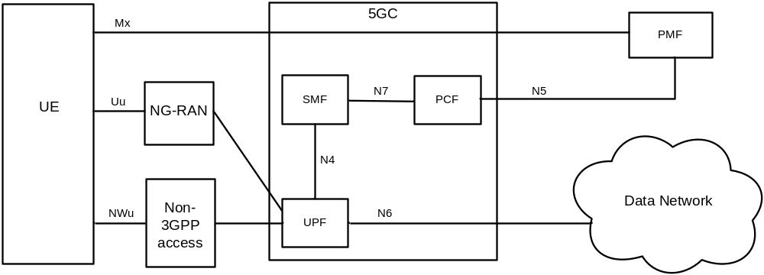
Figure 6.7.2-1: Architectural model with standalone PMF
Editor's note: It is FFS if the PMF should preferably interface with the SMF, instead of the PCF.
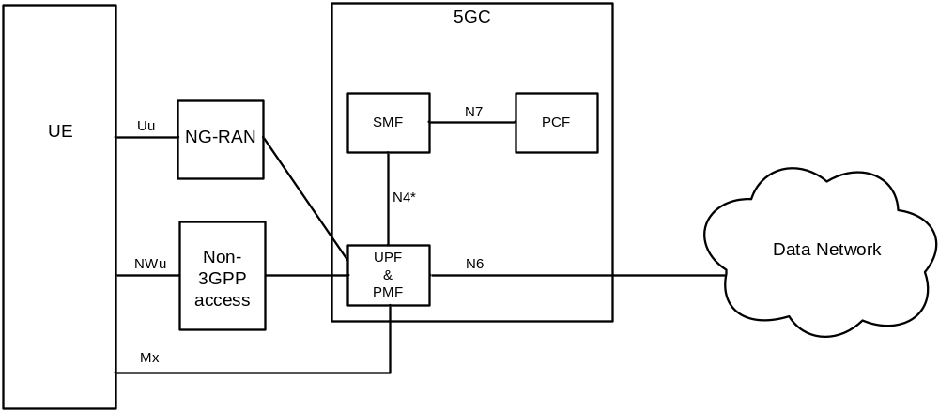
Figure 6.7.2-2: Architectural model with PMF located in UPF
Editor's note: What kind of extensions may be required on the N4 interface is FFS.
Editor's note: When the PMF is collocated with the UPF, the UE could initiate DoS attacks to UPF. How these attacks can be prevented is FFS and requires SA3 involvement.

6.7.3 Procedures

6.7.3.1 Procedure with Standalone PMF
The procedure in the figure below illustrates (a) how the UE receives ATSSS rules and Measurement Assistance Policy rules during the MA-PDU session establishment, (b) how the UE applies the Measurement Assistance Policy to initiate measurement sessions over 3GPP and non-3GPP accesses and measure ANP parameters, and (c) how the UE uses the measured ANP parameters to apply the ATSSS rules and distribute the MA-PDU session traffic across the two accesses.
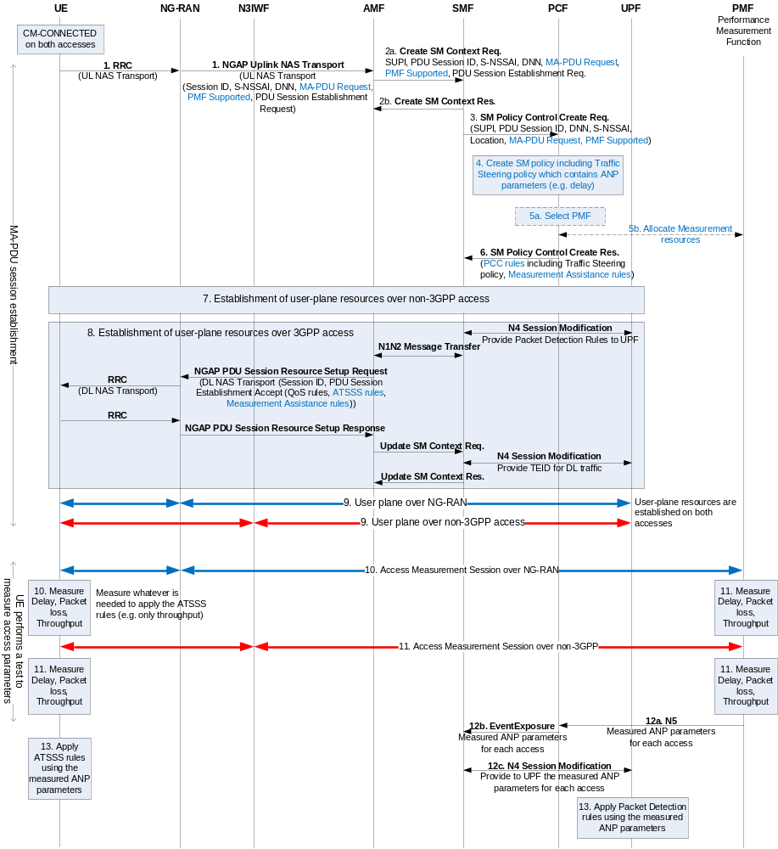
Figure 6.7.3.1-1: Procedure with standalone PMF
1-2. The UE requests a MA-PDU session by sending a NAS message to AMF including a PDU Session Establishment Request (as specified in clause 6.2.3.2, "Combined Establishment"). The NAS message includes a MA-PDU Request indication, which indicates that the request is for a multi-access PDU session. It may also include a PMF Supported indication, which indicates that the UE supports Access Measurements. The UE does not include the PMF Supported indication in step 1, if the indication has been sent to AMF during a Registration procedure.
3. The PMF Supported indication is forwarded to PCF, when the SMF requests Session Management (SM) policy for the MA-PDU session.
4. The PCF derives the SM policy for the MA-PDU session, which includes PCC rules for traffic steering which specify how traffic should be distributed across the two accesses of the MA-PDU session. When deriving the PCC rules for traffic steering, the PCF takes into account the PMF Supported indication received in step 3. If this indication is received, then the PCF may derive PCC rules for traffic steering that contain ANP parameters, e.g. PCC rules of the form "Steer traffic of App-X to the access with the largest Throughput". If this indication is not received (i.e. the UE cannot support measurements), the PCF derives PCC rules for traffic steering that do not contain ANP parameters.
5. If the PCF derives one or more PCC rules for traffic steering that contain ANP parameters, then the PCF must also derive Measurement Assistance Policy rules, which assist the UE in conducting ANP measurements. To derive the Measurement Assistance Policy rules, the PCF may select a PMF and then request from the selected PMF to reserve resources required to support the measurements of the specific UE. In most cases, reserving such resources means instantiating a process in PMF which awaits for the measurements requests from the UE. In some cases, the resource reservation in the PMF may not be required, so the step 5 is not needed. In such cases, the PMF does not use dedicated measurement resources for each UE but uses the same measurement resources shared by all UEs.
Editor's note: The details of the PMF selection in step 5a are FFS. The PMF address could be retrieved either with a DNS query or by using the NRF discovery service (if the PMF is a NF in 5GC). It is also FFS if one or multiple PMFs in the standalone scenario are needed.
6. The PCF sends to SMF the created SM policy for the MA-PDU session, which includes the derived PCC rules for traffic steering and the Measurement Assistance Policy rules. The SMF uses the received PCC rules for traffic steering to create steering rules for the UE (i.e. ATSSS rules) and Packet Detection Rules for the UPF.
7. The SMF initiates the establishment of user-plane resources over the non-3GPP access, as specified in TS 23.502 [6] and according to the MA-PDU session establishment procedure in clause 6.2.3.2, "Combined Establishment". During this step, the UE does not receive a PDU Session Establishment Accept message.
8. The SMF initiates the establishment of user-plane resources over the 3GPP access. This step is similar to the previous step but it is shown in more details because in this step the UE receives a PDU Session Establishment Accept message. This message contains (a) the Measurement Assistance Policy rules provided by PCF and (b) the ATSSS rules, which were created by the SMF by using the PCC rules for traffic steering.
9. The user-plane resources on both accesses have been reserved and, thus, the UE can send and received PDU session traffic (i.e. user data) over both accesses.
10. The UE (possibly before sending any PDU session traffic) starts a measurement session over 3GPP access (NG-RAN) and also starts a measurement session over non-3GPP access. These measurement sessions can be conducted in parallel and utilize the information included in the Measurement Assistance policy provided to UE.
NOTE: A measurement session between the UE and PMF over Mx can be conducted based on procedures defined by 3GPP or based on existing tools, such as the iPerf tool (see https://iperf.fr/).
11. During each measurement session, one or more ANP parameters (e.g. the Throughput, the Delay and the Loss Rate) are measured by the UE and by the PMF.
12. The PMF forwards the values of the measured ANP parameters to the PCF. These values are then sent to UPF via the SMF.
13. The UE and the UPF now use the values of the measured ANP parameters to decide how to route the uplink and the downlink traffic respectively across the two accesses of the MA-PDU session. These decisions are taken by using the ATSSS rules in the UE and the Packet Detection rules in the UPF (provisioned in step 8).

6.7.3.2 Procedure with PMF collocated with UPF
When the PMF is collocated with the UPF, the procedure is modified (and simplified) as shown in the figure below. The steps discussed below show the differences from the standalone case presented in Figure 6.7.3.1-1.
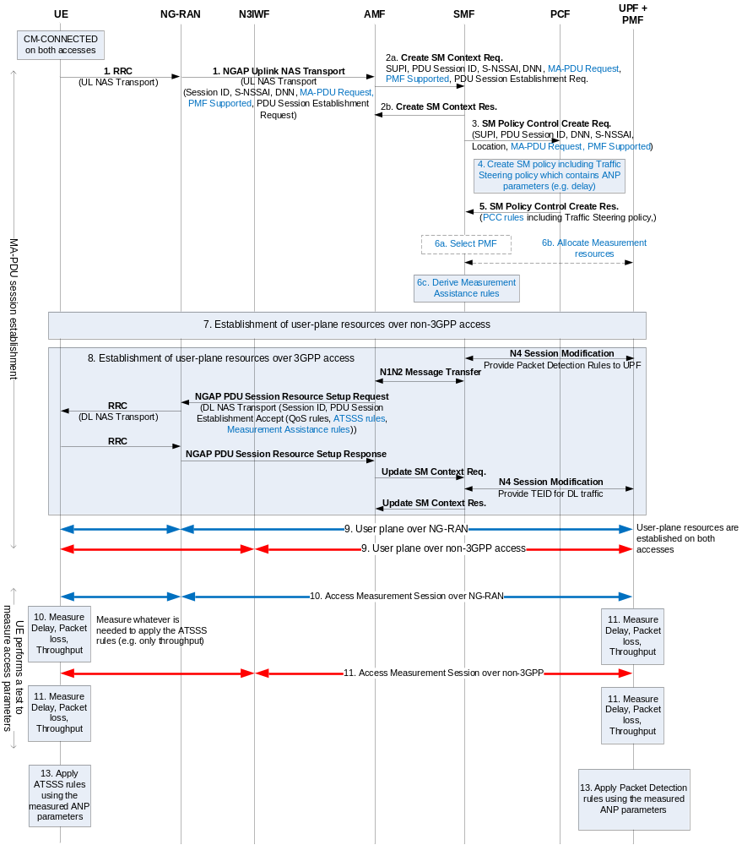
Figure 6.7.3.2-1: Procedure with PMF located in UPF
3-5. As in the standalone case, the PCF derives PCC rules for traffic steering for the MA-PDU session that may contain ANP parameters, e.g. rules of the form "Steer traffic of App-x to the access with the largest Throughput". However, the PCF does not derive Measurement Assistance Policy rules.
6. If the SMF receives one or more PCC rules for traffic steering that contain ANP parameters, then the SMF derives Measurement Assistance Policy rules, which assist the UE in conducting ANP measurements. Before deriving these rules, the PCF may select a PMF and request from the selected PMF to reserve resources required to support the measurements from the UE. If all the PCC rules for traffic steering received by SMF contain no ANP parameters, then the SMF does not derives Measurement Assistance Policy rules (since the UE does not need to perform any measurements).
12. This step is not required because the measured ANP parameters are already available in UPF.

6.8 Solution 8: ATSSS rules for supporting 3GPP RAT differentiation

6.8.1 General
This solution applies to Key Issue #6: Key issue on differentiation of 3GPP RATs in ATSSS rule.
An ATSSS Rule contains the following parameters:
- ATSSS Rule Identifier.
- ATSSS Rule Priority.
- Packet Filter Set.
- Steering Mode
- Access Technology.

The ATSSS Rule Identifier uniquely identifies an ATSSS Rule in the UE.
For the purpose of matching data flows against ATSSS Rules, the Packet Filter Set is applied in the order of the ATSSS Rule Priority.
There are two types of Packet Filter Set, i.e. IP Packet Filter Set, and Ethernet Packet Filter Set, corresponding to those PDU Session Types. The Packet Filter Set may contain multiple packet filters. The Packet Filter Set is defined in TS 23.501 [5] clause 5.7.6.
The Steering Mode represents how the UE steers or switches uplink traffic based on Access Technology. For example, if Steering Mode is "Active-Standby", traffic that matches Packet Filter Set is steered over "Active Access Technology" and if the "Active Technology" becomes unavailable, the UE steers the traffic over "Standby Access Technology".
NOTE 1: The Steering Modes in Solution 4 such as "Active-Standby", "Priority-based", "Best-Access", etc are applicable for this solution.
The Access Technology indicates a prioritized access technology for steering data flows, and possible values for the Access Technology are described in Table 6.8-1. If a 3GPP access technology corresponding to the value configured for the Access Technology is not selected by the UE then the UE shall ignore this configuration until the 3GPP access technology corresponding to the value configured for the Access Technology becomes selected.
NOTE 2: When a UE is using more than two access technologies at same time (e.g. Dual Connectivity), the UE uses Master RAN node's RAT to find matching ATSSS rule. In this case, the data flows may be sent over the Secondary RAN node's RAT, which is different from the RAT in the ATSSS rule.

Table 6.8-1: Possible values for the Access Technology
Value | Description
0 | Reserved
1 | Any 3GPP access technology e.g. NR, E-UTRA
2 | WLAN
3 | NR
4 | E-UTRA
5-255 | Reserved

The SMF sends ATSSS Rule to the UE via NAS signalling. When the SMF sends ATSSS Rule, the SMF includes a default ATSSS Rule, which has a match all Packet Filter Set with the highest ATSSS Rule Priority value. The UE uses the received ATSSS Rule for uplink data flow steering. The UE evaluates UL packets against the Packet Filter Set in the ATSSS rule based on the ATSSS Rule Priority in increasing order until a matching ATSSS rule is found. If there is matching ATSSS rule the UE sends uplink data flow to the target access (i.e. access using the matched Access Technology). If there is no matching ATSSS rule, the UE follows default ATSSS rule.
NOTE-3: The UE does not use ATSSS Rule to determine which access or RAT to connect to.

6.9 Solution 9: Solution for the UL CL case on the Multi-access PDU sessions
6.9.1 General
This solution intends to solve the problem of KI 5 bullet 9. For the multi-access PDU session, the traffic flow also can be supposed to be routed locally. Therefore, the multi-access PDU session should support the usage of an UL Classifier.
Two cases are discussed:
Case 1:
In case the N3IWF is distributed deployed by operator, in order to guarantee the traffic data can be switched between the 3GPP access and the non-3GPP access type efficiently, in case the SMF decides to add the UL CL function during the PDU session establishment, the SMF should insert the UL CL function into the traffic routing of both the 3GPP access type and non-3GPP access type shown as Figure 6.9.1-1.
After the UL CL function is inserted, the UL CL become the ATSSS anchor. The SMF should provide the ATSSS forwarding rules to the UL CL. When UL CL receive the uplink data, UL CL applies filtering rules (e.g. to examine the destination IP address/Prefix of UL IP packets sent by the UE) and determines how the uplink packet should be routed as specified in TS 23.501 [5]. When UL CL receive the downlink data, UL CL determiners which access is selected to transmit the data based on the ATSSS forwarding rules.
If the UL CL function is inserted after PDU Session Establishment, the ATSSS anchor is moved from the original UPF, e.g. UPFA, to the UL CL function.
Case 2:
In case the N3IWF is centric deployed by operator, operator select one of the access to insert the UL CL. For example, if the Application Server is nearby the 3GPP access (NG-RAN), the operator select the 3GPP access to insert the UL CL. If the Application Server is nearby the non-3GPP access (N3IWF), the operator select the non-3GPP access to insert the UL CL.

6.9.2 Architecture description
Case 1: Figure 6.9.2-1 depicts the ATSSS architecture with UL CL function insertion into both 3GPP access and non-3GPP access.
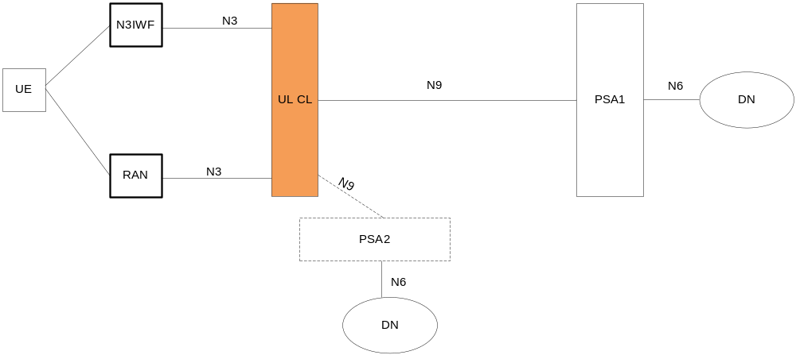
Figure 6.9.2-1 the ATSSS architecture with UL CL function insertion to both 3GPP access and non-3GPP access
NOTE: It is possible for a given UPF to support both the UL CL and the PDU Session Anchor functionalities. In this case, based on the ATSSS forwarding rules, the UL CL performs the access traffic switching, splitting, steering. And UL CL performs the path performance measurement. The PSA1 stops to do the access traffic switching, splitting, steering and path performance measurement after insertion.
Case 2: Figure 6.9.2-2 depicts the ATSSS architecture with UL CL function insertion to single access, e.g., 3GPP access type.

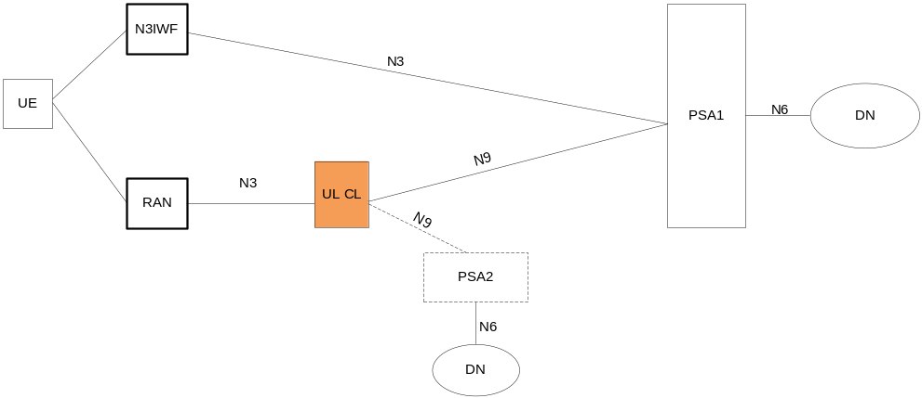
Figure 6.9.2-2 the ATSSS architecture with UL CL function insertion to single access
NOTE-1: It is possible for a given UPF to support both the UL CL and the PDU Session Anchor functionalities.
In this case, the UL CL is inserted into 3GPP access, the PSA1 shall not be impacted.
Editor’s Notes: In case the traffic data is encapsulated between the UE and the PSA1 (e.g. as described in clause 6.1.7 or in clause 6.3 or in clause 6.5), e.g., the GRE, TFCP, MPTCP proxy, how the UL CL identify the traffic which should be locally routed is FFS.
NOTE-2: The Session-AMBR is not able be controlled in case 2.
NOTE-3: SMF shall ensure ATSSS forwarding rules doesn’t have conflict with filtering rules to be sent to UL CL. That means the filtering rules provided by SMF to inform UL CL perform diverting (locally) traffic should exclude the traffic steered by MPTCP function.

6.9.3 PDU session Establishment Procedure with additional UL CL and PDU session Anchor
This clause proposes the procedure to insert UL CL based on the MA PDU Session Establishment Procedure.

6.9.3.1 Establishment of Multi-Access PDU session with UL CL based on the solution 3 architecture framework
During PDU session establishment procedure, the SMF may decide to insert in the data path of a PDU Session an "UL CL" (Uplink classifier).
In case 1, SMF decide to insert the UL CL to both 3GPP access and non-3GPP access.

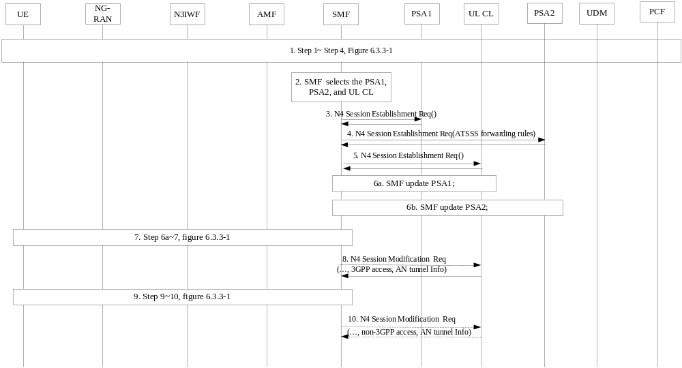
Figure 6.9.3.1-1: Multi-Access PDU Session establishment procedure with UL CL with TFCP tunnel
1. The UE initiates the "UE Requested PDU Session Establishment" procedure, the detail is the same with Step 1~ step 5 as described in figure 6.3.3-1.
2. SMF selects the UPF (UL CL function). Based on the UPF selection criteria the SMF decides to add the UL CL function in this PDU session.
3. The SMF selects a PSA1 and using N4 establish the PSA1 of the PDU Session.
4. The SMF selects a PSA2 and using N4 establish the PSA2 of the PDU Session.
5. SMF sends the N4 session establishment messasge (ATSSS forwarding rules, PSA1 CN tunnel info, PSA2 CN tunnel info) to establish the tunnel between the UL CL and PSA1 and PSA1.
Based on the ATSSS forwarding rule, the UL CL function perform the access traffic switching, splitting, and steering. The UL CL function can perform the path performance measurement.
In case the SMF aware the PDU session is the MA-PDU session, the SMF should add the UL CL function to each traffic routing of 3GPP access and Non-3GPP access.
6a. SMF updates the PSA1 via N4. It provides the UL CL tunnel info for the downlink traffic data.
6b. SMF updates the PSA2 via N4. It provides the UL CL tunnel info for the downlink traffic data.
7. The other steps is described as the step 6a~step 7 in figure 6.3.3-1.
8. The SMF sends the RAN tunnel Info and 3GPP access type to the UL CL function.
9. The step 9~step 10 in figure 6.3.3-1.
10. The SMF sends the N3IWF tunnel Info and Non-3GPP access type to the UL CL function. The UL CL function stored both access tunnel information and the binding access type for this Multi-Access PDU Session. This binding relationship can be used when performing the traffic splitting or switching in user plane.

In case 2: the SMF decide to insert the ULCL to one of the two access, e.g. 3GPP access.
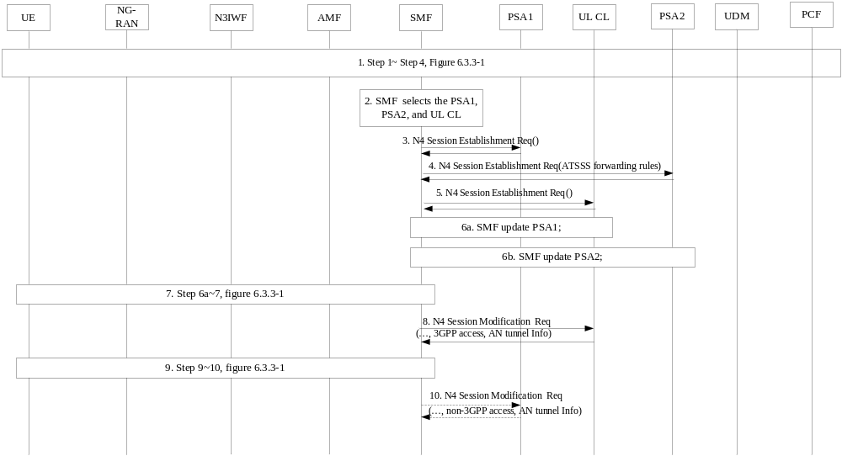
1. The UE initiates the "UE Requested PDU Session Establishment" procedure, the detail is the same with Step 1~ step 5 as described in figure 6.3.3-1.
2. SMF selects the UPF (UL CL function), Based on the UPF selection criteria and operator’s network deployment, the SMF decides to add the UL CL function into the 3GPP access side of the PDU session.
3. The SMF selects a PSA1 and using N4 establish the PSA1 of the PDU Session.
4. The SMF selects a PSA2 and using N4 establish the PSA2 of the PDU Session.
5. SMF sends the N4 session establishment message (PSA1 CN tunnel info, PSA2 CN tunnel info) to establish the tunnel between the UL CL and PSA1 and PSA2.
6a.SMF updates the PSA1 via N4. It provides the UL CL tunnel info for the downlink traffic data.
6b.SMF updates the PSA2 via N4. It provides the UL CL tunnel info for the downlink traffic data.
7. The step 6a~step 7 in figure 6.3.3-1.
8. The SMF sends the RAN tunnel Info to the UL CL function.
9. The step 9~step 10 in figure 6.3.3-1.
10. The SMF sends the N3IWF tunnel Info and Non-3GPP access type to the PSA1. The PSA1 update the tunnel info for the downlink traffic.

6.9.4 Insert UL CL and additional PDU Session Anchor after PDU Session Establishment

6.9.4.1 Insert UL CL to both 3GPP access and Non-3GPP access
After the PDU session establishment procedure, in case 1 described in clause 6.9.1, the SMF may decide to insert in the data path of a PDU Session an "UL CL" (Uplink classifier).
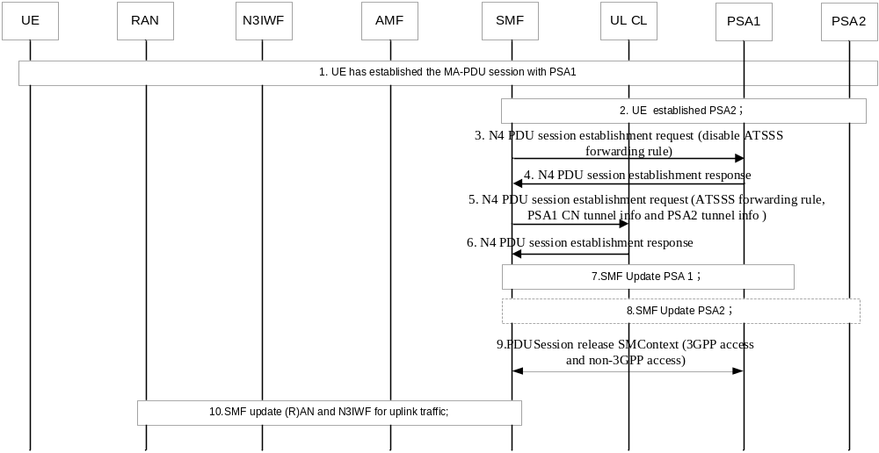
Figure 6.9.4.1-1 Addition of additional PDU session anchor and UL CL in the 3GPPaccess and Non-3GPP access
- UE has an established MA-PDU session with a UPF including the PDU session anchor 1(PSA1 in Figure 6.9.4.2-1). The PDU session User plane involves 3GPP access (the (R)AN and PSA1) and non-3GPP access(the N3IWF and PSA1).
- At some point the SMF decides to establish a new PDU Session Anchor e.g. new flow detection. The SMF selects a UPF and using N4 establish the new PDU Session Anchor 2 (PSA2 in Figure 6.9.4.1-1) of the PDU Session.
- SMF sends the N4 PDU session establishment request (disable ATSSS forwarding rule) to the PSA1. Based on the disable ATSSS forwarding rule indication, the PSA1 should stop to do access traffic switching, splitting and steering. And it stops to perform the path performance measurement as well. If CN Tunnel Info is allocated by the SMF, the new CN Tunnel Info is provided to UPF in this step.
- PSA1 sends the N4 PDU session establishment response to the SMF.
- The SMF selects a UPF and using N4 establish the UL CL for the PDU Session. It provides the necessary uplink forwarding rules towards PSA1 and PSA2 including the PSA1 CN Tunnel Info and the PSA2 CN Tunnel Info. In addition, the AN Tunnel Info of both 3GPP access and non-3GPP access is provided for downlink forwarding. The SMF provides traffic filters indicating what traffic shall be forwarded towards PSA1 and PSA2 respectively. The SMF provides the ATSSS forwarding rule to the UL CL, based on the ATSSS forwarding rules, the UL CL performs the access traffic switching, splitting and steering. The UL CL can perform path performance measurement.
- The UL CL sends the N4 PDU session establishment response to the SMF.
- The SMF updates the PSA1 with the UL CL tunnel info.
- The SMF updates the PSA2 with the UL CL tunnel info.
- The SMF sends the PDU session release SM Context (3GPP access and non-3GPP access). The UPF releases the original PSA1 tunnel info associated with the 3GPP access and non-3GPP access.
- The SMF updates (R)AN/N3IWF via N2 SM information over N11. It provides the UL CL Tunnel Info to the (R)AN/N3IWF for the uplink traffic data.

6.9.4.2 Insert UL CL to a single access
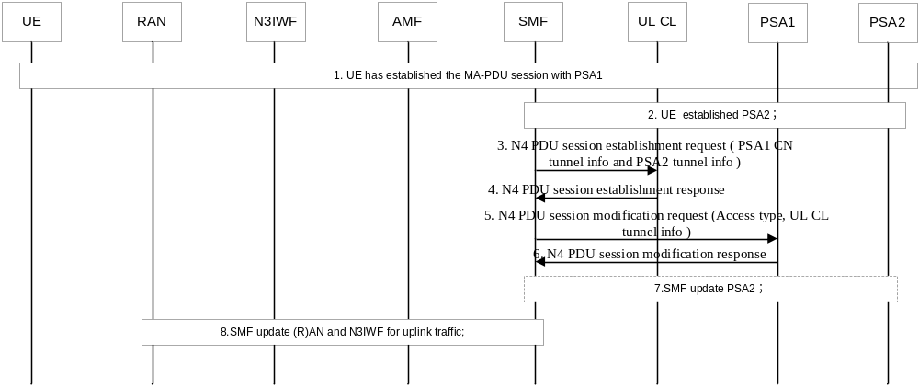 Figure 6.9.4.2-1 Addition of additional PDU session anchor and UL CL in the single access
- UE has an established MA-PDU session with a UPF including the PDU session anchor 1(PSA1 in Figure 6.9.4.1-1). The PDU session User plane involves 3GPP access (the (R)AN and PSA1) and non-3GPP access(the N3IWF and PSA1).
- At some point the SMF decides to establish a new PDU Session Anchor e.g. new flow detection in a single access side. The SMF selects a UPF and using N4 establish the new PDU Session Anchor 2 (PSA2 in Figure 6.9.4.2-1) of the PDU Session.
- The SMF selects a UPF and using N4 establish the UL CL for the PDU Session. Based on the network deployment, the SMF decide to insert the UL CL into 3GPP access side, it provides the necessary uplink forwarding rules towards PSA1 and PSA2 including the PSA1 CN Tunnel Info and the PSA2 CN Tunnel Info. In addition, the RAN Tunnel Info of 3GPP access is provided for downlink forwarding. In this case the SMF provides traffic filters indicating what traffic shall be forwarded towards PSA1 and PSA2 respectively.
- The UL CL sends the N4 PDU session establishment response to the SMF.
5. SMF sends the N4 PDU session modification request (3GPP access, UL CL tunnel info) to the PSA1. The SMF provides the UL CL tunnel info for the downlink traffic data.
6. PSA1 sends the N4 PDU session modification response to the SMF.
7. The SMF updates PSA2 via N4. It provides the UL CL CN Tunnel Info for downlink traffic.
NOTE: In case the Branching Point or UL CL and the PSA2 are co-located in a single UPF then step 7 is not needed.
8. The SMF updates (R)AN via N2 SM information over N11. It provides the UL CL Tunnel Info corresponding to the (R)AN for the uplink traffic data.

6.10 Solution 10: ATSSS Solution using a MA-PDU Session

6.10.1 General
The solution specified in this clause is an ATSSS solution based on concepts introduced in other solutions in this technical report, and specifically on concepts in solution 2, solution 4, solution 5, solution 6 and solution 7.
To support traffic steering, switching and splitting between 3GPP and non-3GPP accesses, this solution establishes a Multi-Access PDU (MA-PDU) session and:
- Applies only the Multipath-TCP (MPTCP) function for steering TCP traffic; or
- Applies only an ATSSS function for steering IP traffic; or
- Applies both the MPTCP function (for TCP traffic) and the ATSSS function (for the rest of the traffic).
Whether both the MPTCP function and the ATSSS function are applied, or whether one of these functions is applied, is negotiated between the UE and the network during the MA-PDU session establishment.
The ATSSS function is a low-layer function in the UE and in the UPF that is specified in this solution for enabling ATSSS. This ATSSS function is required when the MPTCP alone is not sufficient.

6.10.2 Reference Architecture
The reference architecture is shown in the figure below.
The UPF is functionally enhanced (over Rel-15) to support an internal Performance Measurement Function (PMF) and an internal Multipath-TCP (MPTCP) proxy. Both of these new functional elements are further described below. The PMF is also discussed as part of solution 7 and is functionality similar to the UP-AT3SF in solution 6. The MPTCP proxy is similar to the MPTCP proxy in solution 5 but it operates as a transparent (or "on-path") MPTCP proxy, i.e. it is transparent to UE.
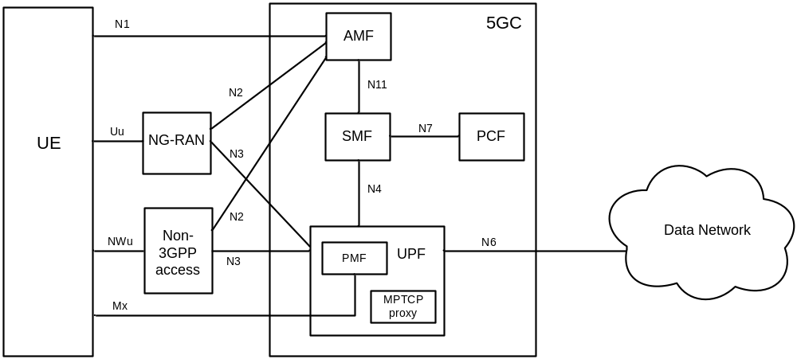
Figure 6.10.2-1: Reference Architecture
The UE, SMF and PCF are also functionally enhanced to support the functionality specified in the next clause.
The Mx reference point supports a new logical interface between the UE and PMF, which is used for access-agnostic measurements.

6.10.3 Functional Description
The key functional features of this solution are summarized below:
Support of MA-PDU sessions (based on Solution 2)
- The solution supports ATSSS with a Multi-Access PDU (MA-PDU) session. In other words, ATSSS procedures are applied after a MA-PDU session is established. How ATSSS can be applies without a MA-PDU session is outside the scope of this solution.
- A MA-PDU is established using a single PDU session ID, as specified in clause 6.2.3.
Editor’s Note: Using different PDU session IDs for a MA-PDU session, as specified in clause 6.2.2, is FFS.
- A MA-PDU session is established either with the Separate Establishment procedure, as specified in clause 6.2.3.1, or, with the Combined Establishment procedure, as specified in clause 6.2.3.2.
- When the UE sends a NAS message to request a MA-PDU session with the Combined Establishment procedure, the UE includes an "MA-PDU Request" indication in the NAS message.
- When the UE sends a NAS message to request a single-access PDU session and the UE supports MA-PDU sessions, the UE includes an "MA-PDU capability" indication in the NAS message. This indication may be used by the network to establish a multi-access PDU session instead of a single-access PDU session, as specified in clause 6.2.4.
- The network may decide to establish a MA-PDU session, instead of the requested single-access PDU session, in order e.g. to offload some PDU session traffic to non-3GPP access.
- The UE may decide to request a MA-PDU session for a DNN based on the provisioned USRP policy. That is, the URSP policy may indicate if a PDU session should preferably be established as a MA-PDU session.
Policy for Multi-Access QoS Control
- During the establishment of a MA-PDU session, the PCF may provide (a) PCC rules for QoS control over 3GPP access, and (b) PCC rules for QoS control over non-3GPP access.
- The PCC rules for QoS control over 3GPP access associate specific service data flows transmitted over 3GPP access with certain QoS parameters (e.g. 5QI, ARP, etc.). Similarly, the PCC rules for QoS control over non-3GPP access associate specific service data flows transmitted over non-3GPP access with certain QoS parameters (e.g. 5QI, ARP, etc.).
Editor’s note: It is FFS if separate PCC rules for QoS control are needed for each access, or if a single set of PCC rules for QoS control can be used for both accesses.
Policy for ATSSS Control (based on Solution 4)
- During the establishment of a MA-PDU session, the PCF may provide PCC rules, which specify how specific service data flows should be routed across the 3GPP and non-3GPP accesses. The SMF maps these PCC rules into (a) ATSSS rules which are sent to UE via the AMF, and (b) Packet Detection Rules which are sent to UPF. If the SMF does not receive PCC rules for ATSSS control from PCF, then the SMF uses its own, predefined PCC rules for ATSSS control.
Editor’s note: It is FFS if the PCC rules for ATSSS are different from the PCC rules for QoS control, or if they can be combined together.
- Each PCC rule for ATSSS control identifies (a) the traffic matching the rule and (b) the steering mode to apply to this traffic. Examples of PCC rules for ATSSS control include the following:
- "Traffic Descriptor: UDP, DestAddr 1.2.3.4", "Steering Mode: Active/Standby, Active=3GPP, Standby=non-3GPP"
  - This means "steer UDP traffic with destination IP address 1.2.3.4 to the active access (3GPP), if available. If the active access is not available, use the standby access (non-3GPP)".
- "Traffic Descriptor: TCP, DestPort 8080", "Steering Mode: Smallest Delay"
  - This means "steer TCP traffic with destination port 8080 to the access with the smallest Delay".
- "Application Id: reference to application detection filter", "Steering Mode: Active/Standby, Active=non-3GPP if Throughput on non-3GPP > 1Mbps"
  - This means "steer traffic that matches the application detection filter (e.g. the traffic of a certain application) to non-3GPP access, if the Throughput on non-3GPP access is greater to 1Mbps.
NOTE 1: The above rules can be applied because the Throughput and the Delay are measured for each access, as detailed below.
NOTE 2: As described below, a PCC rule for ATSSS control may be used to enable MPTCP-based steering, e.g. "Application Id: reference to MPTCP detection filter", "Traffic control policy: Redirect to MPTCP proxy", "Steering Mode: Smallest Delay".
Support of Access-Agnostic Measurements (based on Solution 6 and Solution 7)
- During the establishment of a MA-PDU session, the PCF may provide to UE Measurement Assistance Policy, as specified in clause 6.7. This policy is used by the UE to contact a Performance Measurement Function (PMF) in the network and measure certain parameters over 3GPP and non-3GPP accesses, including the Throughput, Delay and Loss rate. These parameters are referred to as "Access Network Performance" (ANP) parameters. The PMF is collocated with the UPF and it partly similar to the UP-AT3SF in solution 6.
Editor’s note: Further details of the Measurement Assistant Policy are FFS.
- The measurement traffic between the UE and PMF is not charged.
Support of MPTCP (based on Solution 5)
- The solution supports MPTCP as follows:
- During the MA-PDU session establishment, if the UE wants to use MPTCP for traffic steering, the UE provides an "MPTCP Request" indication.
- If the network agrees to enable MPTCP for the MA-PDU session then:
  - The network allocates two IP addresses for the MA-PDU session. This is required, otherwise MPCTP cannot be used. As specified in RFC 6824, "…there must be multiple addresses at least at one endpoint, for MPTCP to be used."
Editor’s note: Whether the two IP addresses are allocated to UE or to the MPTCP proxy is FFS.
  - The UPF is configured (with the appropriate Packet Detection Rules) to detect all or selected MPCTP flows (i.e. TCP flows including an MPTCP option in the TCP header; see RFC 6824) and to redirect them to the transparent MPTCP proxy that is collocated with the UPF. The transparent MPTCP proxy terminates an MPTCP connection with the UE and establishes a regular TCP (non-MPTCP) connection to the remote host. It then relays data traffic between the MPTCP connection and the regular TCP connection, as shown in the figure below. Note that the use of MPTCP is restricted to between the UE and the MPTCP proxy in the UPF. This is because MPTCP is applied in order to enable ATSSS within 5GS, not from end to end.
- 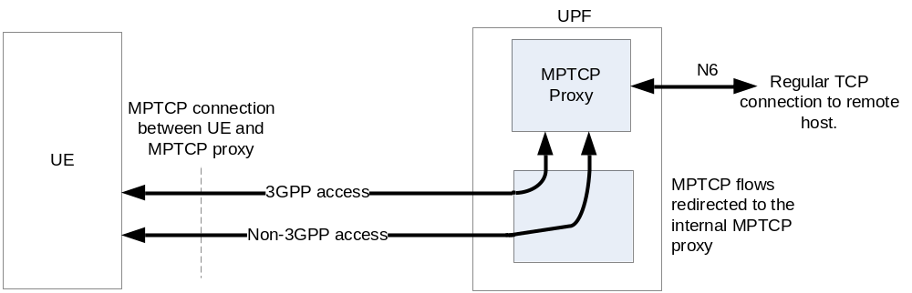
Figure 6.10.3-1: Insertion of MPTCP proxy in the data path
  - The UE is not aware of the MPTCP proxy, i.e. the proxy is transparent to UE.
Editor's note: Although this solution assumes the use of a transparent (or "on-path") MPTCP proxy, the use of a non-transparent (or "off-path") MPTCP proxy is also possible. Which type of MPTCP proxy is selected is FFS.
  - The PCF provide PCC rules for ATSSS control that apply to MPTCP flows, such as the following rule:
    - "Application Id: reference to MPTCP detection filter", "Traffic control policy: Redirect to MPTCP proxy", "Steering Mode: Smallest Delay"
    - This rule redirects all MPTCP flows to the transparent MPTCP proxy (inside the UPF) and configures the MPTCP proxy to route these flows across 3GPP and non-3GPP accesses using a "Smallest Delay" steering mode (this is the same as the "Aggregate MPTCP Service Type" in clause 6.5.5). Other types of steering modes can be used such as the "roundrobin" and "redundant", which are already supported in MPTCP implementations (see https://multipath-tcp.org/pmwiki.php/Users/ConfigureMPTCP).
  - From the PCC rules for ATSSS control, the SMF derives the corresponding Packet Detection Rules for the UPF, which enable the UPF to detect MPTCP flows and redirect them to its internal MPTCP proxy, as mentioned above.
  - From the PCC rules for ATSSS control, the SMF also derives the corresponding ATSSS rules for the UE, which instruct the UE to steer all MPTCP traffic with an "aggregate" steering mode. In the above example, the UE would receive the following ATSSS rule:
    - "Application Id: MPTCP", "Steering Mode: Smallest Delay"
- Within the same MA-PDU session, if MPTCP is enabled, it is possible to steer the MPTCP flows by using the MPTCP protocol (or the MPTCP function) and, simultaneously, to steer all other flows by using lower-layer steering functionality, called the "ATSSS function". This is schematically illustrated in the figure below for the UE. Note that the same set of ATSSS rules is applied to configure the MPTCP function and the ATSSS function. In Fig. 7-1 the MPTCP traffic goes through the MA-PDU session but not through the ATSSS function.
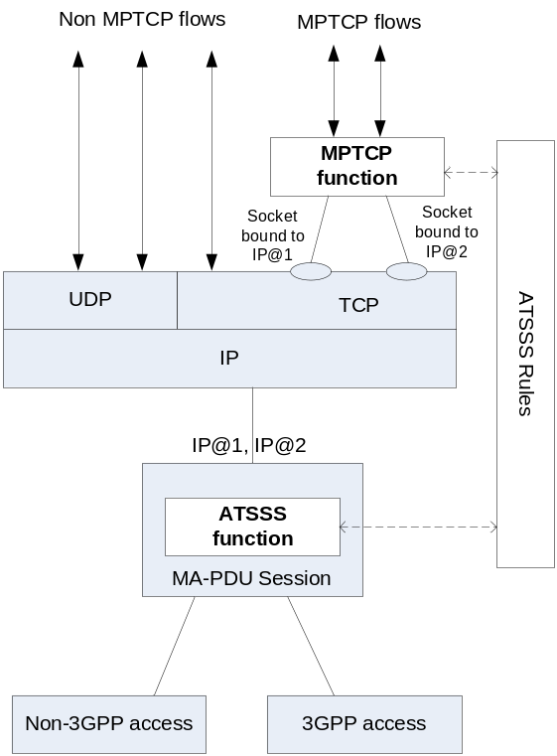
Figure 6.10.3-2: Example UE supporting an MPTCP function and an ATSSS function

6.11 Solution 11: Interworking for Multi-Access PDU Session

6.11.1 General
This solution addresses Key Issue#5 bullet 10 to handle the Multi-Access PDU Session in the scenario of interworking between EPC and 5GC.

6.11.2 Functional Description
Handling MA-PDU Session in different scenarios of interworking between EPC and 5GC are analysed below.

6.11.2.1 Interworking with N26 from EPC to 5GC
There is no change to EPS procedures.
After registration to 5GC (i.e. registration after handover or mobility registration update), if ATSSS rules are provided to the UE, the UE can re-evaluate ATSSS rules and derive whether a PDU Session can be a child PDU Session of MA-PDU Session.
Editor's note: It is FFS whether ATSSS rules are part of USRP rules or not.
If ATSSS rules are not provided to the UE, the UE provides its MA-PDU Session capability to the PGW-C+SMF, e.g. in UE 5G SM Capability, in PDU Session Modification Request. Based on local configuration, if SMF determines that this PDU Session can be a child PDU Session of the MA-PDU Session, SMF provides the UE and the AMF with a MA-PDU Session Capability indication. Then UE initiates the MA PDU Session establishment over N3GPP access, if available, using the separate establishment. This solution has the same mechanism in which UE updates its Reflective QoS capability after moving to 5GC, as described in TS 23.501 [5].
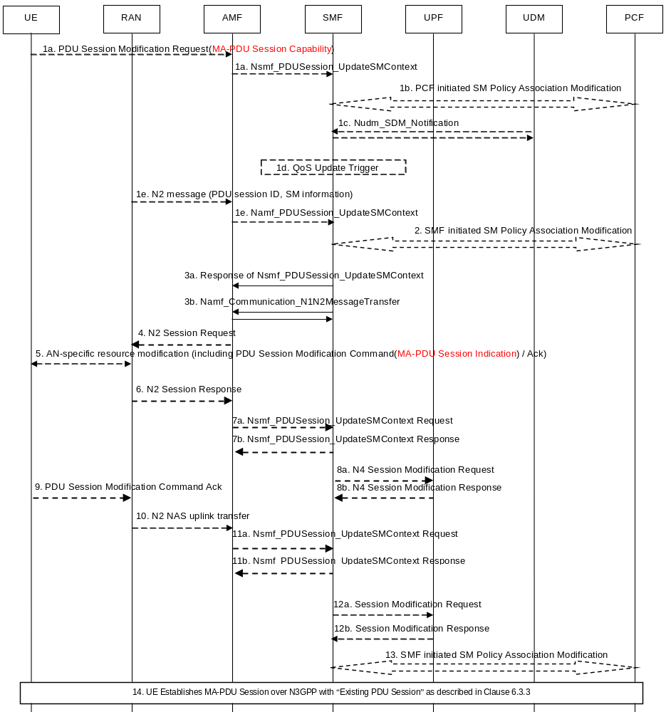
Figure 6.11.2.1-1: ATSSS Interworking PDU Session Modification procedure
UE moves from EPC to 5GC. For UE in connected mode, handover and registration procedures are executed as described in TS 23.502 [6] clause 4.11.1.2 and 4.11.13. For UE in Idle mode, UE does the Mobility Registration Update as described in TS 23.502 [6] clause 4.11.1.3.
The PDU Session Modification procedure as described in TS 23.502 clause 4.3.3.2 is used with the following enhancements:
1a. UE sends NAS message to AMF including PDU Session ID and PDU Session Modification Request message. In the PDU Session Modification Request message, UE indicates its MA-PDU Session capability, e.g. in 5GSM Core Network Capability. This message should be send per PDU Session ID.
1a. AMF sends Nsmf_PDUSession_UpdateSMContext Request to the SMF including the PDU Session Modification Request message.
3a. For a PDU Session, SMF determines whether MA-PDU Session feature can be utilized for this PDU Session, based on UE capability, UE subscription, local configuration, interaction with PCF, etc. If MA-PDU Session feature can be applied, SMF sends Nsmf_PDUSession_UpdateSMContext Response to AMF including the PDU Session ID, MA-PDU Session Indication, PDU Session Modification Accept message. In the PDU Session Modification Accept, SMF indicates to UE that this PDU Session can be a MA-PDU Session.
14. After UE also registers over Non-3GPP and has the same S-NSSAI with the established PDU Session over 3GPP in the Allowed NSSAI for Non-3GPP, if UE determines to add Non-3GPP access to the existing PDU Session related with MA-PDU Session indication, UE initiates the MA-PDU Session Establishment procedure, as described in clause 6.2.3.1.

6.11.2.2 Interworking without N26 from EPC to 5GC
For both single and dual registration, if ATSSS rules are provided to UE, UE can obtain the attributes of PDU Session, e.g. S-NSSAI, DNN, and whether a PDU Session can be a MA-PDU Session, after its registration to 5GC. Then UE establishes a MA-PDU Session if needed. If UE wants to transfer a PDN Connection from EPC to 5GC while establishing a MA-PDU Session, UE can initiate PDU Session Establishment with setting the Request Type to “Existing PDU Session”. These procedures are described in Solution 2 TS 23.793.
If no ATSSS rules are provided to UE, UE can establish a MA-PDU session after obtaining the MA-PDU Session indication from SMF, as the procedures of Solution 2 in this specification.

6.11.2.3 Interworking with N26 from 5GS to EPS
When a MA-PDU Session established in 5GC, if SMF determines that this PDU Session can be transferred to EPC, SMF asks EBI allocation and maps EPS bearer contexts usually as same as treating the normal PDU Session for QoS flows, no matter which access is transmitted, based on local configuration and policy.
For UE in Idle mode, after UE sends the TAU request to MME, MME retrieves UE context from AMF. Then AMF gets the EPS beater contexts from SMF, as described in TS 23.502 clause 4.11.3.2. After the 3GPP leg of MA PDU Session is transferred to EPS through TAU procedure, SMF releases the network resource over N3GPP.
For UE in Connected mode, during the handover, AMF gets the EPS beater contexts from SMF, as described in TS 23.502 clause 4.11.1.2. After handover procedure, SMF releases the network resource over N3GPP.

6.11.2.4 Interworking without N26 from 5GS to EPS
For single and dual registration, if UE wants to transfer a MA-PDU Session to EPC, UE requests PDN connection establishment with “Handover” indication to obtain session continuity. After PDN connection establishment, PGW-C+SMF releases the network resource over N3GPP.

6.11.3 Solution evaluation

6.11.3.1 Impacts on existing entities and interfaces
UE:
- - For interworking with N26 from EPC to 5GC, after moving to 5GC, UE includes MA-PDU Session Capability in PDU Session Modification Request, if no ATSSS rules are provided to UE.
SMF:
- - For interworking with N26 from EPC to 5GC, SMF responses MA-PDU Session indication to UE in PDU Session Modification Accept, if no ATSSS rules are provided to UE.

7 Conclusions
The ATSSS solution in Rel-16 shall be based on the following principles:
Editor's note: These principles below do not specify a complete ATSSS solution for Rel-16, but they provide the guidelines, which the complete solution should be based on. It is FFS how these principles can be amended or modified.
Support of MA-PDU sessions
1. The solution shall support ATSSS with a Multi-Access PDU (MA-PDU) session, i.e. ATSSS procedures shall be applied after a MA-PDU session is established.
Editor's note: If and how ATSSS can be applied without a MA-PDU session is FFS.
2. A MA-PDU session is established with the Separate Establishment procedure, as specified in clause 6.2.3.1, or, with the Combined Establishment procedure, as specified in clause 6.2.3.2.
Editor's note: It is FFS whether only one establishment procedure (Separate or Combined) or both will be supported.
3. When the UE sends a NAS message to request a single-access PDU session and the UE supports MA-PDU sessions, the UE includes an "MA-PDU capability" indication in the NAS message. This indication may be used by the network to establish a multi-access PDU session, instead of the requested single-access PDU session, as specified in clause 6.2.4.
Policy for Multi-Access QoS Control
Editor's note: The PCC rules created by PCF for QoS control in a MA-PDU session are FFS.
Policy for ATSSS Control
4. During the establishment of a MA-PDU session, the PCF may create PCC rules for the MA-PDU session. These rules specify how specific service data flows (SDFs) should be routed across the 3GPP and non-3GPP accesses.
Editor's note: The PCC rules created by PCF for ATSSS control in a MA-PDU session are FFS.
5. The SMF maps the PCC rules into (a) ATSSS rules which are sent to UE via the AMF, and (b) Packet Detection Rules which are sent to UPF. The ATSSS rules are used by the UE for uplink traffic steering and the Packet Detection Rules are used by the UPF for downlink traffic steering.
6. The ATSSS rules are sent to UE with a NAS message when the MA-PDU session is created or when they are updated by SMF/PCF. Similarly, the Packet Detection Rules are sent to UPF when the MA-PDU session is created or when they are updated by SMF/PCF.
7. An ATSSS rule includes the following:
a) A Precedence value, which identifies the priority of this ATSSS rule with respect to other ATSSS rules.
b) A Traffic Descriptor, which identifies a service data flow (SDF). It may include e.g. an Application ID, IP descriptors, non-IP descriptors, etc.
c) A Steering Mode, which identifies how the matching SDF should be steered across 3GPP and non-3GPP accesses. The following Steering Modes will be supported:
- Active-Standby: It is used to steer a SDF on one access (the Active access), when this access is available, and to switch the SDF to the other access (the Standby access), when Active access becomes unavailable. When the Active access becomes available again, the SDF is switched back to this access. If the Standby access is not defined, then the SDF is only allowed on the Active access and cannot be transferred on another access.
- Smallest Delay: It is used to steer a SDF to the access that is determined to have the smallest Round-Trip Time (RTT). As defined below, measurements may be conducted to determine the RTT over 3GPP access and over non-3GPP access.
- Load-Balancing: It is used to split a SDF across both accesses. With a 50/50 load-balancing, the SDF traffic is equally split across the two accesses. With an 80/20 load-balancing, about 80% of the SDF traffic is sent on one access and 20% on the other access.
d) A Steering Function, which identifies whether the MPTCP or the ATSSS function shown in Fig. 7-1 should be used to steer the traffic of the matching SDF. This is useful in case the UE supports multiple functions for traffic steering.
Editor's note: It is FFS (a) if additional steering modes are needed, and (b) if the structure of the ATSSS rule needs to be modified. The details of the Steering Function are also FFS.
8. As an example, the following ATSSS rules could be provided to UE:
a) "Traffic Descriptor: UDP, DestAddr 1.2.3.4", "Steering Mode: Active-Standby, Active=3GPP, Standby=non-3GPP"
- This means "steer UDP traffic with destination IP address 1.2.3.4 to the active access (3GPP), if available. If the active access is not available, use the standby access (non-3GPP)".
b) "Traffic Descriptor: TCP, DestPort 8080", "Steering Mode: Smallest Delay"
- This means "steer TCP traffic with destination port 8080 to the access with the smallest delay". The UE needs to occasionally measure the RTT over both accesses, in order to determine which access has the smallest delay.
c) "Traffic Descriptor: Application-1", "Steering Mode: Load-Balancing, 3GPP=20%, non-3GPP=80%", "Steering Function: MPTCP"
- This means "send 20% of the traffic of Application-1 to 3GPP access and 80% to non-3GPP access by using MPTCP".
Support of Measurements
9. It shall be possible for the UE and the network to measure the RTT over both accesses. Such measurements may be required only under certain conditions, e.g. only when the UE has a valid ATSSS rule using a "Smallest Delay" steering mode.
10. Measurements between the UE and the network take place over the user-plane.
Editor's note: It is FFS if the network can provide measurement policy to UE to assist the UE in taking measurements. It is also FFS if additional measurements (other than RTT) are needed.
Support of MPTCP
11. The solution will support MPTCP as follows:
a) During the MA-PDU session establishment, if the UE wants to use MPTCP for traffic steering, the UE provides an "MPTCP Request" indication.
b) If the network agrees to enable MPTCP for the MA-PDU session then:
i) The network allocates two IP addresses for the MA-PDU session. This is required, otherwise MPTCP cannot be used. As specified in RFC 6824, "…there must be multiple addresses at least at one endpoint, for MPTCP to be used."
Editor’s note: Whether the two IP addresses are allocated to UE or to the MPTCP proxy is FFS.
ii) The network may send MPTCP proxy information to UE, e.g. the IP address(es), port and type (SOCKS5 [9] or TCP Convert Protocol [11]) of the MPTCP proxy.
iii) The network may indicate to UE the list of applications for which MPTCP should be applied.
Editor’s note: It is FFS how the above list of applications can be provided to the UE. It is also FFS whether the MPTCP proxy information must be provided to UE, and/or whether a transparent MPTCP proxy can be used.
12. Within the same MA-PDU session, if MPTCP is enabled, it is possible to steer the MPTCP flows by using the MPTCP protocol (the MPTCP function) and, simultaneously, to steer all other flows by using a lower-layer steering functionality, called the "ATSSS function". This is schematically illustrated in Fig. 7-1, which shows an example UE model with an MPTCP function and an ATSSS function. The MPTCP flows is the traffic of the applications for which MPTCP can be applied (see bullet 11.b.iii). Note that in Fig. 7-1, the MPTCP traffic goes through the MA-PDU session but is not handled by the ATSSS function.
13. The same set of ATSSS rules is applied for steering decisions by the MPTCP function and by the ATSSS function.

Figure 7-1: An example of a UE supporting the MPTCP function and by the ATSSS function

Annex A:
Change history
Change history
Date | Meeting | TDoc | CR | Rev | Cat | Subject/Comment | New version
2017-08 | SA2#122bis | S2-176292  S2-176290  S2-176668  S2-176293  S2-176184 | - | - | - | S2-176292  S2-176290  S2-176668  S2-176293  S2-176184 | 0.1.0
2018-01 | SA2#125 | S2-180450  S2-180983  S2-180987  S2-181361  S2-181362 |  | 02 |  | S2-180450  S2-180983  S2-180987  S2-181361  S2-181362 | 0.2.0
2018-03 | SA2#126 | S2-182202  S2-182501  S2-182504  S2-182505  S2-182883  S2-182884  S2-182885  S2-183038 |  |  |  | S2-182202  S2-182501  S2-182504  S2-182505  S2-182883  S2-182884  S2-182885  S2-183038 | 0.3.0
2018-04 | SA2#127 | S2-184113  S2-184476  S2-184471  S2-184472  S2-184473  S2-184474  S2-184120  S2-184475  S2-184476 |  |  |  | S2-184113  S2-184476  S2-184471  S2-184472  S2-184473  S2-184474  S2-184120  S2-184475  S2-184476 | 0.4.0
2018-06 | SA2#127bis | S2-185622  S2-185623  S2-185624  S2-185625  S2-186279 |  |  |  | S2-185622  S2-185623  S2-185624  S2-185625  S2-186279 | 0.5.0
2018-07 | SA2#128 | S2-187090  S2-187091  S2-187092  S2-187040  S2-187103  S2-187108  S2-187043  S2-187044  S2-187045  S2-186562  S2-187107  S2-187106  S2-187102 |  |  |  | S2-187090  S2-187091  S2-187092  S2-187040  S2-187103  S2-187108  S2-187043  S2-187044  S2-187045  S2-186562  S2-187107  S2-187106  S2-187102 | 0.6.0
2018-08 | SA2#128bis | S2-187864  S2-188667  S2-188603  S2-188665  S2-189043  S2-189041  S2-188608  S2-189042  S2-188610  S2-188611 |  |  |  | S2-187864  S2-188667  S2-188603  S2-188665  S2-189043  S2-189041  S2-188608  S2-189042  S2-188610  S2-188611 | 0.7.0

