SA WG2 Meeting #124 S2-17xxxx
27 November – 01 December 2017, Reno, NV, US (revision of S2-17xxxx)

Source: Nokia, Nokia Shanghai Bell
Title: 23.502: OI#xx handovers between 3GPP and untrusted non-3GPP: home routed scenario and corrections
Document for: Approval
Agenda Item: 6.5.10
Work Item / Release:
Abstract of the contribution:

Discussion
This pCR is intended to correct the handover procedures between 3GPP and untrusted non-3GPP with regards to the following issues:
- There isn’t any call flow shown for handover between 3GPP and N3GPP access for the home routed roaming scenario in subclause 4.9.2.2. The cases where the target and source accesses are in the same PLMN, and where the target and source accesses are in different PLMNs are provided.
- In the PDU session release procedure shown below, the step 3 (resulting in tearing down the PDU session & SM context over N11) was specified with the assumption that a new SM Context is established over N11 for the new access. But when using the same SM context, the SMF cannot tear down the PDU session & SM context at the end of the call flow (cf step 11).
The steps to consider for clause 4.9.2.2 are:
Step 3b
3b. If the PDU Session release is initiated by the SMF, the SMF invokes the Namf_Communication_N1N2MessageTransfer service operation (N1 SM container (PDU Session Release Command), skip indicator).
If the UP connection of the PDU Session is active, the SMF shall also include the N2 Resource Release request (PDU Session ID) in the Namf_Communication_N1N2MessageTransfer, to release the (R)AN resources associated with the PDU Session.
Then step 4 when the UE is in connected state:
4. If the UE is in CM-IDLE state and "N1 SM delivery can be skipped" is not indicated, the AMF initiates the network triggered Service Request procedure to transmit the NAS message (PDU Session ID, N1 SM container) to the UE.
If the UE is in CM-CONNECTED state, then the AMF transfers the SM information received from the SMF in step 4 (N2 SM Resource Release request, N1 SM container) to the (R)AN.
Until step 7b.
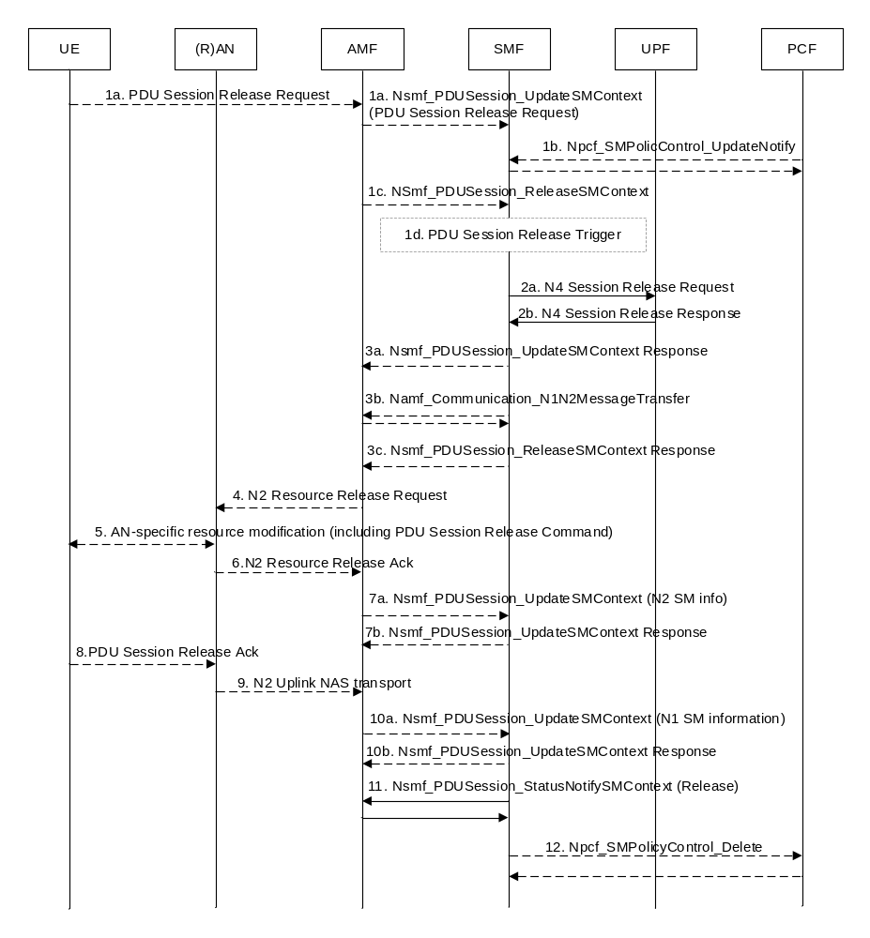
- Further,
- PDU session Release procedure in 4.9.2.1 and 4.9.2.2 should not extend to PCF and UPF, as only 3GPP access resources are involved.
- a typo in step 3 of figure 4.9.2.1-1 needs to be corrected.
- several editorial corrections are required.

Proposal
It is proposed to update TS 23.502 as follows.
FIRST CHANGE

4.9.2 Handover of a PDU Session procedure between 3GPP and untrusted non-3GPP access

4.9.2.1 Handover of a PDU Session procedure from untrusted non-3GPP to 3GPP access (non-roaming and roaming with local breakout)
Clause 4.9.2.1 specifies how to hand over a UE from a source Untrusted non-3GPP access to a target 3GPP access and how a UE can handover a PDU Session from untrusted non-3GPP access to 3GPP access. It is based on the PDU Session establishment procedure for 3GPP access as specified in clause 4.3.2.

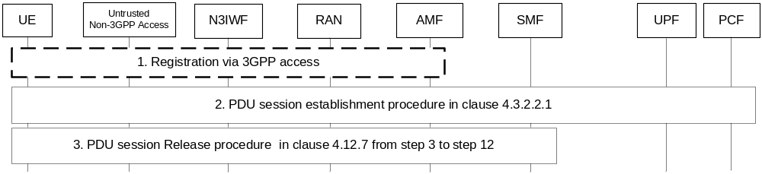
Figure 4.9.2.1-1: Handover of a PDU Session procedure from untrusted non-3GPP access to 3GPP access (non-roaming and roaming with local breakout)
1. If the UE is not registered via 3GPP access, the UE shall initiate Registration procedure as defined in clause 4.2.2.2.2.
2. The UE performs a PDU Session Establishment procedure with the PDU Session ID of the PDU Session to be moved as specified clause 4.3.2.2.1 (PDU Session Establishment for Non-roaming and Roaming with Local Breakout).
3. The V-SMF executes the release of resource in non-3GPP by performing steps 3-12 specified in clause 4.12.7 (except Npcf_SMPolicyControl_Delete service operation to PCF) in order to release the resources over the source non-3GPP access.
The steps 2 and 3 shall be repeated for all PDU Sessions to be moved from to untrusted non-3GPP access to 3GPP access.

4.9.2.2 Handover of a PDU Session procedure from 3GPP to untrusted non-3GPP access (non-roaming and roaming with local breakout)
Clause 4.9.2.2 specifies how to hand over a UE from a source 3GPP access to a target Untrusted non-3GPP access and how a UE can handover a PDU Session from 3GPP access to untrusted non-3GPP access. It is based on the PDU Session establishment procedure for non-3GPP access as specified in clause 4.12.5.

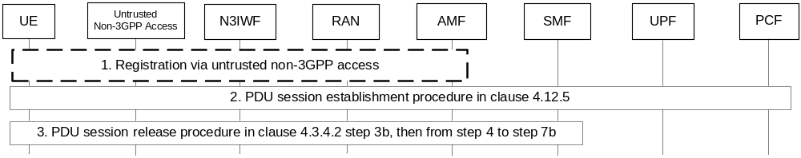
Figure 4.9.2.2-1: Handover of a PDU Session from 3GPP access to untrusted non-3GPP access (non-roaming and roaming with local breakout)
1. If the UE is not registered via untrusted non-3GPP access, the UE shall initiate Registration procedure as defined in clause 4.12.2.
2. The UE performs PDU Session Establishment procedure with the PDU Session ID of the PDU Session to be moved as specified in clause 4.12.5.
3 The V-SMF executes the release of resource in 3GPP by performing step 3b, then steps 4 to 7b specified in clause 4.3.4.2 (UE or network requested PDU Session release for Non-Roaming and Roaming with Local Breakout) in order to release the resources over the source 3GPP access.
The steps 2 and 3 shall be repeated for all PDU Sessions to be moved from 3GPP access to untrusted non-3GPP access

NEXT CHANGE

4.9.2.x Handover of a PDU Session procedure from untrusted non-3GPP to 3GPP access (home routed roaming)

4.9.2.x.x The target AMF is in the PLMN of the N3IWF
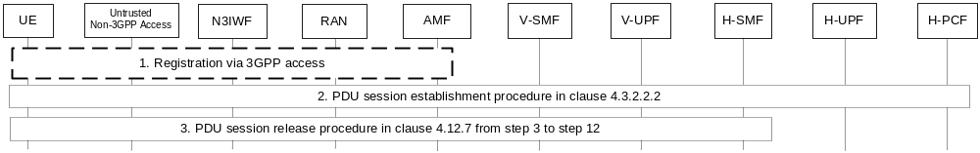
Figure 4.9.2.1-1: Handover of a PDU Session procedure from untrusted non-3GPP access to 3GPP access (home routed roaming)
1. If the UE is not registered via 3GPP access, the UE shall initiate Registration procedure as defined in clause 4.2.2.2.2. The RAN selects the same AMF as the one used via non-3GPP access.
2. The UE performs a PDU Session Establishment procedure with the PDU Session ID of the PDU Session to be moved as specified clause 4.3.2.2.2 (PDU Session Establishment for Home Routed Roaming). The AMF selects the same V-SMF as the one used via non-3GPP access.
3. The V-SMF executes the release of resource in non-3GPP by performing steps 3-12 specified in clause 4.12.7 (except Npcf_SMPolicyControl_Delete service operation to PCF) in order to release the resources over the source non-3GPP access.
The steps 2 and 3 shall be repeated for all PDU Sessions to be moved from to untrusted non-3GPP access to 3GPP access.

4.9.2.x.x The target AMF is not in the PLMN of the N3IWF
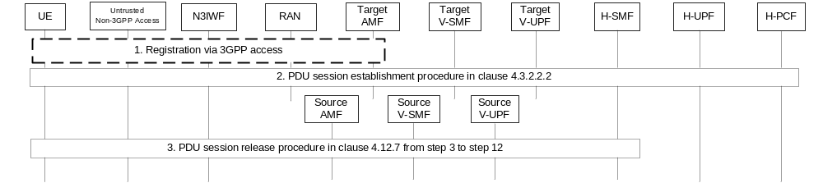
Figure 4.9.2.1-1: Handover of a PDU Session procedure from untrusted non-3GPP access to 3GPP access (home routed roaming)
1. If the UE is not registered via 3GPP access, the UE shall initiate Registration procedure as defined in clause 4.2.2.2.2. This includes the retrieval of the SMF-IDs corresponding to each of the PDU sessions.
2. The UE performs a PDU Session Establishment procedure with the PDU Session ID of the PDU Session to be moved as specified clause 4.3.2.2.2 (PDU Session Establishment for Home Routed Roaming).
3. The H-SMF executes the release of resource in non-3GPP by performing steps 3-12 specified in clause 4.12.7 (except Npcf_SMPolicyControl_Delete service operation to PCF) in order to release the resources over the source V-SMF, V-UPF and non-3GPP access.
The steps 2 and 3 shall be repeated for all PDU Sessions to be moved from to untrusted non-3GPP access to 3GPP access.

NEXT CHANGE

4.9.2.x Handover of a PDU Session procedure from 3GPP to untrusted non-3GPP access (home routed roaming)

4.9.2.x.x The selected N3IWF is in the registered PLMN
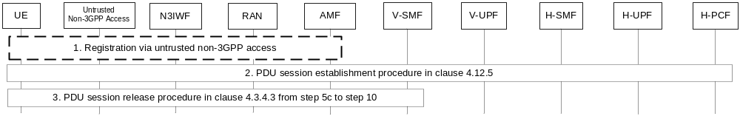
Figure 4.9.2.x-1: Handover of a PDU Session procedure from untrusted non-3GPP access to 3GPP access (home routed roaming)
1. If the UE is not registered via untrusted non-3GPP access, the UE shall initiate Registration procedure as defined in clause 4.12.2. The N3IWF selects the same AMF as the one used via 3GPP access.
2. The UE performs PDU Session Establishment procedure with the PDU Session ID of the PDU Session to be moved as specified in clause 4.12.5. The AMF selects the same V-SMF as the one used via 3GPP access.
3 The V-SMF executes the release of resource in 3GPP by performing step 5c to 10 specified in clause 4.3.4.3 (UE or network requested PDU Session release for Home Routed Roaming) in order to release the resources over the source 3GPP access.
The steps 2 and 3 shall be repeated for all PDU Sessions to be moved from 3GPP access to untrusted non-3GPP access.

4.9.2.x.x The selected N3IWF is not in the registered PLMN
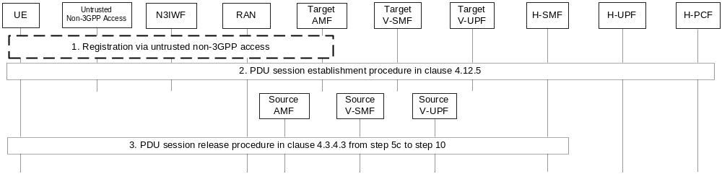
Figure 4.9.2.x-1: Handover of a PDU Session procedure from untrusted non-3GPP access to 3GPP access (home routed roaming)
1. If the UE is not registered via untrusted non-3GPP access, the UE shall initiate Registration procedure as defined in clause 4.12.2. This includes the retrieval of the SMF-IDs corresponding to each of the PDU sessions.
2. The UE performs PDU Session Establishment procedure with the PDU Session ID of the PDU Session to be moved as specified in clause 4.12.5.
3 The H-SMF executes the release of resource in 3GPP by performing step 5c to 10 specified in clause 4.3.4.3 (UE or network requested PDU Session release for Home Routed Roaming) in order to release the resources over the source V-SMF, V-UPF and 3GPP access.
The steps 2 and 3 shall be repeated for all PDU Sessions to be moved from 3GPP access to untrusted non-3GPP access.

END OF CHANGES

