SA WG2 Meeting #143E S2-20xxxxx
February 24 – March 9, 2021, Elbonia

Source: Ericsson
Title: QoS aspects of satellite backhaul and satellite access
Document for: Approval
Agenda Item: 8.11
Work Item / Release: 5GSAT_ARCH / Rel-17
Abstract of the contribution: This contribution analyses different QoS aspects that have been discussed during the work on 5GSAT in SA2 but so far without conclusion. A way forward for rel-17 is proposed.

Introduction
Two scenarios are discussed in SA2:
- satellite access
- satellite backhaul
(only the satellite access scenario is covered in the NTN work in RAN groups).
For several meetings, SA2 has discussed QoS aspects for the two scenarios and, in particular, the issues that arise due to the long delays.
For both scenarios, the problem can be discussed in two areas:
A. Impact to service layer
B. Impact to 5Q QoS framework and RAN/CN QoS handling
Most discussion in SA2 has focused on item B. In addition, the discussion in SA2 has mostly been around what performance (in particular delays/PDB) that can be achieved when SAT access/backhaul is used. However, this is in a sense starting the solution in the wrong end. The discussion should ideally start with item A. When understanding what services can and should be supported over satellite access/backhaul, and their QoS requirements, the corresponding enhancements could be defined for item B. In practice however, an understanding of what is feasible in RAN and CN is needed to ensure that the solution will work in practice.
Below both aspects will be discussed, and solutions proposed.

Impact to service layer
For item A, there may be a need to make the service layer aware that the service is running over an access that has a long delay. This would allow the service layer to take appropriate actions, such as e.g. terminating the service, adjusting application specific properties or informing the end-user. What actions to take is dependent on the application.
For satellite access, it is already planned to extend the RAT type IE with additional values for different satellite categories. The AF could then subscribe to the Change of Access Type notifications from the PCF to learn that satellite access is used, and what type of satellite access. This gives the AF to an indication about the delays that can be expected.
For satellite backhaul, a new notification from the PCF to the AF for "satellite backhaul" can be introduced (such proposal was already made at SA2#141E, see S2-2007727 [3]).
Proposal 1: For satellite backhaul, N5 is enhanced to inform the AF about the backhaul satellite category. (For satellite access, PCF already has the capability to notify the AF about the RAT type.)
Another aspect is that the operator may have committed to a certain level of QoS to deliver certain services. When satellite access/backhaul is used those levels of QoS may not be achievable. Therefore, SLAs may need to take this into account. E.g. if an MNO makes an agreement with an enterprise or other 3rd party to deliver a specific service in a network slice, and the users may be in areas where SAT backhaul or SAT access may be used, the SLA would need to include corresponding agreements. If the service is delay sensitive, it is likely that the service should not be allowed over SAT access/backhaul.
These solutions on making the service layer aware are more or less independent on how item B is addressed.

5Q QoS framework and RAN/CN QoS handling

PDB background
The Packet Delay Budget (PDB) is defined in TS 23.501 and defines an upper bound for the time that a packet may be delayed between the UE and the N6 termination point at the UPF. The PDB is divided into a CN PDB and the AN PDB. See figure below for an illustration.
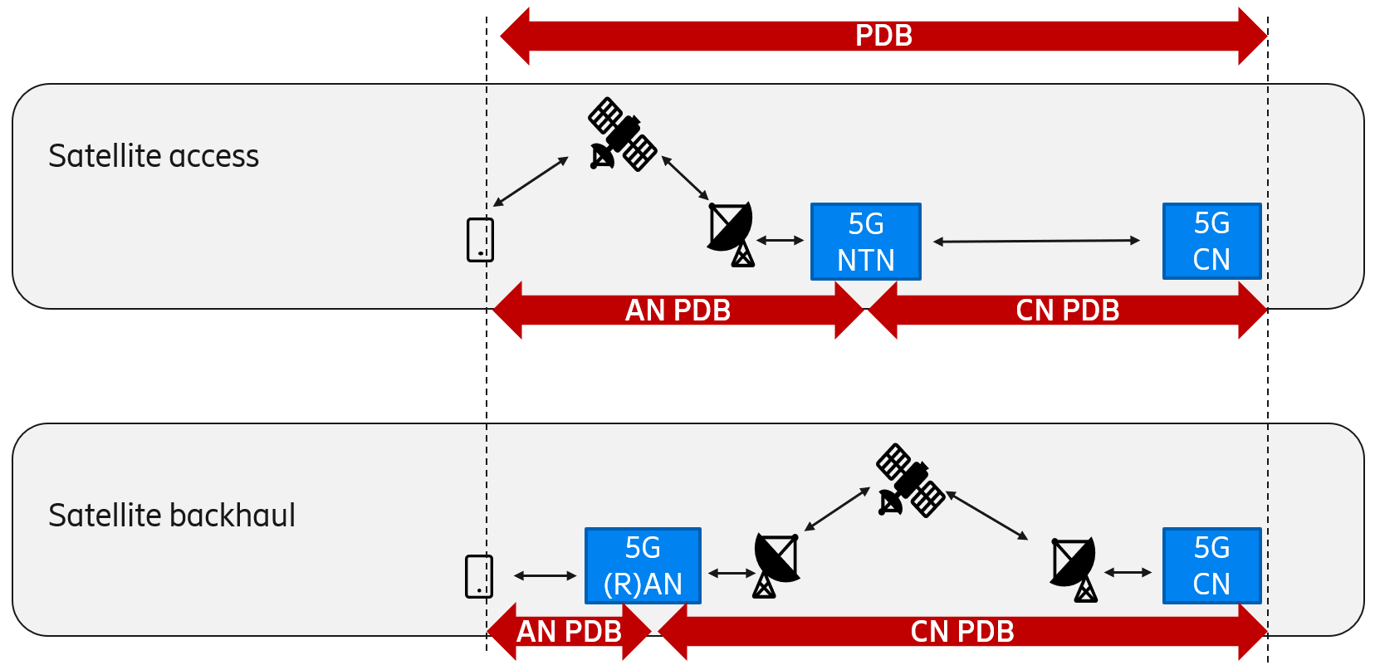
Figure 1: PDB, AN PDB and CN PDB for satellite access and satellite backhaul
In the below discussion we disregard delay-critical GBR resource types. The related delay-critical services will likely not be applicable over satellite access/backhaul.
Below we summarize a few aspects of how PDB is defined in 3GPP:
- For general GBR resource types, there is a requirement that 98% of the packets shall not experience a delay exceeding the 5QI's PDB (assuming they do not exceed GFBR). At the same time, the PDB denotes a "soft upper bound" in the sense that an "expired" packet that has exceeded the PDB does not need to be discarded and is not added to the Packet Error Rate (PER).
- The CN PDB has been standardized for most 5QIs to be 20ms, and in some cases 10ms. The actual delay between RAN and N6 can however differ between scenarios (e.g. non-roaming with a UPF close to the UE, or home-routed roaming between continents). The CN PDB values are also the same as in EPC, where TS 23.203 states:
“A delay of 20 ms for the delay between a PCEF and a radio base station should be subtracted from a given PDB to derive the packet delay budget that applies to the radio interface. This delay is the average between the case where the PCEF is located "close" to the radio base station (roughly 10 ms) and the case where the PCEF is located "far" from the radio base station, e.g. in case of roaming with home routed traffic (the one-way packet delay between Europe and the US west coast is roughly 50 ms). The average takes into account that roaming is a less typical scenario.”
The CN PDB is thus an average value, considering which scenarios are most common, and may not be met in all scenarios.
- The AN PDB is calculated by subtracting the CN PDB from the PDB. In the case of 3GPP access, the PDB is used to support the configuration of scheduling and link layer functions. The PDB is therefore not the same as the one-way-delay of the access. The RAN will make use of different encoding, transmission scheduling, re-transmissions etc to meet PDB and PER in a radio resource efficient manner. In most cases the AN PDB is (much) longer than the one-way-delay.

Satellite backhaul
For satellite backhaul, the challenging part is the CN PDB (see Figure 1). The issue primarily arises for MEO (50-85ms one-way-delay) and GEO (230-280ms one-way-delay), while LEO (4-13ms one-way-delay) should be less of an issue.
One proposal that has been discussed in several meetings (see e.g. S2-2008952 [1]) is to allow a longer CN PDB but then keep PDB constant by making AN PDB shorter by the same amount. This may seem attractive as it would allow existing 5QIs to continue to be used with no changes to the PDB. There are however two problems:
1. It does not work for all cases. For example, for conversational voice (5QI=1) and video (5QI=2), the PDB is 100ms and 150ms respectively, and for GEO the CN PDB alone would need to be much higher.
2. It results in a very small AN PDB for the (terrestrial) RAN, causing a high consumption of radio resources. For example, for the default QoS (5QI=9), the PDB is 300ms with a current AN PDB of 280ms. It could be possible to use 5QI=9 with GEO (e.g. by setting CN PDB = 280ms), but it would give a very small part left for AN PDB (20ms). To ensure that the best-effort 5QI=9 traffic gets delivered in time and with the specified PER (10⁻⁶), the RAN would need to use e.g. robust encoding, consuming a lot of RAN resources. The radio resource cost of best-effort traffic for users with satellite backhaul becomes high, potentially at the expense of more important traffic for users with regular backhaul.
It is thus a limited solution with negative side effects.
Another option is to define new 5QIs (see e.g. S2-2008596 [2]). Note however that in the satellite backhaul case, the RAN is a “regular” terrestrial RAN, potentially with no or very limited reason to upgrade to support new 5QIs introduced due to satellite backhaul. In a roaming case, the satellite backhaul link may also be between the two operators and not between RAN and CN. Another problem is that the purpose of such new 5QIs for the backhaul case would be to extend the CN PDB, not AN PDB. So, there is no need for new RAN behaviour, it is just a standard impact to define new 5QIs that allow the overall “QoS book-keeping” to work out. In other words, defining new 5QIs to support satellite backhaul in practice only results in costs but no real-life benefit.
One can observe that RAN does not care what the PDB or CN PDB are, RAN is only interested in the AN PDB, which is the difference PDB – CN PDB. As long as that difference is the same, there is no need to impact RAN. A solution with minimal impact to RAN would thus be to keep using the existing standardized 5QIs, and allow a longer PDB and longer CN PDB, but keeping AN PDB (i.e. PDB – CN PDB) the same. The standard could be updated to support alternative PDB and CN PDB values (with maintained AN PDB) for those existing 5QIs that correspond to services that are reasonable to use over satellite backhaul. This way forward allows us to avoid impact to terrestrial RAN due to satellite backhaul, and to address the long delays in the 5G QoS specifications.
Proposal 2: Add text in TS 23.501 that standardized 5QIs may have longer PDB and CN PDB (but with unmodified AN PDB) in case of satellite backhaul.

Satellite access (NTN)
For satellite access, the challenging part is the AN PDB (see Figure 1).
The service layer aspects (sub-problem A) can be addressed by defining new RAT types for satellite access and notifying AF (via N5) of the RAT type (as already agreed).
For sub-problem B there are several options:
Option #1: One option is to define new 5QIs (e.g. as proposed in S2-2008596 [2]). Defining new 5QIs for satellite access could be OK, but we would then need to identify for what services this would be useful, and define corresponding QoS characteristics (PDB, PER, etc). It is not useful to simply take standardized 5QIs and define a separate copy with just a PDB value equal to NTN one-way-delay. Such approach does not consider the service level aspect and also not the RAN aspects of e.g. being able to support the PER by retransmissions with a AN PDB longer than one-way-delay. Instead one would need to identify frequently used services that could handle long-delay links and define corresponding QoS classes. This work may need to be done together with SA1, SA4 or SA6.
Option #2: Another option is to use dynamically assigned 5QIs. This will however not work so well in roaming cases.
Option #3: A third option is to use existing standardized 5QIs but apply separate values for the PDB (and AN PDB) in certain cases such as NTN access. This option is similar to the one proposed for satellite backhaul above (Proposal 2). In this approach that NTN RAN would support QoS Flows with existing 5QIs, but treat them using a different AN PDB value from today (CN PDB would be the same as today). Different options can be considered:
- 3a: Standardize new PDB values for NTN RAN. Question is if this would be different PDB values for different satellite categories, or a worst-case value for GEO that could then work also for MEO. Again, the service layer requirements need to be understood to decide on options.
- 3b: Another option is to leave this up to NTN RAN implementation and configuration, and only document in TS 23.501 the option that PDB will be longer than the currently standardized values for NTN RAN. The NTN RAN would then, based on the 5QI and knowledge of the type of application (e.g. voice), have sufficient information to treat the traffic even in case of NTN access.
It should be noted that the 5QI used for a service is not only indicating to RAN what QoS parameters to use. Even though 5QIs are general and not tied to a specific service, in practice some 5QIs (e.g. 5QI=1 for IMS voice) allow RAN to know what service is used and allows RAN to treat the traffic in the best way for that service.
Proposal 3: Use existing 5QIs for existing services (e.g. for IMS services) and leave the PDB value up to implementation/configuration in case of NTN RAN (i.e. option #3b). Possibly discuss further, e.g. together with SA1, SA4, SA6, whether new 5QIs should be defined for other frequently used services specifically used over satellite links.

Proposal
Proposal 1: For satellite backhaul, N7 is enhanced to inform the AF about the backhaul satellite category. (For satellite access, PCF already has the capability to notify the AF about the RAT type.)
Proposal 2: Satellite backhaul: Add text in TS 23.501 that standardized 5QIs may have longer PDB and CN PDB (but with unmodified AN PDB) in case of satellite backhaul.
Proposal 3: Satellite access: Use existing 5QIs for existing services (e.g. for IMS services) and leave the PDB value up to implementation/configuration in case of NTN RAN (i.e. option #3b). Possibly discuss further, e.g. together with SA1, SA4, SA6, whether new 5QIs should be defined for other frequently used services specifically used over satellite links.
In our view these proposals provide a practical approach for rel-17 to cover the different QoS related aspects.
See CRs in S2-200xxxx…

References
[1] S2-2008952: "CN PDB for slow backhaul links", Qualcomm Incorporated
[2] S2-2008596: "Introduce new standardized 5QI to QoS characteristics mapping due to Satellite Access/Satellite Backhaul", XiaoMi
[3] S2-2007727: "Policy control based on satellite category", XiaoMi

