Feedback/comments to CATT/ZTE presentation related to Satellite Backhaul in SA2 5GSAT_ARCH
Relja Djapic, TNO, 04-02-2021
Approach: A slide of CATT/ZTE presentation is copied from the original presentation. The comment/feedback is provided below each slide. The original CATT/ZTE ppt can be found at: https://www.3gpp.org/ftp/Email_Discussions/SA2/5GSAT_ARCH/CallConf03022021/S2-210xxx_Discussion%20on%20satellite%20backhaul_v2.pptx
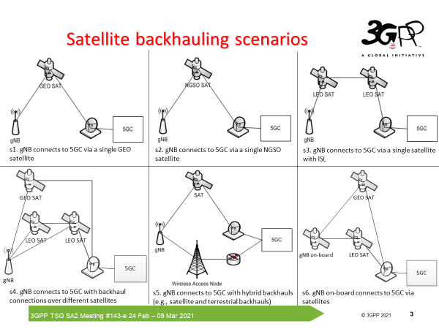
Comments: This is an overview of various possible backhauling scenarios. It is important to make a clear selection of which scenarios should be taken into account in Rel-17. The assumption for Rel-17 is that only transparent satellites are used. The explicit selection of backhauling scenarios needs to be made in order to avoid analysis/development of solutions that are out of scope of Rel-17.
TNO proposes to consider scenario 1 (s1) and scenario 2 (s2) for satellite backhauling in Rel-17.

Action Point (SA2 group): Explicitly agree which scenarios are to be taken into account in Rel-17.

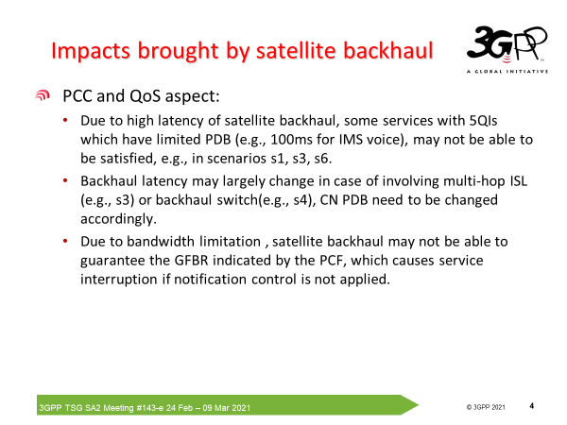
Comments:
- Large number of challenges listed here are out of scope of Rel-17 as no ISL are deployed in Rel-17.
- No multi-hop ISL backhauling in Rel-17. Dynamic switching might occur in case of s2 e.g. in cases when one NGSO satellite is leaving the serving area and the other satellite approaches the same area. However such switching is kept within an acceptable limited range of latency variation values and could be handled by proper network planning. Here, satellite operators play an important role in provisioning of backhauling links meeting the pre-specified requirements (e.g. latency, availability, data rate).
- The aspect of bandwidth limitation is not satellite specific. Any backhauling type could experience bandwidth limitation challenges if not properly planned. In 23.737 the latency due to satellite usage was the only aspect addressed in relation to the satellite backhauling.
Action point (SA2 group): Keep the scope within the one defined in TR 23.737 of satellite backhauling in Rel-17. Do not introduce new issues that are out of scope of TR23.737 / Rel-17.

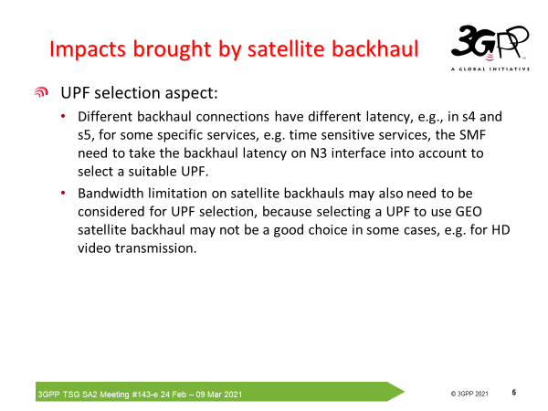

Comments:
- Firstly, I propose not to study s4 in Rel-17. Secondly, for s5 as a hybrid backhauling solution I think Ericsson’s S2-2008453 (‘Backhaul satellite category per network instance’) could be used as (part of) the solution for this problem.
- The question is why is bandwidth limitation introduced at this stage. This is a general challenge also for terrestrial systems and is not satellite specific.
Action points: Keep the focus on scenarios relevant for Rel-17 and do not expand the Key Issue with bandwidth limitation challenges.

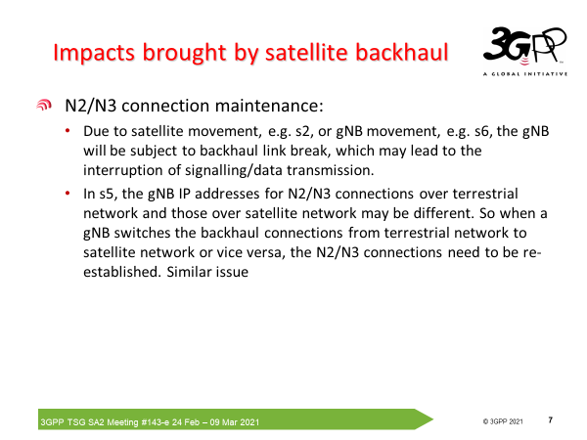

Comment:
- N2/N3 connection maintenance e.g. s2: A possible solution could exploit (S2-2008453). If needed this could be combined with the concept similar to 23.501: ‘5.33.2.2 Support of redundant transmission on N3/N9 interfaces’.
- The second bullet addresses dynamic backhaul change: This could be kept out of scope of Rel-17.
Action point (SA2 group): Identify solutions based on Rel-17 assumptions and avoid dynamic backhaul change aspect at this stage.

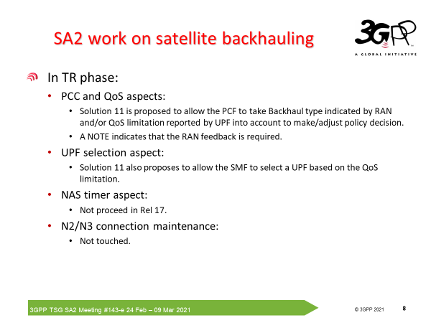
Comments:
- There is a lot of ‘interpretation’ in the slide above on what is claimed in 23.737 e.g. NOTE indicates that the RAN feedback is required. However the NOTE in Solution 11, 23.737 states that RAN feedback is just one of the options “NOTE: The AMF determines the satellite category either by configuration, or by signalling over the N2 interface during NG-AP Setup. If and how to signal the satellite category to the AMF is determined by RAN3.”
- N2/N3 maintenance could be handled by appropriate network planning/management or by using concepts similar to ‘support of redundant transmission on N3/N9’.

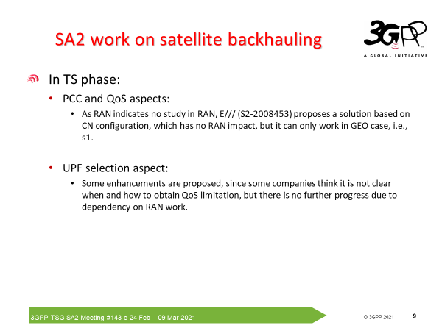

Comments:
- PCC and QoS aspects: To my opinion solution in S2-2008453 is not limited solely to GEO satellites. The concept in the draftCR is a generic one.
- UPF selection aspect: As there is no signaling from RAN on the satellite category the choice is to exploit ‘per configuration’ approach or to use UPF information.
- It should be taken into account that satellite backhauling solutions in Rel-17 shouId not rely on info provisioned by RAN. RAN WG group stated it will not work on backhauling aspects in Rel-17.

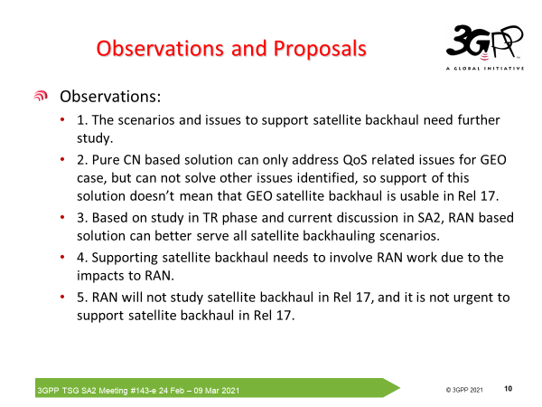

Comments:
- There is a selection of scenarios (s1, s2) that could already be covered in Rel-17. Indeed, there is further study possible for scenarios allowing ISLs and gNB on board satellites but this could be done within SA2 in Rel-18.
- This claim is not completely clear. Requires further clarification!
- It is possible to build configuration/CN based solutions in Rel-17 (thus without satellite category information provisioned by RAN) that could further be improved/enhanced in later Releases.
- It is already states that RAN will not address (satellite) backhauling in Rel-17. RAN can be involved but there are solutions (for a subset of scenarios) that do not require explicit involvement of RAN.
- The elementary aspects related to possible long delays due to satellite backhaul should be addressed in Rel-17 as a basic satellite backhauling solution.

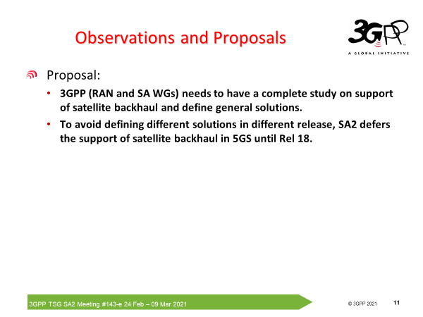

TNO vision on the way forward with respect to satellite backhauling:
- Select a subset of satellite backhauling scenarios (s1 and s2) relevant for Rel-17. In Rel-17 solely transparent satellites are used.
- Keep dynamic backhaul changes aspects out of Rel-17.
- Develop basic satellite backhauling solutions in Rel-17.
- Enhance satellite backhauling solutions in Rel-18. Satellite backhauling could make part of a general backhauling study within SA WG in Rel-18.

