3GPP TSG-SA WG1 Meeting #99e S1-22xxxx
France (hopefully), 14 – 18 November 2022 Revision of S1-222026r5

Source: Tencent, Tencent Cloud
pCR Title: Pseudo-CR on Mobile Metaverse for immersive gaming and live shows
Draft Spec: 3GPP TS / TR 22.856
Agenda item: 7.4
Document for: Approval
Contact: <Yuhang Jia, tonyjia@tencent.com>

Abstract: This contribution proposes updates the use case in Clause 5.6 of TR 22.856, i.e., mobile metaverse for immersive gaming and live show.

1. Introduction
In SA1#99e, use case about mobile metaverse for immersive gaming and live shows has been captured in TR 22.856 in Clause 5.6. This contribution provides update to use case description and also add some potential new requirements.
2. Reason for Change
To update clause 5.6 for TR 22.856, i.e. Mobile Metaverse for immersive gaming and live shows
3. Proposal
It is proposed to agree the following changes to 3GPP TR 22.856.

* * * First Change * * * *

2 References
The following documents contain provisions which, through reference in this text, constitute provisions of the present document.
- References are either specific (identified by date of publication, edition number, version number, etc.) or non-specific.
- For a specific reference, subsequent revisions do not apply.
- For a non-specific reference, the latest version applies. In the case of a reference to a 3GPP document (including a GSM document), a non-specific reference implicitly refers to the latest version of that document in the same Release as the present document.
[1] 3GPP TR 21.905: "Vocabulary for 3GPP Specifications".
[2] 3GPP TS 22.228: "Service requirements for the Internet Protocol (IP) Multimedia core network Subsystem (IMS)".
[3] 3GPP TS 22.173: "IP Multimedia Core Network Subsystem (IMS) Multimedia Telephony Service and supplementary services".
[4] 3GPP TS 22.101: "Service principles".
[5] 3GPP TS 22.261: "Service requirements for the 5G system".
[6] Talaba D, Horvath I, Lee K H, "Special issue of Computer-Aided Design on virtual and augmented reality technologies in product design," Computer-Aided Design 42:361 - 363.
[7] Wang X, Tsai J J-H, "Collaborative Design in Virtual Environments," In: ISCA 48:1-2.
[8] Benford S, Greenhalgh C, Rodden T, "Collaborative virtual environments." Communications of the ACM 44: 79–85.
[9] M. Eid, J. Cha, and A. El Saddik, "Admux: An adaptive multiplexer for haptic-audio-visual data communication", IEEE Tran. Instrument. and Measurement, vol. 60, pp. 21–31, Jan 2011.
[10] K. Iwata, Y. Ishibashi, N. Fukushima, and S. Sugawara, "QoE assessment in haptic media, sound, and video transmission: Effect of playout buffering control", Comput. Entertain., vol. 8, pp. 12:1–12:14, Dec 2010.
[11] N. Suzuki and S. Katsura, "Evaluation of QoS in haptic communication based on bilateral control", in IEEE Int. Conf. on Mechatronics (ICM), Feb 2013, pp. 886–891.
[12] E. Isomura, S. Tasaka, and T. Nunome, "A multidimensional QoE monitoring system for audiovisual and haptic interactive IP communications", in IEEE Consumer Communications and Networking Conference (CCNC), Jan 2013, pp. 196–202.
[13] A. Hamam and A. El Saddik, "Toward a mathematical model for quality of experience evaluation of haptic applications", IEEE Tran. Instrument. and Measurement, vol. 62, pp. 3315–3322, Dec 2013.
[14] O. Holland et al., "The IEEE 1918.1 "Tactile Internet" Standards Working Group and its Standards," Proceedings of the IEEE, vol. 107, no. 2, Feb. 2019.
[15] Lee, L.-H., Braud, T., Zhou, P., Wang, L., Xu, D., Lin, Z., Kumar, A., Bermejo, C., and Hui, P. All One Needs to Know about Metaverse: A Complete Survey on Technological Singularity, Virtual Ecosystem, and Research Agenda, 2021.
[xx] https://en.wikipedia.org/wiki/Video_game_development.
* * * Next Change * * * *

x.1 Mobile Metaverse for Immersive Gaming and Live Shows

x.1.1 Description
Mobile metaverse as a combination of the physical and digital world has already gained the attention of the industry and will benefit from multiple areas, such as gaming, social, medical, industry, transport, and so on [1]. The mobile metaverse will bring us a more immersive experience, which will bring more potential requirements to 5G systems. Among these fields, gaming is considered a pioneer in the development of mobile metaverse. This pCR aims to discuss mobile metaverse for immersive gaming and live shows.
With the support of 5GS, the game players can interact with each other on the cloud or edge server, which may form a digital world called mobile metaverse. The following Figure x.1.1-1 shows the general idea of this use case. The mobile metaverse may be deployed at the cloud or edge server for immersive gaming and live shows. When the players are playing the basketball game, they may achieve an immersive experience with their avatars, and the avatars can interact with each other, whether the players are in proximity or non-proximity. Meanwhile, other players in the metaverse can join in this digital world as spectators to watch the live show. The sensor data captured by the cloud or edge server may perform coding and rendering to generate the virtual images for immersive gaming and live shows, which may be displayed on a big screen, and the interactive service data could be exchanged among the players, avatars. Here, Sensing information include the physical pose/movement, but for a basketball game, the playground and equipments also can have sensor. And this information is useful for the metaverse to perform 3D representation. An immersive experience could be achieved by the players. The major impact on 3GPP is whether and how 5GS can be used to better utilize the sensor information and achieve immersive experiences of the multi-players.
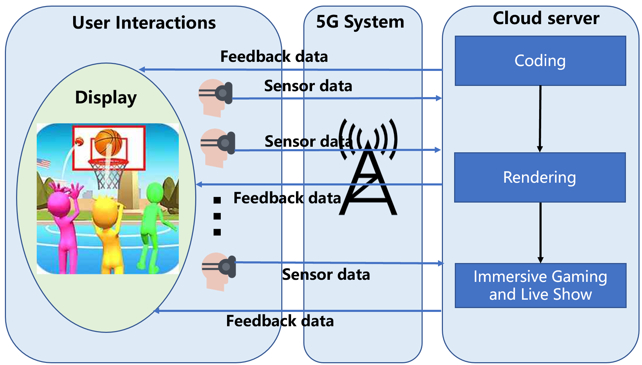
Fig x.1.1-1 Mobile Metaverse for Immersive Gaming and Live Shows

x.1.2 Pre-conditions
The following are pre-conditions for this use case:
- The computing resource used for game design and real-time processing such as game development library and rendering tools could be provided for mobile metaverse on the cloud or edge server.
- 5GS is capable of transporting the uplink/downlink service data.
- The VR/AR/MR/Cloud Gaming mobile devices, such as mobile headsets or other haptic mobile devices, could be connected to the cloud or edge server for supporting the mobile metaverse immersive game and live show via 5GS.

x.1.3 Service Flows
The following are service flows for this use case:
- Player A (a lady who is a fan for gaming metaverse) configures her smartphone, which can be called UE. One path is established between the cloud or edge server and the UE. The UE sends a request to the 5GS, and the 5GS authorizes the request and exposes the capability of metaverse game production and game development (e.g. expose APIs) to the UE. Player A controls her avatar and performs game production and game development based on the rules made by her and the game development or material library stored on the cloud or edge server. She creates a basketball game venue, game rules, NFT characters (with player attributes), supermarkets, etc., all stored and run on the cloud or edge server.
NOTE: The edge may be a burden when it comes to long-term services, such as metaverse data storage and large-scale computing. In such a case, cloud service is essential for being a centralized node to maintaining shared space for thousands or even millions of concurrent users in such a large metaverse, and cloud-edge interaction via 5GS is necessary.
- Player A invites seven players (B, C, D, E, F, G, H) from the metaverse to join the game venue created by himself. These players form two teams to play a 3v3 basketball game match. Among them, B, C, and D are one group, E, F, and G are another group, and H is the game referee. Each member of each group chooses their own NFT character. Then, player A publishes the game match information, and other players as spectators in the metaverse can enter the game venue to watch the match.
NOTE: Players A, B, C, D, E, F, G, and H can be located in different areas in the physical world.
- The game starts. When the players are playing in the venue of the metaverse, 3D positioning accuracy is required for the avatars to represent the players’ location and also gestures for a basketball game. The team members in the physical world control the basketball through 5GS in the uplink direction by a typical mobile input device, e.g., VR headset, VR glasses, and at the same time can interact with each other and pass the basketball to them; though the player has no touch with the basketball in the physical world, he can get some haptic experience of the basketball. The team members both in the physical world and virtual world can interact with each other via 5GS anytime, anywhere for an immersive experience.
- Spectators can watch the game match while eating snacks bought from the supermarket in the venue through 5GS by a typical mobile input device. At the same time, they can view the game attributes, including game rules and player information, by switching the viewing direction. Multiple sensor information can be feedback to spectators an immersive live show experience through 5GS in the downlink direction. The spectators both in the physical world and virtual world can interact with each other via 5GS for an immersive experience.

NOTE: During the running of the game, UE can access to the metaverse with low power consumption to reduce the metaverse game interruption. The cloud or edge server is used for coding, rendering, and generating the mobile metaverse for immersive gaming and live show.
- Player A terminates the game application.

x.1.4 Post-conditions
The following are post-conditions for this use case:
The players in the game match achieved an immersive game experience in the metaverse brought by 5GS.
The spectators in the game match achieved an immersive live show experience.
5GS can address and meet the mobile metaverse game requirements with the cloud or edge side.
Players A, B, C, D, E, F, G, and H may earn money from the mobile metaverse game.

x.1.5 Existing features partly or fully covering the use case functionality
In clause 6.43.2 of 3GPP TS 22.261, there are the following requirements:
The 5G system shall enable an authorized 3rd party to provide policy(ies) for flows associated with an application. The policy may contain e.g. the set of UEs and data flows, the expected QoS handling and associated triggering events, and other coordination information.

The 5G system shall support a means to apply 3rd party provided policy(ies) for flows associated with an application. The policy may contain e.g. the set of UEs and data flows, the expected QoS handling and associated triggering events, and other coordination information.
NOTE: The policy can be used by a 3rd party application for the coordination of the transmission of multiple UEs’ flows (e.g., haptic, audio, and video) of a multi-modal communication session.
x.1.6 Potential New Requirements needed to support the use case
[PR x.1.6-1] The 5G System shall support the transmission of uplink sensor data transmission and downlink feedback information with stringent requirements on packet delay and bandwidth for real-time interaction.
[PR.x.1.6-2] The 5G System shall support a mechanism to obtain the location and gestures of the players with stringent requirements on 3D positioning accuracy.
[PR.5.6.6-3] The 5G System shall support a mechanism to utilize the computing power of mobile metaverse server with stringent requirements.
NOTE: The mobile metaverse server can be deployed at the edge or cloud.
[PR.5.6.6-4] The 5G System shall support the UE to access the metaverse anytime, anywhere with low power consumption.
KPI requirements related to the potential requirements:
Table 5.6.6-1 – Potential key performance requirements for immersive gaming and live shows
Use Case | Characteristic parameter (KPI)
Use Case | End-to-end latency | Service bit rate: user-experienced data rate | Reliability | Positioning accuracy | Computing power | MaximumPower consumption
Mobile Metaverse for immersive gaming and live shows | [5~20] ms | [1~1000] Mbit/s | [>99.99%] | [<1] m | [>16000] EFLOPS (exa floating-point operations per second) | [<10] W

[PR.5.6.6-5] The 5G System shall enable an authorized 3rd party to expose the capability of metaverse game production or development (e.g. expose APIs) to players.
NOTE: Metaverse game production or development means the process of developing a metaverse game and the effort is undertaken by a developer. Similar clarifications can be found in [xx]. How to expose the capability to players is out of scope of the TR.
[PR.5.6.6-6] The 5G System shall support a mechanism to assist the interaction between the edge and cloud in the mobile metaverse.

