3GPP TSG RAN WG2 Meeting #131bis R2-250xxxx
Prague, Czech Republic, 13th – 17th October 2025

Agenda item: 8.4.4
Source: Huawei, HiSilicon (Rapporteur)
Title: Updating the Rel-19 LPWUS capabilities CR and identifying open issues
WID/SID: NR_LPWUS-Core – Release 19
Document for: Discussion and Decision

1 Introduction
This is to trigger the following email discussion.
- [Post131bis][211][LPWUS] CR for TS 38.306 (Huawei)
Intended outcome: Update the CR and identify any additional other open issues.
Deadline: Long

Companies are invited to provide input by Wednesday October 29 18:00 UTC.

Contact information:
Company | Delegate Name | Email
Ericsson | Martin van der Zee | martin.van.der.zee@ericsson.com
Huawei/HiSilicon | Rama Kumar Mopidevi | Rama.kumar@huawei.com

2 Discussion

2.1 Aligning “minimumTimeGap-r19” capability with RAN1 FGs

This is to align “minimumTimeGap-r19” with RAN1 feature group list as pointed out by Lenovo during the main session.

R2-2507586 Corrections on Rel-19 RAN1/4 UE capability Xiaomi CR Rel-19 38.306 19.0.0 1370 - F NR_LPWUS, NR_MIMO_Ph5
Use a baseline for next revision

R2-2507587 Corrections on Rel-19 RAN1/4 UE capability Xiaomi CR Rel-19 38.331 19.0.0 5547 - F NR_LPWUS, NR_AIML_air, NR_ENDC_RF_Ph4
- - Lenovo is concerned that this is not aligned with the feature list. Vivo confirms that it reflects RAN1 intention.
- Use a baseline for next revision

Following is the excerpt from “R1-2506627 Updated RAN1 UE features list for Rel-19 NR after RAN1 #122”:

Features | Index | Feature group | Components | Prerequisite feature groups | Need for the gNB to know if the feature is supported | Applicable to the capability signalling exchange between UEs (Sidelink WI only)”. | Consequence if the feature is not supported by the UE | Type  (the ‘type’ definition from UE features should be based on the granularity of 1) Per UE or 2) Per Band or 3) Per BC or 4) Per FS or 5) Per FSPC) | Need of FDD/TDD differentiation | Need of FR1/FR2 differentiation | Capability interpretation for mixture of FDD/TDD and/or FR1/FR2 | Note | Mandatory/Optional
62. NR_LPWUS | 62-1 | LP-WUS operation in IDLE/INACTIVE mode based on OOK signal | 1. LP-WUS operation in IDLE/INACTIVE mode to trigger paging monitoring based on OOK  2. The support of LP-SS based RRM measurement  5. Minimum time gap between LP-WUS reception and UE to start PDCCH monitoring  6. Support of all M values {1, 2, 4} for FR1 for LP-WUS  7. Support of M value 1 for 120 kHz SCS FR2 for LP-WUS  8. Support of all M values {1, 2, 4} for LP-SS |  | YES | n/a | LP-WUS operation in IDLE/INACTIVE mode based on OOK signal is not supported | Per Band | n/a | n/a | n/a | Component 5 candidate values: {capability 1, capability 2, capability 3}  Note: According to RAN2 agreement, UE supporting LP-WUS reception shall also support RRM measurement relaxation and RRM measurement fully offloading. How to capture this is up to RAN2 | Optional with capability signalling
62. NR_LPWUS | 62-1a | LP-WUS operation in IDLE/INACTIVE mode based on OFDM overlaid sequence | 1. LP-WUS operation in IDLE/INACTIVE mode to trigger paging monitoring based on OFDM overlaid sequence  2a. The support of SSB-based RRM measurement  5. Minimum time gap between LP-WUS reception and UE to start PDCCH monitoring  6. “Support of all M values {1, 2, 4} for FR1 for LP-WUS  7. “Support of M value 1 for 120 kHz SCS FR2 for LP-WUS |  | YES | n/a | LP-WUS operation in IDLE/INACTIVE mode based on OFDM overlaid sequence is not supported | Per band | n/a | n/a | n/a | Component 5 candidate values: {capability 1, capability 2, capability 3}  Note: According to RAN2 agreement, UE supporting LP-WUS reception shall also support RRM measurement relaxation and RRM measurement fully offloading. How to capture this is up to RAN2 | Optional with capability signalling

As shown in the above table, minimum time gap between LP-WUS reception and UE to start PDCCH monitoring has to be reported separately for UE supporting LP-WUS with OOK and OFDM. The endorsed UE capabilities CR (R2-2507586) has the following change:

- minimumTimeGap-r19 indicates the minimum time gap between LP-WUS reception and UE to start PDCCH monitoring. The values of ‘cap1’, ‘cap2’ and ‘cap3’ for each SSB periodicity are shown in below table:
SSB periodicity (ms) | cap1 (ms) | cap2 (ms) | cap3 (ms)
5/10/20 | 70 | 500 | 900
40 | 130 | 600 | 1000
80 | 250 | 800 | 1200
160 | 490 | 1200 | 1600

To align with RAN1 feature list, “minimumTimeGap-r19” has to be reported separate as shown below:

- minimumTimeGap-OOK-r19 indicates the minimum time gap between LP-WUS reception and UE to start PDCCH monitoring when UE indicates support of lpwus-OOK-r19. The values of ‘cap1’, ‘cap2’ and ‘cap3’ for each SSB periodicity are shown in the Table of “values of ‘cap1’, ‘cap2’ and ‘cap3’ for each SSB periodicity” below.

- minimumTimeGap-OFDM-r19 indicates the minimum time gap between LP-WUS reception and UE to start PDCCH monitoring when UE indicates support of lpwus-OFDM-r19. The values of ‘cap1’, ‘cap2’ and ‘cap3’ for each SSB periodicity are shown in the Table of “values of ‘cap1’, ‘cap2’ and ‘cap3’ for each SSB periodicity” below.

- Table of values of ‘cap1’, ‘cap2’ and ‘cap3’ for each SSB periodicity:

SSB periodicity (ms) | cap1 (ms) | cap2 (ms) | cap3 (ms)
5/10/20 | 70 | 500 | 900
40 | 130 | 600 | 1000
80 | 250 | 800 | 1200
160 | 490 | 1200 | 1600

Q1: do companies agree with the above understanding/change?

Company | Yes or No | Comments
Ericsson | Yes, but also see comment | We should discuss how UE and NW use this information, and check if something needs to be clarified:  - For discussion’s sake assume that to reach an OFDM WUR the gNB can send a “short” LP-WUS, while for OOK WUR a “long” LP-WUS is required.  - Suppose the UE supports both OFDM and OOK. And for OOK needs an “early” wake-up, and for OFDM supports a “late” wake-up.  - The gNB has to send “long” LP-WUS when there is one or more UEs monitoring the PO that only support OOK-based WUR. The gNB can send “short” LP-WUS when all the UEs monitoring the PO support OFDM-based WUR.  - It is not clear why/when the UE would decide to wake-up “early”, i.e. the NW may decide to send a “short” LP-WUS to save power / resources.  The UE signals the minimum gap, such that the gNB can determine whether the UE can monitor LP-WUS with the configured time offset(s). However there is a problem when the configured time offset is in between “early” and “late” wake-up of the UE.  Furthermore, perhaps some clarification is needed what the gap between LO and PO is: 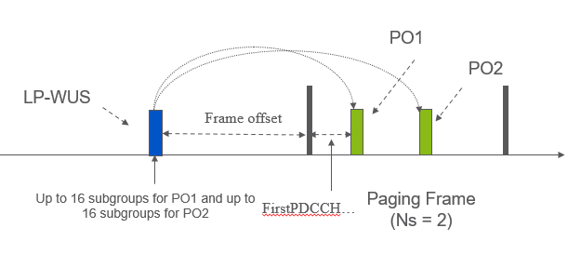  There is a frame offset and firstPDCCH symbol offset.  And there can be a 1:4 mapping of LO to POs over up to 4 Paging Frames (2 PFs depicted below):  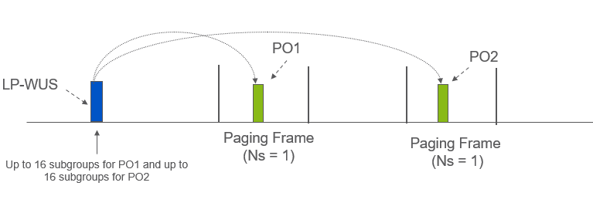  If you have a 1:4 mapping with 1/16th PFs, then UEs experience a very different time gap. With PEI there was a limit up to 2 PFs, but for LP-WUS there is no such restriction.  We also wonder if the possible configuration options should be clarified. Perhaps that is implicitly defined in the formula in 38.213, but that formula is not easy to read. We have the following understanding for now:  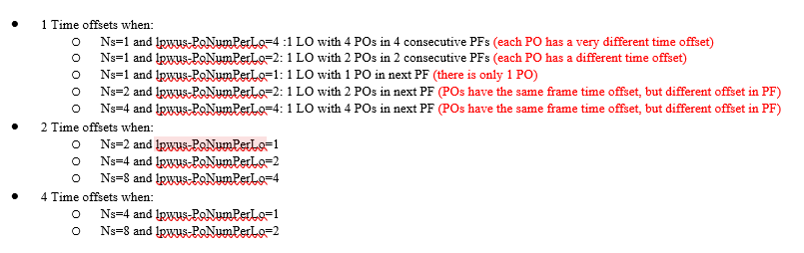  Some of the topics above are not related to the UE capability, but they need to be clear to understand how the “minimum time gap” capability is used by the NW.

2.2 Terminology alignment for “RRM relaxation and offloading”
In R2-2507626, it was pointed out that different specs are using different terminology for “RRM relaxation and offloading” and proposed to align. Spec rapporteurs agreed to align the terminology during offline. Below shows the change in 38.306:

Relaxation of serving cell and further relaxation of neighboring cell RRM measurements and offloading of serving cell RRM measurements | It is mandatory to support relaxation of serving cell and neighboring cell RRM measurements as specified in clause 5.2.4.12.1 in TS 38.304 [21] and offloading of serving cell RRM measurements as specified in clause 5.2.4.12.3 in TS 38.304 [21] if a UE supports reception of LP-WUS in RRC_IDLE/RRC_INACTIVE as specified in TS 38.304 [21]. A UE supporting this feature shall also indicate the support at least one of lpwus-OOK-r19 and lpwus-OFDM-r19.

Q2: do companies agree with the above change?

Company | Yes or No | Comments
Ericsson | Yes

Draft CRs for 38.306 and 38.331 with the changes are provided in Appendix.

Q3: If there are there any other open issues in LP-WUS UE capabilities, please list them below:

Company | Open Issue | Rapporteur’s Response
Ericsson | RAN2 should confirm that no separate UE capability is needed to indicate that the UE supports LP-WUS with Paging Adaptation. When the UE supports LP-WUS and the UE supports Paging Adaptation, then there is a small delta to support LP-WUS with Paging Adaptation, i.e. no need for a separate capability.  However for PEI and Paging Adaptation a separate capability was introduced with a separate bandlist:  So the UE can indicate to support Paging Adaptation and PEI in a certain band, but the UE does not support PEI and Paging Adaptation in that band (but in some other bands where the UE supports PEI). This seems overkill.  In case it is agreed that for LP-WUS and Paging Adaption no new UE capability is needed, then some of the wording needs to be updated to clarify the difference, e.g.: | As both LP-WUS and paging adaptation are Rel-19 features, there is no need to have separate UE capability. We can discuss this during online and clarify.  Proposal:  If the UE supports paging adaptation and LP-WUS in a band, the UE supports the configuration lpwus-LoFrameOffsetListForPagingAdapt. Do not introduce a new UE capability.
  pagingAdaptionPEI-SupportBandList-r19
  Indicates whether the UE supports receiving paging early indication in DCI format 2_7 as specified in TS 38.304 [21] for a list of frequency band for paging adaption. The UE shall support UEID based subgrouping for a frequency band if it indicates supporting of paging early indication reception for the frequency band. The set of OFDM symbols within a slot where UE can monitor the PEI PDCCH in Type 2A CSS is the same as the requirement for paging PDCCH in Type 2 CSS for IDLE and INACTIVE mode UEs.
  A UE supporting this feature shall also indicate support of pagingAdaptation-r19.
  pagingAdaptPEI-Config
  The PEI related configuration for paging adaptation. If the UE supports pagingAdaptionPEI-SupportBandList-r19 paging adaptation for PEI, it ignores pei-Config-r17, if configured.
  lpwus-LoFrameOffsetListForPagingAdapt
  Indicates the frame-level offset between an LO and a reference PO/PF for LP-WUS in the cell for RRC IDLE/INACTIVE (see TS 38.213 [13], clause 10.4C) for paging adaptation. If the UE supports paging adaptation andfor LP-WUS, it ignores lpwus-LoFrameOffsetList, if configured.
  The entry number of offsetForLongerWakeUpDelay or offsetForShorterWakeUpDelay is equal to CEIL (Ns / lpwus-PoNumPerLo), where Ns is the number of paging occasions per paging frame configured in SIB1 for paging adaptation.
  At least one frame-level offset, i.e., offsetForLongerWakeUpDelay or offsetForShorterWakeUpDelay is provided.
Huawei, HiSilicon | In the last meeting, RAN2 made the following agreement:  - The UE capabilities for LP-WUS operation in IDLE/INACTIVE should also be added outside the Rel-19 paging container in UE capability information message. Detailed signalling can be further discussed.  We provided below 2 options in R2-2506965:  - Option 1: only indicating the supported band list for LP-WUS regardless of the receiver type and other capabilities;  - Option 2: indicating the supported band list for LP-WUS and the receiver type.  Which option to go for can be further discussed. | Detailed signalling needs to be discussed.  Added open issue # 38306-1: Discuss detailed signalling to add UE capabilities of LP-WUS operation in IDLE/INACTIVE outside the Rel-19 paging container in UE capability information message.

3 Conclusion
Based on the email discussion, we conclude as below.
The following proposal can be discussed online for confirmation/capturing in chairman’s notes.
Proposal 1: If the UE supports paging adaptation and LP-WUS in a band, the UE supports the configuration lpwus-LoFrameOffsetListForPagingAdapt. Do not introduce a new UE capability.
The following open issue can be addressed by company contributions.
Proposal 2: (38306-1) Discuss detailed signalling to add UE capabilities of LP-WUS operation in IDLE/INACTIVE outside the Rel-19 paging container in UE capability information message.

