3GPP TSG RAN WG2 Meeting #132 R2-250xxxx
Dallas, USA, Nov 17th – 21st, 2025
Agenda Item: 8.0.1
Source: Xiaomi
Title: Comment for [POST131bis][004][UE caps] UE capability CR (Xiaomi)
Document for: Discussion and Decision

Introduction
- [POST131bis][004][UE caps] UE capability CR (Xiaomi)
Intended outcome: Update UE capability CRs post RAN1/RAN4 LS and combine with RAN2 CRs.
Deadline: long
Companies providing input to this email discussion are requested to leave contact information below.
Company | Name | Email Address
Nokia | Andrew Lappalainen | andrew.lappalainen@nokia.com
Huawei | Seau Sian Lim | seau.sian.lim@huawei.com
OPPO | Qianxi Lu | qianxi.lu@oppo.com
Ericsson | Andra Voicu | andra.mihaela.voicu@ericsson.com

Discussion
In R1-2507981, RAN1 asked RAN2 to provide feedback on below questions (the table can be found in RAN1 LS R1-2507981):
For NR_MC_enh2,
RAN1 would like to inform RAN2 of the following agreement:
Agreement:
Ask RAN2 to feedback if it is possible to update prerequisite FG(s) for Rel-18 RAN1 FG 49-4a/4b/4c/4d/5a/5b/6/7/8/9/10/12/12a/13/14 in Rel-19 as follows (red fonts).
Rapporteur understands that directly adding Rel-19 features as prerequisite FGs for Rel-18 FGs is confusing, even it is implemented from Rel-19 specification. To avoid ambiguity, rapporteur suggests o define new Rel-19 FGs for Rel-18 FG 49-4a/4b/4c/4d/5a/5b/6/7/8/9/10/12/12a/13/14, those new Rel-19 FGs will depend on whether FG66-1/66-2 are supported or not.
For example:
Index | Feature group | Rel-18 UE cap | Rel-19 UE cap | Components | Prerequisite feature groups
49-4a | Nominal RBG size of Configuration 3 for FDRA type 0 for DCI format 1_3 | nominalRBG-SizeOfConfig-3-FDRA-Type-0-DCI-1-3-r18 | nominalRBG-SizeOfConfig-3-FDRA-Type-0-DCI-1-3-v1900  A UE supporting nominalRBG-SizeOfConfig-3-FDRA-Type-0-DCI-1-3-v1900 shall also indicate support of FG 66-1. | 1) Support of nominal RBG size of Configuration 3 for FDRA type 0 for DCI format 1_3 | At least one of {49-1, 49-1b, 66-1}

Q1: Do you agree with the above change for Rel-18 RAN1 FG 49-4a/4b/4c/4d/5a/5b/6/7/8/9/10/12/12a/13/14 in Rel-19?
Company | Yes/No | Suggestion/Comment
Nokia | No | We think it is not too confusing to adopt RAN1’s suggestion and prefer to avoid reintroducing redundant -v1900 capabilities.  Since the prerequisites based on 66-1 would only be updated in the Rel-19 spec, only R19 UE would need to consider implementing them and there is no impact to R18 UEs.  Taking 49-4a as an example, if a R19 UE does not support 49-1/49-1b but supports 66-1:  - A R19 NW would interpret 49-4a as supported and could configure the UE based on the underlying support of 66-1  - A R18 NW cannot support 66-1; so, if UE does not support 49-1/49-1b the R18 NW has no way to configure UE to use 49-4a anyway; so there is no issue as such.  Introducing -v1900 versions of the R18 capabilities will not change the above outcome; on the other hand, adding new capabilities will add additional testing/validation burden to UE and NW implementers; so we do not think there are clear enough benefits to justify introducing them.
Huawei | No | It is unclear to us why RAN1 wants to add Rel-19 capabilities to Rel-18 capabilities. As like the rapporteur said, it is indeed confusing and ambiguous to do such thing as for a Rel-18 UE, the Rel-18 capability can always be reported without supporting the Rel-19 capability. It just means that the additional of Rel-19 capability to the pre-requisite seems redundant. From this perspective, we don’t think it is really essential to add this prerequisite even in Rel-19 spec. Furthermore, it is also strange to have different prerequisites for same capability in different releases (even if a R18 capabilities are duplicated in R19).
OPPO | No to R1 suggestion  Open to Rapp suggestion | For the R1 suggestion, we see some ambiguity here, because it would create an error case for legacy network, when it happens that UE reports 49-4a, but does not support 49-1/1b but report 66-1 (which is yet invisible to legacy network).  While if we follow what Rapp suggested, i.e., define new Rel-19 FGs for Rel-18 FG 49-4a/4b/4c/4d/5a/5b/6/7/8/9/10/12/12a/13/14, we can try to differentiate between  1/ R18 version of “49-4a/4b/4c/4d/5a/5b/6/7/8/9/10/12/12a/13/14”, limited to same SCS and same carrier type  2/ R19 version of “FG 49-4a/4b/4c/4d/5a/5b/6/7/8/9/10/12/12a/13/14”, targeted at different SCS and/or different carrier type  And in this way, the 66-1 FG can be defined pre-requisite of the R19 version FGs only, without touching R18 version of the FGs.

Comment
Companies are invited to provide comments if there’s a change that is not agreeable. Other comments are welcomed.
Comment Index | Capability IE/FG | Specification  (306/331) | Comment | Proposed Change | Rapp resolution
N019 | R1 58-1-2 / 58-1-4 | 306/331 | Only the basic components for these capabilities were implemented:  aiml-BM-Case1-r19 ENUMERATED {supported},  aiml-BM-Case2-r19 ENUMERATED {supported}  But the R1 feature list includes multiple other components that need to be reported with the capability, e.g. max number of inference reports, max number of predicted beams, etc. | Add the missing components to 306/331 (unless the intention was just to implement the basic component so the other capabilities dependent on 58-1-2/58-1-4 could be implemented already?).
N020 | R1 58-1-5 | 331 | There is a typo in the capability name:  aiml-BM-Ccase2-PredictedRSRP-r19 SEQUENCE { | Change to: “aiml-BM-Case2-PredictedRSRP-r19”
N021 | R1 58-3-2 / 58-3-4 / 58-3-5 | 306 | Per BC capabilities are missing “PerBC” in the name in 306. | Add “PerBC” to the per BC capability names
  aiml-CSI-PredictionMonitoring-r19 | BC | No | N/A | N/A
  aiml-CSI-PredictionN4-r19 | BC | No | N/A | N/A
  aiml-CSI-PredictionUE-DataCollection-r19 | BC | No | N/A | N/A
  aiml-CSI-PredictionMonitoringPerBC-r19 | BC | No | N/A | N/A
  aiml-CSI-PredictionN4PerBC-r19 | BC | No | N/A | N/A
  aiml-CSI-PredictionUE-DataCollectionPerBC-r19 | BC | No | N/A | N/A
N022 | R1 59-2-1-9 | 306 | ‘Curly quotes’ instead of 'straight quotes' are used in the description for nes-SD-Type1-SP-r19 and nes-SD-Type1-SP-PerBC-r19. Especially for Z' this should be corrected as this is a specific term used in RAN1 specs; but note also that straight quotes shall be used as per 3GPP drafting rules.  Furthermore, we think Z2 / Z'2 is supposed to be Z₂ / Z'₂ as per 38.214. | Change use of ‘curly quotes’ to 'straight quotes' and use subscript for “2” when referring to the Z timeline.  Z’ / Z2 / Z’2 Z' / Z₂ / Z'₂
N023 | R1 60-2a | 306 | There is some redundant text at the end of the capability description for sbfd-Tx-r19. | Delete following text from end of capability description:  "The UE optionally includes sbfd-OneRACH-r19 to indicate whether the UE supports  - numOfPartialPRG-r19 indicates ;  - numOfPartialPRG-r19 indicates ;  - numOfPartialPRG-r19 indicates ;  - numOfPartialPRG-r19 indicates ;
N024 | R1 60-5 / 60-5a | 306 | There is a typo “additional-Ros” under description of preambleRepetitionOneRACH-r19 and preambleRepetitionTwoRACH-r19: should be additional-ROs | Change “additional-Ros” to “additional-ROs” under description for preambleRepetitionOneRACH-r19 and preambleRepetitionTwoRACH-r19
N025 | R1 60-5a | 306 | According to the R1 feature list, component 2 of 60-5a applies to “separate configuration of rsrp-ThresholdMsg1-RepetitionNum2/4/8 and msg1-RepetitionNum for PRACH transmission with preamble repetitions within additional-ROs and PRACH transmission with preamble repetitions within legacy-ROs”.  msg1-RepetitionNum was missed in the description. | Add msg1-ReptitionNum to description of component under preambleRepitionTwoRACH-r19  The UE optionally includes preambleRepetitionTwoRACH-r19 to indicate whether the UE supports preamble repetition within additional-ROs for two separate RACH configurations in RRC_IDLE/INACTIVE/CONNECTED mode, including:  - Determination of the set of Npreamblerep valid additional-ROs and the time period of the set(s) of Npreamblerep_ valid additional-Ros;  - For two separate RACH configurations in RRC_IDLE/INACTIVE/CONNECTED mode, support separate configuration of rsrp-ThresholdMsg1-RepetitionNum2/4/8 and msg1-RepetitionNum for PRACH transmission with preamble repetitions within additional-ROs and PRACH transmission with preamble repetitions within legacy-ROs.
N026 | R1 62-2 | 306 | In the capability description, the alignment is off on the last component maxNumCodepointsPerMO  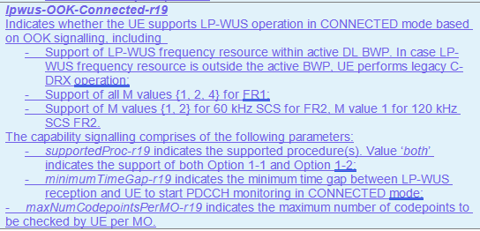 | Fix alignment of capability parameter list in the description of lpwus-OOK-Connected-r19.
N027 | lpwus-SupportedBandList-r19 | 306 | The way the description is written, i.e. “The UE supporting this feature shall also indicate the support of at least lpwus-OOK-r19 or lpwus-OFDM-r19.” almost makes it seem as if lpwus-OOK and lpwus-OFDM are prerequisites for lpwus-SupportedBandList.  Suggest that we just say “UE shall indicate at least one of lpwus-OOK-r19 or lpwus-OFDM-r19.” | Change “The UE supporting this feature shall also indicate the support of at least lpwus-OOK-r19 or lpwus-OFDM-r19.” to “UE shall indicate at least one of lpwus-OOK-r19 or lpwus-OFDM-r19.”
N028 | R1 63-10 | 306 | Prerequisites in capability description for ltm-WithoutCSI-IM-r19 were implemented correctly, i.e. 63-6 or 63-6a or 63-7 or 63-7a, however we notice that 63-7 and 63-7a are redundant since 67-7 requires support of 63-6 and 67-7a requires support of 63-6a.  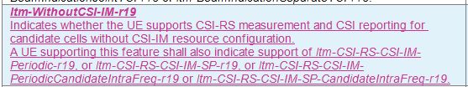 | Change to “A UE supporting this feature shall also indicate support of ltm-CSI-RS-CSI-IM-Periodic-r19 or ltm-CSI-RS-CSI-IM-SP-r19.”
N029 | R4 49-4 | 306 | For fastSCellActivationEarlyMeas-r19, the prerequisite features in the R4 list are:  Both 1) and 2):  1) 39-8 or 39-9 in R18 RAN4 feature list or 18-7 (idleInactiveNR-MeasReport-r16)  2) idleInactiveNR-MeasBeamReport-r16  How this is captured in 38.306 is a bit ambiguous in our view:  “A UE supporting this feature shall also indicate support of measValidationReportEMR-r18 or measValidationReportReselectionMeasurements-r18 or idleInactiveNR-MeasReport-r16, and idleInactiveNR-MeasBeamReport-r16.” | For clarity, suggest following rewording:  “A UE supporting this feature shall also indicate support of idleInactiveNR-MeasBeamReport-r16 and at least one of idleInactiveNR-MeasReport-r16, measValidationReportEMR-r18 or measValidationReportReselectionMeasurements-r18.”
H016 | R4 46-4,46-5 | 331 | mpr-SingleCC-r19 CHOICE {  -- R4 46-4: MPR reduction for single carrier with single value  mpr-SingleCC-SingleValue-r19 ENUMERATED {supported},  -- R4 46-5: MPR reduction for single carrier with multiple values  mpr-SingleCC-MultipleValue-r19 ENUMERATED {supported},  } OPTIONAL, | We are just wondering whether it will be more readable by changing it to the following. Not strong view if companies want to keep it as a CHOICE.  -- R4 46-4: MPR reduction for single carrier with single value  -- R4 46-5: MPR reduction for single carrier with multiple values  mpr-SingleCC-r19 ENUMERATED {singleVal, multipleVal} OPTIONAL,
H017 | R4 47-2 | 306 | May need to update the text to include the table index as updated by R4 feature list:  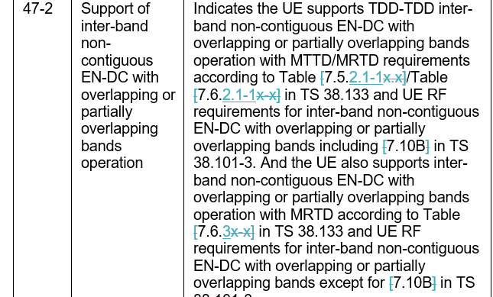 | Updated according to R4 feature list with the table indexes rather than the clause index.
H018 | R4 49-4 | 331 and 306 | Since R4 feature list indicated that the capability required FRx differentiation, it has to be included as per band rather than per UE | Move the capability to BandNR and include the consistency check as follow:  UE shall set the capability value consistently for all FDD-FR1 bands, all TDD-FR1 bands, all TDD-FR2-1 bands and all TDD-FR2-2 bands respectively
H019 | R4 59-1, 59-2 | 331 | I do not remember that the beam management capabilities are in MIMO-ParametersPerBand. This is also a general comment as there are other AIML BM also included MIMO-ParametersPerBand.  Maybe it would be good to group the AIML capabilities into a new group in BandNR so that if it is not supported by UE, it won’t incur additional overhead individually due to optionality | Suggest to move the AIML for BM out of MIMO-ParametersPerBand into the general BandNR.  Suggest to group the per band AIML BM capabilities into a group in BandNR
H020 | R1 58-1-2, 58-1-4, 58-3-1 | 306 | If to include these features with a placeholder: In RAN2#131, it is agreed to include the following into these features:  - Include RAN2 feature ‘UE can provide update of applicability reporting via UAI’ as part of RAN1 FGs (e.g., 58-0-1 and/or FG 58-1-2/3/4/5, the details of those feature group depend on RAN1 progress) once implemented.  This should be implemented with the placeholder capability. I assume this also apply to 58-3-1 | Add the UAI support into the field description for aiml-BM-Case1-r19, aiml-BM-Case2-r19 and aiml-CSI-Prediction-r19
H021 | R1 58-1-3, 58-1-5 | 306 | Editorial. Instead of a ‘,’ between ‘beam prediction’ and ‘reporting of predicted beam, replace it with ‘with’
H022 | R1 58-1-5 | 331 | Typo, extra ‘c’ in the field name | Remove highlighted ‘c’: aiml-BM-Ccase2-PredictedRSRP-r19
H023 | R1 58-3-1-x | 331/306 | None of them are implemented even though there are no FFS on them.
H024 | R1 58-3-5 | 306 | The word ‘significant’ in the NOTE is a bit ambiguous, does it mean ‘more’? | Change to ‘more’?
H025 | R1 60-1 | 306 | Some redundant text at the end of the description:  The UE optionally includes sbfd-OneRACH-r19 to indicate whether the UE supports  - numOfPartialPRG-r19 indicates ;  - numOfPartialPRG-r19 indicates ;  - numOfPartialPRG-r19 indicates ;  - numOfPartialPRG-r19 indicates ; | Remove
H026 | R1 63-7, 63-7a,7b,7c,7d | 331/306 | All should be implemented per BC in CA-ParametersNR | Move them to CA-ParametersNR.
N030 | R1 58-1-6 | 306/331 | In the RAN1 feature list, component 8 of 58-1-6 (aiml-BM-Monitoring-r19) is described as:  8. Supported monitoring resource types  The implementation monitoringResource-r19 could be confusing (and not really accurate) as this parameter refers to different resource types, so we suggest to use monitoringResourceType-r19 instead. | Change aiml-BM-Monitoring-r19 parameter: monitoringResource-r19 to monitoringResourceType-r19 in
E001 | applicabilityReportingCSI-r19,  applicabilityReportingOther-r19 | 306 | RAN2 #131bis agreed the following:  “[E042] Applicability reporting via UAI is always enabled for option A and B. Remove flag from RRC CR and update procedural text to indicate that it is configured if option A or B are configured. Wording offline.”  This means that there is no need to distinguish between supporting initial applicability reporting versus applicability updates and this should be reflected in the definitions for parameters applicabilityReportingCSI-r19 and applicabilityReportingOther-r19. | Suggest to remove the highlighted text below:  applicabilityReportingCSI-r19  Indicates whether the UE supports applicability reporting and/or its updates based on inference configuration provided via CSI-ReportConfig, as specified in TS 38.331 [9].  It is mandatory if UE supports at least one of aiml-BM-Case1-r19, aiml-BM-Case2-r19 and aiml-CSI-Prediction-r19, aiml-CSI-PredictionPerBC-r19.  applicabilityReportingOther-r19  Indicates whether the UE supports applicability reporting and/or its updates based on inference related parameters configuration provided via OtherConfig, as specified in TS 38.331 [9].  It is mandatory if UE supports at least one of aiml-BM-Case1-r19 and aiml-BM-Case2-r19.

Annex post R2-131 meeting
Companies are invited to provide comments if there’s a change that is not agreeable. Other comments are welcomed.
Comment Index | Capability IE/FG | Specification  (306/331) | Comment | Proposed Change | Rapp resolution
OPPO001 | 46-1/2/3 | 331,306 | They are now implemented as MRDC Parameter,  MRDC-Parameters-v1900  While based on our R4 colleagues, MPR reduction were discussed for CA case, rather than MRDC. | Avoid implementation those features as MRDC parameters (in both 331 and 306) | Resolved  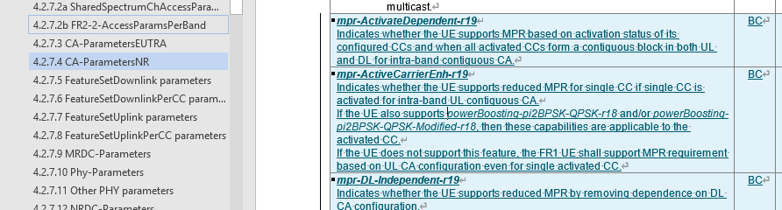
OPPO002 | 46-4/5 | 331,306 | Based on our R4, there is no case where UE report both features, since the support of 46-5 already includes the support of 46-4 | Suggest implement 46-4/5 as a same capability, with two ENUMERATED values pointing to 46-4 and 46-5. | Resolved and updated into choice
OPPO003 | 49-1 | 331,306 | Currently this feature is reported via UE-MRDC-Capability only, but looking at the values in this feature  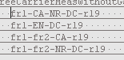  Clearly, the first/third/fourth case is related to NR-SA and NR-DC that should be implemented via UE-NR-Capability. | Implement the values of this feature separately via UE-MRDC-Capability and UE-NR-Capability. | Resolved  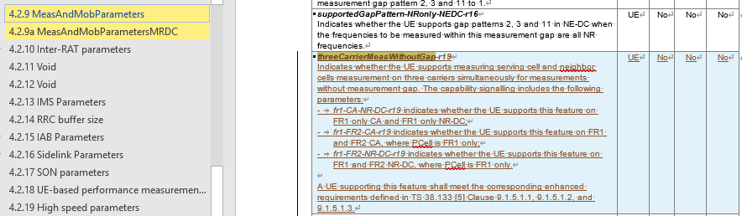  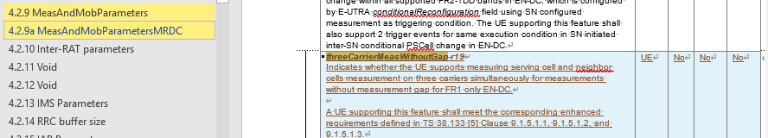  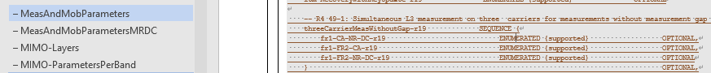
N0001 | R1 59-1-5 | 306 | Prerequisite 59-1-1 is incorrectly written as uei-BR-Event2ModeA-r19. This should be uei-ModeA-Event2-r19 | Change prerequisite to ‘uei-ModeA-Event2-r19’ | Resolved.  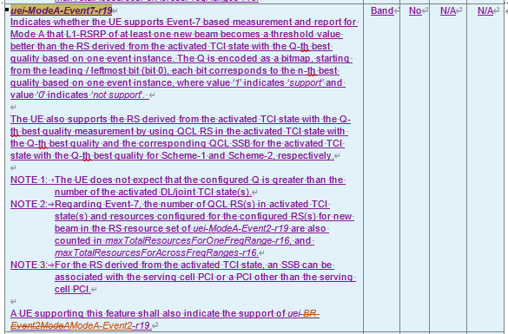
N0002 | R1 59-2-1-1d, 59-2-1-2a, 59-2-1-3a, 59-2-1-4a, 59-2-1-5a | 331 | In all these capabilities for 48 Tx port codebooks, the parameter maxNumberResource-r19 is encoded as INT(2..3), but a bit could be saved by encoding them as ENUMERATED {n2,n3}.  Note that in the corresponding 64 Tx port codebook capabilities maxNumberResource-r19 is already encoded as ENUMERATED {n2,n4}. | Change encoding for maxNumberResource-r19 from INT (2..3) to ENUMERATED {n2,n3}. | Resolved and updated for all  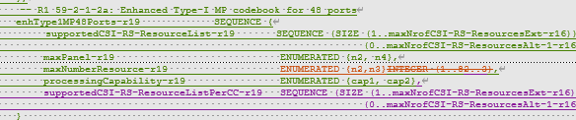
N0003 | R1 59-2-1-6 | 306/331 | This feature was not captured in the CR. All prerequisites (“One or more of {59-2-1-1,1c, 2, 3, 4, 5}”) are already implemented and there are no details left FFS. | Add capability for R1 59-2-1-6 “CSI-RS resource time domain restriction for Type-I and Type II codebook enhancement for up to 128 ports” | Resolved
N0004 | R1 59-2-3-4 | 306/331 | Component 4 (Supported maximum slot duration for NTRP P/SP CSI-RS occasions being confined in) is missing | Add component 4 under the per-band and per-BC capabilities cjtc-PO-ReportSubbandPerBC-r19 / cjtc-PO-ReportSubband-r19  maxSlotDuration-r19 INTEGER (1..2)  maxSlotDuration-r19 indicates the supported maximum slot duration for N_{TRP} P/SP CSI-RS occasions being confined in. | Resolved  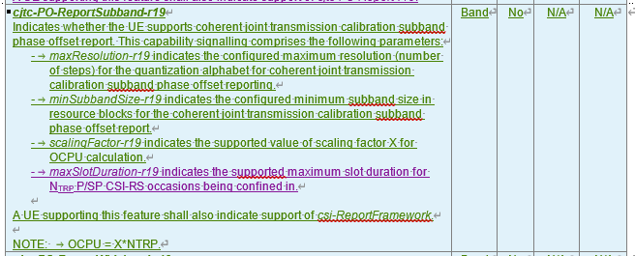  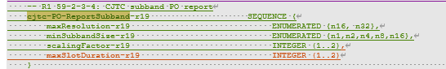  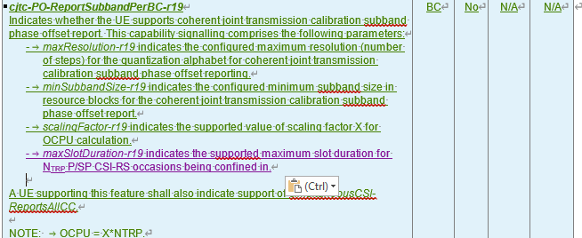  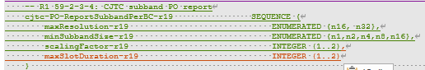
N0005 | R1 59-2-3-5a | 306 | According to the feature list, for this FG, O_{CPU}= 2*X*N_{TRP}; however, this is captured as O_{CPU}= X*N_{TRP} in the parameter description for valueX-r19. | Under description for cjtc-DdFO-ReportProcessing-r19, cjtc-DdFO-ReportProcessingPerBC-r19 parameter valueX-r19 change O_{CPU}= X*N_{TRP} to O_{CPU}= 2*X*N_{TRP.} | Resolved  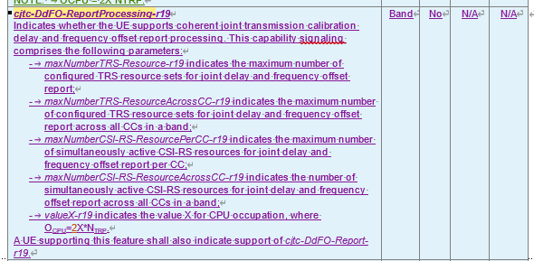  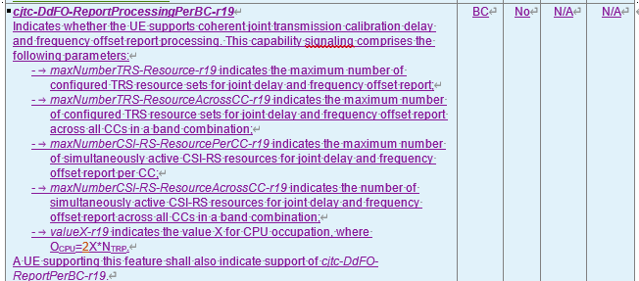
N0006 | R1 59-2-3-6c | 331 | This capability (i.e. cjt-QCL-PDSCH-SchemeE-r19) is mislabeled as 59-2-3-6b in 38.331. | Change label in 331 to 59-2-3-6c. | Resolved
N0007 | R1 59-2-3-7 | 306 | Prerequisite of per-band capability linked-CJTC-Dd-eType2CJT-Joint-r19 is listed as eType2CJTperBC-r18. Should it be eType2CJT-r18? | Double check whether prerequisite should be changed to per-band capability eType2CJT-r18 | Resolved  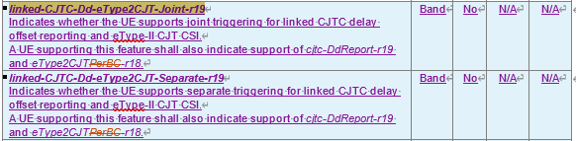
N0008 | R1 59-2-3-7a | 306 | Prerequisite of per-band capability linked-CJTC-Dd-eType2CJT-Separate-r19 is listed as eType2CJTperBC-r18. Should it be eType2CJT-r18? | Double check whether prerequisite should be changed to per-band capability eType2CJT-r18 | Resolved see above
N0009 | R1 59-2-3-10 | 331 | scs960kHz is mislabeled as scs120kHz in the per band and per BC capabilities  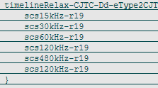 | Change second instance of scs120kHz-r19 to scs960kHz-r19 under timelineRelax-CJTC-Dd-eType2CJT-r19 and timelineRelax-CJTC-Dd-eType2CJT-PerBC-r19 | Resolved  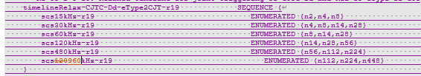  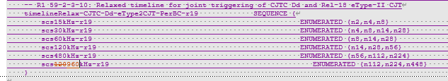
N0010 | R1 59-3-2 | 306 | In the description for this capability in 306, the parameters have an -r18 suffix instead of -r19 suffix, i.e. maxNumberPUSCH-MIMO-Layer-r18 and maxNumberSRS-Resource-r18 | Change suffix of the parameters to “-r19”. | Resolved  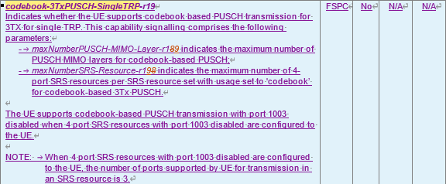
N0011 | R1 59-3-4a | 331 | This capability (i.e. mTRP-PUSCH-RepetitionTypeA-3Port-r19) is mislabeled as 59-3-4 in 38.331. | Change label in 331 to 59-3-4. | Resolved
N0012 | R1 59-3-4d | 306, 331 | This feature was not captured in the CR. The prerequisite 59-4-4b is already implemented and there are no details left FFS. | Add capability for R1 59-3-4d “PDCCH ordered sent by one TRP triggers RACH procedure towards a different TRP based on CRFA for inter-cell without CORESETPoolIndex” | Resolved and see H009 (assume the comment refers to FG59-4-4d)
N0013 | R1 61-4a | 306 | The capability for od-SSB-AlwaysOn-MAC-CE-Diff-r19 is defined based on the support for explicit or joint explicit/implicit deactivation mechanism, but the description in 306 refers to the time relations TimeC1/TimeC2, which are not relevant to this capability. | Update description in 306 to refer to OD-SSB deactivation mechanisms based on explicit / implicit indication and delete part about time relations based on TimeC1, TimeC2. | Resolved  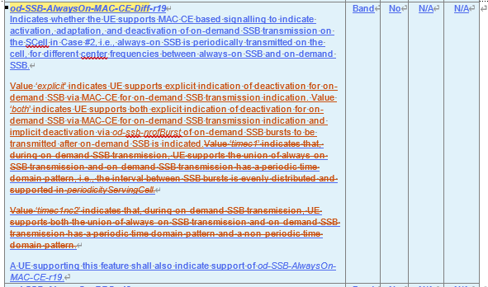
N0014 | R1 63-2 | 306 | The NOTE on indicating at least one non-zero value is confusing; besides, it seems like this should be a normative requirement instead of a note. | Delete NOTE and add following clarification to capability description:  “UE supporting this feature must support a non-zero value for at least one of supportedMaxAperiodic-LTM-CSI-ReportConfig-r19 and supportedMaxSemiPersistent-LTM-CSI-ReportConfig-r19.” | Resolved but kept as a NOTE  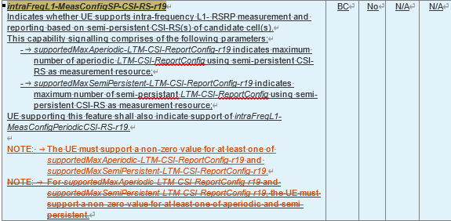
N0015 | R4 46-4 | 306 | In the description and NOTE for mpr-SingleCC-SingleValue-r19, the abbreviation “NRB” should be written as “N_{RB}” (same as it is for mpr-SingleCC-MultipleValue-r19) | Change “NRB” to “N_{RB}” in the description and NOTE of mpr-SingleCC-SingleValue-r19 | Resolved
N0016 | R4 49-1 | 306 | This capability (i.e. threeCarrierMeasWithoutGap-r19) has not been defined in 38.306 even though it is in 331. | Add definition for threeCarrierMeasWithoutGap-r19 to 38.306 CR. | Resolved  See Oppo003
N0017 | R4 50-2 | 306 | The formula for the processing time T_{min} is incomplete in the capability description of od-SSB-AdditionalProcessingTime.  Or maybe the intention is not to write it fully and the description will just refer to the RAN4 specs? | Double check whether formula for T_{min} needs to be updated to align with the feature list (i.e. $T_{min}=3N_{slot}^{subframe,μ}$) or whether the description will just refer to the RAN4 specs. | Resolved  After further checking, this is defined in RAN1 spec. Added the reference in 306.  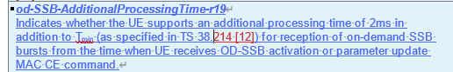  following agreement copied from RAN4:  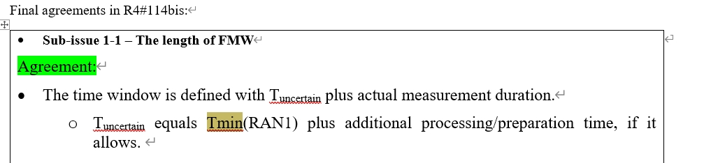
H001 | uei-ModeA-Event2-r19 | 306 | In the NOTE 1, should it be an ‘and the’, rather than a ‘,’? The current sentence does not make sense to me.  NOTE 1: For the configured RS(s) for new beam in the RS resource set, QCL RS in the indicated TCI state and its corresponding QCL SSB for Scheme-1 and Scheme-2, the SSB can be associated with the serving cell PCI or a PCI other than the serving cell PCI. | Change to  NOTE 1: For the configured RS(s) for new beam in the RS resource set and the QCL RS in the indicated TCI state and its corresponding QCL SSB for Scheme-1 and Scheme-2, the SSB can be associated with the serving cell PCI or a PCI other than the serving cell PCI. | Resolved  change it into ‘and its corresponding QCL RS’
H002 | uei-ModeA-Event1-r19 | 306 | Not sure the note is needed as it seems to be the same as the feature  NOTE 1: Event 1 is defined as an event where the quality of the current beam is worse than a certain threshold. | Remove the NOTE 1? | Resolved  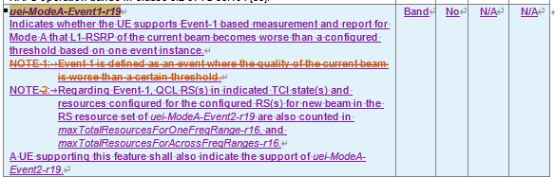
H003 | uei-ModeA-Event7-r19 | 306 | Typo on the pre-requisite:  A UE supporting this feature shall also indicate the support of uei-BR-Event2ModeA-r19. | Change to  A UE supporting this feature shall also indicate the support of uei-ModeA-Event2-r19 | Resolved
H004 | R1 59-2-1-6 |  | This seems to be missing for both per band and per BC. There is no visible sign that this feature is still FFS. |  | Resolved
H005 | cjtc-DdReportProcessing-r19  cjtc-FO-ReportProcessing-r19  cjtc-PO-ReportWidebandProcessing-r19  cjtc-DdFO-ReportProcessing-r19 | 331 | The values for these 2 components are from my reading is that it continues between 12 and 64 with the same intervals. For example, 12 …64 for Component 2 is 12, 16, 20…all the way to 64?  Component 2 candidate values: {2, 4, 6, 8, 12, … 64}  Component 4 candidate values: {2, 4, 6, 8, 12, 16, 20, 24, 28, 32, …, 64} | Check with RAN1? | UECap #1: intermediate candidate values represented by ‘…’  Actually rapporteur has aware that there’s a lot of candidate values with ‘…’. This issue has been noticed to RAN1 feature lead, and they will continue discussion in next meeting. For this meeting, I suggest we don’t inserted any intermediate values and this will be updated once there’s concrete RAN1 agreement.  [update after RAN2 #131bis meeting] RAN1 FL suggests companies to bring tdoc to RAN1 meeting if there’s a need to clarify the intermediate values.
H006 | cjtc-PO-ReportSubbandPerBC-r19  cjtc-PO-ReportSubband-r19 | 331 | Missing Component 4:  4. Supported maximum slot duration for N_{TRP} P/SP CSI-RS occasions being confined in  Component 4 candidate values: {1, 2} | Add the missing component to 331 and 306 | Resolved see N0004
H007 | nonCodebook-CSI-RS-SRS-3TxPUSCH-r18 | 306 | Should we add ‘-r16’ in codebookVariantsList to align with other ASN.1 field in 306. Maybe there are already some that are not aligned previously with this. | Editorial | Resolved  There’s no other Rel-19 capability uses codebookVariantsList, for other legacy capabilities, since there’s only r16 field, there’s no necessary change to update this for legacy caps.
H008 | mTRP-PUSCH-RepetitionTypeA-3Port-r19 | 331 | The annotation should be 59-3-4a. Cut and paste error. | Update the annotation. | Resolved
H009 | 59-4-4d | 331 | It is missing without any FFS |  | Resolved  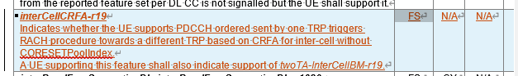
H010 | intraFreqL1-MeasConfigSP-CSI-RS-r19 | 306 | This note looks strange:  NOTE: For supportedMaxAperiodic-LTM-CSI-ReportConfig-r19 and supportedMaxSemiPersistent-LTM-CSI-ReportConfig-r19, the UE must support a non-zero value for at least one of aperiodic and semi-persistent. | Proposed to change to:  NOTE: The UE must support a non-zero value for at least one of supportedMaxAperiodic-LTM-CSI-ReportConfig-r19 and/or supportedMaxSemiPersistent-LTM-CSI-ReportConfig-r19.. | Resolved
H011 | enableTx-RxDuringMeasGap-r19 | 331 | The following does not allow for support more than 1 by the UE  additionalDCI-r19 ENUMERATED {dci0-2and1-2, dci0-3, dci1-3},  RAN1 suggested using a bitmap.  Candidate values of component 2b: 3-bit bitmap {DCI 0_2 and 1_2, DCI 0_3, DCI 1_3} | Follow RAN1 suggestion | Resolved  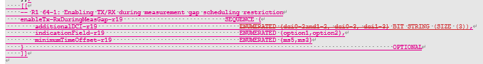  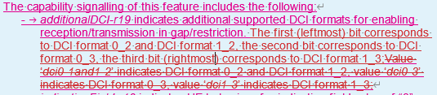
H012 | od-SSB-AdditionalProcessingTime-r19 | 306 | Ediotrial to simplified the text below:  If UE does not support this feature, additional processing time of 5ms is considered for reception of on-demand SSB bursts from the time when UE receives OD-SSB activation or parameter update MAC CE command. | Suggest to align with previous way of writing:  If the field is absent, the UE shall support a default value of additional processing time of 5ms. | Resolved  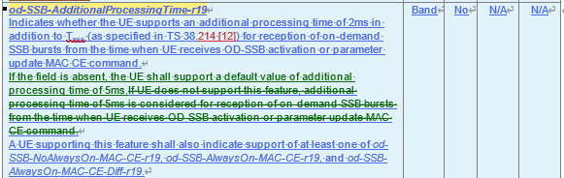
H013 | lpwus-LP-SS-SupportedBandList-r19 | 306/(331) | 1. The description for lpwus-LP-SS-SupportedBandList-r19 is copy and paste incorrectly;  2. The relation between 62-1a and 62-1b is unclear (from RAN1 feature list). Technically, UE indicates whether support 62-1b on top of 62-1a, e.g., the UE reports 62-1a with band list {band A, band B, band C}, UE further reports whether supports 62-1b for band A, band B, and/or band C. The UE cannot report 62-1b with band list {band D, band E}. To fix it:  Option 1: add description for 62-1b, all the band(s) indicated by this field are included in lpwus-OFDM-SupportedBandList-r19.  Option 2: add 62-1b as the sub-field under lpwus-OFDM-SupportedBandList-r19, e.g.,  LPWUS-OFDM-SupportedBandInfo-r19 ::= SEQUENCE {  supportedBandIndicator-r19 FreqBandIndicatorNR,  minimumTimeGap-r19 SEQUENCE {…}  lpwus-LP-SS ENUMERATED {supported} OPTIONAL  } | Change 1:  lpwus-LP-SS-SupportedBandList-r19  Indicates whether the UE supports LP-SS based RRM measurement in IDLE/INACTIVE mode when LP-SS overlaid sequence is configured and all M values {1,2,4} for LP-SS for a list of frequency bands. LP-WUS operation in IDLE/INACTIVE mode based on OOK signal for a list of frequency bands. The UE shall support UEID based subgrouping for a frequency band if it indicates supporting of LP-WUS operation for the frequency band. The capability signalling comprises of the following components:  - Support of LP-SS based RRM measurement in IDLE/INACTIVE mode when LP-SS overlaid sequence is configured;  - Support of all M values {1,2,4} for LP-SS.  Change 2:  Option 1:  A UE supporting this feature shall also indicate support of lpwus-OFDM-SupportedBandList-r19. All the band(s) indicated by this field are also included in lpwus-OFDM-SupportedBandList-r19.  Option 2: please see the Option 2 in comments | Resolved:  - the dependency between FG62-1a and FG 62-1b has been added in 306 based on the updated capability implementation as below:  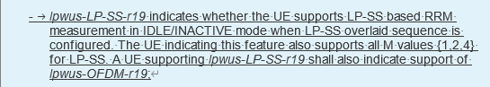
H014 | SIB1 request for idle/inactive UEs | 306 | This capability was decided to be optional with signalling in RAN2. | Capability signalling should be added based on discussion: [POST131][112][NES] UE capability CRs (ZTE) | Resolved  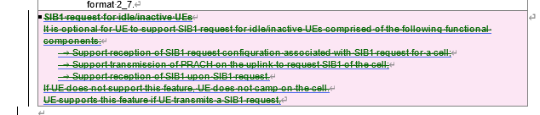  the followings are merged from RAN2 endorsed CR:
H015 | support32-DL-HARQ-ProcessTN-r19  and  support32-UL-HARQ-ProcessTN-r19 | 306 | The following NOTE is for NW configuration restriction (captured in CR R2-2506471) instead of capability reporting. It is confusing to capture in the capability field description, i.e., it is unclear what UE does with this NOTE.  NOTE: For FR1, the maximum number of layers configured for PDSCH is up to 4. | Remove the NOTEs from both capabilities’ description. | Resolved  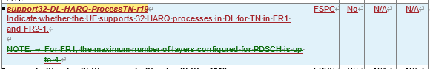  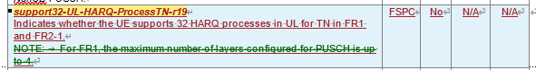
N0018 | R1 64-1 | 306/331 | The parameter additionalDCI-r19 should be defined as a bitmap, as the intention is that the UE could signal support for any combination of dci02and1-2, dci0-3, dci1-3 (including signalling them as all unsupported), in addition to already supporting DCI formats 0_1 and 1_1.  There is a typo in the description of additionalDCI-r19 in 306: Value ‘dci0-1and1-2’ indicates DCI format 0_2 and DCI format 1_2 | Change additionalDCI-r19 to a 3-bit bitmap where the bits represent {dci02and1-2, dci0-3, dci1-3}.  Fix typo in description of additionalDCI-r19 in 38.306:  Value ‘dci0-1and1-2’ indicates Value ‘dci0-2and1-2’ indicates | Resolved
E001 | R1 62-1b  UE-RadioPagingInfo-r19 | 38.331 | There should be a conditional statement added to this capability, i.e. it is only present when lpwus-OFDM-SupportedBandList-r19 is present. | 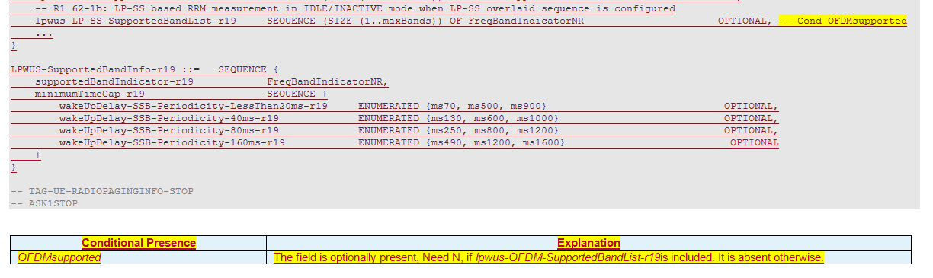 | Not pursued  For capability, such dependency is captured in 306 specification, instead of using a conditon presence. please see the udpates in 306 as below.  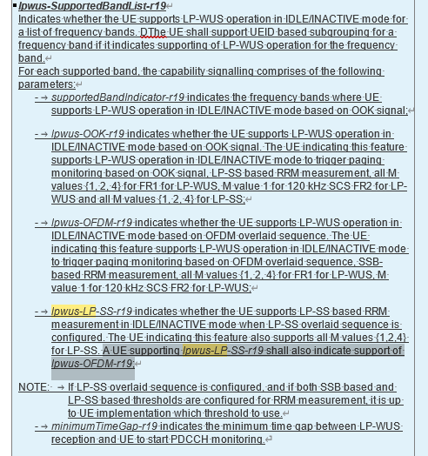
E002 | R1 62-1 and R1 62-1a | 38.331 | The bandlist for LP-SS support should be removed, i.e. the UE is expected to support LP-SS in all the bands where it supports OFDM (lpwus-OFDM-SupportedBandList-r19). | 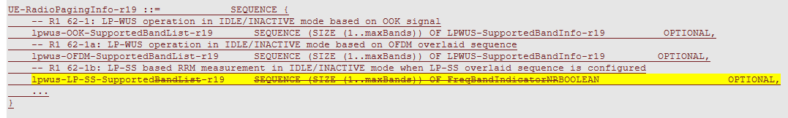 | Resolved. See H013, it has been added in 306.
E003 | R1 62-1 and R1 62-1a | 38.331 | For LP-WUS there is only a need for a single SupportedBandList. When the UE supports both OFDM and OOK, then it supports OFDM and OOK on the same bands. It is good to limit the capability size. | 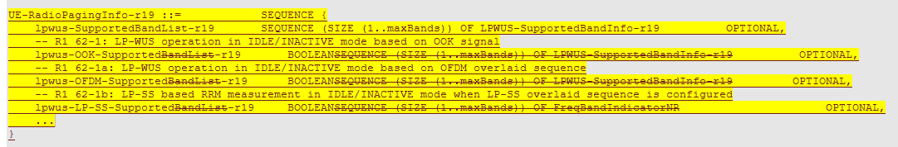 | Resolved. The signaling is further optimized to only include one list of supported band and other capabilities as optional within the field, indicating based on OOK or OFDM overlaid sequence.  