3GPP TSG RAN WG2 Meeting #132 R2-250xxxx
Dallas, USA, Nov 17th – 21st, 2025
Agenda Item: 8.0.1
Source: Xiaomi
Title: Comment for [POST131bis][004][UE caps] UE capability CR (Xiaomi)
Document for: Discussion and Decision

Introduction
- [POST131bis][004][UE caps] UE capability CR (Xiaomi)
Intended outcome: Update UE capability CRs post RAN1/RAN4 LS and combine with RAN2 CRs.
Deadline: long
Companies providing input to this email discussion are requested to leave contact information below.
Company | Name | Email Address
Nokia | Andrew Lappalainen | andrew.lappalainen@nokia.com
Huawei | Seau Sian Lim | seau.sian.lim@huawei.com

Discussion
In R1-2507981, RAN1 asked RAN2 to provide feedback on below questions (the table can be found in RAN1 LS R1-2507981):
For NR_MC_enh2,
RAN1 would like to inform RAN2 of the following agreement:
Agreement:
Ask RAN2 to feedback if it is possible to update prerequisite FG(s) for Rel-18 RAN1 FG 49-4a/4b/4c/4d/5a/5b/6/7/8/9/10/12/12a/13/14 in Rel-19 as follows (red fonts).
Rapporteur understands that directly adding Rel-19 features as prerequisite FGs for Rel-18 FGs is confusing, even it is implemented from Rel-19 specification. To avoid ambiguity, rapporteur suggests o define new Rel-19 FGs for Rel-18 FG 49-4a/4b/4c/4d/5a/5b/6/7/8/9/10/12/12a/13/14, those new Rel-19 FGs will depend on whether FG66-1/66-2 are supported or not.
For example:
Index | Feature group | Rel-18 UE cap | Rel-19 UE cap | Components | Prerequisite feature groups
49-4a | Nominal RBG size of Configuration 3 for FDRA type 0 for DCI format 1_3 | nominalRBG-SizeOfConfig-3-FDRA-Type-0-DCI-1-3-r18 | nominalRBG-SizeOfConfig-3-FDRA-Type-0-DCI-1-3-v1900  A UE supporting nominalRBG-SizeOfConfig-3-FDRA-Type-0-DCI-1-3-v1900 shall also indicate support of FG 66-1. | 1) Support of nominal RBG size of Configuration 3 for FDRA type 0 for DCI format 1_3 | At least one of {49-1, 49-1b, 66-1}

Q1: Do you agree with the above change for Rel-18 RAN1 FG 49-4a/4b/4c/4d/5a/5b/6/7/8/9/10/12/12a/13/14 in Rel-19?
Company | Yes/No | Suggestion/Comment
Nokia | No | We think it is not too confusing to adopt RAN1’s suggestion and prefer to avoid reintroducing redundant -v1900 capabilities.  Since the prerequisites based on 66-1 would only be updated in the Rel-19 spec, only R19 UE would need to consider implementing them and there is no impact to R18 UEs.  Taking 49-4a as an example, if a R19 UE does not support 49-1/49-1b but supports 66-1:  - A R19 NW would interpret 49-4a as supported and could configure the UE based on the underlying support of 66-1  - A R18 NW cannot support 66-1; so, if UE does not support 49-1/49-1b the R18 NW has no way to configure UE to use 49-4a anyway; so there is no issue as such.  Introducing -v1900 versions of the R18 capabilities will not change the above outcome; on the other hand, adding new capabilities will add additional testing/validation burden to UE and NW implementers; so we do not think there are clear enough benefits to justify introducing them.
Huawei | No | It is unclear to us why RAN1 wants to add Rel-19 capabilities to Rel-18 capabilities. As like the rapporteur said, it is indeed confusing and ambiguous to do such thing as for a Rel-18 UE, the Rel-18 capability can always be reported without supporting the Rel-19 capability. It just means that the additional of Rel-19 capability to the pre-requisite seems redundant. From this perspective, we don’t think it is really essential to add this prerequisite even in Rel-19 spec. Furthermore, it is also strange to have different prerequisites for same capability in different releases (even if a R18 capabilities are duplicated in R19).

Comment
Companies are invited to provide comments if there’s a change that is not agreeable. Other comments are welcomed.
Comment Index | Capability IE/FG | Specification  (306/331) | Comment | Proposed Change | Rapp resolution
N019 | R1 58-1-2 / 58-1-4 | 306/331 | Only the basic components for these capabilities were implemented:  aiml-BM-Case1-r19 ENUMERATED {supported},  aiml-BM-Case2-r19 ENUMERATED {supported}  But the R1 feature list includes multiple other components that need to be reported with the capability, e.g. max number of inference reports, max number of predicted beams, etc. | Add the missing components to 306/331 (unless the intention was just to implement the basic component so the other capabilities dependent on 58-1-2/58-1-4 could be implemented already?).
N020 | R1 58-1-5 | 331 | There is a typo in the capability name:  aiml-BM-Ccase2-PredictedRSRP-r19 SEQUENCE { | Change to: “aiml-BM-Case2-PredictedRSRP-r19”
N021 | R1 58-3-2 / 58-3-4 / 58-3-5 | 306 | Per BC capabilities are missing “PerBC” in the name in 306. | Add “PerBC” to the per BC capability names
  aiml-CSI-PredictionMonitoring-r19 | BC | No | N/A | N/A
  aiml-CSI-PredictionN4-r19 | BC | No | N/A | N/A
  aiml-CSI-PredictionUE-DataCollection-r19 | BC | No | N/A | N/A
  aiml-CSI-PredictionMonitoringPerBC-r19 | BC | No | N/A | N/A
  aiml-CSI-PredictionN4PerBC-r19 | BC | No | N/A | N/A
  aiml-CSI-PredictionUE-DataCollectionPerBC-r19 | BC | No | N/A | N/A
N022 | R1 59-2-1-9 | 306 | ‘Curly quotes’ instead of 'straight quotes' are used in the description for nes-SD-Type1-SP-r19 and nes-SD-Type1-SP-PerBC-r19. Especially for Z' this should be corrected as this is a specific term used in RAN1 specs; but note also that straight quotes shall be used as per 3GPP drafting rules.  Furthermore, we think Z2 / Z'2 is supposed to be Z₂ / Z'₂ as per 38.214. | Change use of ‘curly quotes’ to 'straight quotes' and use subscript for “2” when referring to the Z timeline.  Z’ / Z2 / Z’2 Z' / Z₂ / Z'₂
N023 | R1 60-2a | 306 | There is some redundant text at the end of the capability description for sbfd-Tx-r19. | Delete following text from end of capability description:  "The UE optionally includes sbfd-OneRACH-r19 to indicate whether the UE supports  - numOfPartialPRG-r19 indicates ;  - numOfPartialPRG-r19 indicates ;  - numOfPartialPRG-r19 indicates ;  - numOfPartialPRG-r19 indicates ;
N024 | R1 60-5 / 60-5a | 306 | There is a typo “additional-Ros” under description of preambleRepetitionOneRACH-r19 and preambleRepetitionTwoRACH-r19: should be additional-ROs | Change “additional-Ros” to “additional-ROs” under description for preambleRepetitionOneRACH-r19 and preambleRepetitionTwoRACH-r19
N025 | R1 60-5a | 306 | According to the R1 feature list, component 2 of 60-5a applies to “separate configuration of rsrp-ThresholdMsg1-RepetitionNum2/4/8 and msg1-RepetitionNum for PRACH transmission with preamble repetitions within additional-ROs and PRACH transmission with preamble repetitions within legacy-ROs”.  msg1-RepetitionNum was missed in the description. | Add msg1-ReptitionNum to description of component under preambleRepitionTwoRACH-r19  The UE optionally includes preambleRepetitionTwoRACH-r19 to indicate whether the UE supports preamble repetition within additional-ROs for two separate RACH configurations in RRC_IDLE/INACTIVE/CONNECTED mode, including:  - Determination of the set of $N_{preamble}^{rep}$ valid additional-ROs and the time period of the set(s) of $N_{preamble}^{rep}$_ valid additional-Ros;  - For two separate RACH configurations in RRC_IDLE/INACTIVE/CONNECTED mode, support separate configuration of rsrp-ThresholdMsg1-RepetitionNum2/4/8 and msg1-RepetitionNum for PRACH transmission with preamble repetitions within additional-ROs and PRACH transmission with preamble repetitions within legacy-ROs.
N026 | R1 62-2 | 306 | In the capability description, the alignment is off on the last component maxNumCodepointsPerMO  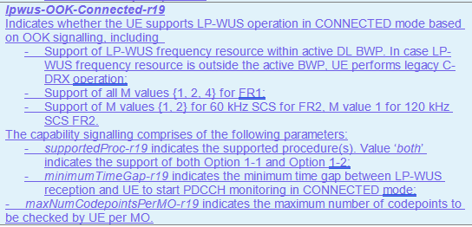 | Fix alignment of capability parameter list in the description of lpwus-OOK-Connected-r19.
N027 | lpwus-SupportedBandList-r19 | 306 | The way the description is written, i.e. “The UE supporting this feature shall also indicate the support of at least lpwus-OOK-r19 or lpwus-OFDM-r19.” almost makes it seem as if lpwus-OOK and lpwus-OFDM are prerequisites for lpwus-SupportedBandList.  Suggest that we just say “UE shall indicate at least one of lpwus-OOK-r19 or lpwus-OFDM-r19.” | Change “The UE supporting this feature shall also indicate the support of at least lpwus-OOK-r19 or lpwus-OFDM-r19.” to “UE shall indicate at least one of lpwus-OOK-r19 or lpwus-OFDM-r19.”
N028 | R1 63-10 | 306 | Prerequisites in capability description for ltm-WithoutCSI-IM-r19 were implemented correctly, i.e. 63-6 or 63-6a or 63-7 or 63-7a, however we notice that 63-7 and 63-7a are redundant since 67-7 requires support of 63-6 and 67-7a requires support of 63-6a.  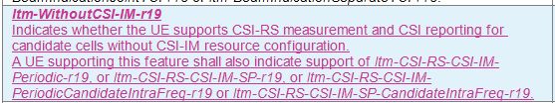 | Change to “A UE supporting this feature shall also indicate support of ltm-CSI-RS-CSI-IM-Periodic-r19 or ltm-CSI-RS-CSI-IM-SP-r19.”
N029 | R4 49-4 | 306 | For fastSCellActivationEarlyMeas-r19, the prerequisite features in the R4 list are:  Both 1) and 2):  1) 39-8 or 39-9 in R18 RAN4 feature list or 18-7 (idleInactiveNR-MeasReport-r16)  2) idleInactiveNR-MeasBeamReport-r16  How this is captured in 38.306 is a bit ambiguous in our view:  “A UE supporting this feature shall also indicate support of measValidationReportEMR-r18 or measValidationReportReselectionMeasurements-r18 or idleInactiveNR-MeasReport-r16, and idleInactiveNR-MeasBeamReport-r16.” | For clarity, suggest following rewording:  “A UE supporting this feature shall also indicate support of idleInactiveNR-MeasBeamReport-r16 and at least one of idleInactiveNR-MeasReport-r16, measValidationReportEMR-r18 or measValidationReportReselectionMeasurements-r18.”
H016 | R4 46-4,46-5 | 331 | mpr-SingleCC-r19 CHOICE {  -- R4 46-4: MPR reduction for single carrier with single value  mpr-SingleCC-SingleValue-r19 ENUMERATED {supported},  -- R4 46-5: MPR reduction for single carrier with multiple values  mpr-SingleCC-MultipleValue-r19 ENUMERATED {supported},  } OPTIONAL, | We are just wondering whether it will be more readable by changing it to the following. Not strong view if companies want to keep it as a CHOICE.  -- R4 46-4: MPR reduction for single carrier with single value  -- R4 46-5: MPR reduction for single carrier with multiple values  mpr-SingleCC-r19 ENUMERATED {singleVal, multipleVal} OPTIONAL,
H017 | R4 47-2 | 306 | May need to update the text to include the table index as updated by R4 feature list:  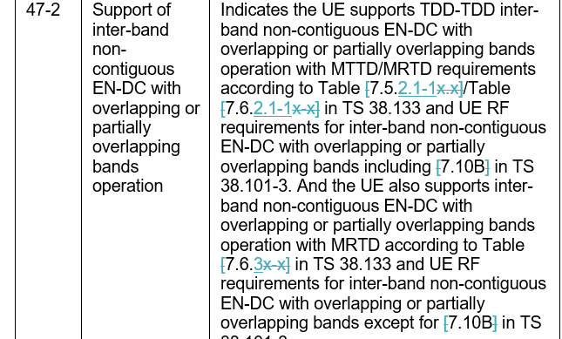 | Updated according to R4 feature list with the table indexes rather than the clause index.
H018 | R4 49-4 | 331 and 306 | Since R4 feature list indicated that the capability required FRx differentiation, it has to be included as per band rather than per UE | Move the capability to BandNR and include the consistency check as follow:  UE shall set the capability value consistently for all FDD-FR1 bands, all TDD-FR1 bands, all TDD-FR2-1 bands and all TDD-FR2-2 bands respectively
H019 | R4 59-1, 59-2 | 331 | I do not remember that the beam management capabilities are in MIMO-ParametersPerBand. This is also a general comment as there are other AIML BM also included MIMO-ParametersPerBand.  Maybe it would be good to group the AIML capabilities into a new group in BandNR so that if it is not supported by UE, it won’t incur additional overhead individually due to optionality | Suggest to move the AIML for BM out of MIMO-ParametersPerBand into the general BandNR.  Suggest to group the per band AIML BM capabilities into a group in BandNR
H020 | R1 58-1-2, 58-1-4, 58-3-1 | 306 | If to include these features with a placeholder: In RAN2#131, it is agreed to include the following into these features:  - Include RAN2 feature ‘UE can provide update of applicability reporting via UAI’ as part of RAN1 FGs (e.g., 58-0-1 and/or FG 58-1-2/3/4/5, the details of those feature group depend on RAN1 progress) once implemented.  This should be implemented with the placeholder capability. I assume this also apply to 58-3-1 | Add the UAI support into the field description for aiml-BM-Case1-r19, aiml-BM-Case2-r19 and aiml-CSI-Prediction-r19
H021 | R1 58-1-3, 58-1-5 | 306 | Editorial. Instead of a ‘,’ between ‘beam prediction’ and ‘reporting of predicted beam, replace it with ‘with’
H022 | R1 58-1-5 | 331 | Typo, extra ‘c’ in the field name | Remove highlighted ‘c’: aiml-BM-Ccase2-PredictedRSRP-r19
H023 | R1 58-3-1-x | 331/306 | None of them are implemented even though there are no FFS on them.
H024 | R1 58-3-5 | 306 | The word ‘significant’ in the NOTE is a bit ambiguous, does it mean ‘more’? | Change to ‘more’?
H025 | R1 60-1 | 306 | Some redundant text at the end of the description:  The UE optionally includes sbfd-OneRACH-r19 to indicate whether the UE supports  - numOfPartialPRG-r19 indicates ;  - numOfPartialPRG-r19 indicates ;  - numOfPartialPRG-r19 indicates ;  - numOfPartialPRG-r19 indicates ; | Remove
H026 | R1 63-7, 63-7a,7b,7c,7d | 331/306 | All should be implemented per BC in CA-ParametersNR | Move them to CA-ParametersNR.

Annex post R2-131 meeting
Companies are invited to provide comments if there’s a change that is not agreeable. Other comments are welcomed.
Comment Index | Capability IE/FG | Specification  (306/331) | Comment | Proposed Change | Rapp resolution
OPPO001 | 46-1/2/3 | 331,306 | They are now implemented as MRDC Parameter,  MRDC-Parameters-v1900  While based on our R4 colleagues, MPR reduction were discussed for CA case, rather than MRDC. | Avoid implementation those features as MRDC parameters (in both 331 and 306) | Resolved  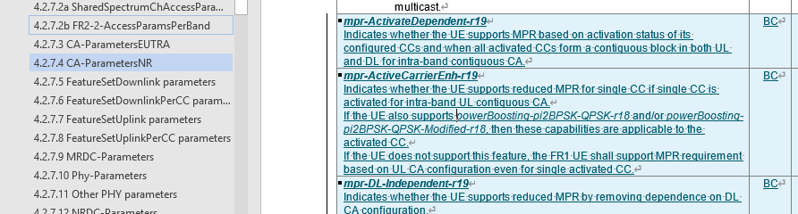
OPPO002 | 46-4/5 | 331,306 | Based on our R4, there is no case where UE report both features, since the support of 46-5 already includes the support of 46-4 | Suggest implement 46-4/5 as a same capability, with two ENUMERATED values pointing to 46-4 and 46-5. | Resolved and updated into choice
OPPO003 | 49-1 | 331,306 | Currently this feature is reported via UE-MRDC-Capability only, but looking at the values in this feature  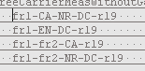  Clearly, the first/third/fourth case is related to NR-SA and NR-DC that should be implemented via UE-NR-Capability. | Implement the values of this feature separately via UE-MRDC-Capability and UE-NR-Capability. | Resolved  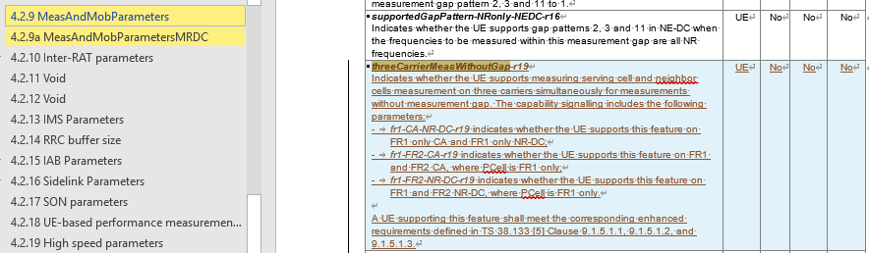  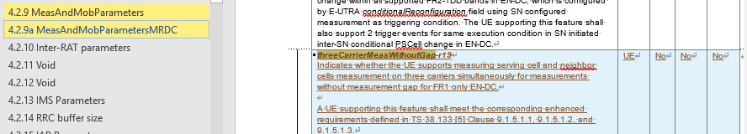  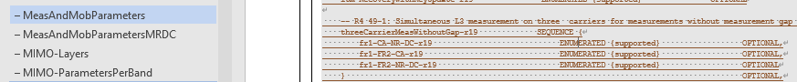
N0001 | R1 59-1-5 | 306 | Prerequisite 59-1-1 is incorrectly written as uei-BR-Event2ModeA-r19. This should be uei-ModeA-Event2-r19 | Change prerequisite to ‘uei-ModeA-Event2-r19’ | Resolved.  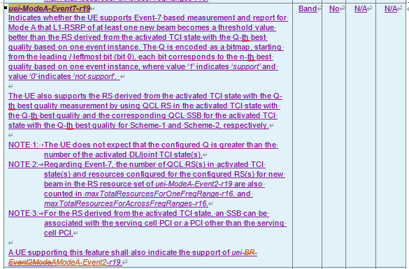
N0002 | R1 59-2-1-1d, 59-2-1-2a, 59-2-1-3a, 59-2-1-4a, 59-2-1-5a | 331 | In all these capabilities for 48 Tx port codebooks, the parameter maxNumberResource-r19 is encoded as INT(2..3), but a bit could be saved by encoding them as ENUMERATED {n2,n3}.  Note that in the corresponding 64 Tx port codebook capabilities maxNumberResource-r19 is already encoded as ENUMERATED {n2,n4}. | Change encoding for maxNumberResource-r19 from INT (2..3) to ENUMERATED {n2,n3}. | Resolved and updated for all  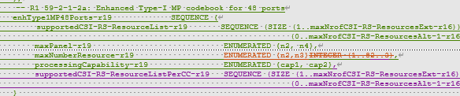
N0003 | R1 59-2-1-6 | 306/331 | This feature was not captured in the CR. All prerequisites (“One or more of {59-2-1-1,1c, 2, 3, 4, 5}”) are already implemented and there are no details left FFS. | Add capability for R1 59-2-1-6 “CSI-RS resource time domain restriction for Type-I and Type II codebook enhancement for up to 128 ports” | Resolved
N0004 | R1 59-2-3-4 | 306/331 | Component 4 (Supported maximum slot duration for NTRP P/SP CSI-RS occasions being confined in) is missing | Add component 4 under the per-band and per-BC capabilities cjtc-PO-ReportSubbandPerBC-r19 / cjtc-PO-ReportSubband-r19  maxSlotDuration-r19 INTEGER (1..2)  maxSlotDuration-r19 indicates the supported maximum slot duration for N_{TRP} P/SP CSI-RS occasions being confined in. | Resolved  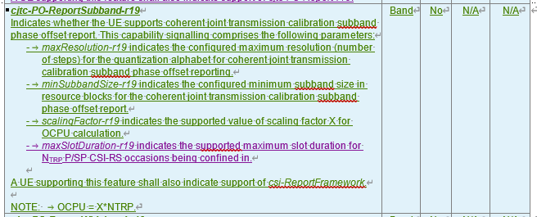  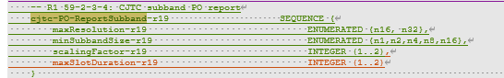  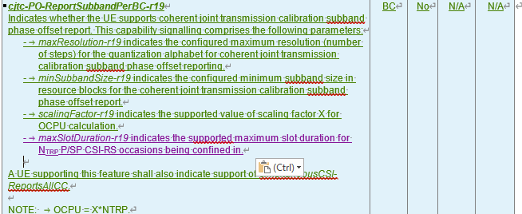  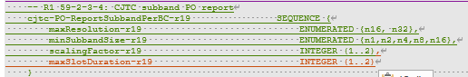
N0005 | R1 59-2-3-5a | 306 | According to the feature list, for this FG, O_{CPU}= 2*X*N_{TRP}; however, this is captured as O_{CPU}= X*N_{TRP} in the parameter description for valueX-r19. | Under description for cjtc-DdFO-ReportProcessing-r19, cjtc-DdFO-ReportProcessingPerBC-r19 parameter valueX-r19 change O_{CPU}= X*N_{TRP} to O_{CPU}= 2*X*N_{TRP.} | Resolved  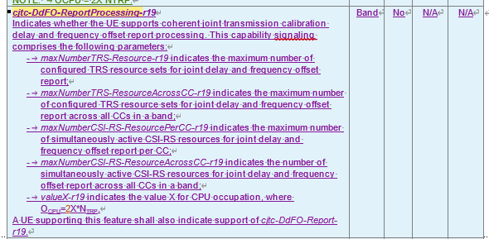  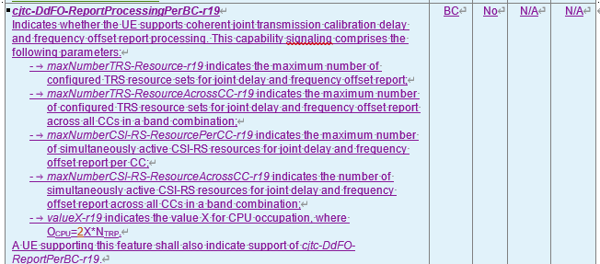
N0006 | R1 59-2-3-6c | 331 | This capability (i.e. cjt-QCL-PDSCH-SchemeE-r19) is mislabeled as 59-2-3-6b in 38.331. | Change label in 331 to 59-2-3-6c. | Resolved
N0007 | R1 59-2-3-7 | 306 | Prerequisite of per-band capability linked-CJTC-Dd-eType2CJT-Joint-r19 is listed as eType2CJTperBC-r18. Should it be eType2CJT-r18? | Double check whether prerequisite should be changed to per-band capability eType2CJT-r18 | Resolved  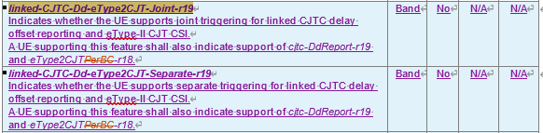
N0008 | R1 59-2-3-7a | 306 | Prerequisite of per-band capability linked-CJTC-Dd-eType2CJT-Separate-r19 is listed as eType2CJTperBC-r18. Should it be eType2CJT-r18? | Double check whether prerequisite should be changed to per-band capability eType2CJT-r18 | Resolved see above
N0009 | R1 59-2-3-10 | 331 | scs960kHz is mislabeled as scs120kHz in the per band and per BC capabilities  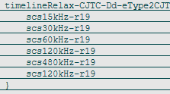 | Change second instance of scs120kHz-r19 to scs960kHz-r19 under timelineRelax-CJTC-Dd-eType2CJT-r19 and timelineRelax-CJTC-Dd-eType2CJT-PerBC-r19 | Resolved  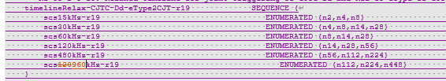  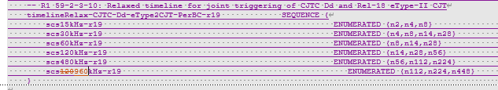
N0010 | R1 59-3-2 | 306 | In the description for this capability in 306, the parameters have an -r18 suffix instead of -r19 suffix, i.e. maxNumberPUSCH-MIMO-Layer-r18 and maxNumberSRS-Resource-r18 | Change suffix of the parameters to “-r19”. | Resolved  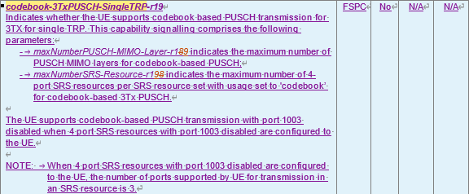
N0011 | R1 59-3-4a | 331 | This capability (i.e. mTRP-PUSCH-RepetitionTypeA-3Port-r19) is mislabeled as 59-3-4 in 38.331. | Change label in 331 to 59-3-4. | Resolved
N0012 | R1 59-3-4d | 306, 331 | This feature was not captured in the CR. The prerequisite 59-4-4b is already implemented and there are no details left FFS. | Add capability for R1 59-3-4d “PDCCH ordered sent by one TRP triggers RACH procedure towards a different TRP based on CRFA for inter-cell without CORESETPoolIndex” | Resolved and see H009 (assume the comment refers to FG59-4-4d)
N0013 | R1 61-4a | 306 | The capability for od-SSB-AlwaysOn-MAC-CE-Diff-r19 is defined based on the support for explicit or joint explicit/implicit deactivation mechanism, but the description in 306 refers to the time relations TimeC1/TimeC2, which are not relevant to this capability. | Update description in 306 to refer to OD-SSB deactivation mechanisms based on explicit / implicit indication and delete part about time relations based on TimeC1, TimeC2. | Resolved  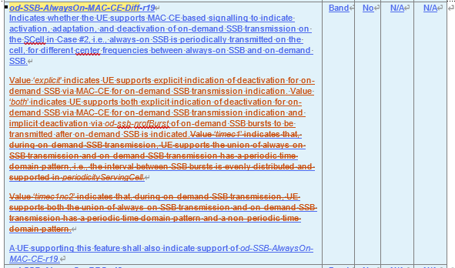
N0014 | R1 63-2 | 306 | The NOTE on indicating at least one non-zero value is confusing; besides, it seems like this should be a normative requirement instead of a note. | Delete NOTE and add following clarification to capability description:  “UE supporting this feature must support a non-zero value for at least one of supportedMaxAperiodic-LTM-CSI-ReportConfig-r19 and supportedMaxSemiPersistent-LTM-CSI-ReportConfig-r19.” | Resolved but kept as a NOTE  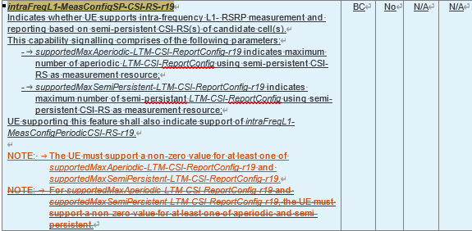
N0015 | R4 46-4 | 306 | In the description and NOTE for mpr-SingleCC-SingleValue-r19, the abbreviation “NRB” should be written as “N_{RB}” (same as it is for mpr-SingleCC-MultipleValue-r19) | Change “NRB” to “N_{RB}” in the description and NOTE of mpr-SingleCC-SingleValue-r19 | Resolved
N0016 | R4 49-1 | 306 | This capability (i.e. threeCarrierMeasWithoutGap-r19) has not been defined in 38.306 even though it is in 331. | Add definition for threeCarrierMeasWithoutGap-r19 to 38.306 CR. | Resolved  See Oppo003
N0017 | R4 50-2 | 306 | The formula for the processing time T_{min} is incomplete in the capability description of od-SSB-AdditionalProcessingTime.  Or maybe the intention is not to write it fully and the description will just refer to the RAN4 specs? | Double check whether formula for T_{min} needs to be updated to align with the feature list (i.e. $T_{min}=3N_{slot}^{subframe,μ}$) or whether the description will just refer to the RAN4 specs. | Resolved  After further checking, this is defined in RAN1 spec. Added the reference in 306.  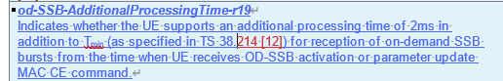  following agreement copied from RAN4:  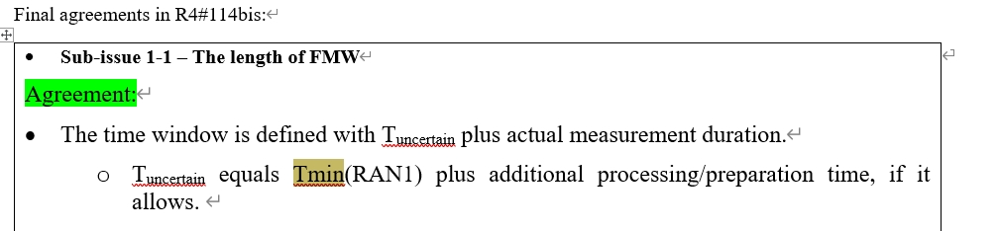
H001 | uei-ModeA-Event2-r19 | 306 | In the NOTE 1, should it be an ‘and the’, rather than a ‘,’? The current sentence does not make sense to me.  NOTE 1: For the configured RS(s) for new beam in the RS resource set, QCL RS in the indicated TCI state and its corresponding QCL SSB for Scheme-1 and Scheme-2, the SSB can be associated with the serving cell PCI or a PCI other than the serving cell PCI. | Change to  NOTE 1: For the configured RS(s) for new beam in the RS resource set and the QCL RS in the indicated TCI state and its corresponding QCL SSB for Scheme-1 and Scheme-2, the SSB can be associated with the serving cell PCI or a PCI other than the serving cell PCI. | Resolved  change it into ‘and its corresponding QCL RS’
H002 | uei-ModeA-Event1-r19 | 306 | Not sure the note is needed as it seems to be the same as the feature  NOTE 1: Event 1 is defined as an event where the quality of the current beam is worse than a certain threshold. | Remove the NOTE 1? | Resolved  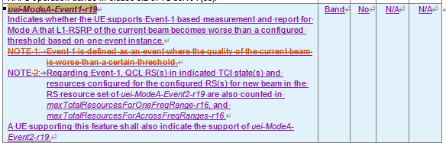
H003 | uei-ModeA-Event7-r19 | 306 | Typo on the pre-requisite:  A UE supporting this feature shall also indicate the support of uei-BR-Event2ModeA-r19. | Change to  A UE supporting this feature shall also indicate the support of uei-ModeA-Event2-r19 | Resolved
H004 | R1 59-2-1-6 |  | This seems to be missing for both per band and per BC. There is no visible sign that this feature is still FFS. |  | Resolved
H005 | cjtc-DdReportProcessing-r19  cjtc-FO-ReportProcessing-r19  cjtc-PO-ReportWidebandProcessing-r19  cjtc-DdFO-ReportProcessing-r19 | 331 | The values for these 2 components are from my reading is that it continues between 12 and 64 with the same intervals. For example, 12 …64 for Component 2 is 12, 16, 20…all the way to 64?  Component 2 candidate values: {2, 4, 6, 8, 12, … 64}  Component 4 candidate values: {2, 4, 6, 8, 12, 16, 20, 24, 28, 32, …, 64} | Check with RAN1? | UECap #1: intermediate candidate values represented by ‘…’  Actually rapporteur has aware that there’s a lot of candidate values with ‘…’. This issue has been noticed to RAN1 feature lead, and they will continue discussion in next meeting. For this meeting, I suggest we don’t inserted any intermediate values and this will be updated once there’s concrete RAN1 agreement.  [update after RAN2 #131bis meeting] RAN1 FL suggests companies to bring tdoc to RAN1 meeting if there’s a need to clarify the intermediate values.
H006 | cjtc-PO-ReportSubbandPerBC-r19  cjtc-PO-ReportSubband-r19 | 331 | Missing Component 4:  4. Supported maximum slot duration for N_{TRP} P/SP CSI-RS occasions being confined in  Component 4 candidate values: {1, 2} | Add the missing component to 331 and 306 | Resolved see N0004
H007 | nonCodebook-CSI-RS-SRS-3TxPUSCH-r18 | 306 | Should we add ‘-r16’ in codebookVariantsList to align with other ASN.1 field in 306. Maybe there are already some that are not aligned previously with this. | Editorial | Resolved  There’s no other Rel-19 capability uses codebookVariantsList, for other legacy capabilities, since there’s only r16 field, there’s no necessary change to update this for legacy caps.
H008 | mTRP-PUSCH-RepetitionTypeA-3Port-r19 | 331 | The annotation should be 59-3-4a. Cut and paste error. | Update the annotation. | Resolved
H009 | 59-4-4d | 331 | It is missing without any FFS |  | Resolved  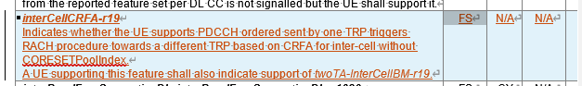
H010 | intraFreqL1-MeasConfigSP-CSI-RS-r19 | 306 | This note looks strange:  NOTE: For supportedMaxAperiodic-LTM-CSI-ReportConfig-r19 and supportedMaxSemiPersistent-LTM-CSI-ReportConfig-r19, the UE must support a non-zero value for at least one of aperiodic and semi-persistent. | Proposed to change to:  NOTE: The UE must support a non-zero value for at least one of supportedMaxAperiodic-LTM-CSI-ReportConfig-r19 and/or supportedMaxSemiPersistent-LTM-CSI-ReportConfig-r19.. | Resolved
H011 | enableTx-RxDuringMeasGap-r19 | 331 | The following does not allow for support more than 1 by the UE  additionalDCI-r19 ENUMERATED {dci0-2and1-2, dci0-3, dci1-3},  RAN1 suggested using a bitmap.  Candidate values of component 2b: 3-bit bitmap {DCI 0_2 and 1_2, DCI 0_3, DCI 1_3} | Follow RAN1 suggestion | Resolved  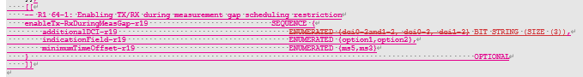  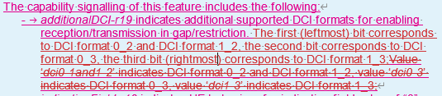
H012 | od-SSB-AdditionalProcessingTime-r19 | 306 | Ediotrial to simplified the text below:  If UE does not support this feature, additional processing time of 5ms is considered for reception of on-demand SSB bursts from the time when UE receives OD-SSB activation or parameter update MAC CE command. | Suggest to align with previous way of writing:  If the field is absent, the UE shall support a default value of additional processing time of 5ms. | Resolved  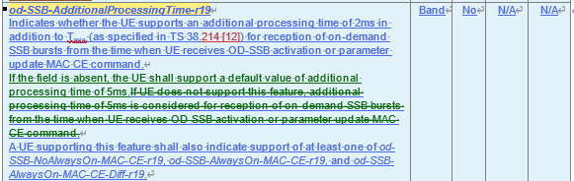
H013 | lpwus-LP-SS-SupportedBandList-r19 | 306/(331) | 1. The description for lpwus-LP-SS-SupportedBandList-r19 is copy and paste incorrectly;  2. The relation between 62-1a and 62-1b is unclear (from RAN1 feature list). Technically, UE indicates whether support 62-1b on top of 62-1a, e.g., the UE reports 62-1a with band list {band A, band B, band C}, UE further reports whether supports 62-1b for band A, band B, and/or band C. The UE cannot report 62-1b with band list {band D, band E}. To fix it:  Option 1: add description for 62-1b, all the band(s) indicated by this field are included in lpwus-OFDM-SupportedBandList-r19.  Option 2: add 62-1b as the sub-field under lpwus-OFDM-SupportedBandList-r19, e.g.,  LPWUS-OFDM-SupportedBandInfo-r19 ::= SEQUENCE {  supportedBandIndicator-r19 FreqBandIndicatorNR,  minimumTimeGap-r19 SEQUENCE {…}  lpwus-LP-SS ENUMERATED {supported} OPTIONAL  } | Change 1:  lpwus-LP-SS-SupportedBandList-r19  Indicates whether the UE supports LP-SS based RRM measurement in IDLE/INACTIVE mode when LP-SS overlaid sequence is configured and all M values {1,2,4} for LP-SS for a list of frequency bands. LP-WUS operation in IDLE/INACTIVE mode based on OOK signal for a list of frequency bands. The UE shall support UEID based subgrouping for a frequency band if it indicates supporting of LP-WUS operation for the frequency band. The capability signalling comprises of the following components:  - Support of LP-SS based RRM measurement in IDLE/INACTIVE mode when LP-SS overlaid sequence is configured;  - Support of all M values {1,2,4} for LP-SS.  Change 2:  Option 1:  A UE supporting this feature shall also indicate support of lpwus-OFDM-SupportedBandList-r19. All the band(s) indicated by this field are also included in lpwus-OFDM-SupportedBandList-r19.  Option 2: please see the Option 2 in comments | Resolved:  - the dependency between FG62-1a and FG 62-1b has been added in 306 based on the updated capability implementation as below:  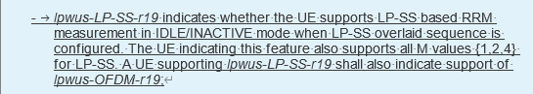
H014 | SIB1 request for idle/inactive UEs | 306 | This capability was decided to be optional with signalling in RAN2. | Capability signalling should be added based on discussion: [POST131][112][NES] UE capability CRs (ZTE) | Resolved  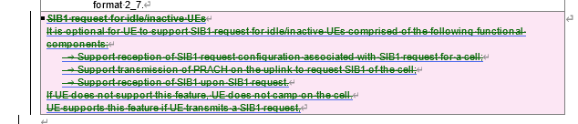  the followings are merged from RAN2 endorsed CR:
H015 | support32-DL-HARQ-ProcessTN-r19  and  support32-UL-HARQ-ProcessTN-r19 | 306 | The following NOTE is for NW configuration restriction (captured in CR R2-2506471) instead of capability reporting. It is confusing to capture in the capability field description, i.e., it is unclear what UE does with this NOTE.  NOTE: For FR1, the maximum number of layers configured for PDSCH is up to 4. | Remove the NOTEs from both capabilities’ description. | Resolved  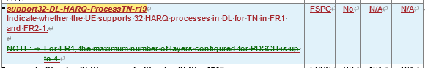  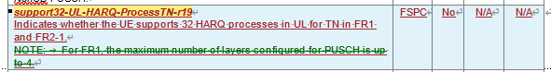
N0018 | R1 64-1 | 306/331 | The parameter additionalDCI-r19 should be defined as a bitmap, as the intention is that the UE could signal support for any combination of dci02and1-2, dci0-3, dci1-3 (including signalling them as all unsupported), in addition to already supporting DCI formats 0_1 and 1_1.  There is a typo in the description of additionalDCI-r19 in 306: Value ‘dci0-1and1-2’ indicates DCI format 0_2 and DCI format 1_2 | Change additionalDCI-r19 to a 3-bit bitmap where the bits represent {dci02and1-2, dci0-3, dci1-3}.  Fix typo in description of additionalDCI-r19 in 38.306:  Value ‘dci0-1and1-2’ indicates Value ‘dci0-2and1-2’ indicates | Resolved
E001 | R1 62-1b  UE-RadioPagingInfo-r19 | 38.331 | There should be a conditional statement added to this capability, i.e. it is only present when lpwus-OFDM-SupportedBandList-r19 is present. | 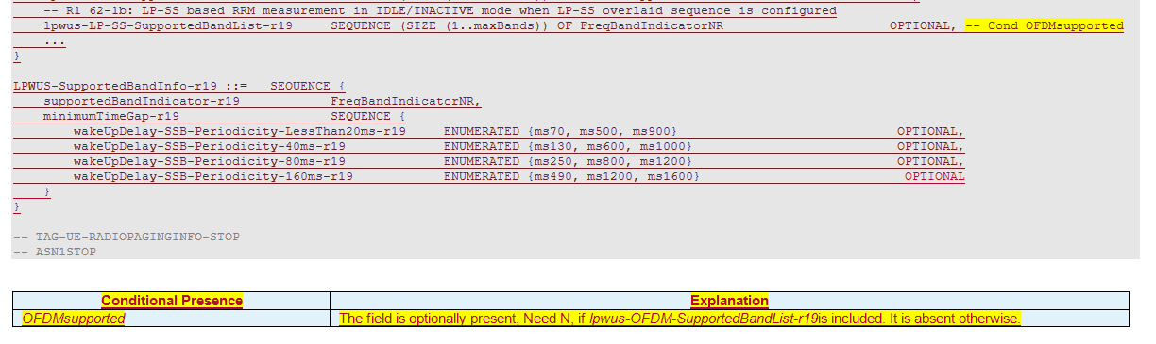 | Not pursued  For capability, such dependency is captured in 306 specification, instead of using a conditon presence. please see the udpates in 306 as below.  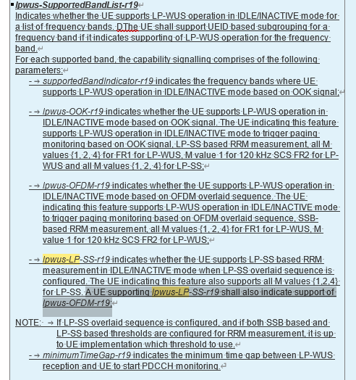
E002 | R1 62-1 and R1 62-1a | 38.331 | The bandlist for LP-SS support should be removed, i.e. the UE is expected to support LP-SS in all the bands where it supports OFDM (lpwus-OFDM-SupportedBandList-r19). | 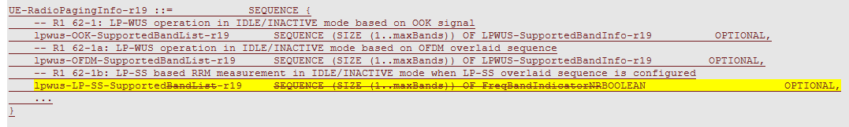 | Resolved. See H013, it has been added in 306.
E003 | R1 62-1 and R1 62-1a | 38.331 | For LP-WUS there is only a need for a single SupportedBandList. When the UE supports both OFDM and OOK, then it supports OFDM and OOK on the same bands. It is good to limit the capability size. | 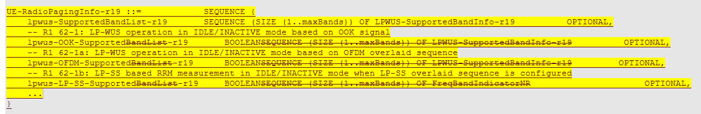 | Resolved. The signaling is further optimized to only include one list of supported band and other capabilities as optional within the field, indicating based on OOK or OFDM overlaid sequence.  