3GPP TSG-WG2 # 131 R2-250xxxx

Bengaluru, India, 25 - 29 August 2025

Agenda item: 8.4.1
Source: Apple
Title: Collection of comments and Open issues to 38.321 CR for LP-WUS
WID/SID: NR_LPWUS-Core – Release 19
Document for: Discussion and Decision

1 Introduction
This is a summary document on collection of comments to TS 38.321 CR for LP-WUS during below running CR discussion:
- [Post130][213][LPWUS] Running CR for 38.321 (Apple)
Intended outcome: Updated and reviewed the CR for endorsement, update the open issue list if needed, can also discuss open issues to form proposals to the next meeting

Companies are invited to provide comments/additional issues in the below table by 31st July, 2025.

2 Collection of comments
Please provide your comments in below table, and Rapporteur will response. Please do not insert any comments in running CR directly, which is hard for Rapporteur to follow all comments.
Company | Detailed comments | Rapporteur response
vivo #1 | CR:  1> if DCP monitoring is configured for the active DL BWP as specified in TS 38.213 [6], clause 10.3, or if LP-WUS monitoring is configured as specified in TS 38.213 [6], clause 10.X; and  1> if the current symbol n occurs within drx-onDurationTimer duration; and  1> if drx-onDurationTimer associated with the current DRX cycle is not started as specified in this clause:  2> if the MAC entity would not be in Active Time considering lpwus-PDCCHMonitoringTimer is not running (if configured)/grants/assignments/DRX Command MAC CE/Long DRX Command MAC CE received and Scheduling Request sent until 4 ms prior to symbol n when evaluating all DRX Active Time conditions as specified in this clause; and  Comment: for Option 1-2, when LP-WUS is received and lpwus-PDCCHMonitoringTimer is indicated to be started, the MAC entity would also be in Active Time, which should be excluded for the case of “ MAC entity would not be in Active Time”. The corresponding change is made above.
Huawei #1 | We have some sympathy on vivo’s comment #1, for LP-WUS case, lpwus-PDCCHMonitoringTimer impacting the Active time should also be considered.  However, we understand the previous intention of the text is for 4ms ambiguity period due to DCI/MAC CE/SR, but for the running timer of lpwus-PDCCHMonitoringTimer, do we still need to consider 4ms ambiguity period, since the current sentence is “considering lpwus-PDCCHMonitoringTimer is not running (if configured) until 4 ms prior to symbol n…”?  Another way may be “2> if the MAC entity would not be in Active Time considering grants/assignments/DRX Command MAC CE/Long DRX Command MAC CE received and Scheduling Request sent until 4 ms prior to symbol n, or LP-WUS received (if configured) until X prior to symbol n, when evaluating all DRX Active Time conditions as specified in this clause; and”. X is UE’s transition time from LP-WUS reception to PDCCH monitoring. No very strong view, the detailed wording can be further discussed.
Huawei #2 | Editorial (naming):  lpwus-PDCCHMonitoringTimer in RRC spec lpwus-PDCCH-MonitoringTimer
Huawei #3 | Editorial:  2> else if LP-WUS monitoring is configured:  3> if lpwus-PDCCHMonitoringTimer is not configured:  4> if LP-WUS indication associated with the current DRX cycle received from lower layer indicated to start drx-onDurationTimer, as specified in TS 38.213 [6]; or  Proposed Change:  4> if LP-WUS indication associated with the current DRX cycle received from lower layer indicateds to start drx-onDurationTimer, as specified in TS 38.213 [6]; or  Editorial: same changes as above.  1> if LP-WUS monitoring is configured and the lpwus-PDCCHMonitoringTimer for this DRX group is configured  2> if LP-WUS indication is received from lower layer indicated to start lpwus-PDCCHMonitoringTimer, as specified in TS 38.213 [6]:  3> start lpwus-PDCCHMonitoringTimer from the beginning of the subframe indicated from lower layer.  Proposed change:  2> if LP-WUS indication is received from lower layer indicateds to start lpwus-PDCCHMonitoringTimer, as specified in TS 38.213 [6]:

2 Open issue list
Followings are the Editor’s NOTE in the running CR.
Editor’s NOTE: The parameter name may be further updated to align with the name used in RRC specification.
<Dual DRX group>
Editor’s NOTE: FFS whether lpwus-PDCCHMonitoringTimer is configured per DRX group or common to DRX groups.
Editor’s NOTE: The case where lpwus-PDCCHMonitoringTimer is not configured includes legacy DRX operation and LP-WUS option 1-1, but not LP-WUS option 1-2.
<Option 1-1>
Editor’s NOTE: The case where LP-WUS monitoring is configured without lpwus-PDCCHMonitoringTimer is LP-WUS Option 1-1.
Editor’s NOTE: The DRX operation in LP-WUS Option 1-1 takes DCP description as baseline.
Editor’s NOTE: The working assumption for UE operation under collision for Option 1-1 needs to be confirmed.
<Option 1-2>
Editor’s NOTE: The case where lpwus-PDCCHMonitoringTimer is configured is LP-WUS Option 1-2.
Editor’s NOTE: The LP-WUS based DRX model is that LP-WUS monitoring and sending LP-WUS indication (together with the timepoint to start timer in Option 1-2) to MAC is captured in RAN1 spec (38.213), and the DRX operation based on the LP-WUS indication is captured in MAC spec.
Editor’s NOTE: The relationship between UE's LP-WUS monitoring and DRX active time is assumed to be reflected in RAN1 spec (38.213), so we will not capture this part in MAC spec.
Editor’s NOTE: FFS in Option 1-2 whether the UE should start the lpwus_PDCCHMonitoringTimer (as if LP-WUS was detected) when the UE is not able to monitor the LP-WUS occasion(s).

The following RAN2 progress needs further confirmation.
RAN2#129bis progress
- Working assumption for the case of potential collision (if any): In Option 1-1, when the UE is not able to monitor the LP-WUS occasion(s) the UE should start the drx-OnDurationTimer (as if LP-WUS was detected). FFS for Option 1-2.
RAN2#130 progress
- Working assumption: LP-WUS can be configured on the PCell with secondary DRX. LP-WUS with secondary DRX is supported with option 1-1 and 1-2, i.e. the UE monitors LP-WUS before the on-duration occasion or periodically outside ActiveTime. When LP-WUS is detected, then UE starts the drx-onDurationTimer (with option 1-1) or the lpwus-PDCCHMonitoringTimer (with option 1-2) in both DRX groups.
- Check whether we need to capture in MAC that UE is not expected to monitor LP-WUS if not in Cell DTX active period.

According to the EN list in running CR, and the RAN2 working assumptions for further confirmation, MAC open issues can be summarized as follows:
- Open issue 1: Support of LPWUS with dual DRX group.
- Open issue 2: UE operation for potential collision.
- Open issue 3: MAC spec impact to support the LP-WUS in Cell DTX operation.

In addition to the above 3 Open issues, please provide your comments on any other MAC specific open issues for discussion in the table.
Company | Open issue | Rapporteur response
vivo | FFS whether to start or restart the bwp-InactivityTimer when UE receives the LP-WUS for PDCCH monitoring.
vivo | For LP-WUS option 1-2, whether only one LP-WUS cycle is supported or two LP-WUS cycle, e.g. long LP-WUS cycle and short LP-WUS cycle are supported.
Huawei | FFS whether UE can switch from LR to MR if it detects LR link quality is not good enough, and inform it to the gNB.  Many papers raised one issue that if the UE detects LR link quality is not good enough, UE can switch to MR and inform it to the gNB. In connected state, the gNB only knows the measurement results from MR based on existing RRC measurement report. Sometimes even when the MR measurement is good, the link quality of LR can be bad due to the weaker tolerance for adjacent-channel interference for LR. That’s why in idle/inactive, we introduce MR and LR based threshold. Both connected and idle/inactive should share the same logic.
Huawei | FFS whether the transition time from LR to MR is aware or transparent to MAC, and how to know it (if needed).  Based on this Editor’s NOTE:  The LP-WUS based DRX model is that LP-WUS monitoring and sending LP-WUS indication (together with the timepoint to start timer in Option 1-2) to MAC is captured in RAN1 spec (38.213), and the DRX operation based on the LP-WUS indication is captured in MAC spec.  For LP-WUS triggered, the transition time seems transparent to MAC, MAC starts the lpwus-PDCCHMonitoringTimer based on PHY indication. However, to UL data triggered case, there is the case MAC needs to determine the SR occasion or RACH occasion, MAC needs to avoid the overlap between SA/RACH occasions and transition time, otherwise, the MAC indicates PHY to transmit SR or preamble but actually PHY cannot successfully send it.  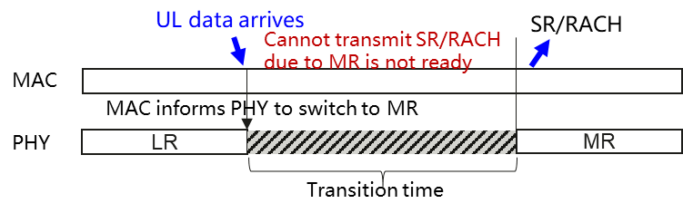  Thus, MAC needs to know when the MR is ready, e.g., 1) MAC knows how long the transition time is, or 2) MAC knows when MR is ready based on PHY indication.

3 Discussion of the Open issues

Open issue 1: Support of LP-WUS with dual DRX group
There are three sub-issues:
  - Issue 1-1: Confirm the RAN2 WF or not?
  - Issue 1-2: If supported, whether to monitor LP-WUS on PCell if the secondary DRX group is in DRX active time?
  - Issue 1-3: If supported, for option 1-2, is lpwus-PDCCHMonitoringTimer configured per DRX group or common for both groups?

Open issue 1-1: Confirm to support the LP-WUS with dual DRX group.
RAN2 made the following working assumption to support the LP-WUS with dual DRX group in RAN2#130 meeting.
As no concerns were raised during the online discussion, Rapporteur think that we can confirm it and discuss the details.
Proposal 1: Confirm the following working assumption to support LP-WUS with dual DRX group.
RAN2#130 progress
- Working assumption: LP-WUS can be configured on the PCell with secondary DRX. LP-WUS with secondary DRX is supported with option 1-1 and 1-2, i.e. the UE monitors LP-WUS before the on-duration occasion or periodically outside ActiveTime. When LP-WUS is detected, then UE starts the drx-onDurationTimer (with option 1-1) or the lpwus-PDCCHMonitoringTimer (with option 1-2) in both DRX groups.

Companies are invited to provide comments on whether to agree the proposal 1.
Company | Yes/No | Comments, if any
OPPO | Yes | Support of LP-WUS with dual DRX group would be beneficial for UE power saving.
vivo | See comments | Supporting LP-WUS with dual DRX group may need more discussion on multiple details in both RAN1 and RAN2, e.g. whether lpwus-PDCCHMonitoringTimer on two DRX groups are same or different, how to ensure minimum offset for both FR1 and FR2 if FR1 and FR2 have different numerology (this is also related to RAN1), whether to monitor LP-WUS in one carrier if it is active time in another carrier, etc.  Besides, RAN1 has agreed that UE is not able to operate LR and MR simultaneously in Rel-19. Thus, LP-WUS cannot be monitored in case UE is in active time in any DRX group. With this, the benefit for LP-WUS in dual DRX becomes very margin.  Considering this WI in RAN1 has already completed, and only one meeting is left in RAN2, we prefer not to support LP-WUS with dual DRX group in last minutes.
Huawei | Yes
NEC | Yes | The NW could configure dual DRX groups when the offset is suitable for both FR1 and FR2 cell groups, i.e., it is up to NW implementation.  Therefore in order to support dual DRX, I guess we need to further consider issue 1-2 and 1-3 listed by rapporteur below.
Summary:

Open issue 1-2: If supported, whether to monitor LP-WUS on PCell if the secondary DRX group is in DRX active time?
If the secondary DRX group is not configured, UE only monitor LP-WUS when UE is not in DRX active time.
With the secondary DRX group configuration, there is a new case that the default DRX group (including PCell) is not in DRX active time, but the secondary DRX group is in DRX active time.
For this new case, there are three options:
- Option 1: UE monitors LP-WUS when both DRX groups are not in DRX active time;
- Option 2: UE monitors LP-WUS when the default DRX group is not in DRX active time and secondary DRX group is in DRX active time.
According to the following RAN1#121 agreement which is indicated in RAN1 LS (R1-2504888), UE is not able to operate LR and MR simultaneously in Rel-19, which means UE cannot monitor LP-WUS and PDCCH at the same time.
RAN1 Agreement:
As the reply to RAN2 LS in R1-2503616, RAN1 assumes that UE is not able to operate LR and MR simultaneously in Rel-19. RAN1 understanding is that the terminology of LR and MR operations are for discussion purpose and will not be specified
- LR operation is the UE operation for LP-WUS monitoring
- MR operation is the UE operation for all other NR signals/channels transmissions/receptions in connected mode

Therefore, if the secondary DRX group is in active time, UE will monitor PDCCH on MR, and UE cannot monitor LP-WUS on LR simultaneously.
Observation: According to RAN1 agreements, UE cannot monitor LP-WUS and PDCCH simultaneously.
Based on the RAN1 agreements and the observation, if secondary DRX group is configured, UE cannot monitor LP-WUS when any DRX group is in DRX active time. We can only go for Option 1.
Proposal 2: If secondary DRX group is configured, UE monitors LP-WUS only when both DRX groups are not in DRX active time.
Companies are invited to provide comments on whether to agree proposal 2.
Company | Yes/No | Comments, if any
OPPO | Yes
Vivo | Yes | According to RAN1 agreement, proposal 2 is the only way.
Huawei | Yes | Agree with vivo.
NEC | Yes | This is based on RAN1 agreement. And further consideration is that if any one of DRX group is in active time overlapping with LP-WUS monitoring, the collision handling described as below open issue 2 can be applied, i.e., when the UE is not able to monitor LP-WUS, the UE can start active timer.
Summary:

Open issue 1-3: If supported, for option 1-2, is lpwus-PDCCHMonitoringTimer configured per DRX group or common for both groups?
In legacy dual DRX group configuration, the drx-onDurationTimer and drx-InactivityTimer can be configured with different values for two DRX groups, and the value for the secondary DRX group should be smaller than that for the default DRX group.
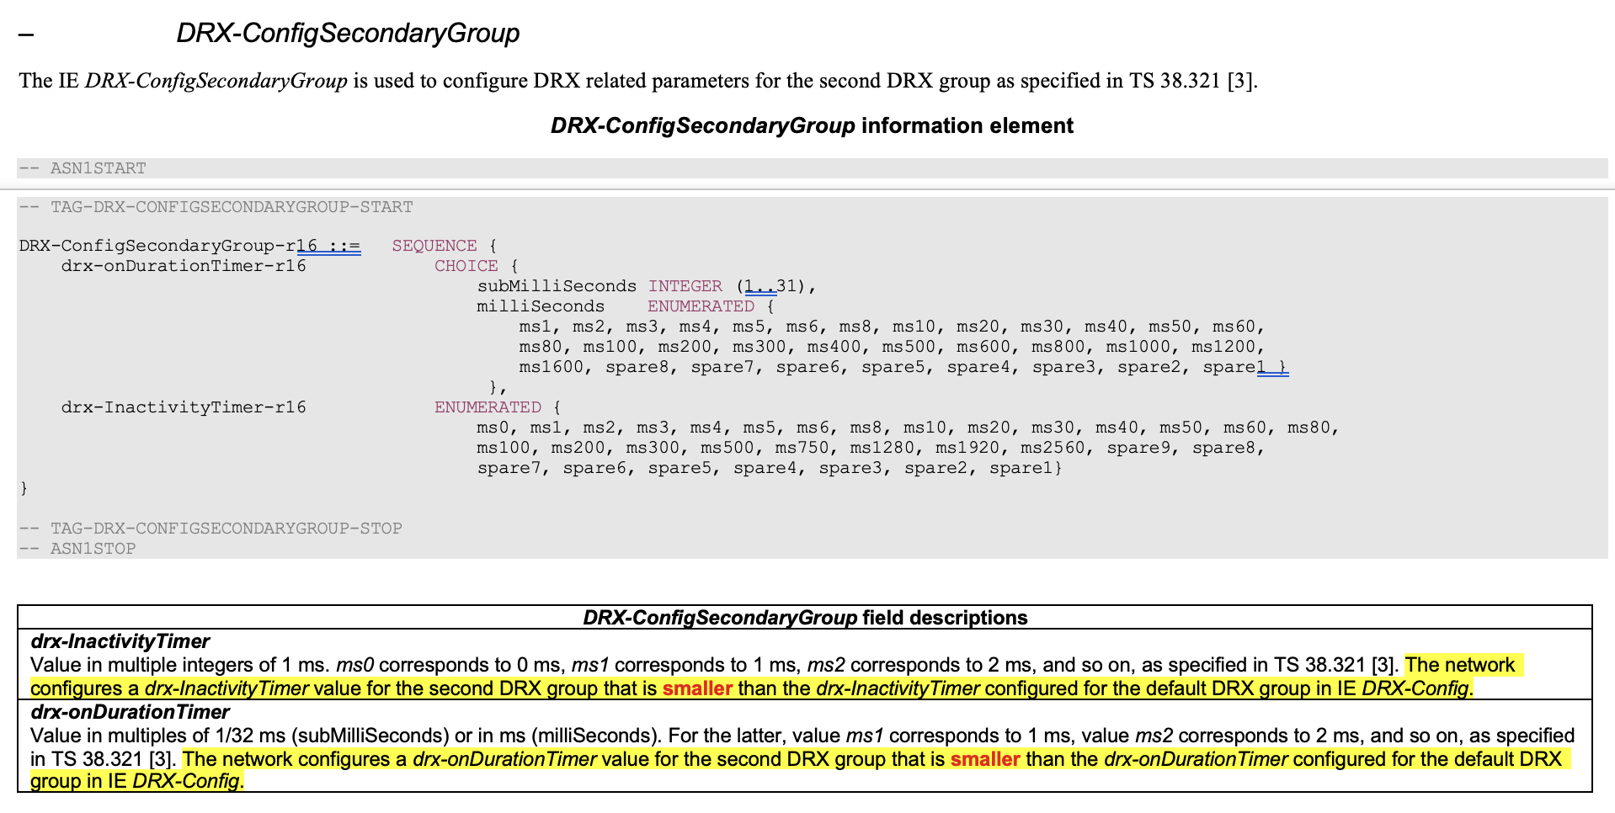
For the LP-WUS configuration with the secondary DRX group configuration, according to the existing configuration, in Option 1-1, the drx-onDurationTimer configuration and the restriction for dual DRX groups should be kept.
- The drx-onDurationTimer configuration for secondary DRX group is smaller than that for the default group.
For Option 1-2, the same principle should be also applied for lpwus-PDCCHMonitoringTimer configuration.
- The lpwus-PDCCHMonitoringTimer configuration for secondary DRX group is smaller than that for the default group.
Proposal 3: If secondary DRX group is configured, the lpwus-PDCCHMonitoringTimer configuration for secondary DRX group is different from that for the default DRX group.
Proposal 3a: The lpwus-PDCCHMonitoringTimer configuration for secondary DRX group is smaller than that for the default DRX group.
Companies are invited to provide comments on whether to agree proposal 3 and 3a.
Company | Yes/No | Comments, if any
OPPO | Yes | Similar to drx-onDurationTimer and drx-InactivityTimer, support of a separate lpwus-PDCCHMonitoringTimer with a smaller timer length for secondary DRX group can enable UE to sleep faster in FR2 cells in case there is no scheduling in FR2 so that more UE power can ba saved.
Vivo | Yes with comments | We are fine to follow the similar design, i.e. separate configuration for two DRX groups. But another question is how to define the time outside active time. It would be different for two DRX groups.
Huawei | Yes | To simplify the solution, we understand the transition time from LR to MR can be same for FR1 and FR2. Since RAN1 agreed that the transition time is irrelevant to SCS, and the TR 38.840 does not have differentiation.  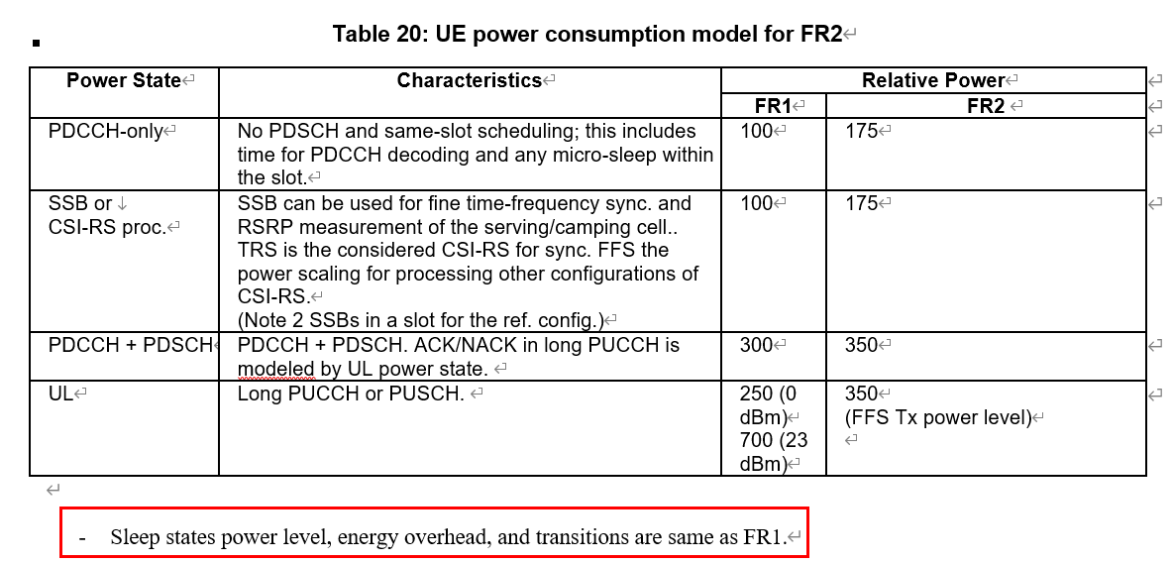
NEC | Yes | It is straightforward mechanism for dual DRX groups, in fact if no different lpwus-PDCCHMonitoringTimer value (LP-WUS option 1-2) configured, there is no gain.
Summary:

Open issue 2: UE operation for the potential collision
There are three sub-issues:
  - Issue 2-1: Confirm the RAN2 WF on UE operation for potential collision for Option 1-1?
  - Issue 2-2: What cases are considered as the potential collision?
  - Issue 2-3: What’s the UE operation for potential collision in Option 1-2?

Open issue 2-1: Confirm the RAN2 WF on UE operation for potential collision for Option 1-1?
RAN2 made the following progress in RAN2#129bis, and RAN1 confirmed the collision case in RAN1#121 agreements and indicated it in RAN1 LS (R1-2504888)

RAN2#129bis progress
- Working assumption for the case of potential collision (if any): In Option 1-1, when the UE is not able to monitor the LP-WUS occasion(s) the UE should start the drx-OnDurationTimer (as if LP-WUS was detected). FFS for Option 1-2.
RAN1#121 Agreement:
As the initial reply to RAN2 LS in R1-2503616, RAN1 confirms that at least the collision with Active Time, measurement gap, and RAR window monitoring for BFR can be considered for the cases/scenarios on when the UE is not able to monitor LP-WUS.

Therefore, Rapporteur think that we can confirm it for option 1-1
Proposal 4: Confirm the following RAN2#129bis working assumption for Option 1-1.
RAN2#129bis progress
- Working assumption for the case of potential collision (if any): In Option 1-1, when the UE is not able to monitor the LP-WUS occasion(s) the UE should start the drx-OnDurationTimer (as if LP-WUS was detected). FFS for Option 1-2.

Companies are invited to provide comments on whether to agree the proposal 4.
Company | Yes/No | Comments, if any
OPPO | Yes
Vivo | Yes
Huawei | Yes
NEC | Yes
Summary:

Open issue 2-2: What cases are considered as the potential collision?
RAN1 LS/agreements confirm the two collision cases:
Case 1) measurement gap, and Case 2) RAR window monitoring for BFR.
RAN1#121 Agreement:
As the initial reply to RAN2 LS in R1-2503616, RAN1 confirms that at least the collision with Active Time, measurement gap, and RAR window monitoring for BFR can be considered for the cases/scenarios on when the UE is not able to monitor LP-WUS.

As LP-WUS Option 1-1 design takes DCP as baseline, we should also consider the UE internal processing timing which is highlighted in yellow in current DCP part (as below) in LP-WUS operation, and consider the same description for LP-WUS operation in Option 1-1.
- Current DCP text to capture the UE operation for the collision and timing issue.
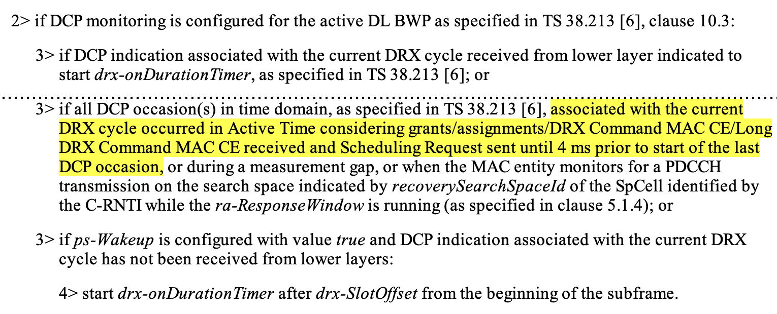

- The proposed LP-WUS text to capture the UE operation in Option 1-1 for the collision and timing issue.
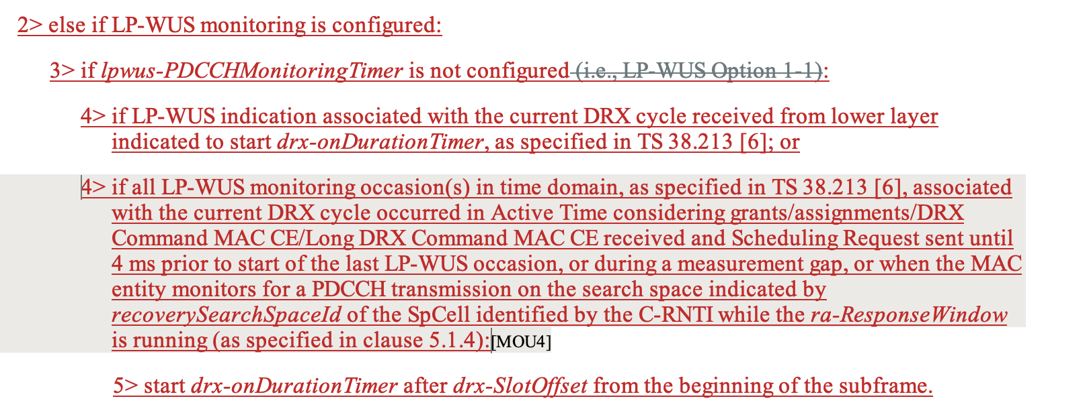

Companies are invited to provide comments on the proposed LP-WUS operation in Option 1-1 for potential collision and internal processing timing issue.
Company | Yes/No | Comments, if any
OPPO |  | Fine to follow the DCP text
vivo | Yes
Huawei | Yes with comments | Fine to follow the DCP text as baseline, but we found that “MUSIM gap” has the same issue and should also be considered. During MUSIM gap, the UE needs to do the activities in SIM2 and the transmission/reception in SIM1 is interrupted. In this case, the UE is not able to monitor LP-WUS.  We think MUSIM gap is missing because DCP was discussed in Rel-16, but MUSIM gap was introduced in Rel-17. So MUSIM gap was not considered for the original DCP text and is still missing after it was introduced. The same update may be needed for DCP but it is Rel-16 CR which does not need to be discussed here.  The update can be:  …, or during a measurement gap, or during a MUSIM gap, or when the MAC entity monitors for a PDCCH transmission on the search space indicated by…
NEC | Yes
Summary:

Issue 2-3: What’s the UE operation for potential collision in Option 1-2?
Regarding the UE operation for the potential collision in Option 1-2, it’s FFS in RAN2#129bis discussion and RAN1 would like RAN2 to make decision for Option 1-2.
RAN2#129bis progress
Working assumption for the case of potential collision (if any): In Option 1-1, when the UE is not able to monitor the LP-WUS occasion(s) the UE should start drx-OnDurationTimer (as if LP-WUS was detected). FFS for Option 1-2.
RAN1#121 Conclusion
From RAN1 perspective, for the case of potential collision (if any) in Option 1-2, when the UE is not able to monitor all the LP-WUS MO(s) in a LP-WUS periodicity,
- It is up to RAN2 to further discuss and finalize the specification support, if any.

We need to check companies view on whether and how to handle the collision in Option 1-2. There are three options:
- Option 1: UE starts the lpwus-PDCCHMonitoringTimer when there is collision. (Same operation as Option 1-1)
- Option 2: UE doesnot start the lpwus-PDCCHMonitoringTimer when there is collision.
- Option 3: NW can configure UE whether to start the lpwus-PDCCHMonitoringTimer or not when there is collision.
Companies are invited to provide the preference amongst the 3 options for collision in Option 1-2.
Company | Preferred Option | Comments, if any
OPPO | Option 1
vivo | Option 2 | For Option 1-1, since the typical configuration of WUS monitoring occasions/periodicity are sparse and aligned with the long DRX cycle. If UE does not start drx-OnDurationTimer when the UE is not able to monitor the LP-WUS occasion(s), the delay for waking up the UE will be as long as one long DRX cycle (e.g., 160ms), which is unacceptable.  However, for option 1-2, for the collision cases/scenarios on when the UE is not able to monitor the LP-WUS occasion(s), it is more reasonable that the UE does NOT start the LP-WUS_PDCCHMonitoringTimer. Because different from option 1-1, option 1-2 typically has more frequent WUS monitoring occasion configuration. Network has sufficient flexibility and opportunities to send WUS to timely wake up MR. If we follow the same solution as for option 1-1, considering the dense LP-WUS monitoring occasions and short periodicity which results in more frequent collisions, the MR will be always waked up unnecessarily and the power consumption will be increased significantly. Therefore, a more reasonable solution should be that for Option 1-2, the UE only wakes up upon detecting a LP-WUS.
Huawei | Option 2 | For option 1-2, the period of monitoring occasions for LP-WUS will be shorter than that of Option 1-1, i.e., the monitoring occasions for LP-WUS appear more frequently. If there will be many overlaps, the lpwus_PDCCHMonitoringTimer will be started frequently, which increase the power consumption. If there won’t be many overlaps, the next monitoring occasion for LP-WUS comes immediately, the impact on the latency is negligible.
NEC | Option 1 | From our perspective, the collision handling (i.e., the UE could blindly start active timer) is beneficial for the scheduling robust or latency.  As long as the periodicity of LP-WUS option 1-2 is larger than LP-WUS_PDCCHMonitoringTimer, this collision handling works, for example, LP-WUS_PDCCHMonitoringTimer = 5ms while LP-WUS periodicity is 20ms.  And we assume the reasonable configuration is that periodicity of LP-WUS should be larger than LP-WUS_PDCCHMonitoringTimer duration.  Therefore, option 1 can be supported.
Summary:

Open issue 3: MAC spec impact to support the LP-WUS in Cell DTX operation
RAN1#120bis agreed that UE doesnot monitor LP-WUS during Cell DTX inactive time.
Agreement
For RRC CONNECTED mode when LP-WUS is configured with Cell DTX, during Cell DTX inactive time, the UE is not expected to monitor LP-WUS both for Option 1-1 and 1-2

And RAN2 needs to further check the MAC spec impact to reflect the RAN1 agreements.
RAN2#130 progress
- Check whether we need to capture in MAC that UE is not expected to monitor LP-WUS if not in Cell DTX active period.

After further check the RAN1 agreed R19 38.213 CR for LP-WUS (R1-2504971), it has been captured in RAN1 spec as below.

10.4D PDCCH monitoring activation by WUS in RRC_CONNECTED
……
A UE does not monitor WUS during DTX inactive period for the primary cell.

Therefore, the change in MAC spec is not needed. and RAN2 doesnot need to further discuss this issue.
Proposal 5: There is no MAC spec impact to reflect the LP-WUS operation in Cell DTX operation.
Companies are invited to provide the comments if have different view.
Company | Yes/No | Comments, if any
OPPO | Yes | It is sufficient to capture this in RAN1 spec.
Vivo | Yes
Huawei | Yes
NEC | Yes
Summary:

3 Conclusion
Based on post-meeting email discussion,

