3GPP TSG-RAN WG2 Meeting #131 R2-25xxxxx

Bengaluru, India, August 25 – 29, 2025
CR-Form-v12.3
CHANGE REQUEST
 | 38.843 | CR | - | rev | - | Current version: | 18.0.0
For HELP on using this form: comprehensive instructions can be found at
http://www.3gpp.org/Change-Requests.

Proposed change affects: | UICC apps |  | ME | X | Radio Access Network | X | Core Network | X

Title: | CR on RAN2 inputs to TR 38.843
Source to WG: | Ericsson
Source to TSG: | R2
Work item code: | FS_NR_AIML_air_Ph2 |  |  |  |  |  | Date: |  |  | 2025-06-20
Category: | F |  |  |  |  |  | Release: |  |  | Rel-19
 | Use one of the following categories:  F (correction)  A (mirror corresponding to a change in an earlier release)  B (addition of feature),  C (functional modification of feature)  D (editorial modification)  Detailed explanations of the above categories can  be found in 3GPP TR 21.900. |  |  |  |  |  |  |  | Use one of the following releases:  Rel-8 (Release 8)  Rel-9 (Release 9)  Rel-10 (Release 10)  Rel-11 (Release 11)  …  Rel-17 (Release 17)  Rel-18 (Release 18)  Rel-19 (Release 19)  Rel-20 (Release 20)
Reason for change: |  | Introduce in the Technical Report, the R2 agreements concerning the following topics:  - From RAN2#129-bis: sharing of NW-side dataset/model parameters for two-sided use cases  - From RAN2#130: analysis of CP solutions for the transfer of collected data for UE-side models.
Summary of change: |  | Section 7.2.1.3.2.1 includes updates related to the analysis of CP solutions for the transfer of collected data for UE-side models.  Section 7.2.1.7 includes updates related sharing of NW-side dataset/model parameters for two-sided use cases
Consequences if not approved: |  | Section 7.2.1.3 will not include updates as per the latest RAN2#129-bis and RAN2#130. Hence, analysis on CP solutions for UE-side data collection and on the sharing of NW-side dataset/model parameters for two-sided use cases.
Clauses affected: |  | 7.2.1.3.2.1, 7.2.1.7
 |  | Y | N
Other specs |  |  | X | Other core specifications |  |  |  | TS/TR ... CR ...
affected: |  |  | X | Test specifications |  |  |  | TS/TR ... CR ...
(show related CRs) |  |  | X | O&M Specifications |  |  |  | TS/TR ... CR ...
Other comments:
This CR's revision history:

START OF CHANGES

7.2.1.3.2 Data collection for UE-side model training
<Text Omitted>

7.2.1.3.2.1 Data collection for UE-side model training – CP solutions analysis
Related to the solutions based on CP and captured in Section 7.2.1.3.2, the following challenges in the Table 7.2.1.3.2.1-1 have been identified, especially for the case of large amount of data to be transferred from a UE.
Table 7.2.1.3.2.1-1. Data Collection CP solutions analysis
Challenges | Description
UE memory allocation | The collected data may need to be stored in the access stratum (AS) buffer for the control plane-based data transfer via AS. Requirements on the UE memory were not discussed.
Segmentation for UE side data collection | A single RRC message can contain maximum about 9KB data. Thus RRC or higher layer segmentation is needed to transfer more data that can fit in a single RRC message The existing RRC message only supports up to 16 segments in UL, which amounts to a maximum of 144KB of collected data that can be transmitted.  RAN2 has not analysed the time window during which this transmission would need to occur or if data could be partitioned and sent over a longer time window
Continuity of the collected data reporting | In case the collected data are not yet fully transferred before a handover, Xn / NG-AP signaling enhancements may be required for the continuity of the data reporting.  Similarly, it could be further discussed the case of collected data not yet fully transmitted before a radio link failure, or before transitions to IDLE/INACTIVE mode.  RAN2 has not assessed the impact on existing signalling, if any, or the extent of such impact.

NEXT CHANGE

7.2.1.7 Sharing of dataset/model parameters from NW-side for two-sided use cases
In the context of two-sided use cases, the sharing of dataset/model parameters from NW-side to UE or UE-side training entity was discussed for the below options:
- Dataset sharing consisting of {(Target CSI, CSI feedback)}
- Encoder parameter sharing
- Encoder parameter sharing + dataset sharing consisting of {target CSI}
A solution for the sharing of dataset/model parameters should follow the below principles:
- Size: From RAN2 point of view, RAN2 aims to define a unified solution (e.g. OTA, non-OTA, or a combined) to support various sizes of dataset/model parameter transfer (dataset and/or parameter sharing size could range from tens of KBs to hundreds of MBs, but in average around hundreds of MBs).
- Continuity: Service continuity of dataset and/or parameter transfer/delivery during UE mobility needs to be supported.
- Controllability: NW decides on if and when to transfer/delivery the dataset and/or model parameter from NW to UE or UE training entity (a server inside MNO or an OTT server).
- Latency: Relaxed latency requirement and infrequent update.
- Visibility: dataset and model parameter to be understandable by UE/UE-side training entity (a server inside MNO or an OTT server).
- Respect for proprietary information: proprietary information of the network and UE should be respected and not disclosed.
The following alternatives for the sharing of dataset/model parameters can be considered:
- Non-Over-The-Air (non-OTA) approach:
  - gNB -> NW dataset/model parameters collection entity -> UE training entity (a server inside MNO or an OTT server)
- Over-The-Air (OTA) approach:
  - gNB -> NW dataset/model parameters collection entity (if needed) -> gNB -> UE -> UE training entity (a server inside MNO or an OTT server)
Figure 7.2.1.7-1 illustrates the above alternatives.
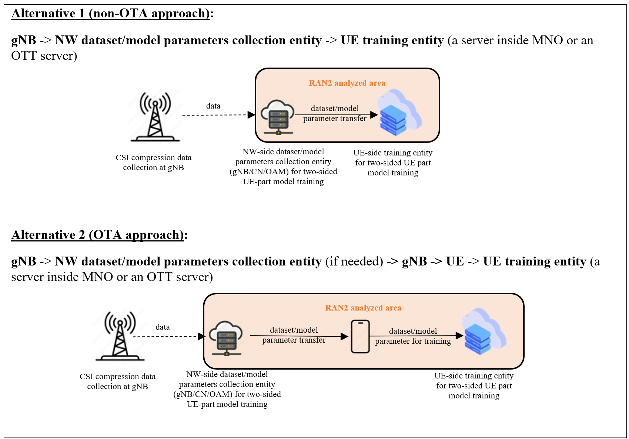
Figure 7.2.1.7-1: Alternatives for the transfer of dataset/model parameters
How the data (including e.g. the dataset/model parameters) are transferred between gNB and NW dataset/model parameters collection entity (OAM/CN) in Alternative 1/2, if needed, is up to RAN3/SA2/SA5. The content of the data to be transferred is up to RAN1.
For non-OTA approaches, different candidate solutions are identified, see below Table 7.2.1.7-1. Other candidate solutions beyond the ones listed below are not precluded to be considered in RAN3, SA2, and SA5.
From RAN2 point of view, it is also assumed that the non-OTA approaches can be supported within Rel-19 existing architecture framework. Confirmation of such assumption is up to RAN3, SA2, and SA5.
Table 7.2.1.7-1. non-OTA candidate solutions
Option | Impacted WGs | Specification impact/Implementation impact
OAM -> UE-side training entity (a server inside MNO or an OTT server), where OAM is NW-side dataset/model parameter collection entity | SA5, SA3 | Up to SA5  (any intermediate node between OAM and UE-side OTT server is up to SA5; CN involvement if needed is up to SA2/SA5 discussion)
CN -> UE-side training entity (a server inside MNO or an OTT server), where CN is NW-side dataset/model parameter collection entity | SA2, SA3 | Up to SA2  (any intermediate node between CN and UE-side OTT server is up to SA2)
gNB -> OAM/CN -> UE-side training entity (a server inside MNO or an OTT server), where gNB is NW-side dataset/model parameter collection entity | RAN3, SA2, SA5, SA3 | Up to RAN3, SA2, SA5  (any intermediate node between gNB/OAM, OAM/UE-side OTT server, CN/UE-side OTT server is up to RAN3/SA2/SA5)

For OTA approaches, i.e., ‘gNB -> NW dataset/model parameters collection entity (if needed) -> gNB -> UE -> UE training entity (a server inside MNO or an OTT server)’, RAN2 identified the following candidate solutions:
- gNB -> UE via CP, where gNB is NW-side dataset/model parameter collection entity
- CN -> UE via gNB, where CN is NW-side dataset/model parameter collection entity
- OAM -> UE via gNB, where OAM is NW-side dataset/model parameter collection entity
Related to such candidate solutions, RAN2 identified the following challenges and the potential suitable scenarios, see below Table 7.2.1.7-2. RAN2 does not have consensus on the feasibility of OTA approaches.
Table 7.2.1.7-2 OTA candidate solutions
gNB -> UE via CP | Challenges | - UE is only required to support 45kB RRC buffer size, according to TS 38.306.  - Significant specification impact:  - Other segmentation beyond RRC layer requires a new SRB protocol stack to perform segmentation, including functions such as handling segmentation, retransmission, etc  - UE selection  - Challenges to support E2E reliability, considering dataset/model parameter transfer is shared by different gNB/vendors during UE mobility and different RRC state transition  - Uu overhead for data collection from UE and dataset/model parameter transfer to UE  - Overloading CP with large datasets would disrupt core control message transmission (e.g. service degradation, reliability, etc)
 | Potential suitable scenario | - Small dataset/model parameter size. However, the maximum RRC segment needs to be further studied  - Split large dataset/model parameter into small pieces, and potentially send to multiple UEs, then gather by UE training entity. RAN2 has not study the feasibility of split dataset/model parameter to multiple UEs.
CN -> UE via gNB | Challenges | - Same challenges as OTA solution ‘gNB->UE via CP’, if OTA solution ‘CN -> UE via gNB’ via CP  - No benefit over non-OTA solution, as dataset/model parameter needs to transmit to CN, then transmit back to gNB. Relaying dataset/model parameter via gNB to UE then back to UE training entity is not desirable.  - Unclear how to guarantee E2E reliability across multiple hops  - A risk of proprietary information exposure if gNB and CN are not from the same NW vendor
 | Potential suitable scenario | - Feasibility analysis of OTA solution ‘CN -> UE via gNB’ via CP is the same as OTA solution ‘gNB -> UE via CP’  - OTA solution ‘CN -> UE via gNB’ and its feasibility is required to be evaluated by RAN3 and SA2.
OAM -> UE via gNB | Challenges | - Same challenges as OTA solution ‘gNB -> UE via CP’, if OTA solution ‘OAM -> UE via gNB’ via CP  - No benefit over non-OTA solution, as dataset/model parameter needs to transmit to OAM, then transmit back to gNB.  - Unclear how to guarantee E2E reliability across multiple hops  - A risk of proprietary information exposure that OAM may share to a second NW vendor
 | Potential suitable scenario | - Feasibility analysis of OTA solution ‘OAM -> UE via gNB’ via CP is the same as OTA solution ‘gNB -> UE via CP’  - OTA solution ‘OAM -> UE via gNB’ and its feasibility is required to be evaluated by RAN3 and SA5.

END OF CHANGES

