This document is to guide you how to use VBA script to analyze and generate the corresponding CDF figures. And the corresponding VBA script explanation and description (taking scenario 2 as an example).

# The Use of VBA Tools:

The usage of VBA tools includes following steps: 1. Setting up the Excel environment and enabling macros; 2. Opening the VBA compilation interface; 2. Running the VBA script.

The Excel file must be saved with the suffix .xlsm to save the macro code.

## Step 1: Setting up the Excel environment and enabling macros.

Please following the path in excel: **File-Option-Trust Center-Macro Settings**, then you will find the Macro Setting page, to enable the VBA macros setting.

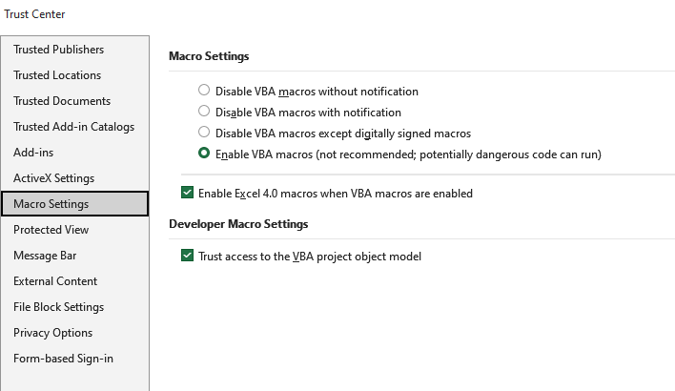

## Step 2: Opening the VBA compilation code window.

Click Developer - View Code as following,

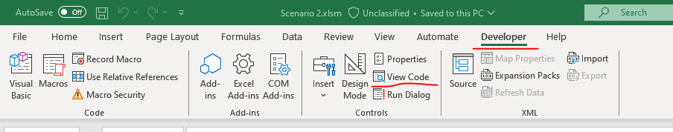

And the VBA code window as below will be opened:

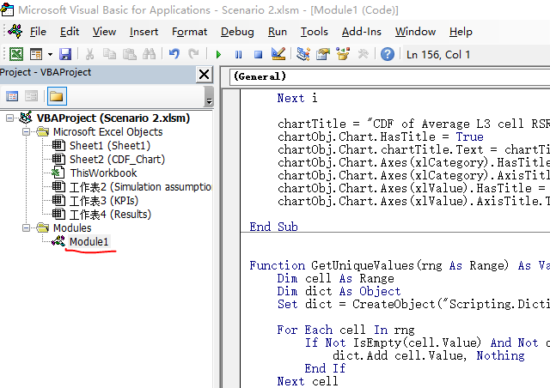

Double click the Modules-Module1, you will see the code.

If you want create a new script, just right click on the VBAproject (e.g., Scenario 2.xlsm) and then insert-Module.

## Step 3: Run the code.

If you want to run the code, just click Run- Run Sub F5.

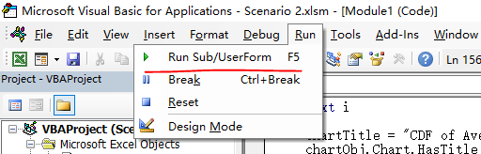

# Explanation and description of the code.

This VBA descript example is for Scenario 2 Case B results filtering and CDF figures generation.

Comprising these steps:

## Open the corresponding sheet.

For example: open the “Results”



## Data type convert.

Due to some column data type is not correct (e.g., need int type, input string type). This is for scenario 2, for other scenarios, need modify the column index (e.g., B/E/X).

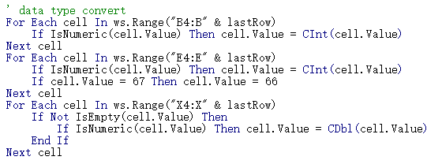

## Set filtering condition.

RAN2# has agreed key parameters for scenarios, so based on the key parameters, we can define the filtering condition (e.g., for scenario 2 case B, with key parameters MRRT/Speed/filtering option). You can also modify the filtering setting as you wanted (e.g., just filtering MRRT with 50%, the just remove 66 and 8).

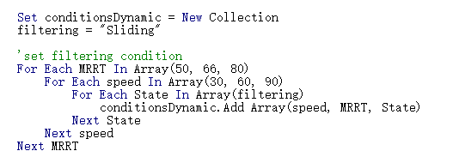

## Get a blanket spreadsheet to store the filtered data.

To store the filtered data, we need create a new sheet.

## Apply filtering condition to get the filtered data.

To get the filtered data, we loop through all rows original data with the filtering conditions of MRRT speed and filtering option. The cell.offset() number represents the index of the column where the key parameter is located (starting from 0). Note: For different scenario that with different template, you may need modify the column index.

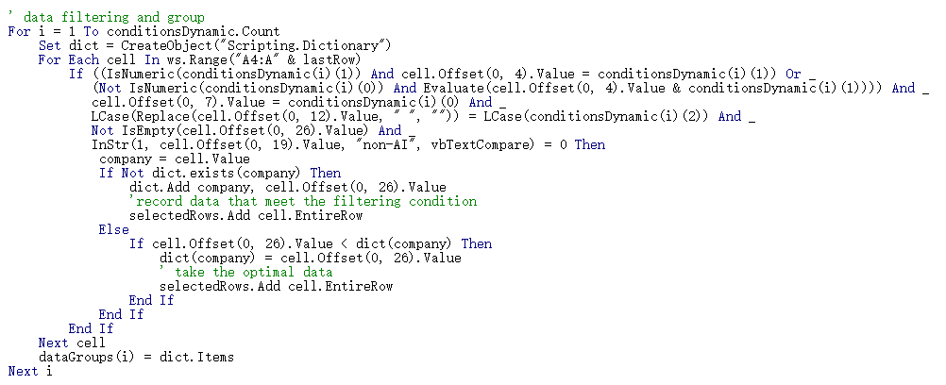

The dictionary dict.() company uses the name of each company as an index, and only saves the optimal result for each company.

## Sort the filtered data and draw the CDF curves.

After we get the filtered data, we need sort the data from smallest to the largest to plot the CDF curves and save the figures.

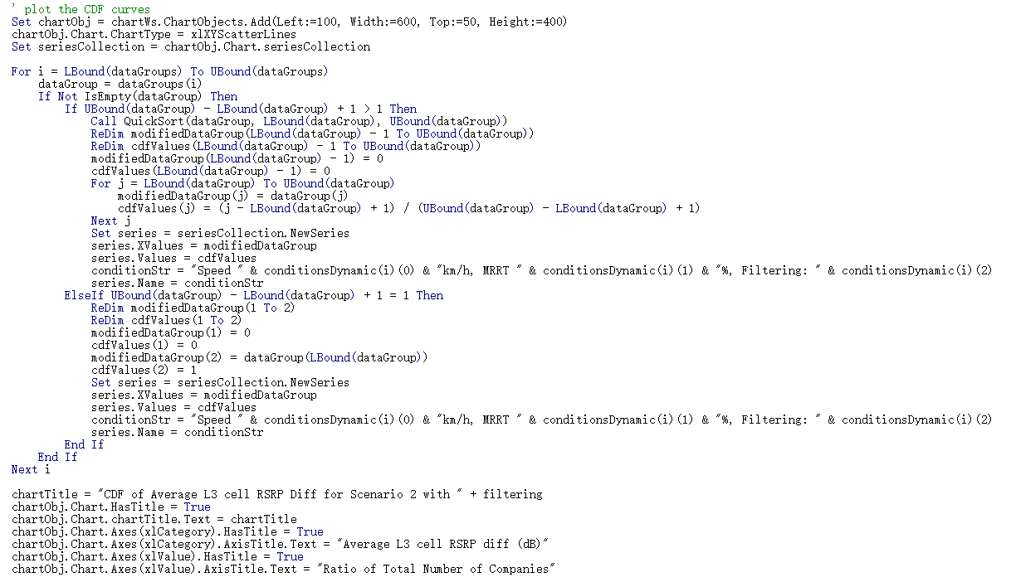

You can also modify the save path/name/title as you wanted.