3GPP TSG-RAN WG2 Meeting #130 R2-25xxxxx
St. Julians, Malta, May 19th– 23rd, 2025

Agenda Item: 8.3.1
Source: OPPO
Title: Summary of [POST130][021][AI Mob] TR update (Oppo)
Document for: Discussion, Decision

Introduction
After RAN2#130 meeting, following post email is arranged:
- [POST130][021][AI Mob] TR update (Oppo)
Intended outcome:
Phase 1:
- review and agree to TR to submit for information to plenary – including simulation results and observations/agreements (AT meeting to continue to short deadline)
- review spreadsheet and provide comments
Phase 2:
- update and review TR will all agreements on spec impact from RAN2#130
Deadline: Short and Long

Discussion
The simulation results captured in section 5.2.2.1[1] is the best one from companies who provided the corresponding simulation result. If there is a Figure above the table, it is for illustration purpose by picking one of the results. For example, the data for Figure 5.2.2.1.1-1 is to illustrate average prediction accuracy of the combination {MRRT=50%, UE speed=30km/h} in Table 5.2.2.1.1-1. Compared to [1], Figures are corrected.
Q1: Comments and/or questions for simulation results captured in section 5.2.2.1
Company Name | Comments and/or questions
ZTE | For temporal domain prediction case A figure 5.2.2.1.3-1, the PW covers multiple values, i.e. 40~1600ms, it is unclear for us how to generate the CDF curve. For example, if one company have multiple simulation results with multiple PW lengths, whether only optimal result (i.e. with shortest PW) is selected to generate CDF curve? Similarly, for table 5.2.2.1.3-1/2, the measurement results with multiple PW length are listed in one cell.  In our understanding, it does not make sense to mix all the results in one CDF figures/table. Our suggestion is to take one typical PW for illustration, or provide different figure/table for different PW length separately.  Rapp: for the same PW range, if company have results for more than one PW length, yes, only best result is picked. On the other hand, one company may contribute result for more than one PW range in the table 5.2.2.1.3-1.
Huawei | It is also a bit unclear to us why different PW lengths are mixed in one CDF/table. We think picking one or two typical values would indeed make more sense as mentioned by ZTE.  Rapp: It is also feasible to do so. The main problem is then there is much less points in the Figure. For example, here is the Figure corresponding to PW length=[40ms~200ms]. You can image if only one PW is selected, then it is bit difficult to have a “nice” Figure. In addition our understanding is that CDF is a way to normalize the result. More points in the Figure help to understand the general trends better.  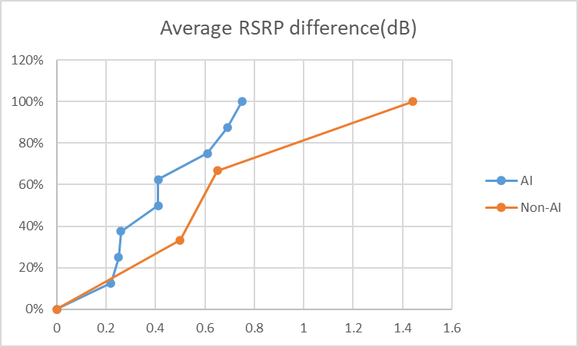
The simulation results captured in section 5.2.2.2[1] for generalization study. The results are not prediction accuracy of baseline, GC#1 and GC#2 directly. Instead, the difference of prediction accuracy between GC#1/2 and baseline is captured to reflect the “prediction accuracy loss”. Positive value(loss) means the prediction accuracy of GC#1/2 is worse than baseline and negative value (gain) reflects the situation of the other way around. Compared to [1] some CDF Figure(s) is added to show the trend.
Q2: Comments and/or questions for simulation results captured in section 5.2.2.2
Company Name | Comments and/or questions
ZTE | For Table 5.2.2.2.1-1 and Table 5.2.2.2.3-1, when study the impact of UE speed over the generalization performance, GC#1-baseline may have two results, for example, if test data is with 30km/h UE speed, there are two cases, one is GC#1 with 60km/h training - baseline, the other is GC#1 with 90km/h training – baseline. A clarification is needed to clarity the meaning of GC#1-baseline here.  Rapp: In this case, the better one is picked. I can try to clarify.
Huawei | It would be good to clarify why in some cases generalized data set outperformed baseline case. Was this due to different data set sizes? This seems rather counter-intuitive.  Rapp: when model is trained with relative less epochs, GC#1 or GC#2 may outperform baseline. At least this is observation from OPPO’s paper.
The simulation results captured in section 5.2.3[1] are to reflect the F1 score of measurement event prediction based on intra-frequency temporal domain case A and case B. Compared to [1] some CDF Figure(s) is added to show the trend.

Q3: Comments and/or questions for simulation results captured in section 5.2.3
Company Name | Comments and/or questions
ZTE | For Figure 5.3.2.2-1 and Table 5.3.2.2-1, no need to mix different MRRT. Considering the data size for MRRT>50% is limited, our suggestion is to only capture the simulation results for MRRT = 50%.  Rapp: Just want to give a “full” picture. The problem with MRRT>50% is that majority company chose to configure MRRT=50% i.e. there is much less result for MRRT>50%.
Huawei | Agree with ZTE that mixing different MRRTs is odd, similarly as for mixing PW lengths.
The simulation results captured in section 5.5.2[1] is to reflect the system level performance, namely HOF ratio, total number of HOF per UE per second and total number of HO attempts per UE per second. The intention of the simulation is to show the performance gain compared to baseline. That’s the reason the difference of SLS metrics between AI and baseline (legacy L3 handover) are captured in the TP. For results in the tables, negative/positive value means gain/loss respectively. Compared to [1] some CDF Figure(s) is added to show the trend.
Q4: Comments and/or questions for simulation results captured in section 5.5.2
Company Name | Comments and/or questions

For the simulation results captured in [2] comments received during online discussion is that there is no place to present the picked simulation results illustrated in Figures. The suggestion from Qualcomm is that additional sheet(s) can collect the picked simulation results so that people can track the data of the Figures. Based on offline discussion, additional sheet capturing data illustrated in the Figure(s) are added. In addition, one handbook is attached to show how to find the VBA code within excel table so that you can try to generate data and corresponding Figures for other scenarios.
Q5: Comments and/or questions for updated simulation results and handbook?
Company Name | Comments and/or questions

Conclusion

Reference
[1] R2-2503542 Draft text proposal to capture simulation results OPPO pCR Rel-19 38.744 0.0.8 FS_NR_AIML_Mob
[2] R2-2503778 Report of [POST129bis][020][AI Mob] Sim. Results Figures (Mediatek) MediaTek Inc. discussion
[3] R2-2503541 Text proposal of TR 38.744 OPPO pCR Rel-19 38.744 0.0.8 FS_NR_AIML_Mob

