3GPP TSG-RAN WG2 #130 R2-250xxxx

St Julian, Malta, 19-23 May 2025

Agenda Item: 8.7.1
Source: Qualcomm Incorporated
Title: List of open issues in MAC
Document for: Discussion

1. Introduction
This document is to collect open issues related to the MAC running CR.
You are welcome to provide additional open issues in the tables blow.

2. Issues

2.1 LCP
- [MAC-01] Impact of priority adjustment on SR priority determination
- [MAC-02] Impact of congestion (i.e. PSI-based SDU discard) on priority adjustment
- Additional issues:
Company | Open issues
Apple | - Priority fallback with consideration of PDU Set integrated handling: Should the UE fallback the priority, if there is no more PDCP SDU with PDCP discard timer remaining value smaller than the threshold, but there is still at least one PDCP SDU with PDU Set Remaining Time smaller than the threshold ?  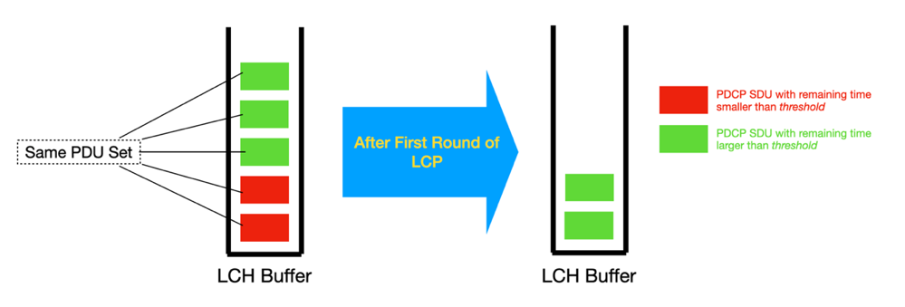

2.2 DSR
- [MAC-03] DSR cancelation in DC configuration
- Additional issues:
Company | Open issues

2.3 XR rate control
- [MAC-04] Which type of ID should be used to identify a QoS flow, e.g. DRB ID + QFI ID or some other identifier
- [MAC-05] Whether the Rate Control MAC CE includes single or multiple QoS flows
- [MAC-06] Any additional fields that should be included in the Rate Control MAC CE
- [MAC-07] Format of the Rate Control MAC CE
- [MAC-08] Handling of triggered UL rate queries (e.g. multiplexing, transmission and cancelation, etc)
- [MAC-09] How UE should handle the Rate Control MAC CE in DC configuration
- Additional issues:
Company | Open issues
Ofinno | (1) Whether to introduce the bitRateQueryProhibitTimer. Granularity of the configured bitRateQueryProhibitTimer.  [rapporteur] It has already been agreed to introduce this timer. The granularity of this timer is being discussed in the RRC running CR.  (2) Whether the UL bit rate query MAC CE can query the available/recommended bit rate without the desired bit rate.  [rapporteur] This feature is already in the endorsed 300 and 321 running CR from the last meeting.  (3) What’s the purpose when bit rate query indicates index “0” in the bit rate table.  [rapporteur] Per the chair’s guideline, as this is a minor issue, companies are invited to discuss it in the running CR review instead of online.  (4) What’s the UE behaviour if the UL resources cannot accommodate the Rel-19 UL bit rate MAC CE.  (5) The cancellation conditions of the triggered bit rate query.  [rapporteur] #4 and #5 will be added under “Handling of triggered UL rate queries”

