**3GPP TSG-RAN WG2 Meeting #129bis [Draft] R2-250xxxx  
Wuhan, China, April 7th – 11th, 2025**

Agenda Item: 8.5.4

Source: OPPO

Title: Summary of [122]

Document for: Discussion, Decision

1. Introduction

This is to discuss the offline as follows.

* [POST129b][122][NES] (OPPO)

**Scope:** Discuss and make conclusions on proposal 1 in R2-2501817.

**Intended outcome:** Discussion summary.

**Deadline: Long email discussion.**

1. Discussion

In this section, the defined scope of the post email discussion is further expanded to dig into details.

In the current RACH framework, CFRA could be initiated by a PDCCH order, by the MAC entity itself, or by RRC signalling. For different CFRA cases, their CFRA resources may be configured differently, i.e.,

1) CFRA for **additional PCI initiated by PDCCH order**: the CFRA resources are configured by *rach-configGeneric* from *additionalRACH-perPCI-ToAddModList-r18*, which is **mandatory** present.



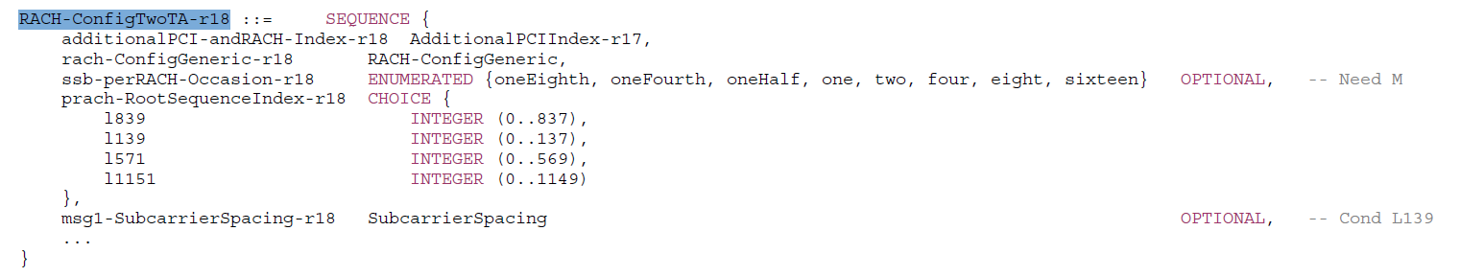

For this case, there is a single mandatory *rach-configGeneric* to refer to, so if one wants to enable the usage of RACH adaptation for this case, network can simply set *rach-configGeneric* to be the additional RACH resource.

And since it is based on PDCCH order, network can ensure the PDCCH order is sent during the period when the additional RACH is activated, so no need to concern the case when the additional RACH resources are (de)activated.

Q1: For CFRA for **additional PCI initiated by PDCCH order**, what is your preference

1. R2 does not consider the support of RACH adaptation in this case;
2. R2 assume the support of RACH adaptation in this case can be done by network implementation without spec impact;
3. R2 aims at supporting RACH adaptation in this case, and spec impact is foreseen (if this option is selected, please indicate what the spec impact is)

|  |  |  |
| --- | --- | --- |
| **Company** | **Option (A/B/C)** | **Comment** |
| OPPO | A or B |  |
| Xiaomi | B |  |
| Samsung | A | Same as legacy behaviour. No new enhancement is needed for CFRA. |

2) CFRA for **L3** **HO initiated by RRC signalling (via *RRCReconfiguration* with *ReconfigurationWithSync*)**: the CFRA resources are configured by *rach-configGeneric* from the *rach-ConfigDedicated* (if provided, otherwise from *rach-configCommon*) of target cell.

3) CFRA for **LTM cell switch initiated by LTM Cell Switch Command MAC CE**: the CFRA resources are configured by *rach-configGeneric* from the *rach-ConfigDedicated* (if provided, otherwise from *rach-configCommon*) of each LTM candidate cell.

4) CFRA for **LTM early sync initiated by PDCCH order**: the CFRA resources are configured by *rach-configGeneric* from *EarlyUL-SyncConfig* of each LTM candidate cell, which is **mandatory** present.

For the case 2) and 3), there is a single optional *rach-configGeneric* to refer to, so if one wants to enable the usage of RACH adaptation for this case, network can simply set *rach-configGeneric* to be the additional RACH resource.

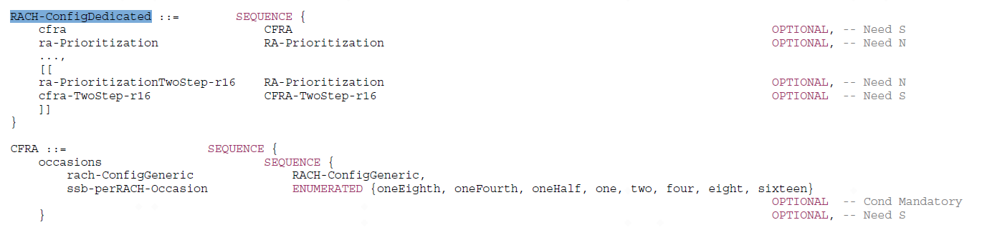

While for case 4), the CFRA resources are configured by *rach-configGeneric* from *EarlyUL-SyncConfig* of each LTM candidate cell, which is **mandatory** present. And thus also network can simply set *rach-configGeneric* to be the additional RACH resource.



And for the LTM cases (for both early UL sync and CSC MAC-CE), due to the uncertainty of the RACH timing, inter-node signaling is necessary (and thus R3 impact) in order for source node to indicate the additional RACH resource, when it is available at target node side.

Q2a: For CFRA for **L3** **HO initiated by RRC signalling (via *RRCReconfiguration* with *ReconfigurationWithSync*)**, what is your preference

1. R2 does not consider the support of RACH adaptation in this case;
2. R2 assume the support of RACH adaptation in this case can be done by network implementation without spec impact;
3. R2 aims at supporting RACH adaptation in this case, and spec impact is foreseen (if this option is selected, please indicate what the spec impact is)

|  |  |  |
| --- | --- | --- |
| **Company** | **Option (A/B/C)** | **Comment** |
| OPPO | A or B |  |
| Xiaomi | B |  |
| Samsung | A | Same as legacy behaviour. No new enhancement is needed for CFRA. |

Q2b: For CFRA for **LTM cell switch initiated by LTM Cell Switch Command MAC CE**, what is your preference

1. R2 does not consider the support of RACH adaptation in this case;
2. R2 assume the support of RACH adaptation in this case can be done by network implementation without spec impact;
3. R2 aims at supporting RACH adaptation in this case, and spec impact is foreseen (if this option is selected, please indicate what the spec impact is)

|  |  |  |
| --- | --- | --- |
| **Company** | **Option (A/B/C)** | **Comment** |
| OPPO | A or B | If companies have a concern on the sync between source and target node regarding the additional RACH (de)activation status, we are surely fine to limit to option-A. |
| Xiaomi | B | For the A/D sync issue, if additional PRACH is provided as CFRA resource, the target cell should ensure the additional PRACH is activated. Even if the additional PRACH becomes deactivated afterwards, the target cell can update the CFRA resource or release the target cell from the candidate cell for LTM if needed based on the existing procedure. |
| Samsung | A | Same as legacy behaviour. No new enhancement is needed for CFRA. |

Q2c: For CFRA for **LTM early sync initiated by PDCCH order**, what is your preference

1. R2 does not consider the support of RACH adaptation in this case;
2. R2 assume the support of RACH adaptation in this case can be done by network implementation without spec impact;
3. R2 aims at supporting RACH adaptation in this case, and spec impact is foreseen (if this option is selected, please indicate what the spec impact is)

|  |  |  |
| --- | --- | --- |
| **Company** | **Option (A/B/C)** | **Comment** |
| OPPO | A or B | If companies have a concern on the sync between source and target node regarding the additional RACH (de)activation status, we are surely fine to limit to option-A. |
| Xiaomi | B | Similar comment as above |
| Samsung | A | Same as legacy behaviour. No new enhancement is needed for CFRA. |

5) CFRA for **BFR initiated by MAC entity itself**: the CFRA resources are configured by *rach-configGeneric* from *BeamFailureRecoveryConfig*.





For the case here, there is a single optional *rach-configGeneric* to refer to, so if one wants to enable the usage of RACH adaptation for this case, network can simply set *rach-configGeneric* to be the additional RACH resource.

The concern here yet is since network cannot know when the BFR is initiated, while the *rach-configGeneric* is provided statically, there might be a case where the additional RACH (provided via *rach-configGeneric*) is **deactivated**, yet the UE initiated the BFR procedure. So from some companies perspective, spec impact is foreseen to handle this case. While there is also company(ies) thinking that when additional RACH is configured to BFR, there is no need to be further dependent on the additional RACH (de)activation status as indicated in DCI 1_0 with P-RNTI.

Q3: For CFRA for **BFR initiated by MAC entity itself**, what is your preference

1. R2 does not consider the support of RACH adaptation in this case;
2. R2 assume the support of RACH adaptation in this case can be done by network implementation without spec impact;
3. R2 aims at supporting RACH adaptation in this case, and spec impact is foreseen (if this option is selected, please indicate what the spec impact is)

|  |  |  |
| --- | --- | --- |
| **Company** | **Option (A/B/C)** | **Comment** |
| OPPO | A or B | For B, our understanding is that when additional RACH is configured to BFR via *rach-configGeneric*, no dependency on the additional RACH (de)activation status as indicated by P-RNTI based DCI, and thus the UE behavior is still the same as in legacy. |
| Xiaomi | B | We think additional PRACH config is configured via SIB1 but should be activated by DCI as agreed by RAN1. It cannot be assumed as always activated after being configured.  But we think one NW implementation solution is if NW configures additional PRACH for BFR, NW should always ensure the additional PRACH as activated. Or if the NW can not always ensure the additional PRACH as activated, NW does not configure the additional PRACH for BFR. Generally, we see no spec impact, we can leave this to NW implementation. |
| Samsung | - | No new enhancement is needed if *rach-configGeneric* is configured in beam failure recovery configuration.  If *rach-configGeneric* is not configured in beam failure recovery configuration, UE will apply *rach-configcommon* in active UL BWP. If this *rach-configcommon* includes additional ROs, UE will use or not use them based on whether they are activated or not according to DCI addressed to P-RNTI. This is same as any other CBRA procedure. |

During online/offline, some company(ies) raised the issue to further check the applicability of normal PDCCH order, i.e., CFRA only, or CBRA as well.

**6. RACH Adaptation for CFRA**

R2-2501817 Discussion on adaptation of common signal channel transmission OPPO discussion Rel-19 Netw_Energy_NR_enh-Core

Proposal 1: R2 confirms time-domain RACH adaptation is supported for CFRA initiated by normal PDCCH order, but not for other CFRA cases. Send LS to R1 if any concern.

[Nokia]: Any technical reason not to apply PDCCH order based CFRA RACH adaptation to other use case? [OPPO]: For example, BFR, RACH configuration is presented as mandatory configuration. And if needed, NW can put additional RACH RO into this configuration. [Samsung, Apple]: Agree with OPPO proposal. And note RAN1 decided that additional RO is only applicable to initial BWP. [Huawei]: Understand RAN1 introduced PDCCH order can be applicable to CBRA also. [Apple]: Understand there is no restriction that PDCCH order is applied to CBRA. [Ericsson]: Not sure if new mechanism for additional RO cannot be used for other cases. [Nokia]: Understand the additional RO activation/deactivation still can be applicable e.g. into BFR case. [OPPO]: Understand without additional RO activation/deactivation, if network wants, the network just includes additional RO into BFR configuration, then the UE uses it unless it is reconfigured or released. [Nokia]: Can we try to agree no additional mechanism is needed for BFR case in order to use additional RO. [Samsung]: For any kind of HO mechanisms, RACH generic is optional and if network wants to use additional RACH RO, network can configure the additional RACH RO to RACH generic configuration. Dynamic activation/deactivation is based on the serving cell’s short message. It seems clear no need of dynamic activation/deactivation to the non-serving cell(s). [Spreadtrum]: Wonder how it works if multiple initial BWPs are configured. [OPPO]: Propose to have post email discussion on this issue.

Q4: For the RAN1 agreed 1-bit indication in DCI 1_0 for C-RNTI, i.e., PDCCH order, what is your view for the applicability?

1. CFRA only
2. CFRA and CBRA.

|  |  |  |
| --- | --- | --- |
| **Company** | **Option (A/B/C)** | **Comment** |
| OPPO | B | Based on our internal check with R1 colleagues. |
| Xiaomi | B | Same understanding from our RAN1 |
| Samsung | B |  |

1. Conclusion

Based on the offline, we reached the following WF