**3GPP TSG-RAN WG2 Meeting #129bisR2-250xxxx**

**, , 7th - 11th April 2025**

**Agenda item: 8.4.1**

**Source: CATT**

**Title:  [Post129][212][LPWUS] Running CR for TS 38.304 (CATT)**

**Document for: Discussion and Decision**

# Introduction

This document is the report of the following discussion:

* [Post129][212][LPWUS] Running CR for TS 38.304 (CATT)

Intended outcome: Running CR for submission to the next meeting

Deadline: Long (Mar. 21st 10:00 UTC)

Please provide your comments by Thursday March 20th 10:00 UTC to allow 24h for the rapporteur to update the CR before the deadline.

Companies providing input to this email discussion are requested to leave contact information below.

|  |  |  |
| --- | --- | --- |
| **Company** | **Delegate name** | **Email address** |
| Xiaomi | Yanhua Li | Liyanhua1@xiaomi.com |
| Ericsson | Martin van der Zee | martin.van.der.zee@ericsson.com |
| NEC | Rao | shi_rao@nec.cn |
| Samsung | Byounghoon Jung | bh14.jung@samsung.com |
|  |  |  |
|  |  |  |
|  |  |  |
|  |  |  |
|  |  |  |
|  |  |  |

# Discussion

## How to capture RRM relaxation and offloading in TS 38.304

According to RAN2 agreements, RAN2 focus on specifying the offloading and relaxation criteria.

Rel-16 relaxed RRM measurements mechanism in idle/inactive, i.e. the possible configuration options and the possible combinations of fulfilment of low mobility and/or not-at-cell-edge, were captured in both TS 38.304 and TS38.133. In [1] it mentioned this duplication had led to many LS exchanges between RAN2 and RAN4. Furthermore the way captured was different in TS 38.304 and 38.133 which made it difficult to compare them, as shown below.

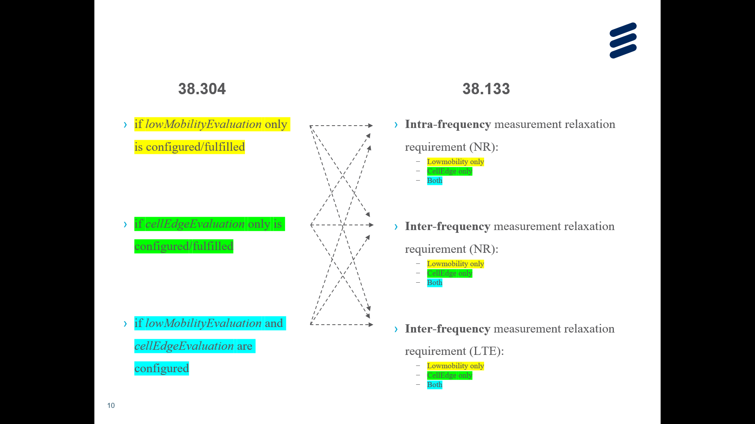

In [1], to avoid overlap between RAN2 and RAN4 specification, it is proposed that RAN2 captures the relaxation and offloading criteria while RAN4 captures different use cases that can be identified based on the configuration and which criteria are fulfilled.

Rapporteur shares the same view. In addition, in Rel-16 relaxed RRM measurements mechanism in idle/inactive in TS38.304, it also distinguishes intra-frequency case and NR inter-frequency/ inter-RAT frequency cases, as shown below [2]:

|  |
| --- |
| - if *cellEdgeEvaluation* is configured and *lowMobilityEvaluation* is not configured; and  - if the relaxed measurement criterion in clause 5.2.4.9.2 is fulfilled:  - the UE may choose to perform relaxed measurements for intra-frequency cells according to relaxation methods in clauses 4.2.2.9 and 4.2C.2.7 in TS 38.133 [8];  - if the serving cell fulfils Srxlev ≤ SnonIntraSearchP or Squal ≤ SnonIntraSearchQ:  - the UE may choose to perform relaxed measurements for NR inter-frequency cells or inter-RAT frequency cells according to relaxation methods in clauses 4.2.2.10, 4.2.2.11 and 4.2C.2.8 in TS 38.133 [8]; |

Rapporteur proposes to discuss how to capture RRM relaxation and offloading in TS 38.304 and TS 38.133 in advance. RAN2 can capture the general description on RRM relaxation and offloading for LP-WUS (e.g. not to capture intra-frequency, inter-frequency or inter-frequency cases) and criteria of RRM relaxation and offloading for LP-WUS. Other details are captured in RAN4.

**Proposal 1: The general description on RRM relaxation and offloading for LP-WUS (e.g. not to capture intra-frequency, inter-frequency or inter-frequency cases) and criteria of RRM relaxation and offloading for LP-WUS are captured in TS 38.304. Other details of RRM relaxation and offloading for LP-WUS are captured in RAN4.**

Companies are invited to give comments on proposal 1.

|  |  |  |
| --- | --- | --- |
| **Company** | **Yes/No on proposal 1** | **Comments** |
| Xiaomi | Yes | RAN2 captures the criteria of RRM relaxation and RAN4 captures how UE performs the RRM relaxation. |
| Ericsson | “Yes”, see comments | **It would be good to agree that as a general principle the RRM requirements will not be duplicated in 38.304 and 38.133.**  We suspect that RAN4 will proceed to capture the LP-WUS RRM requirements in a similar way in 38.133 as has been done for PEI. We support to have a “**general description**” in 38.304, i.e. this could avoid overlap and potential conflicts between 38.304 and 38.133. |
| NEC | Yes | Indeed in previous Rel-16 measurement relaxation discussion, overlapping issue between RAN2 and RAN4 was discussed for a long time. For now by only specifying criterion in RAN2 and requirement in RAN4, this can make things very simple. But should we inform RAN4 of this decision? |
| Samsung | Yes | Agree to capture general description and criteria of RRM relaxation and offloading for LP-WUS in TS 38.304. |
|  |  |  |

## Comments on TS 38.304 running CR

Companies can provide comments and suggestions to the uploaded running CR in this table. Please do not add changes, suggestions, or comments directly to the draft CR document.

|  |  |  |
| --- | --- | --- |
| Company + Issue Number (e.g., C001) | Detailed comments | Rapporteur response |
| X001 | 5.2.4.9.x Relaxed measurement criterion for LP-WUS Comment1:  FFS different UE types, OOK and OFDM need to be considered.  Comment2:  The entry condition for serving cell RRM relaxation is fulfilled when:  - Srxlev > SLP_WUS_RelaxEntryThresholdP_MR, and,  - Srxlev_lr > SLP_WUS_RelaxEntryThresholdP_LR, if SLP_WUS_RelaxEntryThresholdP_LR is configured,  and,  - Squal > SLP_WUS_RelaxEntryThresholdQ_MR, if SLP_WUS_RelaxEntryThresholdQ_MR is configured, and  - Squal_lr > SLP_WUS_RelaxEntryThresholdQ_LR, if SLP_WUS_RelaxEntryThresholdQ_LR is configured,  RSRQ is optionally configured for MR or LR. We can further consider the wording.  Comment3:  FFS whether to consider fully offloading and partial offloading. |  |
| X002 | 5.2.4.9.z Offloading measurement criterion for LP-WUS Do not understanding of the intention of this part. Is this the same thing as 5.2.4.9.x Relaxed measurement? |  |
| X003 | 7.x.1 Condition for LP-WUS monitoring  Comment1:  “The exit condition for LP-WUS monitoring is fulfilled when:  - Srxlev_lr < SLP_WUS_ExitThresholdP_LR, if SLP_WUS_ExitThresholdP_LR is configured, or,  - Squal_lr < SLP_WUS_ExitThresholdQ_LP, if SLP_WUS_ExitThresholdQ_LR is configured,  ”  Comment2:  We can further discuss whether the Entry/exit conditions for LP-WUS monitoring is the same as the entry/exit conditions for RRM relaxation. If it is, then this part is not needed. |  |
| X004 | 7.x.0 General Comment1:  FFS whether “*lastUsedCellOnly*” is introduced for LP-WUS as in PEI. |  |
|  | The UE monitors the legacy PO (and may monitor PEI)  Comment2:  “When the UE starts LP-WUS monitoring, if the UE detects LP-WUS and the LP-WUS indicates the subgroup the UE belongs to monitor its associated PO (and may PEI), as specified in clause 10.xx in TS 38.213 [4], the UE monitors the associated PO (and may PEI) as specified in clause 7.1.” If UE does not detect a LP-WUS on the monitored LO or the LP-WUS does not indicate the subgroup the UE belongs to monitor its associated PO (and may PEI), as specified in clause 10.xx in TS 38.213 [4], the UE is not required to monitor the associated PO (and may PEI) as specified in clause 7.1.  Comment3:  If single value is configured for *lo-Offset*, and if the gap between the LO and the corresponding PO is no less than the wake-up delay that the UEsupports, the UE monitors the PO associated with the offset after receiving a wake-up indication in a LP-WUS, otherwise UE follows the paging monitoring procedure as described in clause 7.1 and/or 7.2. |  |
| E001 | LR Low power wake-up Receiver |  |  |
| E002 | LP-WUS UE may further perform RRM neighbour measurement relaxation as specified in clause 5.2.4.9.0 or RRM serving cell measurement offloading and relaxation as specified in clause 5.2.4.9.x.  If the UE supports LP-WUS and LP-WUS is configured in SIB [details FFS]…  In 38.304 “RRM measurements” typically only refer to neighbour cell measurements, i.e. serving cell relaxation and offloading is new. From that perspective I think it is better to have serving cell relaxation/offloading in a separate section and clearly make this as “**serving** cell measurement relaxation/offloading”.  In 38.300 also the wording “**further**” RRM relaxation is used for the new Rel-19 scaling factors for neighbour cell measurements, i.e. propose to keep it. |  |
| E003 | LP-WUS UE may choose to perform relaxed measurement according to requirements specified in TS 38.133 [8] if the entry condition for RRM measurement relaxation in clause 5.2.4.9.x is fulfilled.  Agree, but an LP-WUS UE should also be allowed to perform relaxed Rel-16 neighbour cell measurements using the LR serving cell measurements, e.g. when “low mobility” is fulfilled the LP-WUS UE is not required to measure intra-frequency at all. This is even stronger than the Rel-19 “further” relaxation. Maybe you can add an FFS for that case. |  |
| NEC001 | 5.2.4.9.x Relaxed measurement criterion for LP-WUS UE5.2.4.9.z Offloading measurement criterion for LP-WUS UE **Comment: it should be LP-WUS UE.** |  |
| NEC002 | 5.2.4.9.x Relaxed measurement criterion for LP-WUS The entry condition for serving cell RRM measurement relaxation is fulfilled when: **Comment: it should be RRM measurement relaxation, to align with others** |  |
| NEC003 | 5.2.4.9.x Relaxed measurement criterion for LP-WUS The entry condition for serving cell RRM relaxation is fulfilled when:  - Srxlev > SLP_WUS_RelaxEntryThresholdP_MR, and,  - Srxlev_lr > SLP_WUS_RelaxEntryThresholdP_LR, if SLP_WUS_RelaxEntryThresholdP_LR is configured, and,  - Squal > SLP_WUS_RelaxEntryThresholdQ_MR, if SLP_WUS_RelaxEntryThresholdQ_MR is configured, and  - Squal_lr > SLP_WUS_RelaxEntryThresholdQ_LR, if SLP_WUS_RelaxEntryThresholdQ_LR is configured,  Where:  - Srxlev = current Srxlev value of the serving cell based on MR (dB).  - Squal = current Squal value of the serving cell based on MR (dB).  - Srxlev_lr= current measured cell RX level value of the serving cell based on LR (dB).  - Squal_lr = current measured cell quality value of the serving cell based on LR (dB).  **Comment: no strong view, but think it is worth to highlight “based on MR” since now we have two separate radio. Also apply to 7.x.1.** |  |
| NEC004 | If single value is configured for *lo-Offset*, and if the gap between the LO and the corresponding PO is no less than the wake-up delay that the UE reports, the UE monitors the PO associated with the offset after receiving a wake-up indication in a LP-WUS, otherwise the UE follows the paging monitoring procedure as described in clause 7.1 and/or 7.2.  If more than one values are configured for *lo-Offset*, and if the gap between the LO associated with the largest offset and the corresponding PO is no less than the wake-up delay the UE reports, the UE monitors the LO associated with the smallest offset value that has a gap between the LO and the PO associated with the offset no less than the wake-up delay, otherwise the UE follows the paging monitoring procedure as described in clause 7.1 and/or 7.2.  **Comment: it should be “the UE”, and we need to align the term (either support or report), since this is a UE capability with parameter, slightly prefer “reports”.** |  |
| NEC005 | SubgroupID = (floor(UE_ID/(N*Ns*Np)) mod subgroupsNumForUEID_LP) + (subgroupsNumPerPO_LP – subgroupsNumForUEID_LP),  where:  N: number of total paging frames in T, which is the DRX cycle of RRC_IDLE state as specified in clause 7.1  Ns: number of paging occasions for a PF  Np is the number of subgroupNumsForUEID for PEI, if configured; otherwise, Np is 1  **Comment-1: subgroupNumForUEID should be subgroupNumsForUEID.**  **Comment-2: in our understanding, no matter the UE supports PEI or not, there is no harm to use a unified LP-WUS formula which already can further reduce false alarm. And on top of further reduce false alarm, if different UE use different parameter Np, it can make the formula computation a little bit messed. However since this is our agreement, we can further discuss this issue based on contribution.** |  |
| NEC006 | The UE monitors one LP-WUS occasion per DRX cycle.  **Comment: even though multiple offsets corresponding to the same PO is introduced by RAN1, this is from NW perspective, we think that the UE only need to select ONE LP-WUS for monitoring. Also this is to refer to PEI description.** |  |
| SS001 | The terminology ‘LP-WUS UE’ must be defined. |  |
|  |  |  |
|  |  |  |
|  |  |  |
|  |  |  |
|  |  |  |

# Conclusion

TBD

# References

1. R2-2501094, LP-WUS and RRM measurements, Ericsson , discussion, RAN2#129
2. 3GPP TS 38.304: "NR; User Equipment (UE) procedures in Idle mode and RRC Inactive state", v18.4.0