3GPP TSG-RAN WG2#129-bis R2-25XXXXX
Wuhan, China, April 7 – April 11, 2025

Agenda Item: 8.5.1
Source: Huawei, HiSilicon
Title: Report of [POST129][101][NES] (Huawei)
Document for: Discussion and decision

1 Introduction
This document is the report of the following discussion:
- [POST129][101][NES] (Huawei)
Scope: Capture all agreements in 38.300 running CR.
Intended outcome: Endorsed 38.300 running CR in R2-2501461.
Deadline: Long email discussion (Mar. 21st 10:00 UTC)

Please provide your comments by Thursday March 20th 10:00 UTC to allow 24h for the rapporteur to update the CR before the deadline.

Companies providing input to this email discussion are requested to leave contact information below.
Company | Delegate name | Email address
OPPO | Qianxi Lu | qianxi.lu@oppo.com
Xiaomi | Li Zhao | zhaoli6@xiaomi.com

2 RRC CR for NES
The post-RAN2#129 draft running stage-2 CR for NES enhancements and a document for providing comments are provided in the discussion folder. Please don’t change the CR text or insert comments to the CR file. Please use the table below for comments and wording suggestions for clarity of the CR tdoc. If you want to highlight several issues, please use comment IDs e.g. HW001, HW002, etc. so it is easier for the rapporteur to respond.

Company and comment ID (e.g. HW001) | Section and detailed comments/suggestions | Rapporteur response
OPPO001 | Paging adaptation for cell level energy saving: in order to reduce gNB signalling, the value of N and Ns are extended to concentrate the POs in sparser PFs. The UE supporting paging adaptation shall monitor PDCCH in its NES specific PO.  [OPPO] The yellow terms is not rigorous, since PO for R19 NES UE can be shared with legacy UE, and also R19 UE may also monitor legacy PO if network does not configure R19 PO at all.
OPPO002 | On-demand SSB transmissions facilitated through serving cell indications enable UEs to perform at least SCell time/frequency synchronization, L1/L3 measurements and SCell activation, and are supported for FR1 and FR2 in non-shared spectrum.  [OPPO] Although it is from WID, but rigorously SCell activation include steps like t/f sync and L3 meas, so not a same level concept?
Xiaomi001 | Adaptation of PRACH in time domain is supported for 4-step RACH and CBRA.  [Xiaomi] should be 4-step CBRA as according to the agreement, there is no conclusion on 2-step CBRA.  Also suggest to add a editors’ note whether to support 2-step CBRA and/or CFRA depends on RAN1
Xiaomi002 | This solution is supported in the following scenarios:  - The SCell is configured to a UE but before the UE receives SCell activation command  - When UE receives SCell activation command  [Xiaomi] according to the following RAN1 agreement, only 3A is excluded, whether to support 3B is still FFS. Suggest to add a note to wait for RAN1 conclusion on 3B.  Conclusion  The following combination of scenarios and cases for indicating OD-SSB are not supported in Rel-19  - Scenario #3A and Case #1  - Scenario #3A and Case #2  Above does not impact discussion on SSB periodicity adaptation in time domain
Xiaomi003 | 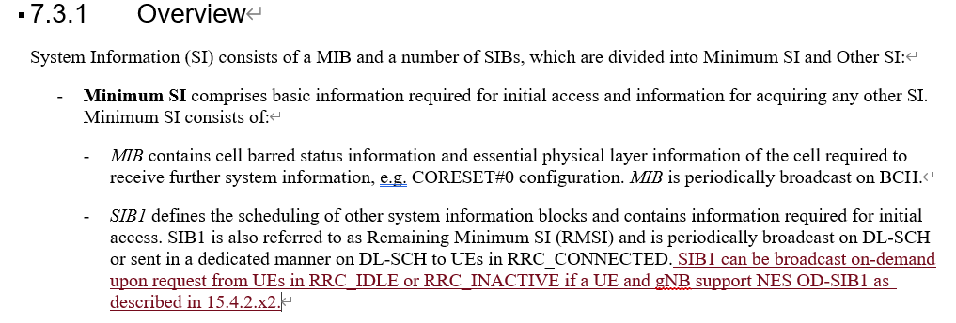  RAN2 agreed that the UE in RRC_CONNECTED can perform on-demand SIB1 procedure for RLD case.  The “RRC_CONNECTE” should be captured.  - Specify the following UE behavior to allow the UEs in RRC_CONNECTED state to acquire OD-SIB1 when T311 is running:  - When T311 is running, the UE can trigger the OD-SIB1 acquisition procedure with stored UL WUS configuration in SIB-X, if it is still valid.  - The legacy cell selection criteria are reused as the trigger condition of OD-SIB1 acquisition.  - The OD-SIB1 acquisition behavior is same as that of RRC_IDLE/IANCTIV UEs.
Xiaomi004 | 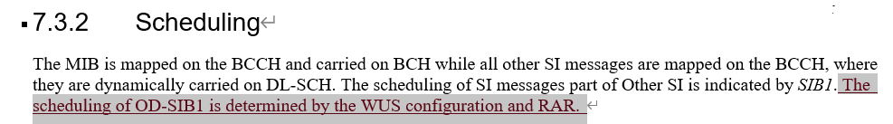  It is too early to capture this sentence due to no agreements and this sentence is also not clear.

